How does SerializerMethodField work and when to use it and what’s the difference between it and using @property decorator??!

Product model: (method: get_discount())
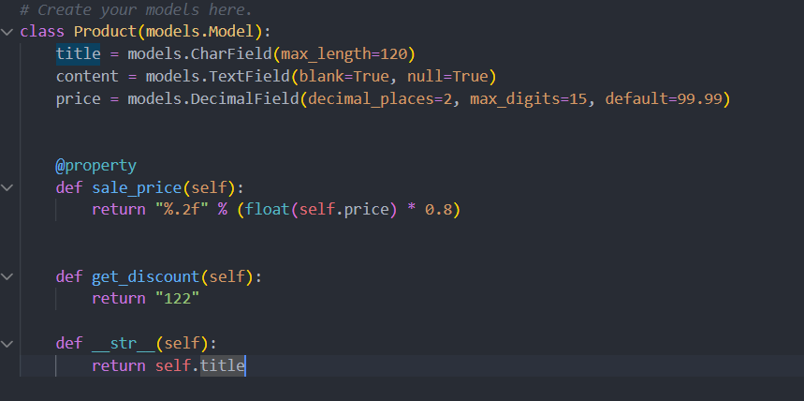
Product serializer: (using discount that retrieve the returned value of the get_discount() method)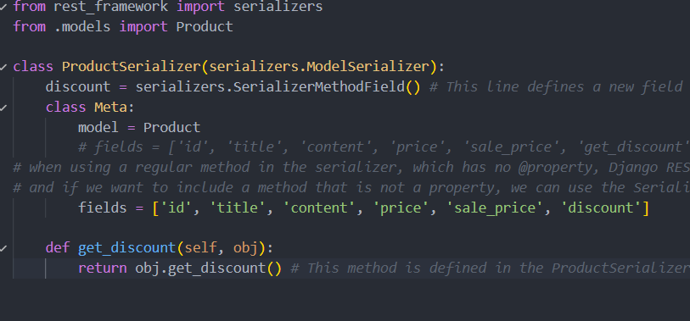
But get_discount is a method, not a field or property, so Django REST Framework won’t automatically call it unless you explicitly tell it to.

✅ How SerializerMethodField works
SerializerMethodField is a read-only field that lets you define custom logic inside the serializer.
When you declare it, DRF will:
- Look for a method named:
get_<field_name>
- Call it automatically
- Pass the model instance (obj) to it
- Use the returned value in the serialized output

🔧 Fix your serializer
You need to explicitly define get_discount as a SerializerMethodField:
from rest_framework import serializers
from .models import Product
class ProductSerializer(serializers.ModelSerializer):
get_discount = serializers.SerializerMethodField()
class Meta:
model = Product
fields = ['id', 'title', 'content', 'price', 'sale_price', 'get_discount']
def get_get_discount(self, obj):
return obj.get_discount()

⚠️ Important detail (this confuses everyone at first)
- Field name: get_discount
- Method name: get_get_discount
Yes, it looks ugly 😄 — but it's because DRF enforces:
get_<field_name>

🧠 Cleaner alternative (better design)
Honestly, your current model method:
def get_discount(self):
return "122"
This is basically a computed value, so a cleaner approach is to make it a @property like sale_price:
@property
def discount(self):
return "122"
Then in serializer:
fields = ['id', 'title', 'content', 'price', 'sale_price', 'discount']
No need for SerializerMethodField at all.

🆚 When to use what?
Use @property when:
- Logic belongs to the model
- It depends only on model fields
Use SerializerMethodField when:
- Logic depends on request/context/user
- You need serializer-specific formatting
- You don’t want to touch the model

💡 Quick intuition
- Model = business logic
- Serializer = representation logic

