343 - Final Project

Canyon: A Message-Body Encryption Gadget for Gmail

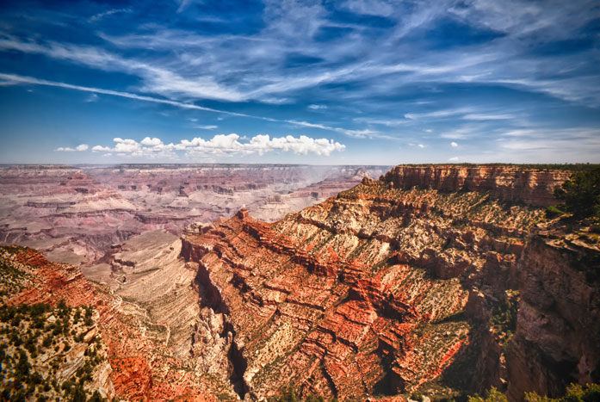

Brand, Ilona, Nora Hayes, Alex Katz, James Quintana and Tyler Robertson

Spring 2014

CSCI 343 - Final Project

Canyon: A Message-Body Encryption Gadget for Gmail

Abstract

This paper presents Canyon, a new encryption option for IMAP mail messages sent using the Gmail web-browser-enabled mail service by Google. We will begin with a survey of existing encryption options, and reveal the necessity of a new option. We then will provide more detail into the functionality of Canyon, our implemented solution, and its use. We will conclude with a summary of the strengths that distinguish Canyon from the previous options, and the areas we have considered for further development.

Background
This section contains information about existing systems of encryption (possibly including their weaknesses), well as general background on why e-mail encryption is important — and why we needed to make a new implementation.

Canyon
[This section contains a description of the functionality of our system (working title Canyon). In particular, we want the information flow described in detail, as well as specifications as to our sources of 3rd party code. Probably should include a diagram or three as well.]

Canyon is our solution to these exigencies. It offers a secure and easy way to communicate encrypted text emails to other users of Canyon. The underlying encryption scheme is inspired by Phil Zimmermann’s PGP, although it does not conform to the OpenPGP standard (RFC 4880). There are two basic components to encryption in Canyon: a public-key (asymmetric) encryption method, and a private-key (symmetric) encryption method. The software uses a combination of user-input and saved state to encrypt and decrypt messages that are sent between users.
All encryption methods are implemented in JavaScript. We chose to use RSA for our asymmetric method. RSA is a strong choice because it does not require transmission across previously-existing secure channels to transmit secret keys. However, it is slow to encrypt very large messages; as such, we chose to use 3DES to encrypt the user’s message with a randomly generated fixed-size symmetric key, then encrypt that key using the RSA (à la PGP). We chose 3DES due to its strength and speed over large messages. We found and employed JS-Encrypt — Travis Tidwell’s wrapper for Tom Wu’s JavaScript implementation of RSA (Tidwell). Canyon uses this library for all RSA-specific functions, including public/private key-pair generation and encrypting the 3DES random key. We sourced our 3DES implementation of another library, CryptoJS, which is an open-source collection of several encryption algorithms including 3DES.
The functionality of Canyon is user-dependent, because it saves state unique to each user that is only accessible to that user. Canyon’s saved state (for a given user) consists of two groups of information: a public/private key pair, and a table of <address:value> pairs where a single pair is an entry corresponding to exactly one other Canyon user; the address is that other user’s email address, and the value is that user’s public key. All these keys are components of the asymmetric encryption method mentioned above; the symmetric system (along with its internal padding scheme) is completely abstracted away and does not make use of Canyon’s saved state.
Encrypting a transmission using Canyon requires only that the sender has an accurate <address:value> pair in their key table for the intended recipient. An input text message is provided by the sender. First, Canyon generates a random key for 3DES. The provided message text is padded to a length multiple of 64 bits; this padded message is encrypted with 3DES and the randomly generated key. The random key is then encrypted using RSA and the recipient’s public key. The encrypted key and encrypted message are output as a securely transmissible message.
Decrypting a received message depends only that the user’s private-key and the public key used by the sender comprise a single generated pair (i.e., the sender did not corrupt their key table, and the recipient did not generate a new key pair but fail to distribute the public component). The received data includes an encrypted 3DES key, which is extracted using RSA and the user’s unique private key. This extracted key is then used with 3DES to decrypt the main message body, which is itself then un-padded using an inverse of the padding scheme mentioned above; this converts the padded 64n-bit message into the original message that the sender wished to communicate.

Using Canyon
[Basic user guide to Canyon. More in-depth explanation of our interface, as well as specifications as to how to interact with it for maximum usefulness. Images may lie ybounden]

Canyon is a Google sidebar gadget: a platform-independent, portable, embedded application that users can interact with when logged into the Gmail web browser front-end.

Advantages
[A detailed description of Canyon’s strengths over the existing systems — specifically address each of the needs listed in the Background section. Possibly address the wheel-of-principles from 1st quarter]

Disadvantages
[List of Canyon’s weaknesses, and how we might go about patching them. Includes holes in communications vectors that Canyon uses; especially note where we (developers) and the users have to place trust that could potentially be abused.]

