phase1output

Alexander Lawless

23/09/2021

# Background/Project Details

## Combined patient population health service needs

The first strand of our analysis will be to collate and summarise GP surgery patient lists for the given 8 practices. This will be achieved using publicly available data from NHS Digital, specifically data on the distribution of GP patients by gender, sex and LSOA along with the number of patients each practice has with selected health conditions specified by Quality Outcome Framework (QOF) returns. Without access to individual level GP data, we will not be able to account for multi-morbidity, that is, we will present the combined volume of patients across the 8 practices who are know to have heart disease for example, alongside the number of COPD, but not the number with both conditions. We will also estimate the volume and nature of referrals to community care for this combined patient population. A preliminary data query, using our Community Services Data Set would suggest our combined population were responsible for approximately 130,000 referrals to community services during 2019, primarily for footcare, MSK problems and the ‘Healthy Child Pathway’. Discussions will be required to agree the most appropriate method of estimating ‘existing’ demand given changes to referrals and care seeking behaviour throughout the pandemic. This exercise will provide high level estimates of demographics and clinical need for the new patient population and will serve as a baseline to feed into our model when predicting wider service engagement and demand. To complete this analysis, we will also identify activity across other aspects of the health and care system used by patients at the 8 practices according to the Cavell Centre service model. This will include but is not necessarily restricted to:

* Outpatient appointments at RSH, PRH and other acute providers
* Appointments/rehab/therapies at RJAH/ShropCom
* Appointments/assessments/therapies at MPFT and other mental health providers
* Diagnostics at SaTH/RJAH/ShropCom
* Midwifery and antenatal care
* Any others from ‘service spec’

The programme team will need to provide definitions of all the activity types and clinical areas that are relevant to the Cavell centre model for each of the above points of delivery so that only relevant data is extracted and counted.

# Population demographics

## Practice populations

**Combined practices patient total:**

## # A tibble: 1 x 4  
## Population Male Female total  
## <chr> <dbl> <dbl> <dbl>  
## 1 Combined 32058 33505 65563

**Practice list size:**

## # A tibble: 8 x 4  
## Practice Male Female Total  
## <chr> <dbl> <dbl> <dbl>  
## 1 Mytton Oak Medical Pract. 5545 5484 11029  
## 2 Radbrook Green Surgery 4858 5160 10018  
## 3 Marden Medical Practice 4449 4856 9305  
## 4 South Hermitage Surgery 3954 4389 8343  
## 5 Claremont Bank Surgery 3783 3943 7726  
## 6 Beeches Medical Practice 3282 3360 6642  
## 7 Marysville Medical Pract 3134 3180 6314  
## 8 Belvidere Medical Pract. 3053 3133 6186

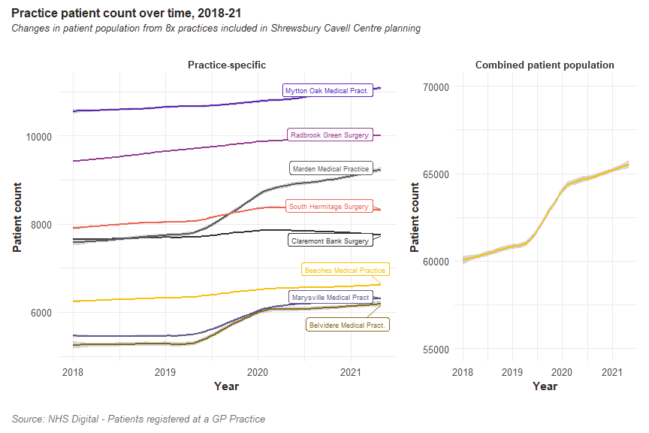

While practices differ in size/patient capacity, changes over time have been largely consisent between practices. All have seen gradual increases in patient population between 2013 and 2020.

## Age and gender structure

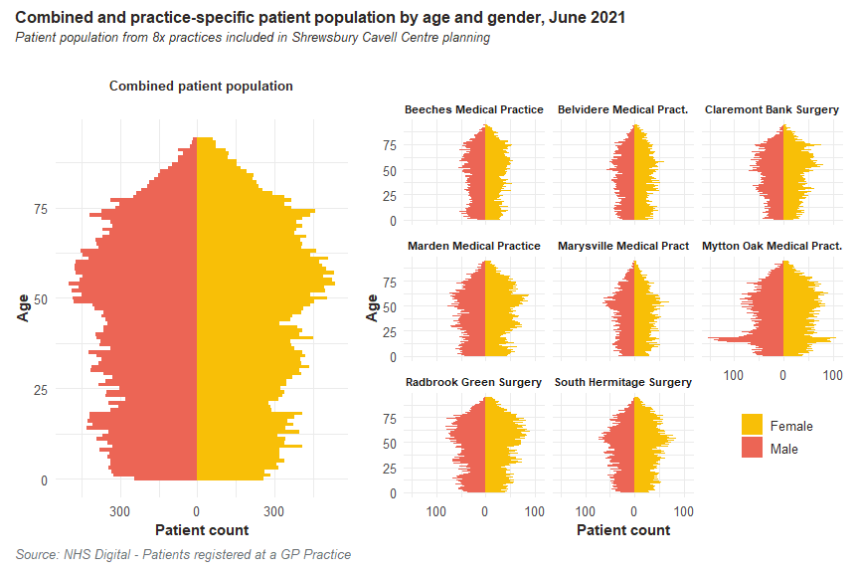

The age and gender profiles are largely similar and a function of local demographics; we can see differing patient volumes but similar proportions of 50+ year old patients across all practices. Mytton Oak displays a particularly large count of under 25’s compared to other practices however this has little impact of the profile of the combined patient population.

## Deprivation

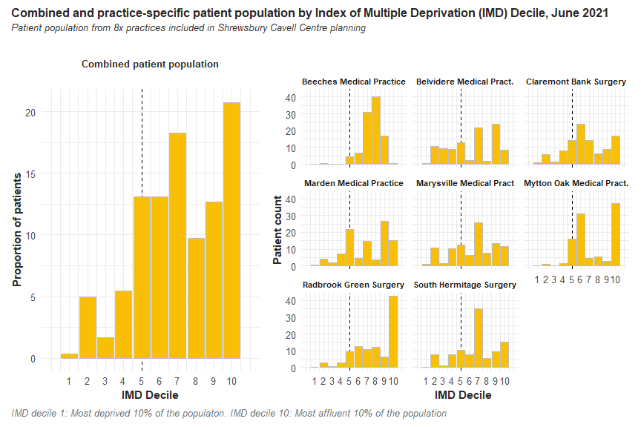

The above graph suggests relatively low levels of deprivation in the Cavell centre patient population with the majority of patients living in more affluent areas of the country. The deprivation level of a patient here is a function of their LSOA of residence; this is not an individual level statistic and as such there may be highly deprived patients, in relative or absolute terms, living in the catchment area.

Local authority data and/or population segmentation tools such as Acorn may educate the analysis to small areas of localised deprivation in the combined population.

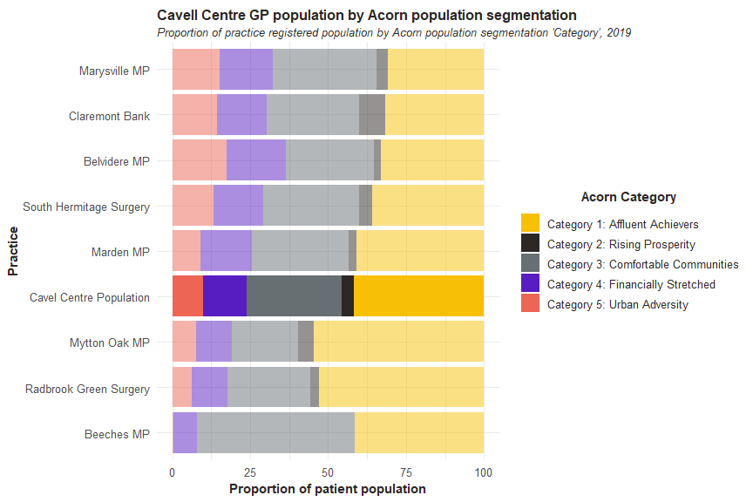

# Clinical profiles

## QOF derived

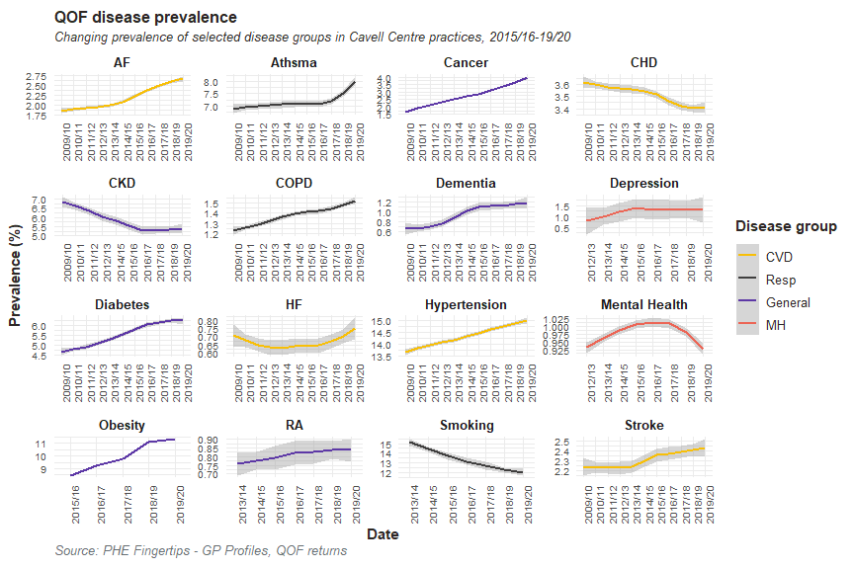

## Practice data

Practice data will offer insight on the volume and rate of patients with comorbidities as well as appointment type, duration and staffing to inform phase 2 modelling.

# Consultation data

Consultation data is available from NHS Digital at: <https://digital.nhs.uk/data-and-information/publications/statistical/appointments-in-general-practice>

Lowest geography data is available at is CCG; as such we assess the age and gender profile of our 8 practices against that of the wider CCG (excluding our patients) to decide if we can directly discount CCG values by the proportion our patients represent and assume similar care utilisation.

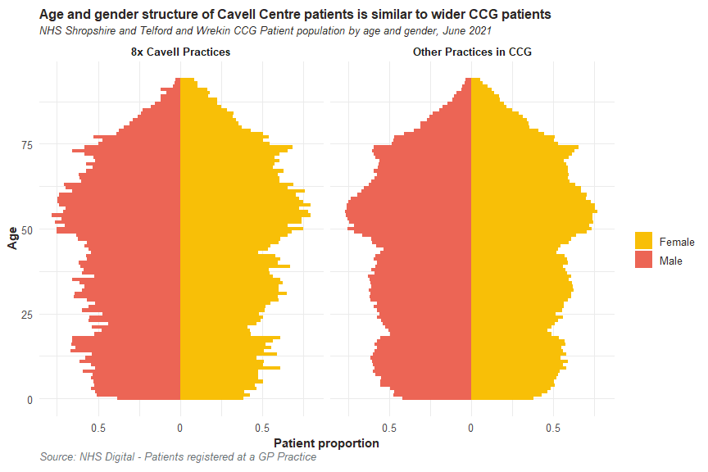

Cavel Centre patient population accounts for 12.8% of CCG patients/consultations. Having multiplied CCG-level, monthly consultation counts by 0.128, we can estimate the volumes attributed to the 8 Cavell Centre practices.

