SUPPLEMENTARY MATERIAL I. EXPERIMENTS, OBSERVATIONAL TESTS, AND REPRODUCIBILITY
Supporting material for: Distinguishability Geometry: Operational Metric and Jacobi–Riccati Response Hierarchy
Public scope note. This supplement is the authoritative apparatus-level record for every retained DG experiment, observational target, numerical feasibility estimate and negative veto. The IBM programme is retained as an empirical geometric baseline and reproducibility record, not as a unique theory-selection experiment. The non-circularity/statistical release gate is stated explicitly in Appendix A.17. The main manuscript provides the compact quantitative navigator; mathematical proofs and claim-boundary questions are collected in Supplementary Material II.
Master Quantitative Experimental and Falsification Map
This navigator distinguishes measured geometric baselines, DG-specific confirmatory protocols, quantitative design targets, phenomenological targets, standard-reference baselines, conditional branches and negative vetoes. Numerical values do not share one evidential status; the status column states the degree of DG specificity explicitly.
Table 1. Quantitative DG experimental, observational, computational, and veto channels.
Channel | Quantitative target / result | Status / DG specificity | Kill / support criterion | Detailed location
IBM fixed-angle / endpoint test | θ=π; P₁≈0.27, 0.51, 0.98 (spread ≈3.7) | Measured geometric baseline. standard-QM compatible | Rejects control-angle-only predictor; does not discriminate DG from standard endpoint quantum geometry | Supp. I A.13
IBM cross-backend transfer | RMSE 0.005001 (Kingston→Fez); 0.009148 (→Marrakesh) | Measured transferability baseline. not DG-specific | Endpoint representation: aggregate agreement across the tested Heron backends (RMSE 0.005–0.009 against a Kingston reference; aggregate means, no uncertainty) | Supp. I A.14
IBM collapse / geodesic control | MAE: angle 0.1098, path 0.0606, endpoint 0.0141; implementation error 0.0345→0.0551 from shortest to longest tested path | Descriptive baseline; a resource-matched causal test is required for any stronger claim | Endpoint population is standard-QM compatible; path-cost association requires matched duration/gate/noise controls | Supp. I A.10, A.15
Cold-atom endpoint transfer | $N≈{10}^{4}$ atoms/shot; probability target ${10}^{−3}$ after averaging at least 25 independent ideal repeats at $p=1/2$. | Design target | Held-out residual organization must transfer after standard channel model is fixed | Supp. I E.2
⁸⁷Rb BEC collective mode | Conditional +1.5 mHz illustration in 100 Hz trap; ηBEC=(ξBEC/LBEC)²≈6.9×10⁻⁶ (reference case) | Phenomenological target | Broad N×T residual must follow pre-specified coherence-length scaling after GP/BdG backgrounds | Supp. I D
Sr clock / Ramsey baseline | Phase-spread rate 8.85×10⁻⁵ rad s⁻¹ at rms height 0.3 mm; 1/e contrast time 1.60×10³–1.60×10⁴ s for rms heights 3–0.3 mm | Standard baseline; no parameter-free DG residual is specified | Standard QM+GR baseline; no parameter-free DG extra phase is claimed | Supp. I B
YIG magnons | No parameter-free amplitude yet | Proposed protocol; no parameter-free amplitude is specified | Pre-registered geometric variable must improve held-out transfer beyond calibrated native model | Supp. I C, F.3
AFM/STM feasibility veto | At 88 μm: estimated ≈1.1×10⁻⁶ pm vs ≈5 pm reference noise | Negative veto | Negative veto: position-space route is not a viable discovery channel | Supp. I E.1
Vacuum / short range | L_{Λ}≈88 μm; E_{Λ}≈2.25 meV from observed ρ_{Λ} | Conditional scale map | Scale mapping only; any force amplitude requires a separate dynamical completion | Supp. I G; Supp. II H–I
Absolute neutrino mass | Independent mass-selection law required | Open problem | No mass threshold follows from the vacuum scale mapping | Supp. I G; Supp. II H–I
Locality/interface scaling kill test | Explicit β={0,1/2,2/3,3/4,4/5,≈1}; withheld extrapolation error <1% for exact closed-form counts (arithmetic check only) | Computational / analytic no-go | Different β across equally local architectures kills locality⇒β=2/3 | Supp. II M + reproducibility package
Stage-IV cosmology | No parameter-free amplitude/evolution curve yet | Not a quantitative DG prediction from the current scale map | Not a quantitative DG test until a pre-specified evolution law is supplied | Supp. I G; Supp. II I
Frozen-protocol held-out quantum discriminator | Frozen predictor; ΔL_{holdout}<0 with correlation-aware interval entirely below zero | Design requirements for a future distinct extension; correction law not yet supplied | Predictor independent of target; held-out protocol/backend; no post-hoc refit | Supp. I A.17
IBM temporal-reparameterization / physical-idle stress series | Tests 1–3: Level-2 separation replicated; Test 7 rejects local m=6 anomaly; Test 8: ΔBIC=11.20; central 95% bootstrap range ≈[−2.2,20.5], ≈51% of resamples ≥6 | Measured stress test; suggestive but evidence for backend-specific drift sensitive to resampling | Supports the weak-delay baseline; strong arbitrary-delay invariance fails and the isolated threshold did not replicate. The observed score favors backend-specific drift, but the broad conditional bootstrap range prevents a decisive exclusion of common physical-idle scaling | Supp. I A.18
Appendix A
Full IBM Quantum Experimental Metadata and Protocols
Scope note (September 2026). The IBM material is retained because it documents the empirical applicability, portability and reproducibility of the endpoint-geometric language across the tested protocol families. The pure-qubit endpoint-population relation is, however, standard-QM compatible and is not counted as an independent DG-specific prediction. Appendix A.17 records the non-circularity boundary and the confirmatory protocol required for DG-specific evidence.
A.1 Motivation and Central Prediction
This appendix documents the complete IBM Quantum programme. Its current evidential role is to determine whether the proposed geometric variables are experimentally usable and transferable, to identify where that description is non-unique, and to supply the baseline needed to design a non-circular theory-discriminating experiment.
Endpoint Fubini–Study distinguishability is therefore treated here as an experimentally audited representation variable across the stated protocol families and hardware implementations.
The descriptive hypothesis tested in the existing IBM data is that protocol families with different controls and trajectories can be organized consistently by endpoint state-space geometry. This is an empirical applicability question. A distinct predictive extension additionally requires an independently justified DG correction law, control of conventional alternatives, and improved prediction on an independent holdout against a frozen quantum/channel/control comparator.
The principal hypothesis tested throughout this appendix is therefore
$P_{e}=f(d_{FS}),$ | (1)
where $d_{FS}$ denotes the Fubini–Study distinguishability between the initial and final quantum states.
Within the existing data, endpoint geometry is the most accurate organizing variable among the compared laboratory angle/path representations. This documents empirical usefulness and portability of the geometric language in the tested protocol families, not uniqueness of DG against standard quantum mechanics or general channel descriptions.
To test this hypothesis, a hierarchy of increasingly demanding experiments was performed, beginning with single-qubit protocols and extending to large-scale hardware-wide experiments involving up to 156 physical qubits distributed across multiple independent IBM Quantum processors.
A.2 Scope of the Experimental Programme
The experimental programme consisted of complementary campaigns designed to probe geometric organization, hardware transferability, trajectory dependence, correlations, scaling and implementation cost. Their present status is descriptive/reproducibility evidence unless a section explicitly states a stronger independently discriminating test.
Statistical-status convention. Earlier exploratory and transferability campaigns report the recorded shot counts and point estimates; where no independent repeat-run campaign was performed, no run-to-run confidence interval is claimed. Those sections are descriptive/reproducibility baselines rather than frozen-protocol confirmatory tests. Formal freezing of predictor, threshold, normalization and release criteria is stated explicitly only where it was performed, in particular in A.17–A.18.
Protocol chronology. Here “frozen protocol” denotes an author-held document dated on the day of the experiment, without an independently verified third-party timestamp. Later designs could use earlier experimental outcomes; freezing within a stage is not external preregistration of the whole sequence.
The first group examined single-qubit protocols with different control profiles and compared several organizing variables. Because pure-qubit population and endpoint Fubini–Study distance are algebraically related in standard quantum mechanics, these tests are geometric baselines rather than DG-specific validation.
The second group examined protocols with similar endpoints and different accumulated path lengths. These data are useful for separating target-state geometry from implementation overhead, but a DG-specific cost law additionally requires resource-matched controls so that duration, gate count, drive exposure and conventional noise do not covary with path length.
The third group investigated history-dependent protocols containing closed loops in state space. Such experiments were designed to determine whether previously traversed paths contribute independently to the final excitation probability.
The fourth group extended the analysis to entangling two-qubit operations in order to determine whether the distinguishability description remains valid in the presence of quantum correlations.
The final large-scale campaigns used up to 127 and 156 physical qubits to test address-wide scalability and cross-backend portability of the chosen geometric representation. They are not tomography of a generic 2¹⁵⁶-dimensional state and are not presented as an independent derivation of DG.
Together, these experiments provide a systematic investigation of distinguishability-based organization across more than two orders of magnitude in system size.
A.3 Experimental Platforms
All experiments were performed using IBM Quantum superconducting quantum processors belonging to the Heron generation.
The primary processors employed in this work were:
• IBM Kingston
• IBM Fez
• IBM Marrakesh
Each processor provided access to 156 physical superconducting qubits and was operated through the IBM Quantum cloud infrastructure.
The use of multiple independent processors tests whether the chosen endpoint representation transfers across hardware rather than being tied to one backend. Transferability is a necessary empirical property for a cross-platform geometric programme, but it is not by itself a theory-selection result.
No backend-specific fitting parameters were introduced during the analysis. Whenever possible, protocols developed on one processor were executed directly on the others without additional optimisation. This allowed a direct test of hardware-independent transferability.
The experimental programme included:
• single-qubit protocols;
• Bloch-sphere trajectory tests;
• history-loop experiments;
• two-qubit entangling protocols;
• 127-qubit hardware-wide benchmarks;
• 156-qubit falsification tests;
• cross-backend transfer experiments;
• geodesic optimal-control experiments.
The complete archive of backend identifiers, execution records, and job metadata is provided below.

A.4 Software Environment
All experiments were executed using the IBM Quantum cloud infrastructure through Qiskit Runtime.
The archived software environment was:
Python version: 3.12.13
Qiskit version: 2.4.1
Qiskit IBM Runtime version: 0.47.0
Platform: Linux x86_64
The complete software environment was preserved together with the experimental datasets to ensure reproducibility of all reported results. The archived metadata include backend characteristics, runtime versions, execution timestamps, and environment information required for independent verification of the experimental procedures.
A.5 IBM Quantum Job Archive
Table 2 summarises the principal IBM Quantum jobs used in the distinguishability study.
Table 2. Principal IBM Quantum jobs used in the experimental programme.
Experiment | Backend | Job ID | Qubits
One-qubit protocol family A–F (first run) | ibm_marrakesh | d8gnp842upec739k2fm0 | 1
One-qubit protocol family A–C (original run) | ibm_marrakesh | d8gmcq9e8nrc73bg654g | 1
One-qubit protocol family A–F (repeat) | ibm_fez | d8go5942upec739k32gg | 1
One-qubit protocol family A–F (repeat) | ibm_marrakesh | d8gp8l9e8nrc73bgahs0 | 1
Bloch-sphere path test | ibm_kingston | d8gppgtv8cos73f3i28g | 1
History-loop test | ibm_kingston | d8gq7nhe8nrc73bgc960 | 1
Time-profile test | ibm_kingston | d8gpfjpe8nrc73bgav1g | 1
Two-qubit entangling test | ibm_kingston | d8gqcqc2upec739k73i0 | 2
127-qubit distinguishability benchmark | ibm_kingston | d8hcie5v8cos73f48ma0 | 127
156-qubit cross-backend transfer test | ibm_kingston | d8hd21s2upec739ktc30 | 156
156-qubit geodesic optimal-control test | ibm_marrakesh | d8hdkphe8nrc73bh2u40 | 156
Temporal reparameterization Test 1 | ibm_kingston | daom5mopqrnc739a74cg | 1
Temporal reparameterization Test 2 | ibm_fez | daomb1n8gn2s739o3il0 | 1
Temporal reparameterization Test 3 | ibm_marrakesh | daomm20pqrnc739a7ps0 | 1
Strong-delay invariance Test 4 | ibm_kingston | daomsc02fm4c73f5me0g | 1
Boundary scan Test 5 | ibm_fez | daon0l02fm4c73f5miqg | 1
Dense boundary/channel diagnostics Test 6 | ibm_marrakesh | dap35of8gn2s739olb20 | 1
Local m=6 replication Test 7 | ibm_marrakesh | dap3gtdr85ps73fg2le0 | 1
Matched-idle Test 8 | ibm_marrakesh | dap3vk02fm4c73f68eqg | 1
Matched-idle Test 8, first Fez attempt (HAL error 9604) | ibm_fez | dap4145r85ps73fg36q0 | 1
Matched-idle Test 8, exact frozen Fez retry | ibm_fez | dap42ttr85ps73fg3930 | 1

Additional execution records, backend metadata, calibration information, and auxiliary datasets were archived throughout the study and form part of the complete reproducibility package associated with this work.
The following sections analyse the experimental results obtained from these datasets and compare the predictive power of conventional control variables with the endpoint distinguishability description proposed in the main text.
A.6 One-Qubit Geometric Baseline
Conventional alternative. The observed one-qubit response can be accounted for by the calibrated native unitary/channel response of the qubit and ordinary readout noise. This baseline therefore tests the usability of the geometric coordinate, not a DG-specific microscopic law.
The first IBM baseline compared endpoint Fubini–Study distance, accumulated path length and laboratory control angle as alternative organizing variables for measured single-qubit excitation populations. Because the pure-qubit population and endpoint distance obey the standard quantum relation P₁=sin²(d_{FS}), this comparison is descriptive rather than a DG-specific theory-selection test.
A family of single-qubit protocols was executed on IBM Quantum hardware using substantially different pulse amplitudes, durations, and control profiles. For each protocol, the excitation probability $P_{e}$ was measured and compared with several candidate organizing variables, including the laboratory control angle $θ$, the accumulated Fubini–Study path length $l_{FS}$, and the endpoint distinguishability $d_{FS}$.
Within the tested protocol family, protocols with similar endpoints were expected to give similar computational-basis populations. This expectation is consistent with standard pure-state quantum geometry and is therefore used here only to audit the practical endpoint representation.
The measured populations showed substantially less scatter when represented by endpoint distance than by the tested laboratory control angle. This establishes empirical convenience of the endpoint coordinate for these data, not an independent prediction beyond standard quantum mechanics. The corresponding excitation curves are shown in Figure 1 (accumulated path length) and Figure 2 (endpoint distinguishability).
The one-qubit experiments therefore supply the simplest empirical baseline for the geometric language and motivate the later transferability and non-circularity tests.
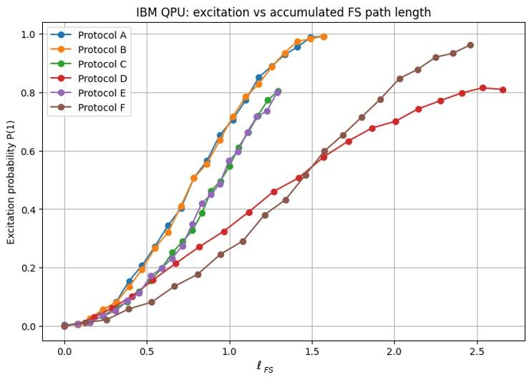
Figure 1. IBM Quantum, one-qubit protocol family (protocols A–F): measured excitation probability versus accumulated Fubini–Study path length ℓFS. No universal collapse is observed against this variable. Curves show recorded point estimates; independent run-to-run uncertainty bands are unavailable.
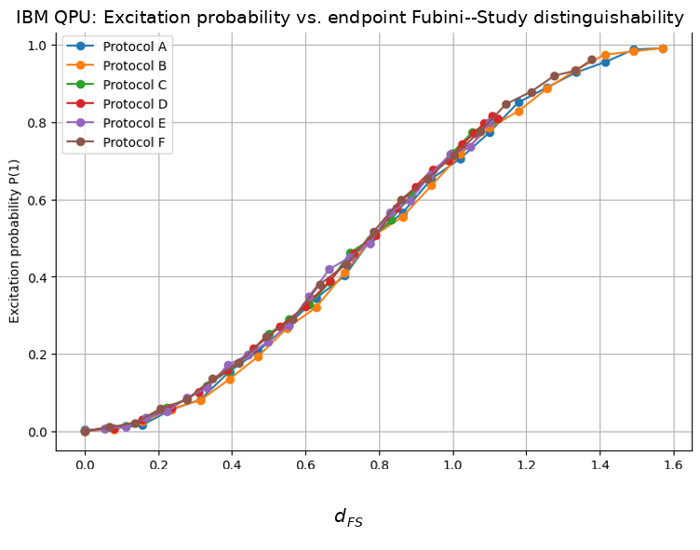
Figure 2. IBM Quantum, one-qubit protocol family (protocols A–F): the same data versus endpoint Fubini–Study distinguishability dFS. The excitation curves collapse onto a common dependence. Curves show recorded point estimates; independent run-to-run uncertainty bands are unavailable.
A.7 Bloch-Sphere Path Baseline
The second baseline compared protocols with similar endpoints and different Bloch-sphere path lengths to separate endpoint-state description from trajectory-dependent implementation effects.
Protocols were constructed with nearly identical endpoint distinguishabilities but substantially different accumulated path lengths. The objective was descriptive: determine whether target population changed appreciably across detours and whether implementation error covaried with the extra path.
The endpoint population is expected from standard quantum state geometry to be primarily tied to the final state; accumulated path length can instead correlate with implementation resources and noise. The experiment therefore tests a practical separation, not a unique DG law.
The tested protocols with nearly identical endpoints produced similar populations despite substantial path-length differences. This is compatible with the standard endpoint-state description; it does not by itself establish a new endpoint law. The corresponding data are shown in Figure 3.
These observations support using endpoint geometry for the target-state coordinate in this protocol family. The association between longer paths and implementation cost remains provisional until conventional resources are matched independently.
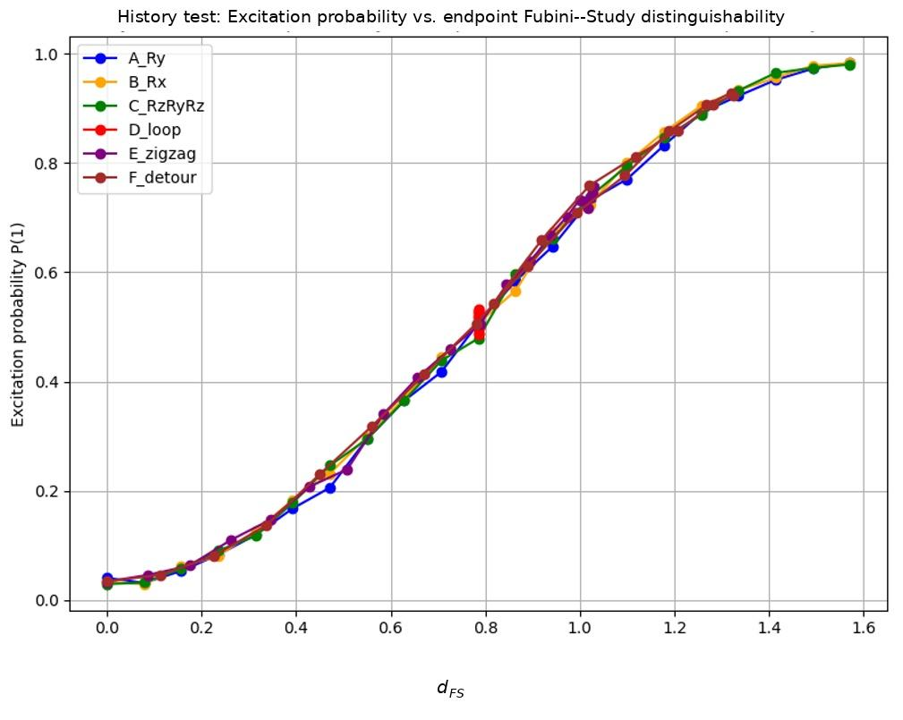
Figure 3. Bloch-sphere path-independence test: measured excitation probability versus endpoint Fubini–Study distinguishability dFS for six trajectories with direct rotations, composite rotations, a loop, a zigzag and a detour (protocols A_Ry, B_Rx, C_RzRyRz, D_loop, E_zigzag, F_detour). Despite substantially different intermediate paths, the curves collapse onto a common dependence. Curves show recorded point estimates; independent run-to-run uncertainty bands are unavailable.
A.8 History-Loop Baseline
The history-loop campaign tested whether adding closed detours changed the final measured population once the endpoint was held approximately fixed.
In these experiments, the quantum state was intentionally driven through additional loops before reaching the same final state. The purpose was to determine whether previously traversed trajectories contribute independently to the final excitation probability.
For the present population readout, standard quantum mechanics already predicts that identical final pure states have identical computational-basis populations regardless of the path. The experiment therefore audits robustness of endpoint preparation under loops rather than a DG-specific history law.
The measured populations remained nearly unchanged across the tested loop structures when the endpoints were matched within the protocol accuracy. The corresponding excitation curves are shown in Figure 4 (versus θ) and Figure 5 (versus dFS).
The history-loop data are retained as an endpoint-preparation and reproducibility baseline; they do not discriminate DG from standard unitary/channel descriptions and do not exclude history-dependent effects in other observables.
Geometric-phase alternatives and the measured readout. The fixed-angle protocols terminate at distinct endpoint distinguishabilities, and the history-loop protocols compare matched final populations after different detours. These population observations are consistent with the standard endpoint-state prediction. Without a dedicated phase-sensitive measurement and quantified uncertainty, they do not establish a general exclusion of geometric-phase contributions.
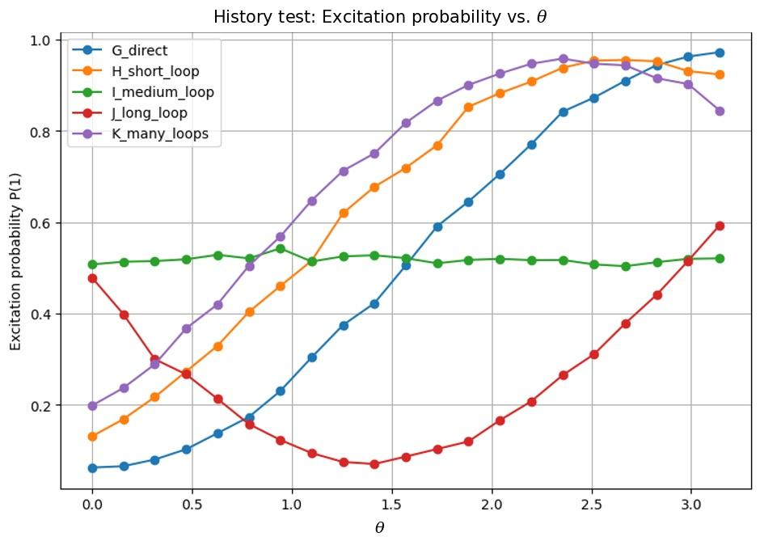
Figure 4. History-dependence test: measured excitation probability versus laboratory control angle θ for five protocols with markedly different geometric histories (G_direct, H_short_loop, I_medium_loop, J_long_loop, K_many_loops). No universal collapse is observed against θ. Curves show recorded point estimates; independent run-to-run uncertainty bands are unavailable.
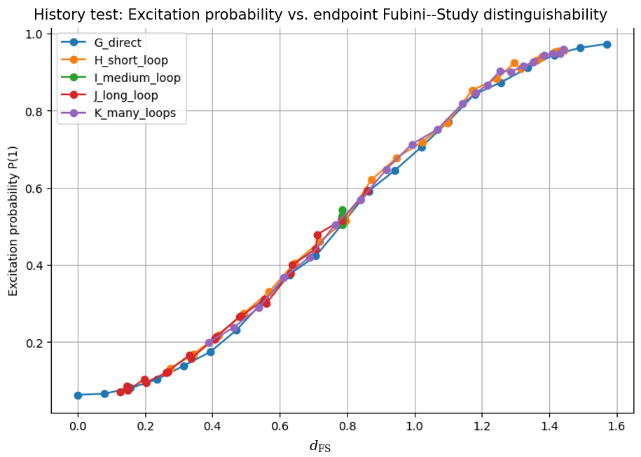
Figure 5. History-dependence test: the same data versus endpoint Fubini–Study distinguishability dFS. The curves collapse onto a common dependence despite the different loop histories. Curves show recorded point estimates; independent run-to-run uncertainty bands are unavailable.
A.9 Two-Qubit Entangling Baseline
Conventional alternative. Entangling-gate calibration, coherent two-qubit control error, crosstalk and standard open-system noise can produce the observed deviations. This section is retained as a baseline for geometric organization and does not attribute the residual uniquely to DG.
The geometric-baseline analysis was next extended to two-qubit protocols containing entangling operations.
A set of two-qubit entangling protocols was executed to test whether the same endpoint-coordinate bookkeeping remains operationally usable beyond the single-qubit examples. This does not constitute a DG-specific entanglement prediction.
For each protocol, the measured excitation probability was compared with several candidate organizing variables. As in the one-qubit experiments, the endpoint distinguishability provided the strongest collapse of the data. The two-qubit set comprises six protocols (P0–P5) on IBM Kingston with 17 values of θ each. Over the pairwise overlapping ranges of the 15 protocol pairs, the mean absolute difference between excitation curves is 0.0084 (maximum 0.044) against dFS, 0.185 (maximum 0.90) against θ, and 0.302 (maximum 0.85) against ℓFS. See Figure 6 (versus θ) and Figure 7 (versus endpoint distinguishability dFS).
The persistence of comparable endpoint organization in the tested two-qubit data shows that the chosen geometric bookkeeping is not restricted to the simplest single-qubit examples; standard multi-qubit quantum mechanics remains fully compatible with the observation.
The tested entangling data therefore support practical extension of the geometric representation, without implying a universal law for arbitrary multi-qubit dynamics or unique evidence for DG.
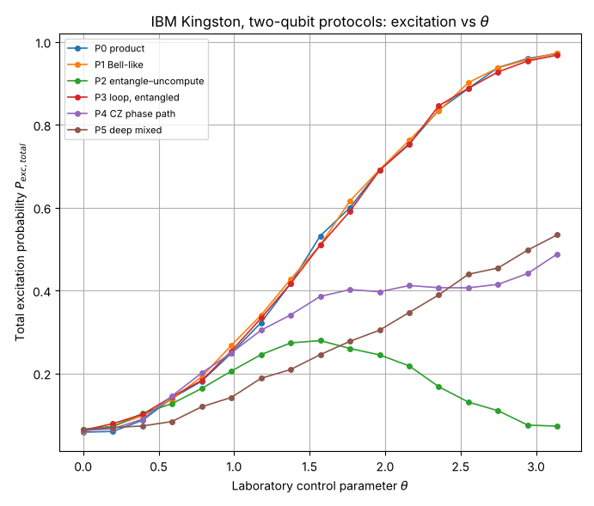
Figure 6. Two-qubit entangling test (IBM Kingston, protocols P0–P5): total excitation probability versus laboratory control angle θ. Identical control ranges produce visibly different excitation curves. Curves show recorded point estimates; independent run-to-run uncertainty bands are unavailable.
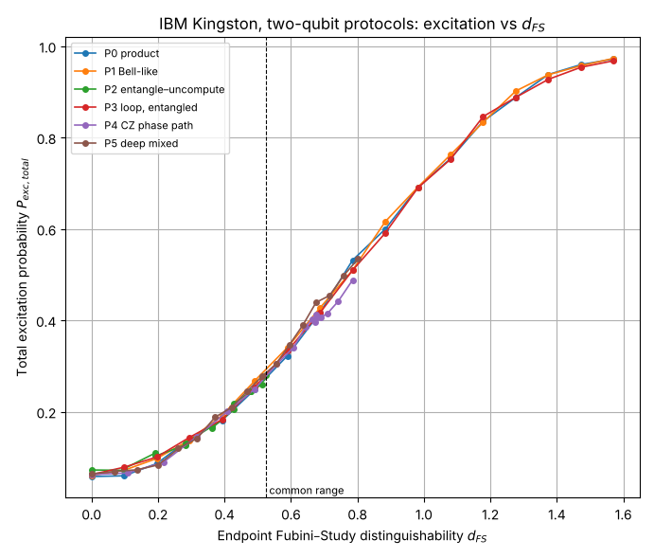
Figure 7. Two-qubit entangling test (same data): total excitation probability versus endpoint Fubini–Study distinguishability dFS. The protocols reach different maximal dFS (0.524 for P2, 0.785 for P4, 0.802 for P5, 1.571 for P0, P1 and P3); the curves collapse onto a common dependence wherever they overlap. Curves show recorded point estimates; independent run-to-run uncertainty bands are unavailable.
A.10 Descriptive Collapse-Metric Comparison
A direct quantitative comparison was performed between several candidate organizing variables.
The mean absolute collapse errors obtained from the original three-protocol run (protocols A–C, 21 values of θ per protocol, 63 circuits) are summarized in Table 3. Table 4 is computed from the later extended run (protocols A–F, IBM Marrakesh, 126 circuits); the two tables do not come from the same dataset.

Table 3. Comparison of collapse quality for different organizing variables (original three-protocol run, protocols A–C, IBM Marrakesh).
Organizing variable | Mean absolute error
Laboratory angle $θ$ | 0.1098
Path length $l_{FS}$ | 0.0606
Endpoint distinguishability $d_{FS}$ | 0.0141

Among the variables compared in this descriptive analysis, endpoint distinguishability has the smallest reported collapse error.
On the original three-protocol run, relative to the tested laboratory angle and path-length coordinates, the endpoint representation reduces the reported descriptive collapse error by approximately factors of eight and four, respectively. These ratios compare representations of the same data and are not DG-versus-QM likelihood ratios.
On the original run the maximum errors are 0.296 (θ), 0.156 (ℓFS) and 0.048 (dFS), the same ordering as the means. On the extended run (Table 4) the endpoint coordinate again has the smallest errors (mean 0.0125, against 0.0915 for θ and 0.1177 for ℓFS), but accumulated path length is there worse than the laboratory angle, so the factor of four relative to path length does not carry over. In both runs, because the endpoint population is standard-QM compatible, these metrics quantify representation quality rather than theory specificity.

Table 4. Maximum collapse errors for several candidate variables (extended run, protocols A–F, IBM Marrakesh).
Variable | Maximum error
θ | 0.304
ℓ_{FS} | 0.496
d_{FS} | 0.0566
T_{G} (path-based) | 0.496
T_{G} (endpoint-based) | 0.0566
These numerical comparisons are useful as reproducibility benchmarks for the endpoint representation. They should not be interpreted as independent quantitative evidence for DG because the target population and endpoint geometry are not theory-independent observables in the pure-qubit setting.

Endpoint-based and path-based geometric-time constructions were compared as alternative reparameterizations of the same IBM protocol data. The purpose is to audit whether the proposed bookkeeping remains stable, not to claim an additional independent observable.
The IBM datasets were analyzed with both path-based and endpoint-based geometric-time definitions and their descriptive collapse errors were compared.
Path-based geometric time produced errors comparable to accumulated path length, while the endpoint-based construction tracked the endpoint-distance representation closely. This is expected because the endpoint-based quantity is constructed from the same endpoint geometry and is not an independent validation channel.
The corresponding maximum collapse errors are summarized in Table 4. The endpoint-based quantity yielded a maximum error of approximately 0.0566, whereas the path-based construction produced substantially larger deviations.
These observations are consistent with the endpoint-based re-expression for the tested data. They do not establish endpoint geometric time as a new physical observable or DG-specific prediction.

A.12 127-Qubit Hardware-Wide Transferability Benchmark
The 127-qubit campaign tested whether the chosen endpoint representation remains operationally stable when many local protocol instances are executed address-wide on Heron processors. It is a scalability/transferability benchmark, not a validation of DG as a distinct theory.
Three protocol families were executed across multiple control parameters and on multiple independent processors. For each protocol, the endpoint distinguishability $d_{FS}$ was calculated and compared with the measured mean excitation probability averaged over all participating qubits. To prevent any multi-body state-space conflation, this benchmark explicitly tracks the ensemble of local, single-qubit excitation profiles executed address-wide simultaneously, rather than a global multi-qubit density matrix.
The resulting address-wide datasets from independent processors showed comparable endpoint-coordinate organization without backend-specific fitting in the reported comparison. The three-backend overlap is shown in Figure 8. This is retained as a cross-hardware representation test.
The observed overlap supports hardware transferability of the chosen endpoint representation across the tested processors. It does not exclude standard hardware/channel explanations and does not establish a global 127-qubit state-space metric.
Three independent IBM Quantum processors participated in the benchmark:
• IBM Kingston
• IBM Fez
• IBM Marrakesh
The corresponding hardware-wide benchmark jobs were:
Table 5. IBM Quantum jobs used for the 127-qubit benchmark.
Backend | Job ID
ibm_kingston | d8hcie5v8cos73f48ma0
ibm_fez | d8hcii9e8nrc73bh1m1g
ibm_marrakesh | d8hciq5v8cos73f48mq0

The significance of this benchmark is practical: state-space endpoint coordinates can be used consistently in address-wide quantum-control comparisons involving more than one hundred simultaneously operated qubits.
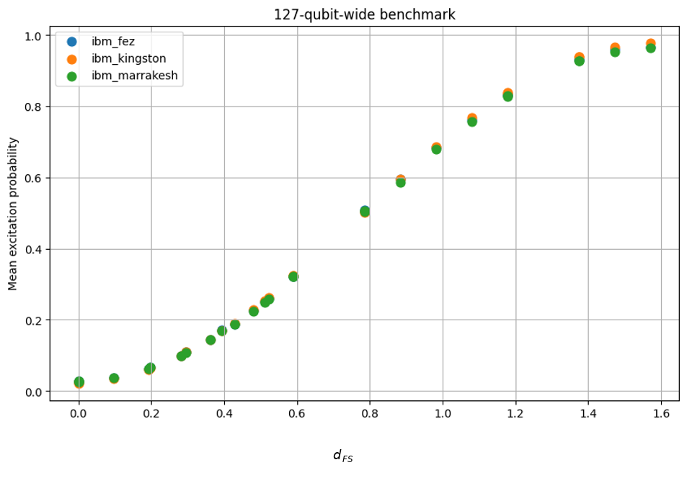
Figure 8. 127-qubit hardware-wide benchmark: measured mean excitation probability versus endpoint distinguishability dFS on IBM Kingston, IBM Fez and IBM Marrakesh (Table 5), address-wide over 127 simultaneously operated qubits per processor. The three backends overlap without backend-specific fitting. Curves show recorded point estimates; independent run-to-run uncertainty bands are unavailable.
A.13 156-Qubit Falsification Benchmark
Protocol-status note. This benchmark is reported as a frozen comparison within the executed campaign, but it is not promoted here to the later A.17 standard of a formally frozen-protocol DG-specific confirmatory test.
A dedicated fixed-angle benchmark was designed to test the restricted hypothesis that laboratory control angle alone can organize the measured response. It should not be read as a direct DG-versus-QM test, because the endpoint-population relation has a standard quantum-geometric explanation.
The benchmark employed the full 156-qubit capacity of IBM Heron processors and was specifically constructed to distinguish between two competing hypotheses:
$H_{angle}: P_{e} = f(θ); H_{endpoint}: P_{e} = f(d_{FS}).$ | (2)
Three protocols (A, B, C) were constructed with identical laboratory control angle θ but substantially different endpoint distinguishabilities d_{FS}.

Table 6. Falsification benchmark with identical laboratory angle (θ=π) and different endpoint distinguishabilities: 156-qubit mean excitation probability on IBM Kingston, Fez and Marrakesh. Data: 156qubit_falsification_test.csv (first three of its seven protocols).
Protocol | d_{FS} | Measured P₁ (Kingston) | Measured P₁ (Fez) | Measured P₁ (Marrakesh)
A | 1.570796 | 0.976519 | 0.969345 | 0.959360
B | 0.523599 | 0.267102 | 0.255753 | 0.252016
C | 0.785398 | 0.508395 | 0.504432 | 0.498335

Note that the endpoint distinguishability is determined by the final quantum state and is therefore not constrained to equal the laboratory control angle. The file also contains four further protocols (D_short, E_medium, F_long and G_crazy) that are not tabulated. For D, E and G the measured P₁ lies within 0.02 of sin²($d_{FS}$) on all three backends. F_long, a long path that ends close to the initial state ($d_{FS}$=0.0747), gives P₁=0.0422, 0.0301 and 0.0291 on Kingston, Fez and Marrakesh against sin²($d_{FS}$)=0.0056, so accumulated path error is clearly visible there.
The results provide a direct falsification of the hypothesis that excitation probability is determined solely by the laboratory control angle.
Despite identical values of $θ=π$, the measured excitation probabilities span nearly the full available probability range, from approximately 0.27 to 0.98.
The ratio $\frac{P_{1}(A)}{P_{1}(B)}≈3.7$ (3.66 on Kingston, 3.79 on Fez and 3.81 on Marrakesh, from Table 6) demonstrates that laboratory control angle alone cannot provide a universal description of the observed outcomes.
The angle-only comparison is a restricted descriptive baseline. Its failure does not count against a complete standard quantum model, which also uses the rotation axis, ordering, initial state and channel evolution.
When represented by endpoint distinguishability, the same data follow the expected endpoint-geometric organization. For the pure-qubit computational-basis population used here, however, that organization is nested in the standard relation P₁=sin²(d_{FS}) and therefore is not independent evidence for DG.
The strength of this benchmark is therefore narrower: it directly rejects control-angle-only organization in the tested protocols and establishes an experimental setting in which the boundary between a useful geometric representation and a theory-discriminating prediction can be audited.
Furthermore, the same ordering of the three protocols appears on all three backends of Table 6, indicating that the observed behaviour is not associated with a particular hardware implementation.
Taken together, the fixed-angle benchmark rejects the control-angle-only hypothesis for these protocols and establishes empirical usefulness of endpoint geometry. It does not discriminate DG from standard pure-state quantum geometry; the required non-circular discriminator is specified in Appendix A.17.
A.14 Cross-Backend Transferability
Transfer across the tested hardware implementations is a descriptive test of the proposed organizing variable. Shared gate models, calibration methods and conventional quantum dynamics can also support transfer. The cross-backend comparison therefore measures agreement within the sampled protocols and does not by itself exclude common hardware systematics.
To test transferability, identical protocol families were executed on multiple IBM Heron processors without backend-specific optimisation. The objective was to determine whether the endpoint-geometric representation retained predictive/organizing consistency across independent processors in the tested hardware family.
Kingston is used as a descriptive reference, not as an independently established ground truth. The released calibration-transfer CSV contains 26 circuit records per backend: 13 direct-Ry and 13 detour-equivalent circuits, with 156-qubit mean populations. The associated job list records 1024 shots per circuit and one listed job for each backend. No independently timestamped rationale for reference selection is available.
The cross-backend RMSE was computed pointwise in endpoint distinguishability. Kingston was used as the reference backend. For each matched value $d_{i}$ of endpoint Fubini–Study distinguishability, the excitation probability measured on the target backend was compared with the Kingston reference value at the same $d_{i}$. The reported error is
RMSE(K→B) = [(1/N) Σᵢ₌₁ᴺ (Pₑᴮ(dᵢ) − Pₑᴷ(dᵢ))²]¹ᐟ² | (3)

Here K is Kingston and B is the target backend. The reanalysis sets endpoint distances smaller than 10⁻⁷ to zero to remove numerical arccos round-off at coincident states. It averages Kingston populations sharing an endpoint, producing 13 reference knots, and linearly interpolates this curve at each of the 26 target circuit coordinates. The RMSE weights circuit records equally; these 26 records are not 26 independent endpoint locations. The direct branch spans 0 to π/2 at π/24 increments, whereas the archived detour-equivalent branch remains at the zero endpoint. The protocol label therefore does not imply equality with the direct-Ry endpoint at the same control angle.
The resulting root-mean-square differences between backend curves were:
These values are descriptive point estimates recomputed from 156qubit_calibration_transfer_test.csv using the stated rule. The saved columns contain circuit-level means, not per-qubit outcomes or joint bitstrings. Consequently neither an independent-qubit binomial interval nor a repeat-run confidence interval is inferred. The uncertainty of the shared Kingston reference would also have to enter such an analysis. The calculation and its input files are supplied in DG_early_IBM_reanalysis.zip.
Table 7. Cross-backend transferability results.
Transfer | RMSE
Kingston → Fez | 0.005001
Kingston → Marrakesh | 0.009148

The two aggregate RMSE values are below 0.01 in absolute probability units. This does not bound every pointwise error by 0.01 and is not a relative one-percent bound over the range.
The aggregate curves agree to the reported absolute-probability RMSE under this reference convention. This descriptive comparison uses no target-backend fit and is compatible with standard quantum predictions. it is not an independent prediction from DG.
Agreement across these Heron processors is compatible with a shared geometric parametrization and common hardware systematics. It does not exclude shared calibration or channel errors. The separate three-endpoint standard-QM residual RMS is approximately 0.01746; its sampling and aggregation differ from those of the transfer RMSEs.
A.15 Geodesic Optimal-Control Test
Uncertainty scope. The geodesic-control CSV contains 36 circuit records per backend: four protocol families at nine angles, averaged over 156 qubits. The accompanying job list records one job per backend and 1024 shots per circuit. No per-qubit or repeated-job outcomes are supplied, so Table 8 reports descriptive point estimates without confidence intervals or a claim that between-protocol differences exceed calibrated noise.
Protocol-status note. This experiment is a descriptive control comparison rather than a formally frozen-protocol DG-specific confirmatory test; conventional duration, gate-count, drive-exposure and noise covariates remain competing explanations.
The final IBM campaign examined whether shorter Fubini–Study paths are associated with lower implementation error among protocols connecting the same endpoints. The observation is retained as descriptive control evidence; it does not yet isolate path geometry from conventional resource and noise exposure.
The distinguishability framework separates two conceptually different quantities:
• endpoint distinguishability, used here as the standard target-state coordinate for the measured population;
• accumulated path length, treated as a candidate implementation-cost coordinate whose independent role requires resource-matched controls.
To test this prediction, four protocol families were constructed. All protocols connected the same initial and final states and therefore possessed identical endpoint distinguishability. However, the accumulated Fubini–Study path lengths differed substantially.
Table 8. Geodesic optimal-control benchmark on IBM Marrakesh at θ=π. Errors are mean residual excitation after the inverse operation, averaged over 156 qubits; one listed job, 1024 shots per circuit.
Protocol class | ℓ_{FS} | Implementation error
Geodesic (shortest path) | 1.57 | 0.0345
Short closed loop | 3.14 | 0.0402
Medium closed loop | 3.14 | 0.0409
Long closed loop | 11.00 | 0.0551

At θ=π, the geodesic protocol has the smallest mean inverse-test error on all three backends. Figure 9 shows the full angle dependence; the ordering is not uniform at every intermediate angle: the geodesic protocol has the lowest error at 7 of 9 angles on Fez, 8 of 9 on Kingston and 9 of 9 on Marrakesh.
Implementation error increased across the tested detours while endpoint target population remained similar. Because path length can covary with duration, gate count, drive exposure and accumulated noise, this association is not identified with a unique geometric-cost law without a resource-matched follow-up. In the nine-angle geodesic-control data the geodesic protocol has the lowest error at 7 of 9 angles on Fez, 8 of 9 on Kingston and 9 of 9 on Marrakesh, with a margin over the best competing loop of at most about 0.006 on an error floor of 0.03–0.045 and no error bars.
The retained interpretation is therefore provisional: endpoint geometry organizes the target-state description while path length is a useful candidate implementation-cost variable. A confirmatory test must match conventional resources and vary geometric path independently.
For the tested protocol family, the data support the following limited operational interpretation:
(i) endpoint geometry provides the standard target-state coordinate for the measured population;
(ii) accumulated path length is associated with implementation error in the tested family, subject to resource confounding;
(iii) at θ=π the shortest tested geodesic had the lowest observed mean implementation error on each backend; a causal minimum-cost statement would require resource-matched duration, gate, drive-exposure, and noise controls.
The geodesic-control experiment therefore motivates a resource-matched optimal-control test rather than establishing a DG-specific cost theorem.
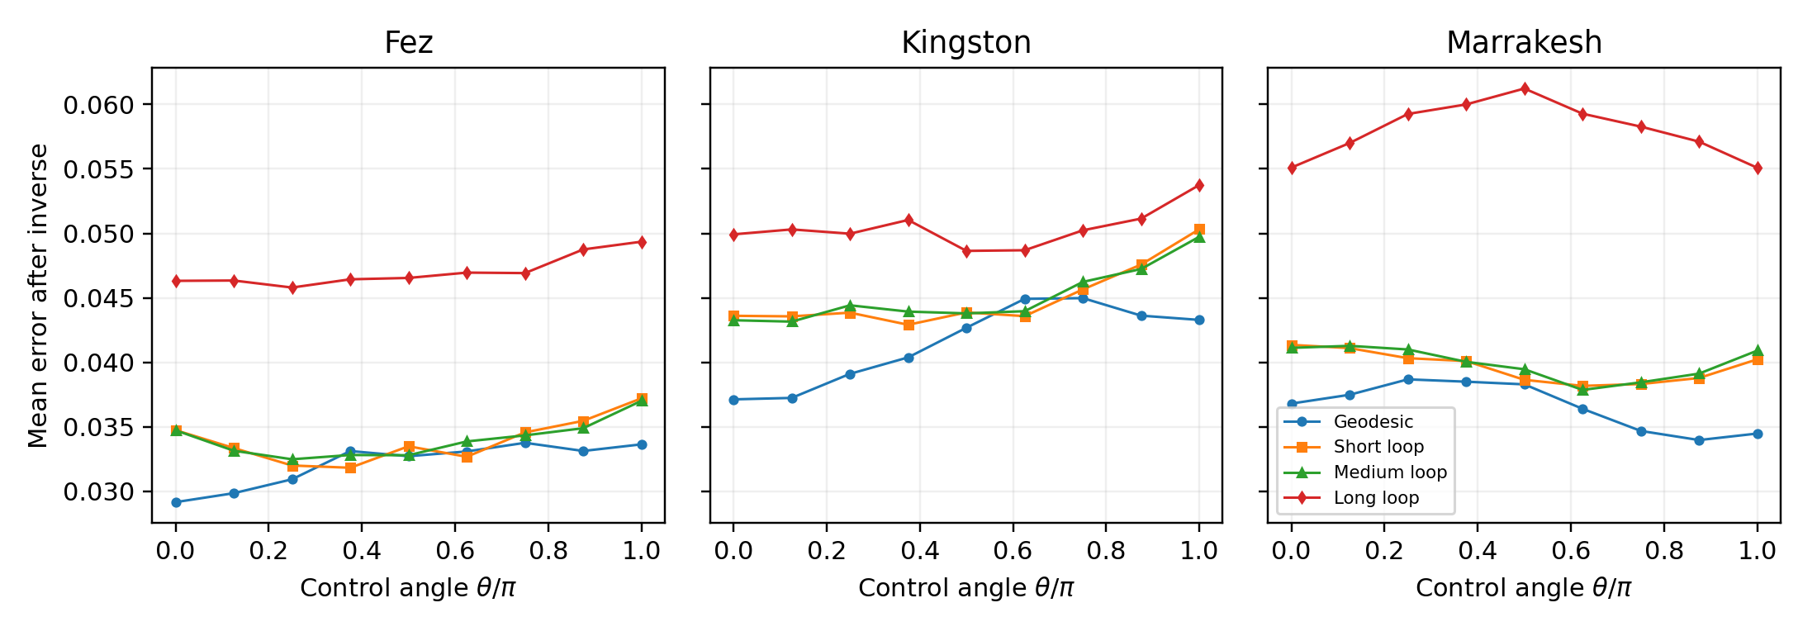
Figure 9. Mean residual excitation after the inverse operation for the four geodesic-control families, at nine control angles on each backend. Data: 156qubit_geodesic_optimal_control_test.csv. Table 8 is the Marrakesh θ=π slice. Curves are descriptive; error bars are unavailable from the released aggregate records. Curves show recorded point estimates; independent run-to-run uncertainty bands are unavailable.
A.16 Reproducibility Statement
All experiments reported in this work were executed through the IBM Quantum cloud infrastructure and archived together with the corresponding metadata.
The archived materials include:
• backend identifiers;
• IBM Quantum job identifiers;
• software environment metadata;
• calibration information;
• one-qubit datasets;
• Bloch-sphere trajectory datasets;
• history-loop datasets;
• two-qubit entangling datasets;
• 127-qubit benchmark datasets;
• 156-qubit falsification datasets;
• cross-backend transferability datasets;
• geodesic optimal-control datasets.
The software environment used for execution was archived together with the datasets and included Python 3.12.13, Qiskit 2.4.1, and Qiskit IBM Runtime 0.47.0. The auxiliary canonical-form comparison described in Supplementary Material II was executed on 3 November 2026 on a Windows workstation with Wolfram Engine 15.0.0, xAct/xTensor 1.3.0, xPerm 1.2.4, and Invar 2.0.5; this stack is separate from the IBM execution environment reported here.
The archive supplies frozen circuits, job records, raw counts and supporting datasets for the frozen-protocol campaigns as released. Earlier figure-only campaigns retain aggregate populations without a complete set of independent repeat-job records. The calibration and geodesic-control campaigns identified in A.14–A.15 additionally retain their released job lists and the stated 1024 shots per circuit. These records do not supply run-to-run uncertainty for all earlier aggregate comparisons. The supplied Python runner reproduces the Test 8 crossing reconstruction and model comparisons. Inclusion of records for the other campaigns does not establish that every IBM figure, table or statistic has a complete executable reconstruction in this release. The early-campaign materials are released as separate archives with the following SHA-256 digests: DG_early_IBM_reanalysis.zip, dff7779ef55e3504f08791254fd7a02107cc42328c49f74a9fe1171774164bae; DG_early_campaigns_A6-A12.zip, 2562f760cb9b08905b1d8b7c53d7ca3071824222bc85dcdb5ff98b496aad4858; DG_tau6_certificate.zip, 277dfe4f956ca3e164f6b99241fecd9c5c6689e0dbeed9adc34a69077f6cda4a. The release runner reports success when its sub-scripts exit without error and does not compare values with the stored expected results. The repository therefore also carries a separate checker, addenda/strict_check/strict_check.py, that fails when the manifest, the τ¹⁰ certificate counts and determinant, the Test 8 point-estimate model comparison or the Appendix M extrapolation error disagree with those expected values. The Appendix M check verifies arithmetic of exact closed-form counts.
Taken together, the IBM programme spans single-qubit, multi-qubit and hardware-wide protocol ensembles on multiple Heron processors. It establishes that endpoint state-space geometry is experimentally usable and transferable in the tested settings and that angle-only organization fails in the fixed-angle benchmark. The pure-qubit population collapse itself is standard-QM compatible, so the programme is retained as the empirical baseline and reproducibility record for the non-circular DG-specific test below.

The September 21–22, 2026 temporal-reparameterization campaign additionally archives frozen circuit inventories, SHA-256 manifests, delay schedules, bootstrap seeds where explicitly frozen, raw counts, job identifiers, and the matched-physical-idle comparison reported in Appendix A.18. The sequence retains negative outcomes as first-class results: failure of strong arbitrary-delay invariance, failure to replicate the isolated m=6 feature, and a point-estimate preference for backend-specific physical-idle scaling that remains sensitive to resampling.
A.17 Non-Circularity and Statistical Release Gate
Non-circularity theorem for the present pure-qubit readout. For a pure qubit prepared in |0⟩, endpoint Fubini–Study distance and computational-basis excitation population obey P₁ = sin²(d_{FS}). Thus a plot of P₁ against d_{FS} is not an independent DG prediction when d_{FS} is reconstructed from the same final-state population, and remains a standard-QM-compatible relation even when d_{FS} is specified independently from the ideal control endpoint or separate tomography. For the displayed fixed-angle points d_{FS} = {π/2, π/6, π/4}, standard QM predicts {1, 0.25, 0.50}, compared with measured {0.976519, 0.267102, 0.508395}.
Identity-of-predictions no-go for the present IBM sector. Consider any fixed preparation, quantum channel sequence and POVM readout. When DG uses the same pure-state trajectories, Fubini–Study metric and standard Born probabilities without an added dynamical or measurement law, its endpoint variable is a function of those standard states; the outcome distribution is unchanged. Consequently, an independently prepared geometric predictor, a withheld backend and arbitrarily many shots cannot separate DG from the same standard quantum model. The present IBM experiments do not specify a separate DG correction to a channel or readout. A favorable fit of a flexible geometric residual would test the frozen phenomenological predictor against a particular baseline, not prove a distinction from standard quantum mechanics as a whole.
Data-status note. The fixed-angle CSV supports the reported population contrasts, but its job attribution is not resolved by the supplied metadata. Job d8hd21s2upec739ktc30 belongs to the separate calibration-transfer campaign and must not be used as the fixed-angle shot-count record. The geodesic-control and calibration-transfer job lists document their respective campaigns. None of these baseline comparisons establishes a DG-specific law.
Release gate for a future distinct extension. Before collecting or opening confirmatory data, specify (i) the conventional quantum/channel/control comparator and its calibration domain, (ii) an explicit DG-induced change to a target probability or other measured quantity, including a fixed functional form and parameter domain, (iii) normalization fixed on declared training data, (iv) an independent holdout by protocol family or hardware, and (v) the target observable and loss. The candidate predictor must not use the held-out target measurement. An endpoint-distance re-expression of the same Born probability does not pass gate (ii). No refit, redefinition or normalization change is permitted after opening the holdout.
Statistical release criterion. Let Lstandard and LDG denote the pre-specified held-out loss (or negative log predictive score) of the frozen standard and DG-augmented predictors on the same independent units. Define ΔLholdout = LDG − Lstandard. Support for the specified predictive extension against the frozen comparator requires ΔLholdout < 0 and a correlation-aware uncertainty interval entirely below zero. This comparison does not identify a DG mechanism unless the distinct correction in gate (ii) is derived independently and competing conventional channel mechanisms are controlled. Resampling must occur at the independent experimental-unit level (for example backend/protocol block rather than individual qubit when correlations are shared). The report must include shot counts, finite-sampling uncertainty, calibration drift diagnostics and the full held-out residuals. Failure of this criterion is reported as a controlled negative result rather than absorbed by post-hoc refitting.
Resource-matched path-cost follow-up. To test whether accumulated Fubini–Study path length has predictive content beyond conventional implementation resources, compare protocols with matched total duration, gate count or calibrated drive exposure and comparable standard error budgets while varying path geometry. Only a residual path-length dependence after these controls can support a geometry-specific implementation-cost statement.
A.18 Laboratory-Time Reparameterization and Open-System Stress Tests
Scope and status. This section records the final frozen-protocol IBM Quantum stress-test sequence performed on 21–22 September 2026. Its purpose was to determine how far the operational separation between laboratory duration and path-based geometric progress survives on noisy open quantum hardware, and to identify the boundary at which inserted waiting time ceases to be a passive reparameterization and becomes additional physical channel evolution.
The tests were sequential kill tests. Each major follow-up froze the circuit family, backend/qubit choice where applicable, distinguishability threshold, bootstrap rule, decision criterion, and claim boundary before opening the new data. Negative results were retained and used to design the next test; no failed hypothesis was repaired by post-hoc threshold or normalization changes.
A.18.1 Common protocol and decision variable
The controlled history was generated by repeated single-qubit rotations Rx(θ) with θ=0.10 rad, implemented through the native single-qubit gate set. At each process point, measurements in the X, Y, and Z bases were used to reconstruct the state-space distinguishability from the prepared initial state. The primary event coordinate was the first crossing j_{cross} of the fixed threshold D*=0.15, obtained by linear interpolation within the first sampled bracket. Unless otherwise stated, uncertainty was evaluated with 5000 bootstrap resamples.
For the prepared |0⟩ reference state used in the threshold analysis, the endpoint infidelity entering the primary crossing reduces to D=1−⟨0|ρ|0⟩=P1 in the Z basis. The X/Y measurements were retained for tomographic and diagnostic reconstruction, while the reproducibility script can therefore recover the same primary j_{cross} values directly from the archived Z-basis counts.
Two coordinates were deliberately kept separate. Laboratory duration τ was determined by scheduled physical gate and delay durations. The path-based geometric coordinate T_{G} accumulated progress along the controlled state-space path and did not assign additional geometric progress merely because the device idled. This distinction is the experimental object under stress. it is not assumed to hold when waiting modifies the open-system trajectory itself.
Table 9. Sequential logic of the temporal-reparameterization stress series. The word Pass refers only to the stated frozen criterion, not to unique validation of DG.
Test | Backend | Frozen question | Outcome / claim status
1–2 | Kingston / Fez | Can the same controlled path be slowed in laboratory time while retaining a nearby geometric crossing? | Pass for Level-2 operational separation; standard-QM/open-system compatible
3 | Marrakesh | Does the Level-2 effect reproduce on a third independent backend and distinguish detours? | Pass on all frozen contrasts
4 | Kingston | Does invariance survive arbitrarily large inserted delays? | Fail: strong delay invariance rejected
5 | Fez | Can a first operational breakdown point be localized on a coarse delay grid? | First failed tested point m=8; backend/grid specific only
6 | Marrakesh | Does a denser grid show a monotonic threshold and channel onset? | No monotonic threshold; isolated m=6 candidate feature
7 | Marrakesh | Does the m=6 feature reproduce under five-fold local replication? | Fail: anomaly rejected
8 | Marrakesh / Fez | Is crossing drift a common function of identical physical idle time? | Frozen point estimate favors the backend-specific model by ΔBIC=11.20; this preference is sensitive to resampling and does not decisively exclude common scaling
A.18.2 Tests 1–2: first cross-backend temporal separation
The first two tests compared three circuit families. Family A followed the direct rotation path with the minimum scheduled duration. Family B followed the same rotation sequence but inserted a fixed delay after each increment. Family C introduced a deliberate state-space detour before continuing the direct progression. The design therefore asked whether laboratory slowing and geometric detouring were operationally separable.
On ibm_kingston the threshold crossings were j_{A}=7.456, j_{B}=7.815 and j_{C}=7.914. The corresponding laboratory crossing times were τ_{A}=477.2 ns, τ_{B}=1500.6 ns and τ_{C}=634.5 ns, while the geometric coordinates were T_{G}(A)=0.3728, T_{G}(B)=0.3908 and T_{G}(C)=0.6957. Thus the direct and slowed families differed strongly in laboratory duration but only weakly in geometric progress, whereas the explicit detour produced a much larger geometric coordinate.
On ibm_fez the same comparison gave j_{A}=7.989, j_{B}=8.345 and j_{C}=7.792; τ_{A}=383.5 ns, τ_{B}=1201.6 ns and τ_{C}=470.0 ns; and T_{G}(A)=0.3994, T_{G}(B)=0.4172 and T_{G}(C)=0.6896. The result therefore transferred qualitatively and quantitatively to a second processor.
Bootstrap testing at D*=0.15 gave a 95% interval for the slowed-minus-fast laboratory-time separation of [952.2,1108.5] ns on Kingston and [759.6,870.5] ns on Fez. The frozen-protocol compression statistic had intervals [0.9665,0.9986] and [0.9621,0.9990], respectively. These tests support the Level-2 operational distinction only. They do not discriminate DG from standard quantum mechanics or from a standard open-system account of the same controlled evolution.
Compression compares quantities partly fixed by the path construction: direct sequences with the same ideal state-space progression are expected to have nearby geometric coordinates even when their durations differ. It is an operational consistency diagnostic, not independent evidence for a new dynamical law. In the frozen Test 3 analysis script the laboratory durations are the nominal multiples of the single-step duration (2 steps for the direct family and 6 for the slowed family), and the geometric times of the two detour families include fixed additive terms (0.20 and 0.40). Criteria P1, P3 and P4 are therefore largely fixed by these definitions. The empirical content of Tests 1–3 is carried by the measured crossing coordinates and by the compression criterion P2, and the statement that the result reproduces on three processors refers to those quantities.
A.18.3 Test 3: independent Marrakesh confirmation
Test 3 repeated the logic on ibm_marrakesh, physical qubit 8, and added two detour sizes. The four frozen families were A_FAST, B_SLOW, C_DETOUR_SMALL and D_DETOUR_LARGE. The observed crossings were j_{A}=8.228, j_{B}=8.831, j_{C}=8.112 and j_{D}=8.259. The laboratory crossing times for the fast and slowed direct families were approximately 592.4 ns and 1907.6 ns. Their geometric coordinates were 0.4114 and 0.4416, while the small and large detours gave 0.6056 and 0.8129.
All four frozen-protocol contrasts passed. The slowed-minus-fast laboratory-time contrast was 1315.2 ns with 95% CI [1192.6,1566.2] ns; the compression statistic was 0.9814 with CI [0.9308,0.9979]; the small-detour excess over the larger of the two direct-family geometric coordinates was 0.1640 with CI [0.1029,0.1952]; and the large-minus-small detour increment was 0.2073 with CI [0.1681,0.2443]. The Level-2 operational effect was therefore reproduced on three independent IBM processors.
A.18.4 Test 4: strong arbitrary-delay invariance is rejected
The next experiment deliberately attempted to falsify the stronger hypothesis that the same path coordinate remains invariant under arbitrarily large inserted laboratory delays. On ibm_kingston, delay multipliers m={0,4,12,32} were tested for the same Rx(0.10) progression. The frozen equivalence criterion required the 95% upper bootstrap quantile of max(j_{cross})-min(j_{cross}) to remain below one process step.
The measured crossings were 7.459, 8.361, 8.576 and 9.179. The observed range was 1.721 process steps and the bootstrap 95% upper quantile was approximately 2.13, so the primary equivalence criterion failed. At the same time, the physical crossing times increased monotonically, approximately 477, 1605, 3842 and 9987 ns. Sufficiently long physical idling changed the realized open-system trajectory. Strong arbitrary-delay invariance was therefore rejected.
A.18.5 Test 5: coarse localization of an operational breakdown region
Test 5 used ibm_fez and the frozen delay grid m={0,2,4,8,12,20,32}. The metric was Δj_{m}=|j_{m}-j₀|, with a per-point Pass requiring the bootstrap 95% upper quantile Q0.95(Δj_{m})<1. The measured j_{cross} values were 8.215, 8.621, 8.580, 8.733, 8.914, 8.868 and 9.090. The corresponding shifts were 0.406, 0.365, 0.518, 0.699, 0.653 and 0.874.
The Q0.95 values were 0.930, 0.946, 1.225, 1.274, 1.314 and 1.539 for m=2,4,8,12,20,32. Hence m=2 and 4 passed, while m=8 and all larger tested points failed; the first failed point on the frozen-protocol grid was m_{break}=8. This number was retained only as an operational boundary for that backend and that discrete grid, not as a fundamental constant. Analysis used a deterministic bootstrap seed 20260921 inherited from the analysis pipeline; because that seed was not explicitly written into the Test-5 metadata, this is retained as an analysis-record caveat rather than retroactively described as a frozen field.
A.18.6 Tests 6–7: the apparent m=6 feature and its failed replication
Test 6 performed a denser scan on ibm_marrakesh, physical qubit 147, using m={0,4,5,6,7,8,9,10,12}. The measured crossings were 8.265, 8.238, 8.175, 8.900, 8.282, 8.060, 8.446, 8.256 and 8.187. Under the frozen criterion, only m=6 crossed the one-step bootstrap boundary: Q0.95=1.145, whereas the neighboring and larger values m=7–12 passed again. The pattern was therefore non-monotonic and did not support a phase-like threshold.
Auxiliary T1-like and T2-like diagnostics were collected at the same frozen reference point. No T1-like onset passed the 5% lower-bound rule. The T2-like loss was largest near m=6 (about 0.0566), but its 95% interval, approximately [0.035,0.080], did not place the lower bound above the frozen 0.05 onset threshold. The mechanism label was therefore no_channel_support in the narrow frozen-protocol sense: the auxiliary diagnostics did not cross the specified threshold. It does not mean that decoherence or channel evolution was absent.
Test 7 was then designed specifically to reproduce or kill the isolated m=6 feature. Five independent local repetitions of m={5,6,7} were run on the same Marrakesh physical qubit, with alternating order to reduce simple temporal drift. The frozen local contrast was C=j₆-(j₅+j₇)/2. Individual contrasts were -0.448, +0.488, +0.422, -0.301 and -0.478. Only two of five repetitions showed the required local maximum, whereas consistency required at least four of five.
Pooling the five repetitions gave j₅=8.163, j₆=8.009 and j₇=8.241, hence C_{pooled}=-0.194 with approximately 95% CI [-0.439,0.169]. The primary statistical criterion and the replicate-consistency criterion both failed. The m=6 feature was therefore rejected as non-reproducible, and no special physical significance is assigned to m=6 or to the corresponding nominal delay near 216 ns per step.
A.18.7 Test 8: matched physical-idle comparison across two processors
The final experiment removed an ambiguity in multiplier-based scans by matching actual physical delay rather than the number of native SX durations. The frozen per-step delays were d={0,144,288,432,576,720} ns on both ibm_marrakesh (q=147, t_{SX}=36 ns) and ibm_fez (q=110, t_{SX}=24 ns). These values correspond to {0,4,8,12,16,20} SX durations on Marrakesh and {0,6,12,18,24,30} on Fez. The sampled crossing window was j=6–10, with no extrapolation allowed outside the frozen bracket.
Table 10. Test-8 matched-physical-idle crossings and shifts relative to the zero-delay crossing on each backend.
Delay d (ns/step) | j_{cross} Marrakesh | j_{cross} Fez | δj Marrakesh | δj Fez
0 | 8.223 | 7.849 | 0 | 0
144 | 8.433 | 7.842 | +0.209 | -0.007
288 | 8.207 | 7.978 | -0.016 | +0.129
432 | 8.425 | 8.807 | +0.202 | +0.958
576 | 8.404 | 8.775 | +0.181 | +0.926
720 | 8.055 | 8.828 | -0.168 | +0.979
Four models were frozen before analysis: M1, a common linear law δ=βt; M2, backend-specific linear laws δ=β_{b} t; M3, a common quadratic law δ=β₁ t+β₂ t²; and M4, backend-specific quadratic laws. Model selection used BIC on the uncensored nonzero-delay point estimates. The decisive threshold was fixed at ΔBIC≥6 between the best common and best backend-specific model.
For the original comparison, n=10 nonzero-delay crossing shifts and k=(1,2,2,4) fitted regression coefficients were used. The score is the Gaussian equal-variance residual-sum-of-squares criterion below, up to terms common to all models. A fitted common variance contributes the same additional parameter penalty to every model and cancels in the differences. This score does not use the covariance induced by a shared zero-delay reference.
${BIC}_{RSS}=nln\left(RSS/n\right)+klnn.$ | (4)
The resulting point-estimate BIC values were BIC(M1)=-16.66, BIC(M2)=-27.86, BIC(M3)=-14.51 and BIC(M4)=-25.45. The best common model was M1 and the best backend-specific model was M2, giving ΔBIC=11.20 in favor of backend-specific scaling. Thus the observed data cross the frozen decisive threshold ΔBIC≥6. This is the frozen-protocol primary model-selection result for Test 8. it is a statement about the observed data set, not by itself proof insensitive to resampling of a backend-specific law.
The preferred backend-specific linear model is not interpreted as a microscopic law. In particular, the Fez data show an abrupt increase between 288 and 432 ns/step and then a plateau-like region, so a simple linear fit is only the best of the four frozen candidate models. A secondary leave-one-out audit removed each of the ten nonzero-delay points in turn and repeated the full model comparison; all ten refits retained ΔBIC≥6, with ΔBIC ranging from approximately 6.93 to 12.42. The observed preference is therefore not driven by a single delay point. Modelling the sampled populations as a function of both the control index and the delay, instead of a thresholded crossing coordinate, would use more of the data and is left for a follow-up.
The Fez step-like change and one-qubit-per-backend design prevent attribution to the backend alone: qubit choice, day/session and calibration remain confounded. The Gaussian plug-in null model M0 fixes all ten shifts to zero and has no fitted regression coefficient; the supplied covariance calculation gives its combined χ²=18.521 for ten coordinates. This is an approximate diagnostic, not an exact chi-square test with a known covariance. Within each backend the circuits were submitted in ascending order of delay in a single job, without randomization or interleaving, so slow drift during the job is confounded with the inserted delay. The circuit inventory contains no T1, T2 or frequency measurements; the backend-reported readout and single-gate errors in the freeze metadata are the only calibration records. The bootstrap discards draws that have no bracketed crossing. For Fez this removes about 4% of the draws at 720 ns per step and about 0.2% at 576 ns per step, and none at shorter delays or on Marrakesh, which biases the retained crossing shifts toward smaller values.
Using each backend’s five-dimensional covariance block, the same M0 diagnostic gives χ²=2.013 for Marrakesh and χ²=16.382 for Fez, each with five nominal degrees of freedom. The corresponding nominal Gaussian tail probabilities are 0.847 and 0.00583. These are conditional plug-in diagnostics: covariance estimation and crossing censoring prevent treating the nominal tail probabilities as exactly calibrated significance levels.
Covariance-aware sensitivity check. Using 20,000 binomial draws per cell with seed 12345, and dropping an entire draw whenever any crossing is unbracketed, leaves 19,080 jointly retained draws. Their ten-dimensional shift covariance includes the shared zero-delay reference. Generalized least squares with this fixed plug-in covariance gives BIC scores 16.496, 9.731, 18.647 and 13.834 for M1–M4, respectively: M1 and M2 remain the best common and backend-specific models, with ΔBIC=6.765 (NumPy 2.3.5, the archived environment; the sampler’s random stream differs in other NumPy versions, and NumPy 2.5.3 gives ΔBIC=6.93 from the same 19,080 retained draws). The same-covariance Gaussian score is shown below; its log-determinant and normalization terms cancel between candidate models. This is an approximate sensitivity score because the covariance is estimated, crossings are nonlinear and censoring is conditioned upon.
${BIC}_{GLS}={\left(y−X\hat{β}\right)}^{T}{\hat{Σ}}^{−1}\left(y−X\hat{β}\right)+kln10.$ | (5)
A separate post-hoc shot-noise sensitivity audit propagated binomial counting noise through the complete pipeline: Z-basis counts → j_{cross} → δj → BIC model comparison, using 5000 bootstrap realizations. The central 95% bootstrap range of ΔBIC was approximately [-2.2,20.5], and about 51% of bootstrap realizations exceeded the frozen ΔBIC=6 threshold; no decisive preference for the common model was observed in this audit. Accordingly, the point estimate and leave-one-out stability favor backend-specific drift, but the finite-shot sampling robustness is limited. This bootstrap analysis is a secondary robustness audit performed after the frozen-protocol primary analysis and is not retroactively part of the frozen decision rule.
The archived seed-20260922 calculation (NumPy 2.3.5) gives a bootstrap median of 6.24 (mean 6.87), rather than treating the point estimate 11.20 as a typical bootstrap value. The conditional sampling and censoring convention is specified below.
This bootstrap median and range are the primary uncertainty summary. The original frozen RSS decision is still reported separately as a point-estimate analysis; selecting a new decision rule after observing the bootstrap would not be a frozen confirmatory analysis.
Reproduction details. Each cell is resampled 5000 times with the recorded deterministic seed. Crossings outside the sampled bracket are discarded separately in each cell; the retained cellwise arrays are truncated to their common minimum length, 4791 under NumPy 2.3.5, for the model-comparison audit. A rerun under NumPy 2.5.3 retains 4793 draws and gives median 6.30 (mean 6.89), central 95% range [−2.16,20.61] and 51.6% of draws above ΔBIC=6, because the binomial sampler’s random stream differs between NumPy versions; the archived results are those of the pinned environment (numpy==2.3.5), and the conclusion is the same. The reported bootstrap range is therefore conditional on bracketed crossings and on this resampling procedure. It is not an unconditional confidence interval for an underlying physical law. The shared zero-delay reference is reused within each backend when constructing the shifts.
The archived Test-8 calibration snapshot is directionally consistent with this interpretation: the backend with the larger fitted drift also had larger recorded single-qubit SX error and readout error. With only two backends this observation has no inferential weight and is retained only as a descriptive motivation for future channel-resolved comparisons.
Execution note. The first Fez submission for Test 8 (job dap4145r85ps73fg36q0) terminated with IBM Runtime/HAL error 9604 during hardware configuration. The frozen circuit set and manifest were not modified. The identical frozen job was resubmitted as dap42ttr85ps73fg3930 and completed successfully. The Marrakesh job was dap3vk02fm4c73f68eqg. The frozen manifest SHA-256 values were 8b5d50b758614754b4253e1c6aff9307ac93cf8d371d00e7802c9bb261fffdc3 for Marrakesh and f9c36ab40da876e34f7e1226a42abe8797fc6b7e6adba1d4a2581a6b7fac5944 for Fez.
A.18.8 Consolidated experimental conclusion and claim boundary
The full sequence gives a deliberately asymmetric result. Tests 1-3 provide a reproducible Level-2 operational separation between laboratory duration and path-based progress for weak temporal stretching and explicit geometric detours; the effect was observed on Kingston, Fez and Marrakesh. Tests 4-8 then remove stronger interpretations. Arbitrary-delay invariance fails, no reproducible well-defined delay threshold was found, the isolated m=6 feature failed dedicated replication, and the matched-idle data favor backend-specific over common drift at the frozen-protocol point-estimate level. The post-hoc shot-noise audit shows that this final model preference is too sensitive to resampling to establish a backend-specific law.
The retained statement is therefore restricted but sharper: reparameterization of a fixed physical history must be distinguished from physically waiting on an open quantum device. A change of labels along the same history need not alter path-based progress; inserting real idle time can activate decoherence, relaxation, drift, calibration changes, or other channel-specific evolution and thereby realize a different history. The IBM series supports the Level-2 distinction within its tested weak-delay regime while ruling out identification of arbitrary laboratory idling with a pure geometric-time reparameterization. It does not establish a universal idle-time law, nor a statistically secure backend-specific microscopic law.
No DG-specific microscopic correction is inferred from these data. All observed delay-dependent effects remain compatible with conventional open-system quantum dynamics; the DG content of the series is the operational distinction and its experimentally audited claim boundary, not a non-standard residual. The supported conclusion is that same-history relabeling is not equivalent to history modified by physical waiting. Any future Level-3 or theory-discriminating experiment must construct the reparameterization independently of hardware-induced channel evolution and satisfy the non-circular release gate of Appendix A.17.
Appendix B
Gravitational Ramsey Dephasing as a Distinguishability Re-expression and Experimental Test
Atomic clocks provide a platform for comparing the gravitational redshift and quantum Ramsey phase accumulation. The standard prediction follows by combining the weak-field GR redshift with the quantum phase law. The purpose of this appendix is narrower: to express both sectoral quantities in the common metric-sector geometric-time bookkeeping used in the main manuscript and to identify experimental ways to test that matched representation. No derivation of the redshift or Ramsey law from distinguishability alone is claimed.
The present framework re-expresses the same result using accumulated geometric time in its QM and GR realizations. This is a structural correspondence, not an independent derivation of the gravitational redshift or Ramsey phase law from distinguishability alone.
Standard sector calculation. Step 1: GR gives the weak-field fractional redshift Δν/ν=gh/c². Step 2: quantum Ramsey evolution gives Δφ=2πΔνT. Combining the two yields Δφ=2πν(gh/c²)T. These are standard physical inputs; the DG construction below is a re-expression of the same matched clock configuration rather than a replacement derivation.
B.1 Distinguishability-geometric re-expression
The observable is the standard clock phase. In a weak static field, GR supplies the fractional redshift Δν/ν=gh/c², while Ramsey evolution supplies the phase rate 2πν. Hence the differential phase is Δφ=2πν(gh/c²)T. DG does not replace either law and does not introduce a universal Earth gravitational rate.
On the quantum side the natural phase/process rate is Λ_{Q}=ΔE/ℏ=2πν, because the clock-transition energy is ΔE=hν. The gravitational redshift modulates that measured quantum rate by the dimensionless factor gh/c², giving δΛ_{Q}=(gh/c²)Λ_{Q} and therefore Δφ=δΛ_{Q} T. This is a bookkeeping re-expression of standard QM+GR.
The stationary-horizon rate Λ_{GR}=κ/c is not used for the Earth clock experiment, because a weak-field laboratory clock comparison is not a stationary-horizon realization. Likewise, c is a velocity normalization for local geodesic separation, not an inverse-time accessibility rate. No additional weak-field rate is introduced by dimensional analogy.
A DG-specific test would have to demonstrate additional transfer or collapse across independently calibrated protocols after the standard redshift, pulse, detuning, light-shift and decoherence models are fixed. Agreement with the redshift/Ramsey formula alone is not evidence unique to DG.
Dephasing in an atomic ensemble. For an ensemble of atoms with a Gaussian distribution of heights σ_{h} (e.g. a Sr lattice clock with finite cloud extent), each atom accumulates a different $ΔT_{G}^{GR}$. The ensemble-averaged Ramsey contrast is:
$C(T) = C_{0}·{⟨e^{iΔφ}⟩}_{σ_{h}} = C_{0}· exp[{-\frac{1}{2}(2πν·\frac{gσ_{h}}{c^{2}}·T)}^{2}]$ | (6)
where C(T) is the Ramsey fringe contrast, C₀ the initial contrast, and σ_{h} the r.m.s. height spread. The Gaussian envelope follows from averaging the standard height-dependent redshift phase over the atomic distribution. In the DG programme this provides a controlled reference model against which any additional residual organization must be tested.
Equivalently, taking the logarithm:
$- ln \frac{C(T)}{C_{0}} = \frac{1}{2}{(2πν·\frac{gσ_{h}}{c^{2}}· T)}^{2}$ | (7)
This is a gravitational-redshift Ramsey dephasing reference calculation expressed in the same channel language used elsewhere in the manuscript. it is not a new force law or a new clock shift.

B.2. Numerical Estimates and Experimental Status
For a strontium optical lattice clock with standard parameters [1]:
Table 11. Parameters used in the Sr optical-clock feasibility estimate.
Parameter | Value | Source
ν_{Sr} (clock frequency) | 4.3×10¹⁴ Hz | The ¹S₀ $→$³P₀ optical clock transition in Sr
ΔE = hν | 2.84×10⁻¹⁹ J | Clock-transition energy gap
σ_{h} (1 mm cloud) | 0.3×10⁻³ m | Typical Sr lattice cloud size
σ_{h} (1 cm cloud) | 3×10⁻³ m | Extended Sr cloud (JILA 2024 setup)
σ_{φ} at T = 1 s (1 mm) | $8.85×{10}^{−5} rad$ | Phase spread per second
σ_{φ} at T = 1000 s (1 mm) | ≈8.85×10⁻² rad | Integrated over 1000 s
T* (1/e contrast time, 1 mm) | $15 985 s$ | Time for C to fall to 1/e
T* (1 cm cloud) | ≈1 599 s | Standard reference at rms height 3 mm
Current Sr clock coherence time | ∼100–1000 s | Limited by laser linewidth, not GR dephasing

For the stated Gaussian rms heights, the standard 1/e contrast time is approximately 15 985 s at 0.3 mm and 1 599 s at 3 mm. These values follow from C/C0=exp[−(aT)²/2] with a=2πνgσh/c², so T*=√2/a. At T=1000 s the predicted contrast loss is approximately 0.39% and 32.4%, respectively. These are reference calculations; achievable coherent interrogation and technical noise require a separate experimental assessment.
Possible experiment 1: controlled height spread at long interrogation times. For the distinct example σh=1 cm and T=1000 s, the standard model gives approximately 98.7% contrast loss. A practical protocol must vary rms height and interrogation time while separately controlling laser, motional and pulse noise. A microgravity implementation requires its actual gravity-gradient model; substituting Earth g is insufficient.
Possible experiment 2: Sr cloud with controlled height spread. Existing optical-clock measurements establish gravitational redshift sensitivity on sub-centimetre scales. A dedicated follow-up would measure Ramsey contrast, not only frequency, as a function of cloud height spread σ_{h} and interrogation time T and test the standard quadratic dephasing envelope. In the DG programme this serves as a controlled test of the matched geometric-time representation, not as a new redshift law.
B.3 What the common re-expression adds. and what it does not
The Ramsey/dephasing formula follows from standard QM+GR, so agreement with it does not by itself distinguish DG. The useful question is whether the common bookkeeping representation remains stable and informative across deliberately varied clock protocols after standard pulse, light-shift, detuning and decoherence effects are included. Table 12 summarizes the logical status.
Table 12. Logical comparison of the standard sector calculation and the DG re-expression.
Standard sector calculation (QM + GR) | DG metric-sector re-expression
Weak-field GR supplies Δν/ν=gh/c² | The GR realization assigns a geometric-time bookkeeping variable using the supplied gravitational process rate
Quantum mechanics supplies Δφ=2πΔνT | The QM realization assigns the corresponding quantum bookkeeping variable using the supplied gap/phase dynamics
The two standard relations are combined for the same physical clock experiment | A matched-clock condition allows the two accumulated variables to be compared for the same physical interval
Physical inputs remain sector-specific | Physical inputs remain sector-specific; the gain is common notation and an explicit matching map
No DG-specific extra phase follows | No DG-specific extra phase is claimed without an additional derived coupling

B.4 Status of accessibility-mismatch extensions
No pulse-intensity-dependent DG correction is retained because no cross-sector dynamical action or coupling coefficient has been derived. Accordingly, no β-dependent Ramsey phase shift or other non-standard pulse correction is asserted in the present framework.
The live experimental question is narrower: after standard pulse, detuning, light-shift and decoherence effects are modelled, does the matched metric-sector geometric-time representation provide useful organization across controlled clock protocols? Any future extra phase term would require an independently derived coupling and a pre-specified causal model.
Status. Standard inputs: weak-field gravitational redshift, Ramsey phase accumulation and Gaussian ensemble dephasing. DG contribution: a common metric-sector bookkeeping representation and a matched-clock comparison. No parameter-free accessibility-mismatch correction is derived; any additional term must be specified independently before testing.
References for Appendix B
[1] T. Bothwell, C.J. Kennedy, A. Aeppli, D. Kedar, J.M. Robinson, E. Oelker, A. Staron, and J. Ye, Resolving the gravitational redshift across a millimetre-scale atomic sample, Nature 602, 420–424 (2022), DOI: 10.1038/s41586-021-04349-7.
Appendix C. YIG Magnonic Resonator Realization
This appendix outlines a possible realization of distinguishability geometry in nonlinear magnonic resonators based on yttrium iron garnet (YIG). The central idea is that nonlinear magnon systems provide direct access to strongly non-adiabatic evolution, making them a natural platform for investigating geometric-time accumulation. Consider a YIG resonator driven by an external microwave pumping field. The system evolves through a sequence of magnonic states characterized by mode amplitudes, phases, and occupation numbers. Within the distinguishability framework, neighboring magnonic configurations are represented as neighboring points in the distinguishability manifold. The corresponding distinguishability distance is dℓ² = G_{AB} dq^{A}dq^{B}. The geometric velocity is v_{G} = dℓ/dt. The accumulated geometric time is T_{G} = ∫ $A$ dt , where $A$ = v_{G} /Λ. The prospective collapse hypothesis is that two different pumping protocols producing identical accumulated geometric times should exhibit equivalent distinguishability signatures, even when the microscopic mode populations evolve differently. Experimentally, distinguishability may be quantified through measurable observables such as:
- magnon occupation number;
- phase coherence;
- nonlinear frequency shift;
- mode-conversion efficiency;
- parametric excitation probability.
Observation of such a collapse would support geometric time as a useful cross-protocol organizing variable beyond laboratory time.
Appendix D. Bose–Einstein Condensate Realization
This appendix discusses a possible realization of distinguishability geometry in Bose–Einstein condensates (BECs). BEC systems are particularly attractive because they provide coherent many-body quantum states whose evolution can be monitored with high precision. Within the distinguishability framework, a condensate trajectory corresponds to a path in the manifold of physically distinguishable many-body states. The local distinguishability distance is dℓ² = G_{AB} dq^{A}dq^{B} . The corresponding geometric velocity is v_{G} = dℓ/dt . The accumulated geometric time is T_{G} = ∫ $A$ dt , where $A$ = v_{G} /Λ. Possible observables include:
Scope of the BEC target. For the reference ⁸⁷Rb parameters, η=(ξBEC/L)²≈6.9×10⁻⁶. The conditional ≈1.5 mHz frequency scale follows only under an additional fractional-frequency rule Δf/f=+η. it is not derived from the congruence-response ansatz. A direct stiffness interpretation instead gives Δf/f≈−η/2. Neither frequency mapping has been physically established, so the numbers are conditional scales, not competing DG predictions. A future N×T test must first fix a consistent mode-response map and account for conventional many-body and trap backgrounds.
- condensate fraction;
- phase coherence;
- interference visibility;
- population imbalance;
- collective-mode amplitudes.
The framework proposes, as a falsifiable hypothesis, that selected condensate observables may collapse when compared at equal metric-sector geometric time.
Specifically, matched metric-sector geometric time is proposed as a candidate collapse variable across controlled condensate protocols; any universality is an experimental hypothesis, not a consequence already established by the present theory.
Matter-wave interferometry provides a direct experimental channel for testing distinguishability accumulation through interference visibility. A valid DG-specific test must pre-specify the geometric-time normalization and the conventional many-body/channel baseline, and then evaluate transfer on held-out protocols without post-hoc refitting. A reproducible residual dependence on the pre-specified geometric variable would support that restricted extension; failure of transfer would constrain or exclude it in the tested domain.
A Bose–Einstein condensate provides a controlled many-body system in which coherence length, density, temperature, and collective modes can be varied experimentally. The question considered here is whether a coherence-dependent modification of the effective geodesic-congruence response can serve as a falsifiable phenomenological ansatz. The framework does not claim that present BEC theory already establishes a modification of Newtonian gravity.
Relation to established analogue-gravity work. BECs are widely used in analogue-gravity settings, where collective excitations simulate fields on effective curved backgrounds. The proposal below is different in intent: it introduces a response-level ansatz connecting condensate coherence to the DG geodesic-congruence bookkeeping. That ansatz is not derived from an established bulk gravitational action and must be tested against conventional Gross–Pitaevskii/Bogoliubov many-body physics.
Meissner analogy and its scope. The comparison with electromagnetic screening is structural only. Equation (8) below defines a phenomenological correction to an effective congruence response. it is not a derived condensate correction to gravitational coupling or to the collective-mode stiffness.
Detailed protocol and stress tests transferred from the main manuscript are collected below so that the public experimental supplement contains the complete BEC feasibility audit.
D.1 Physical Idea
In the BEC realization, the healing length provides a natural coherence scale and the condensate can occupy a highly coherent many-body state. The DG proposal asks whether this coherence scale can enter the effective geodesic-congruence response through an additional dimensionless screening parameter. This is a model hypothesis to be confronted with collective-mode data, not a consequence of the regular metric sector alone.
We therefore introduce Eq. (8) as a response-level ansatz with η=(ξBEC/L)². The healing length is a standard BEC scale, whereas selecting L and coupling this congruence response to a collective mode are independent physical assumptions. Equations (11)–(12) state a separate illustrative mode-frequency rule, not its consequence.
κ₀eff := κ₀(1−η), η := (ξBEC/L)². This defines a congruence-response ansatz. | (8)
The dimensionless parameter η in Eq. (8) measures the size of the hypothesized congruence-response correction. The ansatz neither establishes gravitational screening nor fixes the fractional shift of any collective frequency.
D.2 Numerical Estimate for ⁸⁷Rb
$m=87m_{u}$, $a_{s}=5.8 nm$, $n=10^{14}$ ${cm}^{-3}$, $L=100 μ$ m. | (9)
$ξ_{BEC}≈0.26 μm,η=\frac{ξ_{BEC}^{2}}{L^{2}}≈6.9×10^{-6}$ | (10)
Additional assumption for the illustrative benchmark: Δfbreath/fbreath := +η; ftrap=100 Hz. | (11)
Then f0=√5 ftrap and Δfbreath := f0η ≈ +1.54 mHz. This does not follow from Eq. (8). | (12)
For the reference ⁸⁷Rb parameters, the selected scales give η≈6.9×10⁻⁶. Imposing the separate rule Δfbreath/fbreath=+η and fbreath=√5×100 Hz produces the arithmetic scale +1.54 mHz. If the factor 1−η in Eq. (8) instead multiplies the actual breathing-mode stiffness, then fbreath/f0=√(1−η) and Δfbreath≈−0.77 mHz. The congruence coefficient κ0 has not been identified with that stiffness, so neither conversion is implied by Eq. (8).
A discriminating N×T protocol must first derive or independently stipulate one physical map from κ0eff to the measured collective-mode spectrum, including its sign, coefficient and domain. It must then freeze the conventional GP/BdG, finite-size, Lee–Huang–Yang, finite-temperature and trap backgrounds and test a held-out residual. The reference arithmetic alone supplies no DG-specific frequency prediction.
Table 13. Reference BEC configurations used in the phenomenological feasibility estimate.
Platform | Reference density | Healing length ξ_{BEC} | ηBEC=(ξBEC/LBEC)² | Conditional +η benchmark | Status
Lab ⁸⁷Rb BEC (trap 100 Hz) | 10¹⁴ cm⁻³ | 0.26 μm | 6.9×10⁻⁶ | ≈1.5 mHz | Marginal; differential test
Microgravity BEC (trap ~1 Hz) | 10¹² cm⁻³ | 2.6 μm | 6.9×10⁻⁶ | ≈15 μHz | Future target

Note. The two reference rows use the chosen L≈100 μm and L≈1 mm to obtain η≈6.9×10⁻⁶ in each case. Their listed frequency contributions use the additional +η frequency rule and are conditional arithmetic benchmarks, not shifts derived from the congruence ansatz.
D.3 Status of the screening ansatz relative to Section 3.2
Equation (8) is not derived from the Jacobi/Riccati response hierarchy as a unique medium-dependent gravitational law. Even if Eq. (8) is postulated, no mode-spectrum map follows: treating κ0eff as stiffness leads to the square-root relation, while the +η frequency rule in Eqs. (11)–(12) is an independent assumption. A physical coupling and normalization must be specified before either branch can be tested as a DG prediction.
The formal ansatz contains η=(ξ_{BEC}/L)². Within the same harmonic Thomas–Fermi/hydrodynamic approximation, taking η toward unity means that the healing length is no longer small compared with the condensate/congruence scale, so the approximation used to obtain the estimate breaks down. The η→1 endpoint is therefore a formal boundary of the ansatz, not an experimentally established strong-screening regime.
If κ₀eff is independently identified with mode stiffness: f/f0=√(1−η), hence Δf/f0≈−η/2. | (13)
At f0=√5×100 Hz and η≈6.9×10⁻⁶: Δf≈−0.77 mHz. This stiffness identification is unproved. | (14)
Experimental signature. The chosen reference parameters define η≈6.9×10⁻⁶ but no unique frequency shift. A completed spectrum derivation must specify how κ0eff enters the collective-mode dynamical matrix and distinguish this contribution from conventional GP/BdG, finite-size, Lee–Huang–Yang, finite-temperature and trap effects over a broad N×T domain. Frequency ratios and dipole/Kohn references remain useful observables after that derivation.
Experimental note. Ratios of collective-mode frequencies, such as breathing-to-dipole (Kohn) ratios, are used as preferred precision observables where applicable because such ratios can be determined more accurately than absolute mode frequencies. Frequency ratios and Kohn/dipole references are therefore retained as nuisance-resistant observables in the BEC scan.
D.4 Neutron-Star Coherence as a Veto on the Same Screening Ansatz
The same phenomenological scaling can be stress-tested in neutron-star matter. Superfluid neutrons and superconducting protons possess microscopic coherence lengths, so one may ask whether the BEC-inspired ansatz could appreciably alter stellar support. The estimate below shows that, when the standard BCS coherence length is compared with a kilometre-scale stellar congruence scale, the effect is negligible.
A quantitative stress test gives the opposite of the desired stellar effect. Taking a representative neutron-superfluid BCS coherence length of order 20 fm and a kilometre-scale stellar congruence length L≈10 km gives η≈(20 fm/10 km)²≈4×10⁻³⁶. The corresponding suppression is therefore negligible on stellar scales.

This is roughly 35 orders of magnitude below an order-10⁻¹ correction. The BEC-inspired screening ansatz therefore cannot account for an order-unity change of neutron-star support or explain mass-gap compact objects in its present form.
$ξ/L ≈ 2 × {10}^{−18}, η = {(ξ/L)}^{2} ≈ 4 × {10}^{−36}$ | (15)
Status of the stellar veto. The negative estimate is retained because it kills a tempting extrapolation of the BEC ansatz. A stellar explanation would require a fundamentally different identification of the relevant congruence scale or a non-BCS coherence mechanism; neither is supplied by the current framework.

Appendix E. Scanning-Probe Feasibility Veto and Cold-Atom Interferometry
Scope. This appendix separates a negative feasibility result from a live cold-atom protocol. The scanning-probe estimate is retained only to show why a macroscopic position sensor is not a useful test of the present state-space hypothesis. The cold-atom proposal is reformulated to test endpoint Fubini–Study distinguishability rather than accumulated path length.
E.1 Scanning-probe feasibility veto
The scanning-probe position-space estimate lies far below present AFM/STM noise floors. Even at a 10 mm displacement the estimate is approximately 1.3×10⁻⁴ pm, compared with a best-case mechanical noise floor of order 5 pm. The gap is therefore many orders of magnitude and is not plausibly closed by incremental instrumentation improvements. Also, a mechanical displacement in real space does not directly measure a distance in projective Hilbert space. The scanning-probe route is therefore retained as a quantitative veto, not as a discovery proposal.
Table 14. Position-space feasibility estimate retained as a negative veto.
Displacement L | Estimated effect | Reference mechanical noise
10 μm | 1.3×10⁻⁷ pm | ~5 pm
88 μm | 1.1×10⁻⁶ pm | ~5 pm
1 mm | 1.3×10⁻⁵ pm | ~5 pm
10 mm | 1.3×10⁻⁴ pm | ~5 pm
E.2 Cold-atom interferometry: endpoint-distance protocol
Objective. Test whether endpoint Fubini–Study distinguishability remains a transferable organizing variable on an atomic platform after the conventional pulse-sequence, detuning, decoherence and leakage model has been calibrated independently. No universal transition-probability function f(d) is derived in the present theory; the test must therefore pre-register how the organizing variable is trained and transferred.
Protocol A. endpoint sweep. Use a laser-cooled ⁸⁷Rb or Cs ensemble and construct several pulse families that reach deliberately different final states while sharing one nominal laboratory control condition wherever experimentally possible. Reconstruct the final one-particle state (or the relevant reduced state) by standard tomography and compute the endpoint Fubini–Study distance to the prepared initial state. Fit the conventional control/channel model without DG, then test whether its residuals collapse against the pre-specified endpoint variable across pulse families.
Protocol B. same endpoint, different paths. Construct at least three pulse sequences that realize the same final state to within the tomographic uncertainty but have substantially different accumulated state-space path lengths. The retained IBM interpretation predicts no new target-outcome dependence on the detour once conventional control errors are accounted for, while implementation infidelity may increase with path length. This separates endpoint organization from geometric implementation cost.
Sensitivity target. With $N={10}^{4}$ independently detected atoms per shot and $p=1/2$, projection noise gives a probability standard error of $5×{10}^{−3}$. A target of ${10}^{−3}$ requires at least 25 independent ideal repeats; contrast loss and technical noise can increase this requirement. This is an experimental design target, not a DG prediction.
Table 15. Pre-registered cold-atom test architecture.
Test | Controlled comparison | Primary readout | Support criterion | Failure criterion
Endpoint sweep | Different final states across pulse families | Tomographic endpoint distance + outcome probability | Residual organization transfers with fixed mapping | No transfer beyond calibrated control/channel model
Same endpoint / different paths | Matched final state, different accumulated path length | Target probability + implementation infidelity | Target response stable while implementation cost changes | Irreducible target-outcome dependence on path after controls
Interpretive boundary. A positive result would support transferability of endpoint distinguishability beyond superconducting qubits; it would not by itself distinguish DG uniquely from every standard quantum-control description. A controlled null result at the stated sensitivity would restrict the claimed cross-platform domain.
Appendix F. Cross-Platform Falsification and Threshold Protocols
F.1 General test architecture
Cross-platform tests must be staged in a fixed order: (i) specify the physical channel and conventional platform model; (ii) define the state-space divergence/metric and the channel accessibility rate without using the outcome to be explained; (iii) calibrate any normalization on a declared training set; and only then (iv) test transfer to held-out protocols or a second platform. Post-hoc redefinition of the metric or rate after seeing the result does not count as a successful DG test.
F.2 Threshold tests within a single platform
The regular-sector accessibility ratio 𝒜=v_{G}/Λ is meaningful only after the physical channel supplies Λ. Bare distinguishability geometry does not determine a unique positive rate or detector threshold. A threshold experiment should therefore vary the process rate through the neighbourhood of 𝒜≈1 while the channel definition and normalization are fixed, and ask whether a reproducible change in the residual dynamics occurs at the pre-specified ratio. Failure to find such a feature constrains the proposed threshold interpretation for that realization.
F.3 YIG / magnetic many-body target
YIG resonators are attractive because mode occupation, phase coherence, nonlinear frequency shift and mode-conversion efficiency can be varied over strongly driven trajectories. The public claim is deliberately modest: a pre-specified distinguishability or geometric-time variable is a candidate organizing coordinate. The framework does not currently prove a universal magnetic critical-scaling law or replace the conventional Landau/Ginzburg, spin-wave or nonlinear-magnon description. A useful experiment compares held-out trajectories after those conventional models are fitted.
F.4 Cross-sector conversion-factor correspondence
The natural canonical rate scales ΔE/ℏ, κ/c and k_{B}T/ℏ share units and play analogous conversion roles in their respective sectors. Equality of these rates is not universal: it is an additional matched stationary/equilibrium condition. A direct test therefore requires independently measured sector rates in a configuration for which the matching assumptions are physically justified. Agreement supports that correspondence; disagreement under the stated matching conditions falsifies it. The experiment is not an extraction of ℏ, c or k_{B} from distinguishability curvature.
Table 16. Public cross-platform test map.
Platform / test | Precondition | Measured quantity | DG-side hypothesis | What would count against it
IBM / cold atoms | Calibrated control/channel model | Endpoint state distance and outcome | Held-out transfer of endpoint organization | No residual transfer
YIG magnons | Fixed state-space metric and channel rate | Occupation/coherence/nonlinear response | Useful organization by pre-specified variable | Native model explains data with no transferable residual
Single-platform threshold | Λ fixed independently of tested outcome | Residual dynamics versus 𝒜 | Feature near pre-specified 𝒜≈1 | No reproducible threshold feature
Matched cross-sector rates | Stationary/equilibrium matching physically justified | ΔE/ℏ, κ/c, k_{B}T/ℏ | Equality in matched configuration | Violation under matching assumptions
Architecture / interface scaling | Pre-registered architecture family and held-out response task | Effective interface complexity k_{ε}(N) versus N | Any claimed universal β must transfer across architecture changes | β follows architecture, e.g. (s−1)/s for local s-D blocks, with no independent selector
F.5 Architecture-scaling kill protocol
Purpose. The present DG framework does not claim that locality, finite propagation, or stable coarse interfaces select the surface exponent β=2/3 or three spatial dimensions. The experimental role is therefore a kill test of any future universal-exponent claim, not a prediction that all platforms must realize the same β.
Protocol. Construct controlled families whose number N of internal degrees of freedom is increased while the interaction architecture is held within a declared class. For each size, determine the smallest effective interface complexity k_{ε}(N) needed to predict a pre-registered held-out future-response set to tolerance ε after the conventional platform model has been fitted. Fit k_{ε}(N)∝Nᵝ over a declared scaling window and repeat across at least two inequivalent architectures, such as quasi-1D/2D/3D local lattices or controlled graph connectivities. The endpoint variable, tolerance, training set and held-out responses must be fixed before examining the exponent.
Failure criterion for universality. Ordinary local s-dimensional blocks generically have boundary scaling β=(s−1)/s, so an architecture-dependent exponent is expected without an additional selection mechanism. A measured β≈2/3 in one three-dimensional realization therefore does not establish a universal DG law. A universal 2/3 claim would require reproducible recovery of the same exponent across architecture changes for which standard locality predicts different scaling, or an independently derived physical mechanism that selects the three-dimensional class. Otherwise the universal-exponent hypothesis is rejected while the rest of DG remains unaffected.
Appendix G. Short-Range, Vacuum-Scale, Neutrino and Cosmological Tests
Scope. This appendix contains observational targets. The vacuum mapping, constant-shift theorem and limits of boundary and mass selection are discussed in Supplementary Material II, Appendices H–I.
G.1 Scale mapping from the observed dark-energy density
Using the observed dark-energy density ρ_{Λ} as input and the spatial-volume scaling adopted in the vacuum model, the manuscript maps that input to the characteristic scales L_{Λ}≈88 μm and E_{Λ}≈2.25 meV. These numbers are not independent predictions of ρ_{Λ} and should not be described as a solution of the cosmological-constant problem. Their role is to identify a concrete sub-millimetre/meV scale at which independent constraints can be sought.
G.2 Short-range and Casimir constraints
The current framework does not derive a unique additional force law at L_{Λ}. Accordingly, existing short-range gravity, Casimir and vacuum-sensitive measurements are used as constraints on any future model that couples the inferred scale to an observable deviation. Absence of an anomaly near 88 μm does not by itself falsify the scale mapping; it falsifies only a specified dynamical completion that predicts such an anomaly.
G.3 Neutrino mass: boundary of the vacuum mapping
The vacuum scale mapping does not select an absolute neutrino mass. An admissibility bound and an infrared-selection prescription require an independently justified spectrum and boundary law before they can produce a mass prediction. No numerical neutrino-mass threshold is used here as a DG falsifier. Mass selection is investigated separately.
Published cosmological neutrino constraints [2, 3] depend on the background model, data combination and treatment of oscillation information. They are external constraints and do not establish a mass-selection law for the vacuum mapping.
G.4 Cosmological context and future evolution tests
The vacuum scale map contains no time-derivative information and does not determine an evolution law or equation of state. Survey data can test a dynamical extension only after its equation and observable are independently specified. Neither a neutrino mass nor an evolution law is predicted by the present mapping.
Table 17. Status of the vacuum-related observational programme.
Target | Quantity | Status | Falsification content
Vacuum scale map | L_{Λ}≈88 μm; E_{Λ}≈2.25 meV from observed ρ_{Λ} | Conditional mapping of an observational input | Not a standalone force prediction
Short-range / Casimir | Any specified deviation near the inferred scale | Constraint on future dynamical completion | Null result excludes only a completion predicting an anomaly
Absolute neutrino mass | Independent mass-selection law required | Not predicted here | No numerical mass falsifier is established
Stage-IV cosmology | Boundary-evolution observable only after an independently specified dynamical completion | Additional dynamics required before a Stage-IV observable is defined | Test becomes quantitative only after pre-specified dynamics
References for Appendix G
[2] DESI Collaboration (W. Elbers et al.), Constraints on Neutrino Physics from DESI DR2 BAO and DR1 Full Shape, arXiv:2503.14744 (2025).
[3] D. Naredo-Tuero, M. Escudero, E. Fernández-Martínez, X. Marcano, V. Poulin, Critical look at the cosmological neutrino mass bound, Phys. Rev. D 110, 123537 (2024), DOI: 10.1103/PhysRevD.110.123537; arXiv:2407.13831.

