- Open Slack Workspace
- Click on Workspace Menu(Usually Top left)
- Go to Administration
- Choose Manage Apps
- An webpage should open
- Choose Build from top right
- Choose StartBuilding
- Choose “Create New App”
- Give a Name and choose relevant workspace that you want the App to be installed to.
- Add features and functionality > Go to Permissions
- Scroll down to scopes.
- In Bot Token scopes add following scopes:

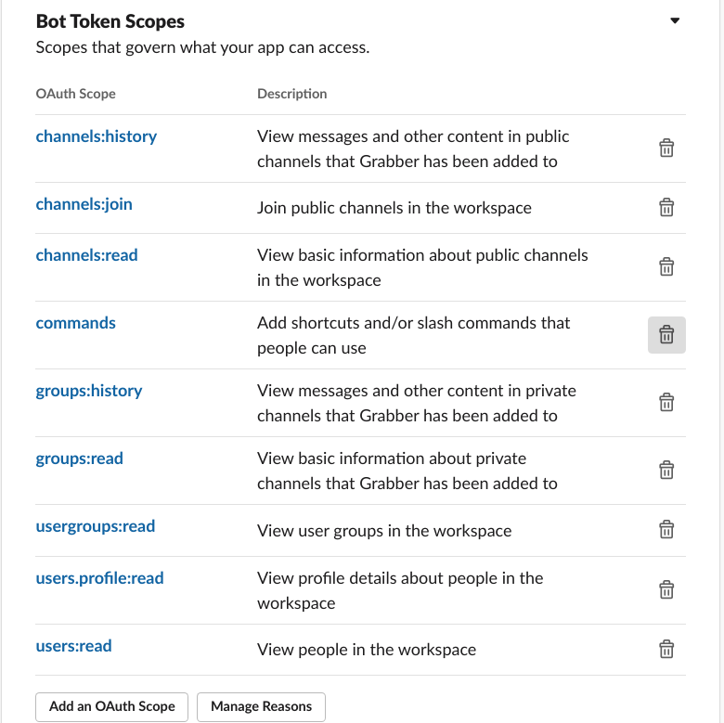

- In User token scopes, add following:

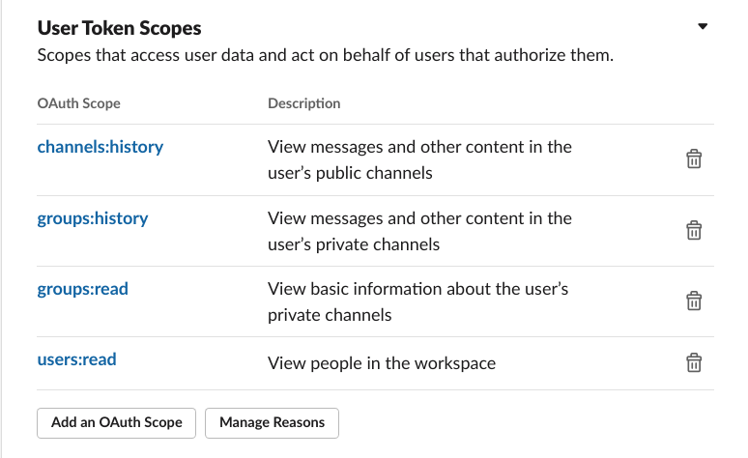
- Save Permissions/Scopes.

- Then scroll up and “Add App to your workplace”

- Then copy the two tokens, we shall use them now in our Channels reading script.

- Download the “New_grab_slack_history.py” from our Repository

- Install Slacker api in conda or base python environment using conda install Slacker or pip install Slacker

- Activate the environment

- Use the following command with tokens from the slack workspaces: for example for HCI Tartu I use the script as follows:

python New_grab_slack_history.py --workspace 'WORKSPACE' --tokenUser 'USERTOKEN' --tokenBot 'BOTTOKEN'

Note that there are three arguments,
- A folder/workspace name that you want the files to download into.
- tokenUser (in single quotes)
- tokenBot (in single quotes)
- The downloaded json files should be in a folder named as per ‘workspace’ argument.

