Statistical Analysis Tables
A Machine Learning Model for Forecasting Mainshock Magnitudes Using PHIVOLCS Foreshock Data
All tables follow APA 7th-edition format: a bold table number, an italic title in title case, horizontal rules only, and a note beneath the table where interpretation is needed. Every table in this document was generated directly from the source catalogue by the accompanying Python script; no value was entered by hand.
Source data: Earthquake Data Sets NEW.xlsx. Analysis seed: 42. Significance level: α = 0.05.
Section A. Data Preparation and Catalogue Description

Table 1
Profile of the PHIVOLCS Earthquake Catalogue After Cleaning
Catalogue attribute | Value
Records in source workbook | 18,338
Events retained after cleaning | 17,667
Retention rate | 96.3%
First event | 29 Mar 1907 20:46:30
Last event | 08 Jun 2026 00:55:12
Temporal span | 119.2 years
Mean annual event rate | 148.2 events/year
Latitude range (°N) | 2.00 to 22.00
Longitude range (°E) | 116.30 to 133.00
Depth range (km) | 0.0 to 700.0
Working magnitude range | 4.0 to 8.3
Events M ≥ 5.0 | 3,607
Events M ≥ 6.0 | 445
Events M ≥ 7.0 | 87
Note. Working magnitude is the first available scale in the order Mw > Ms > Mb > Ml. The catalogue is an event list, not a uniformly complete record; detection capability improves markedly after the 1970s (see Table 8).

Table 2
Data-Cleaning Audit Trail
Step | Records before | Removed | Records retained | Note
Records extracted from workbook | 18,338 | 0 | 18,338 | Banner and repeated header rows removed
Valid origin date/time | 18,338 | 0 | 18,338 | Year/month/day must form a real calendar date
Epicentre inside study region | 18,338 | 0 | 18,338 | lat 0.0-25.0, lon 110.0-140.0
Hypocentral depth in range | 18,338 | 0 | 18,338 | 0-750 km
At least one reported magnitude | 18,338 | 0 | 18,338 | Ml, mb, Ms or Mw present
Working magnitude in range | 18,338 | 0 | 18,338 | policy = 'hierarchy', preference Mw > Ms > Mb > Ml
Nearest active fault recorded | 18,338 | 0 | 18,338 | Source coordinates and distance present and non-negative
Duplicate origins collapsed | 18,338 | 671 | 17,667 | within 1 s and 1 km
Note. Rules were applied in the order shown. A record removed by an earlier rule is not re-tested by a later one, so the counts sum to the retained total.

Table 3
Availability and Distribution of the Four Reported Magnitude Scales
Magnitude scale | n reported | % of catalogue | n adopted as working scale | M | SD | Mdn | Min | Max | Skew | Kurt
Ml | 8,288 | 46.9 | 3,202 | 4.35 | 0.40 | 4.30 | 1.30 | 6.50 | 0.89 | 2.57
Mb | 6,824 | 38.6 | 1,730 | 5.23 | 0.39 | 5.20 | 2.50 | 7.80 | -0.19 | 6.09
Ms | 11,899 | 67.4 | 11,830 | 4.50 | 0.54 | 4.30 | 3.50 | 8.30 | 2.12 | 6.29
Mw | 905 | 5.1 | 905 | 5.00 | 0.60 | 5.00 | 4.00 | 7.80 | 1.01 | 1.46
Note. n reported counts events for which the scale is populated; n adopted counts events for which it became the working magnitude. Ml saturates near M 6.5 and mb near M 6.0, which is why Mw and Ms take precedence.

Table 4
Co-Reporting of Magnitude Scales Within the Catalogue
Scales reported together | n events | % of catalogue
Ms | 6,725 | 38.1
Ml + Mb + Ms | 5,073 | 28.7
Ml | 3,202 | 18.1
Mb | 1,729 | 9.8
Mw | 835 | 4.7
Ms + Mw | 69 | 0.4
Mb + Ms | 21 | 0.1
Ml + Ms | 11 | 6.23e-02
Ml + Mb | 1 | 5.66e-03
Ml + Mw | 1 | 5.66e-03
Note. Mw is co-reported with another scale for very few events, which is the reason no catalogue-wide conversion to Mw was attempted (see Table 5).

Table 5
Orthogonal Regression Relations Between Magnitude Scales
Predictor | Response | n | Slope | Intercept | r | SEE | Usable
Ml | Mb | 5,102 | 0.971 | 1.134 | 0.898 | 0.162 | Yes
Ml | Ms | 5,112 | 1.338 | -1.224 | 0.908 | 0.213 | Yes
Ml | Mw | 1 | — | — | — | — | No (n < 10)
Mb | Ms | 5,122 | 1.468 | -3.261 | 0.830 | 0.302 | Yes
Mb | Mw | 0 | — | — | — | — | No (n < 10)
Ms | Mw | 76 | 0.988 | 0.095 | 0.869 | 0.242 | Yes
Note. Major-axis (orthogonal) regression of the response on the predictor, fitted on events reporting both scales. SEE = standard error of the estimate. Relations involving Mw rest on too few co-reported events to support catalogue-wide homogenisation, and were not applied.

Table 6
Distance to the Nearest Active Fault, and Its Verification
Quantity | Value
Events with a nearest-fault distance | 17,667
Distinct fault source points | 797
Distance, M (SD) in km | 59.82 (75.26)
Distance, median in km | 32.98
Distance range in km | 0.18 to 617.26
Events within 25 km of a fault | 7,024 (39.8%)
Median recomputation difference in km | 0.0557
Maximum recomputation difference in km | 5.323
Agreement within 1 km | 17,354 of 17,667 (98.23%)
Note. Fault lines were mapped in QGIS and the distance measured with the Haversine formula on a sphere of radius 6,371 km, as the methodology specifies. The supplied value is used as given. It is recomputed here from the two coordinate pairs beside it purely as a transcription check; the residual differences are a rounding effect that grows with distance and is immaterial inside the 100 km observation radius.

Table 7
Descriptive Statistics for the Principal Seismic Parameters
Variable | n | M | SD | SE | 95% CI LL | 95% CI UL | Mdn | Min | Max | Range | Q1 | Q3 | IQR | Skew | Kurt
Magnitude (working scale) | 17,667 | 4.569 | 0.548 | 0.004 | 4.561 | 4.577 | 4.400 | 4.000 | 8.300 | 4.300 | 4.100 | 4.900 | 0.800 | 1.612 | 3.938
Focal depth (km) | 17,667 | 54.899 | 86.340 | 0.650 | 53.626 | 56.172 | 33.000 | 0.000 | 700.000 | 700.000 | 13.000 | 59.000 | 46.000 | 4.205 | 21.247
Latitude (deg N) | 17,667 | 9.984 | 4.862 | 0.037 | 9.913 | 10.056 | 9.400 | 2.000 | 22.000 | 20.000 | 6.000 | 13.377 | 7.377 | 0.489 | -0.635
Longitude (deg E) | 17,667 | 124.652 | 2.545 | 0.019 | 124.614 | 124.689 | 125.619 | 116.300 | 133.000 | 16.700 | 122.360 | 126.621 | 4.261 | -0.591 | -0.805
Distance to nearest fault (km) | 17,667 | 59.818 | 75.261 | 0.566 | 58.708 | 60.927 | 32.983 | 0.178 | 617.260 | 617.082 | 15.604 | 63.462 | 47.858 | 2.398 | 6.177
Note. CI = confidence interval for the mean. Skewness and kurtosis are bias-corrected; for a normal distribution both approach zero.
Section B. Frequency Distributions

Table 8
Frequency Distribution of Events by Magnitude Class
Magnitude class | f | % | Cumulative % | Mdn depth (km)
4.0–4.4 | 9,074 | 51.4 | 51.4 | 27.0
4.5–4.9 | 4,986 | 28.2 | 79.6 | 33.0
5.0–5.4 | 2,450 | 13.9 | 93.5 | 38.0
5.5–5.9 | 712 | 4.0 | 97.5 | 33.0
6.0–6.9 | 358 | 2.0 | 99.5 | 34.0
≥ 7.0 (Major) | 87 | 0.5 | 100.0 | 33.0
Note. Class boundaries begin at the catalogue's own reporting threshold. No event in the workbook carries a working magnitude below M 4.0, so the conventional micro and minor classes are empty by construction.

Table 9
Recorded Seismicity by Decade
Decade | f | % | M (magnitude) | SD | Max | Mdn depth (km) | f (M ≥ 6.0)
1900s | 5 | 2.83e-02 | 7.22 | 0.32 | 7.6 | 33.0 | 5
1910s | 12 | 6.79e-02 | 7.14 | 0.49 | 7.9 | 33.0 | 12
1920s | 35 | 0.2 | 6.65 | 0.62 | 8.3 | 33.0 | 32
1930s | 84 | 0.5 | 6.23 | 0.68 | 7.7 | 33.0 | 62
1940s | 25 | 0.1 | 6.77 | 0.97 | 8.3 | 33.0 | 22
1950s | 76 | 0.4 | 5.94 | 0.85 | 7.7 | 33.0 | 45
1960s | 720 | 4.1 | 5.10 | 0.40 | 7.7 | 65.0 | 21
1970s | 2,316 | 13.1 | 4.77 | 0.49 | 7.9 | 35.0 | 28
1980s | 1,898 | 10.7 | 4.40 | 0.40 | 6.6 | 50.0 | 8
1990s | 2,698 | 15.3 | 4.53 | 0.51 | 7.8 | 20.0 | 47
2000s | 2,265 | 12.8 | 4.49 | 0.49 | 7.5 | 24.0 | 33
2010s | 3,517 | 19.9 | 4.50 | 0.49 | 7.6 | 22.0 | 60
2020s | 4,016 | 22.7 | 4.46 | 0.48 | 7.8 | 19.0 | 70
Note. The rise in recorded events tracks the expansion of the PHIVOLCS seismic network. Decadal counts are therefore a measure of observation, and any temporal trend must be read with that in mind.

Table 10
Frequency Distribution of Events by Hypocentral Depth Class
Depth class | f | % | Cumulative % | M (magnitude) | SD | Max
Shallow (<70 km) | 13,983 | 79.1 | 79.1 | 4.54 | 0.54 | 8.30
Intermediate (70-300 km) | 3,267 | 18.5 | 97.6 | 4.66 | 0.55 | 7.80
Deep (>300 km) | 417 | 2.4 | 100.0 | 4.83 | 0.68 | 7.30
Note. Depth classes follow the USGS convention. Shallow events dominate and carry the greatest surface hazard for a given magnitude.

Table 11
Cross-Tabulation of Magnitude Class by Hypocentral Depth Class
Magnitude class | Shallow (<70 km) | Intermediate (70-300 km) | Deep (>300 km) | Total
4.0–4.4 | 7,535 (83.0%) | 1,385 (15.3%) | 154 (1.7%) | 9,074
4.5–4.9 | 3,838 (77.0%) | 1,032 (20.7%) | 116 (2.3%) | 4,986
5.0–5.4 | 1,770 (72.2%) | 593 (24.2%) | 87 (3.6%) | 2,450
5.5–5.9 | 529 (74.3%) | 157 (22.1%) | 26 (3.7%) | 712
6.0–6.9 | 241 (67.3%) | 88 (24.6%) | 29 (8.1%) | 358
≥ 7.0 (Major) | 70 (80.5%) | 12 (13.8%) | 5 (5.7%) | 87
Note. Cell entries are counts with row percentages in parentheses.
Section C. Inferential Statistics

Table 12
Tests of Normality for the Seismic Parameters
Variable | n | Shapiro–Wilk W | p (S–W) | D'Agostino K² | p (K²) | K–S D | p (K–S) | Skewness | Kurtosis | Decision at α = .05
Magnitude | 17,667 | 0.870 | < .001 | 5,629.128 | < .001 | 0.149 | < .001 | 1.612 | 3.938 | Reject normality
Depth | 17,667 | 0.551 | < .001 | 15,187.427 | < .001 | 0.266 | < .001 | 4.205 | 21.247 | Reject normality
Latitude | 17,667 | 0.959 | < .001 | 1,313.382 | < .001 | 0.067 | < .001 | 0.489 | -0.635 | Reject normality
Longitude | 17,667 | 0.914 | < .001 | 2,424.487 | < .001 | 0.149 | < .001 | -0.591 | -0.805 | Reject normality
Note. Shapiro–Wilk is computed on a random subsample of 5,000 events, the largest n for which the statistic is defined. All four variables depart from normality, which is why rank-based tests are reported alongside parametric ones throughout.

Table 13
Pearson Correlation Matrix for the Seismic Parameters
Variable | 1 | 2 | 3 | 4
1. Magnitude | —
2. Depth | .122*** | —
3. Latitude | -.031*** | -.241*** | —
4. Longitude | -.010 | .028*** | -.728*** | —
Note. N = 17,667. * p < .05. ** p < .01. *** p < .001. Leading zeros are omitted.

Table 14
Pairwise Associations Among the Seismic Parameters
Variable pair | n | Pearson r | p (r) | Spearman ρ | p (ρ) | r² | Strength (Cohen)
Magnitude – Depth | 17,667 | .122 | < .001 | .168 | < .001 | .015 | Small
Magnitude – Latitude | 17,667 | -.031 | < .001 | -.044 | < .001 | 9.807e-04 | Negligible
Magnitude – Longitude | 17,667 | -.010 | .175 | .007 | .372 | 1.042e-04 | Negligible
Depth – Latitude | 17,667 | -.241 | < .001 | -.273 | < .001 | .058 | Small
Depth – Longitude | 17,667 | .028 | < .001 | .113 | < .001 | 8.040e-04 | Negligible
Latitude – Longitude | 17,667 | -.728 | < .001 | -.676 | < .001 | .530 | Large
Note. With N in the tens of thousands nearly every association is statistically significant; r² and the strength label, not p, carry the practical meaning.

Table 15
Magnitude by Depth Class: Group Descriptive Statistics
Group | n | M | SD | Mdn | Min | Max
Shallow (<70 km) | 13,983 | 4.541 | 0.538 | 4.400 | 4.000 | 8.300
Intermediate (70-300 km) | 3,267 | 4.658 | 0.554 | 4.600 | 4.000 | 7.800
Deep (>300 km) | 417 | 4.831 | 0.683 | 4.700 | 4.000 | 7.300

Table 16
Omnibus Tests of Magnitude Differences Across Depth Classes
Test | Statistic | df | p | Effect size | Effect size index | Interpretation
Levene (median-centred) | 26.038 | 2, 17664 | < .001 | — | — | Variances unequal
One-way ANOVA | 110.225 | 2, 17664 | < .001 | 0.012 | η² | Small
Welch's ANOVA | 91.350 | 2, 1048.9 | < .001 | 0.012 | ω² | Small
Kruskal–Wallis H | 244.707 | 2 | < .001 | 0.014 | ε² | Small
Note. Levene's test rejects homogeneity of variance, so Welch's ANOVA and the Kruskal–Wallis test are the defensible omnibus results; the classical F is reported only for comparison.

Table 17
Dunn's Post Hoc Comparisons of Magnitude Across Depth Classes
Comparison | Mean rank difference | z | p | p (Bonferroni) | Cliff's δ | Decision
Shallow (<70 km) vs. Intermediate (70-300 km) | -1,274.506 | -12.908 | < .001 | < .001 | -.143 | Significant
Shallow (<70 km) vs. Deep (>300 km) | -2,466.875 | -9.769 | < .001 | < .001 | -.277 | Significant
Intermediate (70-300 km) vs. Deep (>300 km) | -1,192.369 | -4.512 | < .001 | < .001 | -.141 | Significant
Note. p values are Bonferroni-adjusted for the number of pairwise comparisons. Cliff's δ is a non-parametric effect size bounded by ±1.

Table 18
Chi-Square Test of Independence: Magnitude Class by Depth Class
Test | χ² | df | N | p | Cramér's V | Effect size | Decision at α = .05
Pearson χ² test of independence | 255.024 | 10 | 17,667 | < .001 | 0.085 | Medium | Reject independence
Note. Cramér's V is benchmarked against the degrees of freedom of the table.

Table 19
Standardised Residuals for the Magnitude-by-Depth Cross-Tabulation
Magnitude class | Shallow (<70 km) | Intermediate (70-300 km) | Deep (>300 km)
4.0–4.4 | 13.08 | -11.36 | -5.97
4.5–4.9 | -4.46 | 4.74 | -0.19
5.0–5.4 | -9.06 | 7.85 | 4.18
5.5–5.9 | -3.25 | 2.5 | 2.32
6.0–6.9 | -5.57 | 3.0 | 7.23
≥ 7.0 (Major) | 0.3 | -1.13 | 2.09
Note. Residuals beyond ±1.96 mark cells contributing significantly to the chi-square statistic at α = .05.

Table 20
Mann–Kendall Trend Tests on the Annual Seismicity Series
Series | n (years) | Mann–Kendall S | Z | Kendall's τ | p | Sen's slope (per year) | Trend
Annual event count | 114 | 4,704 | 11.526 | .730 | < .001 | 3.459 | Increasing
Annual maximum magnitude | 114 | -956 | -2.343 | -.148 | .019 | -0.004 | Decreasing
Annual mean magnitude | 114 | -4,396 | -10.763 | -.683 | < .001 | -0.026 | Decreasing
Annual count of M ≥ 6.0 events | 114 | 1,059 | 2.612 | .164 | .009 | 0.018 | Increasing
Note. Sen's slope is the Theil–Sen median slope per year. A trend in recorded counts confounds real seismicity with network growth; the magnitude series is the less confounded of the four.

Table 21
Comparison of Recorded Magnitudes Before and After 1980
Statistic | Value
n (pre-1980) | 3,273
M (pre-1980) | 4.957 (SD = 0.648)
n (1980–present) | 14,394
M (1980–present) | 4.481 (SD = 0.481)
Welch's t | 39.571
p (Welch's t) | < .001
Cohen's d | 0.922
Mann–Whitney U | 35,058,464
p (Mann–Whitney) | < .001
Rank-biserial correlation | -0.488
Note. 1980 approximates the modernisation of the national seismic network. A difference here is at least as likely to reflect improved detection of small events as a change in seismicity.
Section D. Frequency–Magnitude Distribution

Table 22
Completeness Magnitude and Gutenberg–Richter Parameters for the Full Catalogue
Subset | N events | Mc (MAXC) | Mc (GFT) | GFT R (%) | N ≥ Mc | b (MLE) | SE b (MLE) | a (MLE) | b (LSQ) | SE b (LSQ) | a (LSQ) | R² (LSQ)
Full catalogue | 17,667 | 4.200 | 4.900 | 90.558 | 4,442 | 0.920 | 0.014 | 8.155 | 0.963 | 0.028 | 8.448 | 0.974
Note. Mc (MAXC) is the maximum-curvature estimate with the conventional +0.2 correction; Mc (GFT) is the 90% goodness-of-fit estimate of Wiemer and Wyss (2000). b (MLE) is the Aki–Utsu estimator with the Shi and Bolt (1982) standard error. A b-value near 1.0 is typical of subduction seismicity.

Table 23
Gutenberg–Richter Parameters by Decade, 1980 to Present
Subset | N events | Mc (MAXC) | Mc (GFT) | GFT R (%) | N ≥ Mc | b (MLE) | SE b (MLE) | a (MLE) | b (LSQ) | SE b (LSQ) | a (LSQ) | R² (LSQ)
1980 | 1,898 | 4.200 | 4.500 | 91.128 | 689 | 1.173 | 0.041 | 8.118 | 1.346 | 0.019 | 8.975 | 0.996
1990 | 2,698 | 4.200 | 4.700 | 89.135 | 887 | 0.941 | 0.031 | 7.371 | 0.989 | 0.019 | 7.633 | 0.989
2000 | 2,265 | 4.200 | 4.400 | 88.234 | 1,162 | 0.884 | 0.024 | 6.955 | 0.998 | 0.013 | 7.520 | 0.995
2010 | 3,517 | 4.200 | 4.700 | 91.938 | 1,106 | 0.990 | 0.030 | 7.696 | 1.045 | 0.026 | 8.009 | 0.983
2020 | 4,016 | 4.200 | 4.000 | 91.846 | 4,016 | 0.851 | 0.013 | 7.007 | 0.960 | 0.014 | 7.530 | 0.992
Note. Restricted to 1980 onward, where the catalogue is dense enough for stable per-decade estimates. Drift in Mc across decades is a completeness effect; drift in b is the physically interesting quantity.

Table 24
Gutenberg–Richter Parameters by Hypocentral Depth Class
Subset | N events | Mc (MAXC) | Mc (GFT) | GFT R (%) | N ≥ Mc | b (MLE) | SE b (MLE) | a (MLE) | b (LSQ) | SE b (LSQ) | a (LSQ) | R² (LSQ)
Shallow (<70 km) | 13,983 | 4.200 | 4.900 | 90.882 | 3,223 | 0.920 | 0.017 | 8.016 | 0.914 | 0.025 | 8.029 | 0.975
Intermediate (70-300 km) | 3,267 | 4.200 | 4.900 | 87.222 | 1,049 | 0.969 | 0.030 | 7.767 | 1.027 | 0.025 | 8.125 | 0.984
Deep (>300 km) | 417 | 4.600 | 4.700 | 77.459 | 222 | 0.667 | 0.042 | 5.480 | 0.730 | 0.036 | 5.840 | 0.941
Note. Differences in b between depth regimes are interpreted as differences in the stress state of the seismogenic volume.
Section E. Declustering and Feature Engineering

Table 25
Space–Time Windows Implied by Maeda's Method
Precursor magnitude (Mpre) | Spatial window L (km) | Temporal window ta (days) | Magnitude cut-off (Mpre − Md)
4.00 | 1.58 | 1.05 | 3.00
5.00 | 5.01 | 5.79 | 4.00
6.00 | 15.85 | 27.14 | 5.00
7.00 | 50.12 | 123.38 | 6.00
8.00 | 158.49 | 557.08 | 7.00
Note. Windows follow Equations 1 and 2 of Hirose et al. (2021). An event inside the window of an earlier event and at least 1.0 magnitude unit smaller (Equation 3) is classified as dependent.

Table 26
Outcome of Maeda's Declustering Procedure
Declustering stage | n | % of input
Events entering Maeda's method | 17,667 | 100.0
Dependent events removed (Eq. 1–3) | 2,207 | 12.5
Independent events retained | 15,460 | 87.5
Retained events M ≥ 5.0 | 3,261 | 18.5
Retained events M ≥ 6.0 | 431 | 2.4
Retained events M ≥ 7.0 | 86 | 0.5
Note. Percentages are of the events entering the procedure.

Table 27
Catalogue Descriptive Statistics Before and After Declustering
Catalogue | N | M | SD | Mdn | Min | Max | n (M ≥ 5.0) | n (M ≥ 6.0) | Mdn depth (km)
Full catalogue | 17,667 | 4.569 | 0.548 | 4.400 | 4.000 | 8.300 | 3,607 | 445 | 33.000
Declustered catalogue | 15,460 | 4.579 | 0.561 | 4.400 | 4.000 | 8.300 | 3,261 | 431 | 33.000
Note. Removing dependent events raises the mean magnitude because the removed population is, by construction, the small one.

Table 28
Gutenberg–Richter Parameters for the Declustered Catalogue
Subset | N events | Mc (MAXC) | Mc (GFT) | GFT R (%) | N ≥ Mc | b (MLE) | SE b (MLE) | a (MLE) | b (LSQ) | SE b (LSQ) | a (LSQ) | R² (LSQ)
Full catalogue | 15,460 | 4.200 | 4.900 | 90.469 | 3,994 | 0.893 | 0.015 | 7.978 | 0.950 | 0.028 | 8.350 | 0.972
Note. Compare with Table 21. Declustering typically lowers b, since clustered sequences are magnitude-poor relative to background seismicity.

Table 29
The 27 Engineered Seismic Features
# | Feature | Category | Description
1 | NO | Basic statistics | Number of earthquakes in the observation window
2 | Mag_max | Basic statistics | Maximum magnitude in the observation window
3 | Mag_mean | Basic statistics | Mean magnitude in the observation window
4 | b_lsq | Gutenberg–Richter law | b-value by least-squares regression
5 | a_lsq | Gutenberg–Richter law | a-value by least-squares regression
6 | b_std_lsq | Gutenberg–Richter law | Standard deviation of b_lsq
7 | std_gr_lsq | Gutenberg–Richter law | Deviation from the Gutenberg–Richter law (LSQ)
8 | b_mlk | Gutenberg–Richter law | b-value by maximum likelihood (Aki–Utsu)
9 | a_mlk | Gutenberg–Richter law | a-value by maximum likelihood
10 | b_std_mlk | Gutenberg–Richter law | Standard deviation of b_mlk
11 | std_gr_mlk | Gutenberg–Richter law | Deviation from the Gutenberg–Richter law (MLE)
12 | dM_lsq | Energy and magnitude deficit | Magnitude deficit from a_lsq and b_lsq
13 | dM_mlk | Energy and magnitude deficit | Magnitude deficit from a_mlk and b_mlk
14 | Energy | Energy and magnitude deficit | Square root of the summed seismic energy release
15 | x7_lsq | Activity-rate change and probability | Probability of occurrence derived from b_lsq
16 | x7_mlk | Activity-rate change and probability | Probability of occurrence derived from b_mlk
17 | zvalue | Activity-rate change and probability | Seismic rate change (z statistic)
18 | beta | Activity-rate change and probability | Seismic rate change (β statistic)
19 | T_elaps6 | Time elapsed | Days since the last M 6.0 earthquake
20 | T_elaps65 | Time elapsed | Days since the last M 6.5 earthquake
21 | T_elaps7 | Time elapsed | Days since the last M 7.0 earthquake
22 | T_elaps75 | Time elapsed | Days since the last M 7.5 earthquake
23 | Dist_min | Distance to nearest fault | Closest approach to an active fault in the observation window
24 | Dist_mean | Distance to nearest fault | Mean distance to the nearest active fault
25 | Dist_std | Distance to nearest fault | Standard deviation of the fault distances
26 | Dist_wmean | Distance to nearest fault | Fault distance weighted by released energy
27 | Dist_trend | Distance to nearest fault | Change in fault distance across the window, km per day
Note. The first 22 follow Wang et al. (2023) as tabulated in the study methodology. The last 5 summarise the distance to the nearest active fault, which Data Collection names as a selected parameter but which has no row in that table. Every feature is computed from the events inside the observation window: 14 days and 100 km preceding the mainshock. The mainshock's own distance to a fault is deliberately excluded, being a property of the event under forecast.

Table 30
Construction of the Forecast Sequence Data Set
Quantity | Value
Candidate mainshocks (independent, M ≥ 5.0) | 3,261
Rejected: window opens before the catalogue starts | 1
Rejected: fewer than 3 events in the observation window | 2,725
Forecast sequences retained | 535
Observation window | 14 days, 100 km radius
Period covered | Feb 1957 – Feb 2026
Target magnitude, M (SD) | 5.378 (0.447)
Target magnitude range | 5.0 – 7.3
Median foreshocks per window | 6
Sequences with an M ≥ 6.0 target | 58
Sequences with an M ≥ 7.0 target | 8
Note. A mainshock qualifies at M ≥ 5.0 and requires at least 3 catalogued events inside its observation window. Observation windows are drawn from the full catalogue rather than the declustered one, because the small dependent events Maeda's method removes are precisely the precursory activity the features are meant to measure.

Table 31
Descriptive Statistics for the 27 Engineered Features
Feature | n valid | n missing | M | SD | Mdn | Min | Max | Skew
NO | 535 | 0 | 12.295 | 16.028 | 6.000 | 3.000 | 185.000 | 4.605
Mag_max | 535 | 0 | 5.607 | 0.683 | 5.600 | 4.100 | 7.400 | 0.444
Mag_mean | 535 | 0 | 4.797 | 0.366 | 4.746 | 4.033 | 6.600 | 0.675
b_lsq | 511 | 24 | 0.841 | 0.625 | 0.702 | -0.000 | 3.010 | 1.388
a_lsq | 511 | 24 | 4.577 | 3.267 | 3.799 | 0.000 | 20.169 | 1.433
b_std_lsq | 511 | 24 | 0.225 | 0.228 | 0.160 | 0.000 | 1.592 | 2.362
std_gr_lsq | 511 | 24 | 0.092 | 0.038 | 0.089 | 0.000 | 0.236 | 0.109
b_mlk | 505 | 30 | 1.288 | 0.924 | 0.987 | 0.245 | 8.686 | 3.057
a_mlk | 505 | 30 | 6.727 | 4.538 | 5.345 | 1.630 | 45.644 | 2.842
b_std_mlk | 505 | 30 | 0.495 | 0.417 | 0.361 | 0.000 | 2.588 | 1.882
std_gr_mlk | 504 | 31 | 0.240 | 0.175 | 0.182 | 0.028 | 1.140 | 2.529
dM_lsq | 497 | 38 | -2.161e+13 | 4.818e+14 | 0.067 | -1.074e+16 | 0.789 | -22.293
dM_mlk | 505 | 30 | 0.261 | 0.338 | 0.194 | -0.785 | 1.488 | 0.879
Energy | 535 | 0 | 4.013e+11 | 8.187e+11 | 1.365e+11 | 7.462e+09 | 5.105e+12 | 3.694
x7_lsq | 511 | 24 | 0.079 | 0.187 | 0.008 | 9.313e-10 | 1.000 | 3.844
x7_mlk | 505 | 30 | 0.009 | 0.020 | 0.001 | 8.757e-27 | 0.184 | 4.411
zvalue | 535 | 0 | -0.736 | 1.250 | -1.000 | -4.551 | 3.386 | 0.743
beta | 535 | 0 | 9.794 | 9.081 | 6.872 | -2.535 | 65.289 | 1.873
T_elaps6 | 535 | 0 | 2,877.477 | 5,122.076 | 565.978 | 0.002 | 43,535.173 | 3.298
T_elaps65 | 535 | 0 | 7,974.919 | 10,656.963 | 4,723.816 | 0.017 | 43,535.173 | 2.043
T_elaps7 | 535 | 0 | 15,033.696 | 14,979.316 | 8,476.343 | 0.017 | 43,535.173 | 0.921
T_elaps75 | 535 | 0 | 26,877.709 | 15,347.825 | 25,378.537 | 488.881 | 43,535.173 | -0.168
Dist_min | 535 | 0 | 38.242 | 61.045 | 15.182 | 0.563 | 321.031 | 2.773
Dist_mean | 535 | 0 | 58.430 | 65.030 | 36.244 | 3.723 | 349.895 | 2.470
Dist_std | 535 | 0 | 15.526 | 9.996 | 13.527 | 0.087 | 60.397 | 1.642
Dist_wmean | 535 | 0 | 57.200 | 65.283 | 37.478 | 2.650 | 354.330 | 2.433
Dist_trend | 535 | 0 | 190.179 | 4,053.208 | 0.416 | -370.418 | 93,688.621 | 23.074
Note. Statistics describe the features as computed. Missing values arise where a window is too sparse to support a b-value fit; they are median-imputed from the training rows of each fold only. Before modelling, the energy, occurrence-probability and elapsed-time features are log-transformed and every feature is winsorised at the training 1st and 99th percentiles — both monotone, so the tree ensembles are unaffected and the linear, kernel and neural models are protected from the heavy tails these quantities carry by construction.

Table 32
Correlations Between Each Engineered Feature and the Mainshock Magnitude
Feature | n | Pearson r | p (r) | Spearman ρ | p (ρ) | Strength
Energy | 535 | .335 | < .001 | .059 | .174 | Medium
x7_mlk | 505 | .311 | < .001 | .182 | < .001 | Medium
Mag_max | 535 | .173 | < .001 | .078 | .073 | Small
dM_mlk | 505 | .124 | .005 | .128 | .004 | Small
a_mlk | 505 | -.122 | .006 | -.192 | < .001 | Small
T_elaps75 | 535 | .114 | .008 | .127 | .003 | Small
std_gr_mlk | 504 | -.109 | .014 | -.126 | .005 | Small
T_elaps65 | 535 | -.107 | .013 | -.223 | < .001 | Small
b_mlk | 505 | -.105 | .018 | -.182 | < .001 | Small
a_lsq | 511 | -.094 | .034 | -.124 | .005 | Negligible
b_lsq | 511 | -.089 | .044 | -.122 | .006 | Negligible
T_elaps6 | 535 | -.085 | .050 | -.209 | < .001 | Negligible
b_std_mlk | 505 | -.083 | .061 | -.123 | .006 | Negligible
T_elaps7 | 535 | -.082 | .058 | -.127 | .003 | Negligible
Dist_std | 535 | -.063 | .144 | -.009 | .837 | Negligible
b_std_lsq | 511 | -.062 | .164 | -.096 | .030 | Negligible
std_gr_lsq | 511 | .059 | .181 | .023 | .599 | Negligible
Dist_wmean | 535 | -.037 | .393 | -.031 | .475 | Negligible
Dist_trend | 535 | -.036 | .400 | -.034 | .432 | Negligible
Dist_mean | 535 | -.033 | .450 | -.042 | .332 | Negligible
beta | 535 | -.030 | .491 | -.071 | .103 | Negligible
Dist_min | 535 | -.024 | .573 | -.054 | .214 | Negligible
zvalue | 535 | .022 | .614 | .012 | .790 | Negligible
Mag_mean | 535 | -.015 | .736 | -.083 | .054 | Negligible
dM_lsq | 497 | -.011 | .804 | .104 | .021 | Negligible
x7_lsq | 511 | .006 | .894 | .123 | .006 | Negligible
NO | 535 | 7.282e-04 | .987 | -.049 | .260 | Negligible
Note. Pearson r and Spearman ρ against the observed mainshock magnitude across all sequences. These are univariate associations and do not account for the interactions the ensemble models exploit.
Section F. Probability of Occurrence

Table 33
Construction of the Occurrence Data Set
Radius (km) | Anchors | Thinned out | Period | P(M ≥ 5) observed | n positive (M ≥ 5) | P(M ≥ 6) observed | n positive (M ≥ 6) | P(M ≥ 7) observed | n positive (M ≥ 7)
50.0 | 1,702 | 1,481 | Aug 1965 to May 2026 | 25.4 | 433 | 5.8 | 98 | 0.5 | 8
100.0 | 2,239 | 2,098 | Feb 1957 to May 2026 | 29.5 | 660 | 4.6 | 102 | 0.4 | 10
200.0 | 4,125 | 2,904 | Feb 1957 to May 2026 | 35.9 | 1,479 | 5.3 | 220 | 0.4 | 18
Note. Each anchor is a moment and a place with at least 3 catalogued events in the preceding 14 days, labelled by whether an independent earthquake of the stated size followed within the next 14 days. This is the reverse of the magnitude model's window, which looks backward. Anchors within a day and half a radius of one already kept are dropped, because a single swarm would otherwise contribute dozens of near-identical rows.

Table 34
Does the Model Beat the Historical Rate? Rolling-Origin Scores
Radius (km) | Threshold | Anchors | Positives | Historical rate (%) | Folds scored | M ROC AUC | SD AUC | M Brier skill (%) | SD Brier skill | Verdict
50.000 | M ≥ 5 | 1,702 | 433 | 25.441 | 5 | 0.639 | 0.087 | 5.981 | 11.062 | Model beats the base rate
50.000 | M ≥ 6 | 1,702 | 98 | 5.758 | 3 | 0.658 | 0.178 | -10.199 | 23.629 | No skill beyond the base rate
50.000 | M ≥ 7 | 1,702 | 8 | 0.470 | 0 | — | — | — | — | Too few events to model
100.000 | M ≥ 5 | 2,239 | 660 | 29.477 | 5 | 0.620 | 0.045 | 5.752 | 6.879 | Model beats the base rate
100.000 | M ≥ 6 | 2,239 | 102 | 4.556 | 4 | 0.558 | 0.174 | -15.445 | 17.728 | No skill beyond the base rate
100.000 | M ≥ 7 | 2,239 | 10 | 0.447 | 0 | — | — | — | — | Too few events to model
200.000 | M ≥ 5 | 4,125 | 1,479 | 35.855 | 5 | 0.582 | 0.044 | 2.099 | 2.895 | Model beats the base rate
200.000 | M ≥ 6 | 4,125 | 220 | 5.333 | 4 | 0.556 | 0.026 | -0.577 | 0.418 | No skill beyond the base rate
200.000 | M ≥ 7 | 4,125 | 18 | 0.436 | 0 | — | — | — | — | Too few events to model
Note. Scored across expanding-window folds rather than one split: with four to thirty positives in a test block, a single split returns an AUC anywhere between .13 and .80 for the same cell. A cell counts as modelled only if the calibrated probability beats quoting the base rate, meaning a positive mean Brier skill score and a mean AUC above .55. The historical rate column is a real conditional frequency and remains a defensible answer wherever the model does not clear that bar.

Table 35
Probability of Occurrence With 95% Confidence Intervals
Radius (km) | Threshold | n anchors | n occurred | Rate (%) | Wilson 95% CI | Margin of error (pp) | Year-block 95% CI | Block MoE (pp)
50.00 | M ≥ 5 | 1,702 | 433 | 25.44 | 23.4 to 27.6 | 2.07 | 19.8 to 31.1 | 5.63
50.00 | M ≥ 6 | 1,702 | 98 | 5.76 | 4.7 to 7.0 | 1.11 | 2.6 to 9.2 | 3.33
50.00 | M ≥ 7 | 1,702 | 8 | 0.47 | 0.2 to 0.9 | 0.34 | 0.1 to 1.0 | 0.48
100.00 | M ≥ 5 | 2,239 | 660 | 29.48 | 27.6 to 31.4 | 1.89 | 24.1 to 34.7 | 5.30
100.00 | M ≥ 6 | 2,239 | 102 | 4.56 | 3.8 to 5.5 | 0.87 | 2.3 to 7.1 | 2.38
100.00 | M ≥ 7 | 2,239 | 10 | 0.45 | 0.2 to 0.8 | 0.29 | 0.0 to 1.0 | 0.48
200.00 | M ≥ 5 | 4,125 | 1,479 | 35.85 | 34.4 to 37.3 | 1.46 | 32.3 to 39.1 | 3.40
200.00 | M ≥ 6 | 4,125 | 220 | 5.33 | 4.7 to 6.1 | 0.69 | 3.8 to 6.8 | 1.53
200.00 | M ≥ 7 | 4,125 | 18 | 0.44 | 0.3 to 0.7 | 0.21 | 0.2 to 0.8 | 0.33
Note. Rate is the observed frequency: of n anchors where a sequence was already under way, the proportion followed within 14 days by an independent earthquake of that size at that distance. The Wilson interval is the standard interval for a proportion and is reported because a reader will expect it; Wald's is unusable at these rates, returning a negative lower bound. The year-block interval resamples whole years instead of individual anchors, dropping the independence assumption Wilson requires: these anchors are overlapping windows cut from one catalogue and a single productive swarm supplies many of them. Where the two disagree, the block interval is the defensible one. Margin of error is the half-width of the corresponding interval, in percentage points.
Section F. Model Construction and Comparison

Table 36
Chronological 60:20:20 Partitioning of the Sequence Data Set
Partition | n sequences | % of total | Period covered | M (target) | SD | Min | Max | n (M ≥ 6.0)
Training | 321 | 60.000 | Feb 1957 – Mar 2008 | 5.319 | 0.395 | 5.000 | 7.300 | 24
Validation | 107 | 20.000 | Apr 2008 – Oct 2019 | 5.408 | 0.465 | 5.000 | 7.100 | 14
Test | 107 | 20.000 | Nov 2019 – Feb 2026 | 5.523 | 0.535 | 5.000 | 7.100 | 20
Note. The split is strictly by time: every validation sequence postdates every training sequence, and every test sequence postdates both. A random shuffle would let a model learn from the future of its own test set.

Table 37
Magnitude-Class Distribution Across the Three Partitions
Magnitude class | Training f | Training % | Validation f | Validation % | Test f | Test %
Moderate (5.0-5.9) | 297 | 92.5 | 93 | 86.9 | 87 | 81.3
Strong (6.0-6.9) | 21 | 6.5 | 12 | 11.2 | 17 | 15.9
Major (>=7.0) | 3 | 0.9 | 2 | 1.9 | 3 | 2.8
Note. Major events are rare in every partition. This imbalance is the reason Cohen's κ, rather than raw accuracy, is treated as the headline agreement statistic.

Table 38
Random Forest Hyperparameter Search (Top 12 Configurations)
n_estimators | max_depth | min_samples_leaf | max_features | Validation RMSE
300 | 8.0000 | 1 | 0.5000 | 0.3815
600 | 8.0000 | 1 | 0.5000 | 0.3830
300 | 16.0000 | 1 | 0.5000 | 0.3858
300 | 8.0000 | 2 | 0.5000 | 0.3861
300 | — | 1 | 0.5000 | 0.3870
600 | 16.0000 | 1 | 0.5000 | 0.3877
600 | — | 1 | 0.5000 | 0.3880
600 | 8.0000 | 2 | 0.5000 | 0.3886
300 | 16.0000 | 2 | 0.5000 | 0.3907
300 | — | 2 | 0.5000 | 0.3909
600 | 16.0000 | 2 | 0.5000 | 0.3910
600 | — | 2 | 0.5000 | 0.3910
Note. Configurations ranked by root mean squared error on the validation partition. Grid search was scored on the held-out development set rather than by k-fold cross-validation, which would shuffle the time ordering back together.

Table 39
Inventory of the Forecasting Models Compared
Model | Family | Input representation | Key settings
Climatology (training mean) | Baseline | None (constant) | Predicts the training-set mean for every sequence
Persistence (previous mainshock) | Baseline | Previous target | Reuses the magnitude of the preceding mainshock
Random Forest | Tree ensemble (bagging) | 22 engineered features | n_estimators=300, max_depth=8, min_samples_leaf=1, max_features=0.5
Extra Trees | Tree ensemble (bagging) | 22 engineered features | n_estimators=200, max_depth=10, fully randomised splits
Gradient Boosting | Tree ensemble (boosting) | 22 engineered features | n_estimators=400, lr=0.05, max_depth=3, subsample=0.8
Histogram GB | Tree ensemble (boosting) | 22 engineered features | max_iter=400, lr=0.05, max_depth=6
Support Vector Regression | Kernel method | 22 engineered features | RBF kernel, C=10, ε=0.05, standardised inputs
k-Nearest Neighbours | Instance based | 22 engineered features | k=10, distance weighting, standardised inputs
Elastic Net | Regularised linear | 22 engineered features | α=0.05, L1 ratio=0.5
Ridge Regression | Regularised linear | 22 engineered features | α=5.0
Multilayer Perceptron | Feed-forward network | 22 engineered features | hidden=(64, 32), α=1.0, early stopping on a 20% inner split
LSTM | Recurrent network | 10 × 5 event stream | 32 units, Adam (lr=0.01), early stopping (patience 40)
GRU | Recurrent network | 10 × 5 event stream | 32 units, two gates, same optimiser as the LSTM
1D-CNN | Convolutional network | 10 × 5 event stream | 24 filters, kernel 3, ReLU, global max pooling
ARIMA | Classical time series | Order-indexed target series | (p, d, q) up to (2, 1, 2), selected by AIC
ARIMAX | Classical time series | Target series + 5 exogenous features | As ARIMA, with the 5 features most correlated with the target in the training rows
Note. 16 forecasters across four families, all scored on the same sequences. The two baselines are included because a forecasting model earns its claim only by beating them.

Table 40
Rolling-Origin Cross-Validation Results Across All Models
Model | Folds | M RMSE | SD RMSE | Min RMSE | Max RMSE | M MAE | Mean rank
Random Forest | 5 | 0.397 | 0.087 | 0.288 | 0.522 | 0.289 | 3.800
Elastic Net | 5 | 0.405 | 0.107 | 0.275 | 0.545 | 0.284 | 4.600
Extra Trees | 5 | 0.407 | 0.087 | 0.297 | 0.534 | 0.297 | 5.600
Gradient Boosting | 5 | 0.414 | 0.073 | 0.335 | 0.530 | 0.301 | 7.200
ARIMAX | 5 | 0.415 | 0.096 | 0.310 | 0.555 | 0.293 | 6.200
ARIMA | 5 | 0.418 | 0.128 | 0.260 | 0.583 | 0.303 | 6.600
Climatology (training mean) | 5 | 0.418 | 0.130 | 0.263 | 0.580 | 0.287 | 6.200
LSTM | 5 | 0.424 | 0.132 | 0.266 | 0.591 | 0.299 | 7.400
k-Nearest Neighbours | 5 | 0.426 | 0.117 | 0.278 | 0.561 | 0.295 | 8.400
GRU | 5 | 0.426 | 0.111 | 0.289 | 0.557 | 0.307 | 8.400
Histogram GB | 5 | 0.429 | 0.072 | 0.335 | 0.517 | 0.321 | 6.800
Ridge Regression | 5 | 0.438 | 0.084 | 0.326 | 0.549 | 0.309 | 9.200
Support Vector Regression | 5 | 0.479 | 0.106 | 0.371 | 0.602 | 0.342 | 12.000
Persistence (previous mainshock) | 5 | 0.491 | 0.113 | 0.338 | 0.617 | 0.347 | 13.800
Multilayer Perceptron | 5 | 0.733 | 0.197 | 0.497 | 0.982 | 0.560 | 14.000
1D-CNN | 5 | 0.832 | 0.157 | 0.600 | 1.032 | 0.652 | 15.800
Note. Expanding-window validation over the training and validation partitions: each fold trains on everything before its test block and forecasts the block that follows. SD across folds is the more honest measure of a model's reliability than any single split, and Mean rank is what the Friedman test in Table 37 operates on.

Table 41
Friedman Test for Differences Among the Models
Quantity | Value
Friedman χ² | 41.929
df | 15
p | < .001
Models compared (k) | 16
Validation folds (N) | 5
Nemenyi critical difference (α = .05) | 15.029
Decision | At least one model differs
Note. The Friedman test is the standard rank-based omnibus comparison of several models across several data splits (Demšar, 2006). The Nemenyi critical difference is the gap in mean rank two models must show before they can be called distinguishable.

Table 42
Mean Ranks and Nemenyi Post Hoc Comparison Against the Leading Model
Model | Mean rank | Rank difference from best | Distinguishable from best
Random Forest | 3.800 | 0.000 | No
Elastic Net | 4.600 | 0.800 | No
Extra Trees | 5.600 | 1.800 | No
Climatology (training mean) | 6.200 | 2.400 | No
ARIMAX | 6.200 | 2.400 | No
ARIMA | 6.600 | 2.800 | No
Histogram GB | 6.800 | 3.000 | No
Gradient Boosting | 7.200 | 3.400 | No
LSTM | 7.400 | 3.600 | No
GRU | 8.400 | 4.600 | No
k-Nearest Neighbours | 8.400 | 4.600 | No
Ridge Regression | 9.200 | 5.400 | No
Support Vector Regression | 12.000 | 8.200 | No
Persistence (previous mainshock) | 13.800 | 10.000 | No
Multilayer Perceptron | 14.000 | 10.200 | No
1D-CNN | 15.800 | 12.000 | No
Note. A model marked 'No' cannot be distinguished from the best performer at α = .05. The Nemenyi critical difference scales with the number of models and shrinks only with the number of folds, so comparing many models over a few folds can produce a critical difference wider than the whole range of ranks — in which case every row reads 'No'. That is a statement about the power of this test, not evidence that the models perform equally; the leaderboard and its confidence intervals are the more informative comparison.

Table 43
Test-Partition Leaderboard for All 16 Models
Rank | Model | RMSE | 95% CI for RMSE | MAE | R² | Bias | % within ±0.3 | Skill vs. climatology (%)
1 | Extra Trees | 0.492 | [0.409, 0.575] | 0.380 | 0.147 | 0.050 | 52.336 | 23.586
2 | Random Forest | 0.498 | [0.415, 0.579] | 0.386 | 0.125 | 0.026 | 49.533 | 21.631
3 | ARIMAX | 0.510 | [0.417, 0.602] | 0.385 | 0.085 | -0.029 | 49.533 | 18.022
4 | Elastic Net | 0.513 | [0.416, 0.607] | 0.380 | 0.073 | -0.060 | 54.206 | 16.984
5 | k-Nearest Neighbours | 0.514 | [0.422, 0.603] | 0.372 | 0.068 | -0.098 | 54.206 | 16.556
6 | Gradient Boosting | 0.524 | [0.426, 0.617] | 0.403 | 0.033 | 0.090 | 41.121 | 13.352
7 | Ridge Regression | 0.526 | [0.438, 0.610] | 0.402 | 0.026 | 0.012 | 43.925 | 12.786
8 | Histogram GB | 0.527 | [0.438, 0.613] | 0.403 | 0.023 | 0.033 | 46.729 | 12.468
9 | Support Vector Regression | 0.527 | [0.441, 0.605] | 0.394 | 0.022 | -0.082 | 51.402 | 12.424
10 | ARIMA | 0.545 | [0.437, 0.651] | 0.388 | -0.048 | -0.111 | 57.009 | 6.164
11 | GRU | 0.551 | [0.446, 0.651] | 0.396 | -0.069 | -0.102 | 50.467 | 4.247
12 | LSTM | 0.560 | [0.452, 0.663] | 0.399 | -0.103 | -0.116 | 54.206 | 1.196
13 | Climatology (training mean) | 0.563 | [0.449, 0.673] | 0.382 | -0.116 | -0.182 | 60.748 | 0.000
14 | Multilayer Perceptron | 0.585 | [0.476, 0.697] | 0.428 | -0.206 | 0.050 | 48.598 | -8.001
15 | 1D-CNN | 0.675 | [0.579, 0.770] | 0.525 | -0.606 | -0.067 | 39.252 | -43.885
16 | Persistence (previous mainshock) | 0.723 | [0.606, 0.836] | 0.525 | -0.841 | 0.013 | 52.336 | -64.883
Note. Every model refitted on the combined training and validation partitions, then scored once on the untouched test partition. Skill is the percentage reduction in mean squared error relative to climatology; a negative value means the model is worse than quoting the historical average, which is the result a reader most needs to see.

Table 44
Diebold–Mariano Comparisons Among the Five Leading Models
Model | Extra Trees | Random Forest | ARIMAX | Elastic Net | k-Nearest Neighbours
Extra Trees | — | .540 | .828 | .984 | .725
Random Forest | .540 | — | .944 | .715 | .488
ARIMAX | .828 | .944 | — | .513 | .486
Elastic Net | .984 | .715 | .513 | — | .639
k-Nearest Neighbours | .725 | .488 | .486 | .639 | —
Note. Cell entries are two-sided p values for the null hypothesis that the row and column models have equal forecast accuracy on the test partition. The test is paired on the absolute errors of the same sequences.

Table 45
Regression Performance Across the Three Partitions for the Two Headline Models
Model and partition | n | MSE | RMSE | MAE | MAPE (%) | R² | Bias (ME) | Max |error| | % within ±0.3 | % within ±0.5 | 95% CI for RMSE
Random Forest — training | 321 | 0.035 | 0.188 | 0.146 | 2.679 | 0.773 | 2.317e-04 | 0.878 | 90.966 | 97.819 | [0.168, 0.209]
Random Forest — validation | 107 | 0.146 | 0.381 | 0.299 | 5.356 | 0.320 | -0.023 | 1.055 | 59.813 | 85.047 | [0.327, 0.436]
Random Forest — test | 107 | 0.248 | 0.498 | 0.385 | 6.743 | 0.126 | -0.009 | 1.718 | 50.467 | 71.963 | [0.414, 0.579]
LSTM — training | 321 | 0.143 | 0.378 | 0.286 | 5.219 | 0.078 | 0.054 | 1.842 | 66.044 | 91.277 | [0.325, 0.431]
LSTM — validation | 107 | 0.251 | 0.501 | 0.382 | 6.846 | -0.173 | 0.029 | 2.084 | 42.991 | 76.636 | [0.392, 0.622]
LSTM — test | 107 | 0.299 | 0.547 | 0.411 | 7.088 | -0.054 | -0.067 | 1.758 | 44.860 | 78.505 | [0.447, 0.646]
Note. Both models here are fitted on the training partition alone, so the gap between training and test error is each model's optimism; a large gap indicates overfitting. Confidence intervals are percentile bootstrap intervals over 2,000 resamples. MSE, RMSE and MAE are in magnitude units.

Table 46
Training Outcome of the Three Sequence Networks
Setting | LSTM | GRU | 1D-CNN
Deep-learning backend in use | numpy | numpy | numpy
Architecture | 32 units | 32 units | 24 filters, kernel 3
Trainable parameters | 4,897 | 3,681 | 409
Epochs run (of 300 max) | 52 | 64 | 121
Best validation MSE | 0.1930 | 0.1832 | 0.3694
Optimiser | Adam (lr = 0.01) | Adam (lr = 0.01) | Adam (lr = 0.01)
Early stopping | patience 40 | patience 40 | patience 40
Input | 10 × 5 event stream | 10 × 5 event stream | 10 × 5 event stream
Note. All three networks share the optimiser, the early-stopping rule and the input tensor, so the comparison isolates the architecture. The GRU carries roughly a quarter fewer parameters than the LSTM; the convolutional net has no recurrence at all, and including it tests whether the task actually requires a memory of the sequence.

Table 47
Statistical Comparison of the Two Headline Models on the Test Partition
Comparison | Statistic | Value | p | Interpretation
Random Forest vs. LSTM | Mean |error| difference | -0.0133 | — | positive favours LSTM
 | Paired t | -0.4605 | .646 | Not significant
 | Wilcoxon signed-rank W | 2,773.0000 | .718 | Not significant
 | Diebold–Mariano DM | -0.4605 | .645 | Not significant
 | Cohen's d (paired errors) | -0.0370 | — | No significant difference
Note. Tests are paired on the absolute errors of the same test sequences. Diebold–Mariano is the standard forecast-comparison test; the Wilcoxon signed-rank test is reported because the loss differentials are not normal.

Table 48
Random Forest Feature Importance for Mainshock Magnitude
Rank | Feature | Impurity importance | Permutation importance | SD (permutation) | Cumulative impurity %
1 | T_elaps65 | 0.1720 | 0.0616 | 0.0369 | 17.2024
2 | T_elaps75 | 0.0302 | 0.0219 | 0.0075 | 20.2195
3 | beta | 0.0389 | 0.0206 | 0.0112 | 24.1081
4 | T_elaps7 | 0.0500 | 0.0198 | 0.0195 | 29.1103
5 | Dist_mean | 0.0286 | 0.0128 | 0.0064 | 31.9721
6 | Dist_std | 0.0464 | 0.0108 | 0.0089 | 36.6169
7 | Dist_wmean | 0.0350 | 0.0087 | 0.0100 | 40.1186
8 | Energy | 0.0666 | 0.0072 | 0.0120 | 46.7774
9 | dM_mlk | 0.0284 | 0.0045 | 0.0065 | 49.6207
10 | zvalue | 0.0446 | 0.0045 | 0.0055 | 54.0773
11 | Mag_mean | 0.0281 | 0.0033 | 0.0029 | 56.8905
12 | std_gr_mlk | 0.0406 | 0.0026 | 0.0070 | 60.9496
13 | dM_lsq | 0.0231 | 0.0001 | 0.0038 | 63.2571
14 | b_lsq | 0.0148 | -0.0007 | 0.0029 | 64.7386
15 | NO | 0.0231 | -0.0011 | 0.0063 | 67.0478
16 | a_mlk | 0.0254 | -0.0014 | 0.0066 | 69.5891
17 | x7_lsq | 0.0122 | -0.0020 | 0.0029 | 70.8053
18 | x7_mlk | 0.0250 | -0.0021 | 0.0047 | 73.3008
19 | Mag_max | 0.0417 | -0.0027 | 0.0102 | 77.4666
20 | b_mlk | 0.0233 | -0.0037 | 0.0041 | 79.7951
21 | a_lsq | 0.0154 | -0.0053 | 0.0030 | 81.3371
22 | std_gr_lsq | 0.0230 | -0.0054 | 0.0033 | 83.6420
23 | Dist_min | 0.0234 | -0.0061 | 0.0047 | 85.9869
24 | b_std_mlk | 0.0244 | -0.0067 | 0.0038 | 88.4269
25 | T_elaps6 | 0.0472 | -0.0068 | 0.0043 | 93.1486
26 | b_std_lsq | 0.0226 | -0.0084 | 0.0053 | 95.4055
27 | Dist_trend | 0.0459 | -0.0087 | 0.0081 | 100.0000
Note. Impurity importance is the model's built-in metric and is biased toward high-cardinality continuous features. Permutation importance is measured on the held-out test partition and is the more trustworthy ranking; it reports the increase in error when a feature is randomly shuffled.

Table 49
Confusion Matrix for Magnitude-Class Forecasts on the Test Partition
Actual class | Moderate (5.0-5.9) | Strong (6.0-6.9) | Major (>=7.0) | Total actual
Moderate (5.0-5.9) | 84 (96.6%) | 3 (3.4%) | 0 (0.0%) | 87
Strong (6.0-6.9) | 16 (94.1%) | 1 (5.9%) | 0 (0.0%) | 17
Major (>=7.0) | 3 (100.0%) | 0 (0.0%) | 0 (0.0%) | 3
Note. Rows are observed classes, columns are forecast classes. Cell entries are counts with row percentages in parentheses; the diagonal holds the correct forecasts. An empty column means the classifier never issued that forecast: under this degree of class imbalance the majority vote of the forest is the common class for every sequence, even with balanced class weights. Tables 48 and 49 assess the same forecasts without relying on that vote.

Table 50
Per-Class Precision, Recall and F1-Score on the Test Partition
Magnitude class | Precision | Recall | F1-score | Support
Moderate (5.0-5.9) | .816 | .966 | .884 | 87
Strong (6.0-6.9) | .250 | .059 | .095 | 17
Major (>=7.0) | .000 | .000 | .000 | 3
Macro average | .355 | .341 | .326 | 107
Weighted average | .703 | .794 | .734 | 107
Note. Support is the number of test sequences observed in each class. The macro average weights every class equally and is the fairer summary under imbalance.

Table 51
Overall Classification Agreement, Including Cohen's Weighted Kappa
Metric | Estimate | 95% CI | Interpretation
Accuracy | .794 | [0.720, 0.869] | —
Macro F1 | .326 | [0.283, 0.398] | —
Cohen's κ | .027 | [-0.080, 0.198] | Slight
Weighted κ (quadratic) | .009 | [-0.076, 0.145] | Slight
Test sequences (N) | 107 | — | —
Majority-class rate (no-skill accuracy) | .813 | — | Reference for the accuracy above
Note. Quadratic weighting penalises a forecast that misses by two classes far more than one that misses by one, as the study methodology requires. Interpretation follows the Landis and Koch benchmarks. Compare the accuracy against the majority-class rate in the final row before reading it as skill.

Table 52
Threshold-Free Probabilistic Skill for the M ≥ 6.0 Forecast
Probability source | ROC AUC | Average precision | Brier score | Brier skill score | Base rate
Random Forest classifier P(M ≥ 6.0) | .699 | .432 | .141 | .075 | .187
Random Forest regression, Platt-scaled | .697 | .459 | .162 | -.068 | .187
Note. ROC AUC above .50 and a positive Brier skill score indicate discrimination beyond the base rate. This is the evidence for whether the model carries any usable signal about strong events, independent of where the decision threshold is placed — a classifier whose argmax is degenerate can still rank correctly. The regression forecast is converted to a probability by Platt scaling fitted on the training and validation partitions alone.

Table 53
Operational Skill of the Forecast Treated as an M ≥ 6.0 Alarm
Quantity | Value
True positives (forecast and observed M ≥ 6.0) | 7.000
False positives (false alarms) | 5.000
False negatives (missed events) | 13.000
True negatives | 82.000
Probability of detection (POD / recall) | 0.350
False-alarm ratio (FAR) | 0.417
Probability of false detection (POFD) | 0.057
Critical success index (CSI) | 0.280
Hanssen–Kuipers skill score (POD − POFD) | 0.293
Note. Derived from the regression forecasts by thresholding at M 6.0. POD and FAR answer the question a disaster-management reader has, which class accuracy does not: how many strong events are caught, and at what cost in false alarms.

Table 54
Residual Diagnostics for the Three Leading Models
Model | n | Mean residual | SD | t (mean = 0) | p (bias) | Shapiro–Wilk W | p (normality) | Heteroscedasticity slope | p (heterosced.) | Ljung–Box Q | p (autocorr.)
Extra Trees (test) | 107 | 0.050 | 0.492 | 1.043 | .299 | 0.934 | < .001 | 0.317 | .016 | 5.473 | .857
Random Forest (test) | 107 | 0.026 | 0.500 | 0.545 | .587 | 0.932 | < .001 | 0.252 | .092 | 3.827 | .955
ARIMAX (test) | 107 | -0.029 | 0.511 | -0.581 | .562 | 0.887 | < .001 | 0.216 | .379 | 5.269 | .872
Note. A significant mean residual indicates systematic bias; a significant heteroscedasticity slope indicates error that grows with the forecast magnitude; a significant Ljung–Box Q indicates residuals that remain autocorrelated in time.

Section G. Figures

Figure 1
Distribution of Magnitude and Focal Depth in the Cleaned Catalogue
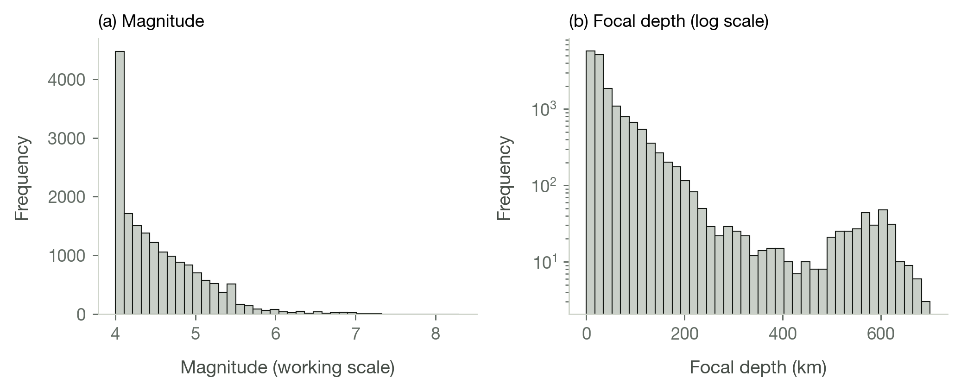
Note. N = 17,667 events.

Figure 2
Epicentral Distribution of Catalogued Earthquakes
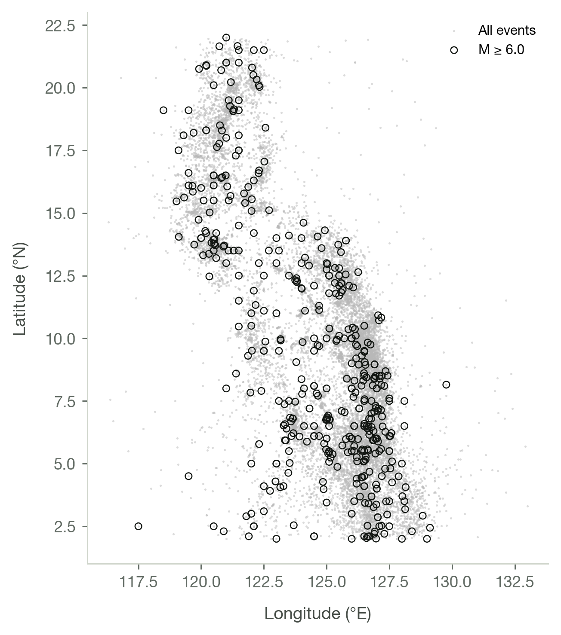
Note. Open circles mark events of M ≥ 6.0.

Figure 3
Frequency–Magnitude Distribution and the Gutenberg–Richter Fit
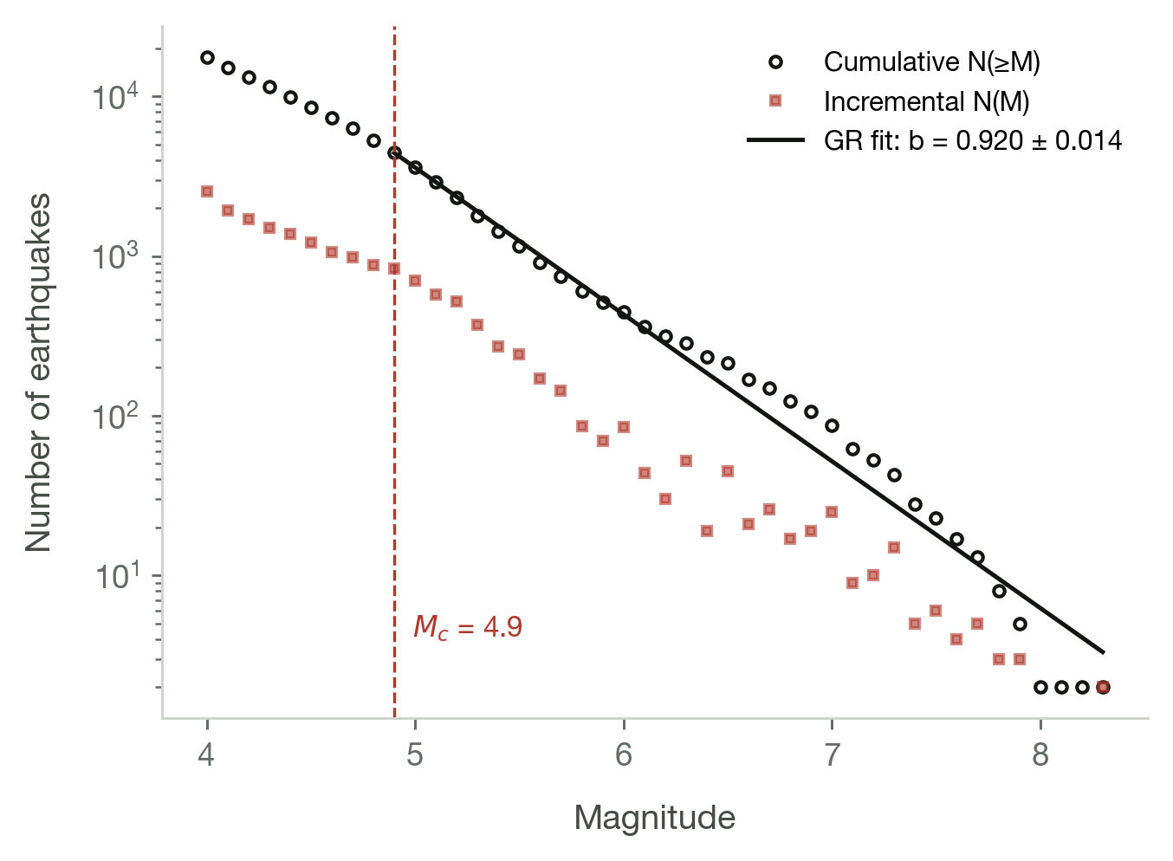
Note. The fitted line uses the Aki–Utsu maximum-likelihood b-value above Mc.

Figure 4
Annual Recorded Seismicity and Annual Maximum Magnitude
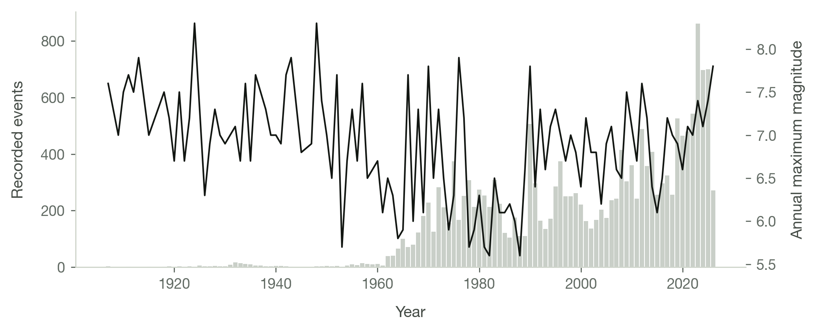
Note. Bars are event counts (left axis); the line is the annual maximum magnitude (right axis).

Figure 5
Distribution of Validation RMSE Across Rolling-Origin Folds
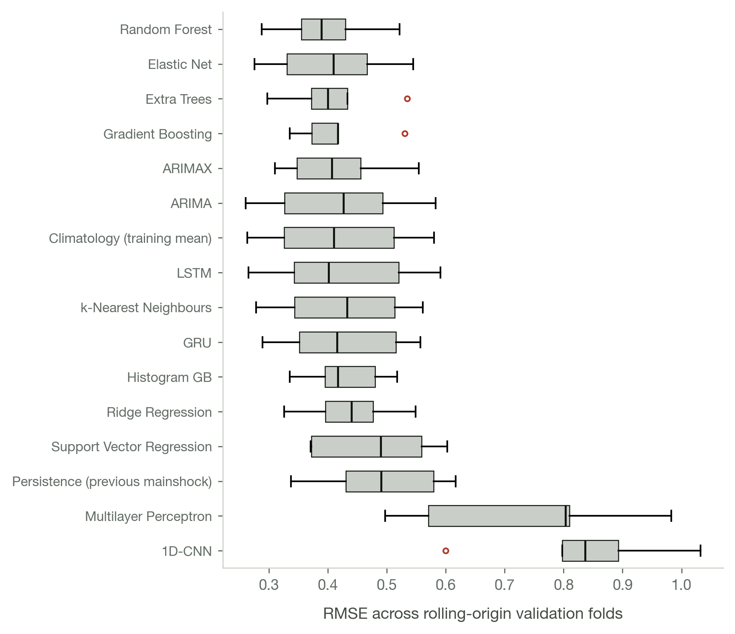
Note. Models ordered by mean RMSE. The width of each box is the model's instability across folds, which a single test score cannot show.

Figure 6
Test-Partition RMSE for All 16 Models
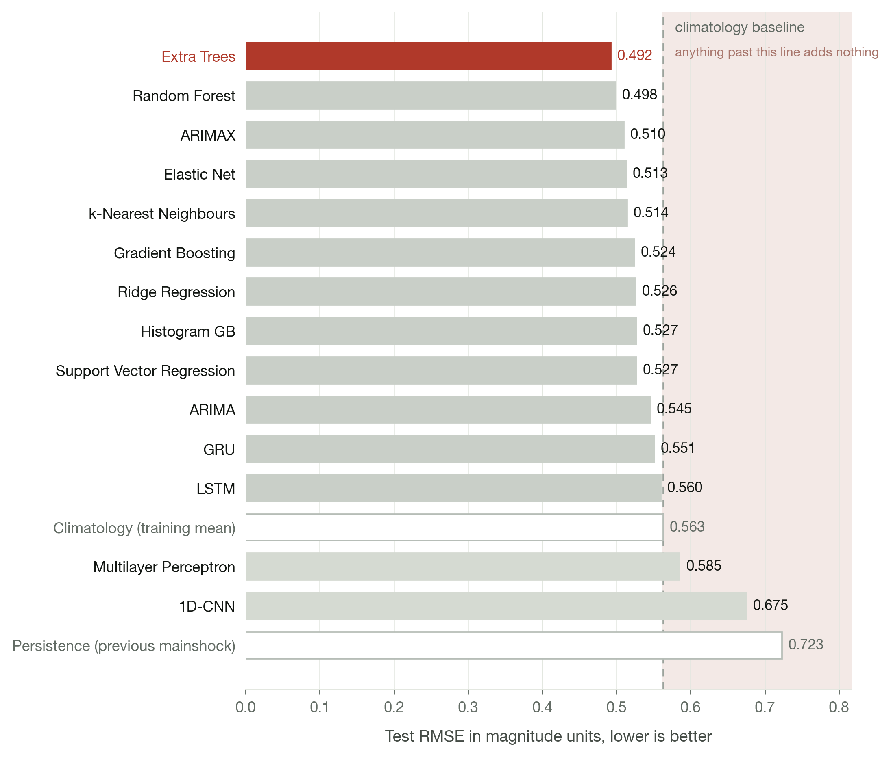
Note. The dashed line marks the climatology baseline; any bar to its right is a model that fails to beat the historical average.

Figure 7
Validation Learning Curves for the Three Sequence Networks
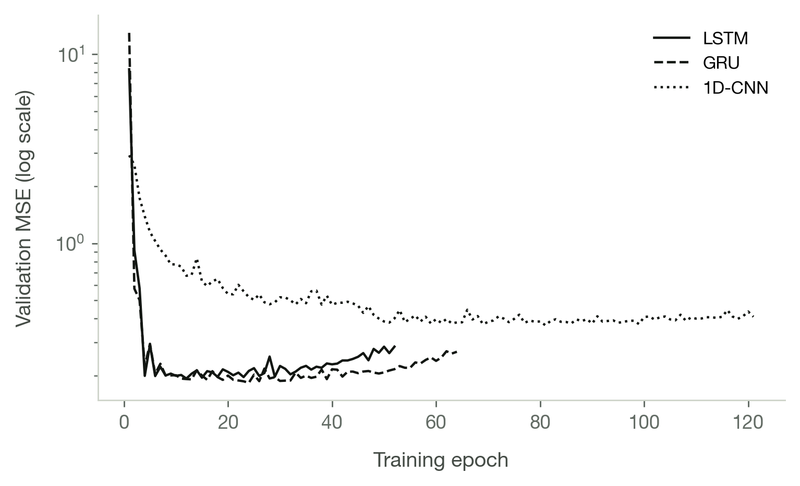
Note. Early stopping restores the weights at each curve's minimum.

Figure 8
Permutation Feature Importance for the Random Forest Model
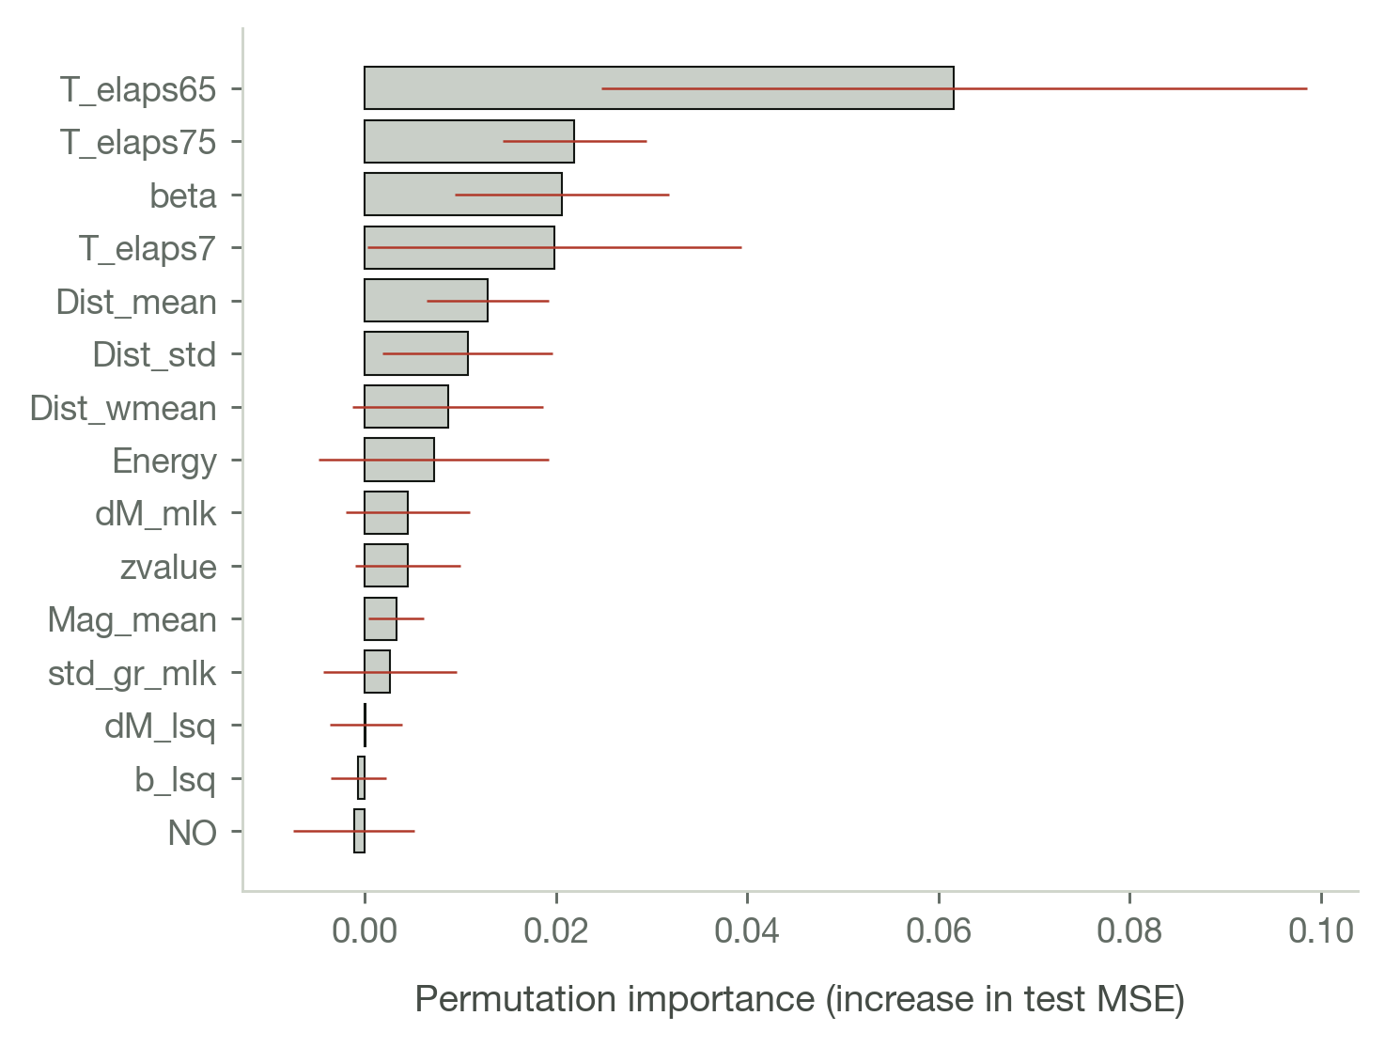
Note. Error bars are ±1 SD over 20 permutation repeats on the test partition.

Figure 9
Forecast Versus Observed Mainshock Magnitude for the Three Leading Models
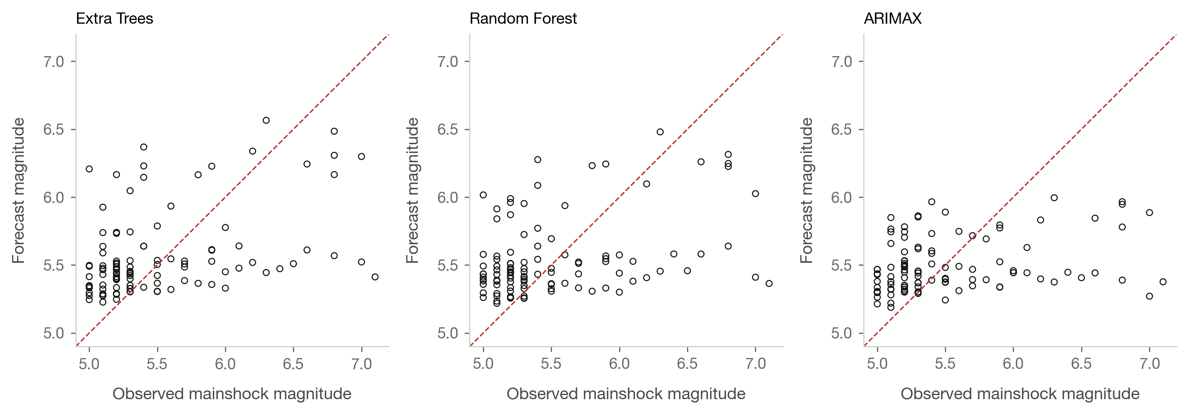
Note. The dashed line is perfect agreement.

Figure 10
Residuals Against Forecast Magnitude
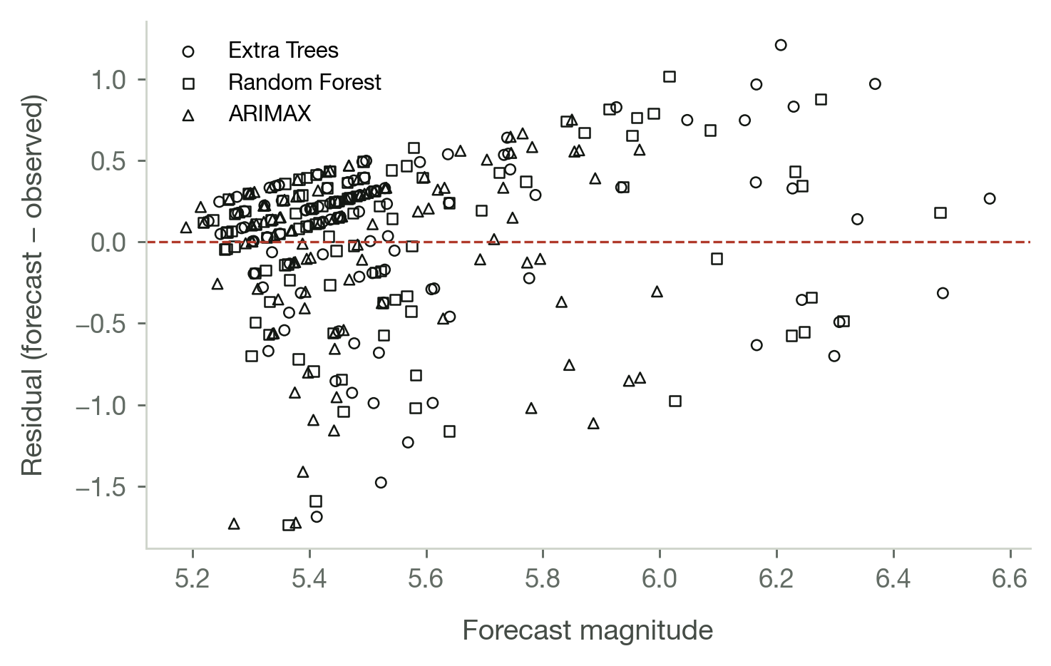

Figure 11
Confusion Matrix for Magnitude-Class Forecasts
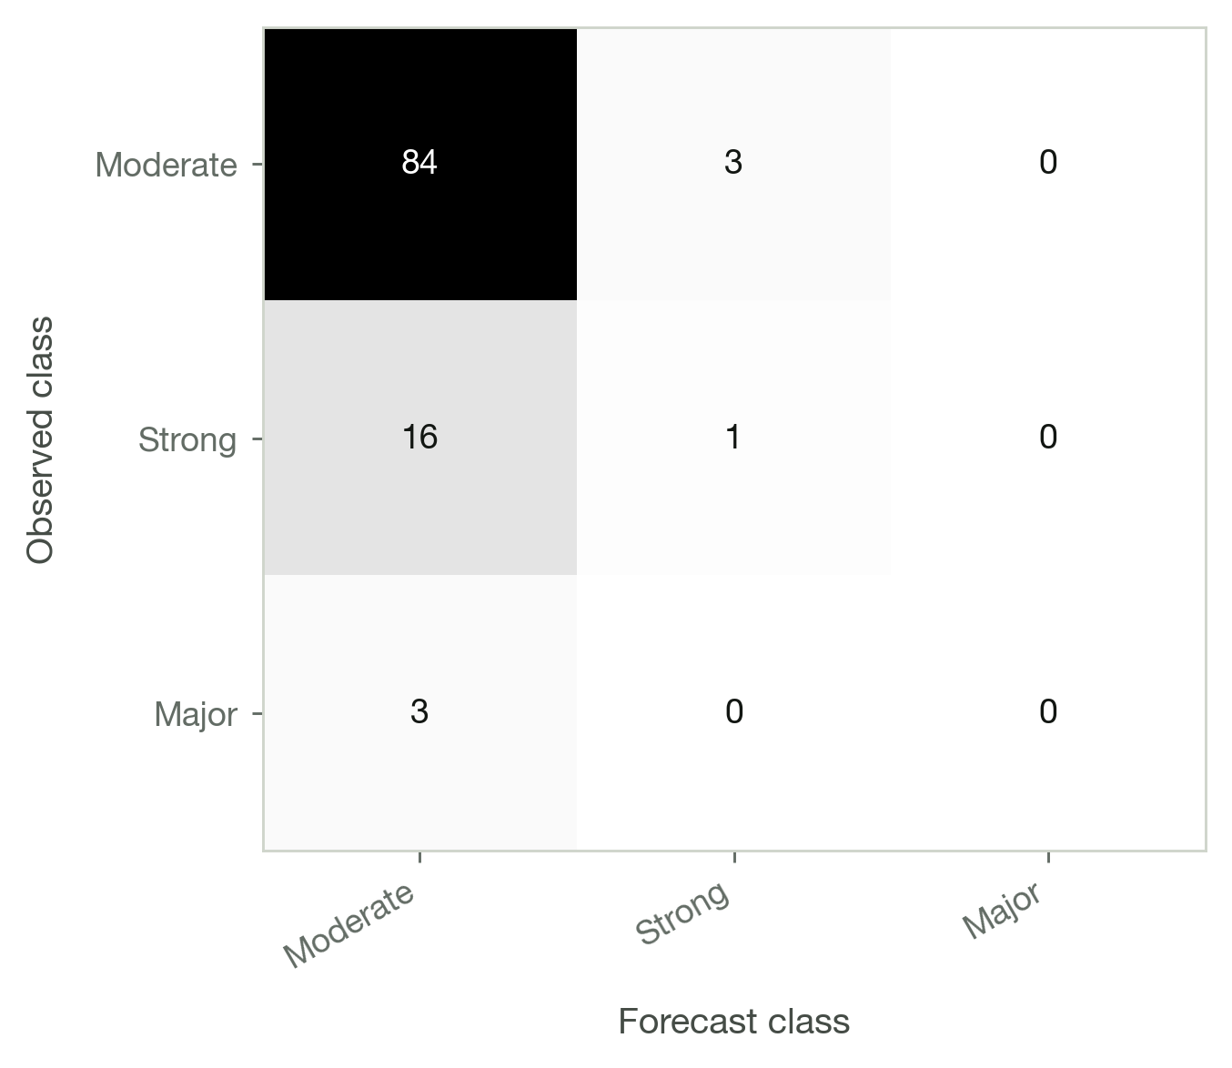
List of Tables
Table 1. Profile of the PHIVOLCS Earthquake Catalogue After Cleaning
Table 2. Data-Cleaning Audit Trail
Table 3. Availability and Distribution of the Four Reported Magnitude Scales
Table 4. Co-Reporting of Magnitude Scales Within the Catalogue
Table 5. Orthogonal Regression Relations Between Magnitude Scales
Table 6. Distance to the Nearest Active Fault, and Its Verification
Table 7. Descriptive Statistics for the Principal Seismic Parameters
Table 8. Frequency Distribution of Events by Magnitude Class
Table 9. Recorded Seismicity by Decade
Table 10. Frequency Distribution of Events by Hypocentral Depth Class
Table 11. Cross-Tabulation of Magnitude Class by Hypocentral Depth Class
Table 12. Tests of Normality for the Seismic Parameters
Table 13. Pearson Correlation Matrix for the Seismic Parameters
Table 14. Pairwise Associations Among the Seismic Parameters
Table 15. Magnitude by Depth Class: Group Descriptive Statistics
Table 16. Omnibus Tests of Magnitude Differences Across Depth Classes
Table 17. Dunn's Post Hoc Comparisons of Magnitude Across Depth Classes
Table 18. Chi-Square Test of Independence: Magnitude Class by Depth Class
Table 19. Standardised Residuals for the Magnitude-by-Depth Cross-Tabulation
Table 20. Mann–Kendall Trend Tests on the Annual Seismicity Series
Table 21. Comparison of Recorded Magnitudes Before and After 1980
Table 22. Completeness Magnitude and Gutenberg–Richter Parameters for the Full Catalogue
Table 23. Gutenberg–Richter Parameters by Decade, 1980 to Present
Table 24. Gutenberg–Richter Parameters by Hypocentral Depth Class
Table 25. Space–Time Windows Implied by Maeda's Method
Table 26. Outcome of Maeda's Declustering Procedure
Table 27. Catalogue Descriptive Statistics Before and After Declustering
Table 28. Gutenberg–Richter Parameters for the Declustered Catalogue
Table 29. The 27 Engineered Seismic Features
Table 30. Construction of the Forecast Sequence Data Set
Table 31. Descriptive Statistics for the 27 Engineered Features
Table 32. Correlations Between Each Engineered Feature and the Mainshock Magnitude
Table 33. Construction of the Occurrence Data Set
Table 34. Does the Model Beat the Historical Rate? Rolling-Origin Scores
Table 35. Probability of Occurrence With 95% Confidence Intervals
Table 36. Chronological 60:20:20 Partitioning of the Sequence Data Set
Table 37. Magnitude-Class Distribution Across the Three Partitions
Table 38. Random Forest Hyperparameter Search (Top 12 Configurations)
Table 39. Inventory of the Forecasting Models Compared
Table 40. Rolling-Origin Cross-Validation Results Across All Models
Table 41. Friedman Test for Differences Among the Models
Table 42. Mean Ranks and Nemenyi Post Hoc Comparison Against the Leading Model
Table 43. Test-Partition Leaderboard for All 16 Models
Table 44. Diebold–Mariano Comparisons Among the Five Leading Models
Table 45. Regression Performance Across the Three Partitions for the Two Headline Models
Table 46. Training Outcome of the Three Sequence Networks
Table 47. Statistical Comparison of the Two Headline Models on the Test Partition
Table 48. Random Forest Feature Importance for Mainshock Magnitude
Table 49. Confusion Matrix for Magnitude-Class Forecasts on the Test Partition
Table 50. Per-Class Precision, Recall and F1-Score on the Test Partition
Table 51. Overall Classification Agreement, Including Cohen's Weighted Kappa
Table 52. Threshold-Free Probabilistic Skill for the M ≥ 6.0 Forecast
Table 53. Operational Skill of the Forecast Treated as an M ≥ 6.0 Alarm
Table 54. Residual Diagnostics for the Three Leading Models

