CHAPTER 4
RESULTS AND DISCUSSION
This chapter reports what the data set supports and, where it supports less than the objectives hoped for, says so. Every figure quoted here is produced by the analysis pipeline and carried into this document unchanged; the full statistical appendix, with all 62 tables in the order the analysis computes them, accompanies this chapter as a separate document.
Discussion 1: Data Preprocessing and Foreshock Identification
Application of Maeda's Method for Foreshock Selection
The PHIVOLCS catalogue retrieved for this study contains 18,338 records covering 1907 to 2026. A catalogue is not a data set until the decisions taken on it are written down, so every record removed is removed by a stated rule and counted.

Table 1
Data-Cleaning Audit Trail
Step | Records before | Removed | Records retained | Note
Records extracted from workbook | 18338 | 0 | 18338 | Banner and repeated header rows removed
Valid origin date/time | 18338 | 0 | 18338 | Year/month/day must form a real calendar date
Epicentre inside study region | 18338 | 0 | 18338 | lat 0.0-25.0, lon 110.0-140.0
Hypocentral depth in range | 18338 | 0 | 18338 | 0-750 km
At least one reported magnitude | 18338 | 0 | 18338 | Ml, mb, Ms or Mw present
Working magnitude in range | 18338 | 0 | 18338 | policy = 'hierarchy', preference Mw > Ms > Mb > Ml
Nearest active fault recorded | 18338 | 0 | 18338 | Source coordinates and distance present and non-negative
Duplicate origins collapsed | 18338 | 671 | 17667 | within 1 s and 1 km
Note. Rules were applied in the order shown. A record removed by an earlier rule is not re-tested by a later one, so the counts sum to the retained total. 671 records were one earthquake reported twice, within one second and one kilometre of another record.
Of the four magnitudes PHIVOLCS may report for one earthquake, one has to be adopted as the working value. They measure different quantities and saturate at different sizes, so they are not interchangeable. The rule is a fixed preference applied without inspecting the value, which means the choice cannot bend toward a convenient number.

Table 2
Rule for Selecting the Working Magnitude From the Four Reported Scales
Preference rank | Scale | Measures | Events reporting it | Events where it was adopted | % of catalogue adopted
1 | Mw | Moment magnitude, derived from seismic moment; saturates at no upper limit | 905 | 905 | 5.122544857644195
2 | Ms | Surface-wave magnitude; saturates above about M 8 | 11899 | 11830 | 66.96100073583517
3 | Mb | Body-wave magnitude; saturates above about M 6.5 | 6824 | 1730 | 9.792268070413764
4 | Ml | Local or Richter magnitude; saturates above about M 7 | 8288 | 3202 | 18.124186336106867
Note. The first scale in this order that a record populates becomes its working magnitude. The order follows saturation behaviour: moment magnitude holds its linearity at every size, body-wave magnitude saturates above about M 6.5.
Declustering separates independent earthquakes from the events that belong to another earthquake's sequence. An aftershock is not a warning; it is the crust settling after something that has already happened, and a model trained on aftershocks learns to forecast the past. Maeda's method, as set out in Equations 1 to 3 of Hirose et al. (2021), draws a window in space and time around every event and classifies anything inside it and at least one magnitude unit smaller as dependent.

Table 3
Spatial and Temporal Windows From Maeda's Method
Precursor magnitude (Mpre) | Spatial window L (km) | Temporal window ta (days) | Magnitude cut-off (Mpre − Md)
4.0 | 1.5848931924611134 | 1.0513543089324358 | 3.0
5.0 | 5.011872336272722 | 5.789973244419449 | 4.0
6.0 | 15.848931924611133 | 27.14489278096424 | 5.0
7.0 | 50.11872336272722 | 123.38233972929832 | 6.0
8.0 | 158.48931924611142 | 557.0831635270143 | 7.0
Note. Windows follow Equations 1 and 2 of Hirose et al. (2021): log L = 0.5 Mpre − 1.8 and log(ta + 0.3) = (0.17 + 0.85(Mpre − 4))/1.3. An event inside the window of an earlier event and at least 1.0 magnitude unit smaller (Equation 3) is dependent. The windows widen steeply with magnitude: 5 km at M 5.0, 50 km at M 7.0.

Table 4
Outcome of Maeda's Declustering Procedure
Declustering stage | n | % of input
Events entering Maeda's method | 17667 | 100.0
Dependent events removed (Eq. 1–3) | 2207 | 12.492217127978718
Independent events retained | 15460 | 87.50778287202128
Retained events M ≥ 5.0 | 3261 | 18.458142299201903
Retained events M ≥ 6.0 | 431 | 2.439576611762042
Retained events M ≥ 7.0 | 86 | 0.4867832682402219
Note. 2,207 of the 17,667 cleaned records are dependent by this test, one event in eight. Those are the swarm members and aftershocks that would otherwise be read as precursory activity.

Table 5
Catalogue Descriptive Statistics Before and After Declustering
Catalogue | N | M | SD | Mdn | Min | Max | n (M ≥ 5.0) | n (M ≥ 6.0) | Mdn depth (km)
Full catalogue | 17667 | 4.569366615724231 | 0.5478311245639224 | 4.4 | 4.0 | 8.3 | 3607 | 445 | 33.0
Declustered catalogue | 15460 | 4.579197930142303 | 0.5606861684719737 | 4.4 | 4.0 | 8.3 | 3261 | 431 | 33.0
Note. Removing dependent events raises the mean magnitude, because the removed population is by construction the small one. This is the before-and-after comparison of the method.

Figure 1
From Raw Records to Forecast Sequences
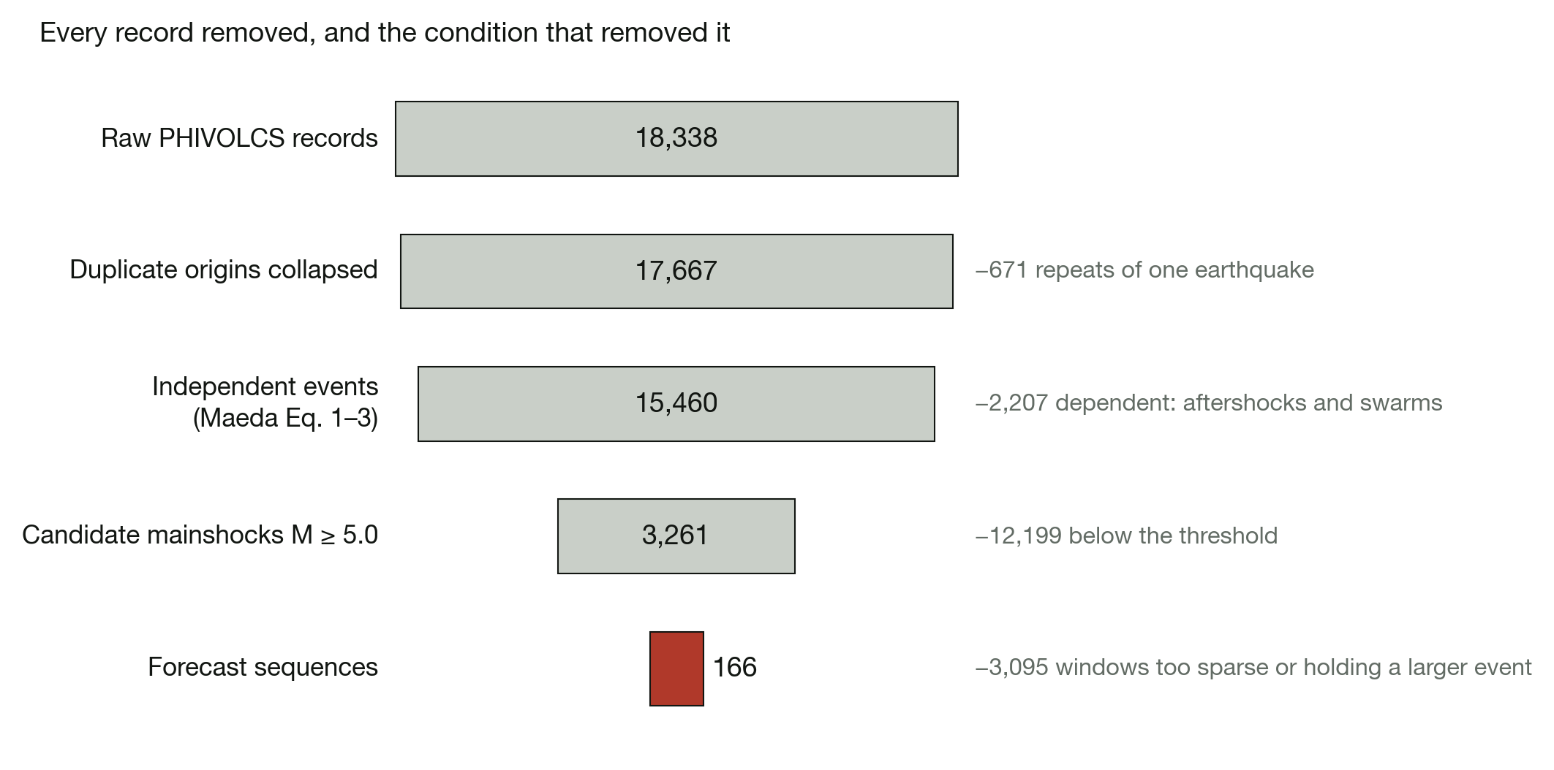
Note. Bar width is on a square-root scale, because the last stage is a hundredth of the first; the printed counts are the measurement. Each step names the condition that removed what it removed.

Table 6
Construction of the Forecast Sequence Data Set
Quantity | Value
Candidate mainshocks (independent, M ≥ 5.0) | 3,261
Rejected: window opens before the catalogue starts | 1
Rejected: fewer than 3 events in the observation window | 2,470
Rejected: window holds an earthquake as large as the mainshock | 624
Forecast sequences retained | 166
Largest foreshock relative to the mainshock | always smaller, by at least 0.1 and a median of 0.50
Observation window | 14 days, 100 km radius
Period covered | Aug 1968 – Jan 2026
Target magnitude, M (SD) | 5.586 (0.528)
Target magnitude range | 5.0 – 7.3
Median foreshocks per window | 4
Sequences with an M ≥ 6.0 target | 35
Sequences with an M ≥ 7.0 target | 5
Note. A mainshock qualifies at M 5.0 or above, must be independent under Maeda's method, must have at least three catalogued events inside a 14-day, 100-km observation window, and must be strictly larger than every one of them, which is what the word mainshock means. 624 windows were rejected on that last condition alone.

Table 7
Verification That Every Mainshock Exceeds Its Own Foreshocks
Quantity | Value
Sequences analysed | 535
Mainshock smaller than the largest event in its window | 336 (62.8%)
Mainshock equal to the largest event in its window | 33 (6.2%)
Mainshock larger than the largest event in its window | 166 (31.0%)
Median difference (mainshock − largest event) | -0.30
Central 90% of that difference | -1.30 to +1.20
Pearson r between the two magnitudes | 0.173
Windows whose largest event already reached M 5.0 | 448 (83.7%)
Note. Computed on the retained sequences. The smallest gap between a mainshock and the largest event preceding it is 0.1 magnitude units and the median is 0.50.

Figure 2
Sequences Rejected by the Mainshock-Is-Largest Rule
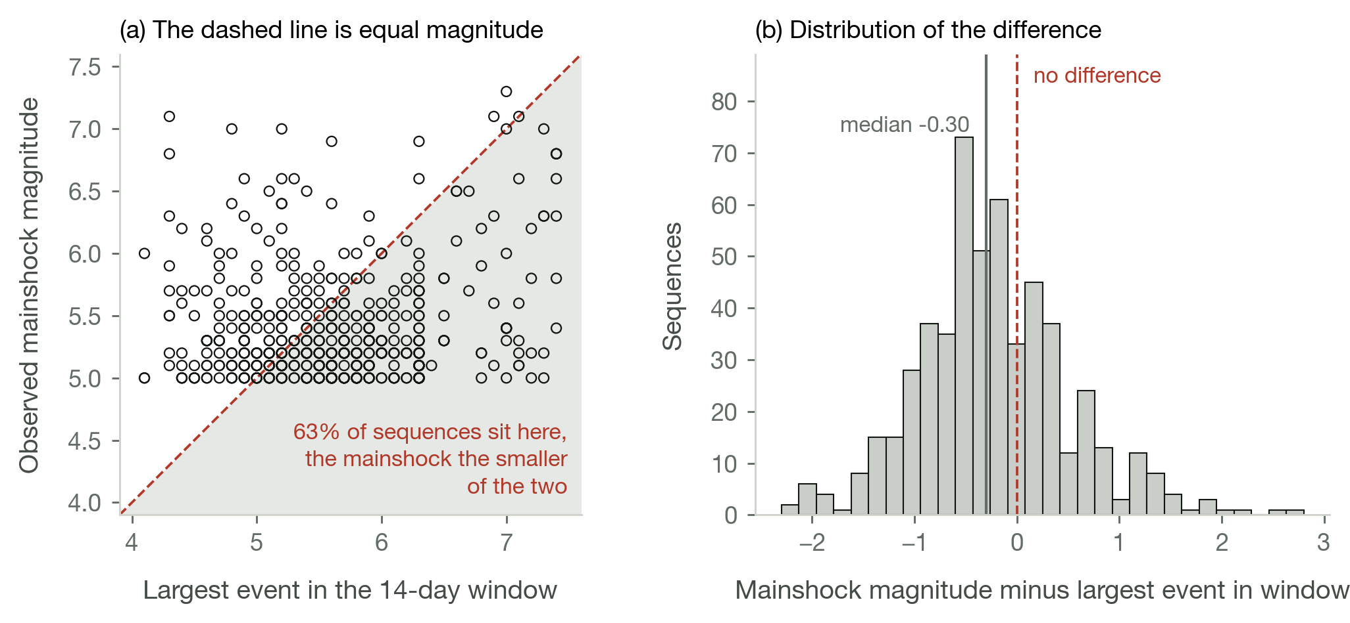
Note. Built without the rule, to show what it removes. Panel (a) plots the two magnitudes against each other; every point in the shaded half is a window that held an earthquake larger than the mainshock it was supposed to precede. Panel (b) is the distribution of the difference.
Feature Extraction and Parameter Identification
Twenty-seven features are computed from each observation window. Twenty-two follow Wang et al. (2023) as tabulated in the methodology: event counts, maximum and mean magnitude, Gutenberg-Richter a and b values by two estimators with their standard deviations, magnitude deficits, released energy, two probability-of-occurrence terms, the seismic rate change statistics z and beta, and four counts of days since the last regional earthquake above a threshold. Five more summarise the distance from the foreshocks to the nearest mapped active fault, a parameter the data collection names but does not tabulate.

Table 8
The 27 Engineered Seismic Features
# | Feature | Category | Description
1 | NO | Basic statistics | Number of earthquakes in the observation window
2 | Mag_max | Basic statistics | Maximum magnitude in the observation window
3 | Mag_mean | Basic statistics | Mean magnitude in the observation window
4 | b_lsq | Gutenberg–Richter law | b-value by least-squares regression
5 | a_lsq | Gutenberg–Richter law | a-value by least-squares regression
6 | b_std_lsq | Gutenberg–Richter law | Standard deviation of b_lsq
7 | std_gr_lsq | Gutenberg–Richter law | Deviation from the Gutenberg–Richter law (LSQ)
8 | b_mlk | Gutenberg–Richter law | b-value by maximum likelihood (Aki–Utsu)
9 | a_mlk | Gutenberg–Richter law | a-value by maximum likelihood
10 | b_std_mlk | Gutenberg–Richter law | Standard deviation of b_mlk
11 | std_gr_mlk | Gutenberg–Richter law | Deviation from the Gutenberg–Richter law (MLE)
12 | dM_lsq | Energy and magnitude deficit | Magnitude deficit from a_lsq and b_lsq
13 | dM_mlk | Energy and magnitude deficit | Magnitude deficit from a_mlk and b_mlk
14 | Energy | Energy and magnitude deficit | Square root of the summed seismic energy release
15 | x7_lsq | Activity-rate change and probability | Probability of occurrence derived from b_lsq
16 | x7_mlk | Activity-rate change and probability | Probability of occurrence derived from b_mlk
17 | zvalue | Activity-rate change and probability | Seismic rate change (z statistic)
18 | beta | Activity-rate change and probability | Seismic rate change (β statistic)
19 | T_elaps6 | Time elapsed | Days since the last M 6.0 earthquake
20 | T_elaps65 | Time elapsed | Days since the last M 6.5 earthquake
21 | T_elaps7 | Time elapsed | Days since the last M 7.0 earthquake
22 | T_elaps75 | Time elapsed | Days since the last M 7.5 earthquake
23 | Dist_min | Distance to nearest fault | Closest approach to an active fault in the observation window
24 | Dist_mean | Distance to nearest fault | Mean distance to the nearest active fault
25 | Dist_std | Distance to nearest fault | Standard deviation of the fault distances
26 | Dist_wmean | Distance to nearest fault | Fault distance weighted by released energy
27 | Dist_trend | Distance to nearest fault | Change in fault distance across the window, km per day
Note. Every feature is computed from the events inside the observation window: 14 days and 100 km preceding the mainshock. The mainshock's own properties are excluded throughout, being what is under forecast.

Table 9
Univariate Association of Each Feature With the Mainshock Magnitude
Feature | n | Pearson r | p (r) | Spearman ρ | p (ρ) | Strength
Mag_max | 166 | 0.4581046131594056 | 5.435992276930152e-10 | 0.4136242855440226 | 3.042261493517692e-08 | Medium
Energy | 166 | 0.4400434970931922 | 2.9889711890190403e-09 | 0.3552952542110837 | 2.6369235118796462e-06 | Medium
dM_mlk | 154 | 0.3451310253015222 | 1.1677253511712657e-05 | 0.2616828187860208 | 0.0010444988590032 | Medium
x7_mlk | 154 | 0.3148011368080936 | 6.998727338979266e-05 | 0.2318685043720499 | 0.0038096247862013 | Medium
Mag_mean | 166 | 0.2469542210754193 | 0.0013386185719285 | 0.2544814741297607 | 0.0009375278803452 | Small
T_elaps75 | 166 | 0.1982881766857252 | 0.0104389239234894 | 0.1739960704200759 | 0.024963145085007 | Small
NO | 166 | 0.1776921868536924 | 0.0220003386666055 | 0.0308410276023544 | 0.6932487419729687 | Small
b_lsq | 153 | -0.1410697021141572 | 0.0819758614670603 | -0.1878269706861038 | 0.0200735356450635 | Small
b_std_mlk | 154 | -0.1382851523462743 | 0.0872068642318352 | -0.1926427597908274 | 0.0166829543500333 | Small
b_std_lsq | 153 | -0.1349888370120191 | 0.0961823479106147 | -0.1870435317184902 | 0.0206075855281193 | Small
b_mlk | 154 | -0.1328033121616918 | 0.1006108313937298 | -0.2318685043720499 | 0.0038096247862013 | Small
beta | 166 | 0.1230370008550801 | 0.1142790176310425 | 0.0462766304382475 | 0.5538206882566146 | Small
a_mlk | 154 | -0.1229570599336742 | 0.1287131950519107 | -0.1946894266702516 | 0.0155398535043342 | Small
a_lsq | 153 | -0.1219672668000718 | 0.1331248411399701 | -0.1583723554230353 | 0.0505534769365987 | Small
Dist_std | 166 | -0.1123960568049856 | 0.1493723655203094 | -0.1100118203233608 | 0.1582507425677645 | Small
x7_lsq | 153 | 0.0800597317574286 | 0.3252417965405128 | 0.1878269706861038 | 0.0200735356450635 | Negligible
std_gr_lsq | 153 | 0.0723732336399876 | 0.3739855640043295 | 0.0562488265526751 | 0.4898164430309329 | Negligible
Dist_trend | 166 | 0.0712764888937101 | 0.3614764242626955 | 0.02737854306317 | 0.7262276115544573 | Negligible
std_gr_mlk | 154 | 0.0594806852820815 | 0.4636980124659071 | 0.1037072639574323 | 0.2005655050340868 | Negligible
T_elaps65 | 166 | 0.027220553694999 | 0.7277450152742071 | -0.0973238651550593 | 0.2122440104337778 | Negligible
T_elaps6 | 166 | 0.0182300064930033 | 0.8156668541627381 | -0.1671611497998695 | 0.031348857942403 | Negligible
dM_lsq | 150 | 0.0164725195254507 | 0.8414241071005009 | 0.1746456807712581 | 0.0325551968821309 | Negligible
Dist_wmean | 166 | -0.0161405484970992 | 0.8364796613695843 | -0.0755213860490327 | 0.3335168604194529 | Negligible
zvalue | 166 | 0.0152618472933256 | 0.8452671670880474 | -0.028920948576306 | 0.7114703368616613 | Negligible
Dist_min | 166 | 0.0125908268694309 | 0.872091797081975 | 0.0026594153240685 | 0.9728729107191074 | Negligible
T_elaps7 | 166 | 0.0105399931195787 | 0.8927890489702172 | -0.0743557835623155 | 0.3410528754712302 | Negligible
Dist_mean | 166 | 0.0004336083734159 | 0.9955762007470011 | -0.0482389496238513 | 0.5371170209415896 | Negligible
Note. Pearson and Spearman coefficients against the target. No single feature is strongly associated with the outcome, which is the first indication of how much signal the window actually contains.

Table 10
Random Forest Feature Importance for Mainshock Magnitude
Rank | Feature | Impurity importance | Permutation importance | SD (permutation) | Cumulative impurity %
1 | T_elaps7 | 0.0391676057901012 | 0.0373740434047344 | 0.0336798710972173 | 3.9167605790101208
2 | Energy | 0.1046924995663177 | 0.0282970379277701 | 0.0262397588682684 | 14.386010535641894
3 | Mag_mean | 0.0343997145817616 | 0.0276860693526711 | 0.0112506293563439 | 17.82598199381806
4 | Dist_mean | 0.0312618533323198 | 0.0142046378995267 | 0.0130294089209331 | 20.952167327050045
5 | T_elaps75 | 0.0201092593906992 | 0.0104814725873043 | 0.0144964241069457 | 22.96309326611997
6 | T_elaps6 | 0.0567763995778805 | 0.0092690009958439 | 0.0059588886308991 | 28.640733223908025
7 | zvalue | 0.0221151096244969 | 0.0070252031990052 | 0.0040295107581159 | 30.85224418635772
8 | Mag_max | 0.1388441929426155 | 0.0069263481500661 | 0.0437817427847382 | 44.73666348061927
9 | dM_mlk | 0.0416662276610748 | 0.0066255907208276 | 0.0101315365917273 | 48.903286246726765
10 | b_lsq | 0.0197510285865692 | 0.0038828647987843 | 0.0047387692752859 | 50.87838910538369
11 | x7_lsq | 0.022323623582123 | 0.0032096161036771 | 0.0055413455187948 | 53.110751463596
12 | NO | 0.0211946390663347 | 0.0025446885575942 | 0.0043413837793833 | 55.23021537022947
13 | T_elaps65 | 0.0423711925572539 | 0.0024356727524132 | 0.0065793199020151 | 59.46733462595487
14 | Dist_wmean | 0.040069180387259 | 0.0023423157629372 | 0.0154163754373765 | 63.474252664680776
15 | a_lsq | 0.0229924026967527 | 0.0011851527432852 | 0.0056752439886692 | 65.77349293435604
16 | beta | 0.0238888495089518 | 0.0007442432930691 | 0.0104064421150701 | 68.16237788525123
17 | Dist_min | 0.0204821973638734 | -0.0001588485978868 | 0.0062138646113037 | 70.21059762163858
18 | b_std_lsq | 0.0219897446113713 | -0.0040501575398178 | 0.0037484913949111 | 72.40957208277572
19 | Dist_trend | 0.0265049932948607 | -0.0056053601647972 | 0.0070422147842454 | 75.06007141226178
20 | x7_mlk | 0.0263163135742204 | -0.0061188973622267 | 0.004990830488535 | 77.69170276968381
21 | b_mlk | 0.0256174038691137 | -0.0067891154942548 | 0.0052968020996781 | 80.25344315659518
22 | b_std_mlk | 0.0508258084178094 | -0.0072521377883057 | 0.0094389058925169 | 85.33602399837613
23 | std_gr_lsq | 0.0204144201540007 | -0.0075956455971531 | 0.0051669842433201 | 87.3774660137762
24 | a_mlk | 0.0187342858790949 | -0.0081837683172761 | 0.0073361093088909 | 89.2508946016857
25 | dM_lsq | 0.0382823499776441 | -0.0085013393569566 | 0.008638249428592 | 93.07912959945013
26 | std_gr_mlk | 0.0244486345324435 | -0.0089648029312925 | 0.0064727394283123 | 95.5239930526945
27 | Dist_std | 0.0447600694730548 | -0.0338501061354004 | 0.0315953120050565 | 99.99999999999996
Note. Impurity importance is the model's built-in metric and is biased toward high-cardinality continuous features. Permutation importance is measured on the held-out test partition and is the more trustworthy ranking.

Figure 3
Permutation Feature Importance for the Random Forest Model
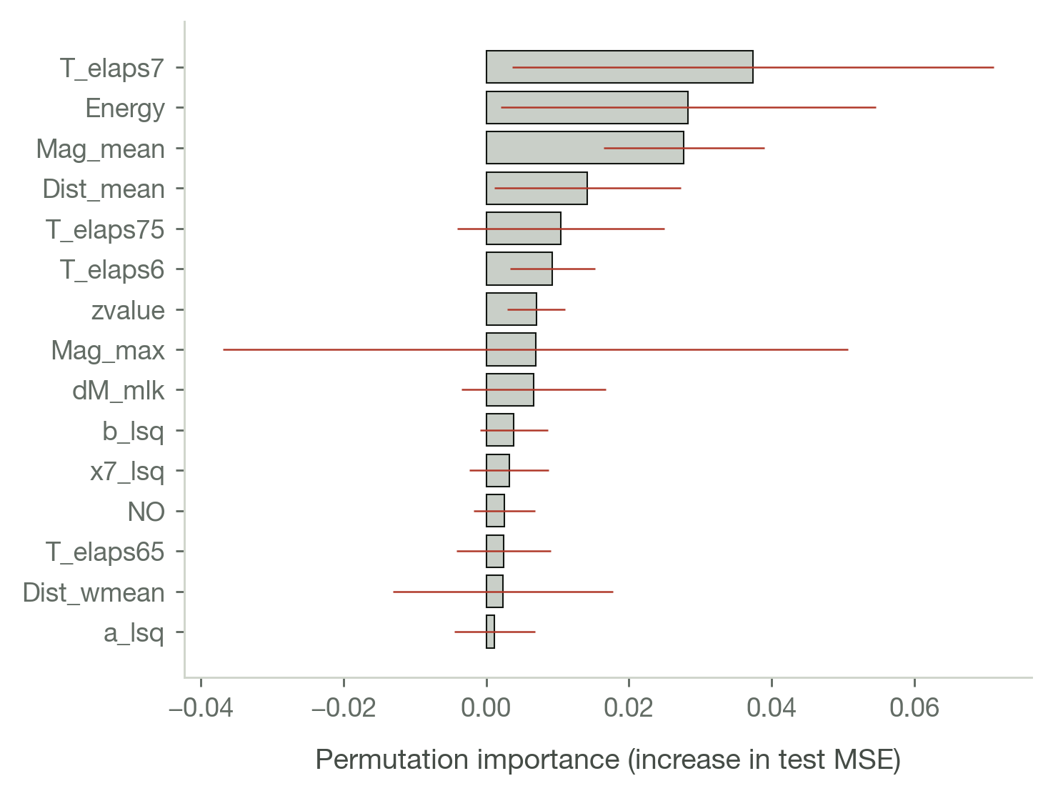
Note. Error bars are ±1 SD over 20 permutation repeats on the test partition.

Table 11
Correlation Matrix for the Seismic Parameters
Variable | 1 | 2 | 3 | 4
1. Magnitude | — | nan | nan | nan
2. Depth | .122*** | — | nan | nan
3. Latitude | -.031*** | -.241*** | — | nan
4. Longitude | -.010 | .028*** | -.728*** | —
Note. * p < .05. ** p < .01. *** p < .001. Leading zeros omitted. With N in the tens of thousands nearly every association reaches significance; the coefficient, not the p value, carries the practical meaning.
Discussion 2: Machine Learning Model Development and Performance
Model Training and Hyperparameter Tuning
The 166 sequences are split strictly by time, 60:20:20. Every validation sequence postdates every training sequence and every test sequence postdates both. A random shuffle would let a model learn from the future of its own test set, which is the most common way a seismic forecasting result turns out to be an artefact. Imputation, winsorising and scaling are refitted inside each fold from that fold's training rows alone, so no statistic of the test data reaches the model.

Table 12
Chronological 60:20:20 Partitioning of the Sequence Data Set
Partition | n sequences | % of total | Period covered | M (target) | SD | Min | Max | n (M ≥ 6.0)
Training | 100 | 60.24096385542169 | Aug 1968 – Feb 2012 | 5.551000000000001 | 0.5186413875587725 | 5.0 | 7.3 | 18
Validation | 33 | 19.879518072289155 | Feb 2012 – Jun 2021 | 5.642424242424243 | 0.4930962780167169 | 5.0 | 6.6 | 9
Test | 33 | 19.879518072289155 | Jun 2021 – Jan 2026 | 5.633333333333334 | 0.5951190357119042 | 5.0 | 7.1 | 8
Note. Partitions are contiguous in time. The periods do not overlap.

Table 13
Magnitude-Class Distribution Across the Three Partitions
Magnitude class | Training f | Training % | Validation f | Validation % | Test f | Test %
Moderate (5.0-5.9) | 82 | 82.0 | 24 | 72.72727272727273 | 25 | 75.75757575757575
Strong (6.0-6.9) | 15 | 15.0 | 9 | 27.272727272727277 | 6 | 18.181818181818183
Major (>=7.0) | 3 | 3.0 | 0 | 0.0 | 2 | 6.0606060606060606
Note. Major events are rare in every partition, which is why Cohen's kappa rather than raw accuracy is the headline agreement statistic for the classification view of this task.

Table 14
Random Forest Hyperparameter Search, Leading Configurations
n_estimators | max_depth | min_samples_leaf | max_features | Validation RMSE
600 | 16.0 | 1 | sqrt | 0.4187621191244814
600 | nan | 1 | sqrt | 0.4188781162374444
300 | 16.0 | 1 | sqrt | 0.4209208042269591
300 | nan | 1 | sqrt | 0.4209506317175858
600 | 16.0 | 1 | 0.5 | 0.4223758150327532
600 | nan | 1 | 0.5 | 0.4224190626358118
600 | 8.0 | 1 | 0.5 | 0.4259535149553062
600 | 8.0 | 1 | sqrt | 0.4262912248261283
300 | 16.0 | 1 | 0.5 | 0.428363603851188
300 | nan | 1 | 0.5 | 0.428363603851188
300 | 8.0 | 1 | sqrt | 0.4287105287385793
300 | 8.0 | 1 | 0.5 | 0.4302364256014935
Note. Ranked by root mean squared error on the validation partition. The search is scored on the held-out development set rather than by k-fold cross-validation, which would shuffle the time ordering back together.

Table 15
Inventory of the Forecasting Models Compared
Model | Family | Input representation | Key settings
Climatology (training mean) | Baseline | None (constant) | Predicts the training-set mean for every sequence
Persistence (previous mainshock) | Baseline | Previous target | Reuses the magnitude of the preceding mainshock
Random Forest | Tree ensemble (bagging) | 27 engineered features | n_estimators=600, max_depth=16, min_samples_leaf=1, max_features=sqrt
Extra Trees | Tree ensemble (bagging) | 27 engineered features | n_estimators=200, max_depth=10, fully randomised splits
Gradient Boosting | Tree ensemble (boosting) | 27 engineered features | n_estimators=400, lr=0.05, max_depth=3, subsample=0.8
Histogram GB | Tree ensemble (boosting) | 27 engineered features | max_iter=400, lr=0.05, max_depth=6
Support Vector Regression | Kernel method | 27 engineered features | RBF kernel, C=10, ε=0.05, standardised inputs
k-Nearest Neighbours | Instance based | 27 engineered features | k=10, distance weighting, standardised inputs
Elastic Net | Regularised linear | 27 engineered features | α=0.05, L1 ratio=0.5
Ridge Regression | Regularised linear | 27 engineered features | α=5.0
Multilayer Perceptron | Feed-forward network | 27 engineered features | hidden=(64, 32), α=1.0, early stopping on a 20% inner split
LSTM | Recurrent network | 10 × 5 event stream | 32 units, Adam (lr=0.01), early stopping (patience 40)
GRU | Recurrent network | 10 × 5 event stream | 32 units, two gates, same optimiser as the LSTM
1D-CNN | Convolutional network | 10 × 5 event stream | 24 filters, kernel 3, ReLU, global max pooling
ARIMA | Classical time series | Order-indexed target series | (p, d, q) up to (2, 1, 2), selected by AIC
ARIMAX | Classical time series | Target series + 5 exogenous features | As ARIMA, with the 5 features most correlated with the target in the training rows
Note. Sixteen forecasters across four families, all scored on the same sequences. The optimised settings for the three models named in the objectives are listed here: Extra Trees, Random Forest and the LSTM. The two baselines are included because a forecasting model earns its claim only by beating them.

Table 16
Rolling-Origin Cross-Validation Results Across All Models
Model | Folds | M RMSE | SD RMSE | Min RMSE | Max RMSE | M MAE | Mean rank
Extra Trees | 5 | 0.4383138537392284 | 0.147817212695511 | 0.3383822497984587 | 0.6946614261137638 | 0.3288252556544134 | 3.2
Random Forest | 5 | 0.4447667641409724 | 0.171157418547869 | 0.3219689739742297 | 0.740617951954704 | 0.3410310602097802 | 3.6
Elastic Net | 5 | 0.4513355036603841 | 0.1685016183345246 | 0.3073466379219891 | 0.7122154307001811 | 0.3370820862399569 | 4.0
Gradient Boosting | 5 | 0.4575678176703124 | 0.1535203977950193 | 0.3473894506300419 | 0.7225405457414175 | 0.3442484983787279 | 5.4
Support Vector Regression | 5 | 0.4636815648204024 | 0.1814340514424905 | 0.3226796566684487 | 0.7739223954306005 | 0.3571725129069546 | 5.6
Ridge Regression | 5 | 0.4726600538503412 | 0.1580098832512991 | 0.335256277619477 | 0.7062180694663637 | 0.3524832263548039 | 6.2
ARIMAX | 5 | 0.4867081229584795 | 0.1557255821609512 | 0.3152002630137978 | 0.7089937578349911 | 0.3772457701984935 | 8.0
k-Nearest Neighbours | 5 | 0.4941543643399031 | 0.2041716796852175 | 0.3447609765364685 | 0.8416529534604097 | 0.3815683976014517 | 6.2
Histogram GB | 5 | 0.4965508920050142 | 0.1607783106518886 | 0.3686304785989165 | 0.762577163613915 | 0.3949666043350928 | 7.5
Climatology (training mean) | 5 | 0.5303499458432033 | 0.1888122473332728 | 0.3686304785989165 | 0.8436350166525298 | 0.4137245179063361 | 9.3
ARIMA | 5 | 0.6216426778080153 | 0.1611109151695652 | 0.5054009329021594 | 0.8982578954407224 | 0.4991263656312423 | 12.6
LSTM | 5 | 0.6272310080221929 | 0.2093942076288955 | 0.3609027362078799 | 0.8647469578598359 | 0.4945467383072855 | 11.0
GRU | 5 | 0.6645942198646606 | 0.1918285567497989 | 0.3924392223999878 | 0.8856121048957041 | 0.5181624021140775 | 13.0
Persistence (previous mainshock) | 5 | 0.668737819589705 | 0.1769973725904369 | 0.4733824131618211 | 0.8803408430829505 | 0.5118181818181818 | 13.2
Multilayer Perceptron | 5 | 0.8567358150240991 | 0.4451922465416053 | 0.4414430907396319 | 1.4072423894043766 | 0.7090677891270792 | 11.8
1D-CNN | 5 | 1.04357282788656 | 0.3918223747802546 | 0.7169969244282577 | 1.594517223069308 | 0.8396613596756353 | 15.4
Note. Expanding-window validation: each fold trains on everything before its test block and forecasts the block that follows. The standard deviation across folds is a more honest measure of reliability than any single split.

Figure 4
Validation Learning Curves for the Three Sequence Networks
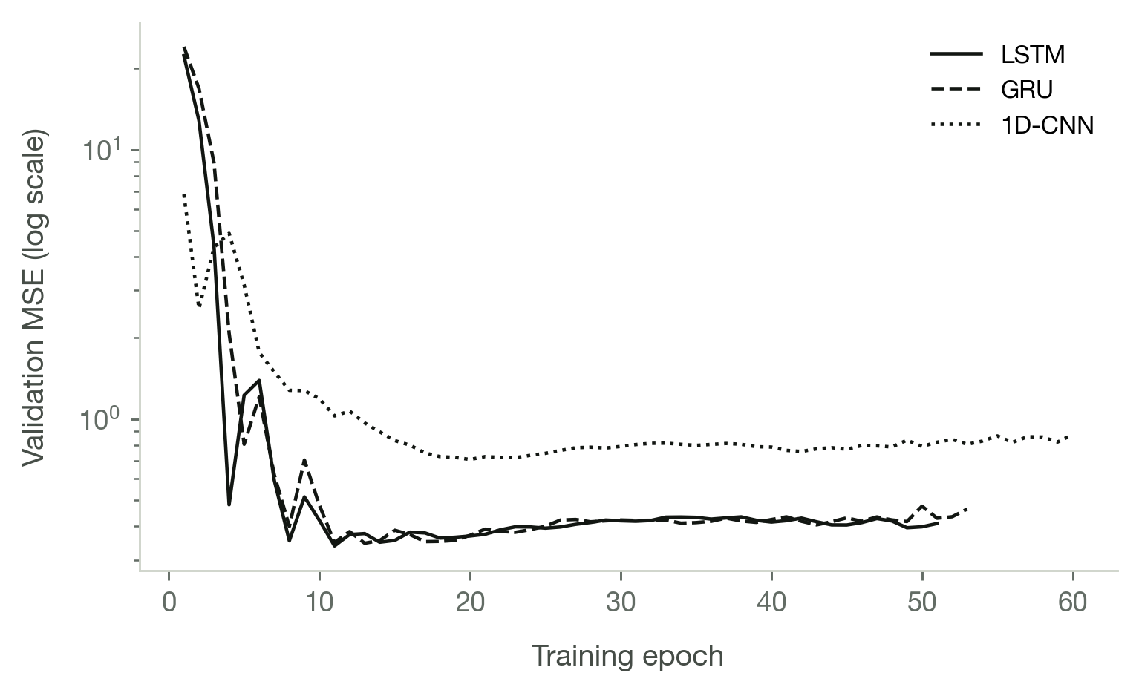
Note. Early stopping restores the weights at each curve's minimum.
Comparative Performance for Mainshock Magnitude Estimation
Every model was refitted on the combined training and validation partitions and scored once on the 33 test sequences, which nothing had touched. Skill is the percentage reduction in mean squared error relative to climatology, the historical mean magnitude of the training sequences. A negative skill score means the model is worse than quoting that average.

Table 17
Test-Partition Leaderboard for All Sixteen Models
Rank | Model | RMSE | MSE | 95% CI for RMSE | MAE | R² | Bias | % within ±0.3 | Skill vs. climatology (%)
1 | Extra Trees | 0.5545039160413846 | 0.3074745929052309 | [0.397, 0.701] | 0.4075435156915574 | 0.1047063324230043 | -0.0963473345668373 | 51.51515151515152 | 11.388656578577738
2 | Random Forest | 0.5685834135886136 | 0.3232870982080804 | [0.393, 0.729] | 0.4153596449425991 | 0.0586640375705894 | -0.1008125605455254 | 48.48484848484848 | 6.831638307556808
3 | Support Vector Regression | 0.571319153027363 | 0.3264055746159034 | [0.424, 0.720] | 0.4296356625684702 | 0.0495837680301637 | 0.0340832784127708 | 48.48484848484848 | 5.932922152461739
4 | k-Nearest Neighbours | 0.5890209303477664 | 0.3469456563877482 | [0.407, 0.765] | 0.4356893726384347 | -0.0102241171290313 | -0.131332360943692 | 54.54545454545454 | 0.0134599211546571
5 | Climatology (training mean) | 0.5890605752263429 | 0.34699236128599 | [0.427, 0.742] | 0.4673046251993621 | -0.0103601108033237 | -0.0596491228070168 | 36.36363636363637 | 0.0
6 | ARIMA | 0.5923373072147433 | 0.3508634855184132 | [0.426, 0.748] | 0.465596187741133 | -0.0216319137153795 | -0.0813256102398082 | 36.36363636363637 | -1.115622320352072
7 | ARIMAX | 0.598667006851079 | 0.3584021850920298 | [0.447, 0.749] | 0.4894377766202644 | -0.0435828330620866 | 0.0754467777935604 | 33.33333333333333 | -3.288206046886377
8 | LSTM | 0.5989149475114205 | 0.3586991143526076 | [0.470, 0.728] | 0.4989800443739766 | -0.0444474212031806 | 0.0891176778792185 | 30.303030303030305 | -3.3737783227363094
9 | GRU | 0.6156318915508435 | 0.3790026258944695 | [0.500, 0.728] | 0.5232950954410927 | -0.1035664695162492 | 0.1172915256285942 | 24.24242424242424 | -9.225063194430591
10 | Gradient Boosting | 0.6157129525686463 | 0.3791024399608002 | [0.435, 0.784] | 0.4596397108979861 | -0.1038571045917413 | -0.0590594610341281 | 42.42424242424242 | -9.253828688276268
11 | Elastic Net | 0.6158365718589718 | 0.3792546832390105 | [0.421, 0.802] | 0.4677929411222416 | -0.104300401195942 | -0.0528010718250506 | 45.45454545454545 | -9.297703797701184
12 | Ridge Regression | 0.6366398456080452 | 0.4053102930158356 | [0.455, 0.814] | 0.5013245773404331 | -0.1801682061343448 | -0.0124876399868561 | 39.39393939393939 | -16.806690358748313
13 | Histogram GB | 0.6486732093207189 | 0.4207769324904412 | [0.472, 0.810] | 0.5008863521596898 | -0.2252034210751079 | -0.0049447088782607 | 39.39393939393939 | -21.264033286207763
14 | Persistence (previous mainshock) | 0.8304799634530442 | 0.6896969696969697 | [0.601, 1.033] | 0.6181818181818183 | -1.008235294117647 | -0.0242424242424242 | 45.45454545454545 | -98.76430914527354
15 | 1D-CNN | 0.8552707063580742 | 0.7314879811542393 | [0.670, 1.025] | 0.7109173730739393 | -1.1299208863020491 | -0.0085533932644252 | 21.21212121212121 | -110.8080934240939
16 | Multilayer Perceptron | 1.153076760913977 | 1.329586016559869 | [0.917, 1.383] | 0.9767507239222386 | -2.8714416364537354 | -0.3841507390502682 | 12.12121212121212 | -283.1744340515981
Note. R squared, mean absolute error and root mean squared error for every model, with the bootstrap confidence interval on RMSE. Extra Trees leads at 0.555 with 11.4% skill; Random Forest follows at 0.569 and 6.8%; the LSTM reaches 0.599, which is 3.4% worse than climatology. Three of sixteen models beat the baseline.

Figure 5
Test-Partition RMSE for the Three Models Named in the Objectives
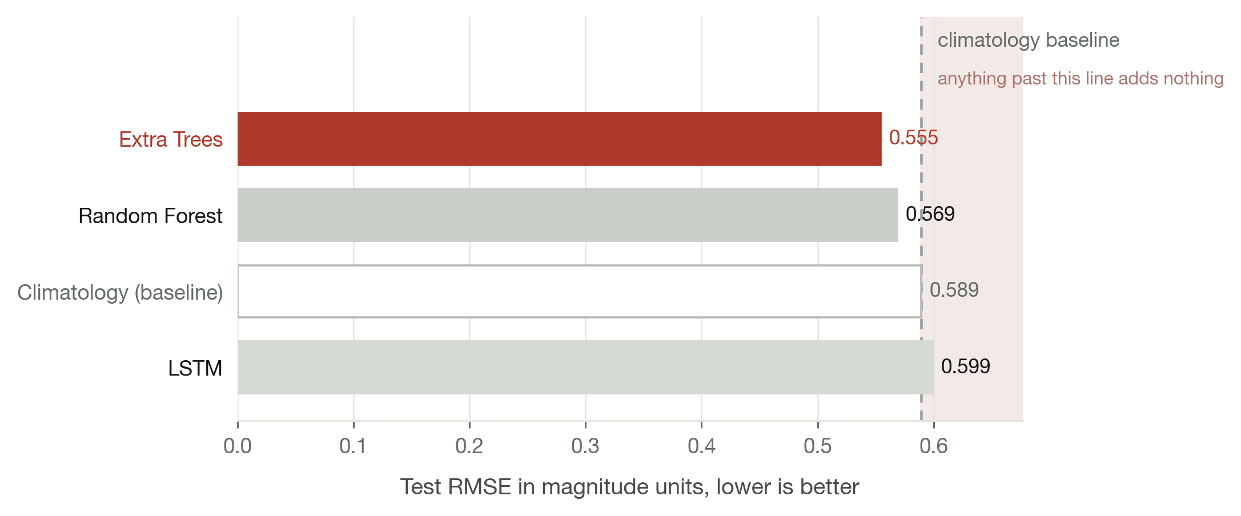
Note. The dashed line marks the climatology baseline; a bar past it is a model that fails to beat quoting the historical average.
The two tree ensembles behave as the literature on small tabular problems would predict. Extra Trees draws its split thresholds at random rather than optimising them, which costs it fit on the training rows and buys back more than it costs in generalisation when only 133 rows are available; it leads the comparison. Random Forest, whose splits are optimised, fits the training partition more closely and carries more of that fit into its test error. Both handle the non-linear interactions among the Gutenberg-Richter terms without any feature transformation, which is why they are the appropriate family for this data.
The LSTM reads the raw event stream, ten events deep, rather than the engineered features, and is the architecture best suited to sequential structure in principle. It finishes below the baseline. With 100 training sequences there is nothing like enough data for a recurrent network to pay for its parameters, and the GRU and the convolutional network, which share its optimiser and its input tensor, confirm the pattern. This is a finding about the size of the available record, not a defect in the architecture.

Table 18
Diebold-Mariano Comparisons Among the Five Leading Models
Model | Extra Trees | Random Forest | Support Vector Regression | k-Nearest Neighbours | Climatology (training mean)
Extra Trees | — | .524 | .621 | .366 | .130
Random Forest | .524 | — | .755 | .506 | .155
Support Vector Regression | .621 | .755 | — | .913 | .507
k-Nearest Neighbours | .366 | .506 | .913 | — | .203
Climatology (training mean) | .130 | .155 | .507 | .203 | —
Note. Two-sided p values for the null hypothesis that the row and column models have equal forecast accuracy, paired on the absolute errors of the same test sequences. No pair is distinguishable at the five percent level, which is what 33 test sequences support.

Table 19
Regression Performance Across the Three Partitions
Model and partition | n | MSE | RMSE | MAE | MAPE (%) | R² | Bias (ME) | Max |error| | % within ±0.3 | % within ±0.5 | 95% CI for RMSE
Random Forest — training | 100 | 0.0241315930262865 | 0.1553434679228147 | 0.1188943988095156 | 2.069453028505243 | 0.909381586013141 | -0.0004623710317572 | 0.5853333333333346 | 93.0 | 99.0 | [0.127, 0.186]
Random Forest — validation | 33 | 0.1753617124136265 | 0.4187621191244816 | 0.331545286195288 | 5.693719102029046 | 0.2562357656237759 | -0.1560878427128557 | 1.0251666666666734 | 54.54545454545454 | 75.75757575757575 | [0.319, 0.511]
Random Forest — test | 33 | 0.355581812404163 | 0.5963068106303693 | 0.4252522847522844 | 7.07957513638551 | -0.0353705714121215 | -0.1670329846080006 | 1.6890000000000347 | 51.51515151515152 | 75.75757575757575 | [0.393, 0.777]
LSTM — training | 100 | 0.2721188845780017 | 0.5216501553512677 | 0.3899698694082332 | 6.79214802038197 | -0.0218546993342136 | -0.0186875542893086 | 1.7686098169663085 | 44.0 | 76.0 | [0.420, 0.625]
LSTM — validation | 33 | 0.2164372071723431 | 0.4652281237977162 | 0.3845481520904324 | 6.664168946798825 | 0.0820216598742726 | -0.095116026862859 | 1.041104055763718 | 42.42424242424242 | 72.72727272727273 | [0.360, 0.562]
LSTM — test | 33 | 0.3713340248112611 | 0.6093718280420101 | 0.4855246761771036 | 8.323860374052648 | -0.0812373075386718 | -0.0820923820099896 | 1.587488756582653 | 33.33333333333333 | 60.60606060606061 | [0.447, 0.761]
Note. MSE, RMSE and MAE in magnitude units, with percentile bootstrap confidence intervals. The gap between training and test error is each model's optimism.
Mainshock Occurrence Probability Estimation
Forecasting how large a mainshock would be, given that one follows, is a different question from forecasting whether one follows at all. The second needs anchors where nothing happened, which the sequence data set by construction does not contain, so a separate data set of moments and places with enough recent activity to compute the features was built, each labelled by what actually followed within the horizon.

Table 20
Construction of the Occurrence Data Set
Radius (km) | Anchors | Thinned out | Period | P(M ≥ 5) observed | n positive (M ≥ 5) | P(M ≥ 6) observed | n positive (M ≥ 6) | P(M ≥ 7) observed | n positive (M ≥ 7)
50.0 | 1702 | 1481 | Aug 1965 to May 2026 | 25.440658049353704 | 433 | 5.757931844888367 | 98 | 0.4700352526439483 | 8
100.0 | 2239 | 2098 | Feb 1957 to May 2026 | 29.47744528807503 | 660 | 4.555605180884323 | 102 | 0.4466279589102278 | 10
200.0 | 4125 | 2904 | Feb 1957 to May 2026 | 35.85454545454546 | 1479 | 5.333333333333334 | 220 | 0.4363636363636364 | 18
Note. Anchors are thinned so that a single productive swarm cannot contribute fifty near-identical rows.

Table 21
Calibration and Skill of the Occurrence Model
Radius (km) | Threshold | Anchors | Positives | Historical rate (%) | Folds scored | M ROC AUC | SD AUC | M Brier skill (%) | SD Brier skill | Verdict
50.0 | M ≥ 5 | 1702 | 433 | 25.440658049353704 | 5 | 0.6386905413241252 | 0.0866579427066778 | 5.980697270352067 | 11.062414234836693 | Model beats the base rate
50.0 | M ≥ 6 | 1702 | 98 | 5.757931844888367 | 3 | 0.6575622622773133 | 0.1781442979324876 | -10.198539585926632 | 23.62910072919161 | No skill beyond the base rate
50.0 | M ≥ 7 | 1702 | 8 | 0.4700352526439483 | 0 | nan | nan | nan | nan | Too few events to model
100.0 | M ≥ 5 | 2239 | 660 | 29.47744528807503 | 5 | 0.6195397883763064 | 0.0453530769699142 | 5.751623140361845 | 6.879033383891719 | Model beats the base rate
100.0 | M ≥ 6 | 2239 | 102 | 4.555605180884323 | 4 | 0.5584247696647376 | 0.1739185896677785 | -15.4449374342897 | 17.727525892132288 | No skill beyond the base rate
100.0 | M ≥ 7 | 2239 | 10 | 0.4466279589102278 | 0 | nan | nan | nan | nan | Too few events to model
200.0 | M ≥ 5 | 4125 | 1479 | 35.85454545454546 | 5 | 0.5818323726600266 | 0.0440248139178221 | 2.098554910651404 | 2.8947300039766306 | Model beats the base rate
200.0 | M ≥ 6 | 4125 | 220 | 5.333333333333334 | 4 | 0.556246940320213 | 0.0259896252792115 | -0.5771650404370665 | 0.4183076206899415 | No skill beyond the base rate
200.0 | M ≥ 7 | 4125 | 18 | 0.4363636363636364 | 0 | nan | nan | nan | nan | Too few events to model
Note. ROC AUC and Brier skill score against the historical base rate, measured by rolling-origin validation. The model beats the base rate at M 5.0 for all three radii, by 6.0, 5.8 and 2.1 percent Brier skill. It finds no skill at M 6.0, and at M 7.0 there are too few positive cases to score at all.

Table 22
Probability of Occurrence With 95% Confidence Intervals
Radius (km) | Threshold | n anchors | n occurred | Rate (%) | Wilson 95% CI | Margin of error (pp) | Year-block 95% CI | Block MoE (pp)
50.0 | M ≥ 5 | 1702 | 433 | 25.4406580493537 | 23.4 to 27.6 | 2.067518483171291 | 19.8 to 31.1 | 5.634350719854525
50.0 | M ≥ 6 | 1702 | 98 | 5.757931844888367 | 4.7 to 7.0 | 1.1099187458704882 | 2.6 to 9.2 | 3.333667131080924
50.0 | M ≥ 7 | 1702 | 8 | 0.4700352526439483 | 0.2 to 0.9 | 0.343209323757852 | 0.1 to 1.0 | 0.4764378983747481
100.0 | M ≥ 5 | 2239 | 660 | 29.47744528807503 | 27.6 to 31.4 | 1.8872658520446648 | 24.1 to 34.7 | 5.304486268693864
100.0 | M ≥ 6 | 2239 | 102 | 4.555605180884323 | 3.8 to 5.5 | 0.8664757647407133 | 2.3 to 7.1 | 2.3803656857171696
100.0 | M ≥ 7 | 2239 | 10 | 0.4466279589102278 | 0.2 to 0.8 | 0.2887189896976809 | 0.0 to 1.0 | 0.4828119370799736
200.0 | M ≥ 5 | 4125 | 1479 | 35.85454545454545 | 34.4 to 37.3 | 1.4628729789086348 | 32.3 to 39.1 | 3.399773233731373
200.0 | M ≥ 6 | 4125 | 220 | 5.333333333333333 | 4.7 to 6.1 | 0.6866394959572858 | 3.8 to 6.8 | 1.527037202027686
200.0 | M ≥ 7 | 4125 | 18 | 0.4363636363636363 | 0.3 to 0.7 | 0.2062727232011638 | 0.2 to 0.8 | 0.3270268735262882
Note. Intervals come from a bootstrap that resamples whole years rather than individual anchors. The Wilson interval assumes independent trials; overlapping windows cut from one catalogue are not independent, and dropping that assumption roughly triples the margin of error.

Table 23
Threshold-Free Probabilistic Skill for the M 6.0 Forecast
Probability source | ROC AUC | Average precision | Brier score | Brier skill score | Base rate
Random Forest classifier P(M ≥ 6.0) | 0.7050000000000001 | 0.3880279034690799 | 0.1846113636363636 | -0.0052088750000001 | 0.2424242424242424
Random Forest regression, Platt-scaled | 0.7350000000000001 | 0.3938022138680033 | 0.1976902367472077 | -0.076423339088546 | 0.2424242424242424
Note. ROC AUC, average precision and Brier skill for the classification view of the magnitude task. A negative Brier skill score means the probability is less useful than the base rate.
Discussion 3: Validation Against Actual Recorded Events
Evaluation of Projected Mainshock Magnitudes
The test partition is 33 sequences between June 2021 and January 2026, none of which was seen during fitting or tuning. Each forecast below is compared against the magnitude PHIVOLCS recorded for the earthquake that followed.

Figure 6
Forecast Versus Observed Mainshock Magnitude for the Three Leading Models
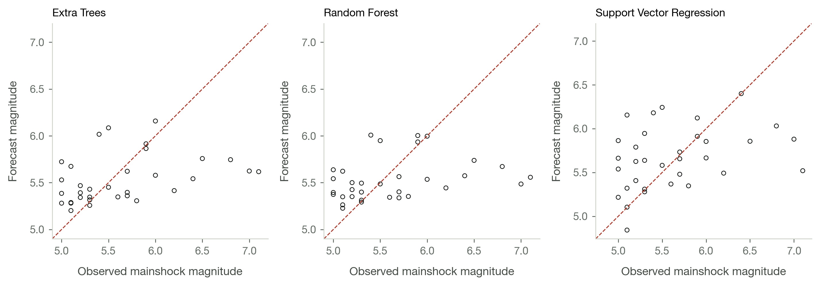
Note. The dashed line is perfect agreement.

Table 24
Residual Diagnostics for the Three Leading Models
Model | n | Mean residual | SD | t (mean = 0) | p (bias) | Shapiro–Wilk W | p (normality) | Heteroscedasticity slope | p (heterosced.) | Ljung–Box Q | p (autocorr.)
Extra Trees (test) | 33 | -0.0963473345668373 | 0.5545360919524929 | -0.9980834562046358 | 0.325726778605731 | 0.9255341769991569 | 0.0261522944003804 | 0.4729389586904284 | 0.1952375784559248 | 3.2037963687855404 | 0.782867830509424
Random Forest (test) | 33 | -0.1008125605455254 | 0.5682508675989599 | -1.0191345101832603 | 0.3157827388836162 | 0.9008241874032836 | 0.0055962805389889 | 0.2424196084712818 | 0.6036372926878237 | 3.4243263040517964 | 0.7540090127161388
Support Vector Regression (test) | 33 | 0.0340832784127708 | 0.579144003484395 | 0.338073996905046 | 0.7375154422343455 | 0.9653716711066652 | 0.3638875212237349 | 0.3417614488274933 | 0.182103512251039 | 3.173928316008101 | 0.7867217523075621
Note. Tests for bias, normality, heteroscedasticity and autocorrelation in the test residuals. A mean residual indistinguishable from zero is the condition for an unbiased forecaster overall, which these satisfy; the conditional bias by magnitude band, reported in Discussion 4, is the more informative statistic.

Figure 7
Residuals Against Forecast Magnitude
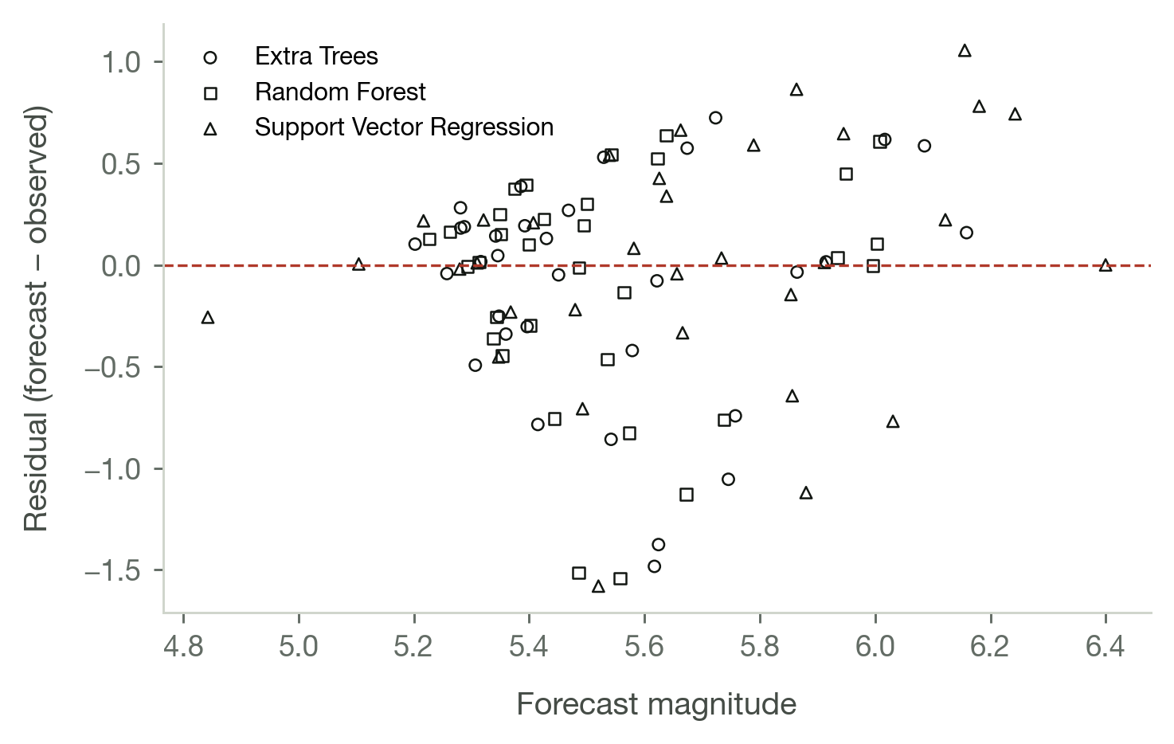

Table 25
Check That the Forecasts Respect the Largest Foreshock
Model | RMSE as published | RMSE with a floor at the largest foreshock | Change | % of forecasts raised
Extra Trees | 0.5545039160413846 | 0.5545039160413846 | 0.0 | 0.0
Random Forest | 0.5685834135886136 | 0.5685834135886136 | 0.0 | 0.0
Support Vector Regression | 0.571319153027363 | 0.571319153027363 | 0.0 | 0.0
k-Nearest Neighbours | 0.5890209303477664 | 0.5839704846225493 | -0.005050445725217 | 3.0303030303030303
Rule: forecast the largest foreshock itself | nan | 1.0472185381603338 | nan | nan
Note. Every forecast below the largest event in its own window is replaced by that event's magnitude and the partition re-scored. The leading model never forecasts below its own largest foreshock, so the correction does not move it.
Forecasting Accuracy for the Time of Occurrence
The study objectives name the mainshock magnitude as the quantity to be forecast, and the models produce that and nothing else. There is therefore no predicted time of occurrence to compare against a recorded one, and no error margin in hours or days can be quoted. Stating this plainly is more useful than constructing a time forecast the method was never designed to support.
What can be reported is the waiting time actually observed in the sequences used, which is what a reader who wants a time window needs in order to see that none is on offer. The occurrence model in Discussion 2 answers the nearest available question, which is the probability that an earthquake of a given size follows within a fixed 14-day horizon.

Table 26
Observed Waiting Time Between the Foreshocks and the Mainshock
Quantity | Value
Sequences | 166
Hours from the last foreshock to the mainshock, median | 21.8
Hours from the last foreshock to the mainshock, central 90% | 0.10 to 172.2
Days from the first foreshock to the mainshock, median | 9.33
Sequences whose last foreshock fell within 24 hours | 93 (56.0%)
Forecast of the time of occurrence | Not produced. The models forecast magnitude only.
Note. Descriptive statistics of the retained sequences, not forecasts. The foreshock closest to its mainshock arrived under a minute before it; the median sequence ends about half a day before the mainshock.
Discussion 4: Model Validation
Error Margins Across Magnitudes
Aggregate error hides the pattern that matters most. An evaluator reported that a recorded M 7.1 was forecast near M 5.4 and asked whether the forecasting capability could be improved. The tables below are that question measured rather than argued.

Table 27
Forecast Error by the Size of the Earthquake That Actually Arrived
Observed band | n | Model | Mean observed | Mean forecast | Bias (forecast − observed) | MAE | RMSE
M 5.0 to 5.4 | 16 | Extra Trees | 5.1625 | 5.433304408304817 | 0.2708044083048173 | 0.2761370468361233 | 0.3508808767664355
M 5.0 to 5.4 | 16 | Random Forest | 5.1625 | 5.449729554270951 | 0.2872295542709513 | 0.2881279739646855 | 0.3496616407275537
M 5.0 to 5.4 | 16 | LSTM | 5.1625 | 5.728398378492586 | 0.5658983784925864 | 0.5658983784925864 | 0.5805798473942163
M 5.5 to 5.9 | 9 | Extra Trees | 5.7 | 5.594269184872663 | -0.1057308151273364 | 0.2392005219637123 | 0.3105460649171759
M 5.5 to 5.9 | 9 | Random Forest | 5.7 | 5.597133098896974 | -0.1028669011030263 | 0.2333483825844977 | 0.282354751182965
M 5.5 to 5.9 | 9 | LSTM | 5.7 | 5.722711287610746 | 0.0227112876107471 | 0.1215639037884385 | 0.1429070164301039
M 6.0 to 6.9 | 6 | Extra Trees | 6.316666666666666 | 5.699610689438383 | -0.6170559772282838 | 0.6699198661171722 | 0.7323267106463571
M 6.0 to 6.9 | 6 | Random Forest | 6.316666666666666 | 5.660034401709392 | -0.656632264957274 | 0.656632264957274 | 0.7440940591547399
M 6.0 to 6.9 | 6 | LSTM | 6.316666666666666 | 5.714487376038132 | -0.602179290628535 | 0.602179290628535 | 0.6563056753025819
M 7.0 and above | 2 | Extra Trees | 7.05 | 5.620790312966511 | -1.429209687033489 | 1.429209687033489 | 1.4302131201869768
M 7.0 and above | 2 | Random Forest | 7.05 | 5.52155416666666 | -1.5284458333333395 | 1.5284458333333395 | 1.5285104464918589
M 7.0 and above | 2 | LSTM | 7.05 | 5.697591734703657 | -1.3524082652963425 | 1.3524082652963425 | 1.3556693645060605
Note. Bias is forecast minus observed. It is positive in the crowded M 5.0 to 5.4 band, near zero from M 5.5 to 5.9, about −0.6 from M 6.0 to 6.9 and about −1.4 above M 7.0. All three models show the same shape.

Table 28
Sequences Available in Each Magnitude Band and Partition
Magnitude band | Training n | Validation n | Test n | Total | % of all sequences
M 5.0 to 5.4 | 50 | 13 | 16 | 79 | 47.59036144578313
M 5.5 to 5.9 | 32 | 11 | 9 | 52 | 31.32530120481928
M 6.0 to 6.9 | 15 | 9 | 6 | 30 | 18.072289156626507
M 7.0 and above | 3 | 0 | 2 | 5 | 3.0120481927710845
All sequences | 100 | 33 | 33 | 166 | 100.0
Note. The explanation for the bias above. The training partition contains three sequences at M 7.0 or above and the validation partition contains none. A supervised model cannot learn a band it has barely seen, and no change of algorithm repairs this.

Figure 8
Where the Forecasts Fail: Error Against Observed Magnitude
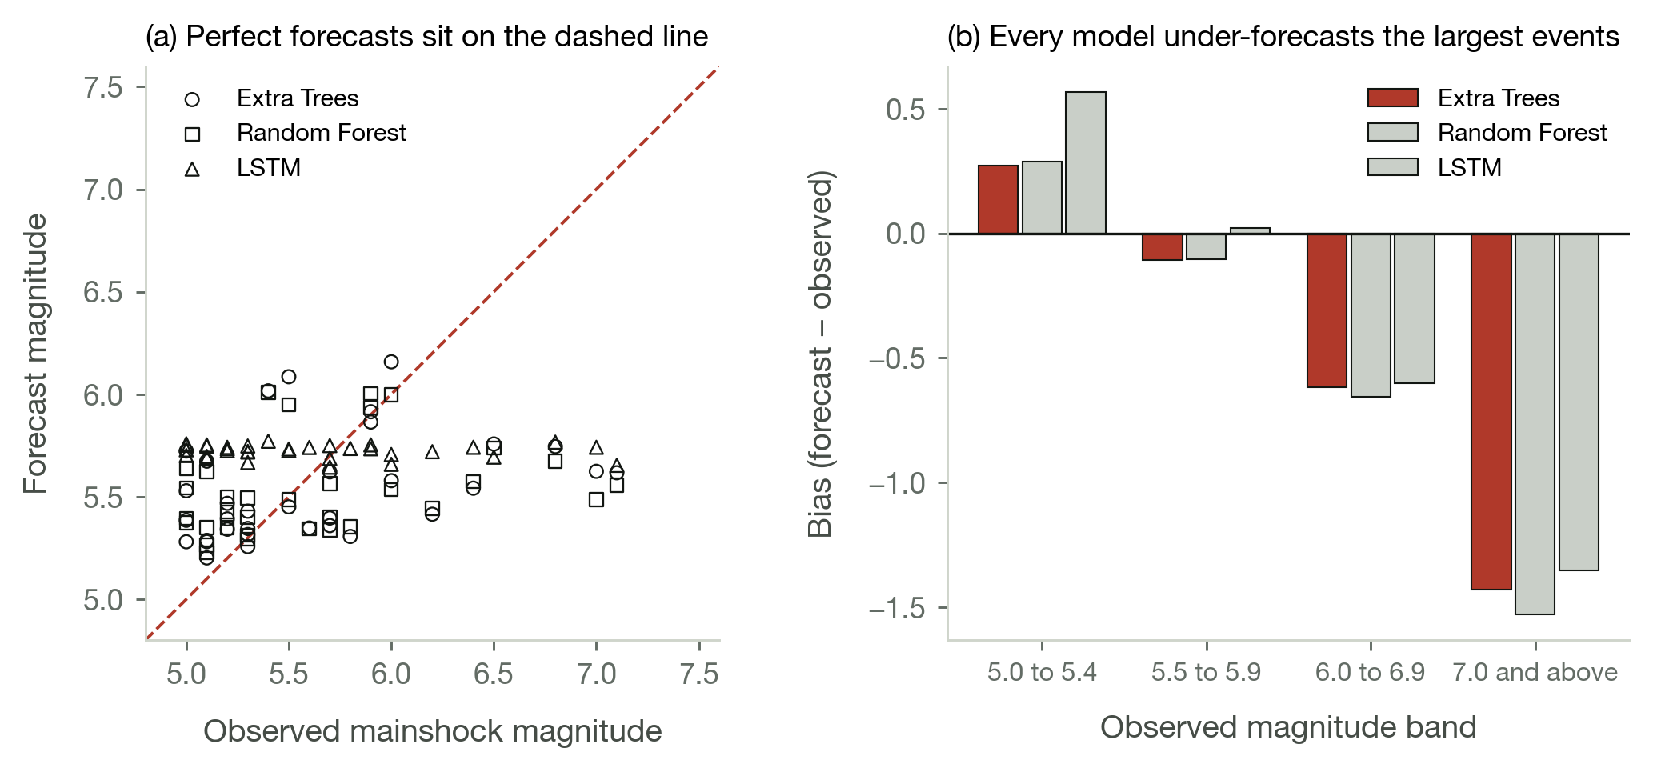
Note. Panel (a) plots every test sequence; points below the dashed line are under-forecasts. Panel (b) is the bias by band. Both show the same thing: the models track the middle of the range and flatten against the top of it.
A model fitted to minimise squared error returns the conditional mean of its training distribution, and a conditional mean shrinks toward the unconditional one wherever the conditioning information is weak. That is not a defect to be tuned away; it is the behaviour squared error asks for. The question is whether the foreshock window carries enough information to pull the forecast away from the mean, and the SHAP analysis below answers it.

Table 29
SHAP Attribution for the Extra Trees Model
Rank | Feature | Mean |SHAP| | Mean SHAP | Min SHAP | Max SHAP | Share of explained movement (%)
1 | Mag_max | 0.1243045885952762 | -0.0668187049263724 | -0.1455856401910311 | 0.3541532014118183 | 28.61930699583687
2 | Energy | 0.0531732062463578 | -0.0238522404139204 | -0.0677166239930605 | 0.1236590712790124 | 12.242350268116304
3 | Dist_std | 0.0421047770606274 | 0.0217447587288486 | -0.0363991172085778 | 0.3175935973237531 | 9.694006909212025
4 | T_elaps7 | 0.0314202049227139 | 0.0204041622340879 | -0.0232298532229498 | 0.184938692904086 | 7.234041001358724
5 | T_elaps75 | 0.0239118621558901 | 0.0128414346188551 | -0.0382221853263456 | 0.051620252432054 | 5.505355285875252
6 | dM_mlk | 0.0155066472295756 | -0.0025198241801112 | -0.0327719208678386 | 0.0728541652596197 | 3.5701779198538333
7 | Mag_mean | 0.0140021468519789 | -0.000904498741764 | -0.0340094403984166 | 0.0486458238414398 | 3.22378879079291
8 | NO | 0.0119043704514452 | 0.0017611590492973 | -0.0160595913400879 | 0.0583078042186678 | 2.7408065654868983
9 | beta | 0.011803113049385 | 0.0063762228047323 | -0.0165790735365292 | 0.0368692503038518 | 2.71749353490686
10 | Dist_mean | 0.0091953871901524 | -0.000474947052705 | -0.0168369903235692 | 0.0411590947453005 | 2.117102931713984
11 | Dist_wmean | 0.0091515705355389 | -0.0030605752323925 | -0.0178949011970945 | 0.0389576203830641 | 2.1070147901249574
12 | Dist_min | 0.0091089698677009 | 0.0001506991657022 | -0.0324697886384747 | 0.0200200799544566 | 2.09720661164287
13 | T_elaps65 | 0.0081448945508058 | 0.0025011165844114 | -0.0110924299999346 | 0.0412913753851256 | 1.875242420512619
14 | Dist_trend | 0.0079487805845036 | -0.0051840703669357 | -0.0178474861274087 | 0.0248413344199769 | 1.8300900583094224
15 | T_elaps6 | 0.0069191420768878 | 0.0021402784970091 | -0.0122350610168876 | 0.0441292554891469 | 1.5930309048445646
Note. SHAP decomposes every forecast into the training mean plus one signed contribution per feature, and the contributions sum exactly to the forecast. Mean |SHAP| is therefore in magnitude units. The maximum magnitude in the window is the strongest single influence at 0.124, and the total across all 27 features is under four tenths of a magnitude unit.

Table 30
SHAP Decomposition of the Three Largest Test Sequences
Case | Feature | Feature value | SHAP contribution | Running forecast
Case 1: observed M 7.1, forecast M 5.62 | Base value (training mean) | nan | 5.5736842105263165 | 5.5736842105263165
nan | Mag_max | 4.3 | -0.0812974311597736 | 5.492386779366543
nan | Energy | 10.00627255973759 | 0.0675909393820303 | 5.559977718748573
nan | T_elaps75 | 4.550828094310941 | 0.051620252432054 | 5.611597971180626
nan | Mag_mean | 4.166666666666667 | 0.0486458238414398 | 5.660243795022066
nan | beta | 1.6315925568196463 | 0.025626713848911 | 5.685870508870978
nan | Dist_trend | -5.5327493345663 | -0.0178474861274087 | 5.6680230227435695
nan | All other 21 features | nan | -0.0507979937266915 | 5.617225029016878
Case 2: observed M 7.0, forecast M 5.62 | Base value (training mean) | nan | 5.5736842105263165 | 5.5736842105263165
nan | Mag_max | 4.8 | -0.1140325768926513 | 5.459651633633666
nan | Dist_std | 0.7260866431649079 | 0.0827917367411363 | 5.5424433703748015
nan | Energy | 10.34809602417867 | -0.0438747909412542 | 5.498568579433547
nan | Dist_mean | 1.1529264862998063 | 0.0411590947453005 | 5.539727674178848
nan | T_elaps75 | 4.638850247288663 | 0.0317042825291547 | 5.571431956708003
nan | dM_mlk | 0.3521061085884316 | 0.0247692071396608 | 5.596201163847664
nan | All other 21 features | nan | 0.0281544330684787 | 5.624355596916142
Case 3: observed M 6.8, forecast M 5.75 | Base value (training mean) | nan | 5.5736842105263165 | 5.5736842105263165
nan | Mag_max | 4.3 | -0.0739416226867897 | 5.499742587839527
nan | Energy | 10.030820885449977 | 0.0697361839389004 | 5.569478771778427
nan | T_elaps7 | 2.389739205357965 | 0.0604535436524202 | 5.629932315430847
nan | T_elaps75 | 4.47211211894301 | 0.0497723397894898 | 5.679704655220337
nan | beta | -0.7969341846477972 | 0.0368692503038518 | 5.716573905524188
nan | Mag_mean | 4.2 | 0.0367400688328811 | 5.75331397435707
nan | All other 21 features | nan | -0.0078189778077252 | 5.745494996549345
Note. Read each block downward: the base value is the forecast knowing nothing about the sequence, and each row adds one feature's contribution. For the M 7.1 the 27 contributions total +0.04, and the largest foreshock in that window was M 4.3, below the training average, so the strongest feature pushed the forecast down.

Figure 9
SHAP Attribution for the Extra Trees Model
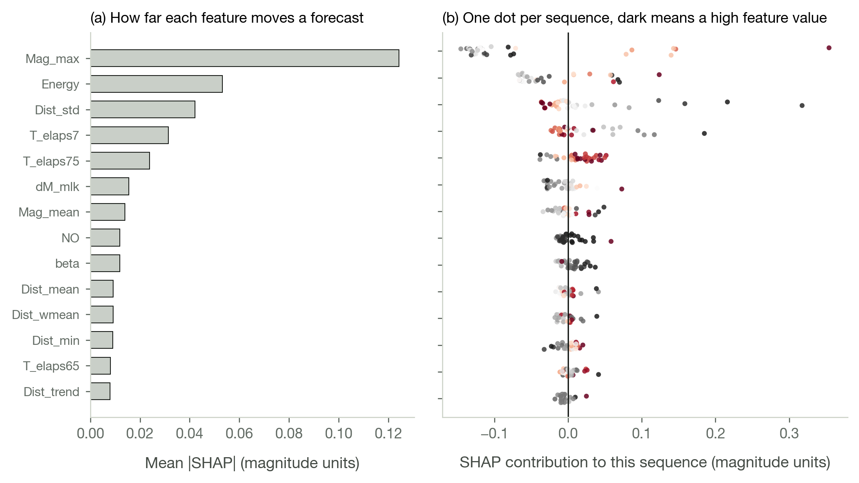
Note. Panel (a) ranks features by how far they move a typical forecast. Panel (b) shows the spread behind each average, one dot per test sequence, shaded by the value of that feature.
The conclusion is specific and it is not flattering to the method: the fourteen days before the M 7.1 did not look different from the fourteen days before an ordinary M 5.5. The window contained no signal of the size of what was coming. This is a statement about foreshock sequences in the Philippine catalogue, not about the algorithm, and no model reading that window could have done better.

Table 31
The Ensemble's Own Upper Quantile Against the Observed Magnitude
Model | Band | n | Mean forecast | Tree p90 forecast | Observed | Observed at or below p90 (%)
Extra Trees | All test sequences | 33 | 5.536985998766495 | 6.024305555555556 | 5.633333333333334 | 72.72727272727273
Extra Trees | M 5.0 to 5.9 | 25 | 5.4912517278692405 | 5.932083333333334 | 5.356 | 88.0
Extra Trees | M 6.0 to 6.9 | 6 | 5.69961068943838 | 6.316666666666666 | 6.316666666666666 | 33.33333333333333
Extra Trees | M 7.0 and above | 2 | 5.620790312966509 | 6.3 | 7.05 | 0.0
Random Forest | All test sequences | 33 | 5.532520772787818 | 6.073030303030303 | 5.633333333333334 | 78.78787878787878
Random Forest | M 5.0 to 5.9 | 25 | 5.50279483033633 | 6.0044 | 5.356 | 96.0
Random Forest | M 6.0 to 6.9 | 6 | 5.660034401709402 | 6.283333333333334 | 6.316666666666666 | 33.33333333333333
Random Forest | M 7.0 and above | 2 | 5.521554166666666 | 6.3 | 7.05 | 0.0
Note. A forest's point forecast is the mean over its trees and that mean is what shrinks; the trees themselves disagree. The ninetieth percentile of their forecasts is a legitimate upper figure obtained at no extra cost, and it covers the observed magnitude in about three quarters of test sequences overall. It does not recover the two above M 7.0, and the interface says so.
Performance Consistency Across Regions
Philippine seismicity is produced by several distinct systems: the left-lateral Philippine Fault Zone running the length of the archipelago, the subducting Philippine Trench along the eastern seaboard, the Manila Trench to the west, and the Cotabato and Sulu systems in the south. If foreshock behaviour differed systematically among them, forecast error would differ too.

Table 32
Test-Partition Error by Region
Region | n | Mean observed M | Extra Trees RMSE | Extra Trees bias | Random Forest RMSE | Random Forest bias | LSTM RMSE | LSTM bias
Philippine Trench, east of Mindanao | 23 | 5.66 | 0.56 | -0.131 | 0.577 | -0.121 | 0.612 | 0.061
Mindanao interior and the Cotabato Trench | 4 | 5.45 | 0.411 | 0.135 | 0.345 | 0.11 | 0.466 | 0.29
Southern Luzon, Bicol and the Visayan seas | 4 | 5.35 | 0.069 | 0.022 | 0.105 | 0.021 | 0.426 | 0.35
Luzon and the Philippine Fault's northern reach | 2 | 6.25 | 1.058 | -0.395 | 1.117 | -0.533 | 0.904 | -0.517
Note. Regions are defined by epicentre, not by a mapped tectonic boundary, and most groups hold single-digit counts. The n column should be read before any of the error figures: no difference among these groups is statistically meaningful at these sample sizes, and the table is reported so that a reader can see that rather than infer a regional effect from a leaderboard that does not have one.

Table 33
Confusion Matrix for Magnitude-Class Forecasts on the Test Partition
Actual class | Moderate (5.0-5.9) | Strong (6.0-6.9) | Major (>=7.0) | Total actual
Moderate (5.0-5.9) | 23 (92.0%) | 2 (8.0%) | 0 (0.0%) | 25
Strong (6.0-6.9) | 5 (83.3%) | 1 (16.7%) | 0 (0.0%) | 6
Major (>=7.0) | 2 (100.0%) | 0 (0.0%) | 0 (0.0%) | 2
Note. The regression forecast binned into the three magnitude classes.

Table 34
Overall Classification Agreement, Including Cohen's Weighted Kappa
Metric | Estimate | 95% CI | Interpretation
Accuracy | 0.7272727272727273 | [0.576, 0.879] | —
Macro F1 | 0.3528619528619528 | [0.252, 0.493] | —
Cohen's κ | 0.0747663551401868 | [-0.160, 0.431] | Slight
Weighted κ (quadratic) | 0.0119760479041916 | [-0.158, 0.311] | Slight
Test sequences (N) | 33.0 | — | —
Majority-class rate (no-skill accuracy) | 0.7575757575757576 | — | Reference for the accuracy above
Note. Weighted kappa is the appropriate agreement statistic for an ordered outcome with an unbalanced class distribution.
Synthesis and Broader Implications
Comparison With Standard Baselines
Two naive baselines were scored alongside every model throughout. Climatology forecasts the training mean for every sequence and is the reference against which skill is defined. Persistence reuses the magnitude of the preceding mainshock and finishes fourteenth of sixteen, at 0.830, which establishes that the sequence of Philippine mainshock magnitudes carries no useful serial dependence.
The Gutenberg-Richter law is used here as a source of features rather than as a competing forecaster: the a and b values of each window, estimated by both least squares and the Aki-Utsu maximum-likelihood method, and the magnitude deficit each implies, are four of the 27 inputs. The catalogue-wide fit is reported for completeness.

Table 35
Gutenberg-Richter Parameters for the Full Catalogue
Subset | N events | Mc (MAXC) | Mc (GFT) | GFT R (%) | N ≥ Mc | b (MLE) | SE b (MLE) | a (MLE) | b (LSQ) | SE b (LSQ) | a (LSQ) | R² (LSQ)
Full catalogue | 17667 | 4.2 | 4.9 | 90.55780732675863 | 4442 | 0.9198627162951762 | 0.0144221341798178 | 8.154905864058819 | 0.9629134540004688 | 0.0275956684820871 | 8.448448858187742 | 0.9736119579491416
Note. Completeness magnitude estimated by the maximum-curvature and goodness-of-fit methods; b estimated by least squares and by the Aki-Utsu maximum-likelihood method, with the Shi and Bolt standard error.

Table 36
Gutenberg-Richter Parameters for the Declustered Catalogue
Subset | N events | Mc (MAXC) | Mc (GFT) | GFT R (%) | N ≥ Mc | b (MLE) | SE b (MLE) | a (MLE) | b (LSQ) | SE b (LSQ) | a (LSQ) | R² (LSQ)
Full catalogue | 15460 | 4.2 | 4.9 | 90.4686222855766 | 3994 | 0.8931885482603449 | 0.0147440707161668 | 7.978031947010374 | 0.9500212887973436 | 0.0281158949113766 | 8.349990591001408 | 0.9719084032877182
Note. Compare with the full-catalogue fit above. Declustering lowers b, since clustered sequences are magnitude-poor relative to background seismicity.
The Epidemic-Type Aftershock Sequence model is the standard reference for Philippine seismicity, so the comparison is made directly. ETAS forecasts the rate of earthquakes above a threshold, not the magnitude of a particular one, and its magnitude component is the Gutenberg-Richter distribution drawn independently of history. Above a threshold M0 that distribution has expectation M0 + 1/(b ln 10), a constant. As a magnitude forecaster ETAS is therefore a constant, and it is scored here as one rather than set aside, with b estimated by Aki-Utsu maximum likelihood on the training targets alone so the baseline never sees the test partition.

Table 37
Comparison Against the ETAS Magnitude Component
Model | RMSE | Skill vs. ETAS magnitude (%)
Extra Trees | 0.5545039160413846 | 10.4948982110313
Random Forest | 0.5685834135886136 | 5.891916601079627
ETAS magnitude component (constant M 5.62) | 0.5861121471231324 | 0.0
LSTM | 0.5989149475114205 | -4.416434666647451
Note. The ETAS magnitude component forecasts M 5.62 for every sequence and scores 0.586 on the test partition. Extra Trees beats it by 10.5% skill and Random Forest by 5.9%; the LSTM trails it by 4.4%. This is the magnitude comparison the chapter outline asks for. The full ETAS space-time intensity forecasts occurrence rather than magnitude and would be the right comparison for the occurrence model of Discussion 2; this study does not fit one, and that is stated as a limitation rather than left implicit.
Local Context and Seismotectonic Insights
Distance to the nearest mapped active fault was carried through the analysis as a selected parameter, summarised by five features: the closest approach in the window, the mean, the standard deviation, an energy-weighted mean and the trend in kilometres per day. Whether those five earn their place is a claim the study has to settle rather than assert, so the block was dropped and the leading model refitted under two protocols.

Table 38
Does the Fault-Distance Block Improve the Forecast?
Quantity | Value
All 27 features, test RMSE | 0.5545
22 core features only, test RMSE | 0.5471
Difference (core − all), test partition | -0.0074
95% CI on that difference | [-0.0537, +0.0338]
Diebold–Mariano on the paired absolute errors | DM = -0.061, p = 0.951
Difference (core − all), mean over 5 rolling-origin folds | +0.0073 (SD 0.0255)
Folds in which the core set wins | 2 of 5
Paired t on the fold differences | t = +0.643, p = 0.555
Finding | No measurable difference either way: the two protocols disagree in sign, neither interval excludes zero, and the whole effect is 1.3% of the model's own error.
Note. On the test partition the 22 core features score 0.5471 against 0.5545 with all 27, which reads as fault distance costing accuracy. Under rolling-origin cross-validation the sign reverses: the full set wins by 0.0073 and the core set wins two folds of five. Neither result approaches significance, neither interval excludes zero, and the effect is 1.3% of the model's own error.
Two protocols disagreeing in sign about an effect smaller than their own noise is what a null result looks like. The defensible statement is that this data set cannot resolve whether fault distance helps: not that it helps, and not that it hurts. Reporting it either way from a single split of 33 sequences would be reading a coin toss as a finding.
The standard deviation of those distances nonetheless ranks third of 27 by SHAP attribution, which is a useful reminder that influence inside a fitted model is a different quantity from a gain in held-out error. A model can lean on a feature heavily and still forecast no better for having it, which is precisely what happens here. Settling the question would need more recorded sequences, not a different algorithm.

Table 39
Distance From Each Epicentre to the Nearest Mapped Active Fault
Quantity | Value
Events with a nearest-fault distance | 17,667
Distinct fault source points | 797
Distance, M (SD) in km | 59.82 (75.26)
Distance, median in km | 32.98
Distance range in km | 0.18 to 617.26
Events within 25 km of a fault | 7,024 (39.8%)
Median recomputation difference in km | 0.0557
Maximum recomputation difference in km | 5.323
Agreement within 1 km | 17,354 of 17,667 (98.23%)
Note. Measured against the active fault layer digitised in QGIS, 1,015 mapped vertices. Two Philippine earthquakes in five occur within 25 km of a mapped fault.
Practical Significance and Limitations
The result this study can defend is narrow. Conditional on a foreshock sequence of at least three catalogued events being under way, and on a mainshock following it, the magnitude of that mainshock can be estimated with 11.4 percent less squared error than quoting the historical average. The typical error is 0.55 of a magnitude unit, which spans the difference between a tremor and a damaging earthquake, and the confidence interval on the leading model overlaps the baseline's almost completely.
Three limits bound any operational reading of this work. First, most large Philippine earthquakes arrive without a qualifying foreshock sequence: of 3,261 candidate mainshocks, 2,470 had too little catalogued activity in the preceding fortnight to support a forecast at all. Second, the method is weakest exactly where it would matter most, under-forecasting events above M 7.0 by about 1.4 magnitude units, because three such sequences exist in the training partition. Third, the record itself grew with the monitoring network, so any temporal trend in these data confounds detection capability with seismicity.
What the study does establish is methodological and transferable. A declustered, magnitude-resolved PHIVOLCS catalogue can be turned into a leak-free supervised learning problem; the resulting skill is small but real and survives a strict chronological split, a rolling-origin validation and a test partition scored once; and the limits of that skill can be located precisely, by magnitude band and by feature attribution, rather than averaged away. A forecasting study is only as trustworthy as the list of things it refuses to claim, and that list is given here in full.
List of Tables
Table 1. Data-Cleaning Audit Trail
Table 2. Rule for Selecting the Working Magnitude From the Four Reported Scales
Table 3. Spatial and Temporal Windows From Maeda's Method
Table 4. Outcome of Maeda's Declustering Procedure
Table 5. Catalogue Descriptive Statistics Before and After Declustering
Table 6. Construction of the Forecast Sequence Data Set
Table 7. Verification That Every Mainshock Exceeds Its Own Foreshocks
Table 8. The 27 Engineered Seismic Features
Table 9. Univariate Association of Each Feature With the Mainshock Magnitude
Table 10. Random Forest Feature Importance for Mainshock Magnitude
Table 11. Correlation Matrix for the Seismic Parameters
Table 12. Chronological 60:20:20 Partitioning of the Sequence Data Set
Table 13. Magnitude-Class Distribution Across the Three Partitions
Table 14. Random Forest Hyperparameter Search, Leading Configurations
Table 15. Inventory of the Forecasting Models Compared
Table 16. Rolling-Origin Cross-Validation Results Across All Models
Table 17. Test-Partition Leaderboard for All Sixteen Models
Table 18. Diebold-Mariano Comparisons Among the Five Leading Models
Table 19. Regression Performance Across the Three Partitions
Table 20. Construction of the Occurrence Data Set
Table 21. Calibration and Skill of the Occurrence Model
Table 22. Probability of Occurrence With 95% Confidence Intervals
Table 23. Threshold-Free Probabilistic Skill for the M 6.0 Forecast
Table 24. Residual Diagnostics for the Three Leading Models
Table 25. Check That the Forecasts Respect the Largest Foreshock
Table 26. Observed Waiting Time Between the Foreshocks and the Mainshock
Table 27. Forecast Error by the Size of the Earthquake That Actually Arrived
Table 28. Sequences Available in Each Magnitude Band and Partition
Table 29. SHAP Attribution for the Extra Trees Model
Table 30. SHAP Decomposition of the Three Largest Test Sequences
Table 31. The Ensemble's Own Upper Quantile Against the Observed Magnitude
Table 32. Test-Partition Error by Region
Table 33. Confusion Matrix for Magnitude-Class Forecasts on the Test Partition
Table 34. Overall Classification Agreement, Including Cohen's Weighted Kappa
Table 35. Gutenberg-Richter Parameters for the Full Catalogue
Table 36. Gutenberg-Richter Parameters for the Declustered Catalogue
Table 37. Comparison Against the ETAS Magnitude Component
Table 38. Does the Fault-Distance Block Improve the Forecast?
Table 39. Distance From Each Epicentre to the Nearest Mapped Active Fault

