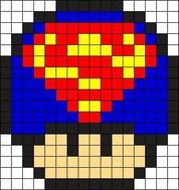

|  |  |  |  |  |
| --- | --- | --- | --- | --- |
| COLOR | NUMBER OF SHADES | FRACTION | DECIMAL | PERCENT |
| BLUE | 58 | 58/400 | 0.145 | 1.45% |
| RED | 50 | 50/400 | 0.125 | 1.25% |
| YELLOW | 22 | 22/400 | 0.055 | 5.5% |
| BLACK | 62 | 62/400 | 0.155 | 15.5% |
| BROWN | 32 | 32/400 | 0.08 | 8% |