Alexandra P. Veluz

BSIT-4H

**PARTS OF A COMPUTER**

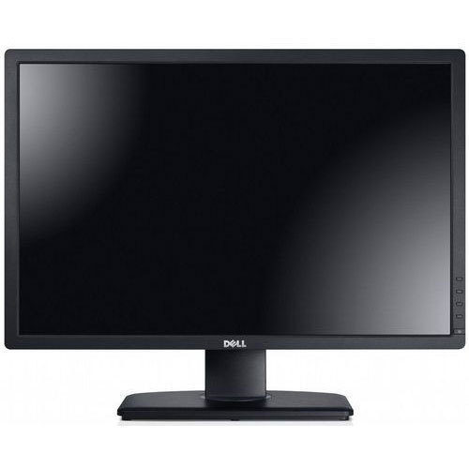

**MONITOR**

A monitor is a display device, similar to a television, which interprets and shows the graphical output signal from your computer's graphics card. This allows you to interact with the computer using various devices such as a mouse or keyboard by viewing the display interface.

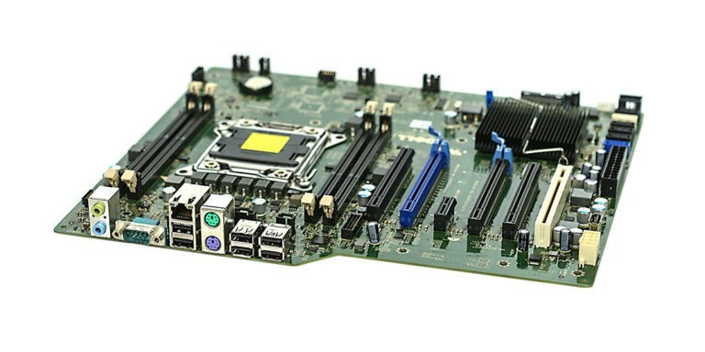

**MOTHERBOARD**

A computer's mainboard, circuit board, and foundation are all terms used to describe it. All components and external peripherals link to the motherboard, which serves as the computer's fundamental communications backbone. Without it, none of the computer's components, such as the CPU, GPU, or hard drive, would be able to communicate with one another. Without it, none of the computer pieces, such as the CPU, GPU, or hard drive, could interact.

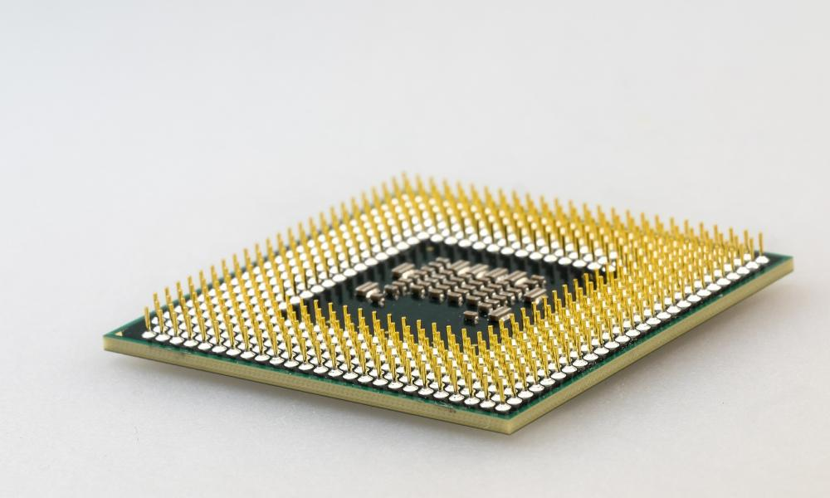

**CENTRAL PROCESSING UNIT CPU**

The CPU can be considered of as a computer's brain. On a computational level, it processes all of the data. It reads data from the RAM and processes it in order for the computer to do the tasks it is programmed to do or The CPU of a computer processes all instructions received from the computer's hardware and software. The CPU, for example, processed the instructions to open and display this web page on your computer using a web browser. The processor is installed and secured in a motherboard CPU socket that is compatible with it.

**RANDOM ACCESS MEMORY RAM**

RAM is a type of data storage that allows for quick read and write operations. RAM is also volatile, which means that if the power goes off, it loses all of the data it has stored. It provides a temporary storage and access location for applications. It saves the information that your computer is now consuming so that it can be immediately accessible. Your system's speed and performance are directly proportional to the amount of RAM you have installed. It can be slow and sluggish if your PC has insufficient RAM.

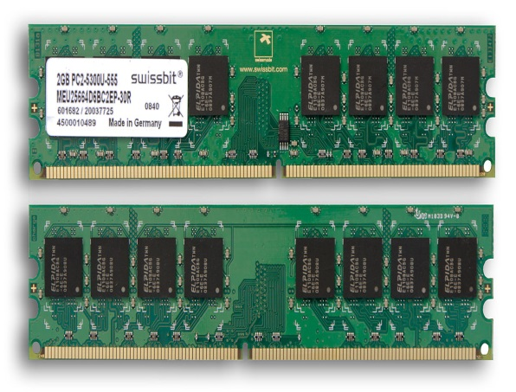

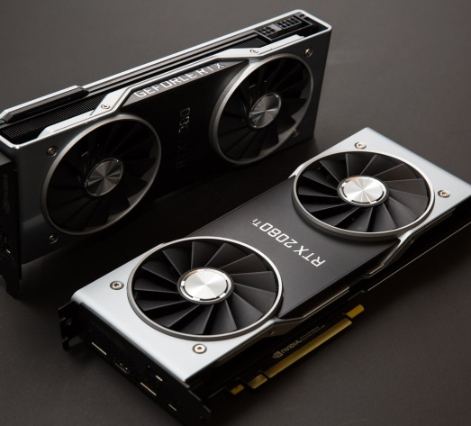

**GRAPHIC CARD**

Is an expansion card that connects to a computer motherboard. Graphics cards convert data from your computer's central processing unit (CPU) into visual information that can be viewed on a monitor.   The graphics card receives information about the image from the CPU; It determines how to create the image by utilizing the pixels on the screen. The information is subsequently sent to the monitor through a cable.

**SOUND CARD**

A sound card is a computer expansion card or integrated circuit that produces sound that can be heard through speakers or headphones. Despite the fact that a sound card isn't required, it's included on every computer, either in an expansion slot or incorporated into the motherboard (onboard). A sound card is a computer expansion component that receives and sends audio. With the help of a software application and a device driver, sound cards can be setup and used. A microphone is typically used as an input device to receive audio data, whereas speakers or headphones are typically used to output audio data.

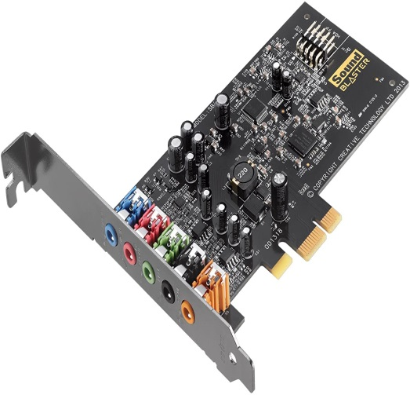

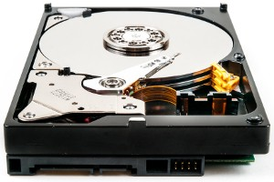

**HARD DRIVE**

It is commonly mounted inside in a computer, directly connected to the motherboard's disk controller. A hard drive is a piece of hardware that holds all of your digital files includes documents, photos, music, videos, programs, application preferences, and the operating system. External and internal hard drives are both available. A hard drive, unlike volatile storage like RAM, retains its data even when turned off. This is why you can restart a computer when the HDD is turned off and still have access to all of the data when it is turned back on.

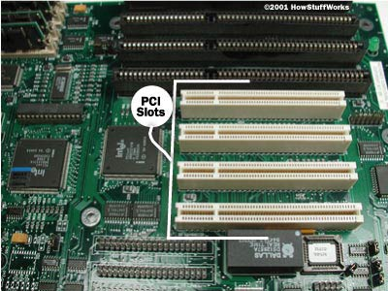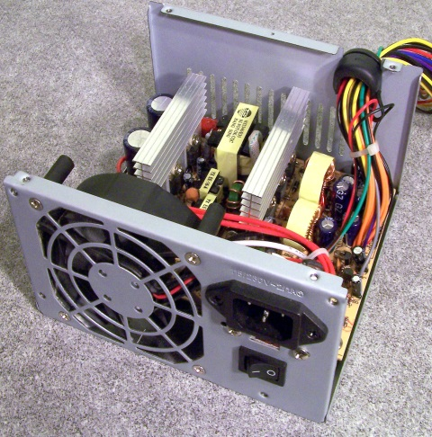

**EXPANSION SLOT**

An expansion slot is a socket on the motherboard that is used to install an expansion card (or circuit board) that adds video, sound, enhanced graphics, Ethernet, or RAM to a computer. The expansion card contains an edge connector that fits perfectly into the expansion slot, as well as a row of contacts that are used to link the motherboard to the card's electronics, which are generally integrated circuits. A computer system can have anywhere from one to seven expansion slots, depending on the case and motherboard form factor. Up to 19 expansion cards can be placed on a backplane system.

**POWER SUPPLY**

The power supply is the one component that is absolutely necessary for a computer to function. A computer would be little more than a collection of plastic and metal if it didn't have it. The power supply transforms your home's alternating current (AC) line to the direct current (DC) required by your computer. The power supply is the metal box that is normally placed in a case corner. Because it houses the power cord receptacle and the cooling fan, the power supply is visible from the back of many systems.

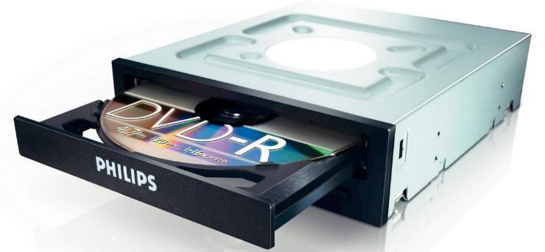

**Optical Drive**

A computer system with an optical drive allows users to use DVDs, CDs, and Blu-ray optical drives. The Drive has several lenses that transmit electromagnetic waves onto optical discs, allowing it to read and write data. Optical drives are found in a wide range of electronic devices, including VCD players, CD players, Blu-ray players, DVD players, and video game consoles including the Microsoft Xbox One, Sony PlayStation 2, 3, and 4, and Nintendo Wii U.

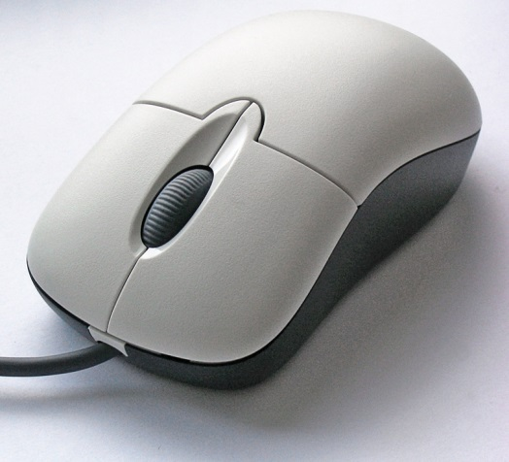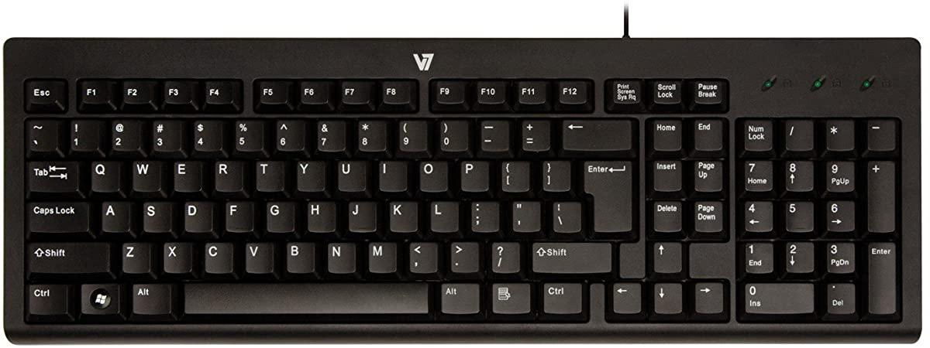

**MOUSE**

A mouse allows the user to move a pointer on the monitor and interact with the computer in a more natural way. When the mouse moves, the computer receives instructions to move the cursor on the screen so that it can interact with files, windows, and other software items. Even though the mouse is a peripheral device that sits outside the main computer housing, it's an essential piece of computer hardware in most systems

**Keyboard**

A computer keyboard is a hardware device that operates in line with the user's commands. It is made up of circuits, switches, and processors that assist in the transmission of keystroke messages to the computer. The "keys" on a keyboard are mechanical switches or push-buttons. When you press one of these buttons, an electrical circuit is closed, and the keyboard sends a signal to the computer telling it whatever letter, number, or symbol you want displayed on the screen. The character is then displayed on the screen, usually where the flashing text cursor is located.

RAM

* RAM allows your computer to perform many of its everyday tasks, such as loading applications, browsing the internet, editing a spreadsheet, or experiencing the latest game. Memory also allows you to switch quickly among these tasks, remembering where you are in one task when you switch to another task.
* RAM is used to store information that needs to be used quickly. This means that opening many programs, running various processes or accessing multiple files simultaneously is likely to use a lot of RAM. Particularly complexed programs like games or design software will use most RAM.
* When your computer is turned on, it loads data into RAM. Programs that are currently running, and open files, are stored in RAM; anything you are using is running in RAM somewhere. As soon as the electricity to the RAM is cut, it forgets everything; that's why an unsaved document is lost if the computer locks up or there is a power failure. When you save a document it goes on a hard drive, or another type of media storage device. Typically, this type of storage is magnetic, and does not depend on electricity to remember what is written on it. However, it's much slower than RAM. The computer can access anything stored in RAM nearly instantly. Things on the hard drive need to be located, read and sent to RAM before they can be processed. If your computer says you are low on disk space you have too many programs or files on your computer. To correct this, you will need a new hard drive, or will need to uninstall unused programs or delete unneeded files off the computer. If your computer says you are low on memory, you have too many programs running, or your computer does not have the RAM needed to run the software you want to. Restarting your computer will clear the RAM and usually clears up 90% of low memory errors. If your computer has more RAM than the programs minimum requirements, and restarting the computer does not solve the problem, the error could be caused by a buffer overflow, or another technical issue that is outside the scope of this tutorial.
* Ang memorya ay naka-install sa mga [memory module slot na matatagpuan sa motherboard](https://tl.eyewated.com/ano-ang-tingin-ng-inside-ng-iyong-pc/) .

Graphic Card

* The images you see on your computer [monitor](https://computer.howstuffworks.com/monitor.htm) are made of tiny dots called pixels. At most common resolution settings, a screen displays more than 2 million pixels, and the computer has to decide what to do with each one in order to create an image. To do this, it needs a
* M,translator -- something to take [binary data](https://computer.howstuffworks.com/bytes.htm) from the [CPU](https://computer.howstuffworks.com/microprocessor.htm) and turn it into a picture you can see. This translator is known as a graphics processor, or GPU.
* Meron na syang pinag sasaksan ng monitor na DVI, S-video- VGA, video memory GPU heat sink

Because of the large processing requirements for a gaming graphics card, [fans](https://computerinfobits.com/how-to-speed-up-graphics-card-fan/) are almost a given.

A graphics card plugs into a PCI Express (Peripheral Component Interconnect Express) slot on the motherboard. It is a serial expansion bus slot capable of a high amount of bandwidth in two directions.

A graphics card has a GPU (Graphics Processing Unit) which is the main component that requires cooling.

* A GPU is slower than a CPU, but it is designed to deal with mathematical operations required for video rendering.

SOUND CARD

A sound card is a computer expansion component that receives and sends audio. With the help of a software application and a device driver, sound cards can be setup and used. A microphone is typically used as an input device to receive audio data, whereas speakers or headphones are typically used to output audio data.

Incoming digital audio data is converted to analog audio by the sound card, which can then be played by the speakers. In the opposite situation, the sound card can transform analog audio data from the microphone into digital data that can be saved on the computer and edited with audio software.

HARD DRIVE

A hard drive can store any [data](https://www.computerhope.com/jargon/d/data.htm), including pictures, music, videos, text documents, and any files created or [downloaded](https://www.computerhope.com/jargon/d/download.htm). Also, hard drives store files for the operating system and [software programs](https://www.computerhope.com/jargon/p/program.htm) that run on the computer.

The hard drive is sometimes referred to as the "C drive" because Microsoft Windows, by default, designates the "C" drive letter to the primary [partition](https://www.lifewire.com/what-is-a-partition-2625958) on the primary hard drive in a computer.

While this isn't a technically correct term to use, it is still prevalent. For example, some computers have multiple drive letters (e.g., C, D, and E) representing areas across one or more hard drives. The hard disk drive also goes by the name HDD (its abbreviation), hard drive, hard disk, magnetic hard drive, mechanical hard drive, fixed drive, fixed disk, and fixed disk drive.

Regardless of what it's called, the primary hard drive typically contains the [root folder](https://www.lifewire.com/what-is-a-root-folder-or-root-directory-2625989) of the operating system used.

ur PC almost certainly supports more than just one HDD and a CD/DVD drive, or whatever else there is.

POWER SUPPLY

The power supply is located at the back of the computer, usually at the top. However, many more recent [tower](https://www.computerhope.com/jargon/t/tower.htm) computer cases house the power supply at the bottom back of the case. In a desktop computer case (all-in-one), the power supply is located at the back left or back right. Despite the name, Power Supply Units (PSU) do not **supply** systems with power - instead they **convert** it. Specifically, a power supply converts the alternating high voltage current (**AC**) into direct current (**DC**), and they also regulate the DC output voltage to the fine tolerances required for modern computing components.

Notes for second lesson

Overview of system maintenance

System operation it is an ongoing operation in which the system operates until it’s replaced with a new system

* Pag may info na papalitan mag kakaroon ng system operation

Kung may system operation with system maintenance it is involves servicing, maintaining and improving info system through its lifetime, system operation and support occur in parallel

* Pag di nag woworking ng maay0os need na palitan lahat ng dapat na ginagamit ay up to date

System maintenance- consist of ff section

Type of maintenance

* There are several type of maintenance for the information system
* Maintenance is changes made to an information system to fix or enhance its functionality

Conducting and managing maintenance

4 types of maintenance

1. corrective maintenance- refers to changes made to repairs the defects in the design, copding or implementation of the system

* It diagnoses and corrects errors in operational system
* When corrective maintenance occurred, it needs to be repaired and resolve as soon as possible
* Exp incorrect report title, incorrect report total and wrong format for report
* For example na nag input ka na iba ung lumalabas kelangan na agad ayusin

2. Adaptive maintenance- based on business needs and provide enhancement to a system

* It is different with corrective maintenance because adaptive maintenance is less urgent since business and technical changes may be occur over some period of time
* The needs occur when change in the organization such as new product or services new thecnology or introduce of a web based system
* It is only a small part of an organization maintenance effort, it’s not urgent but its add values to the organization
* Pag may order ka na di na pupunch lalo na kung bago ung product or services ang gagawin ay antay lang muna sa order for a couple of minutes
* Web based- ginagamit ng web with a server para makapag communicate dun sa system url or browser pero connected sa system for example 7 11 web based ang browser ay nasa server
* Web site- user kung saan ay mag viview using browser ung ,ag user ang coconnect

3. Perfective maintenance- improves system efficiency, reliability or maintainability

* Normally it comes from users when they submit a request the support team will initiate a perfective maintenance
* When user concerns with performance we should determine either perfective maintenance can increase the system performance or not
* Adaptive and corrective maintenance more important that perfective maintenance
* Sometimes perfective maintenance can be considered as a part of new project
* For example, if an employee has a problem they will submit a report because the employee is having difficulty in their computer tsaka lang sila mag peperfective maintenance chaka lang gagawin ng maintenance lahat ng computer sa department,

4. Preventive maintenance- changes are made in order to avoid future problems and reduce the system failure

* To avoid any problems, it requires analysis of areas where the problem might be occurred
* Normally, preventive maintenance is initiated by the team
* It often result in increased user satisfaction and decreased downtime
* Preventive maintenance is important in order to avoid future problems
* For example in your computer magkaroon ng backup

Conducting and managing maintenance

1, cost maintenance

2. Configuration management

3. Maintenance team

4. Managing maintenance request

Requirement 3 %

Designing 8%

Implementation 7%

Testing 15%

Maintenance 67%

What are common operating system in a company

In your won ideas, create a steps or guide on how to install an os system using virtual machine

Video

Wirte guides