Empanto, Joycel H

Engelbert, Calma

Veluz, Alexandra P.

Sales and Inventory Management with Barcode Scanner for Erlinda’s Store

**LOGIN MODULE**

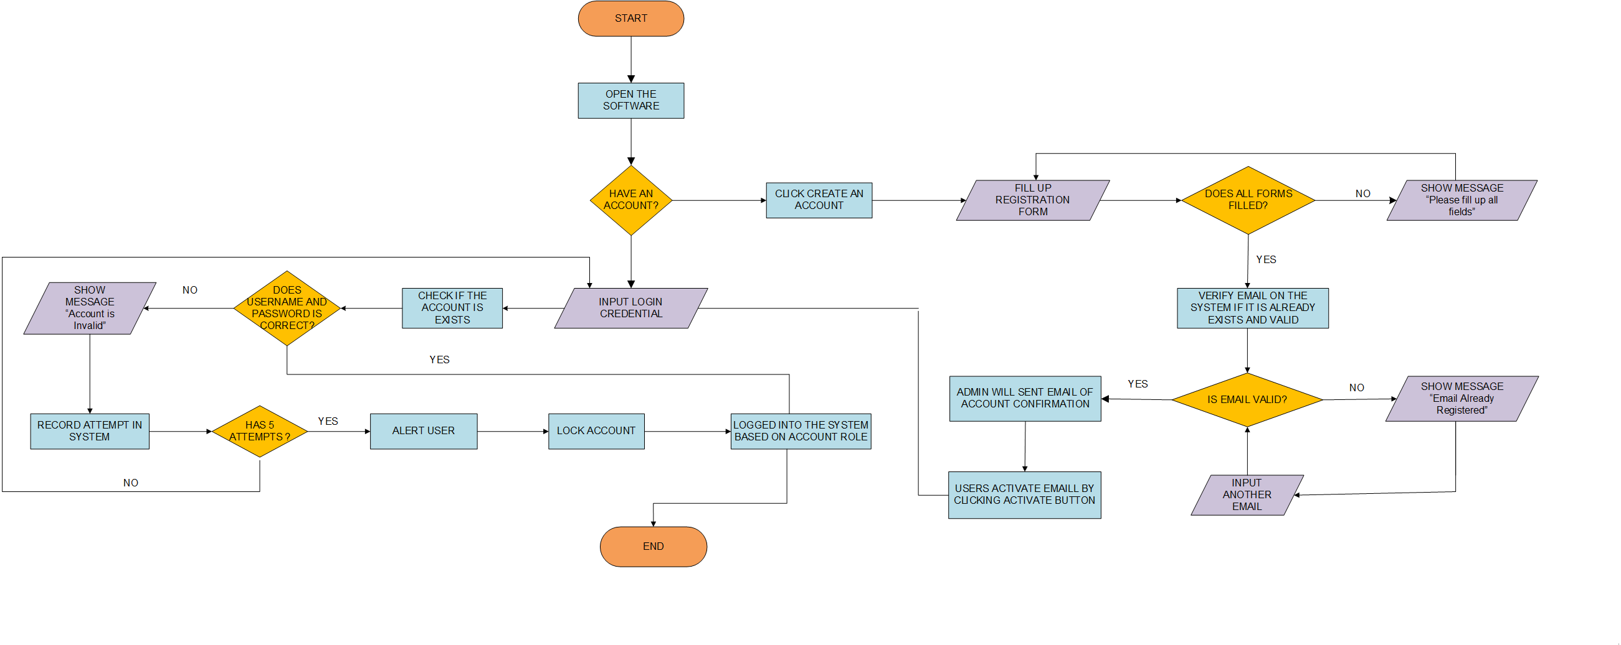

**ACCOUNT MODULE**

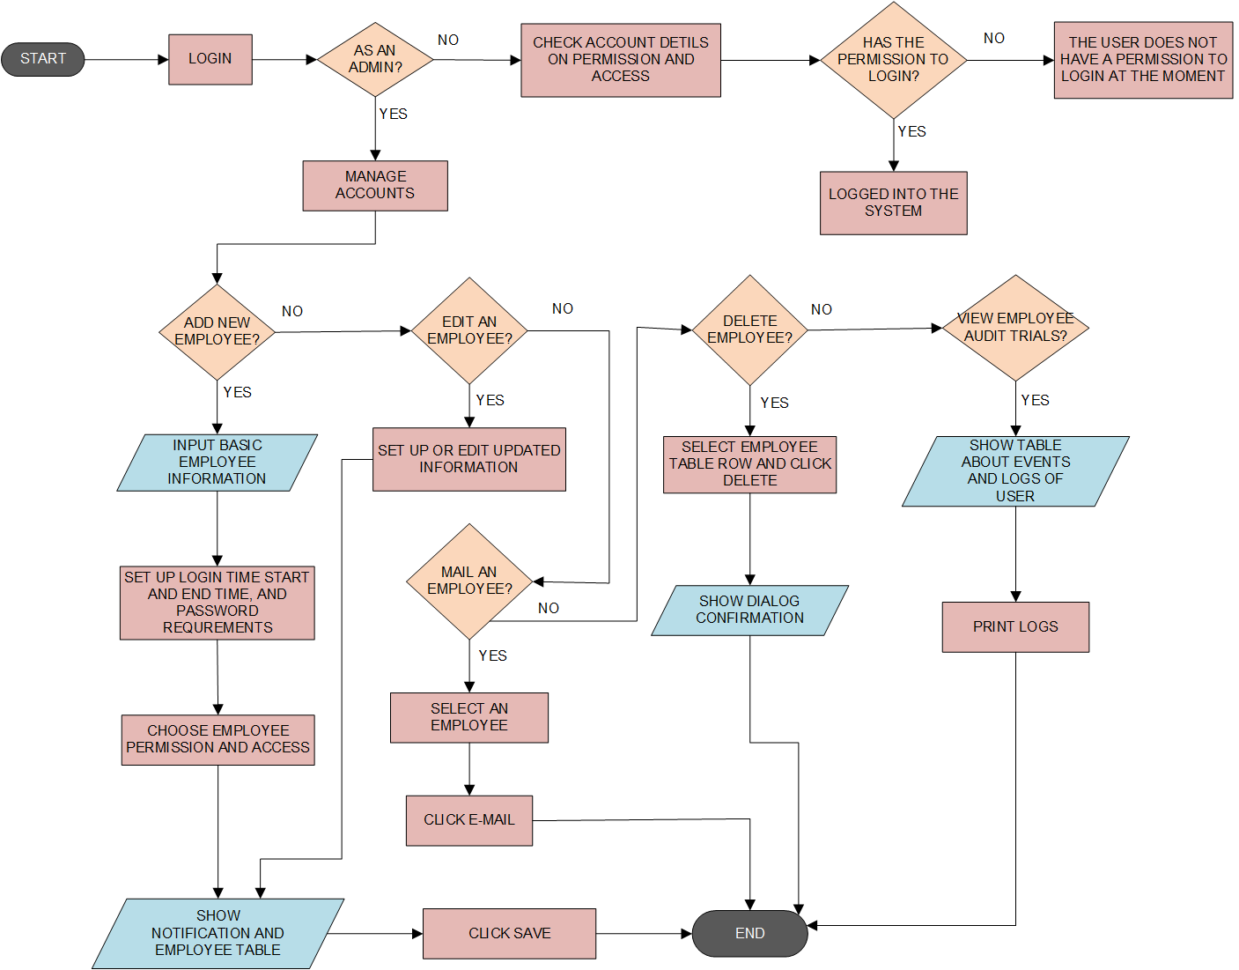

**ITEM MODULE**

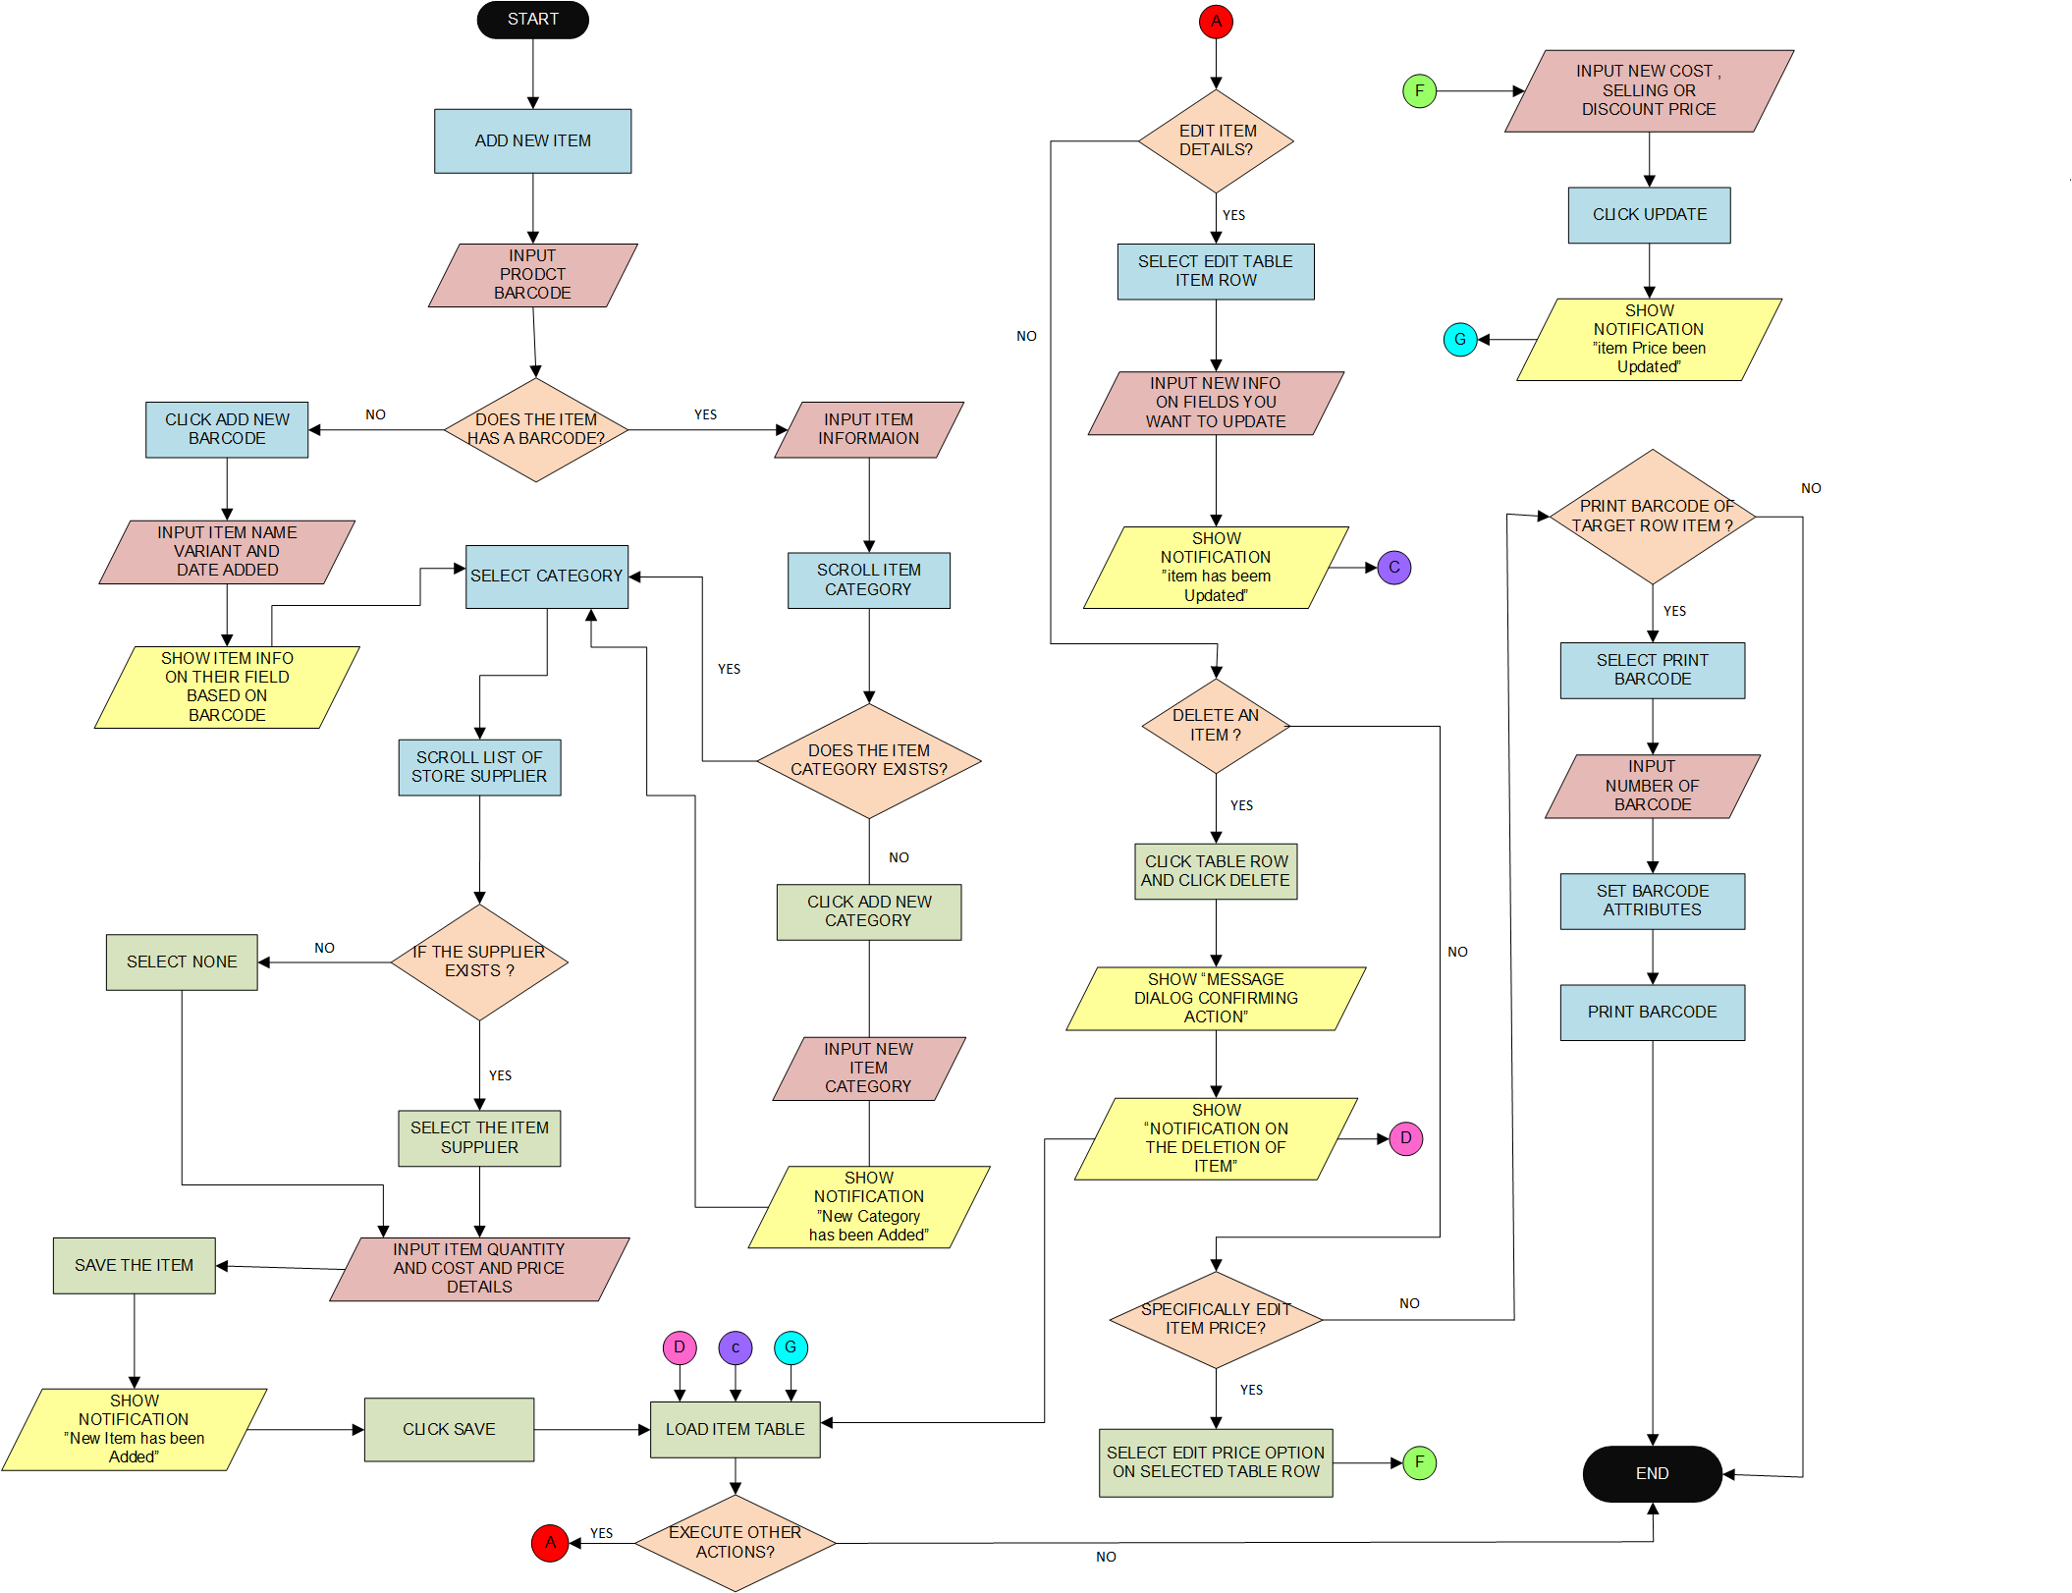

**INVENTORY MODULE**

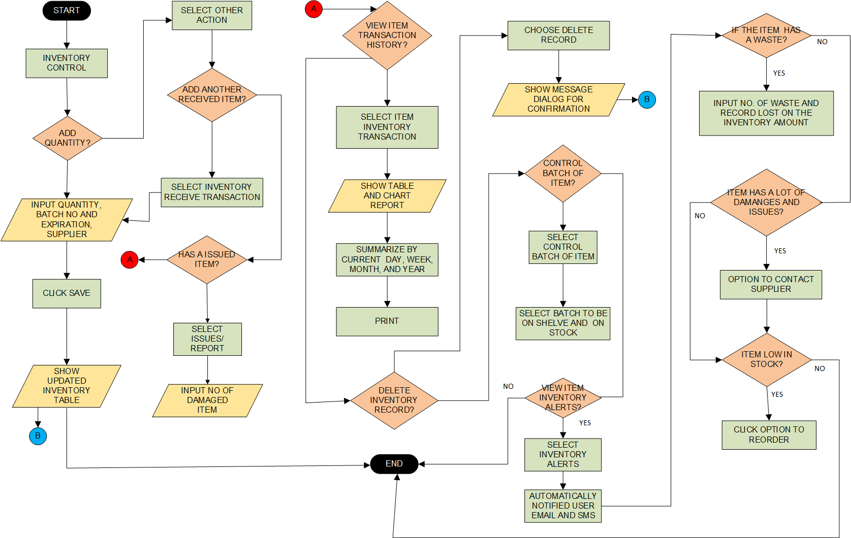

**SUPPLIER MODULE**

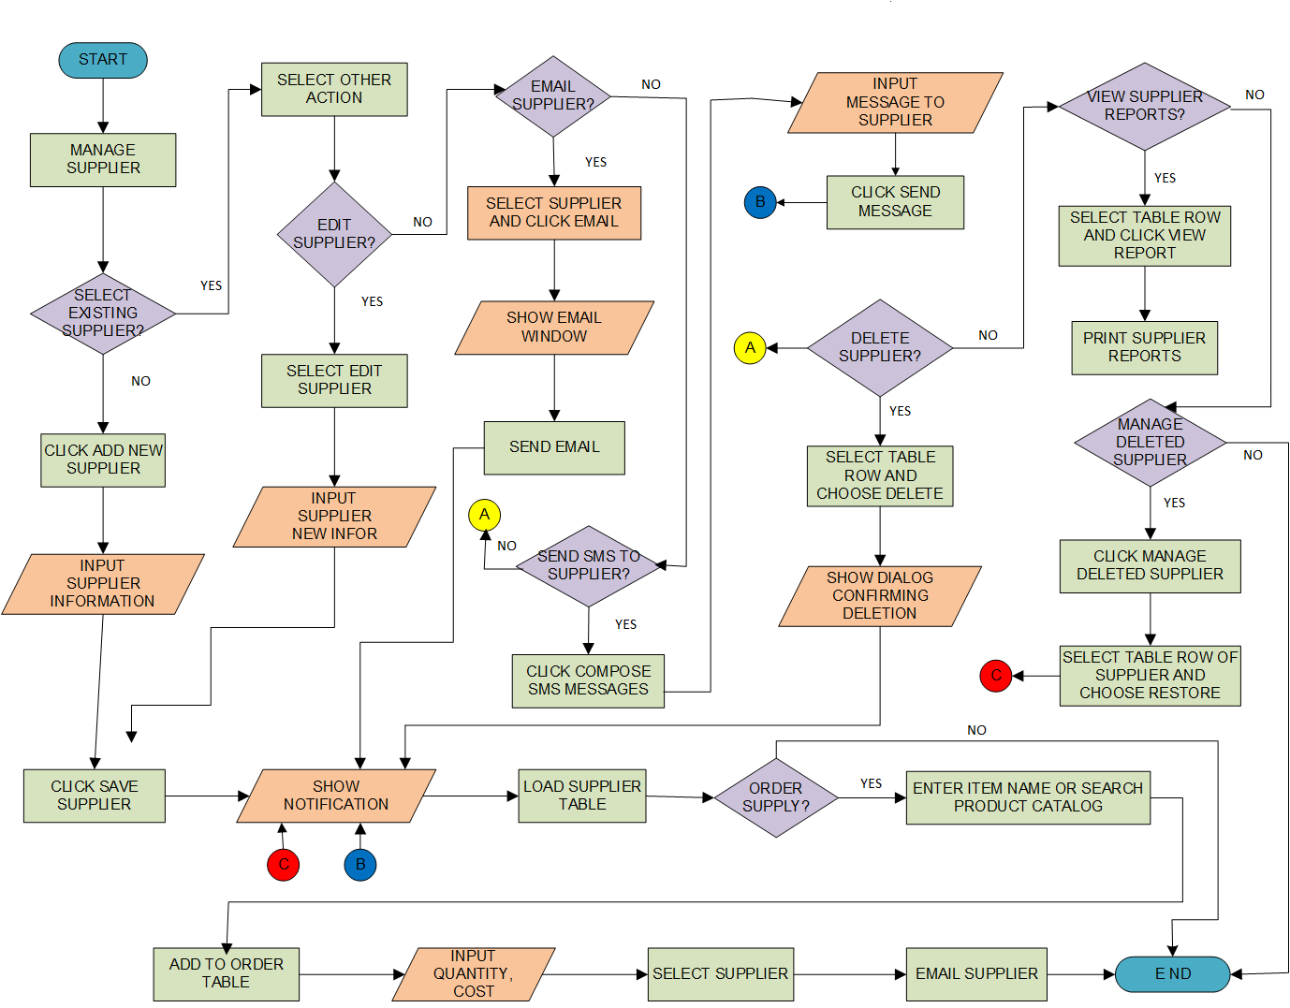

**SALES ORDER MODULE**

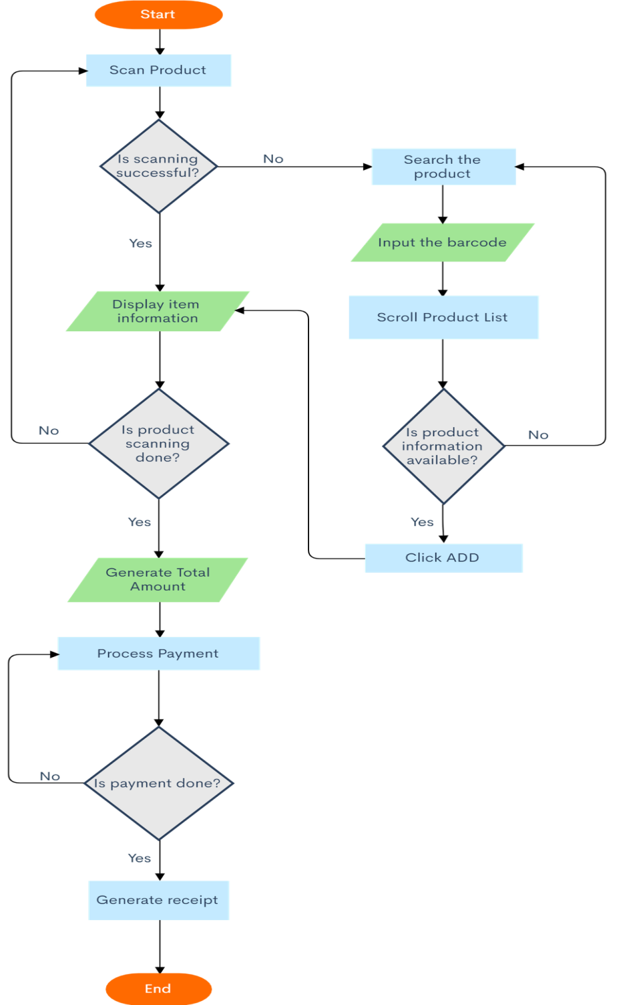

**FINANCIAL AND ANALYTICS MODULE**

