ESS Technical Agreement
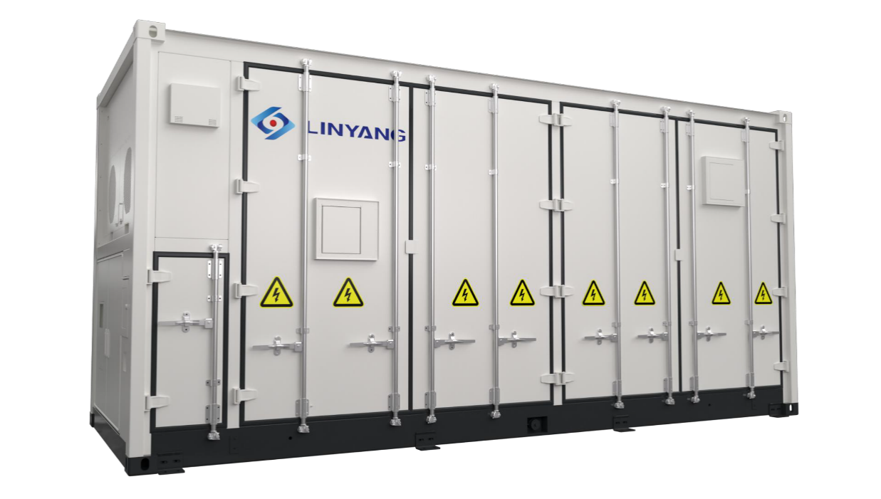

The Customer | XXX
Project Name | Cyprus 2.5MW/10MWh Project
Project Requirement@ Nominal | 2.5MW/10MWh
Installation Capacity | 2.5MW/10MWh
Project Location | Famagusta
Contact | Customer side:  XXX  Linyang side:  XXX
Version | 1.0

2026/04/29
Jiangsu Linyang Energy Storage Technology Co., Ltd

Content
Content 1
1 Overview 5
2 Standard 6
3 System Design 8
3.1 Product Environmental Adaptability Information 8
3.2 System Configuration 8
3.3 System Equipment List (Supply Scope) 9
4 System Introduction 11
4.1 Battery Unit 11
4.1.1 Battery Cell 12
4.1.2 Battery Pack 13
4.1.3 Battery String 13
4.1.4 Battery Management System (BMS) 14
4.1.5 Liquid Cooling System 20
4.1.6 Fire Suppression System 22
4.2 Auxiliary Power 25
4.3 PCS&MV Skid 25
4.3.1 Product Specification 26
4.4 RMU 28
5 Disclaimer 29
6 Signature 31

Figures
Fig. 1 Appearance of 5.015MWh container (Reference) 11
Fig. 2 Appearance of battery cell (Reference) 12
Fig. 3 The diagram of battery pack (Reference) 13
Fig. 4 Communication framework of BMS (Rated 5.015 MWh System) (Reference) 15
Fig. 5 Flow direction of coolant in pack (Reference) 20
Fig. 6 Liquid cooling design of system (Reference) 21
Fig. 7 System schematic (Reference) 21
Fig. 8 Logic diagram of the container BESS and fire protection system (Reference) 24
Fig. 9 Appearance of PCS&MV Skid (Reference) 26

Tables
Tab. 1 System Equipment List (Supply Scope) 9
Tab. 2 Parameters of energy storage system 11
Tab. 3 Specification of battery cell 12
Tab. 4 Parameters of battery pack 13
Tab. 5 Parameters of battery string 13
Tab. 6 Technical parameters and indicators required for the battery management system 14
Tab. 7 Fault diagnosis item list 15
Tab. 8 Data upload list（by the final design） 17
Tab. 9 BMS electrical parameters 18
Tab. 10 BMS data collection parameters 18
Tab. 11 BMS computation & storage parameters 19
Tab. 12 BMS other parameters 20
Tab. 13 The liquid cooling unit main technical parameters 22
Tab. 14 The components in fire suppression system 24
Tab. 15 Technical Parameters of PCS&MV Skid 26

Abbreviations
BESS | Battery Energy Storage System
BMS | Battery Management System
BMU | Battery Management Unit
PDU | Power Distribution Unit
DC | Direct Current
AC | Alternating Current
DOD | Depth of Discharge
EMS | Energy Management System
FSS | Fire Suppression System
POC | Point of Connection
SOC | State of Charge
SOH | State of Health
RMU | Ring Main Unit

- Overview
Purpose
The purpose of this document is to clearly define LINYANG’s scope of supply for Battery Energy Storage System (BESS) projects and to specify the technical characteristics of all equipment included within this scope.
Scope of Supply and Technical Features
The scope of supply and the technical specifications outlined herein are based on technical discussions and mutual understanding between the Customer and LINYANG.
Customer’s Obligations
To prevent any misunderstandings or unforeseen non-conformities, the Customer shall provide LINYANG with all relevant technical requirements in writing prior to the issuance of the purchase order.
Technical Agreement
A comprehensive Technical Agreement, incorporating all technical requirements, shall be executed by both parties before the commencement of factory production. The Technical Agreement shall only be deemed valid and enforceable once it has been duly reviewed, agreed upon, and signed by both the Customer and LINYANG.
Language
All nameplates, specification sheets, and other technical information of the equipment shall be in English.

- Standard
The battery product shall meet standard as shown below in this project.
IEC62619: Secondary cells and batteries containing alkaline or other non - acid electrolytes - Safety requirements for secondary lithium cells and batteries, for use in industrial applications
IEC63056: Secondary cells and batteries containing alkaline or other non - acid electrolytes - Safety requirements for secondary lithium cells and batteries for use in electrical energy storage systems
EN61000-6-2: Electromagnetic compatibility (EMC) - Part 6 - 2: Generic standards - Immunity standard for industrial environments
EN61000-6-4: Electromagnetic compatibility (EMC) - Part 6 - 4: Generic standards - Emission standard for industrial environments
EN62477-1: Safety requirements for power electronic converter systems and equipment - Part 1: General
The PCS product shall meet standard as shown below in this project.
IEC 62477: Safety Requirement for Power Electronic Converter System and Equipment
EN 61000: Electromagnetic Compatibility (EMC)
NC RfG: Grid Connection Requirements for Generators (Inverters, PCSs) (in compliance with EU 2016/631 and PTPiREE procedures).
EN50549-2: Requirements for grid connection and operation of generating units connected to medium-voltage distribution networks
VDE FNN (V2.1): German grid code that requires inverter-based resources to provide grid-forming capabilities, including voltage and frequency support, inertial response, and stable operation in weak grids.
Note: Any additional grid-forming requirements exceeding VDE FNN (V2.1) shall be subject to price recalculation, and a revised formal quotation will be provided. Both parties shall further confirm such requirements through mutual consultation.

- System Design
  - Product Environmental Adaptability Information
No. | Project Information
1 | System Application | Outdoor
2 | Temperature Range | -20~40℃
3 | Humidity Range | 0~95%
4 | Required Anti-corrosion Level | C5-M
5 | Altitude | <2000m
6 | AC connection voltage | 22kV
  - System Configuration
The whole solution has 1 ESS block; the total rating is 2.5MW/10.03MWh
The 2.5MW/10.03MWh ESS block comprises one 2.5MW PCS and MV skid-mounted units, as well as two battery container units with a capacity of 5.015MWh each.
Each LFP battery container contains the battery system, battery management system, thermal management system, fire suppression system, and control cabinet.
Each PCS&MV Skid Unit (2.5MW) consists of 2 sets of PCS (1.25MW), 1 set of 22kV transformer, 1 set of Auxiliary transformer and 1 set of RMU.
*Note:
1. The attenuation of battery storage and shipment should be considered when testing the AC usable capacity.
2. The test of AC usable capacity shall be conducted according to the test conditions of SAT.
3. The EMS is provided by customer. Communication protocol is Modbus. It is required to consider the grid forming, black start and synchronization control function .
  - System Equipment List (Supply Scope)
                - System Equipment List (Supply Scope)
2.5MW/10.03MWh Liquid-Cooling Energy Storage System Configuration List |  |  |  | Famagusta, Cyprus
No. | Item | Specifications | Unit | Qty | Remark
1 | 1500V Liquid Cooling Battery Container | 20 HC 5.015MWh lithium iron phosphate battery system | set | 2
1.1 | Battery | 5.015MWh (314Ah, 1P104S4S*12P, 0.5C, including BMU, BCU, BAU three-level battery management, high-voltage box, battery rack and system accessories, etc.) | set | 1 | - EVE battery cell
1.2 | BMS | Including BMU、BCU、BAU three-level architecture | set | 1
1.3 | Control Busbar Cabinet | 12 in 1, including UPS, switches, etc. | set | 1
1.4 | Temperature Control System | Liquid cooling unit | set | 1
1.5 | Fire Suppression System | Pack and system level aerosol fire suppression, system level combustible gas detectors + explosion-proof ventilation system, water fire suppression system | set | 1
1.6 | Container | Dimensions: (W*H*D) 6058 × 2896 × 2438mm  Anti-corrosion level: C5-M | pcs | 1 | - C5-M  - IP55 rating  - ≤2000m  - Auxiliary power provided by PCS&MV Skid:  AC380V A/B/C/N/PE, 48kVA & AC220V L/N/PE 1kVA  - Paint Color: Door & Container body RAL9003;  Bottom RAL9005
2 | PCS&MV Skid Container | 2.5MW | set | 1
2.1 | PCS | BCS1250K-C-HUD | set | 2 | - Grid forming  - Black Start  - Off-grid operation  - Kehua  - C5-M  - IP65 rating  - No derating at 45℃
2.2 | Step-up Transformer | 2500kVA/ 22-0.69kV, oil immersed | set | 1 | -2500kVA@40℃  -Dy11  -Al/Al  -Ecodesign Tier2  - Transformer body: IP68, Other parts: IP54  - Mineral oil
2.3 | Auxiliary Transformer | 125kVA/ 0.69-0.38kV, dry type | set | 1 | - Auxiliary power for Battery Container, PCS & MV Skid
2.4 | Ring Main Unit | SF6 free | set | 1 | -Mingyang  -DCV  -24kV  -SF6 free  -630A
2.5 | Enclosure and Aux | Dimensions: (W*H*D) 6058 × 2896 × 2438mm  Including internal cable accessories, auxiliary power distribution. Anti-corrosion level: C5-M, etc. | pcs | 1 | - C5-M  - IP54 rating  - ≤2000m  - Paint Color: Door & Container body RAL9003;  Bottom RAL9005  - Standard for no supply of oil retention tank
Note:
1. NOT included: the power cables and the communication cables between the PCS&MV skid, the EMS and the battery container.
2. The nameplate capacity is 2.5MW/10.03MWh.
3. Product applicable altitude: <2000m; Ambient temperature range: -20℃~40℃.
4. Single battery container noise: 75dB at 1m, single PCS noise: 75dB at 1m.
5. Grid support: Active & reactive power control, grid forming, off-grid and black start.
- System Introduction
  - Battery Unit

              - Appearance of 5.015MWh container (Reference)
                - Parameters of energy storage system
Item |  | Specification
Battery type |  | 314Ah
Configuration |  | 12P416S
Rated energy/ kWh |  | 5015
Battery voltage range/ V |  | 1164.8 ~ 1497.6
Duration/ h |  | ≥4
Communication |  | Ethernet / CAN / RS485
Thermal Management |  | Liquid cooling
Fire Suppression System |  | Automatic fire protection system & explosion-proof system & emergency water system
Dimension (W x D x H)/ mm |  | 6,058 x 2,438 x 2,896
Weight/ T |  | ~ 41.5
Operation temperature/ ℃ | Charge | 0 ~ 50
 | Discharge | -20 ~ 50
Humidity (storage/operating) |  | ＜95% RH (non-condensing)
Max. working altitude |  | 2000m
IP level |  | IP55
Degree of anti-corrosion |  | C5
Communication interfaces |  | Ethernet
Certificates |  | IEC62619, IEC 63056, IEC 62477-1, IEC61000, UN38.3/UN3536
    - Battery Cell
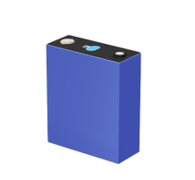
              - Appearance of battery cell (Reference)
                - Specification of battery cell
Item |  | Specification
Battery type |  | LFP
Capacity/ Ah |  | 314
Nominal voltage/ V |  | 3.2
Voltage range/ V |  | 2.5 ~ 3.65
Rated energy/ Wh |  | 1004.8
Charge/Discharge Current | Standard | 0.5P
Dimension (W x D x H)/ mm |  | (207.7±1.0) x (71.7±2.0) x (174±1.0)
Weight/ Kg |  | 5.6±0.3
Operation temperature/ ℃ | Charge | 0 ~ 50
 | Discharge | -20 ~ 50
Certificates (All finished) |  | UL 1973 / UL 9540A / IEC 62619  UN 38.3 / GB/T 36276 / ROHS / Bankability
    - Battery Pack
                - Parameters of battery pack
Item |  | Specification
Pack type |  | 1P104S
Capacity/ Ah |  | 314
Rated energy/ kWh |  | 104.499
Configuration |  | 1P104S
Nominal voltage/ V |  | 332.8
Voltage range/ V |  | 291.2-374.4
Duration/ h |  | ≥2
Operation temperature/ ℃ | Charge | 0 ~ 50
 | Discharge | -20 ~ 50
Dimension (W x D x H)/ mm |  | (790±5) *(2180±5) *(252±5)
Weight/ Kg |  | ~690±10
IP level |  | IP67
Thermal management |  | Liquid cooling
Certificates |  | IEC 62619/63056/EN IEC 61000-6-2/61000-6-4
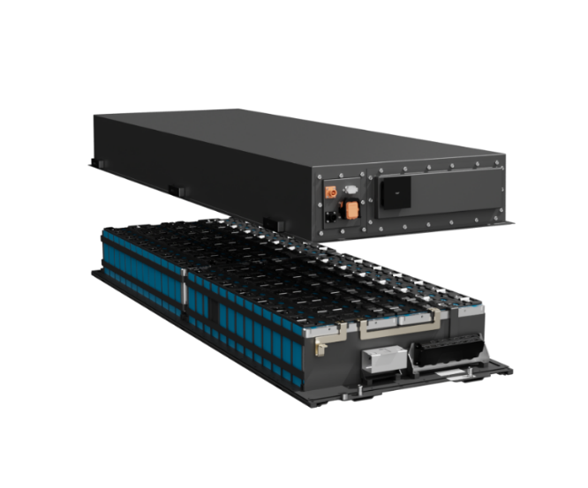
              - The diagram of battery pack (Reference)
    - Battery String
                - Parameters of battery string
Item |  | Specification
String type |  | 1P416S
Battery type |  | LFP
Capacity/ Ah |  | 314
Key Component |  | 4 Packs
Rated energy/ kWh |  | 417.996
Configuration |  | 1P416S
Nominal voltage/ V |  | 1331.2
Voltage range/ V |  | 1164.8 ~ 1497.6
Duration/ h |  | ≥2
Operation temperature/ ℃ | Charge | 0 ~ 50
 | Discharge | -20 ~ 50
Thermal management |  | Liquid cooling
Certificates (All finished) |  | IEC 62619/63056/EN IEC 61000-6-2/61000-6-4
    - Battery Management System (BMS)
                - Technical parameters and indicators required for the battery management system
Level | Configuration | Functionality
Level 1 | BMU *1 per Pack | - Detects individual cell voltage and temperature, compiles the collected data, and reports it.  - Acts as the balancing unit for cell voltage, performing autonomous balancing or following commands from higher-level units.  - Conducts real-time self-diagnosis of sampling and balancing circuits, reporting results in real-time.  - Communicates with the higher-level BCU through Daisy Chain communication.
Level 2 | BCU *1 per battery string | - Collects temperature, voltage, current, and SOC information uploaded by battery packs within the string.  - Calculates battery SOH based on calibration operations.  - Manages the normal operation and alarm information of the battery string, controlling the opening and closing of the string’s DC switch as needed.  - Issues balancing commands based on the voltage status within the string.  Issues insulation detection commands as per higher-level instructions.  - Uploads battery string parameters and switch status to the BAU through Ethernet or CAN communication, and receives control instructions from BAU.
Level 3 | BAU *1 | - Collects and manages BCU information from the second level through the switch, overseeing voltage, current, temperature, and SOC of lower levels.  - Manages the direction of the energy flow of the storage system in coordination with the EMS, SCADA, and PCS management systems.  - Monitors bus voltage, total current, and bus insulation.  - Consolidates overall alarm and protection statuses and decides whether to control the main circuit breaker for protection.  - Calculates the SOC of connected batteries and calibrates battery capacity based on the cycle status.  - Transmits data to the touchscreen and responds to local control commands issued from the touchscreen.
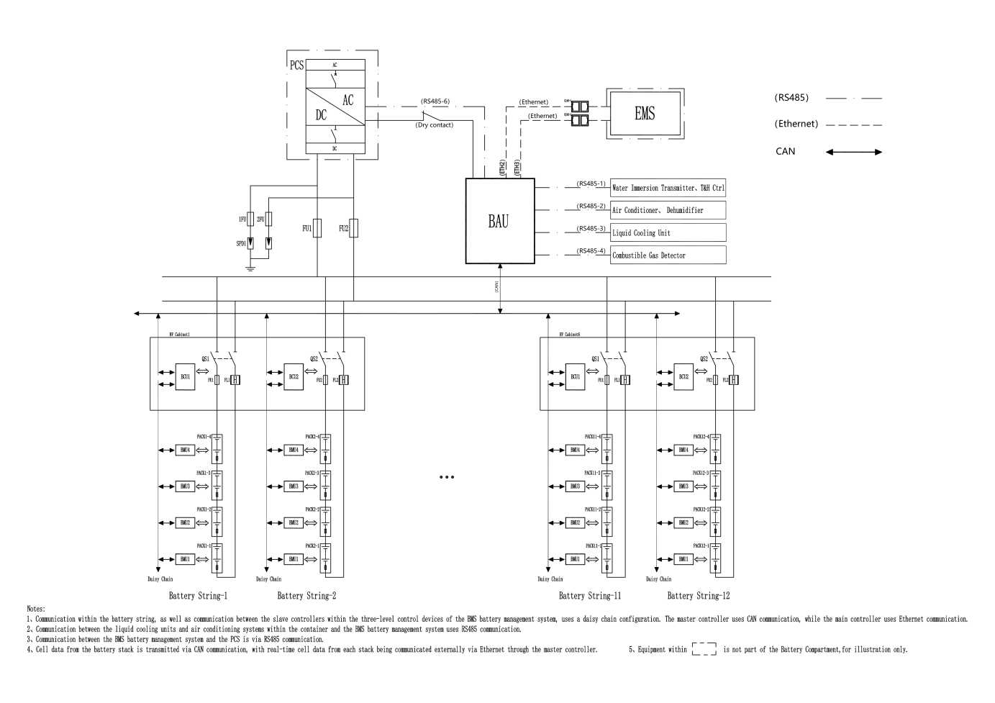
              - Communication framework of BMS (Rated 5.015 MWh System) (Reference)
                - Fault diagnosis item list
No. | Alarms and Fault Protection
1 | Cell Charging Voltage Primary Warning
2 | Cell Charging Voltage Secondary Warning
3 | Cell Charging Voltage Tertiary Warning
4 | Cell Discharging Voltage Primary Warning
5 | Cell Discharging Voltage Secondary Warning
6 | Cell Discharging Voltage Tertiary Warning
7 | Pack Charging Voltage Primary Warning
8 | Pack Charging Voltage Secondary Warning
9 | Pack Charging Voltage Tertiary Warning
10 | Battery String Charging Voltage Primary Warning
11 | Battery String Charging Voltage Secondary Warning
12 | Battery String Charging Voltage Tertiary Warning
13 | Battery String Discharging Voltage Primary Warning
14 | Battery String Discharging Voltage Secondary Warning
15 | Battery String Discharging Voltage Tertiary Warning
16 | Level 1 Alarm Value for Voltage Range Difference of Battery Cells in Battery String During Charging
17 | Level 2 Alarm Value for Voltage Range Difference of Battery Cells in Battery String During Charging
18 | Level 3 Alarm Value for Voltage Range Difference of Battery Cells in Battery String During Charging
19 | Level 1 Alarm Value for Voltage Range Difference of Battery Cells in Battery String During Discharging
20 | Level 2 Alarm Value for Voltage Range Difference of Battery Cells in Battery String During Discharging
21 | Level 3 Alarm Value for Voltage Range Difference of Battery Cells in Battery String During Discharging
22 | Battery String Charging Current Primary Warning
23 | Battery String Charging Current Secondary Warning
24 | Battery String Charging Current Tertiary Warning
25 | Battery String Discharging Current Primary Warning
26 | Battery String Discharging Current Secondary Warning
27 | Battery String Discharging Current Tertiary Warning
28 | Cell Overtemperature Primary Warning
29 | Cell Overtemperature Secondary Warning
30 | Cell Overtemperature Tertiary Warning
31 | Cell Low temperature Primary Warning
32 | Cell Low temperature Secondary Warning
33 | Cell Low temperature Tertiary Warning
34 | Level 1 Alarm Value for Temperature Range Difference of Battery Cells in Battery String During Charging
35 | Level 2 Alarm Value for Temperature Range Difference of Battery Cells in Battery String During Charging
36 | Level 3 Alarm Value for Temperature Range Difference of Battery Cells in Battery String During Charging
37 | Level 1 Alarm Value for Temperature Range Difference of Battery Cells in Battery String During Discharging
38 | Level 2 Alarm Value for Temperature Range Difference of Battery Cells in Battery String During Discharging
39 | Level 3 Alarm Value for Temperature Range Difference of Battery Cells in Battery String During Discharging
40 | Cut-off Threshold of Cell Temperature Maximum Deviation during Battery String Charging
41 | Cut-off Threshold of Cell Temperature Maximum Deviation during Battery String Discharging
42 | Level 3 Insulation Resistance Alarm Signal of Battery String
43 | Level 1 Insulation Resistance Alarm Signal of Battery String
                - Data upload list（by the final design）
No. | Data Type | Data Name | Remarks
1 | Battery stack status | Alarm Total
2 |  | Fault Total
3 |  | Current Status | Idle, Charging, Discharging
4 | Battery Stack information | Battery Stack Average SOC
5 |  | Battery Stack Discharge Power Limit
6 |  | Battery Stack Charge Power Limit
7 |  | Battery Stack Discharge Current Limit
8 |  | Battery Stack Charge Current Limit
9 |  | Current Total Discharge Capacity
10 |  | Current Total Charge Capacity
11 |  | Battery Stack Voltage
12 |  | Battery Stack Current
13 |  | Battery String Operating Status
14 |  | Battery String Charge/Discharge Status
15 |  | Battery String Operating Mode
16 |  | Battery String Control Mode
17 | Battery String information | Battery String Total Current
18 |  | Battery String Operating Power
19 |  | Battery String Total Voltage
20 |  | Battery String Overall SOC
21 |  | Battery String Operating SOC
22 |  | Battery String Available SOC
23 |  | Battery String SOH
24 |  | Battery String Charge Current Limit
25 |  | Battery String Discharge Current Limit
26 |  | Battery String Charge Power Limit
27 |  | Battery String Discharge Power Limit
28 |  | Battery String Charge Capacity
29 |  | Battery String Discharge Capacity
30 |  | Battery String Minimum Cell Voltage
31 |  | Battery String Minimum Voltage Cell Group Number
32 |  | Battery String Minimum Voltage Cell Number
33 |  | Battery String Maximum Cell Voltage
34 |  | Battery String Maximum Voltage Cell Group Number
35 |  | Battery String Maximum Voltage Cell Number
36 |  | Battery String Minimum Cell Temperature
37 |  | Battery String Minimum Temperature Cell Group Number
38 |  | Battery String Minimum Temperature Cell Number
39 |  | Battery String Maximum Cell Temperature
40 |  | Battery String Maximum Temperature Cell Group Number
41 |  | Battery String Maximum Temperature Cell Number
42 | Cell information | Cell Voltage
43 |  | Cell Temperature
                - BMS electrical parameters
Item |  | Parameter | Remarks
*Balancing Method |  | Passive
*Balancing Current |  | 100mA
*Balancing Efficiency |  | /
*Power Consumption | Cell Monitoring Module Power Consumption | ≤2W
 | BMS Control Module Power Consumption | ≤3W
 | BMS Display and Control Module Power Consumption | ≤15W
                - BMS data collection parameters
Item |  | Parameter | Remarks
Voltage collection | Group Terminal Voltage Detection Range | <1500V
 | Group Terminal Voltage Detection Accuracy | ±0.5%
 | Single Cell Voltage Detection Range | 1.5~4.5V
 | Single Cell Voltage Detection Accuracy | ±3mV
 | Voltage Collection Interval | ≤100ms
 | Voltage Transmission Mode | Change-based Upload+ Periodic Upload
 | Voltage Transmission Interval | ≤5s
Current collection | Current Detection Range | ±500A
 | Current Detection Accuracy | ≤±0.5%
 | Current Collection Interval | ≤50ms
 | Current Transmission Mode | Change-Based Transmission + Periodic Transmission
 | Current Transmission Interval | ≤1s
Temperature Collection | Temperature Detection Range | -40～125℃
 | Temperature Measurement Accuracy | ±1℃
 | Temperature Resolution | ≤1℃
 | Temperature Collection Interval | ≤1s
 | Temperature Transmission Mode | Change-Based Transmission + Periodic Transmission
 | Temperature Transmission Interval | ≤5s
Isolation Resistance Detection | Detection Accuracy | <10%
                - BMS computation & storage parameters
Item |  | Parameter | Remarks
*SOE Calculation Accuracy |  | ≤5% | Self-calibration function recommended
SOE Calculation Update Cycle |  | ≤3s
Energy Calculation Error |  | ≤±3%
Event Logging |  | ≥100000 lines | Accurate to sec
Information Storage Duration |  | 180 days
Fault Recording | Current Recording Interval | ≤50ms
 | Voltage Recording Interval | ≤1s
 | Temperature Recording Interval | ≤5s
 | Recording Duration | ≥10min
                - BMS other parameters
Item | Parameter | Remarks
BMS System Architecture | Three-tier BMS Architecture
Protection Level | IP 3X | Dust Protection Measures Required
*Durability | 10years
    - Liquid Cooling System
The battery part of the system adopts liquid cooling technology to dissipate heat. Liquid cooling technology brings less loss and better temperature uniformity. The liquid cooling system mainly comprises of pipes, pumps, heat exchangers and compressors. The coolant of the system is mixed solution of ethylene glycol and water. The coolant flows from the water inlet pipe to the 6 main longitudinal branches. Each main branch is divided into 8 branches and flows to the liquid cooling pack to cool / heat the cell. After flowing out of the pack, it is summarized to the return pipe through the branch pipe and returned to the liquid cooling unit.
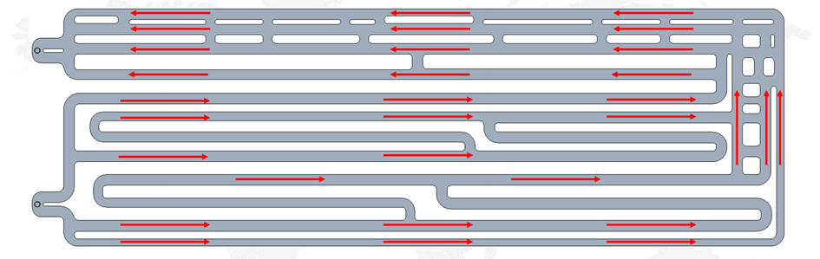
              - Flow direction of coolant in pack (Reference)
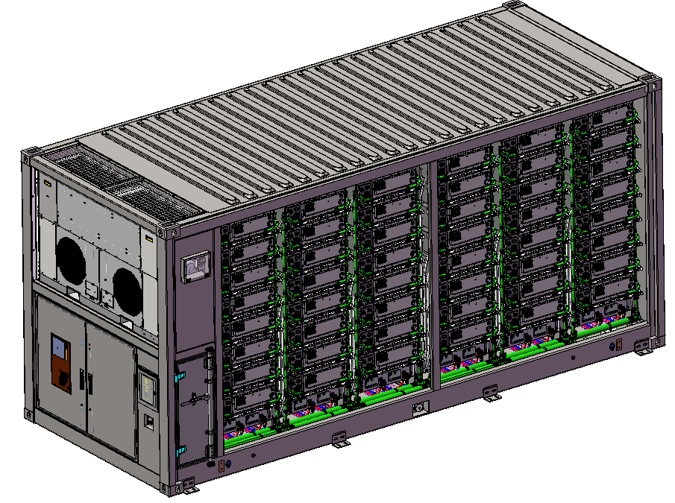
              - Liquid cooling design of system (Reference)
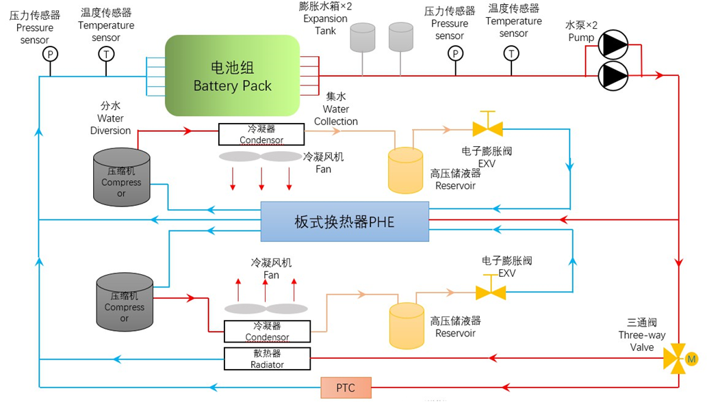
              - System schematic (Reference)
                - The liquid cooling unit main technical parameters
Model | BTMS-600-ESB11
Cooling Capacity / kW | 60(The ambient temperature is 45 °C and the outlet water temperature is 20 °C)
Heating Capacity / kW | 16
Total Power Supply / V | 480V (323~552V)
Frequency / Hz | 50/60
Phase | 3
No. of Wires | 5
Total A – Cooling / A | 43
Maximum Operating Current / A | 60
Total A – Heating / A | 26
Refrigerant, Type | R513a
Amount / oz | 113*2
Design Pressure | -
High Side / psig (MPa) | 319 (2.2)
Low Side / psig (MPa) | 217 (1.5)
Operating Ambient Temperature / ℃ | -30~55
Coolant Outlet Temperature / ℃ | 5~35(Cooling); ＜40(Heating)
Rate Of Flow / L/Min | 500(@150kPa
Altitude / m | 0~4000
IP | IP26(Entire machine) IP67(Electrical components)
Cabinet Outer Enclosure
Length / mm (max) | 2100
Depth / mm | 550
Height / mm (max) | 1230
Thickness / mm (min) | 2.5
Material | Aluminum
Weight / kg | ≤410
Color | RAL9003
    - Fire Suppression System
The designs the container fire protection solution with automatic fire protection system + explosion-proof system + explosion venting system + emergency water system (see topology and logic diagram of the fire protection system of the container of electrochemical energy storage), which strictly follows the relevant national standards and norms in order to ensure the scientificity, reasonableness and validity of the scheme, comprehensively safeguard fire protection of the electrochemical energy storage system, and ensure that the system can be safely run and highly effective response to fire accidents.
(1) Ventilation systems:
When combustible gas is generated from thermal runaway of the battery cell in the container, the combustible gas detector will immediately activate the ventilation system to ventilate the area when it detects that the concentration of combustible gas has reached a preset value, so as to prevent the risk of explosion when the combustible gas reaches the explosive concentration and encounters external energy.
- Automatic fire-fighting systems:
Each battery pack integrates one unit of QRR0.144G/S condensed-aerosol fire-suppression module, monitored by an embedded temperature-sensing wire. When thermal runaway drives the cell temperature to the preset threshold, the wire immediately registers the event and actuates the module, achieving rapid knock-down and preventing fire propagation.
When a fire occurs in the container, the smoke detector and the temperature detector detect the fire and transmits the signal to the gas fire suppression controller, which activates the aerosol fire extinguishing device in the container to start the fire extinguishing.
(3) Emergency water system:
Due to environmental or other factors, the automatic fire suppression system fails or the fire spreads to become a fire, professionals need to connect the water from the municipal fire hydrant to the water fire interface on the container to start the emergency water supply system.
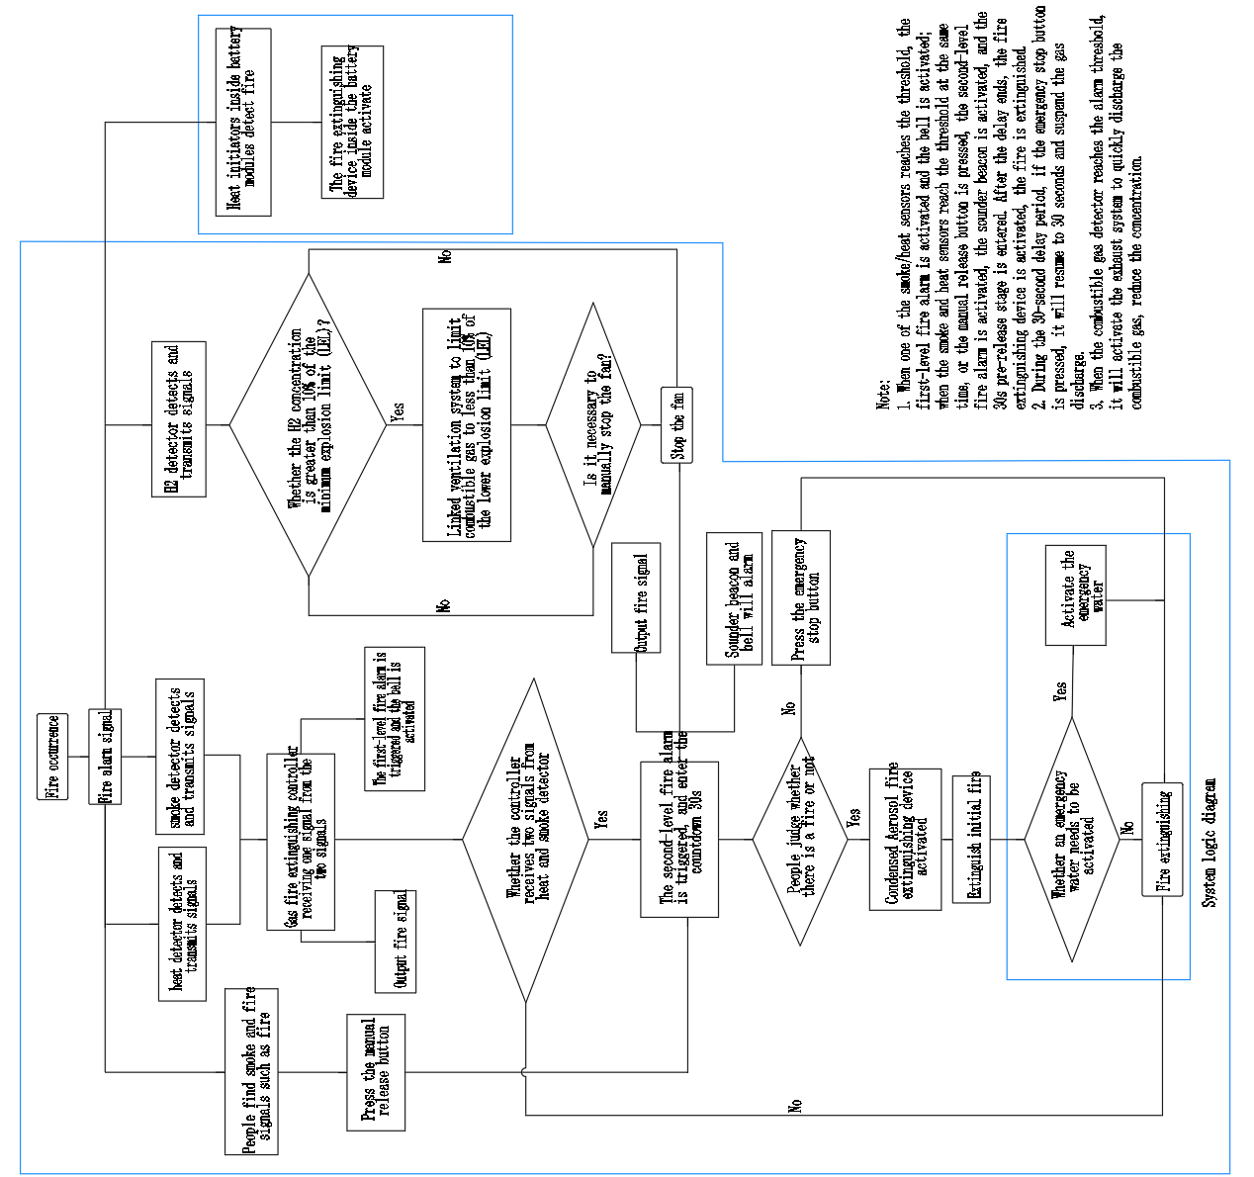
              - Logic diagram of the container BESS and fire protection system (Reference)
                - The components in fire suppression system
No | Protective  zone | Name | Model | Unit | Qty | Remark
1 | Automatic fire fighting systems | module level condensed aerosol fire extinguishing | QRR0.144G/S-MS-144-F-02-11 | Pcs | 96
2 |  | Condensed aerosol fire extinguishing device | QRR0.75G-U01 | Pcs | 5
3 |  | Extinguishant control panel | K11031M2 | Pcs | 1
4 |  | Smoke detector | 55000-316 | Pcs | 2
5 |  | Heat detector | 55000-121 | Pcs | 2
6 |  | Detector base | 45681-200APO | Pcs | 4
7 |  | Sounder beacon | 958CHL1000 | Pcs | 1
8 |  | Bell | CBE6-RS-024-EN | Pcs | 1
9 |  | Extinguishing holds off | K91000M10 | Pcs | 1
10 |  | Extinguishant Status Indicator | K911110M8 | Pcs | 1
11 |  | Backup battery | SSP12-7 | Pcs | 2
12 | Explosion proof exhaust system | Air intake fan | SSP12-7 | Pcs | 1
13 |  | Explosion-proof exhaust fan | CNF-350A | Pcs | 1
14 |  | Fan star & stop button | / | Pcs | 1
15 |  | Combustible gas detector | Xgard Bright-H2 | Pcs | 2
16 | Emergency water system | / | / | SET | 1
17 | Auxiliary materials | / | / | SET | 1
  - Auxiliary Power
The Battery container relies on an external power supply (from auxiliary transformer in PCS&MV skid in this case). The specific parameters are as follows:
Supply Type | Power Supply | Voltage Level | Frequency
External Auxiliary Power Supply | 48kVA | AC380V A/B/C/N/PE | 50Hz
 | 1kVA | AC220V L\N\PE | 50Hz
  - PCS&MV Skid
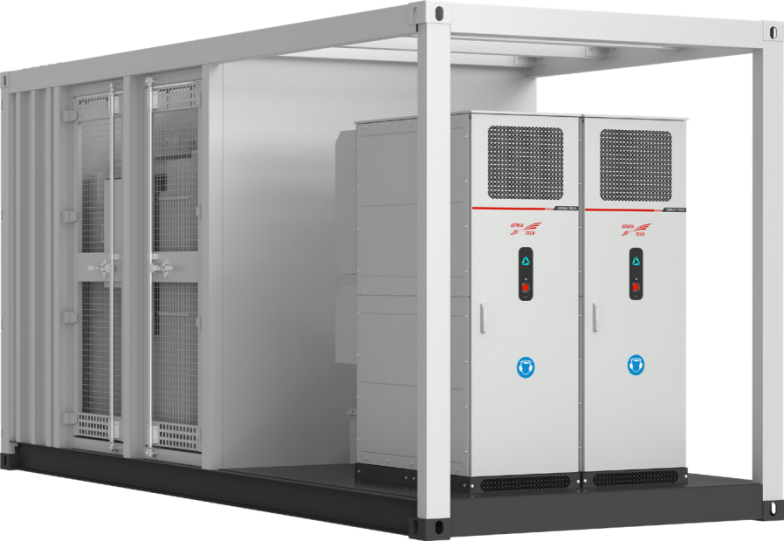
              - Appearance of PCS&MV Skid (Reference)
    - Product Specification
                - Technical Parameters of PCS&MV Skid
Technical Specification
Items | BCS2500K-C-HUD/T2
DC input
Max. DC voltage | 1500Vdc
DC voltage range | 1000-1500Vdc
Max. DC current | 1402A*2
Soft start | Yes
AC output (On-grid)
Rated AC output power | 2500kW@45℃
Max. AC output power | 2750kVA
Rated grid-tied voltage | 690Vac 3P3W+PE
Grid voltage range | -15%~10% (settable)
Grid frequency range | 50/60Hz
Max. output current | 2301A@690V
Power factor | >0.99 (at rated power)
Adjustable power factor | 1 (leading)~1 (lagging)
THDi | <3% (at rated power)
AC output (Off-grid)
Rated AC output voltage | 690Vac
Output voltage accuracy | 1%
Max. output current | 2301A@690V
THDu | <3% (liner load)
Rated output frequency | 50/60Hz
PCS efficiency
Max. efficiency | 99%*
Transformer
Rated power | 2500kVA@40℃
Voltage transformation ratio | 0.69/22kV
Rated frequency | 50 Hz (default)
Vector group | Dy11
Isolation mode | oil-immersed transformer (without emergency oil tank)
Minimum Peak Efficiency Index | Tier 2 Eco design
IP grade | body: IP68, Other parts: IP54
Anti-corrosion grade | C5-M
Auxiliary transformer
Type | Dry type
Rated power | 125 kVA
Rated frequency | 50 Hz (default)
Vector group | Dyn11
Rated voltage | 690 V / 380 V
IP grade | IP54
Anti-corrosion grade | C5-M
General data
IP rating | IP65(PCS) IP54(Skid)
Operation temperature | -35ºC~60ºC (>45ºC derating)
Relative humidity | 0~100% (no-condensing)
Cooling type | Intelligent air cooling
Dimensions (W×H×D) | 6058×2896×2438mm
Weight | <14000kg
Altitude | 2000m (>1000m derating)
Display | LED
Communication protocol | Modbus-RTU, Modbus-TCP, IEC61850, IEC104
Communication interface | RS485, CAN, Ethernet
NOTES:
- The PCS can work at all 4 quadrants with unity leading and lagging power factor.
  - RMU
The high-voltage switchgear serves as a critical device for connecting and interrupting the high-voltage side of the transformer with the upper-level power system. It includes necessary electrical equipment such as high-voltage vacuum circuit breakers, high-voltage earthing switches, high-voltage bushings, surge arresters, live line indicators.
Items | Specifications
Switchgear Type | Ring Main Unit
Rated voltage (kV) | 24
Insulating medium | SF₆-Free
Rated frequency (Hz) | 50
Enclosure protection degree | IP3X
Gas tank protection degree | IP67
Rated Operating Current (A) | 630
Switchgear Short Circuit Rating (kA/s) | 20kA/1s

- Disclaimer
        - The LINYANG shall not be held liable for defects, damages or underperformance of the device caused by the following conditions during the warranty period.
          - The on-site storage time of the device exceeds the limit specified in the contract.
          - The external ambient temperature and humidity for storage/operation of the device are beyond the allowable range.
          - The Customer fails to operate or maintain the device in accordance with Product Specifications and System Manual.
          - The device is used beyond the specified scope in the technical agreement.
          - The Customer fails to charge and discharge the battery within the storage limit in accordance with the requirements of the LINYANG. The device shall be stored for no more than 6 months after it leaves the LINYANG factories.
          - Allowing any battery string to hold a 0% SOC condition (or low SOC condition caused black start failure) or allowing any cell voltage to be held at or below 2.7V (Minimum Cell Voltage) for more than 120 consecutive hours during maintenance or shutdown period.
          - Force Majeure, including government acts, wars, and natural disasters.
          - Other faults or defects that are not caused by the LINYANG.
        - Adjustments shall be made to the capacity performance guarantee specified in the agreement, where capacity losses occur under the following three conditions:
          - The Customer caused delay in commissioning and grid connection.
          - Due to reasons attributable to the Customer, the storage temperature has deviated from the specified range.
          - Failure of the Customer to set RSOC of the ESS in accordance with the specified range during usage.
        - The capacity mentioned in this chapter shall be tested in accordance with the requirements of the LINYANG.
        - The LINYANG only provides the equipment, and does not provide any primary or secondary cables outside the container or between container. The LINYANG provides remote guidance wiring, but is not responsible for the laying, wiring, plugging, etc. of the cables.
        - If the energy storage container is not put into operation or connected to the grid, it needs to be regularly charged (at least once every 3 months) If a series of problems arise due to the battery being discharged due to long-term storage, LINYANG shall not be responsible.
        - The energy storage container is a standard product. If it is used in a specific project and involves functions other than the standard functions, communication with LINYANG is. If the standard functions cannot meet the needs, customization development will be necessary, and there will be development costs.
        - Regarding black start: The Owner/EPC shall be responsible for confirming the load required for black start, calculating the excitation inrush current during load startup, and ensuring the loads meet the PCS black start requirements. We shall not be liable for any black start failure caused by excessive startup current that exceeds the PCS load capacity.
- Signature
Signed by

Signed by

