Alexander Dean

Robert Boothe

COS 285

13 September 2017

Report: Program 2

The purpose of Program 2 was to develop a Java class that would fetch all of the Songs in the previously-constructed SongCollection whose beginning matched a user-inputted string. In addition to this, a Comparator was added to the Song class that compared songs based on their Artist. Finally, a counter was utilized to count how many comparisons were done in the program. This was used later on to calculate if the program matched the Big O theoretical time for the algorithms it contains. The following results were received when searching for various strings in the program. The strings to test are specified in the Homework 2 handout.

searching for: Beatles

Beatles, The, "1822! (Speech)"

Beatles, The, "A Beginning"

Beatles, The, "A Day In The Life"

Beatles, The, "A Hard Day's Night"

Beatles, The, "A Little Rhyme (Speech)"

Beatles, The, "A Shot Of Rhythm And Blues"

Beatles, The, "A Taste Of Honey"

Beatles, The, "Across The Universe"

Beatles, The, "Act Naturally"

Beatles, The, "Ain't She Sweet"

Figure 1: Search results for "Beatles"

searching for: Santana

Santana, "Africa Bamba"

Santana, "All I Ever Wanted"

Santana, "All The Love Of The Universe"

Santana, "America"

Santana, "Amor' (Sexo)"

Santana, "Angel Ft Sarah Mclachlan"

Santana, "Aye Aye Aye"

Santana, "Black Magic Woman/Gypsy Queen"

Santana, "Brown Skin Girl"

Santana, "Cartel De Santa - Perros"

Figure 2: Search results for "Santana"

searching for: Arlo

Arlo Guthrie, "City Of New Orleans"

Arlo Guthrie, "Coming Into Los Angeles"

Arlo Guthrie, "The Motorcycle Song"

Figure 3: Search results for "Arlo"

searching for: A

Aerosmith, "Ain't Enough"

Aerosmith, "Ain't that a Bitch"

Aerosmith, "All Your Love"

Aerosmith, "Amazing"

Aerosmith, "Angel"

Aerosmith, "Angel's Eye"

Aerosmith, "Animal Crackers"

Aerosmith, "Attitude Adjustment"

Aerosmith, "Avant Garden"

Aerosmith, "Baby, Please Don't Go"

Figure 4: Search results for "A"

searching for: Z

ZZ Top, "(Somebody Else Been) Shakin' Your Tree"

ZZ Top, "2000 Blues"

ZZ Top, "36-22-36"

ZZ Top, "A Fool For Your Stockings"

ZZ Top, "Antenna Head"

ZZ Top, "Arrested For Driving While Blind"

ZZ Top, "Asleep In The Desert"

ZZ Top, "Avalon Hideaway"

ZZ Top, "Backdoor Love Affair"

ZZ Top, "Backdoor Medley. I. Back Door Love Affair"

Figure 5: Search results for "Z"

searching for: X

Figure 6: Search results for "X"

For the search for “A”, the program performed 13 comparisons during the binary search, and returned 580 results. To see if it matches the appropriate Big O time, the formula below was performed.

$$580+\log_{2}\left(10514\right)=593.36$$

This value is very similar to the sum of 13 and 580. Error was calculated for this using the below equation.

$$\frac{593-593.36}{593}= -0.06\%$$

This error is very respectable, and demonstrates that the program does match the expected $O\left(K+\log_{2}{N}\right)$ that was given in the homework handout.

To ensure that the program still functioned within the provided GUI, the below screenshot shows a result for searching for “Pink Floyd”, then selecting the song “Another Brick in the Wall (Part II)” to display its lyrics.

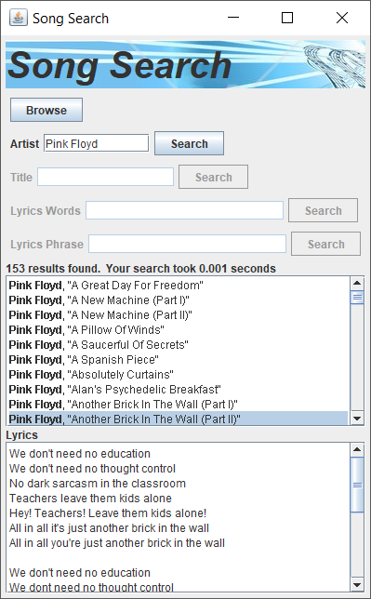

Figure 7: GUI displaying functioning search by Artist capability.