Equity Volatility
Wing Model Fitting

Adam Barber

26 November 2009
Version 1.0
DRAFT

Table of contents

1. Wing Model 3
1.1 Problem Description 3
1.1.1 Wing Model Description 3
1.1.2 Between cut offs 3
1.1.3 Outside cut-off range 4
1.1.4 Inside cut-off range 4
1.2 Fitting Approach 5
1.2.1 Inside cut-off range 5
1.2.2 Cut-off points and extremities 6
1.2.3 Example fit 7

Wing Model

Problem Description

Wing Model Description

The wing model is a set of four piecewise parabolas, defined over five regions, in the transformed strike coordinates,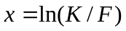,

where

is the strike, and
is the forward.

The five regions over which the x-axis is partitioned are defined by the cut-off points, and the upper and lower smoothing ranges.

Within the cut-off points, two continuously differentiable piecewise parabolas are defined.

Within each smoothing range, a single parabola extrapolates to a constant function value exterior to the smoothing range.

Exterior to the specified smoothing ranges, the wing model function takes on a constant value.

Between the cut offs

The lower (upper) cut-offs lie at a point less (greater) than the forward. These are -axis extremities with reference to the central skew point. These extremities determine what subset of the strike-volatility data is used to fit the two piecewise parabolas. Within these cut-offs, two piecewise parabolas, obeying certain regularity conditions, are then fit. The resulting two piecewise parabolas, 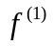(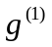) are applied as the wing volatility function between the cut-offs

Define

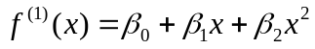, and 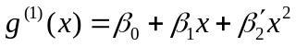.

In Orc parlance, denoted by italics,

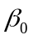is the current volatility,
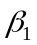is the current slope,
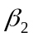is the put curvature, and
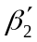is the call curvature.

Let 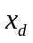denote the lower cut-off, and
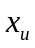denote the upper cut-off.

Between the specified cut-off points, in the interval 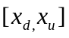, the wing model is defined as

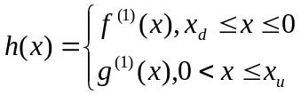 (1)

Inside the cut-off range

Exterior to the lower and upper cut-off points is defined a cut-off range. In the lower (upper) cut-off range the parabola () is extrapolated by means of another piecewise continuous parabola 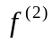(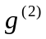) to the corresponding lower (upper) constant function value defined in (3).

Specifically, in the lower cut-off range, which is defined by 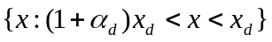, the parabolais determined by the following conditions:

- 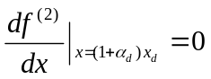
- 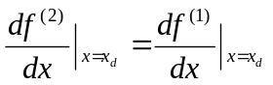 (2)
- 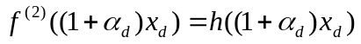

The three equations in three unknowns determine the resulting parabola which is taken as h(x) over the lower cut-off domain.

Similarly in the upper cut-off range which is defined by 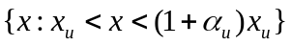, a corresponding parabola 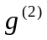is fit using an analogous set of conditions to the above, and the resulting parabola is taken as h(x) over the upper cut-off domain.

Mathematically:

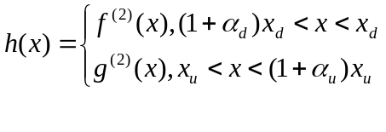
For the solution to equation (2) giving the explicit formulae for parabolasand, see the Orc Trader Manual.

Outside the cut-off range

This region is defined as

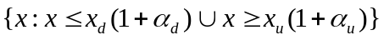,

where

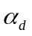denotes the down smoothing range, 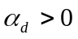

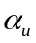denotes the up smoothing range, 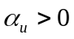

When x lies outside the cut-off range, h takes the corresponding constant value defined in equation (3).

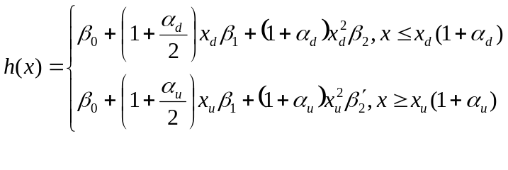 (3)

Fitting Approach

Inside the cut-off range

On the sets of transformed strike, volatility pairs 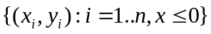 and 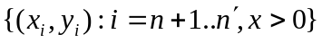,

Define, respectively, the functions

, and 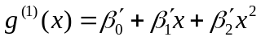.

The fitting problem is then to minimise the expression below

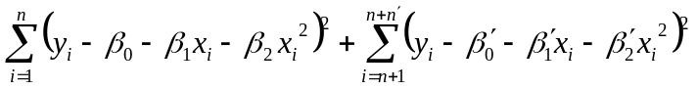

subject to

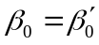 and 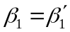.

Differentiating the sum of squares expression with respect to 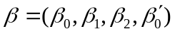, equating to zero, and rearranging terms yields the matrix problem:

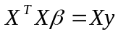,

where

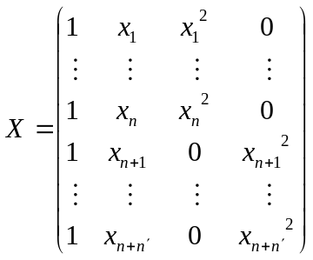, 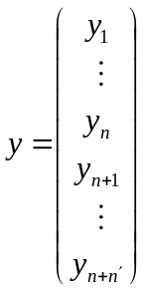

Solving the above system for gives usand.

Cut-off points and extremities

In the previous section a fitting methodology was described, which under the assumption of smooth input data, adequately captures the volatility skew with respect to strike between some specified cut-off points. Importantly, once the cut-off points 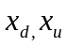 are established, there is a direct relationship determining the values takes outside from the parameter set 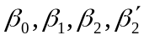. This is explained in (1.1.3) and (1.1.4).

In an attempt to restrict the degrees of freedom of the fitting problem, the present section proposes some appropriate fit-independent selections for the cut-off points and smoothing ranges. Given we have smoothed, arbitrage free input data, the aim is to capture the complete input data domain, and apply the fitting approach outlined in (1.2.1) to its entirety. The rationale here is that as the input data is smoothed and validated, there is no reasonable basis to assume the existence of noise or outliers, and hence restrict our fitting domain.

In the first paragraph below a method for transforming the SD domain to the Orc log moneyness cut-off domain is described. In the second paragraph a smoothing range is proposed.

Cut off points
Given the domain of smoothed SD provided data is fixed in respect to 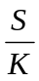, and spans constant values to 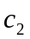, we correct the upper and lower ranges of the -domain with an adjustment for the forward. In the current SD data, set 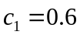, to 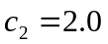, so 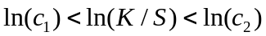.

Observe that the current SD range defined by and is also asymmetrical, as 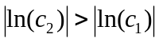. To capture and fit to the maximum number of points from the SD data domain, set the lower and upper x-axis cut-offs to

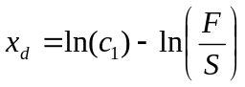,
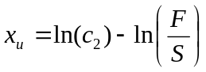.

Obviously this parameter choice will yield the desired transformed (SD) strike domain of

,

meaning we will capture the entire SD data domain in our fitting algorithm.

Smoothing range

The smoothing range parameters determine the breadth of the domain over which the extrapolation to the constant function value occurs. Given observation of SD surfaces and ASX market data the following constant values are proposed:

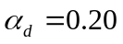and 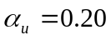

The next section outlines an example SD data set fit, employing this methodology.

Example fit

The figure below shows an example wing model calibration, using the methodology described above. Note that the horizontal axis is the untransformed strike (in dollars), and the vertical axis is volatility (%). The triangles show the SD volatility-strike pairs, while the light unbroken line illustrates the fitted Wing Model function .

Observe the following salient points

- The entire domain of SD data lies within our choice of lower and upper cut-offs, described in (1.2.2)
- Two piecewise parabolas, ,with differing curvature, are fit inside the cut-off range to the SD data set (See 1.2.1)
- The parabola in the down smoothing range smooths the progression from a steep skew at 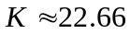, to the constant function value defined when the strike is less than the down smoothing endpoint (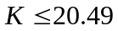). A corresponding smoothing parabola applies in the up smoothing range.
- The down smoothing range, and up smoothing range, although equal as proposed in (1.2.2), are represented below in the dollars strike domain, hence reveal different width on this axis.

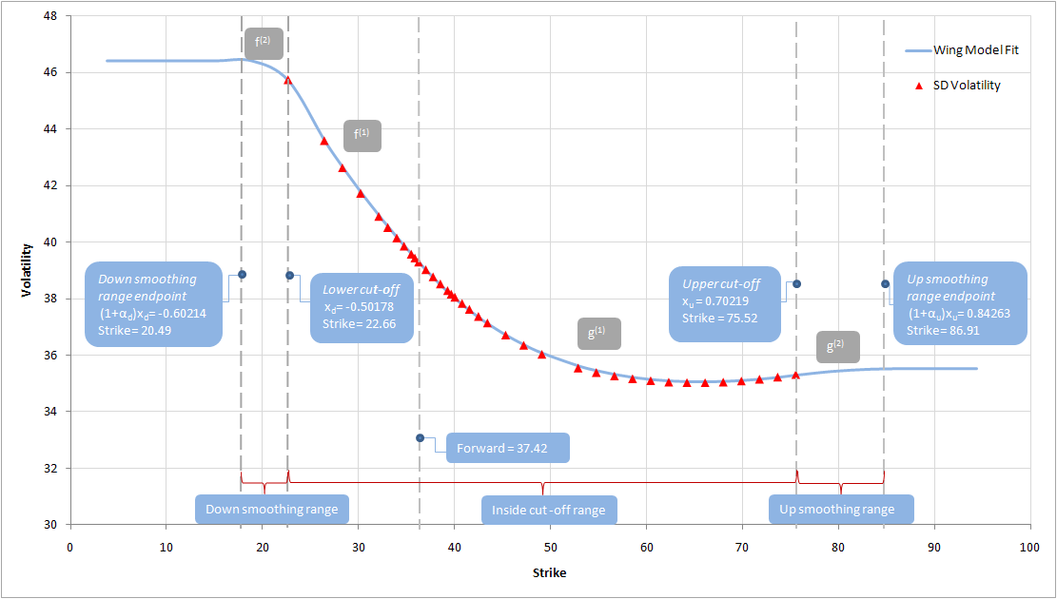

Figure: Example Wing Model Fit to BHP 3M SD Curve, as at 10/08/2009

Document control
If you have any queries regarding the information in this document, please forward details to:

Contact point | Adam Barber
Title | Quantitative Analyst
Phone | (02)92951335
Email | Adam.J.Barber@nab.com.au

Document history

Section | Page | Release | Issued | Comments

Distribution

Copy # | Release | Issued | Recipient(s)

