Analysis of Puerto Rico Timeseries Reports
Alexander X. Gonzalez-Torres

Below, I include time-series visualizations made by this project’s pipeline for the Commonwealth of Puerto Rico. From the report, I include indicators that were seemingly affected by Hurricane Maria. I add some notes with context on the indicator and what the visualization suggests.

Notes:

2008: Great Recession
< 2009: Acevedo Vila Administration
2009: "Fortuño Administration",
2013: "Garcia Padilla Administration"
2019: "Roselló-Pierluisi-Vazquez Administration"
2020: COVID-19

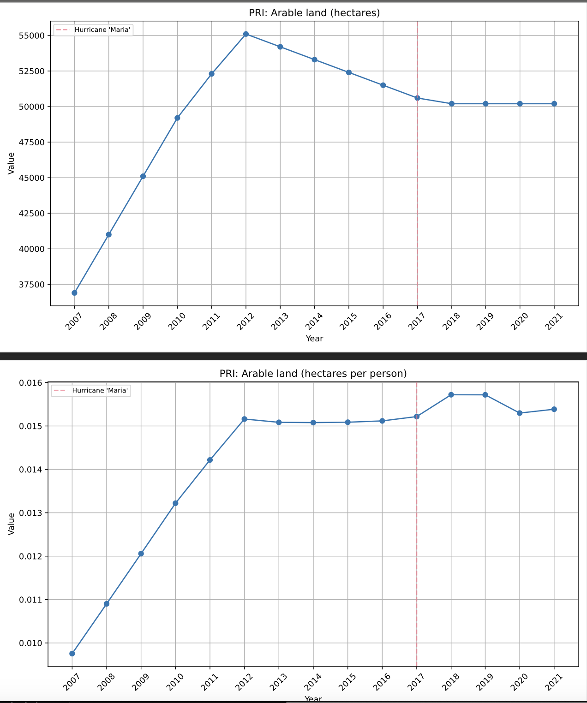

ALEXANDER: Suggests population drop post-Maria.

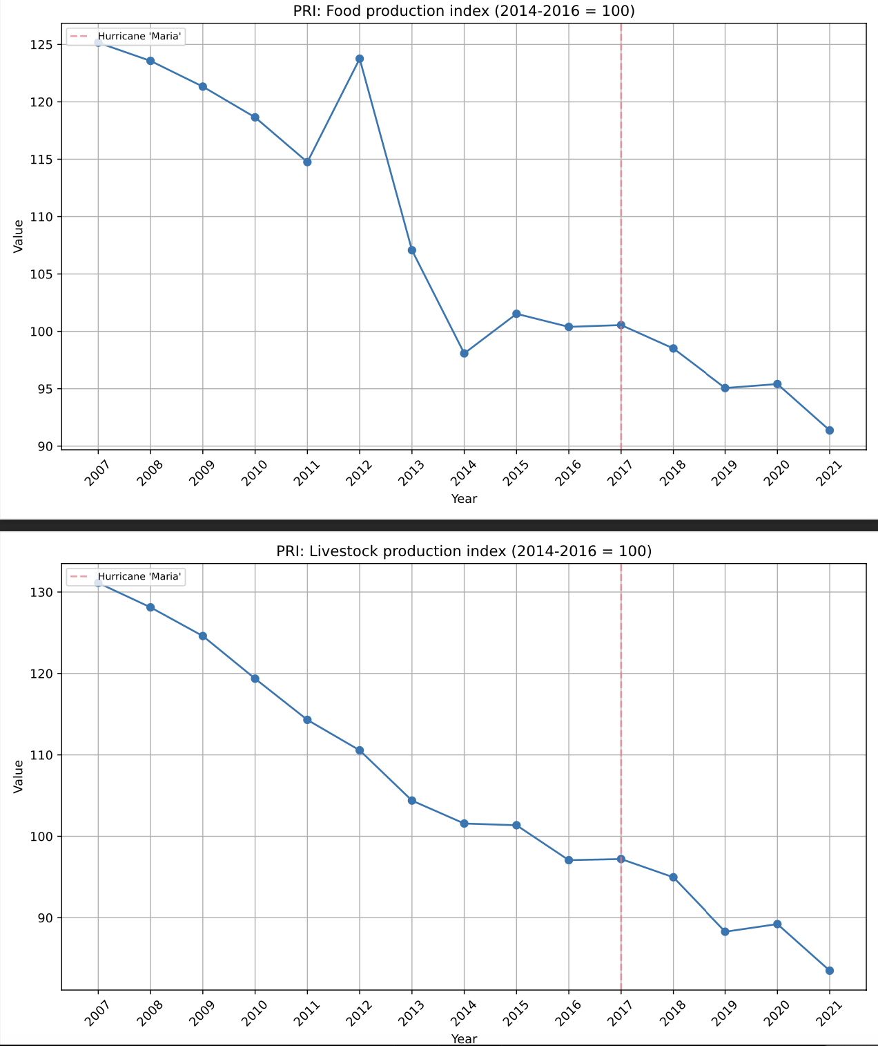

ALEXANDER: These indexes are pegged to production between 2014-2016. Values above 100 suggest growing production, below 2017 falling production. 2016 to 2017 was relatively stable, and a big drop off happens after 2017. Suggests diminished production after Maria.

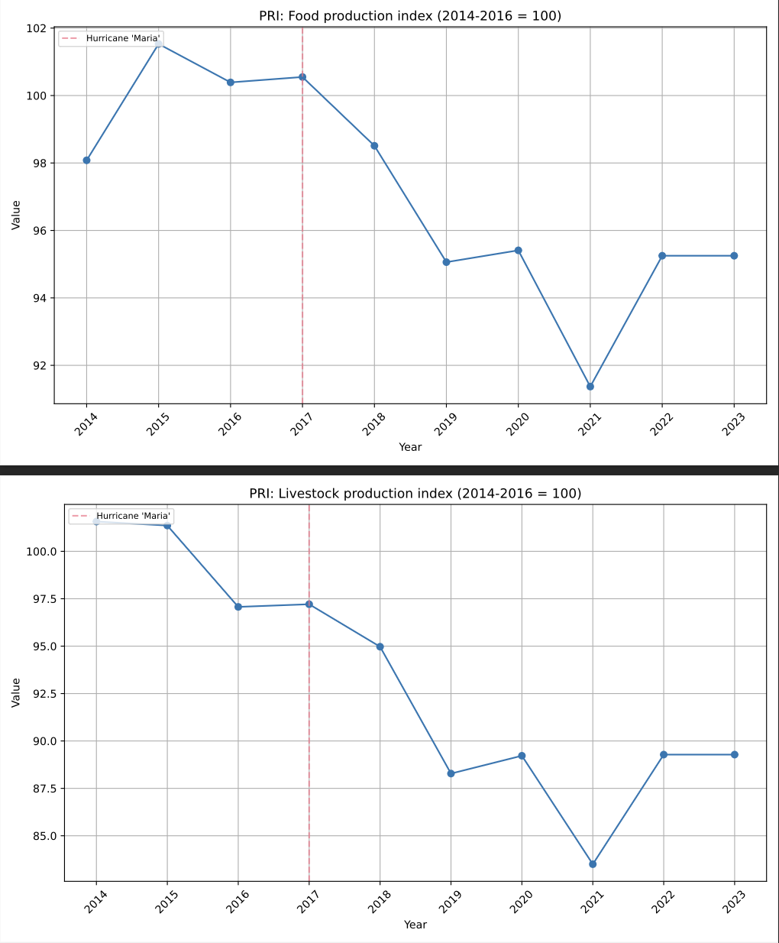

ALEXANDER: Zoom-In of Food and Livestock production indexes.
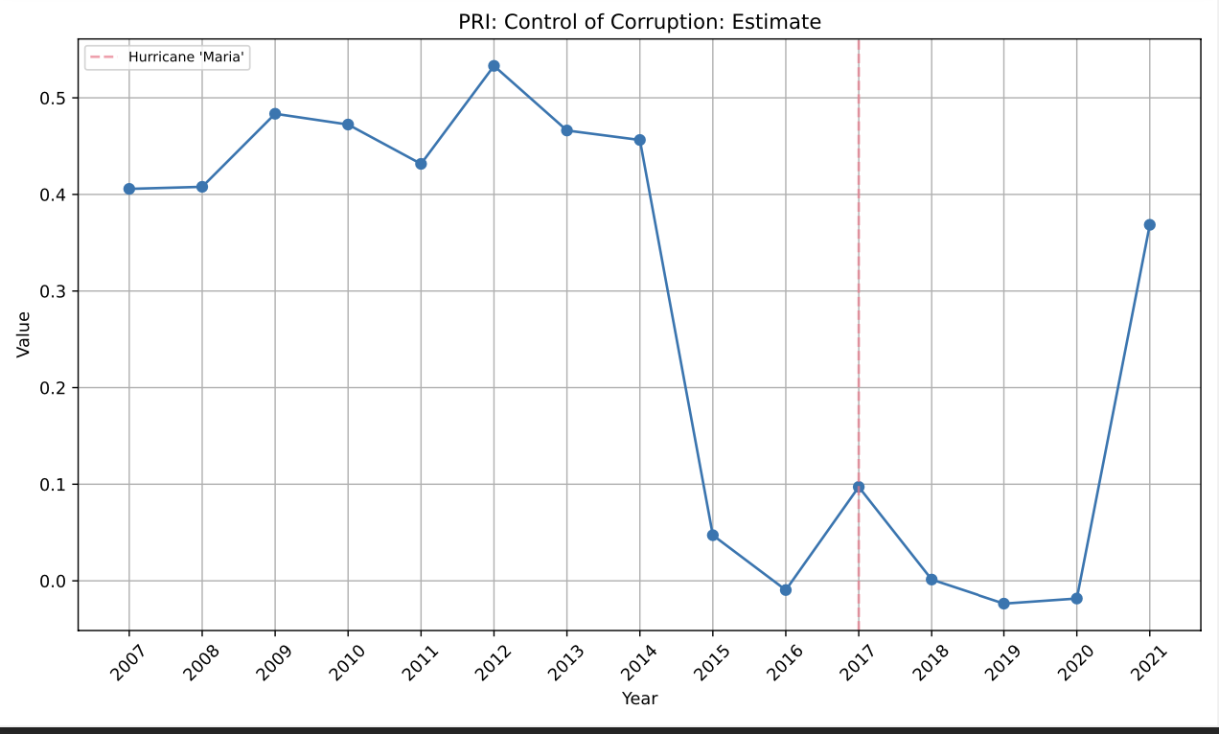

ALEXANDER:

This index measures perceptions of corruption in public power. A higher value suggests better control of corruption, while a lower value indicates weaker control or higher corruption perceptions. Values range approximately between -2.5 (poor control) and 2.5 (strong control).

The are upward spikes around 2017 (Maria) and 2021 (COVID), which coincide with ‘rally around the flag’ phenomena following national tragedy (George W Bush was incredibly popular after 9/11, for example).

Notice a dip into negative territory in the years following Hurricane Maria, which coincides with the negative public sentiment that led to the Summer of 2019 protests that brought down the Rosselló, Jr. administration. Among other things, perceptions of mismanaging the response to Maria led to these protests.

There is an uptick after his resignation (2020).

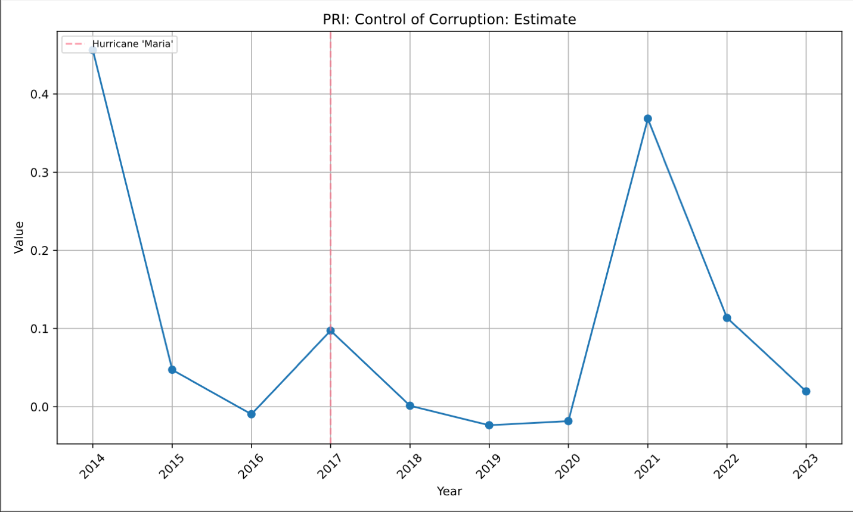

ALEXANDER: Corruption Zoom-In.

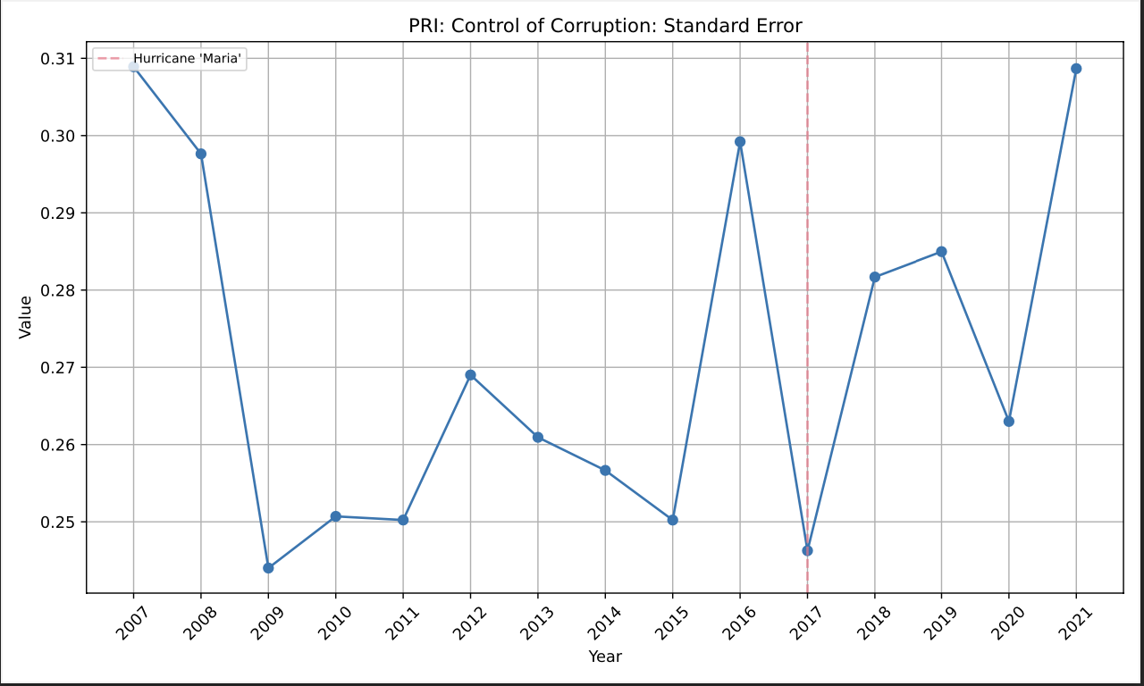

ALEXANDER: Supposedly .2-.3 is normal SE for governance metrics? Look into this.
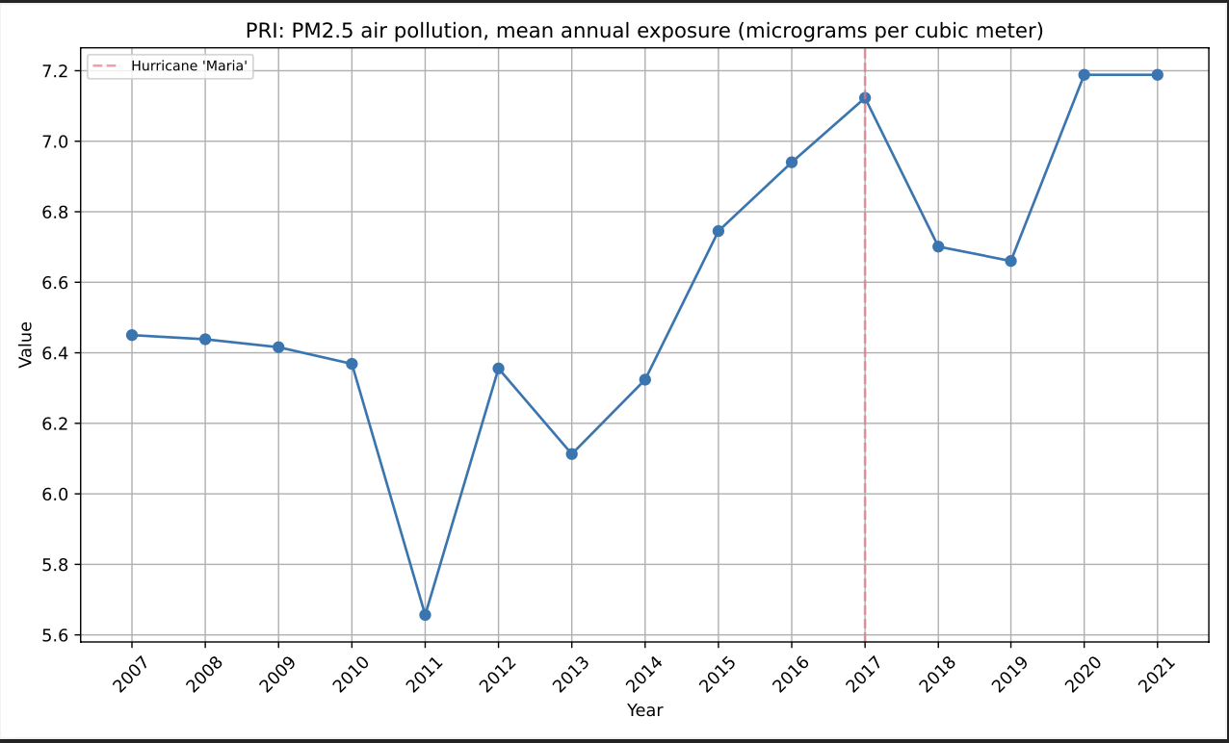

ALEXANDER: Interestingly, Maria had more of an effect on air pollution than COVID did.
Look for safety thresholds?

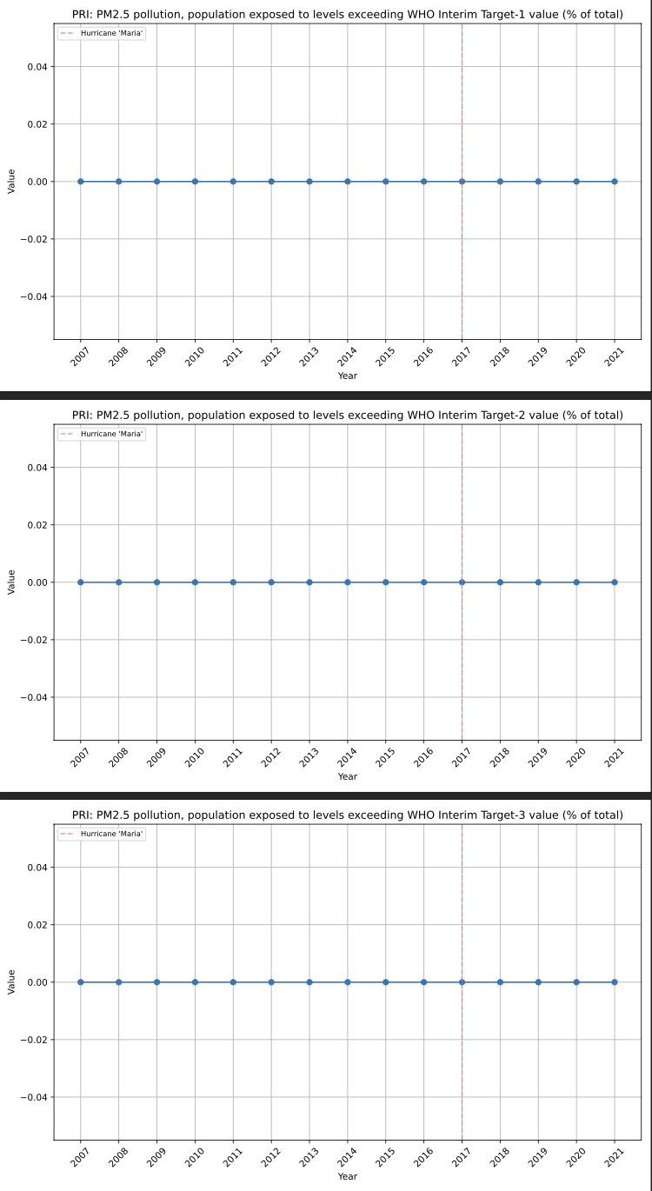
ALEXANDER: Ah, nevermind.
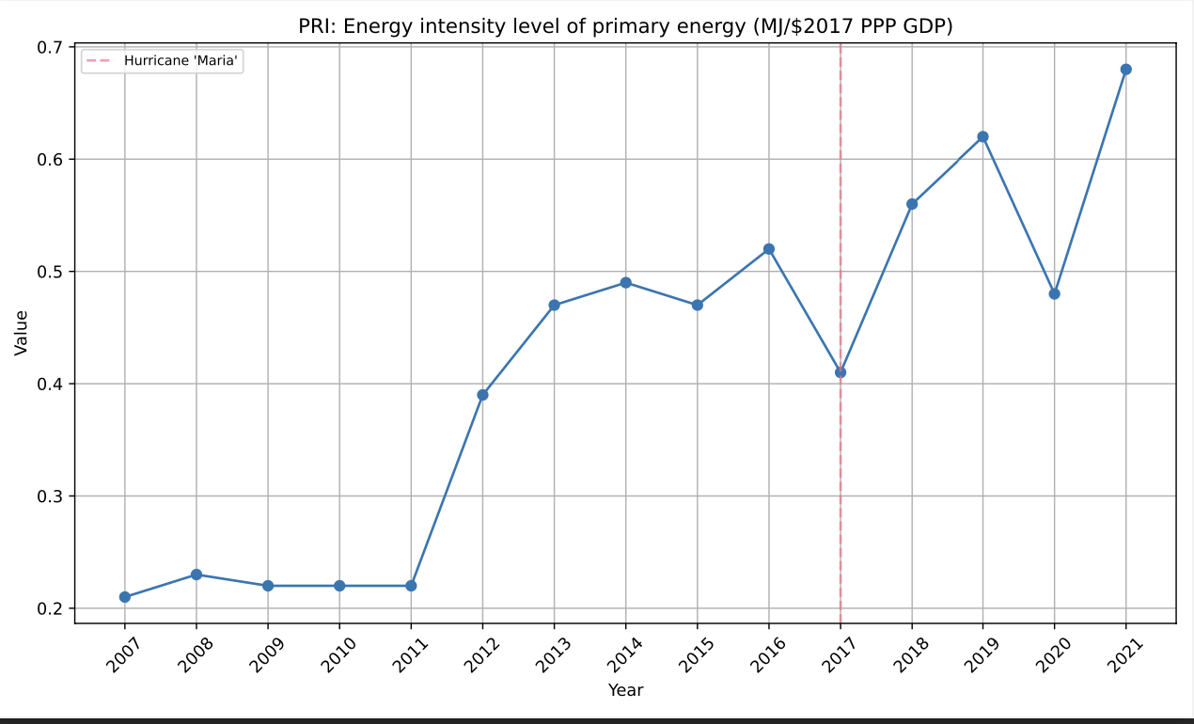
ALEXANDER: Nothing interesting here, but the figure calls to me for whatever reason. M/C were just blips.

