User
Attribute | Type | Restrictions
id | UUID | PK
name | VARCHAR(100) | NOT NULL
email | VARCHAR(255) | Unique, NOT NULL
passworld | VARCHAR(255) | NOT NULL
createdAt | TIMESTAMP | NOT NULL, DEFAULT NOW()
updatedAt | TIMESTAMP | NOT NULL, DEFAULT NOW()

Project
Attribute | Type | Restrictions
id | UUID | PK
name | VARCHAR(200) | NOT NULL
description | TEXT | NOT NULL
repoUrl | VARCHAR(500) | NOT NULL
isPublic | BOOLEAN | NOT NULL, DEFAULT True
creatorId | UUID | NOT NULL, FK(User)
createdAt | TIMESTAMP | NOT NULL, DEFAULT NOW()
updatedAt | TIMESTAMP | NOT NULL, DEFAULT NOW()

Project_Member
Attribute | Type | Restrictions
id | UUID | PK
projectId | UUID | NOT NULL, FK(Project)
userId | UUID | NOT NULL(User)
role | ENUM(’MP’, ’TST’) | NOT NULL
isCreator | BOOLEAN | NOT NULL, DEFAULT false
joinedAt | TIMESTAMP | NOT NULL, DEFAULT NOW()
createdAt | TIMESTAMP | NOT NULL, DEFAULT NOW()
updatedAt | TIMESTAMP | NOT NULL, DEFAULT NOW()

Bug
Attribute | Type | Restrictions
id | UUID | PK
projectId | UUID | NOT NULL, FK(Project)
title | VARCHAR(300) | NOT NULL
description | TEXT | NOT NULL
severity | ENUM('CRITICAL', 'HIGH', 'MEDIUM', 'LOW') | NOT NULL
priority | ENUM('HIGH', 'MEDIUM', 'LOW') | NOT NULL
status | ENUM('REPORTED', 'ASSIGNED', 'IN_PROGRESS', 'RESOLVED', 'IN_TESTING', 'CLOSED') | NOT NULL, DEFAULT ’REPORTED’
reporterId | UUID | NOT NULL, FK(Project_Member)
assigneeId | UUID | NULLABLE, FK(Project_Member)
githubCommitUrl | VARCHAR(500) | NULLABLE
resolvedAt | TIMESTAMP | NULLABLE
closedAt | TIMESTAMP | NULLABLE
closedBy | UUID | NULLABLE, FK(Project_Member)
createdAt | TIMESTAMP | NOT NULL, DEFAULT NOW()
updatedAt | TIMESTAMP | NOT NULL, DEFAULT NOW()

Bug_Assignment
Atributte | Type | Restrictions
id | UUID | PK
bugId | UUID | NOT NULL, FK(Bug)
assignedTo | UUID | NOT NULL, FK(Project_Member)
assignedBy | UUID | NOT NULL, FK(Project_Member)
status | Enum('PENDING', 'ACCEPTED', 'REJECTED') | NOT NULL, DEFAULT ’PENDING’
assignedAt | TIMESTAMP | NOT NULL, DEFAULT NOW()
respondedAt | TIMESTAMP | NULLABLE
createdAt | TIMESTAMP | NOT NULL, DEFAULT NOW()
updatedAt | TIMESTAMP | NOT NULL, DEFAULT NOW()

Activity
Attributte | Type | Restrictions
id | UUID | PK
projectId | UUID | NOT NULL, FK(Project)
bugId | UUID | NULLABLE, FK(Bug)
userId | UUID | NOT NULL, FK(User)
type | ENUM('PROJECT_CREATED' 'PROJECT_UPDATED' 'PROJECT_DELETED' 'MEMBER_ADDED' 'MEMBER_REMOVED' 'BUG_REPORTED' 'BUG_ASSIGNED' 'BUG_ASSIGNMENT_ACCEPTED' 'BUG_ASSIGNMENT_REJECTED' 'BUG_STATUS_CHANGED' 'BUG_RESOLVED' 'BUG_CLOSED' 'USER_JOINED_AS_TESTER') | NOT NULL
message | VARCHAR(500) | NOT NULL
createdAt | TIMESTAMP | NOT NULL, DEFAULT NOW()

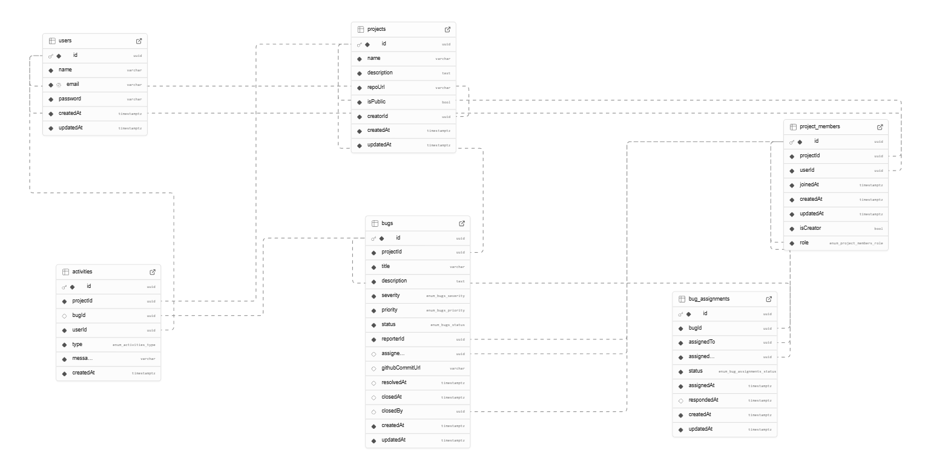
Schema bazei de date:

