**Human biometeorological data collection, modeling and weather analysis**

**Human biometeorology** investigates the relationship between humans and the atmosphere. A person is characterized by his clothing and activity, the air environment can be outdoor or indoor. In what follows, we look at an outdoor person.

The air environment of a person outside varies greatly; this variability can be characterized on the space-time scale of climate and weather. A person's clothing can be appropriate for the summer (minimum) or winter (maximum) season, their activity can change, for instance, one can lie down, stand, walk or run (other activity types are also possible). We assume that the person is in good health.

**Data collection:**the human-atmosphere relationship is characterized by data, by linking data on humans and the atmosphere. We are mostly interested in the thermal load of the air environment and the thermal perception of people in it. There are two data collection methods: longitudinal and transversal data collection. In the case of longitudinal data collection, 1 person collects weather data over as long a period as possible to create the longest possible time series (the length of the time series is equal to the number of weather observations). When collecting transversal data, many people provide information about themselves in the current weather situation. In this case too, the goal is to make the time series as long as possible (the length of the time series is equal to the number of people).

In this project, we carry out longitudinal data collection while simultaneously documenting data gathered on the human participants and the weather. Among the weather data, we document solar radiation (GR), air temperature (Ta), air humidity (rh), wind speed (W) and cloudiness (N). With regard to human data, the following are captured: anthropometric data (body mass, body length, age, sex), thermal perception (seven-level scale: "very warm", "warm", "slightly warm", "neutral", "cool", "cold" and "very cold”), the clothing worn and the type and intensity of the activity. Longitudinal observations began in the summer of 2016 and have been carried out continuosuly to this day. The person conducting the observation is Dr. Ferenc Ács. We can report on the following data collections:

Table 1 Longitudinal observations focusing on characterizing the relationship between human activity and thermal load (Notation: *: documentation of body mass before and after the run with a scale, measurement of the average running speed based on an estimate of the distance (5 km) and duration (stopwatch); **: estimation of the average running speed (distance: 404 m/lap, measuring the duration of the distance with a stopwatch) and average heart rate (based on a smart watch)

|  |  |  |  |  |  |  |
| --- | --- | --- | --- | --- | --- | --- |
| Observation | Human characteristics | | | Air environment | Period | Publication |
| Activity | Clothing | Thermal perception |  | | |
| 1. | *running | documentation of the clothing worn | -- | GR, Ta, rh, W, N | 2016.08.09-2018.05.23 | Ács et al. (2019) |
| 2. | walking | -- | determining of thermal sensation types | GR, Ta, rh, W, N | 2020.04.01-2021.06.29 | Ács et al. (2022) |
| 3. | lying down | short sports pants | determining of thermal sensation types | GR, Ta, rh, W, N | 2022.05.12-2022.09.18 | -- |
| 4. | *running | documentation of the clothing worn | -- | GR, Ta, rh, W, N | 2023.02.07- ongoing | -- |
| 5. | **running | -- | -- | -- | 2022.10.09- ongoing | -- |

**Modeling:** Recently, energy balance-based models are the most widespread (Pochter et al., 2018). The main advantage of these models is that they can also simulate the effect of human factors on thermal load. The energy balance equation can be used in two ways. The usual procedure is to calculate skin surface and/or clothing surface temperatures based on knowledge of activity (metabolic heat flow density) and clothing worn (thermal resistance of clothing). This is the so-called „forward” procedure. The other method calculates the thermal resistance of the clothing and/or the evaporative resistance of the skin surface based on the knowledge of the activity and the temperature of the skin surface. This is the so-called „backward” procedure. Models using the "backward" process are also called inverse "forward" models (briefly inverse models). In human biometeorology, traditional „forward” models are much more widespread than inverse models (de Freitas and Grigorieva, 2015).

The thermal load is estimated based on running our own inverse models. The environmental heat deficit is simulated with a clothing thermal resistance (rcl) model (briefly clothing index model), which estimates the rcl (m2·℃/W) value that exists in the case of energy balance. The environmental heat surplus is simulated with a skin evaporative resistance (rskin) model, which calculates the rskin (m2·hPa/W) value ensuring the energy balance at the human body-environment interface.

**Weather analysis:** Weather can also be analyzed from the point of view of human thermal load and thermal perception.We may hear such remarks during the announcement of the weather, but this important aspect is not highlighted and evaluated. To fill this gap, we conduct longitudinal observations for the following weather conditions.

Table 2 Longitudinal observations in select weather situations to characterize human thermal load

|  |  |  |  |  |
| --- | --- | --- | --- | --- |
| Observation | Characterization of the weather situation in keywords | Air environment | Period | Publication |
| 1. | cyclone, warm front | GR, Ta, rh, W, N | 2021.03.12– ongoing | -- |
| 2. | cyclone, cold front | GR, Ta, rh, W, N | 2021.03.05- ongoing | -- |
| 3. | convection, anticyclone | GR, Ta, rh, W, N | 2021.03.01- ongoing | -- |
| 4. | advection, anticyclone | GR, Ta, rh, W, N | 2021.02.27- ongoing | -- |
| 5. | frosty dawns, mornings, anticyclone | GR, Ta, rh, W, N | 2020.01.23- ongoing | -- |
| 6. | fog | GR, Ta, rh, W, N | 2017.02.15- ongoing | -- |

**Some results:** Our results form a "cloud of points" as we use the methodology of longitudinal observation. Here are some results.

1. Point-cloud characterizing the relationship between clothing thermal resistance, operative temperature and thermal sensation types. The human walks at a speed of 1.1 ms-1.

1. Point-cloud characterizing the relationship between skin evaporative resistance, operative temperature and thermal sensation types. The human is in the resting position. (the illustration was made by Erzsébet Kristóf)

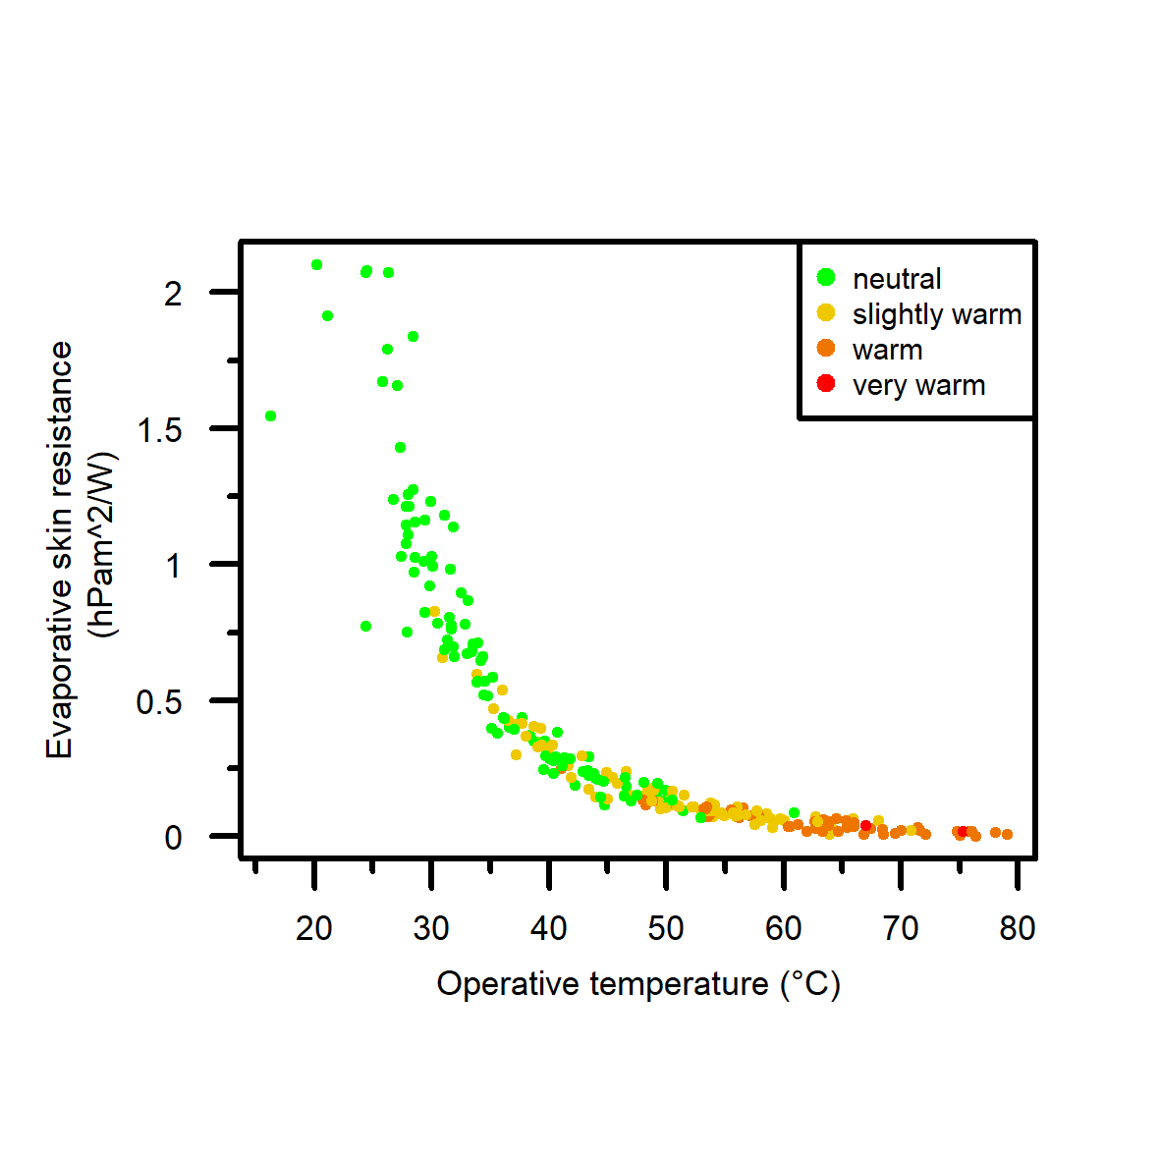

1. Point-cloud characterizing the relationship between heart rate, activity types and average movement speed. (the figure was made by Zsófia Szalkai)

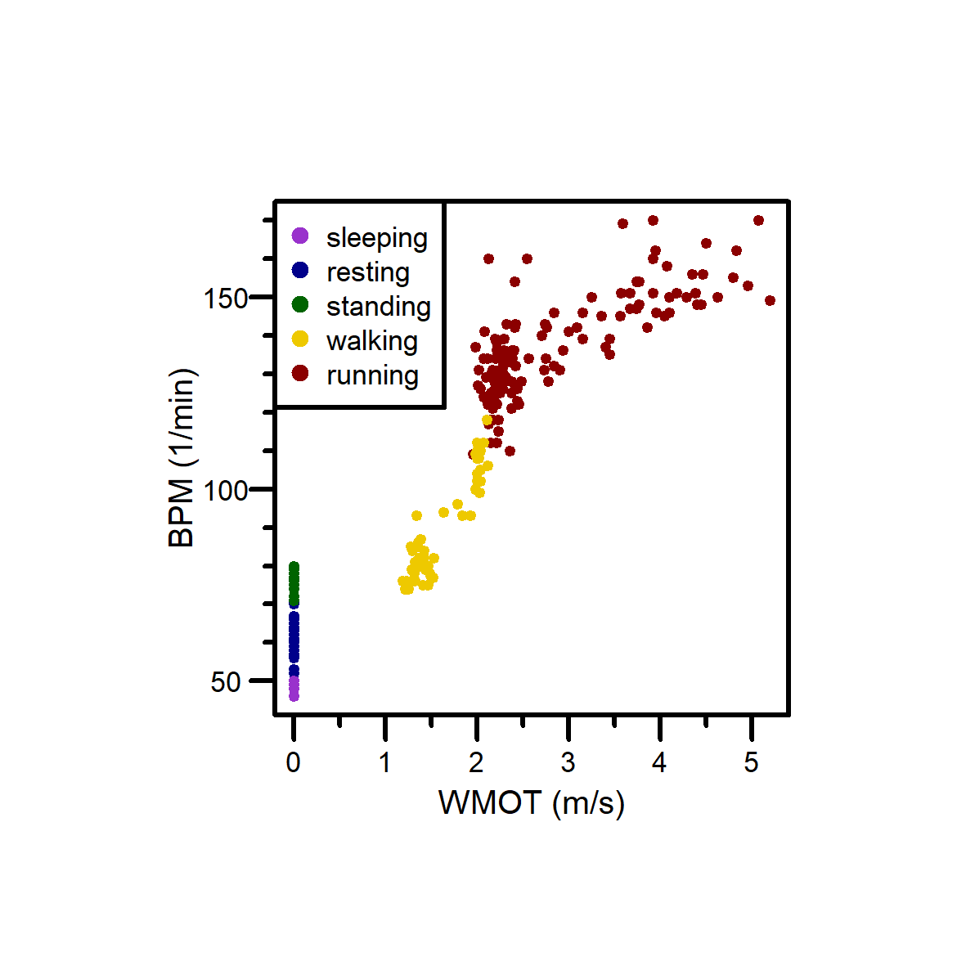

1. Point-cloud characterizing the relationship between clothing thermal

resistance and operative temperature in the fog. The human walks at a speed of 1.1 ms-1. (the figure was made by Zsófia Szalkai)

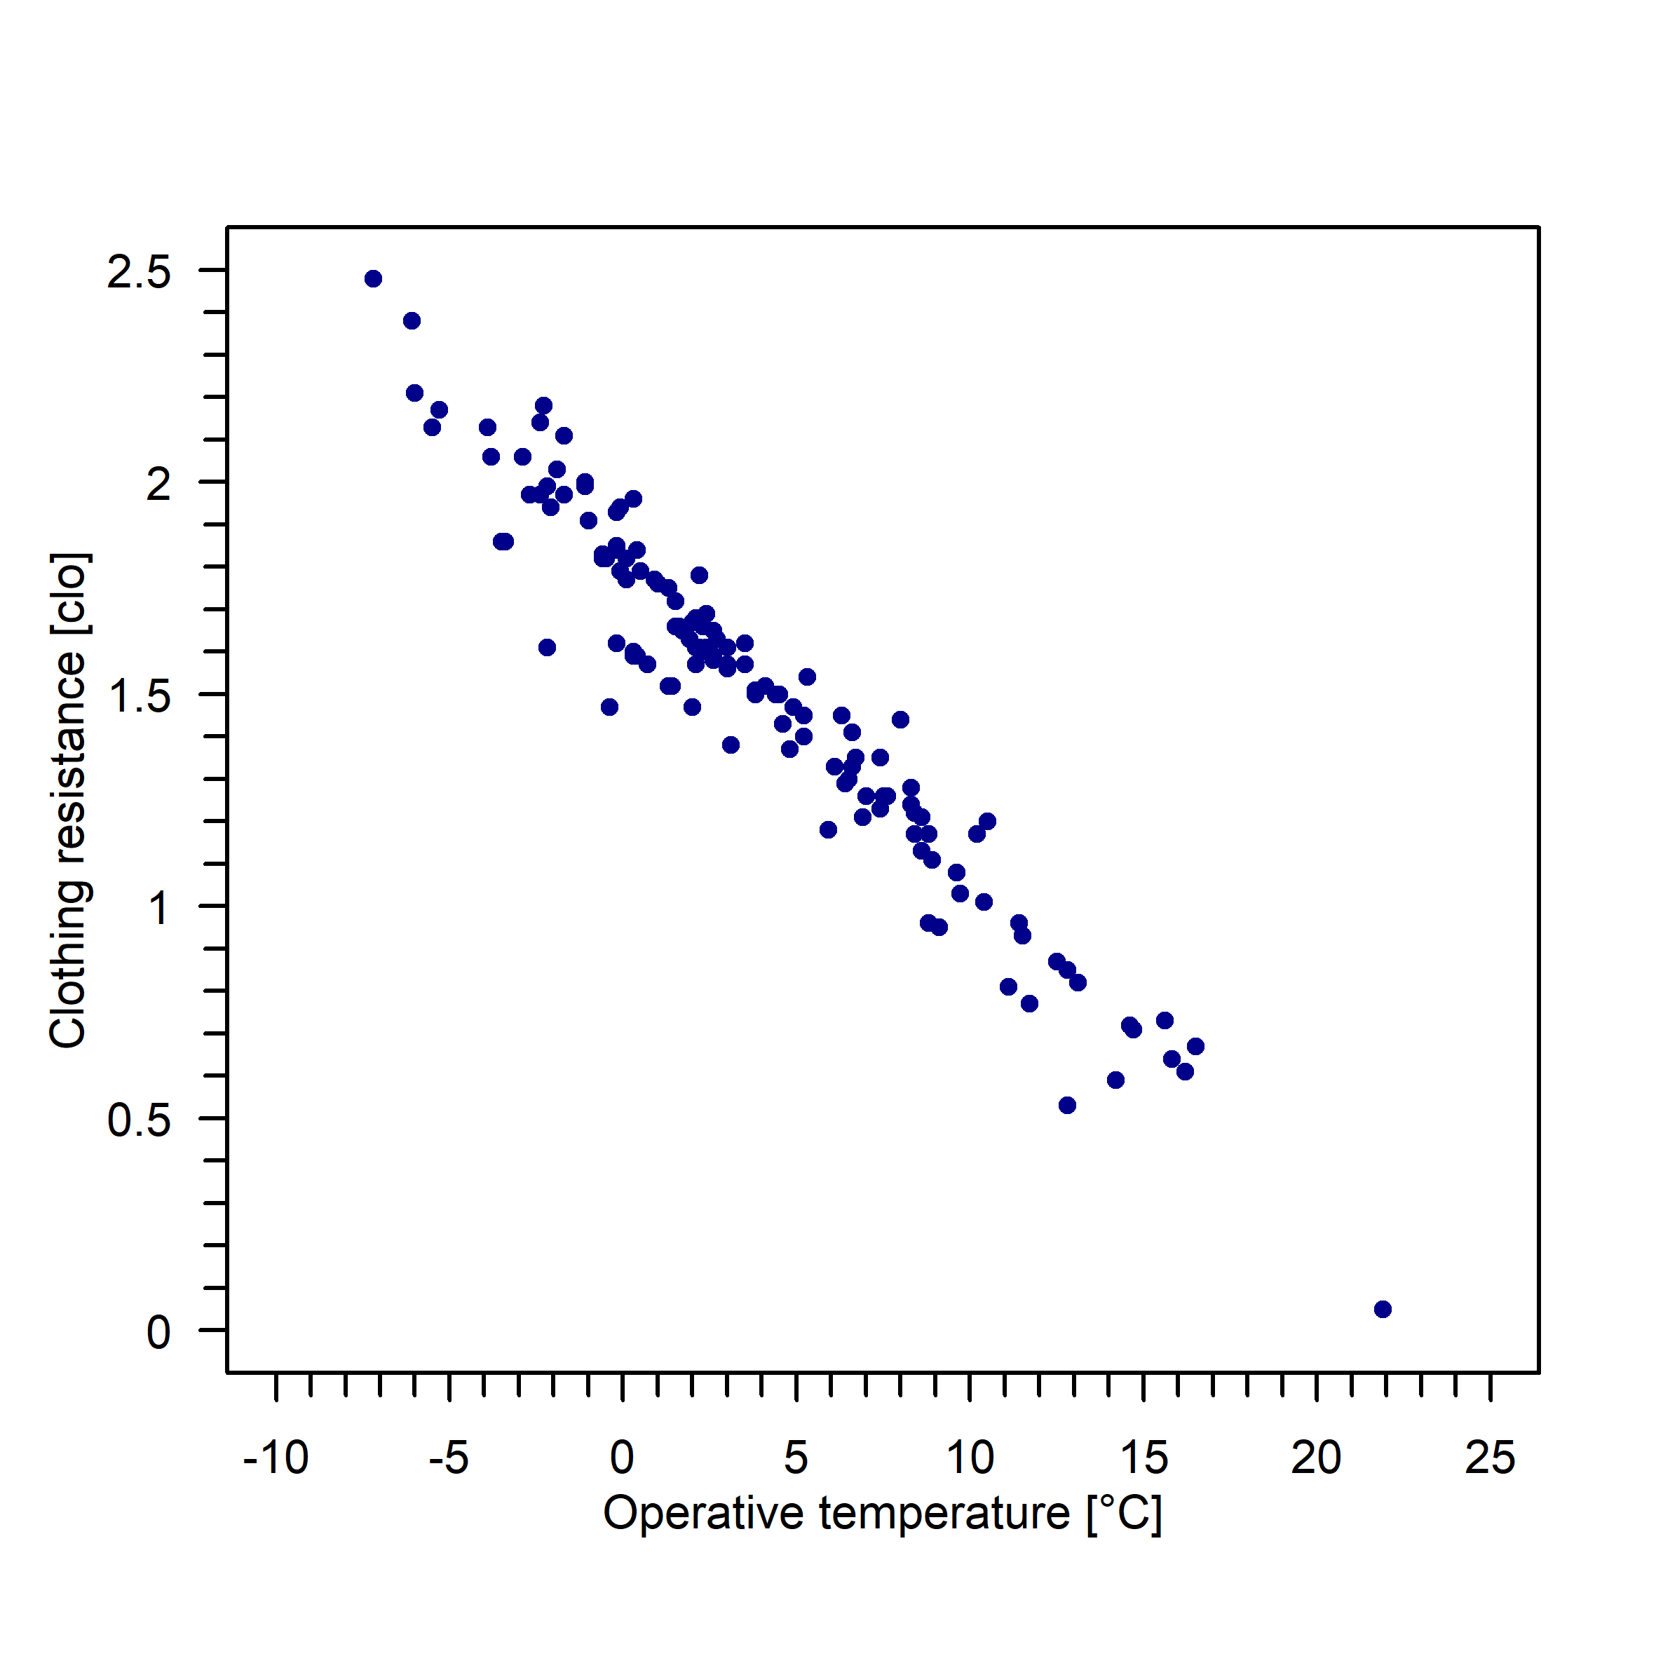

**References**

Ács, F.; Kristóf, E.; Zsákai, A. New clothing resistance scheme for estimating outdoor environmental thermal load. *Geographica Pannonica* **2019**, *23*(4), 245–255. <https://doi.org/10.5937/gp23-23717>

Ács, F.; Kristóf, E.; Zsákai A. Individual local human thermal climates in the Hungarian lowland: Estimations by a simple clothing resistance–operative temperature model. *Int. J. Climatol.* **2022**, DOI: 10.1002/joc.7910

de Freitas, C.R.; Grigorieva, E.A. A comprehensive catalogue and classification of human thermal climate indices. *Int. J. Biometeorol.* **2015**, *59*, 109–120.

Potchter, O.; Cohen, P.; Lin, T.P.; Matzarakis A. Outdoor human thermal perception in various climates: A comprehensive review of approaches, methods and quantification. *Sci. Total Environ.* **2018,** *631–632*, 390–406. <https://doi.org/10.1016/j.scitotenv.2018.02.276>