SQL_DCL_Alexandra_Manica_HW_Task1

Task 1.
Figure out what security precautions are already used in your 'dvd_rental' database. Prepare description for
- Existing users/roles and their permissions
- Table-level privileges
- Any existing row-level security policies
- Database-level settings like connection limits or authentication methods

Prepare a detailed description in a text or docx file. Include SQL queries you used and their outputs for evidence

Explain whether it is sufficient or risky. Identify at least one potential security vulnerability and suggest an improvement

- Task 1.1.
Existing users/roles and their permissions

Answear:

- Query:
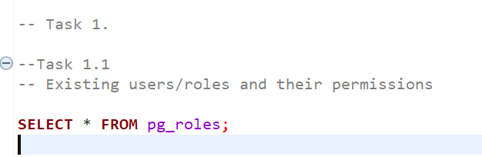

- Result:

The query on pg_roles shows that most existing entries are built-in PostgreSQL roles such as pg_read_all_data, pg_write_all_data, pg_monitor, and other predefined administrative roles. These roles do not have login capability (rolcanlogin = false) and therefore are not direct user accounts.

The only visible login-enabled role is postgres, which has rolsuper = true, rolcreaterole = true, rolcreatedb = true, and rolreplication = true. This means that the postgres role has full administrative privileges over the PostgreSQL instance.
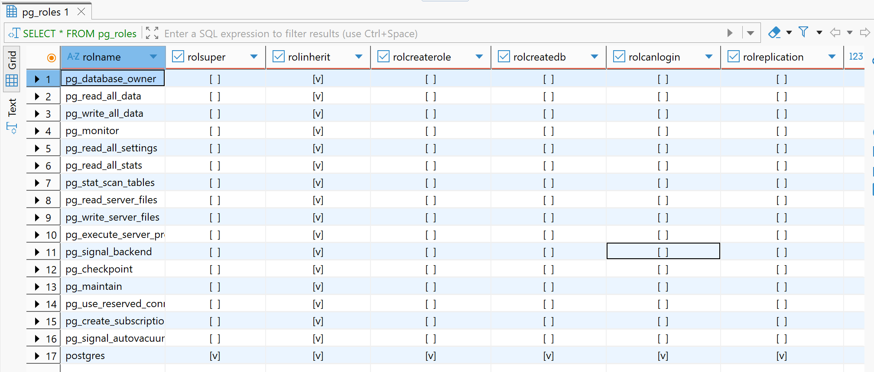

- Task 1.2.
Table-level privileges

Answear:

- Query:
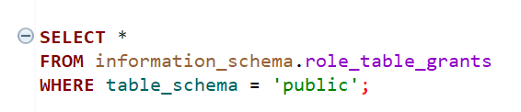
- Result:

The output shows that table privileges in the public schema are granted to the postgres role. This role has full access to the tables, including SELECT, INSERT, UPDATE, DELETE, TRUNCATE, REFERENCES, and TRIGGER.
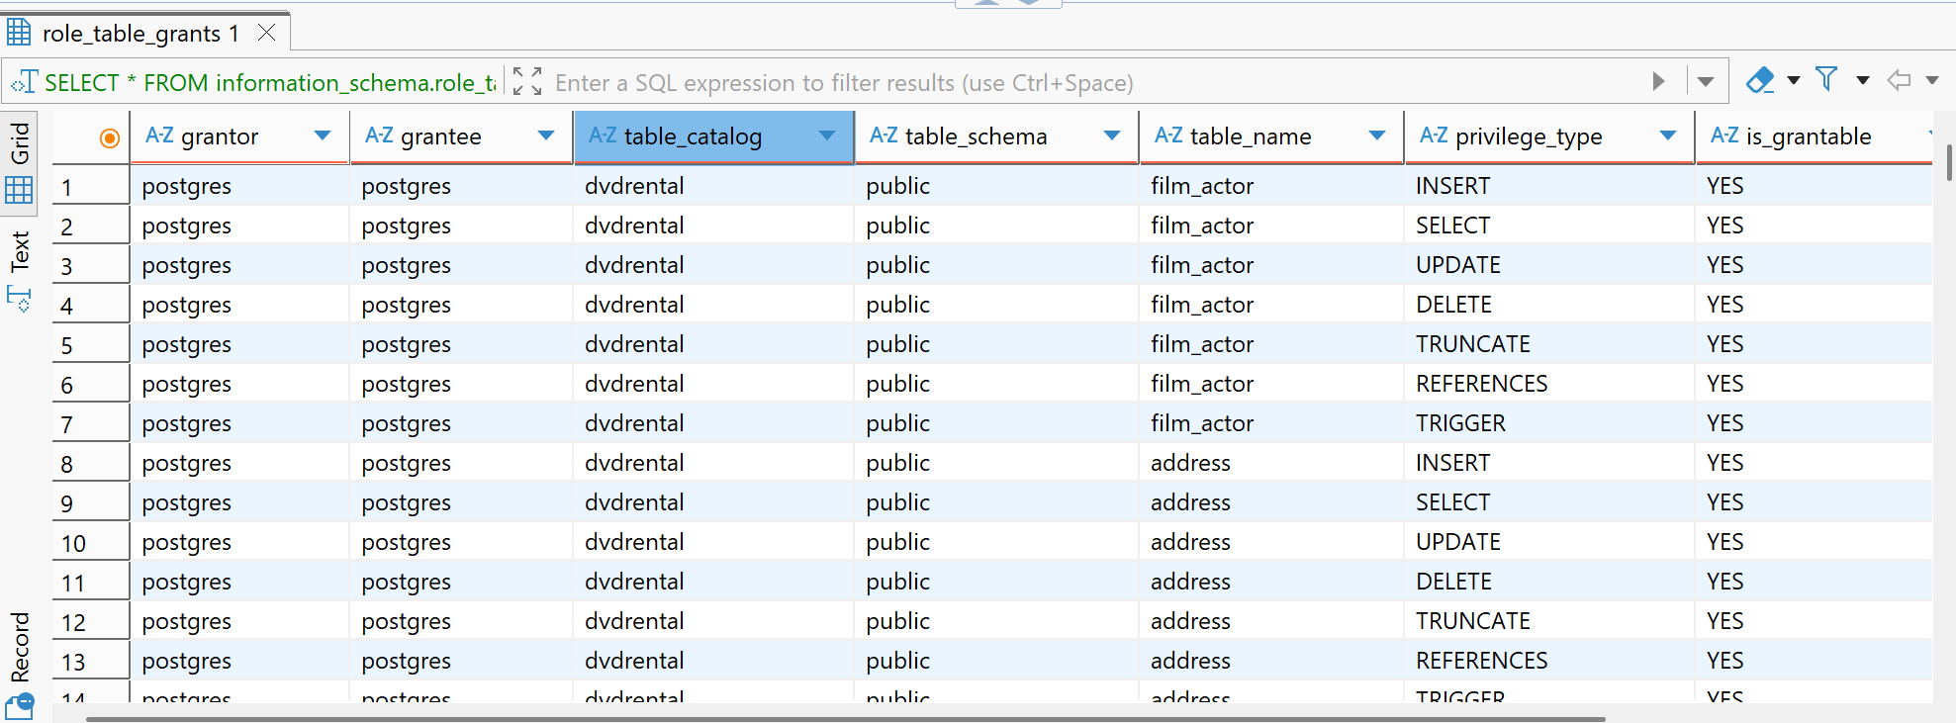

- Task 1.3.
Any existing row-level security policies

Answear:

- Query:
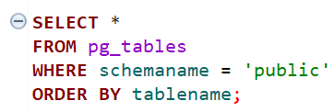

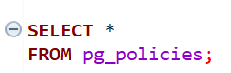
- Result:

The query on pg_tables shows that row-level security is not enabled (rowsecurity = false) for the tables in the public schema. Additionally, the pg_policies query returned no results, indicating that no row-level security policies are defined.

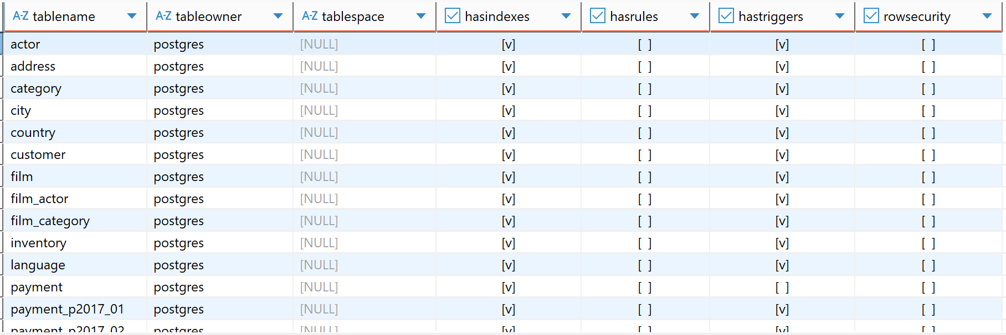

- Task 1.4.
Database-level settings like connection limits or authentication methods

Answear:

- Query:
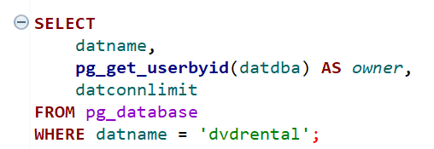
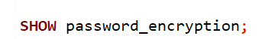
- Result:

The database dvdrental is owned by the postgres role, which has full administrative privileges. The connection limit is set to -1, meaning there is no restriction on the number of concurrent connections.

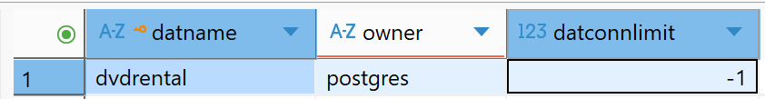

Authentication methods in PostgreSQL are configured in the pg_hba.conf file, which is outside the database schema and cannot be fully inspected using SQL queries. However, the current password encryption method can be checked using SHOW password_encryption indicating that scram-sha-256 is used.
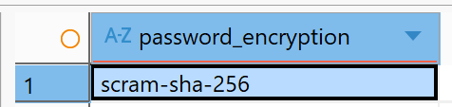
- Security

The current setup works, but it can be considered risky because it relies on the postgres superuser, which has full access to the database. It’s a good thing that no privileges are granted to PUBLIC, but there is no row-level security in place. This means that any user with access to a table can see all its data. The main issue is the lack of role separation. To improve security, it would be better to use roles with limited permissions and apply row-level security where needed

