SQL_DCL_Alexandra_Manica_HW_Task4

Task 4.

Prepare answers to the following questions
- How can one restrict access to certain columns of a database table?
- What is the difference between user identification and user authentication?
- What are the recommended authentication protocols for PostgreSQL?
- What is proxy authentication in PostgreSQL and what is it for? Why does it make the previously discussed role-based access control easier to implement?

- Task 4.1.
How can one restrict access to certain columns of a database table?
Answear:
Access to specific columns can be restricted using column-level privileges with the GRANT statement. This allows a user to access only selected columns instead of the entire table.

Practical example:
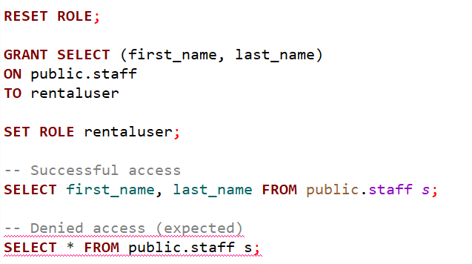
Real scenario

In a real application, employees may be allowed to view basic staff information such as first and last name, but not sensitive details like emails.
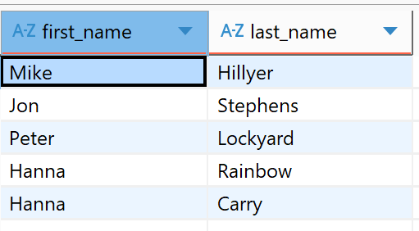

- Task 4.2.
What is the difference between user identification and user authentication?
Answear:
User identification means stating who the user is, for example by providing a username. Authentication means proving that identity, usually by providing the correct password.
Practical example:
In the dvd_rental database, the role rentaluser was created with a password.
When connecting to PostgreSQL:
- the username rentaluser represents identification
- the password rentalpassword represents authentication
If the correct username and password are provided, the user is allowed to connect. If the password is wrong, access is denied.
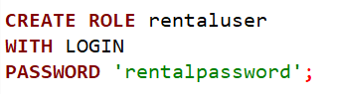
Real scenario
In a real application, a user first enters their username to identify themselves, and then enters a password to prove they are really that user.

- Task 4.3.
What are the recommended authentication protocols for PostgreSQL?
Answear:
PostgreSQL provides multiple authentication methods, each defining how a user proves their identity. Some methods are simple, such as trust (no password) and password-based authentication.
However, the recommended authentication protocol is SCRAM-SHA-256, as it provides strong password security. SCRAM-SHA-256 is a password authentication method that uses hashing to verify user credentials without sending the actual password over the network.
Practical example:
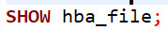
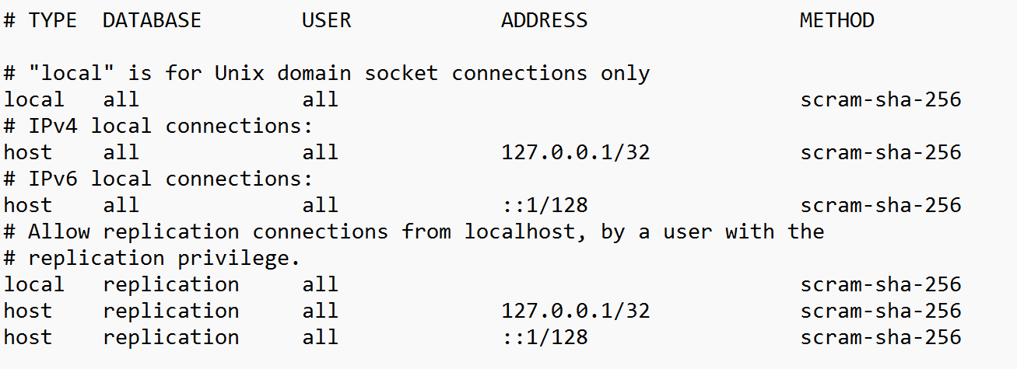

Real scenario
In production systems, applications use scram-sha-256 to ensure that passwords are securely stored and protected against attacks.

- Task 4.4.
What is proxy authentication in PostgreSQL and what is it for? Why does it make the previously discussed role-based access control easier to implement?
Answear:
Proxy authentication allows one user to act on behalf of another user using commands such as SET ROLE. It is used to simplify role-based access control by allowing applications to switch roles dynamically without creating multiple database connections.

Practical example:
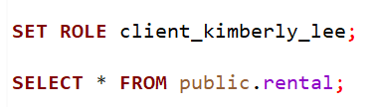
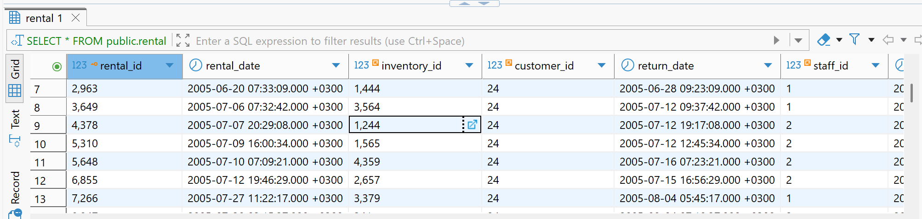

Real scenario
In a real application, the backend connects using a general database user and then switches roles depending on the logged-in user, ensuring that each user only accesses their own data.

