SQL_DDL_Func_HW - Task 6

Task 6.1.

- What operations do the following functions perform: film_in_stock, film_not_in_stock, inventory_in_stock, get_customer_balance, inventory_held_by_customer, rewards_report, last_day? You can find these functions in dvd_rental database.

Answear:

- inventory_in_stock: the function returns TRUE if a given inventory item (film copy) has never been rented or if all its rentals are returned (have a non-null return_date), and returns FALSE if there is at least one active rental ( a rental with return_date IS NULL).

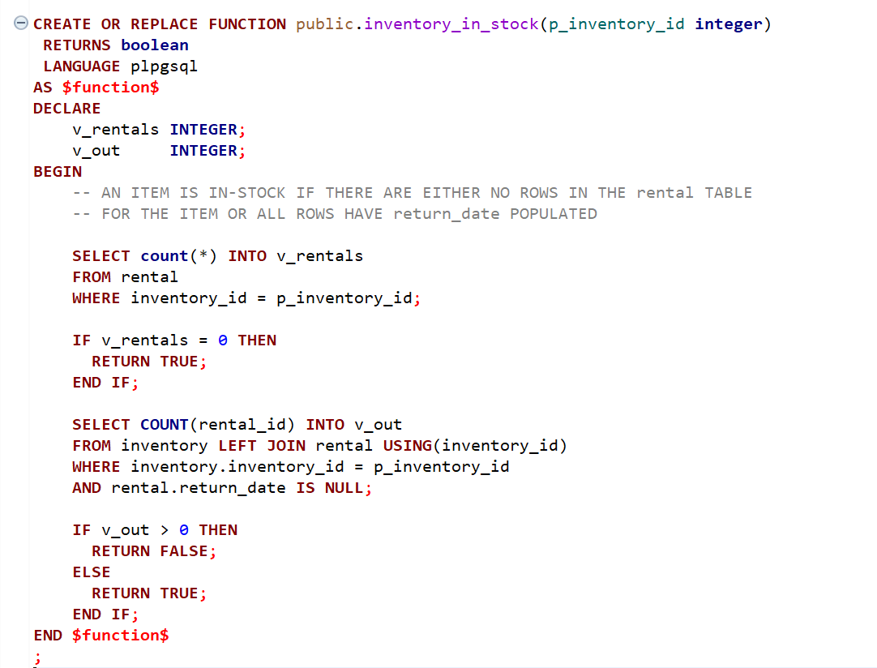

- film_in_stock: the function returns the inventory_id values of all copies of a given film in a specific store that are currently available, by filtering the inventory table based on film_id, store_id, and the result of the inventory_in_stock function (explained above).
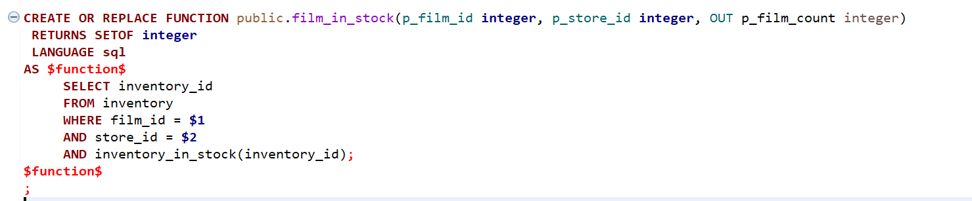

- film_not_in_stock: returns the inventory_id values of all copies of a given film in a specific store that are currently not available, by filtering the inventory table based on film_id, store_id, and the negated result of the inventory_in_stock function

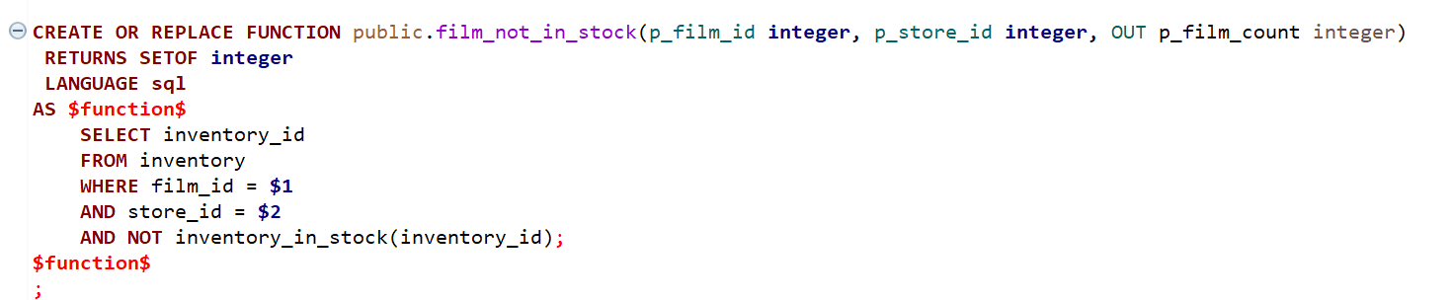

- get_customer_balance: The function calculates the customer balance by summing rental fees and late fees for all rentals before the given date, and subtracting all payments made before that date,

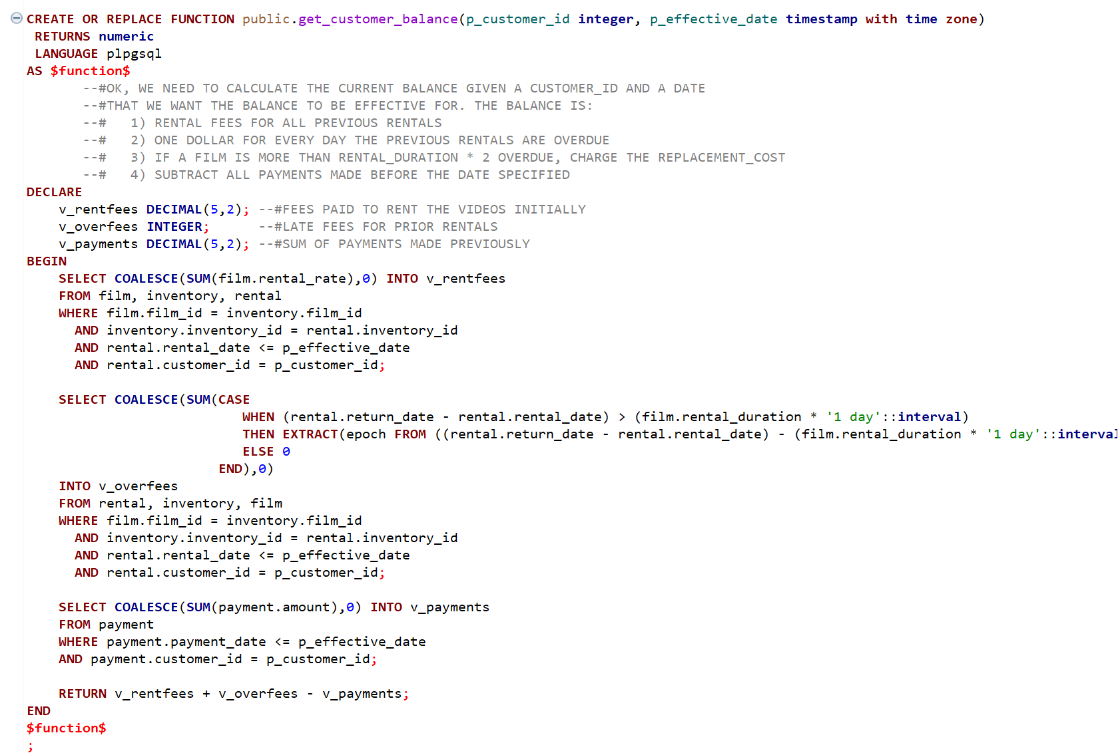

- inventory_held_by_customer: The inventory_held_by_customer function returns the customer_id of the customer who currently holds a specific inventory item by selecting the rental record where the inventory_id matches and the return_date is NULL (indicating an active rental).

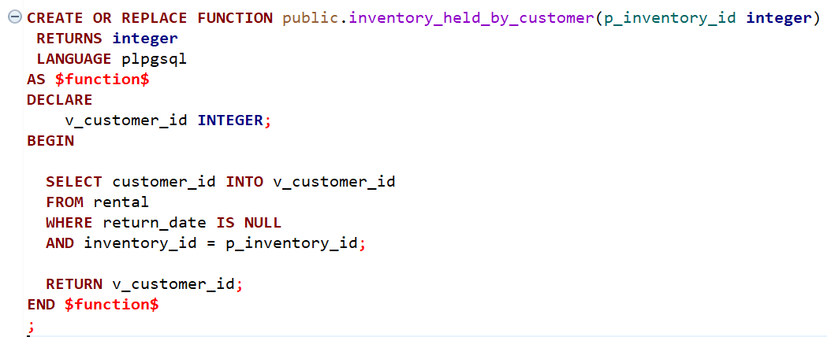

- rewards_report: the function returns all customers who, during a specific month (calculated as the month three months before the current date), have made more than a given number of purchases and spent more than a specified total amount, by inserting customer_ids who meet the defined purchase and spending conditions, into a temporary table and then returning their full customer records.

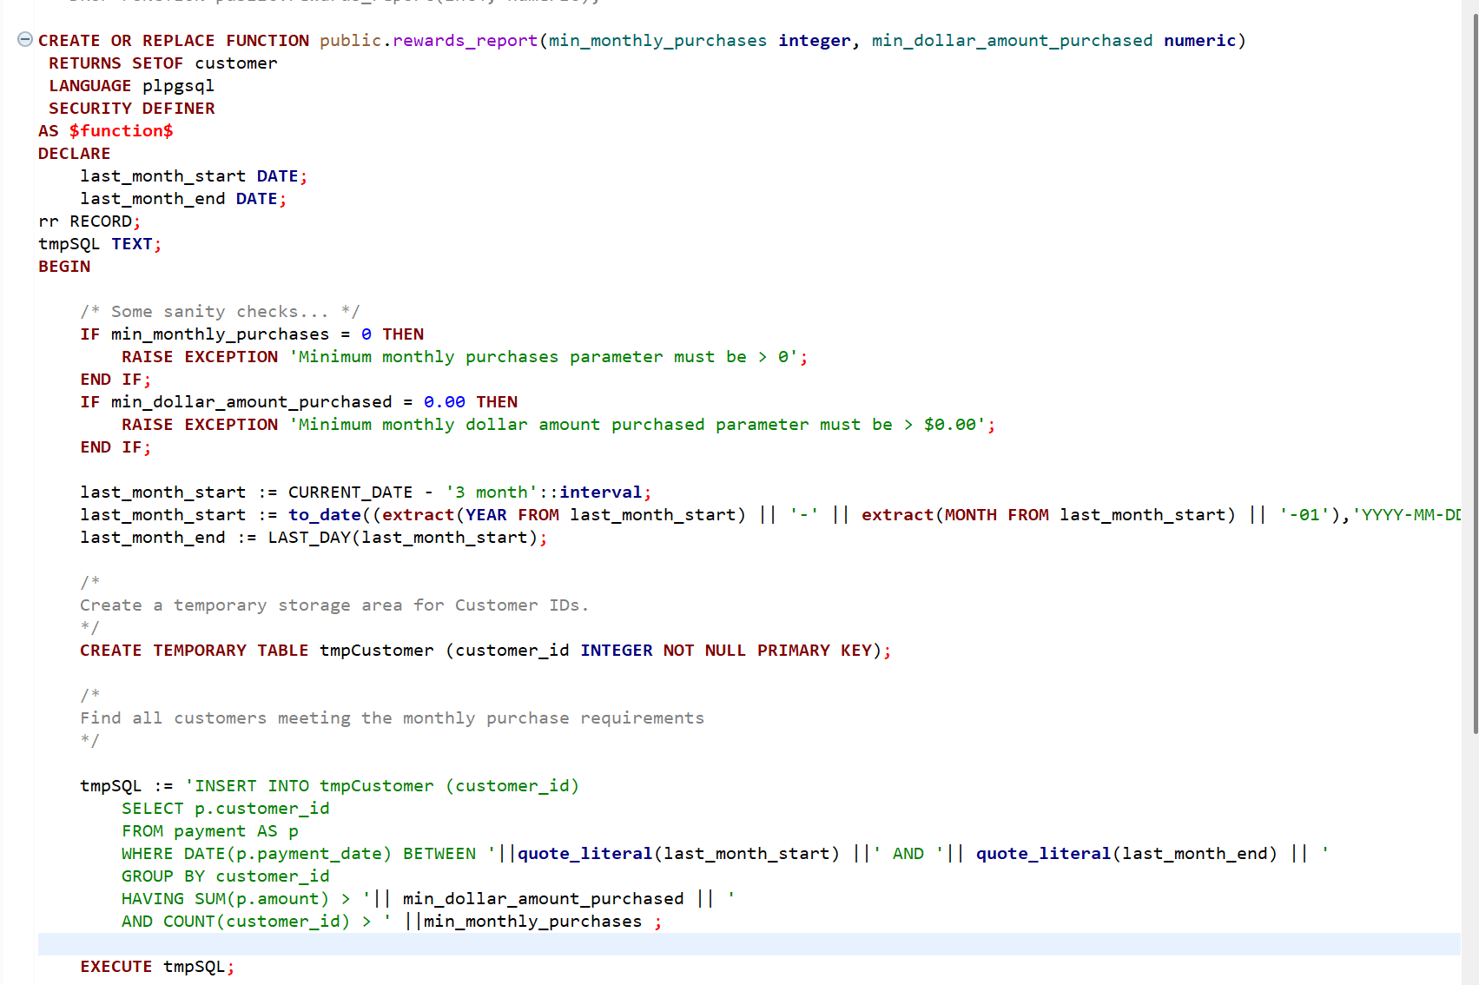

- last_day: The function returns the last day of the month for a given date by constructing the first day of the next month and subtracting one day, with special handling for December to roll over to the next year.
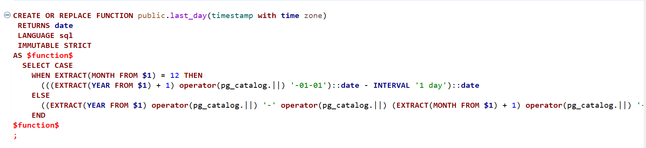

Task 6.2.
- Why does ‘rewards_report’ function return 0 rows? Correct and recreate the function, so that it's able to return rows properly.
- Is there any function that can potentially be removed from the dvd_rental codebase (inefficient? redundant)? If so, which one and why?

Answear:
- The function returns 0 rows because it filters payments based on a month calculated from the current date, while the dvdrental database contains data up to 2017 , so no records match the date range.
- The function was corrected by replacing the CURRENT_DATE with the maximum payment_date from the payment table, ensuring that the date range matches the available data while preserving the original structure of the function.
- The corrected function is available in the SQL script for SQL_DDL_Func_HW pull request.

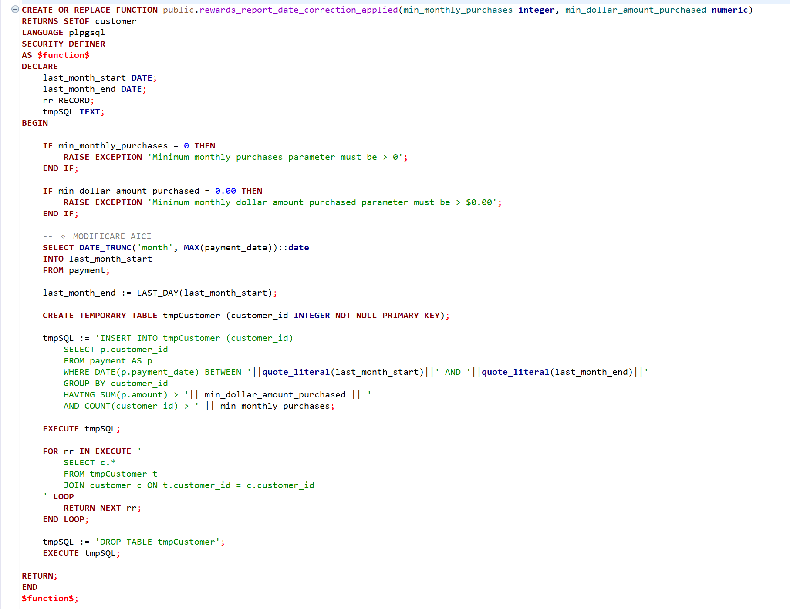
- The film_not_in_stock function is redundant because it only returns the negated result of inventory_in_stock, which can be handled directly in queries using the NOT operator.

Task 6.3.
- Which functions violate best practices?

Answear:
- rewards_report violates best practices because it uses dynamic SQL and a temporary table even though this is not necessary. The same result can be achieved with a simple query, so the function becomes more complicated and harder to maintain. It also uses CURRENT_DATE, which can lead to no results in the dvdrental database because the data is old.
- get_customer_balance violates best practices because it uses old-style joins instead of modern JOIN syntax, which makes the code harder to read. Also, the logic in the code does not fully match the rules described in the comments, since the replacement cost is never actually applied.
- film_not_in_stock is poorly designed because it only returns the opposite result of another function (inventory_in_stock). This makes it unnecessary, since the same logic can be written directly in a query using NOT.

Task 6.4.
- The ‘get_customer_balance’ function describes the business requirements for calculating the client balance. Unfortunately, not all of them are implemented in this function. Try to change function using the requirements from the comments.

Answear:
- The function was modified by handling NULL return dates using the effective date, implementing the missing replacement cost rule, preventing negative late fees, and simplifying the logic into a single, clearer query.
- The corrected function is available in the SQL script for SQL_DDL_Func_HW pull request.
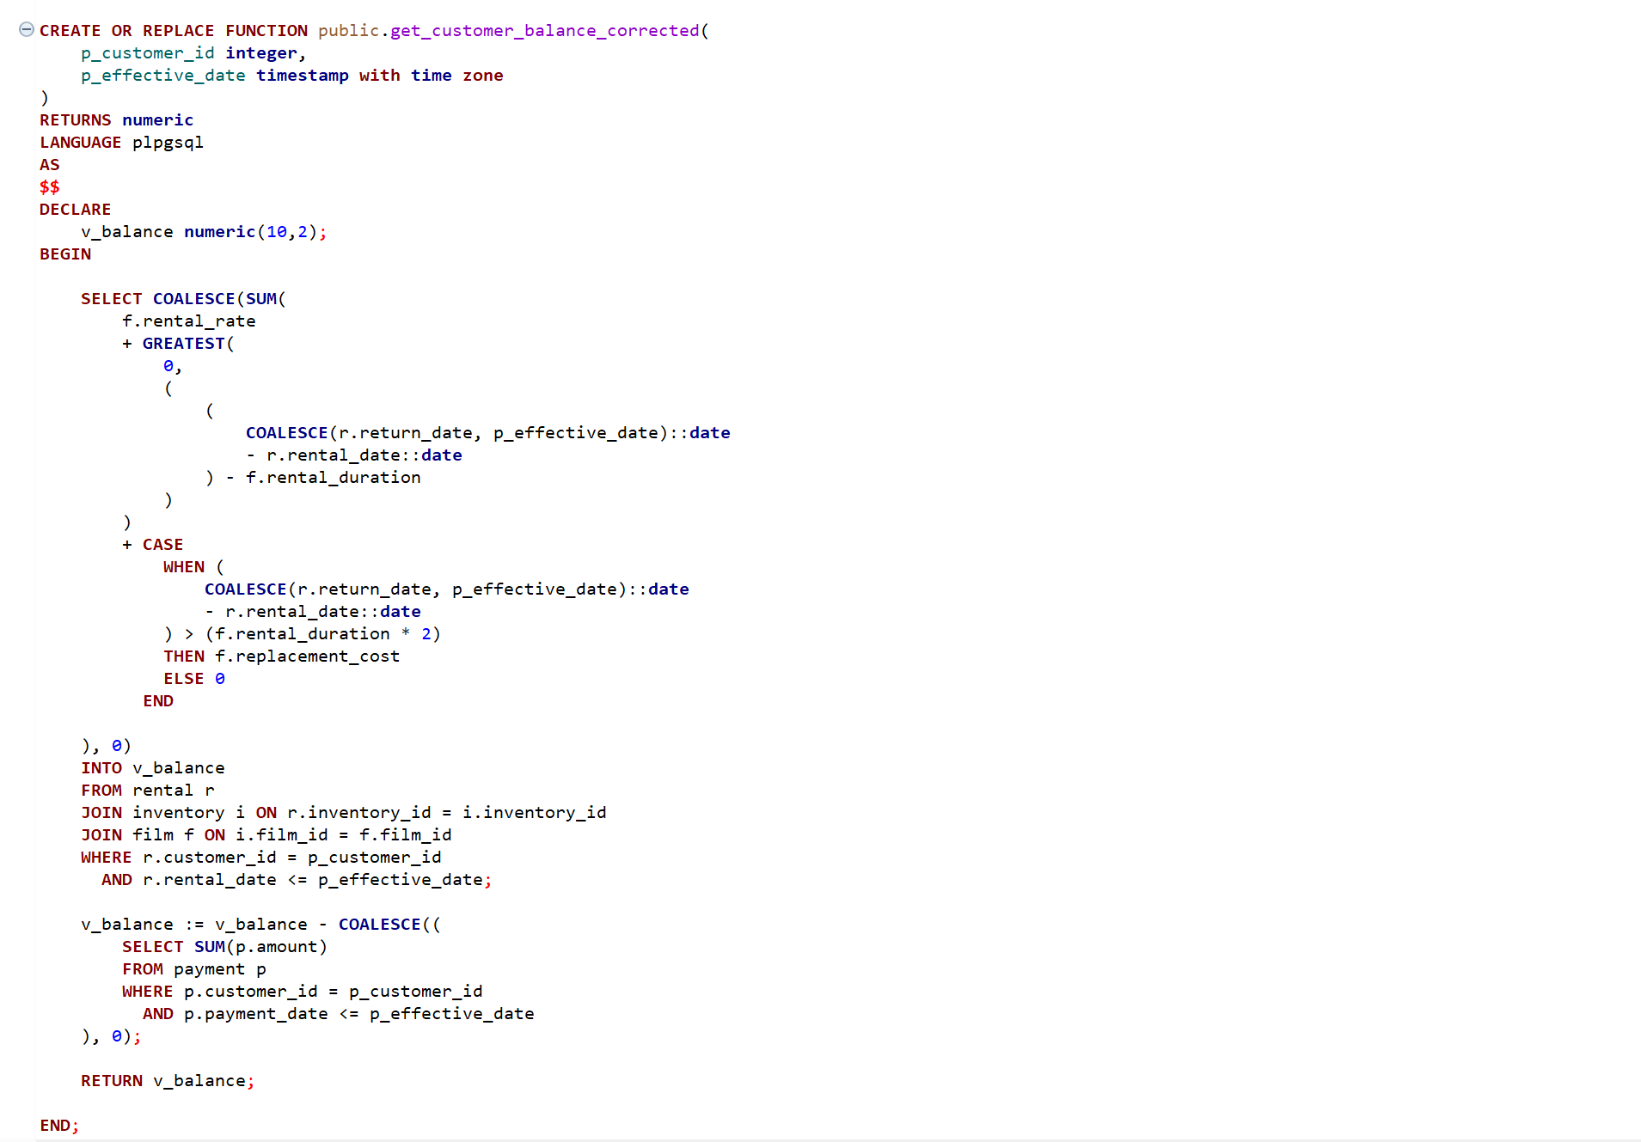

Task 6.5.
- How do ‘group_concat’ and ‘_group_concat’ functions work? (database creation script might help) Where are they used?

Answear:
- The _group_concat function defines how two text values are concatenated with a comma separator and is internally used in the group_concat function.

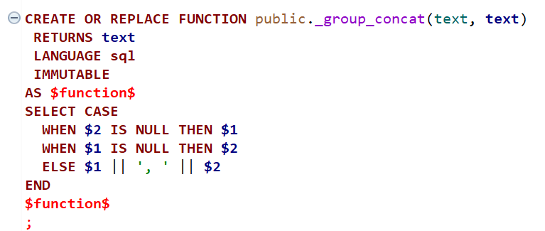

- The group_concat applies this logic across multiple rows to produce a single comma-separated string, and it is used in views such as actor_info and film_list to combine multiple values into one field.
- For example, in the film_list view, the group_concat function is used to combine multiple actor names into a single comma-separated string associated with each film.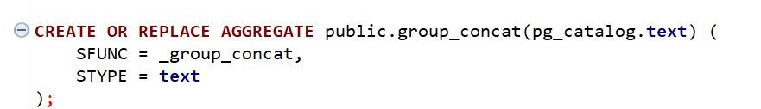

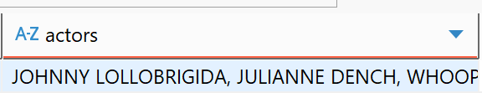

Task 6.6.
- What does ‘last_updated’ function do? Where is it used?

Answear:
- The last_updated function is a trigger function that automatically updates the last_update column to the current timestamp whenever a row is modified, and it is used in on multiple tables (actor, film, category, city, language etc) in the database.

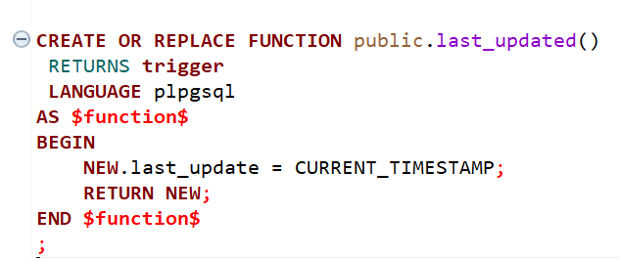
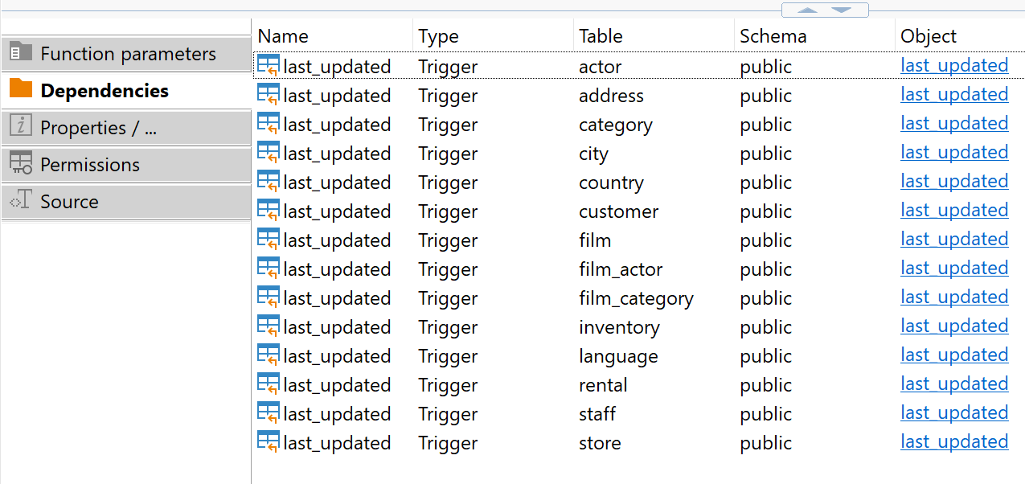

Task 6.7.
- What is tmpSQL variable for in ‘rewards_report’ function? Can this function be recreated without EXECUTE statement and dynamic SQL? Why?

Answear:
- The tmpSQL variable is used to store dynamically constructed SQL queries as text, which are later executed using the EXECUTE statement.
- The function can be recreated without EXECUTE and dynamic SQL because all table names, columns, and conditions are fixed, so a static SQL query can be used instead.

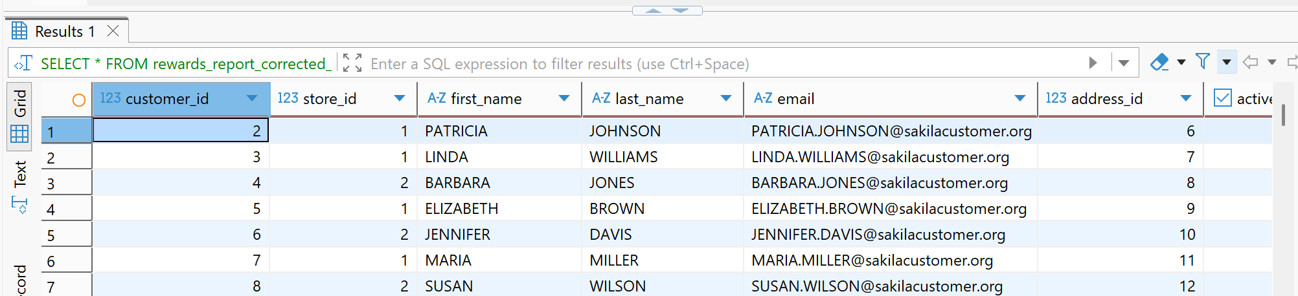
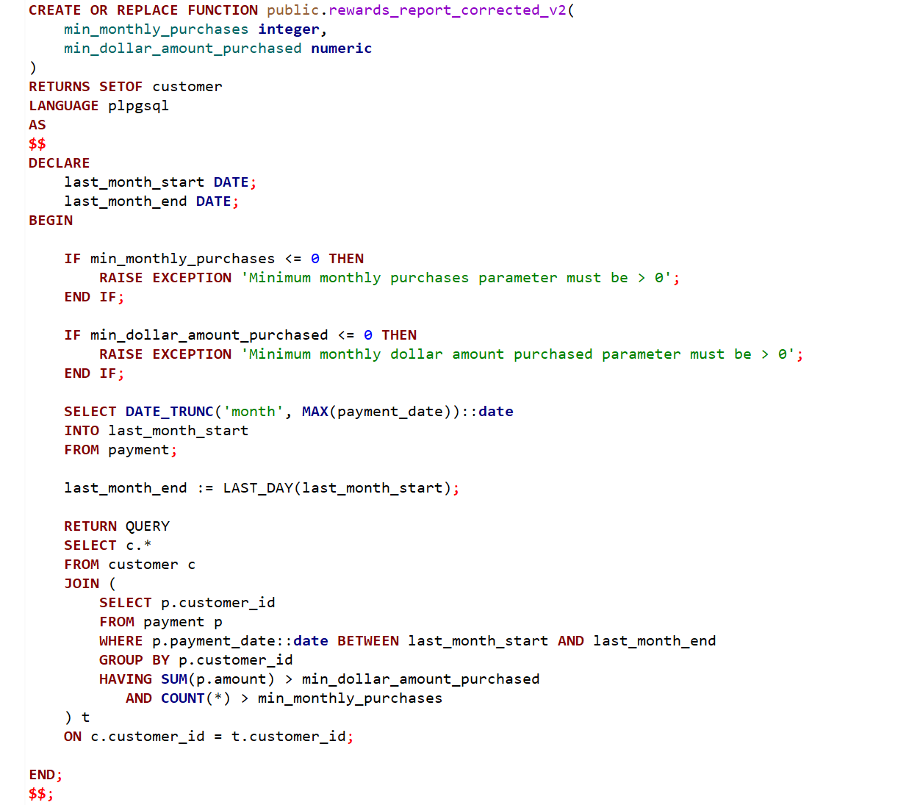

Task 6.8.
- Can any function produce incorrect results? Why?

Answear:
- Yes, some functions can produce incorrect results.
- The get_customer_balance function does not fully implement the business rules (missing replacement cost and incorrect handling of NULL return dates).
- The rewards_report function may return no results because it uses CURRENT_DATE, which does not match the data in the database

