Household Appliances Store
- Business Description
The selected domain is a household appliances store. The database is designed to support the main business processes of the store: managing customers, employees, suppliers, product categories, brands, products, customer orders, procurement orders, and inventory movements.
The store sells household appliances such as ovens, vacuum cleaners, washing machines, air conditioners, refrigerators, and other similar products. Customers place orders for products, employees process those orders, suppliers provide products to the store through procurement orders, and inventory movements are recorded to track stock changes.
- Conceptual Model
The diagram below summarises all foreign key relationships between the tables. Each relationship is described in terms of its cardinality and business meaning.

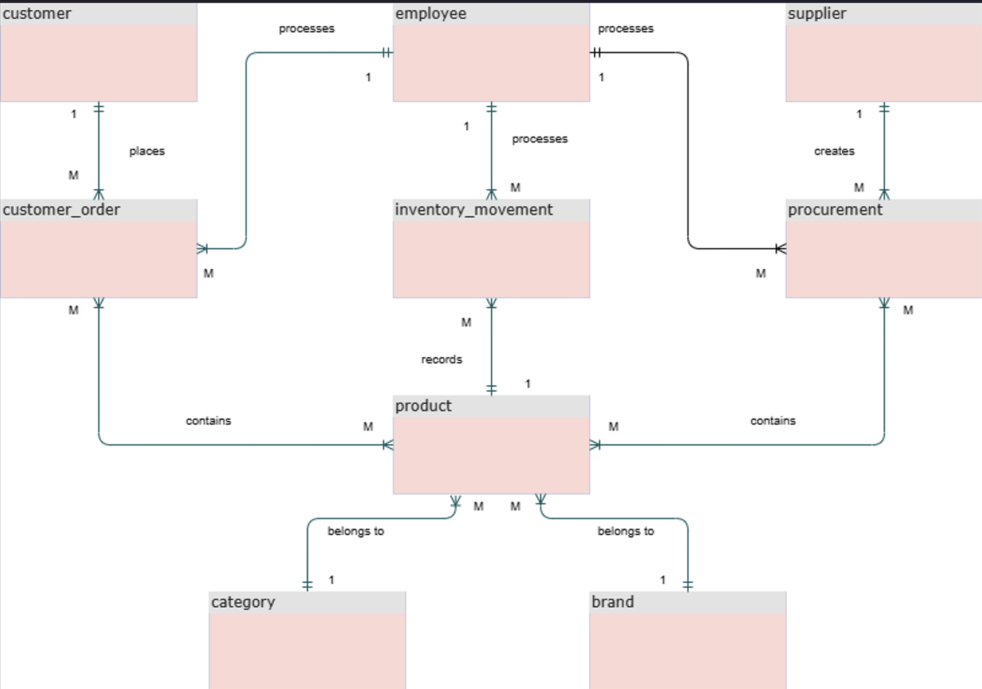
The model contains two explicit many-to-many relationships, both resolved through bridge tables. A customer order can include multiple products, and the same product can be included in multiple orders (this is resolved by order_line). Similarly, a procurement can include multiple products, and the same product can appear in multiple procurements (this is resolved by procurement_line) .

- Logical Model
The logical model is designed in Third Normal Form. Each relation represents one business concept, each non-key attribute depends on the whole key, and transitive dependencies are avoided.

Design Choice | 3NF Reason
Brand and category separated from product | Brand name and category name are stored once and referenced by product using foreign keys.
Order header separated from order lines | Customer and employee information belong to the order header, while product quantity and price belong to order_line.
Procurement header separated from procurement lines | Supplier and employee belong to procurement, while purchased products and acquisition costs belong to procurement_line.
Historical prices kept in transaction lines | order_line.unit_price stores the selling price at the time of the order; procurement_line.unit_price stores the purchase cost at the time of procurement.
Inventory tracked through movements | inventory_movement stores the stock history instead of overwriting only one stock value.

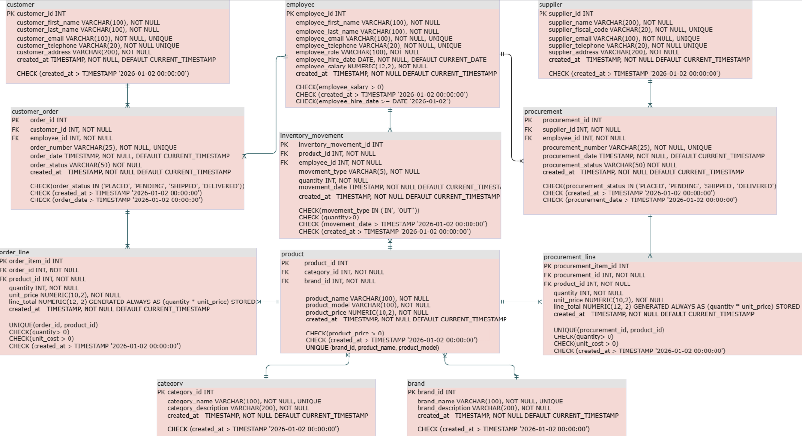

- Table Relationships
The relationships between tables are structured to reflect real-world scenarios such as customer purchases, supplier procurements, and stock movements.
- Each product belongs to exactly one category and one brand.
- A customer can place many orders, but each order belongs to one customer.
- An employee can process many customer orders and many procurement orders.
- A supplier can be associated with many procurement orders.
- One customer order can contain many products, and one product can appear in many orders. This many-to-many relationship is resolved through order_line.
- One procurement order can contain many products, and one product can appear in many procurements. This many-to-many relationship is resolved through procurement_line.
- Inventory movements record stock changes for products and identify the employee who registered each movement.

Parent Table | Child Table | Cardinality | Business Meaning
customer | customer_order | 1 : many | One customer can place many orders over time.
employee | customer_order | 1 : many | One employee can process many customer orders.
employee | procurement | 1 : many | One employee can manage many procurement orders.
employee | inventory_movement | 1 : many | One employee can record many stock movements.
supplier | procurement | 1 : many | One supplier can fulfil many procurement orders.
customer_order | order_line | 1 : many | One order contains one or more product line items. (many-to-many relationship of customer_order - product resolved)
product | order_line | 1 : many | One product can appear in many order lines. (many-to-many relationship of customer_order - product resolved)
procurement | procurement_line | 1 : many | One procurement contains one or more product line items. (many-to-many relationship of procurement- product resolved)
product | procurement_line | 1 : many | One product can appear in many procurement lines. (many-to-many relationship of procurement- product resolved)
category | product | 1 : many | One category groups many products.
brand | product | 1 : many | One brand manufactures many products.
product | inventory_movement | 1 : many | One product can have many stock movement records over time.

- Table Descriptions

5. 1. Table customer
The customer table stores personal and contact information for every individual who places an order at the store. Each record represents a unique buyer identified by name, email address, telephone number, and physical address.

Field Name | Field Description | Data Type | Constraints
customer_id | PK - unique identifier for the customer | INT | PRIMARY KEY
customer_first_name | Customer's first name | VARCHAR(100) | NOT NULL
customer_last_name | Customer's last name | VARCHAR(100) | NOT NULL
customer_email | Customer's email address | VARCHAR(100) | NOT NULL, UNIQUE
customer_telephone | Customer's phone number | VARCHAR(20) | NOT NULL, UNIQUE
customer_address | Customer's physical address | VARCHAR(200) | NOT NULL
created_at | Record creation timestamp | TIMESTAMP | NOT NULL, DEFAULT CURRENT_TIMESTAMP, CHECK > 2026-01-02

5. 2. Table employee
The employee table stores information about all staff members who work at the household appliances store. Each record represents one individual employee identified by name, contact details, role, hire date, and salary.

Field Name | Field Description | Data Type | Constraints
employee_id | PK - unique identifier for the employee | INT | PRIMARY KEY
employee_first_name | Employee's first name | VARCHAR(100) | NOT NULL
employee_last_name | Employee's last name | VARCHAR(100) | NOT NULL
employee_email | Employee's work email | VARCHAR(100) | NOT NULL, UNIQUE
employee_telephone | Employee's phone number | VARCHAR(20) | NOT NULL, UNIQUE
employee_role | Job role or position title | VARCHAR(100) | NOT NULL
employee_hire_date | Date the employee was hired | DATE | NOT NULL, DEFAULT CURRENT_DATE, CHECK >= 2026-01-02
employee_salary | Monthly gross salary | NUMERIC(12,2) | NOT NULL, CHECK > 0
created_at | Record creation timestamp | TIMESTAMP | NOT NULL, DEFAULT CURRENT_TIMESTAMP, CHECK > 2026-01-02

5. 3. Table supplier
The supplier table holds information about the companies or individuals who supply household appliances to the store. Each record represents one supplier identified by name, fiscal code, email, telephone, and address.
Field Name | Field Description | Data Type | Constraints
supplier_id | PK - unique identifier for the supplier | INT | PRIMARY KEY
supplier_name | Legal name of the supplier company | VARCHAR(200) | NOT NULL
supplier_fiscal_code | Unique national fiscal/tax code | VARCHAR(20) | NOT NULL, UNIQUE
supplier_email | Supplier's contact email | VARCHAR(100) | NOT NULL, UNIQUE
supplier_telephone | Supplier's phone number | VARCHAR(20) | NOT NULL, UNIQUE
supplier_address | Supplier's registered address | VARCHAR(200) | NOT NULL
created_at | Record creation timestamp | TIMESTAMP | NOT NULL, DEFAULT CURRENT_TIMESTAMP, CHECK > 2026-01-02

5. 4. Table category
The category table classifies household appliances into logical product groups such as refrigerators, washing machines, or vacuum cleaners. Separating categories into their own table avoids repeating category descriptions in every product record and makes it easy to rename or reorganize categories without touching the product table.
Field Name | Field Description | Data Type | Constraints
category_id | PK - unique identifier for the category | INT | PRIMARY KEY
category_name | Descriptive name of the category | VARCHAR(100) | NOT NULL, UNIQUE
category_description | Longer description of the category | VARCHAR(200) | NOT NULL
created_at | Record creation timestamp | TIMESTAMP | NOT NULL, DEFAULT CURRENT_TIMESTAMP, CHECK > 2026-01-02

5. 5. Table brand
The brand table stores the manufacturers and brand names of the appliances sold in the store, such as Samsung, Bosch, or Whirlpool. Extracting brand data into its own table removes a repeating, updatable attribute from the product table and avoids update anomalies — if a brand name changes, only one row needs to be updated rather than every product record.

Field Name | Field Description | Data Type | Constraints
brand_id | PK - unique identifier for the brand | INT | PRIMARY KEY
brand_name | Brand or manufacturer name | VARCHAR(100) | NOT NULL, UNIQUE
brand_description | Brief description of the brand | VARCHAR(200) | NOT NULL
created_at | Record creation timestamp | TIMESTAMP | NOT NULL, DEFAULT CURRENT_TIMESTAMP, CHECK > 2026-01-02

5. 6. Table product
The product table is the central catalog of all household appliances available in the store. Each record represents a distinct product model identified by its name, model number, price, and associated category and brand.
The composite UNIQUE constraint on (brand_id, product_name, product_model) ensures no duplicate product listings exist for the same brand and model combination.
Field Name | Field Description | Data Type | Constraints
product_id | PK - unique identifier for the product | INT | PRIMARY KEY
category_id | FK → category. Category this product belongs to | INT | NOT NULL, FK
brand_id | FK → brand. Manufacturer of this product | INT | NOT NULL, FK
product_name | Commercial name of the appliance | VARCHAR(100) | NOT NULL
product_model | Model number or code | VARCHAR(100) | NOT NULL
product_price | Current retail price | NUMERIC(10,2) | NOT NULL, CHECK > 0
created_at | Record creation timestamp | TIMESTAMP | NOT NULL, DEFAULT CURRENT_TIMESTAMP, CHECK > 2026-01-02

5. 7. Table customer_order
The customer_order table records every sales transaction initiated by a customer. Each row represents a single order placed at a specific date, assigned a unique order number, and associated with both the customer who placed it and the employee who processed it. Order-level information — the overall status, date, and parties involved — is stored here, while the individual products within the order are stored in the order_line table.
Field Name | Field Description | Data Type | Constraints
order_id | PK - unique identifier for the order | INT | PRIMARY KEY
customer_id | FK → customer. Who placed the order | INT | NOT NULL, FK
employee_id | FK → employee. Who processed the order | INT | NOT NULL, FK
order_number | Human-readable order reference code | VARCHAR(25) | NOT NULL, UNIQUE
order_date | Date and time the order was placed | TIMESTAMP | NOT NULL, DEFAULT CURRENT_TIMESTAMP, CHECK > 2026-01-02
order_status | Current status of the order | VARCHAR(50) | NOT NULL, CHECK IN ('PLACED','PENDING','SHIPPED','DELIVERED')
created_at | Record creation timestamp | TIMESTAMP | NOT NULL, DEFAULT CURRENT_TIMESTAMP, CHECK > 2026-01-02

5. 8. Table order_line
The order_line table resolves the many-to-many relationship between customer_order and product. A single order can contain multiple products, and the same product can appear in multiple orders — this bridge table captures each line item with its quantity and unit price at the time of purchase.
Storing unit_price here (rather than always reading it from product) is deliberate : the price of a product can change over time, but the price charged to the customer must remain fixed at the time of the transaction.
The line_total column is declared as GENERATED ALWAYS AS (quantity * unit_price) STORED, which means it is computed automatically by the database engine and never stored as a manually entered value — this avoids any possibility of inconsistency and does not violate 3NF, because it is a derived column explicitly declared as such in the schema.
A composite UNIQUE constraint on (order_id, product_id) prevents the same product from appearing twice in one order.

Field Name | Field Description | Data Type | Constraints
order_item_id | PK - unique identifier for the line item | INT | PRIMARY KEY
order_id | FK → customer_order | INT | NOT NULL, FK
product_id | FK → product | INT | NOT NULL, FK
quantity | Number of units ordered | INT | NOT NULL, CHECK > 0
unit_price | Price per unit at time of order | NUMERIC(10,2) | NOT NULL, CHECK > 0
line_total | Computed total for this line (quantity × unit_price) | NUMERIC(12,2) | GENERATED ALWAYS AS (quantity * unit_price) STORED
created_at | Record creation timestamp | TIMESTAMP | NOT NULL, DEFAULT CURRENT_TIMESTAMP, CHECK > 2026-01-02

5. 9. Table procurement
The procurement table records purchase orders made by the store from its suppliers. Each row represents one procurement event — when, from which supplier, handled by which employee, and what overall status it currently holds.
Individual products within a procurement are tracked in procurement_line. The structure mirrors customer_order intentionally: just as an order tracks the sale side, a procurement tracks the replenishment side.
Field Name | Field Description | Data Type | Constraints
procurement_id | PK - unique identifier for the procurement | INT | PRIMARY KEY
supplier_id | FK → supplier. Who supplies the goods | INT | NOT NULL, FK
employee_id | FK → employee. Who manages this procurement | INT | NOT NULL, FK
procurement_number | Human-readable procurement reference code | VARCHAR(25) | NOT NULL, UNIQUE
procurement_date | Date and time the procurement was created | TIMESTAMP | NOT NULL, DEFAULT CURRENT_TIMESTAMP, CHECK > 2026-01-02
procurement_status | Current status of the procurement | VARCHAR(50) | NOT NULL, CHECK IN ('PLACED','PENDING','SHIPPED','DELIVERED')
created_at | Record creation timestamp | TIMESTAMP | NOT NULL, DEFAULT CURRENT_TIMESTAMP, CHECK > 2026-01-02

5. 10. Table procurement_line
The procurement_line table resolves the many-to-many relationship between procurement and product. A single procurement can include multiple product types, and the same product can be procured in multiple procurement orders.
Each row records the quantity and cost per unit at the moment of procurement.As with order_line, unit_cost is stored at procurement time to preserve historical accuracy — supplier prices can change between orders. The line_total is GENERATED ALWAYS AS (quantity * unit_price) STORED, computed automatically.
A composite UNIQUE constraint on (procurement_id, product_id) prevents duplicate product entries within the same procurement.

Field Name | Field Description | Data Type | Constraints
procurement_item_id | PK - unique identifier for the line item | INT | PRIMARY KEY
procurement_id | FK → procurement | INT | NOT NULL, FK
product_id | FK → product | INT | NOT NULL, FK
quantity | Number of units procured | INT | NOT NULL, CHECK > 0
unit_cost | Cost per unit from supplier at time of procurement | NUMERIC(10,2) | NOT NULL, CHECK > 0
line_total | Computed total cost (quantity × unit_cost) | NUMERIC(12,2) | GENERATED ALWAYS AS (quantity * unit_cost) STORED
created_at | Record creation timestamp | TIMESTAMP | NOT NULL, DEFAULT CURRENT_TIMESTAMP, CHECK > 2026-01-02

5. 11. Table inventory_movement
The inventory_movement table provides full inventory tracking by recording every change to product stock levels. Each row represents one discrete stock event: a product entering inventory (IN — typically following a procurement delivery), leaving inventory (OUT — following a customer order fulfillment).
This table makes it possible to answer questions such as: how much stock of a given product entered the warehouse last month, who made a particular stock change, or what was the running stock level on a specific date.
The current stock for any product can always be derived by summing all movement quantities for that product.The primary key is inventory_movement_id. Two foreign keys are present: product_id references the product being moved, and employee_id references the employee who recorded the movement.
Field Name | Field Description | Data Type | Constraints
inventory_movement_id | PK - unique identifier for the movement record | INT | PRIMARY KEY
product_id | FK → product. Which product was moved | INT | NOT NULL, FK
employee_id | FK → employee. Who recorded the movement | INT | NOT NULL, FK
movement_type | Direction of the stock change | VARCHAR(10) | NOT NULL, CHECK IN ('IN','OUT','ADJUSTMENT')
quantity | Number of units moved | INT | NOT NULL, CHECK > 0
movement_date | Date and time the movement occurred | TIMESTAMP | NOT NULL, DEFAULT CURRENT_TIMESTAMP, CHECK > 2026-01-02
created_at | Record creation timestamp | TIMESTAMP | NOT NULL, DEFAULT CURRENT_TIMESTAMP, CHECK > 2026-01-02

