Alexandra Mendoza 1001778854 Homework 2
2025-10-24

#1
mydata <- read.csv("SampleData.csv")
shapiro_testA <- shapiro.test(mydata$A)
print(shapiro_testA)
##
## Shapiro-Wilk normality test
##
## data: mydata$A
## W = 0.36936, p-value = 7.103e-08
shapiro_testB <- shapiro.test(mydata$B)
print(shapiro_testB)
##
## Shapiro-Wilk normality test
##
## data: mydata$B
## W = 0.88003, p-value = 0.02613
qqnorm(mydata$A, main = "Q-Q Plot of Sample A")
qqline(mydata$A, col = "red", lwd = 2)
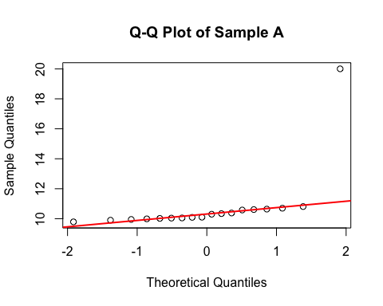
qqnorm(mydata$B, main = "Q-Q Plot of Sample B")
qqline(mydata$B, col = "red", lwd = 2)
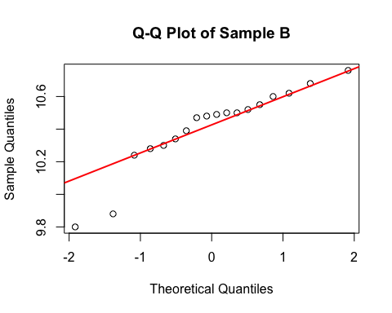

Interpretation for #1:
The normality test for sample A gave a p-value < 0.05, therefore, we can conclude that sample A deviates significantly from normality. The normality test for sample B gave a p-value < 0.05, therefore we can conclude that sample B deviates significantly from normality.

#2
mydata <- read.csv("SampleData.csv")
A <- mydata$A
B <- mydata$B
t.test(A, B, var.equal = TRUE)
##
## Two Sample t-test
##
## data: A and B
## t = 0.69657, df = 34, p-value = 0.4908
## alternative hypothesis: true difference in means is not equal to 0
## 95 percent confidence interval:
## -0.7339806 1.4995362
## sample estimates:
## mean of x mean of y
## 10.79389 10.41111
t.test(A, B, var.equal = FALSE)
##
## Welch Two Sample t-test
##
## data: A and B
## t = 0.69657, df = 17.392, p-value = 0.4953
## alternative hypothesis: true difference in means is not equal to 0
## 95 percent confidence interval:
## -0.7746178 1.5401733
## sample estimates:
## mean of x mean of y
## 10.79389 10.41111

Interpretation for #2:
While the p-value for the t-test under unequal variances was slightly larger than the p-value for the t-test under equal variances, both p-values were less than 0.05, so we can conclude that there is a significant difference between the means of samples A and B.

#3
table_matrix <- matrix(
c(73, 14,
756, 826),
nrow = 2,
byrow = TRUE
)
rownames(table_matrix) <- c("Recurrent", "No_Recurrence")
colnames(table_matrix) <- c("Placebo", "Apixaban")
table_matrix
## Placebo Apixaban
## Recurrent 73 14
## No_Recurrence 756 826
fisher.test(table_matrix)
##
## Fisher's Exact Test for Count Data
##
## data: table_matrix
## p-value = 1.334e-11
## alternative hypothesis: true odds ratio is not equal to 1
## 95 percent confidence interval:
## 3.152431 11.016690
## sample estimates:
## odds ratio
## 5.691495
chisq.test(table_matrix, correct = FALSE)
##
## Pearson's Chi-squared test
##
## data: table_matrix
## X-squared = 43.038, df = 1, p-value = 5.368e-11

Interpretation for #3:
For both tests the p-values are very small (less than 0.05), therefore we can conclude that there is a significant association between treatment and recurrence.

#4
mydata <- read.csv("Table27_3.csv")
## Warning in read.table(file = file, header = header, sep = sep, quote = quote, :
## incomplete final line found by readTableHeader on 'Table27_3.csv'
chisq.test(x = mydata$observed, p = mydata$expected / sum(mydata$expected))
##
## Chi-squared test for given probabilities
##
## data: mydata$observed
## X-squared = 0.47002, df = 3, p-value = 0.9254

Interpretation for #4:
Because the p-value is very large (bigger than 0.05), we can conclude that the observed data fit the expected model.

