Perfect Coffee

* Discipline: Programming for Mobile Devices
* Owner: Alexandra-Denisa Pert
* Date: 12.05.2020
* Coordinator: Liviu Octavian Mafteiu-Scai
* Institution: West University of Timisoara, Department of Computer Science, Romania
* Description: The project was created in order to help the customers of coffee shops to buy the desired type of coffee.
* Goal: A functional app to order the desired coffee, check the latest news on the coffee shop’s website and login on the app.
* Introduction: There are some similar applications in Romania, but only for some big companies such as TED’s coffee™, Starbucks coffee™, but in those apps you can’t really order a simple cup of coffee; you can only order grounded coffee, some products with their name such as branded mugs, thermos travel mugs and see the presentation of the coffee shops around Romania.
* Functionality:

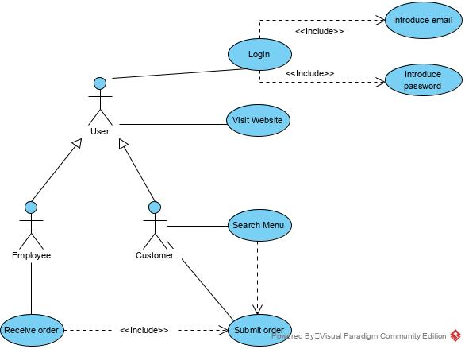

* User Interface:

* Executing the application: a beautiful, representative main page:

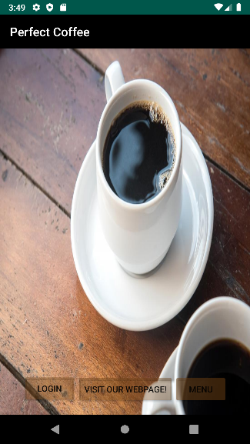

* from where you can navigate either to the login page:

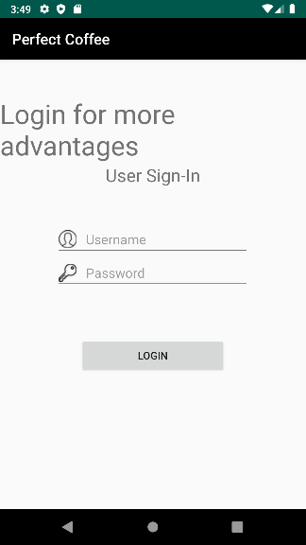

* access the google.ro page, but any webpage can be accessed with minor changes in the application (this page is made for the coffeeshop’s webpage for more promovation):

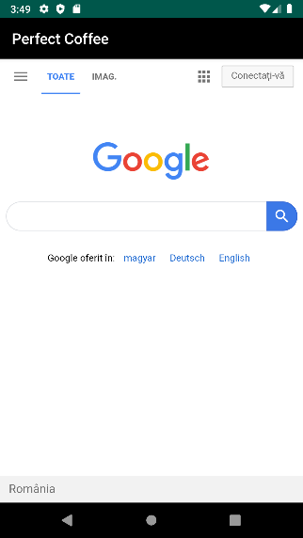

* and navigate into the menu page in order to see what you the coffee shop has to offer:

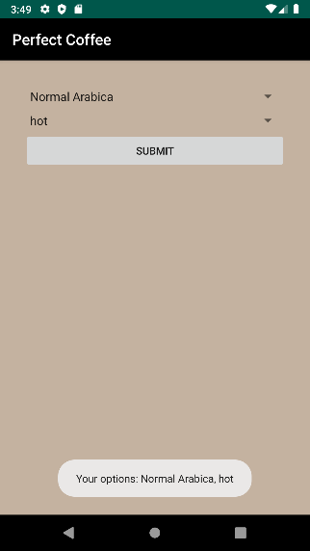

* Application structure:
* For the main page, it was used an XML file (for the background and layouts of the page and the 3 buttons at the bottom of the page) and a Java file for launching the other 3 screens (LoginScreen, WebViewScreen and MenuScreen) and viewing their layouts .
* Login Screen: it was used an XML file (for the background and layouts of the page, but also to include the text boxes and the small images with the key regarding the password and the human regarding the user) and a Java file in order to view the layout of activity_login.
* WebView Screen: it was used an XML file (for the background and layouts of the page) and a Java file to view the layout, enable javascript, and also load the specific URL address. This needed specific permission to the internet in the AndroidManifest.xml file.
* MenuScreen: it was used an XML file (for the background and layouts of the page and for defining the 2 spinners and submit button) and 2 Java files: one for adding listeners to the button and spinner item selection, adding items to each spinner, and finally sending the order to Firebase database “cofi-c590f” through the ‘submit’ button; and another one for showing custom selections at each spinner selection.
* Improvements and extensions:
* Main screen can have a background of a video of coffee in making or a slideshow with the coffeeshop’s products.
* Login screen should be functional and send the data to Firebase Authentication, and also the signup option should be available. After you login you should be send to an extra privileged page where you can have some additional promotions and offers.
* Menu screen can have more options for the coffee and even options for tea, water and soft drinks. Also there may be the option to order at home (where this button should send you to another page for entering private info like the address, phone nr, etc.) or the option to order in the restaurant and pick-up yourself.
* Annexes:

https://developer.android.com/guide/topics/ui/

https://sites.google.com/a/e-uvt.ro/mafteiu-scai_liviu/2019-2020/pmd/