Documentation

I have created a Web API application and I am consuming those services in an MVC application.

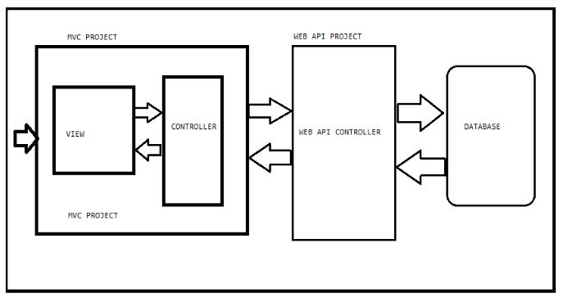

**UML diagrams**

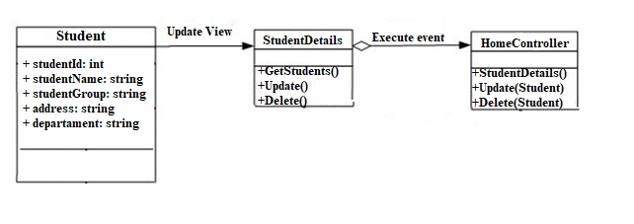

**SoaML**

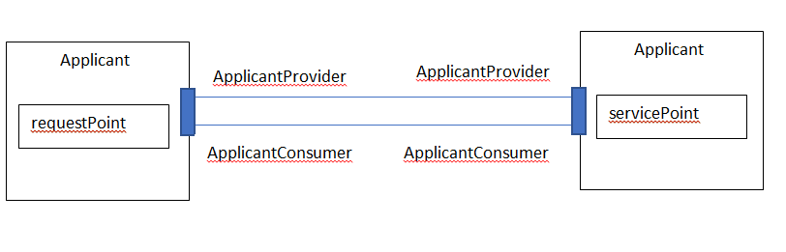

**Business Process Model and Notation** (**BPMN**)

