MQ BTG configurator
Software Requirements Specification
Version 1.0

Table of contents
Glossary 3
Overview 4
Functionallity 5
2.1 Main Functionallity 5
2.2 CM Functionallity 6
2.2.1 MQ BTG Configurator 6
2.2.2 MQ BTG Editor 8

Glossary
1 phase — the first implementation of this tool, which excludes automatic changes on the site when changes are made in the CM.
Buy-In — collecting a fixed amount from the player in MQ BTG before the game starts. There are only players with the same buy-in in the same room. The winner receives the sum of buy-ins exclusion the casino commission(rake).
CM — Betsoft backoffice designed to generate statistical reports, as well as configure various functionalities.
MQ BTG — MQS game mode in which players compete against each other. Each player pays a buy-in when entering the room. The winner at the end of the round takes the sum of buy-ins, with the exclusion of the casino commission.
MQB — an online casino site that allows players to play MQS games (including MQ BTG). All players can play on any of 2 currencies (MQC and MMC).
MQS — a series of multiplayer action casino games. The main purpose of the game is to shoot mobs.
Prize Pool Values — the maximum prize pool for a room, calculated through its buy-ins. It is calculated as the room buy-in multiplied by the maximum number of people for that room.
Rake — casino commission deducted from each player's buy-in.
Room — a game room in MQ BTG games that brings together players who will compete with each other.
Web-team — development team responsible for creating and editing the MQB project website.

Overview
The main functionality of this tool is to control the BTG mode for MQS games using CM.
The user should be able to get a list of MQS games with available BTG mode for one of the MQB banks (MQC or MMC). For each game, the user should be able to change the different settings described in the "Functionallity" section.
After the first phase of the implementation of this tool, any changes made from the CM must be agreed with the Web team in order to change the content on the MQB site.
In the future, changes occurring using this tool should automatically change the content of the MQB site. For example, turning off the BTG mode for game should remove the display of this mode on the site.

Functionallity

2.1 Main Functionallity
The user should be able to change the following settings for each game:
- Enable/disable BTG mode.
- Select multiple Buy-ins from the list of available ones (minimum 6).
- Change rake ranging from 0 to 10 percent.
Using this tool, the user should be able to view the current values of the settings listed above for each game, as well as:
- Max Number of Players.
- Prize Pool Values.

2.2 CM Functionallity
The tool must be a set of reports located in "Management" - "MQ" - "MQ BTG Configurator".
This report must be visible to users with the following roles:
- Operator (MQB Management only).
- Authentication Manager.
- Support.

2.2.1 MQ BTG Configurator
The user must select one of the MQB banks using the standard bank selection form. After selecting a bank and pressing the "Search" button, the user should see a table with the attributes presented in table 1. Interface of this report is shown in picture 1.
Table 1 – attributes of table.
№ | Title | Description | Type
1 | Game Name | The name of the game used in the back office.  Clickable. | Text
2 | BTG Mode | Can be ON or OFF. Also, with ON the background color of the cell becomes green, with OFF - red. | Bool
3 | % Rake | Rake expressed as a percentage. | Number
4 | Buy-Ins | The current buy-in set for the game. Values are listed separated by commas. | Text
5 | Max Number of Players | The maximum number of people for one room of this game. | Number
6 | Prize Pool Values | Prize pool calculated for each of the available buy-ins. Values are listed separated by commas. | Text

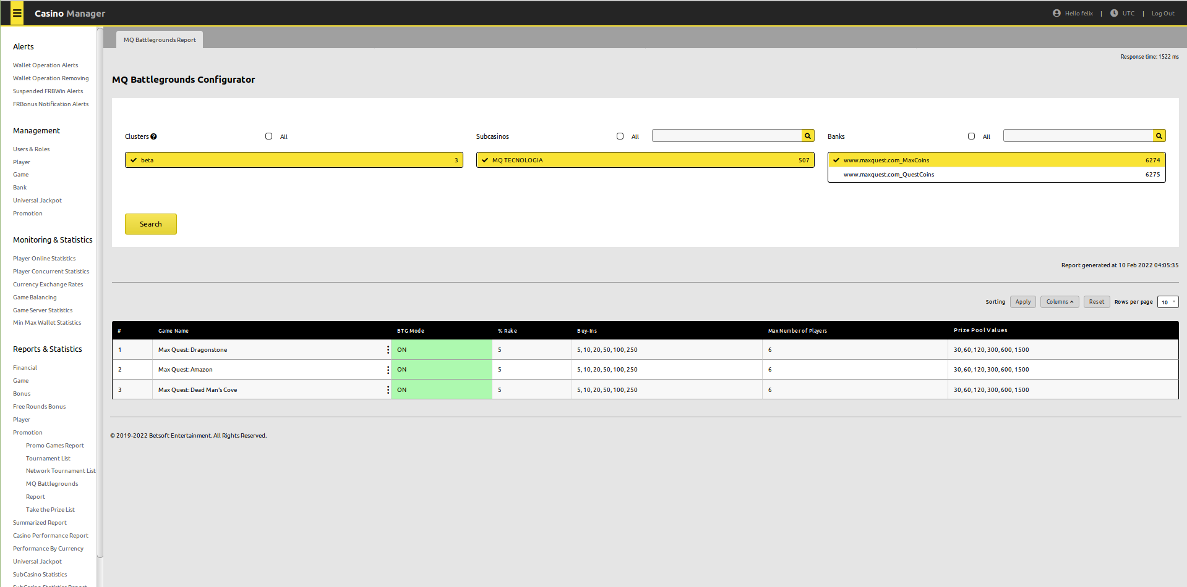
Picture 1 – Interface of the main page of report "MQ BTG Configurator"

Clicking on the "Game Name" of the game should open the "MQ BTG Editor" pop-up window. The functionality and properties of this window are described in section 2.2.2.

2.2.2 MQ BTG Editor
This section is a pop-up window that allows to edit the BTG mode settings for a specific game.
The name of the game and the bankId should be displayed at the top of this window. At the bottom of this window there should be buttons "Save" and "Cancel".
In this window, the user can change the following parameters:
№ | Title | Description | Type
1 | BTG Mode ON | If set, then the BTG mode for this game is enabled. | Checkbox
2 | Buy-Ins | Allows the player to select buy-ins. Constraints are described in Section 2.1. | Multiselect.
3 | All Buy-Ins | Allows to select all available buy-ins for this game as active. | Checkbox
4 | % Rake | Allows to set the rake. Can be entered from the keyboard or set using the interface to increase (decrease) the value in steps of 1. Constraints are described in Section 2.1. | Input

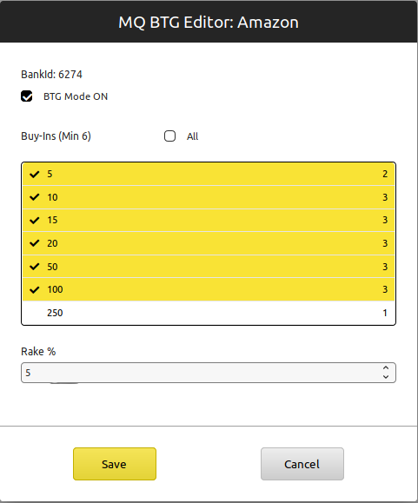
Picture 2 – Interface of Edit window

