MQ BTG Bots
Software Requirements Specification
Version: 1.2

Table of Content
Table of Content 2
Glossary 3
Overview 4
Main functionality 5
2.1 Bot management 5
2.1.1 Creation of bots 5
2.1.2 Information about bots 6
2.1.3 Edit bot 6
2.2 General logic of bots 7
UI/UX for CM 10
3.1 Login page 10
3.2 Main page 11
3.2 Add new bot 12
3.3 Details about bot 12
3.4 Edit bot 14
3.5 History 15

Glossary
Admin panel — web application that allows to manage bot settings (create/delete, activate/deactivate, etc.) and also view the history of the bot in CM by redirecting.
Bots — program that control a regular MQB account and allows to imitate the behavior of a real player. In this case, to keep the game activity.
Buy-In — collecting a fixed amount from the player in MQ BTG before the game starts. The winner receives the sum of buy-ins excluding the seating fee (aka rake).
CM — Betsoft backoffice designed to generate statistical reports, as well as configure various functionalities.
MQ BTG — MQS game mode in which players compete against each other. Each player pays a buy-in when entering the room. The winner at the end of the round takes the sum of buy-ins, excluding the seating fee (aka rake).
MQB — an online skill games website that allows players to play MQS games (including MQ BTG) and fun mode casino games. All players can play any of the MQS games on any of 2 currencies (MQC and MMC).
MQS — a series of multiplayer action casino games. The main purpose of the game is to shoot mobs.
Room — a game room in MQ BTG games that brings together players who will compete with each other.
RNG — advanced randomizer.

Overview
The main object of this functionality is bots. The main purpose is to keep the game active, in case there are not enough players to start the round with a single real player and a long waiting period to start. The use of bots should be kept to a minimum and used only to keep the game active.
Each bot account must be an MQB account, like a real player account, and have both currencies (MQC and MMC). Each bot should have characteristics similar to real players, i.e. nickname, avatar, etc. The behavior of the bot should be as indistinguishable from real players as possible. The bot can lose like real players or win.* The bot like a real players always pays the seating fee/rake.
Bots should be managed through the admin panel and the MQB website (to replenish the balance of bots), as well as view the history of the bot's games in the CM by redirecting from the admin panel. The creation and settings of each bot should be managed by a person a – bot manager.

* — In theory, it is possible to make an optimal strategy. However, with such a strategy, the probability of detection of bots by players or third parties is very high. Therefore, we believe that using the concept of an optimal strategy is inexpedient and unsafe for this functionality.

Main functionality
The main functionality consists of managing bots and the general logic of bots.

2.1 Bot management
The bot manager should be able to perform the following actions on bots:
- Create bots through the admin panel and get access (login and password) to the bot's MQB accounts.
- View details about the bot in the admin panel.
- Removing bots through the admin panel.
- Edit bots.
- Activation/deactivation of each bot through the admin panel.
- Replenishment of the balance of each bot through the MQB site via promo code.
- Receive an email notification when a certain lower balance threshold is reached.
- Withdrawal of the bot balance via MQB site.

2.1.1 Creation of bots
Each bot is created using the admin panel. When creating a bot, the bot manager should be able to enter the following information:
- MQ BTG Games — what games the bot can play (specific or all available).
- Username — username, which can then be used on the MQB site.
- Email — valid email that will be used to verify the account.
- Country — invented by a bot manager.
- First name — invented by a bot manager.
- Last name — invented by a bot manager.
- Phone Number — invented by a bot manager.
After creating the bot, the bot manager should receive:
- Bot creation status (success/failure).
- Generated password for the MQB account.
After that, the bot manager needs to verify the account using an email.
NickName and Avatar must be generated for each bot by the server before the start of the game from the list of pre-registered pairs NickName-Avatar. This reduces the likelihood that players will find out about bots.

2.1.2 Information about bots
The bot manager should be able to view all the information entered during creation about each bot, as well as:
- Balance of MMC and MQC of bot at the moment.
- Bot status (activated/deactivated).
- Login and password for this bot on the MQB site.
- Bot history.

2.1.3 Edit bot
The bot manager should be able to change the list of games that the bot can play.

2.2 General logic of bots
Each bot is a program that control an MQB account and can play on any of the 2 banks of MQB. The number of bots is configured by the bot manager and is not limited. Also, the bot can play all MQS games or only specific ones (selected by the bot manager).
Each bot can be deactivated. Only activated bots can participate in game sessions.
Each bot has its own balance (separately for MQC and MMC). The bot manager must replenish these balances after creating the bot using a promo code. If the bot's balance reaches a certain lower threshold (can be configured), then an email notification should be sent to the bot manager. (TBD)
To increase randomness, each of the active bots must play. There should only be one bot in one room.
Each active bot should enter a room that satisfies the conditions:
- 1 real player is trying to enter.
- The game start timer is less than 10 seconds.
- The bot has enough balance for this buy-in.
- The bot is configured to play this particular game.
To increase randomness, approximately every 5th expected bot entry (randomly) should be skipped, i.e. the bot will not enter the game.
Before the start of the game, the bot is assigned a nickname and avatar by the server, which can be relevant only for a specific bot for the entire duration of the game session. The list of pairs nickname-avatars must be pre-created on the server side and reserved for bots.
The behavior of the bot during the game should be similar to the behavior of a real player. Bots have to sometimes lose and sometimes win.
If another player join to the first game of the bot and the real player (the first round of the session) at the last moment of waiting period, then the bot must stay in the room and play this round.
If another player join to the any non-first round of game with bot, then the bot must decide based on the RNG to stay in the room or not.
If at the end of the round only the one real player and the bot are still in the room, then the bot must decide based on the RNG whether to play the next round or not.
At the end of each round, the bot must appear on the leaderboard, just like regular players. In case of a win, the bot must take the winnings equal to the sum of all buy-ins, excluding the seating fee (aka rake). (like any player in case of winnings).
After each round, the bot must check if the balance is sufficient for the next round. If the balance for this buy-in is insufficient, then the bot must exit the game. If the bot's balance is not enough even for the smallest buy-in the bot will be deactivated.*
Bots have no limits and can play until they are deactivated or run out of balance.*
The bot can be removed from the admin panel. The removal will remove the dependence of the real MQB account on the bot functionality. Also, the entry about this bot will have to be removed from the list of all existing bots.
The logic of each bot is shown in Diagram 1.

* - from an implementation point of view, the balance of bots is a limited value, so these conditions are necessary in the specification and diagram.
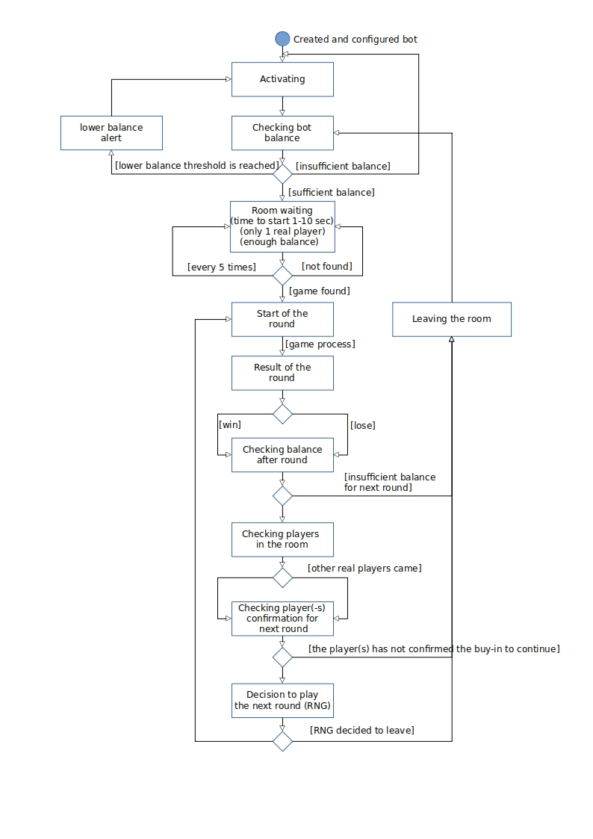
Diagram 1 — Activity diagram

UI/UX for CM
Web application for managing bots, as well as view the history of the bot in CM by redirecting. Login data should be issued at the request of the BSG.
The functionality and data for these application are described in section 2.1 (Main functionality/Bot management).

3.1 Login page
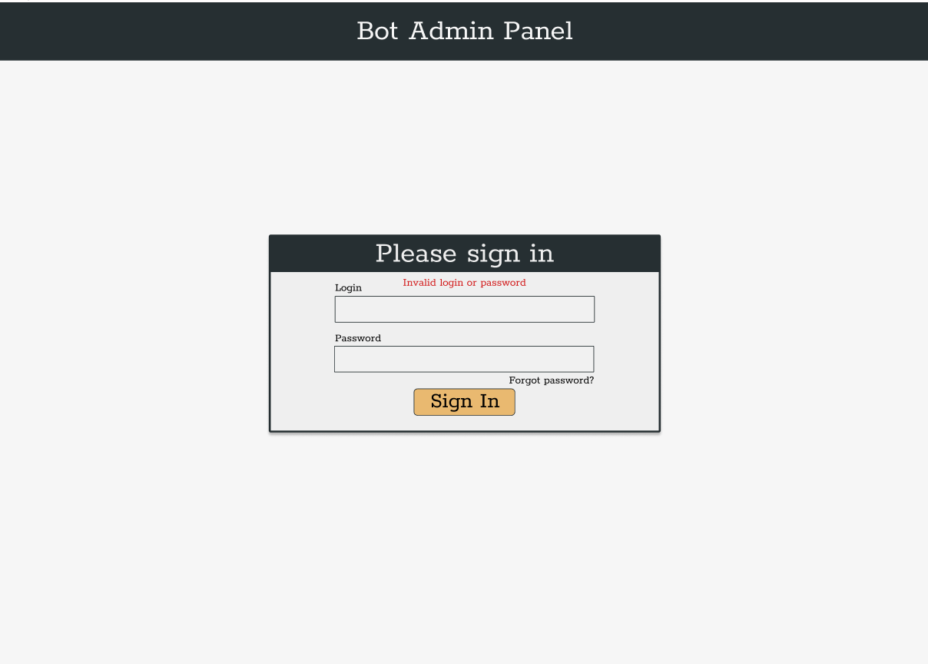
This page should allow the bot manager to enter a login and password and log in to the system. In case of successful authorization, the user should be redirected to the main page.
Picture 1 – Login page

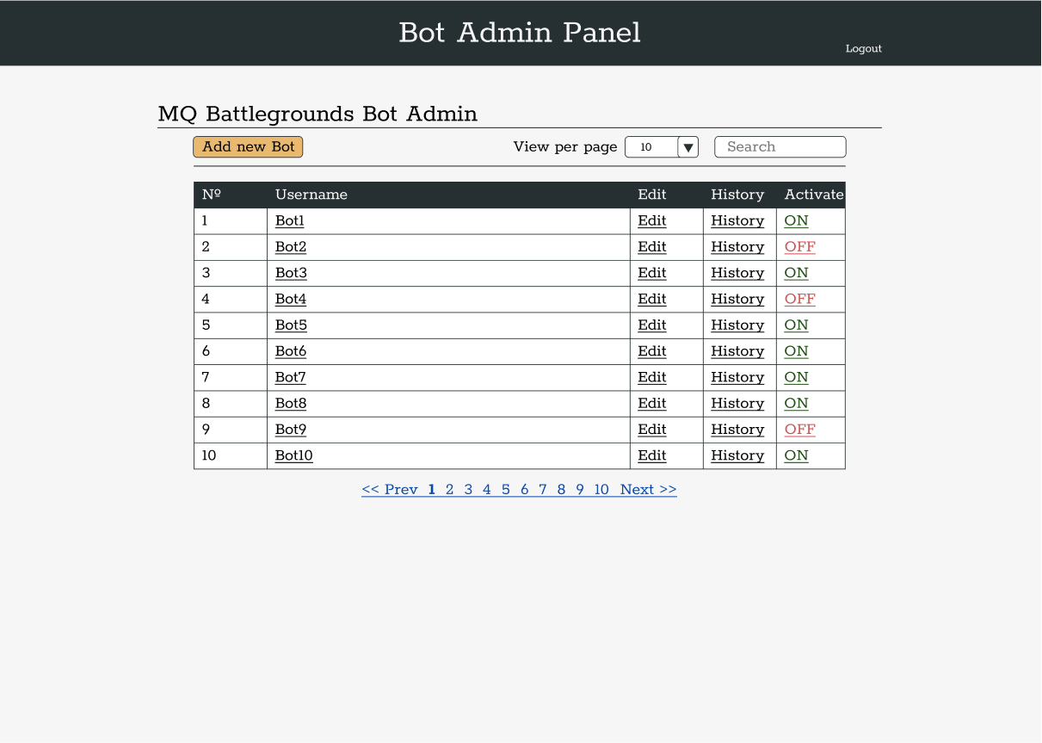
3.2 Main page
This page should contain a list of existing bots, as well as a button for creating new bots. Each bot should have "Active","History" and "Edit" buttons.
The "Add new Bot" button should redirect user to a "Add new Bot" page.
The "Active" button should have 2 positions – ON and OFF. If the user sees the ON button, then the bot is active, otherwise it is deactivated.
By clicking on the "History" button, the user should be redirected to the "Player Game Info" CM report for the account of this bot.
The "Edit" button should take the user to the bot editing page.
There should also be a "select" to select the number of displayed objects on the page and search by username of the bot.
Picture 2 – Main page

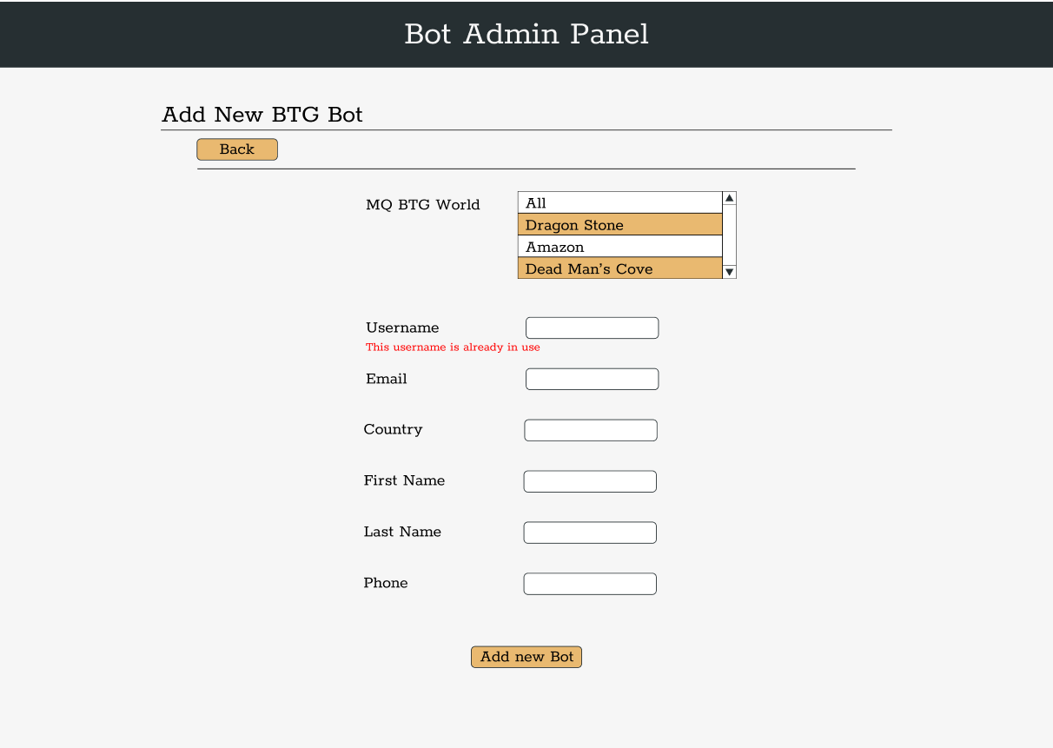
3.2 Add new bot
On this page, the bot manager can create a new bot. Manager must enter values for all parameters. After clicking on the "Add a new bot" button, the bot manager will receive the creation status. The user can also return to the main page with the "Back" button.
Picture 3 – Add new Bot page

3.3 Details about bot
The transition to this page is carried out by clicking on the username of the bot on the main page of the report. On this page, you can see the current characteristics of the bot, as well as its account credentials and balance.
Also from this page you can move to the bot editing page, and the bot game history in CM. There is also a button to delete the bot. Deleting the bot must be confirmed in the pop-up window. Removing the bot will completely decouple the real MQB account from the bot functionality.
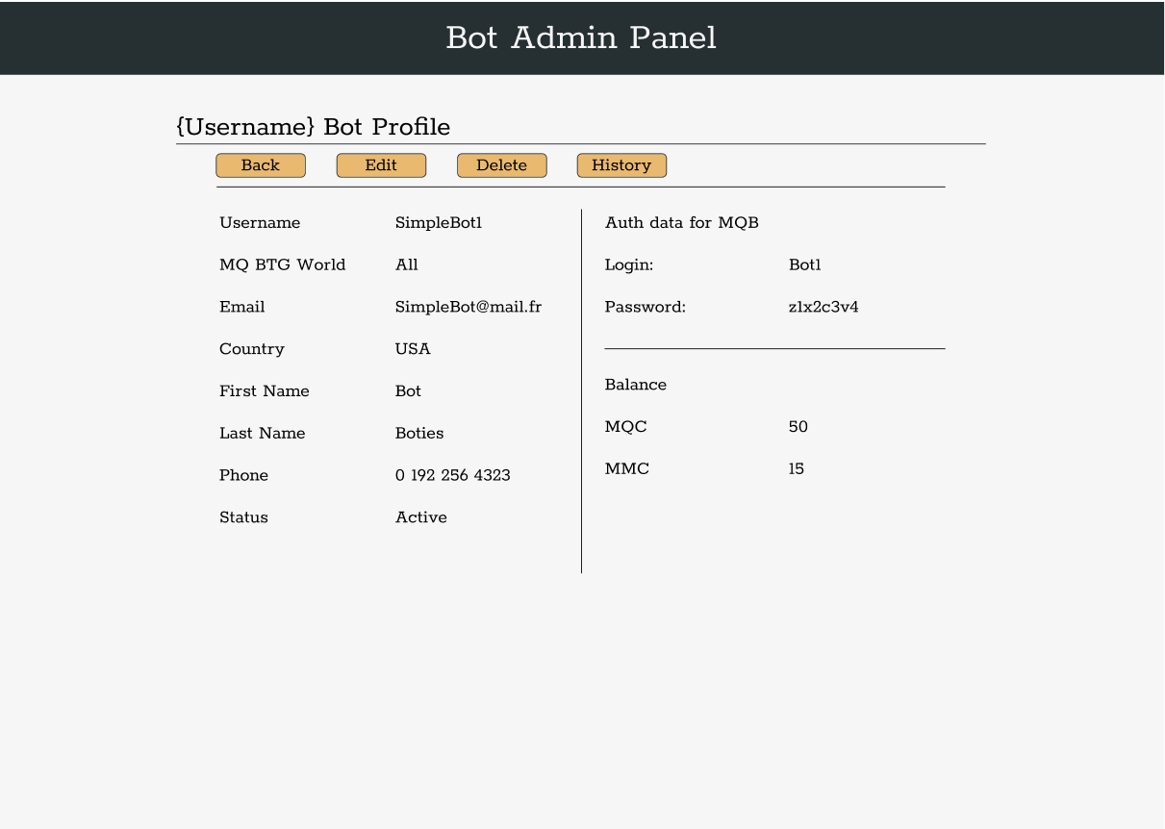
Picture 4 – Detailed Info page

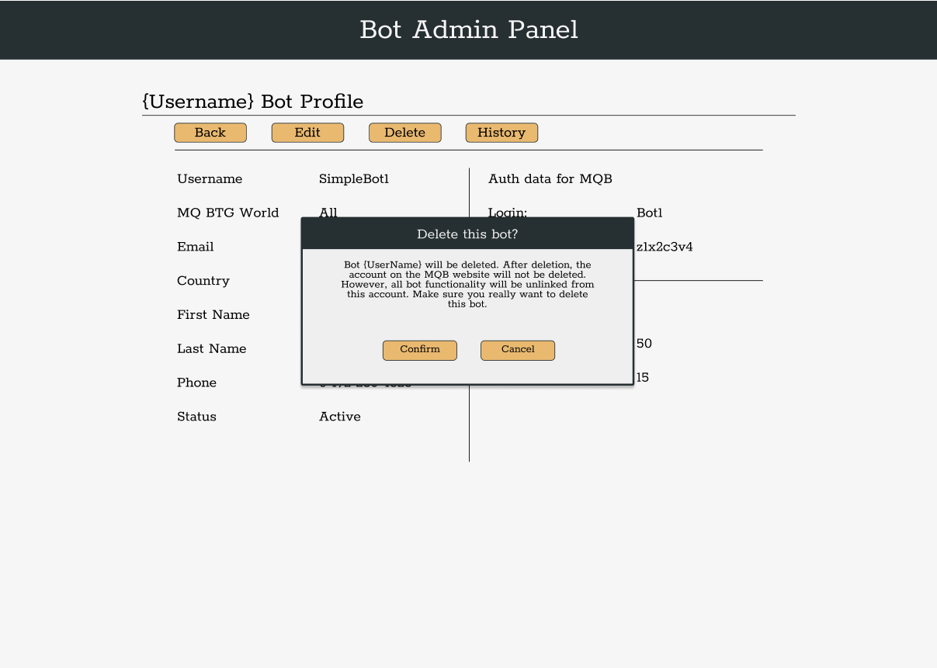
Picture 5 — Deleting confirmation

3.4 Edit bot
This page allows the bot manager to change the list of games that the bot can play.
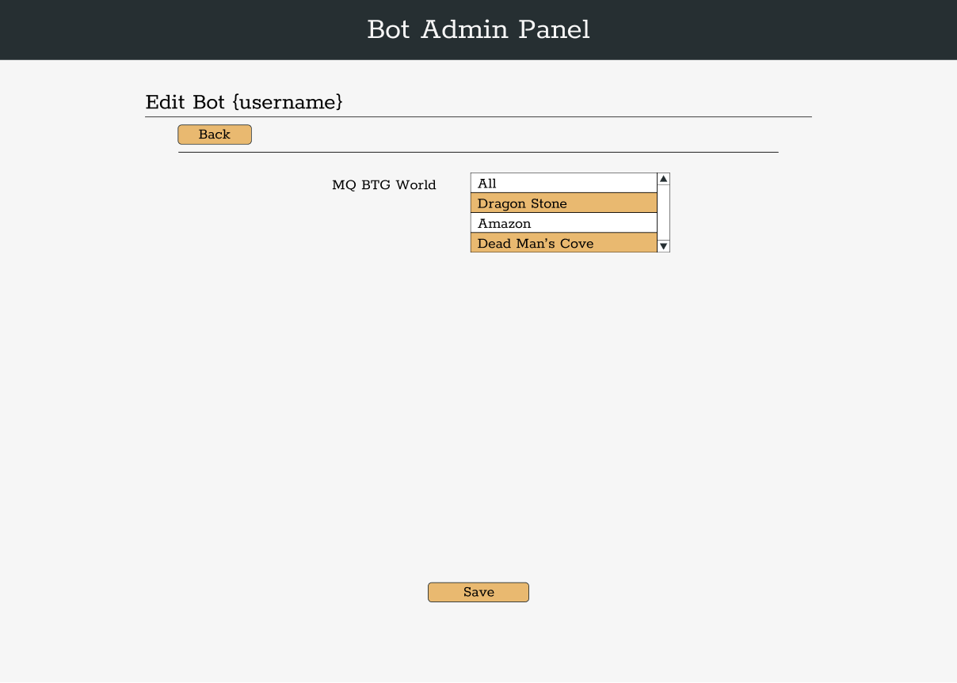
Picture 6 — Edit bot page

3.5 History
Click on the "History" button will redirect the user to the "Player Game Info" report in CM.

