Tournaments Promo
Software Requirements Specification
Version 1.1

Table of contents
Glossary 3
Overall description 4
Main functionality 5
2.1 Types 5
2.1.1 Highest value single spin win amount 5
2.1.2 Highest value total of all bet amounts 5
2.1.3 Highest value total of all win amounts 6
2.2 Creation and management 7
2.2.1 Creation 7
2.2.2 Management 13
2.3 Gameplay 14
2.3.1 Filtering 14
2.3.2 LeaderboardPlayerId generating 14
2.3.3 Welcome message 14
2.3.4 Show Before Start 15
2.3.5 Show After Finished 15
2.3.6 Qualification 15
2.3.7 Leaderboard 16
2.3.8 Motivational Messages Logic 18
2.3.9 Payouts 18
2.4 API 20
2.5 Reports 21
2.5.1 Drive Tournaments List 21
2.5.2 Drive Tournament Winner List 22
2.5.3 Drive Tournament Leaderboard 23
2.5.4 Prize Pool by Currency 23
2.5.5 Promotion List 24
UI/UX 25
3.1 Welcome Message 25
3.2 Top Bar Item 26
3.3 Promo detail screen 27
3.3.1 Leaderboard 28
3.3.2 How To Qualify 29
3.3.3 Options 30
3.3.4 Promo Rules 31
3.4 Motivational message 31

Glossary
Casino Manager (CM) — BSG backoffice system, through which promotional campaigns can be created and the necessary reports on ongoing and completed promotions are available.
LeaderboardPlayerId — unique player ID displayed in the game during tournaments. Has a direct relationship with ExtId. Designed to hide the real ExtId.
Motivational Message — notification that players participating in the tournament receive in case of improvement in their positions (and some other logical events).
Promo Campaign Container — container for sets of promotional tools such as Take The Prize, Tournaments and others. Designed to unify common settings across promo tools used in the same Promotional Campaign. Implementation in Phase 1 is not required.
Qualification — a series of criteria that a player must meet in order to start the promo. For example: the minimum wager amount, or the minimum number of spins.
RDv2 Games — BSG games (slots and table games) that support the RDv2 concept, giving the adapted application the ability to adjust the UX to the environment in which it runs.
Top Bar Item — section of the Unified Top Bar Panel, that contains information about the promo, remaining prizes and the time left to the end of the promo.
Unified Engine — architecture framework that implements a set of base classes that act as the basis for developing the frontend side of BSG games.
Welcome Screen — a popup window with brief information about a particular Tournaments promotion, which is displayed to the user who first joins that promotion.

Overall description
Drive Tournament Promo is a new in-game promotional tool for engaging players and boosting game performance. The main idea is that players can take part in the tournament if they qualify (special criteria). If qualification criteria are not set, then all players who have launched specific games during the promo will participate in the tournament.
The tournament has several types. Depending on the type, points are awarded for fulfilling the necessary conditions. The winners are the players who scored the most points during the tournament (there may be several prizes with different payouts). During the tournament, players should be able to see their scores and the scores of top players presented as a progress bar.
Drive Tournaments can be both local and network. That is, it should be possible to create a tournament both for one or several banks of one sub-casino of one cluster, or for banks of different clusters and different sub-casino. If several sub-casinos are selected, then the tournament is considered a network.
All players or only the specified ones can take part in tournaments.
All RDv2 games must support tournament functionality. There can be several tournament promos for one game. If qualified, the player always takes part at once in all promos assigned to a specific game of a specific bank. Any list of available games can be selected for each tournament.
Drive Tournaments promo should be supported only on the GP3 platform and not on the SB.
The player should see the winnings in his currency. The exchange rate is set on a certain date before the start of the promotion and does not change until the end of the promotion. If after conversion, the resulting value in the player's currency is greater than one, it will be rounded down to 0 decimal places, otherwise it will remain unchanged.
The creation and management of tournaments, as well as the viewing of reports, must be done through the CM.

Main functionality
The functionality of tournaments consists of several parts:
- Types.
- Creation and management of tournaments.
- Gameplay.
- API.
- Reporting.

2.1 Types
There must be 3 new types in this promo. Points are calculated differently depending on the type of tournament. All point calculations consider currency rates.
All types have a multiplier that must be set when creating a tournament and which affects the scoring.
This multiplier can take one of 3 values:
- 10.
- 100.
- 1000.
The final score values may not be integer.

2.1.1 Highest value single spin win amount
The first type is «Highest value single spin win amount». In this case, more points are scored by the player whose payout relative to the bet for 1 round is greater than the other players. Scoring formula:
- Score = (Amount of win / Amount of bet) x Amount of bet (converted to EUR) x Multiplier.

2.1.2 Highest value total of all bet amounts
The second type is «Highest value total of all bet amounts». In this case, more points are scored by the player whose total bets for the entire duration of the tournament are greater than other players. Scoring formula:
- Score = Sum of all bets during tournament x Currency Rate to EUR x Multiplier.

2.1.3 Highest value total of all win amounts
The third type is «Highest value total of all win amounts». In this case, more points are scored by the player whose total winnings for the entire duration of the tournament is greater. Scoring formula:
- Score = Sum of all wins during tournament x Currency Rate to EUR x Multiplier.

2.2 Creation and management
All management of this promo must be carried out through the CM. Possible statuses of the created promo:
- Ready (possible to edit).
- Started.
- Cancelled.
- Finished.

2.2.1 Creation
At this stage of the Drive Tournaments implementation, promos will be created through the CM as an independent type of promo (in the future, they will be child elements of the Promo Campaign container).
Tournaments will be created through the «Management» — «Promotion» — «Create Drive Tournament» item.
The list of games for the Tournaments Promo is formed according to the «union» principle. I.e., all RDv2 games available on all banks will be displayed. When creating a promo, the user will select the games and banks that participate in the promo. If for one of the banks some of the chosen games are not available, it means that this bank will promote only those games which it has.
At the current stage, the Drive Tournament can only be created if all mandatory parameters are correctly specified.
№ | Title | Description | Type | Mandatory
1 | Tournament name | When creating a new Tournament Promo, users will be required to provide a Drive Tournament Promotion Name. | Text | Yes
2 | Base Currency | The main currency specified inside the Tournament will impact the process of defining the prize structure and calculating the overall cost of this Tournament promo. | currency select | Yes
3 | Exchange rate date | Date used to define the exchange rate. | Date | Yes
4 | Tournament Type | The user must select the Drive Tournament type from the available ones. Possible types are specified in section 2.1. | select box | Yes
5 | Type Multiplier | The user must select the multiplier, which will be used to calculate the score. Possible multipliers are specified in section 2.1. | Select | Yes
6 | Prize Table (Number of prizes and values in Main Currency) | Prize Table structure will contain all information regarding prize data depicted in Base Currency. User can set multiple tiers of prizes. Each tier should define a range of places and value of prize in main currency for these places. For example:  - Position 1 = $10000.  - Position 2 = $5000.  - Position 3 = $2500.  - Position 4-25 = $100.  It should be presented as a dynamic table. Each row in the table should consist of information about positions and value of prizes. Users should have the possibility of adding/editing and removing rows. The maximum number of prizes is 1000. | complex monetary value | Yes
7 | Start Date & Time | Timezone should be based on user Casino Manager settings. Defines the Time when the promo gets activated. | Date & Time | Yes
8 | End Date & Time | Timezone should be based on user Casino Manager settings. Defines the Time when the promo ends. | Date & Time | Yes
9 | Show Before Start | When defined, the players will see information about upcoming promo. The maximum value is 72 hours. | number (hours) | No
10 | Show after End | When defined, the players will still see the promo after it ends. The maximum value is 72 hours. | number (hours) | No
11 | Display Tournament Welcome Message | If «true» the player would be presented with a Welcome Message inside the game informing him of various information. Welcome Message content is defined in the Localized Tournament Welcome Message parameter. | checkbox | No
12 | Localised Tournament Welcome Message | CSV file with text and language code. The text should support simple text styling. | file | No
13 | Clusters, Subcasinos and Banks | The list of participating banks for the Tournament. Depending on the user access level, he/she will be able to select from a list of participating clusters, subcasinos and banks.  If a user selects banks from more than one Subcasino the the Tournament becomes a Network Tournament. | multi-select | Yes
14 | Games | The list of games participating in the Tournament Promo. Only games which support Tournament Promo should be available for selection. | multi-select | Yes
15 | Number of Visible Leaderboard Positions | The number of entries displayed in the leaderboard. Maximum 1000. | Input | Yes
16 | Participation Requirements | Participation Requirements will [optionally] set some conditions which will determine player qualification into the Drive Tournament Promo. Participation Requirements should be calculated from the [Start Date] of the given Tournament.  The user is able to define many or none of the following requirements:  - Minimal bet  - Minimal amount of spins  - Minimal bet sum | complex (three checkbox fields) | No
17 | Player’s list:  - All Players  - Only Players from CSV file  - All Players except the ones from CSV file  For Tournament for each of the Subcasino there should be a possibility of defining such a list. | This setting should be presented in a form of list. The player list setting should only display banks that use black/white lists. For the rest, it will consider «All Players» by default. | complex | No
18 | Excluding countries | The user has the possibility of selecting countries from which players should be excluded. | Country multi-select | No
19 | Localized Rules (CSV file with text and language code.) | CSV file with text and language code.  A limited set of html4 tags for text formatting must be supported:  - line breaks,  - text color,  - bold/italic/underline,  - li/ul items. | file | No
20 | Localized Title (CSV file with text and language code) | CSV file with text and language code. If not provided the Drive Tournament Name should be used as a title. | file | No
21 | Show Smart Motivational messages | Smart motivational messaging system will give the possibility of pushing messages to the game clients and display them based on predefined logic.  The logic is described in section 2.4.3 | checkbox | No

2.2.2 Management
After creating a tournament, if the start date is later than the current one (even if «Show Before Start» is set), then it has the «Ready» status. With this status, the tournament can be completely edited (all fields) or canceled.
When the tournament starts, its status changes to «Started». With this status, no changes can be made. However, it is possible to cancel the tournament. If you cancel the tournament, it will change the status to «Cancelled». All reports for this tournament will also be available in CM.
When the tournament is over, it has the status «Finished».

2.3 Gameplay
During the game, the player should see all information about all promos according to the «UI/UX» section.

2.3.1 Filtering
For a player, starting games with a tournament should not be different from starting a regular game mode. If the player is not in the blacklist and does not try to enter the game from a prohibited region, then the tournament mode is launched for him. Otherwise, the regular game mode.
Blacklist and whitelist and country filtering must be configured when creating a tournament (position 17,18 of Table 1).
Filtering by country should work through the geoIP.
Filtering by country is a priority. I.e., if a player is on the whitelist, but entry from his country is prohibited, then the player should not see information about the tournament and take part in it.

2.3.2 LeaderboardPlayerId generating
It is crucial for Operators and Regulators that the real players ids are not used in the in-game leaderboards and that they are different for each tournament. This requirement causes necessity for randomizing player ids per tournament.
Each LeaderboardPlayerId must be represented as a 10-digit number.
LeaderboardPlayerId must be stored on the server for a specific tournament and a specific player. For each tournament, identifiers must be generated separately. That is, 1 player should have different IDs for different tournaments.
It should be possible to determine a winners Ext.Id by their LeaderboardPlayerId and TournamentId. For identification should be used a special section of the CM, described in section 2.5.2.

2.3.3 Welcome message
This functionality allows players who have available to the tournament to see brief information about the tournament at the beginning of the game (if the corresponding setting was set when creating the tournament).
A player should see the welcome message for a particular tournament once during that tournament. This also applies to the «Show Before Start» and «Show After Finished» settings. I.e., if the player saw the welcome message of the tournament even before it started (because the «Show Before Start» setting is set), then the player should not see the welcome message for this tournament when entering the tournament games further.
UI/UX are presented in section 3.1.

2.3.4 Show Before Start
This functionality allows all players who have available to the tournament to see information about the upcoming promo a few hours before start of this tournament (indicated during creation, the limit is indicated in position 9 of Table 1).
If this setting is enabled, then the player should see information about the upcoming tournament in the game for the specified number of hours in the «Top bar Item», «Promo detail screen» and once in the «Welcome message» (if it is configured for the tournament).
Note: If a tournament was created while the player was playing the game, they will not be able to see information about that tournament.

2.3.5 Show After Finished
This functionality allows all players who have available to the tournament to see information about the tournament for several hours after this tournament ends (indicated during creation, the limit is indicated in position 10 of Table 1).
If this function is enabled, then the player will be able to see information about the ended tournament for the specified number of hours after it ends in the «Top bar Item», «Promo detail screen» and once in the «Welcome message» (if it is configured for the tournament).

2.3.6 Qualification
This functionality allows to limit the number of players participating in the tournament to only those players who fulfill the necessary conditions.
Only a qualified player takes part in the tournament. After passing the qualifying conditions, the player begins to increment their scores for the tournament during the game.
Qualifying conditions are specified when creating a tournament (position 16 of Table 1). If neither condition is specified, then any player who has available to the tournament is considered qualified.
The player could view the completed qualification conditions in the interface described in section 3.3.2.

2.3.7 Leaderboard
This functionality allows players to see the leaderboard for tournament in game. I.e., the player must see the results of the top players and his own result. The identifiers of the players in the leaderboard must be generated according to the logic of section 2.3.2. The player should be able to see the exact number of his scores for this tournament, as well as the number of top players.
The number entries displayed in the leaderboard must be equal to the value of the «Number of Visible Leaderboard Positions» parameter specified when creating the tournament (the limit is indicated in position 15 of Table 1).
If the player's position is included in the list of displayed players (according to the «Number of Visible Leaderboard Positions» setting), then all players in the leaderboard should be shown in order up to "Number of Visible Leaderboard Positions", but at the end there should also be an entry about the last player and look like this:
№ | LeaderboardPlayerId | Score
 | … (multi-line skip characters)
Last Number | 713113137 | 150

If a player ranks lower on the leaderboard than other players displayed according to the «Number of Visible Leaderboard Positions» setting, then the leaderboard must be changed. In this case, at the end of the leaderboard, the player should see his own result, as well as the scores of the lower player and the higher player, as well as the last player's score. However, the top number of entries must be equal to the value of the «Number of Visible Leaderboard Positions» setting.
For example, the value of «Number of Visible Leaderboard Positions» is 10. The player is currently ranked 20th out of all players in the tournament. In this case, the leaderboard should look like this:
№ | LeaderboardPlayerId | Score
1 | 847978767 | 5749
2 | 783511085 | 4675
3 | 262933253 | 4588
4 | 286363528 | 3976
5 | 266573528 | 3901
6 | 565482223 | 2995
7 | 486354884 | 2852
8 | 4863534884 | 2700
9 | 4834354884 | 2686
10 | 4863554884 | 2383
 | … (multi-line skip characters)
19 | 713113137 | 1678
20 | YOU | 1600
21 | 657821610 | 1595
 | … (multi-line skip characters)
100 | 828663693 | 950

It is also necessary to follow the rule for the case when the player's score is on the boundary values of «Number of Visible Leaderboard Positions».
If «Number of Visible Leaderboard Positions» is 10 and the player is in:
- 9th place – shown top 10 + last.
- 10th place – shown top 11 + last.
- 11th place – shown top 12 + last.
- 12th place – shown top 13 + last.
- 13th place – shown top 10 + 12-13-14 + last.
- Etc.
Leaderboard update time should be as short as possible. For single-cluster tournaments about 1 minute. For multi-cluster tournaments, about 5 minutes. It may vary depending on the number of tournament players at the moment.
Leaderboard UI/UX described in section 3.3.1

2.3.8 Motivational Messages Logic
During the game, the player should receive motivational messages according to a special logic. Messages should be displayed according to the UI/UX section. These messages must be generated in real time during the gameplay of the players and must not be stored on the server.
In the first phase, at least one message of the form «Nice! You’re now in position [POSITION]! Keep on playing!» must be implemented. A message should be displayed to players if their position in the leaderboard improves. However, at the very beginning of the tournament players will often change their positions in the leaderboard and this motivational message should not spam the players.

2.3.9 Payouts
The winners of the tournament should be awarded after the end of the tournament according to the prize table. In the event of a tie for a prize place, the player who scores that number of points first must win.
There are two types of payouts: manual and automatic.
Automatic payouts are available only to licensees who agree and configure the endpoint and custom API processing. The rest of the licensees must assign the winnings manually.
API for automatic payouts is described in section 2.4.

2.4 API
For automatic payouts, a special API should be developed.
The licensee must provide an endpoint to process requests for this API.
The API must contain the following fields:
- TournamentID.
An array of winners with the following fields:
- UserId.
- Place.
- Payout.
- TransactionId.
Only one request must be sent per licensee at the end of the tournament containing all winners and amounts.

2.5 Reports
In the first phase, this promo should have some simple CM reports. Reports will be in the «Reports and Statistics» — «Promotion» section.

2.5.1 Drive Tournaments List
This report provides a list of all created tournaments, as well as the necessary information about them. Report Attributes:
№ | Title | Description | Type
1 | Tournament Id | The unique identifier for the tournament. Generated by the system. Clicking on this field redirect to the Drive Tournament Leaderboard (section 2.5.3) report. | int/number
2 | Tournament Name | Tournament name. Specified when creating a tournament. | text
3 | Type | One of the possible values described in sections 2.1.1-2.1.3. | text
4 | Start/End Time | Tournament start and end date. | Date
5 | Status | Current tournament status:  - Ready.  - Started.  - Cancelled.  - Finished. | enum
6 | Exchange Rate Date | The day on which the currency exchange rate is fixed and used for the whole duration of the promo. Transition to the New Tournament Pool by Currency report is made by clicking. | date
7 | Network | If banks from more than one Subcasino are involved this param is set to True. | bool
8 | Number of winners | The number of players who received a prize in the tournament. Clicking on this field redirect to the Drive Tournament Winner List (section 2.5.2) report. | int/number
9 | Total Prize Pool | The total value of the prize pool in the base currency. | Monetary value
10 | Currency | The main promo currency in which the prize pool is set. | Currency

2.5.2 Drive Tournament Winner List
The report must contain data on all winners of the tournament. The data must be generated once after the end of the tournament. During the tournament, the report must be empty.
It should be possible to export this report to XLS/CSV.
Default sorting by the «Position» field.
№ | Title | Type
1 | Cluster Name | text
2 | Subcasino Name | text
3 | Bank Name | text
4 | Ext.Id | text
5 | Leaderboard Player Id | number
8 | Position | int/number
9 | Score | int/number
10 | Prize | monetary value
11 | Currency | currency

2.5.3 Drive Tournament Leaderboard
This report should show the current leaderboard for this tournament. The data should be updated once per hour.
The report must contain the following attributes:
№ | Title | Type
1 | LeaderboardPlayerId | text
2 | Current Score | int/number
3 | Current Position | int/number

2.5.4 Prize Pool by Currency
A report that allows to view prize payouts in different currencies. The report uses CM currency conversions for all currencies. The report should be presented with a drop-down table for each currency. The following attributes should be in the report:
№ | Title | Description | Type
1 | Position | Positions of winners with the same payouts. For example:  - 1  - 4-10  - 15-20 | number
2 | Prize for each position (in base currency) | Payout for the position in base currency. | monetary value
3 | Prize for each position (in converted currency) | Payout for the position in converted currency. | monetary value
4 | Exchange Rate (from base currency) | The rate of the converted currency to the base. | number

2.5.5 Promotion List
As for other promos all created Drive Tournaments should be displayed in the «Management» — «Promotion» — «Promotion List».
Also, for these tournaments all the functionality of this report should be available. That is, the functions of changing the promo configuration, canceling, etc.
Possible fields to change, as well as statuses, are described in section 2.2.2.

UI/UX
The player should receive all information about current promos, as well as upcoming and past ones (if configured). All information should be displayed directly in the game window of the running game. All interfaces should be adaptive and not interfere with the main gameplay.
In accordance with the main functionality of this promo, several sections can be distinguished to describe the interfaces:
- Welcome Message.
- Top Bar Item.
- Promo detail screen.
- Motivational message.

3.1 Welcome Message
The interface must function according to the logic described in section 2.3.3.
If there is currently more than one promo new to the player, then the player should be able to view each welcome message.
If the tournament hasn’t started yet but the «Show before start» attribute forces the tournament to be promoted already, instead of «Time Remaining» it should state «Starting in». (TBD)
If the tournament has finished already but the «Show after end» attribute forces the tournament to be promoted, instead of «Time Remaining» it should state «Finished». (TBD)
The welcome message contains:
- «PROMO EVENT» label.
- Localized Promo name.
- Localized Tournament welcome message.
- The total prize pool.
- Time remaining.
- «For more info» button (redirects to the Promo detail screen)
- «Play» button (close the welcome message).
- A toggle between the welcome screen of active promos.
For the Localized Tournament Welcome Message the following set of html4 tags must be supported:
- line breaks,
- text color,
- bold/italic/underline,
- li/ul items.
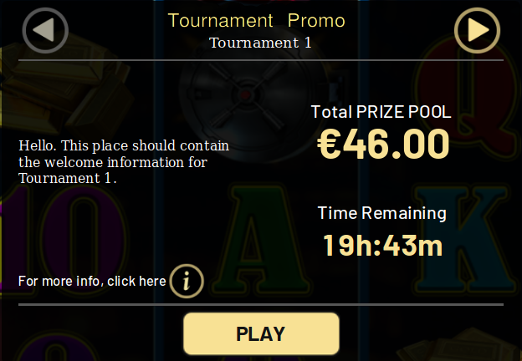
Picture 1 – Welcom Message

3.2 Top Bar Item
This interface should be located at the top of the game window and show the player sequentially all available promos for this game at the current moment, as well as information about each.
The name of the promo should be displayed on the left side of this interface. On the right side of the interface, the following information should be displayed sequentially with a certain time interval:
- «Place [place of player in leaderbord]» — position of the player in the leaderboard (if qualified).
- «Unqualified» — if the qualification conditions are not met by the player.
- «Remaining time [time]» — the remaining time until the end of the tournament.
- «Starting in [time]» — the remaining time before the start of the tournament, if the "Show Before Start" parameter is set.
- «Finished [time]» — the time when the tournament ended, if the «Show After End» parameter is set.
After all the above parameters have been shown for the current promo, the same parameters will be displayed for the next active promo, if it exists.
Clicking on any information on this interface should open the «Promo Details Screen» window for the corresponding promo.
Picture 2 – Sample of Top Bar Items

3.3 Promo detail screen
This interface allows the player to get the most complete information about the promo, as well as disable (enable) notifications. If there is more than one active promo at the moment, then the player should be able to view information for each. This interface can be accessed in different ways:
- From the «Welcome Message» by clicking «more info» button.
- From the «Top Bar Item» by clicking on any information.
- Using the standard «Game Rules» button.
This interface has 5 tabs:
- Leaderboard.
- Prizes.
- How To Qualify.
- Options.
- Promo Rules.

3.3.1 Leaderboard
On this tab, the player can see his position in the leaderboard, as well as the top players. All entries are presented as progressbars. If the player clicks on any of the progressbars, then the player scores will be displayed on top of each one. The interface must follow the logic described in section 2.3.7.
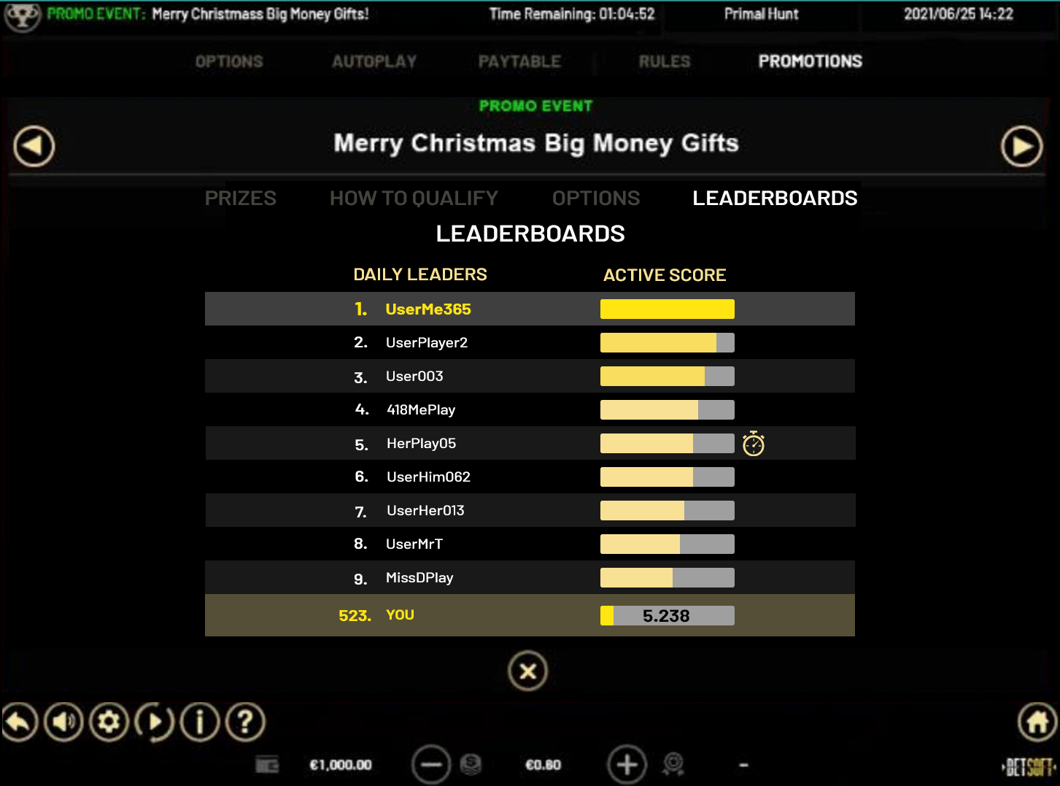
Picture 3 – Leaderboard without scores (before click)
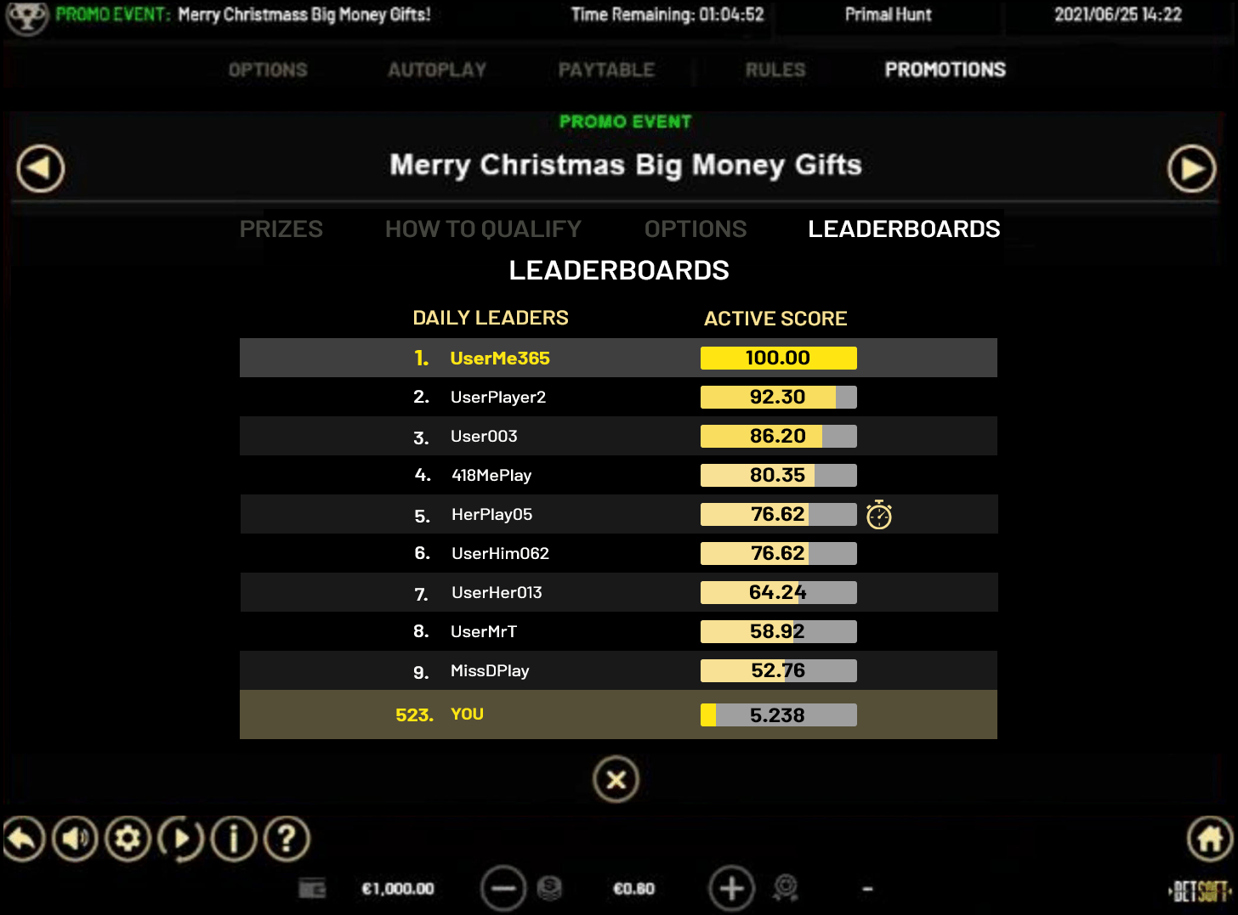
Picture 4 – Leaderboard with scores (after click)
If this promo has not started yet (the «show before start» parameter is set), then in this window the time before the start of this promo should be displayed to the player.

3.3.2 How To Qualify
This tab displays a list of criteria, with all passed criteria marked with a green check mark.
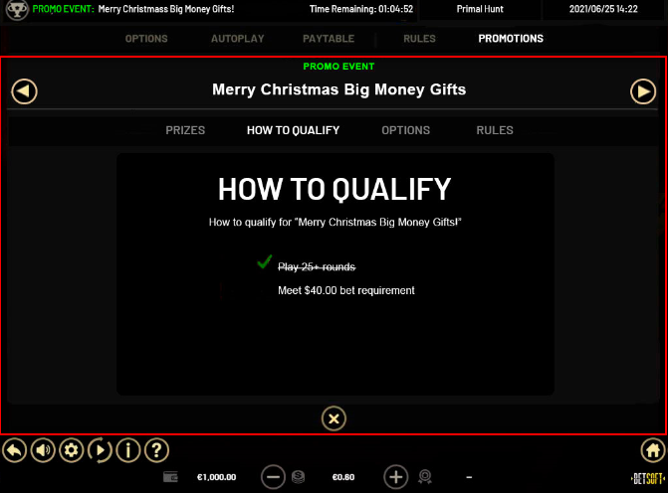
Picture 5 – How to qualify tab

3.3.3 Options
This tab displays options and settings for the promo with the ability to select: Do not notify about another winners.
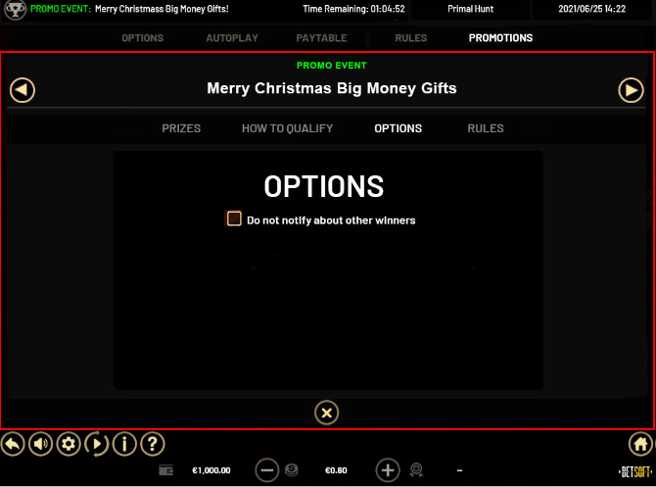
Picture 6 – Options tab

3.3.4 Promo Rules
This tab displays the rules.
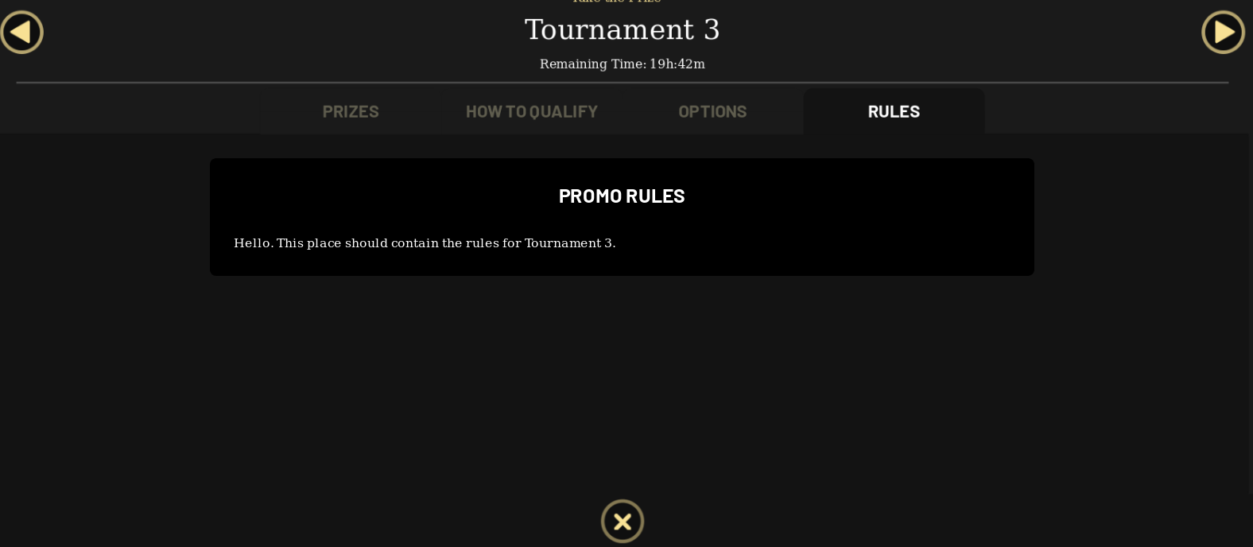
Picture 7 – Rules tab

3.4 Motivational message
The interface is a small pop-up window located slightly above the main playing field (reels) and appears according to the logic presented in section 2.5 of this specification.
[TBD]

