Undiscovered Egypt – Leaderboard Specification Produced for BetSoft

Author: Daniel Cooper

Scope
This document describes the leaderboard and non-cash award system for the Undiscovered game (now called “Hero’s Quest”).
This document is complementary to

Change Control
Date | Author | Version | Comments
28.03.18 | Daniel Cooper | 1.6 | 1st draft
05.04.18 | Daniel Cooper | 1.7 | Changed spec to combine achievements with collections (see 3.2)

Contents
Undiscovered Egypt – Leaderboard Specification Produced for BetSoft 1
Author: Daniel Cooper 1
Scope 1
Change Control 1
2. Overview 2
3. Non-cash Awards 2
3.1 Prize Types 2
3.2 Collection Book 2
3.2.1 Example Page 3
3.2.1 Groups (pages) 3
3.2.2 Treasure objects 4
3.2.1 In Game alert 11
3.2.2 Awards by enemy 11
3.2.3 Leaderboard points 12
3.3 Achievements 14
3.3.1 Enemy Destruction 15
3.3.1 Treasure Collection 15
3.3.2 Ranks 15
4. LEADERBOARDS 16
4.1 General 16

Overview
The leaderboard will be for all players.
Every week 1% of bets will be awarded to the top 3- 10 players (this should be easily configured as we may need to change this after launch). An enemy, collecting a special weapon, or completing an achievement will all award points towards the leaderboard.

Non-cash Awards

Prize Types
When an enemy is destroyed, they may drop and non-cash award for the player; this may take the form of collectable objects, or some points to advance them on the leaderboard.

Collection Book
The Collection book has a number of ‘pages’, each page has a group of treasures, there are awards (leaderboard points) for collecting certain numbers of items and for collecting a certain number of each item on a page (a ‘collection’).

Example Page
Note: This page is a rough mock up, the actual page will be laid out with horizontal bars and will need scrolling functionality (in case the player has a very small number of one item and a very large number of another item.
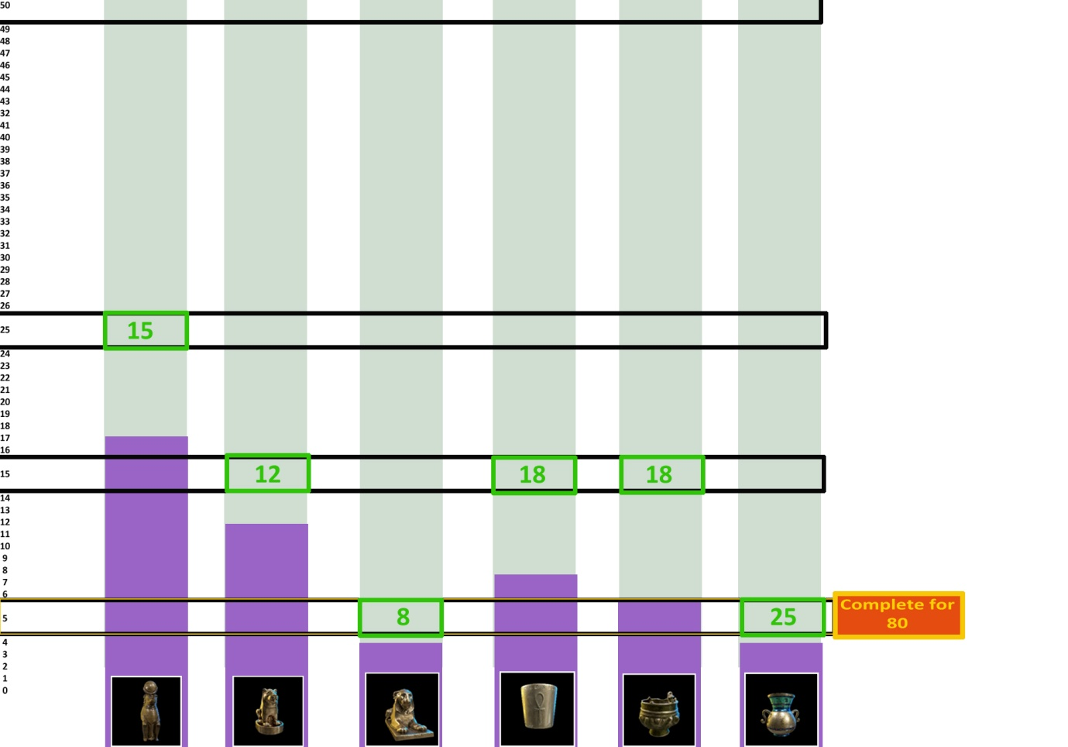
The purple bars advance for each item collected
The green values are the award for getting one bar to that level
The yellow and orange box on the right is the award for getting all bars to that level
The bars will be made horizontal with the awards in vertical columns.

Groups (pages)

Treasure Groups | Group Name | number of items
 | Statues | 4
 | Bowls and Jars | 4
 | Jewely | 5
 | Rare Jewelry | 6
 | Ritual Objects | 7
 | Scarabs | 7
 | Sphynxes | 4
 | Anubis | 4
 | Horus | 6
 | Osiris | 3
 | Pharaohs | 3
Enemy Groups | Scarab | 4
 | Mummy | 6
 | Gods | 3

Treasure objects
ID | Object image | Name | Probability | Collection
1 | 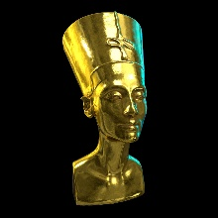 | The Golden Bust of Nefertiti | Super Rare | Pharaohs
2 | 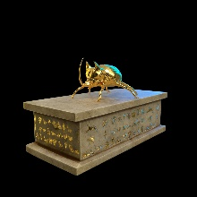 | Sacred Golden Scarab | Super Rare | Scarabs
3 | 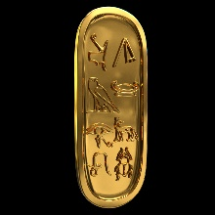 | The Golden Cartouche | Super Rare | Ritual Objects
4 | 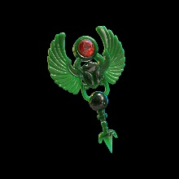 | The Jade Brooch | Super Rare | Rare Jewelry
5 | 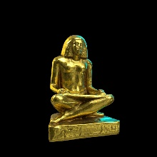 | The Golden Scribe | Super Rare | Ritual Objects
6 | 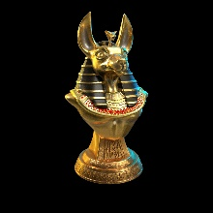 | Golden Bust of Anubis | Super Rare | Anubis
7 | 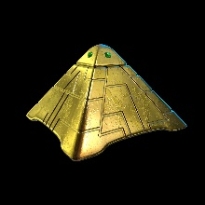 | Sacred Golden Pyramid | Super Rare | Ritual Objects
8 | 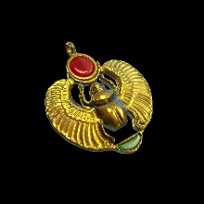 | Garnet Scarab Amulet | Super Rare | Scarabs
9 | 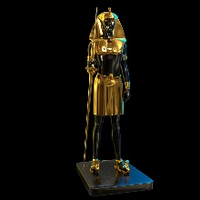 | Onyx Statue of the Pharaoh | Super Rare | Pharaohs
10 | 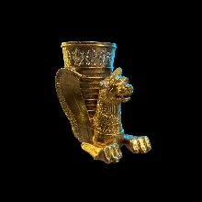 | Goblet of the Griffin | Super Rare | Ritual Objects
11 | 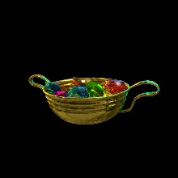 | Offering Bowl of Gems | Super Rare | Ritual Objects
12 | 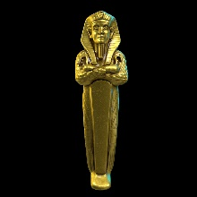 | Golden Statue of Tutankhamun | Super Rare | Pharaohs
13 | 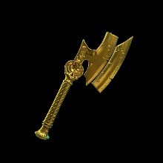 | The Blade of Osiris | Very Rare | Osiris
14 | 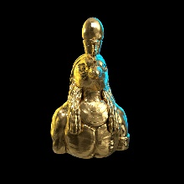 | Golden Bust of Horus | Very Rare | Horus
15 | 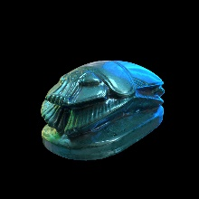 | Lapis Scarab | Very Rare | Scarabs
16 | 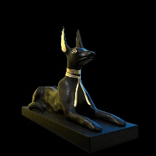 | Onyx Servant of Anubis | Very Rare | Anubis
17 | 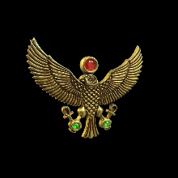 | Eagle of Ruby and Emerald | Very Rare | Rare Jewelry
18 | 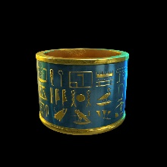 | Lapis Cuff of the Queen | Very Rare | Rare Jewelry
19 | 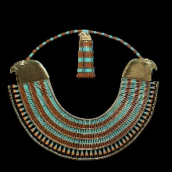 | Collar of Horus | Very Rare | Horus
20 | 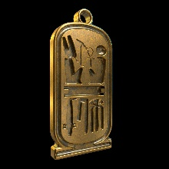 | Cartouche of Gold Amulet | Very Rare | Rare Jewelry
21 | 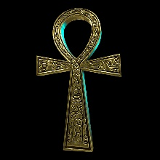 | Golden Ankh | Very Rare | Rare Jewelry
22 | 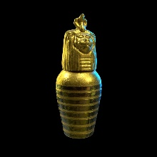 | Golden Canopic Jar | Very Rare | Bowls and Jars
23 | 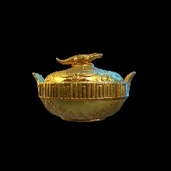 | Alligator Offering Bowl | Very Rare | Ritual Objects
24 | 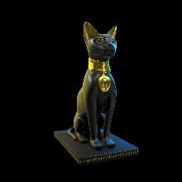 | Onyx Servant of Bastet | Rare | Statues
25 | 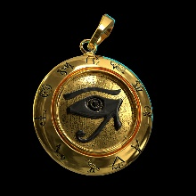 | Eye of Horus Amulet | Rare | Horus
26 | 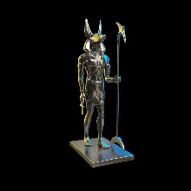 | Silver Statue of Anubis | Rare | Anubis
27 | 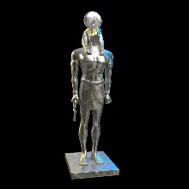 | Silver statue of Horus | Rare | Horus
28 | 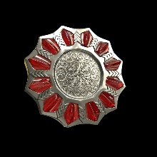 | Silver and Ruby Brooch | Rare | Rare Jewelry
29 | 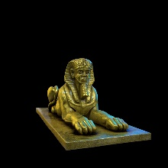 | Golden statue of the Sphynx | Rare | Sphynxes
30 | 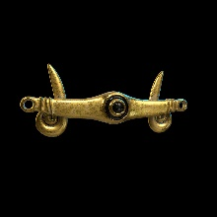 | Golden Torque Clasp | Rare | Jewelry
31 | 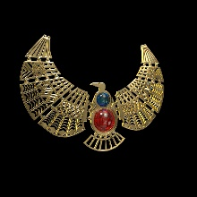 | Collar of the Egyptian Queen | Rare | Jewely
32 | 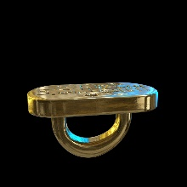 | Golden Cartouche Ring | Rare | Jewely
33 | 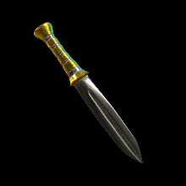 | Ceremonial Golden Dagger | Rare | Ritual Objects
34 | 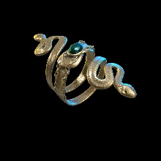 | Silver Ring of the Snake | Uncommon | Jewely
35 | 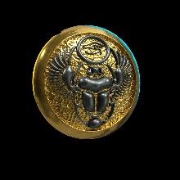 | Brass Scarab Sigil | Uncommon | Scarabs
36 | 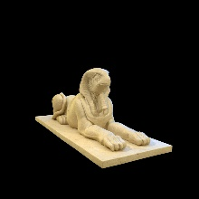 | Alabaster Sphynx of Horus | Uncommon | Sphynxes
37 | 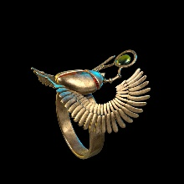 | Bejeweled Scarab Ring | Uncommon | Scarabs
38 | 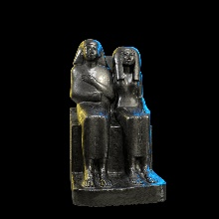 | Onyx Priest Ahmose Statue | Uncommon | Statues
39 | 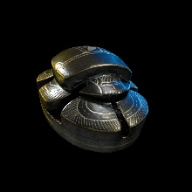 | Onyx Scarab | Uncommon | Scarabs
40 | 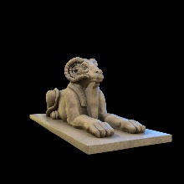 | Alabaster Sphynx of Khnum | Uncommon | Sphynxes
41 | 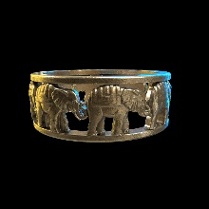 | Golden Packaderm Bracelet | Uncommon | Jewely
42 | 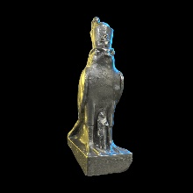 | Silver Servant of Horus | Uncommon | Horus
43 | 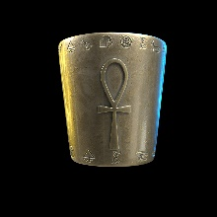 | Brass Ankh Bracer | Uncommon | Jewely
44 | 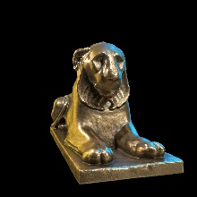 | Brass Lion of the Gods | Uncommon | Sphynxes
45 | 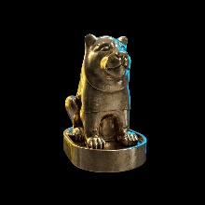 | Brass Lion of the Goddess | Common | Statues
46 | 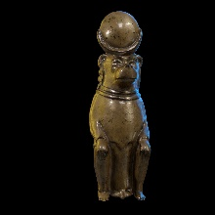 | Brass Monkey | Common | Statues
47 | 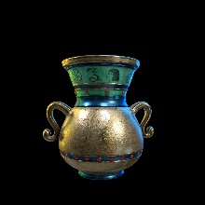 | Vase of Osiris | Common | Osiris
48 | 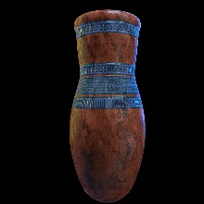 | Vase of Amenhotep | Common | Bowls and Jars
49 | 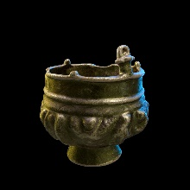 | Ancient Pot of Osiris | Common | Osiris
50 | 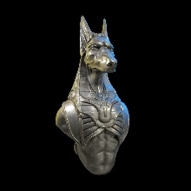 | Knight of Anubis Bust | Common | Anubis
51 | 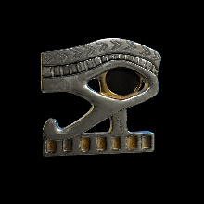 | Eye of Horus Sigil | Common | Horus
52 | 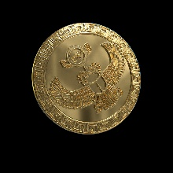 | Soaring Scarab Golden Coin | Common | Scarabs
53 | 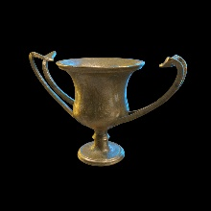 | Amphora of the Serpent | Common | Bowls and Jars
54 | 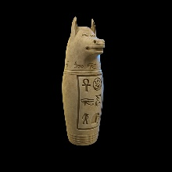 | Canopic Jar of Clay | Common | Bowls and Jars

In Game alert
If an achievement award is triggered during game play, then the player should be alerted in game.

Awards by enemy
This table shows the probability of a treasure being dropped; the treasure should only be dropped when an enemy is destroyed (only one treasure per enemy can be dropped with the exception of Boss’s, which may drop multiple treasures.).
Enemy | Common | Uncommon | Rare | Very Rare | Super Rare | Total
Scarab black | 10% | 2% |  |  |  | 12%
Scarab gold | 10% | 2% | 1% |  |  | 13%
Scarab gem covered | 12% | 3% | 2% | 1% |  | 18%
Standard Mummy | 12% | 1% | 1% | 1% |  | 15%
Medium Mummy A | 15% | 2% | 1% | 1% |  | 19%
Medium Mummy B | 12% | 3% | 3% |  |  | 18%
Medium Mummy C | 15% | 2% | 2% | 3% |  | 22%
Powerful Pharaoh Mummy A | 20% | 26% | 17% | 5% | 2% | 70%
Powerful Pharaoh Mummy B | 25% | 20% | 15% | 10% | 5% | 75%
Standard Mummy (Hoard) | 5% | 10% | 10% | 5% | 2% | 32%
Medium Mummy A (Hoard) | 5% | 15% | 10% | 15% | 5% | 50%
Medium Mummy B (Hoard) | 5% | 10% | 10% | 5% | 10% | 40%
Medium Mummy C (Hoard) | 20% | 5% | 5% | 15% | 5% | 50%
Scarab black (Hoard) | 15% | 10% |  |  |  | 25%
Scarab gold (Hoard) | 20% | 10% | 5% |  |  | 35%
Scarab gem covered (Hoard) | 25% | 10% | 5% | 5% | 2% | 47%
Boss |  | 30% | 30% | 20% | 20% | 100%
Boss (Hoard) |  | 25% | 30% | 20% | 25% | 100%

Leaderboard points
Below the awards per item are listed. The enemy and treasure values are
Event | Points Awarded | Group | When
Scarab | 1 | Scarab | Killing enemy and Per item in collections
Scarab black | 1 | Scarab | Killing enemy and Per item in collections
Scarab gold | 2 | Scarab | Killing enemy and Per item in collections
Scarab gem covered | 3 | Scarab | Killing enemy and Per item in collections
Standard Mummy | 2 | Mummy | Killing enemy and Per item in collections
Medium Mummy A | 3 | Mummy | Per item in collections
Medium Mummy B | 4 | Mummy | Killing enemy and Per item in collections
Medium Mummy C | 5 | Mummy | Killing enemy and Per item in collections
Powerful Pharaoh Mummy A | 8 | Mummy | Killing enemy and Per item in collections
Powerful Pharaoh Mummy B | 8 | Mummy | Killing enemy and Per item in collections
Boss
Osiris | 15 | God | Killing enemy and Per item in collections
Anubis | 15 | God | Killing enemy and Per item in collections
Horus | 15 | God | Killing enemy and Per item in collections
Bonus Weapon collected | 5 |  | When weapon is collected
Collecting any item | 1 |  | When item is collected
Hitting any enemy | 1 |  | On hit
Completing Achievement | Variable |  | Completing achievement
Completing all level achievements | Variable |  | Completing page of achievements
Reward Chest | Variable |  | Rewarded randomly

Achievements
Achievements consist of a number of goals that must be achieved in order to complete and unlock an award.
An example might be to collect 3 Standard Mummy’s (firing the final shot that destroys them)
Each level will have a number of achievements, as each level is unlocked, those achievements become available.
When the player advances a level, any uncompleted achievements from the previous level remain available.
Any treasures/enemies collected that are not used in currently available achievements are not saved, and so are lost.
The player should be able to see achievements for levels they have not reached, but it should be made clear to them that those achievements are locked to them.

Enemy Destruction
- Collect n of the same type of enemy (by destroying them)– for higher levels we will increase the number of enemies that need to be collected (and increase the value of the award appropriately)
- Collect group of enemies (Scarab, Mummy, Pharaoh, Boss)

Treasure Collection
- Each Treasure achievement will be for n of a given treasure.

Ranks
Players will advance through the ranks as they play; each rank will have a number of levels (levels will vary by rank) so we don’t run out of ranks too quickly.
Players will level up through achievements; each rank starts with 1 achievement to level up and increases by 1 achievement every level (so a level 10 Traveler would need to complete 11 achievements to level up)
Rank | Number of levels | Level up award | Rank Up award
Apprentice | 5 | 3
Journeyman | 10 | 4 | 20
Traveler | 20 | 5 | 50
Explorer | 40 | 7 | 100
Adventurer | 70 | 9 | 200
Ace | 100 | 12 | 300
Leader | 150 | 15 | 400
Hero | 200 | 20 | 500
Legend | Infinite | 25 | 1000

The players level and rank must be maintained when the table is reset

LEADERBOARDS

General
- The leaderboard is reset weekly (we should maintain an all time leaderboard (in case we wish to use this in the future, and we should be prepared to create daily or monthly leaderboards in the future, if this seem like they would be popular).
- When the player logs in, they should be able to view their position in the leaderboard and their final position (and any prize awarded) in the previous week.
- The prizes for the top n positions in the leaderboard should be displayed (and should tick up where appropriate. (1% of all bets contribute to these prizes)

