Zombie Shooter – Specification Produced for BetSoft

Author: Daniel Cooper

Scope
This document defines the functionality for the new Zombie Arcade game, based on the initial requirements laid out in Alien-Specifications-NearFinal.pdf , work on defining an Arcade Shooter game and subsequent conversations.
This is a new class of games will take the mechanics of the game Fishing World, an arcade and occasional gambling game, and blend it with a theme and game play elements to entice the younger “gamer” market, primarily in Asia, which is currently an emergent market for our company. Uniting a simplistic “click to bet/shoot” mechanic with an action-shooter featuring perks, achievements, bonuses and more will bring to market a new breed of games sure to place Betsoft’s lead even further ahead in innovation, creativity and industry dominance.

Change Control
Date | Author | Version | Comments
27.01.2017 | Daniel Cooper | 1.0 | Document created based on AlienCapture_Specification_V1.3.docx – focus changing from Alien Shooter to Zombie shooter game  It should be noted that the game mechanic (3.2) has changed significantly and should be reviewed carefully.
14.03.2017 | Daniel Cooper | 1.1 | Changed the special boss round to a zombie hoard round (3.2.2)
29.03.2017 | Daniel Cooper | 1.2 | Corrections made to game play examples after dev feedback. Some more details added regarding Banks and currency.
04.04.2017 | Daniel Cooper | 1.3 | Added some mock-ups of the game
19.04.2017 | Daniel Cooper | 1.4 | Made clear that the game is to be in isometric 3D

Contents
Zombie Shooter – Specification Produced for BetSoft 1
Author: Daniel Cooper 1
Scope 1
Change Control 1
2. Overview 3
3. Game Play 3
3.1 Theme 3
3.2 Game Mechanic 3
3.2.1 Staking 3
3.2.2 Persistent Strength value. 3
3.1 Rewards 5
3.2 Bosses 5
3.2.1 Environmental Bosses 6
3.2.2 Special Location Zombie Hoard 6
3.2.3 Boss game recovery 7
3.3 Weapons 7
3.4 Weapon Upgrade 8
3.5 Environments 9
4. LEADERBOARDS & ACHIEVEMENTS 9
4.1 User Names 9
4.2 Leaderboards 9
4.2.1 Daily 9
4.2.2 Weekly 10
4.2.3 Monthly 10
4.2.4 All Time 10
4.3 Rankings 10
4.1 Achievements 11
5. Multiplayer 11
5.1 Rooms 12

Overview
This is a new style of gambling, based on Fishing World (http://www.gg626.com/game/index.do?gameId=1&lang=EN&trial=1).
This is a faux skill game where each bullet fired is a bet; if the result of the bet is a win, then the object targeted is destroyed or damaged and the prize awarded.
Given that each bet must be resolved between the player firing and the projectile hitting the target, an extremely fast server response is required.
It should be noted that although this game is based on Fishing World, there are some significant differences, most significantly the fact that our game will take place in an isometric 3D environment, and one object will be able to block the sightline of another.

Game Play

Theme
The game play area is inhabited by Zombies, it is proposed that we go for a realistic look.
The aim of the player is to dispel or destroy the Zombies by shooting them
Each winning shot should degrade the zombie, so perhaps the first winning shot could cause an arm to drop off.
It has not been decided whether this will be a bloody zombie slaughter, or a gentler dispelling type theme.

Game Mechanic
The key consideration is the enemy ‘strength’ and how this is defined.
Enemy Strength is essentially the probability that the player will win when they hit a given enemy.
The strength of the enemy must be stored on the server and should not be visible to the player.

Design
The layout of the game is expected to look something like this (this is not actual game):
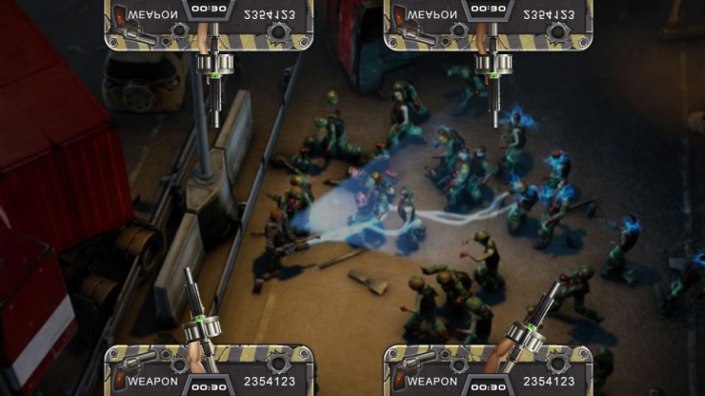
The game will be isometric 3D (that is,faux3D). Below is a mock-up of how it is currently being imagined:
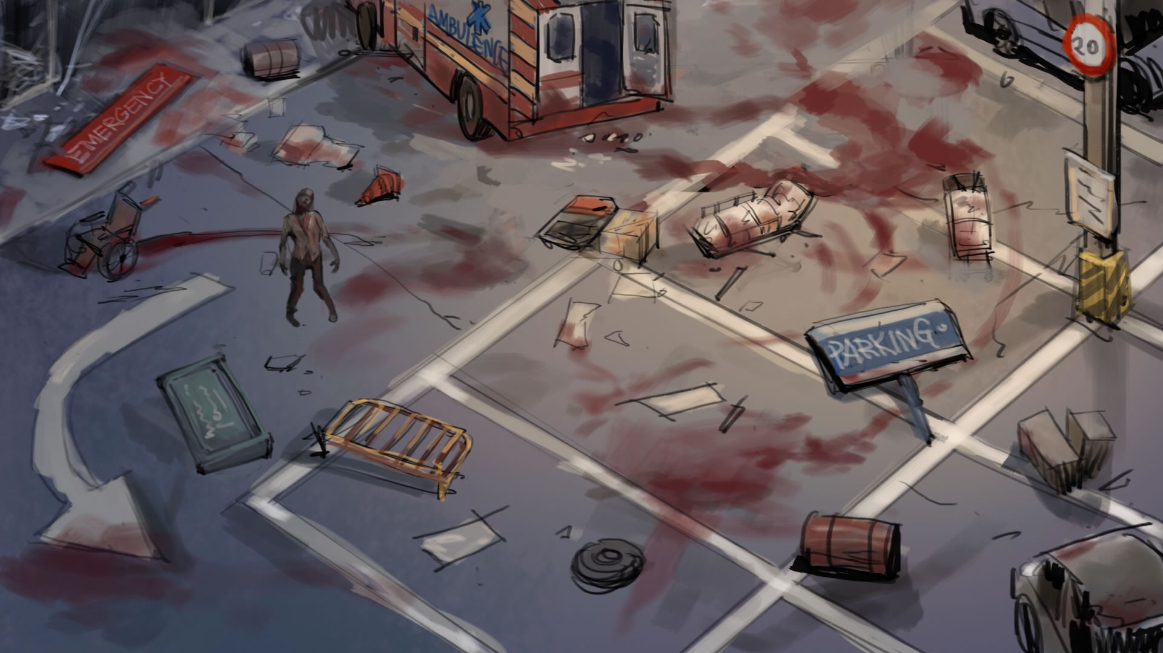

Staking
The player should be able to select a stake level; this is the cost per shot in the game. Any wins in the game will be cost per shot multiplied by win value.

Persistent Strength value.
This mechanism may seem overly complex, but the idea is that with stronger guns we give players the chance to destroy/dispel the zombie in a single shot.
The Strength value is set when the enemy is initially generated and remains the same until the enemy (or part of it) is destroyed (awards a win).
I would suggest we assign a Strength value to the Zombie and a Strength value to the player’s weapon.
We calculate if the player hits the zombie by simply generating a random number between 0 – WeaponStrength; if the result is higher than the Zombie strength, then the player hits the Zombie and is guaranteed a win.
The zombie should be split into discreet parts (eg. arms, headgear, body)
Once a zombie has been hit, we select the prize/prizes to be awarded.
We should use the players score – the Zombie strength to calculate the position on the win ladder.
The body part strength are a ladder, in the example below, if the players score was 30 or lower, they are awarded the right arm and a x1 multiplier; if they scored 31 to 60 they are awarded both the left and right arms, with 2x1 multiplier.
Example
Weapon Strength = 100
Zombie strength = 70
30% chance of player hit
Shot1
Players rolls 50 – miss
Shot 2
Player rolls 74
Hit
Modified hit value = 4
Right arm awarded, player wins x1 stake.
Shot 3
(prizes are now calculated from 2nd table below)
Player rolls 96
Hit
Modified hit value = 22
Left arm and Helmet awarded, player wins X2 stake + X3 stake.

Player weapon
Ladder position | Body Part | Strength | Award
0-10 | Right Arm | 18 | X2
11-20 | Left Arms | 18 | X2
21-30 | Head Gear | 26 | X3
31+ | Body | - | X6
Total |  |  | X13

When a prize is won (and removed from the ladder), the items on the ladder shift down by the strength of the removed item.
In the table below, the Right arm has been awarded
Ladder position | Body Part | Strength | Award
0-10 | Left Arms | 18 | X2
11-20 | Head Gear | 26 | X3
21+ | Body | - | X6
Total |  |  | X11

It should be noted that the strength of any given Zombie should not be greater than the strength of the weakest weapon; otherwise it will be impossible for that weapon to defeat the Zombie
With some zombies it would be good if they were carrying something, a weapon or a treasure, this would be added to ladder

Rewards
Although most rewards will be awarded for just hitting the Zombie, it may be interesting to have them carrying some bonus rewards, that when dropped, are awarded to the player.
Bosses should show a more gradual degradation than normal enemies when they are hit, and players doing damage should win a percentage of the bonus prize.

Bosses
There is a requirement to have bosses appear during game play.
- These will use RTP taken from the base game to make them more rewarding than normal game play, though each attack on a boss will still require a bet by the player.

Environmental Bosses
Each location will have its own boss

Triggering
I suggest that we make these bosses location specific and have a chance of triggering their appearance either for every shot or for every win.
Some RTP should be reserved from the base game to give the bosses an RTP somewhat over 100%
The defeat of a regular boss should enable the player(s) to move to a new location; in the case of a multiplayer game, this would have to be a forced transition.
If we triggered the boss on the defeat of a zombie we could either have the zombie magically transform into a boss zombie, or just have the boss walk onto the screen.

Combat
Since this boss will precede the transition to a new location, all players will have to play.
Since we are going to give the boss an RTP of greater than 100% we will need to give a weapon bonus to players dependant on how much they have bet in the game. If a player has not bet at all, they will need a handicap on their weapon.
The boss should have a variable strength, so each hit by the player increases the chance of getting a win.
Each hit by the player should do random damage to the boss.
I would propose variable damage per shot with the cash reward at the end being in proportion to the damage done.
The boss is defeated when a player does equal or more damage than the strength of the boss.

Special Location Zombie Hoard
When a location boss has been beaten and a new location is unlocked, it will occasionally (by random selection) be a special Boss Location that the players are taken to.

Combat

There will be a hoard of Zombies that the players have to clear.

The location will feature a big prize that will be awarded to all players who contribute to its completion. The amount that each player earns will be a direct relation to their contribution of hits during the fight.

I see no reason why this mechanism could not work for both single and multiplayer games.

Prizes

Reserve some RTP for special boss locations so a greater value can be given to the boss than the cost of beating it.

I would suggest that we use the same strength system with these bosses that we use for the Environmental Bosses (see above), with a minimum number of shots required, to create a rewarding experience of a reasonable duration (it would be undesirable for the first shot to potentially end the feature and annoy all the players that didn’t win).

It could be interesting to have each shot do some random damage to the boss, to add a bit of variety.

It may be worth considering immediately rewarding players when they do damage to the boss (rather than only rewarding them when the boss is defeated), so the whole feature feels rewarding.

A table at the end of the battle to display the top contributers and a bonus for them would work well

Boss game recovery
It is important to consider how we handle a player losing connection during a boss game, since we have allocated extra RTP for these games, a player would reasonably feel cheated if they were part of a boss battle, lost connection, and received no compensation or game recovery.
A possible solution would be to award a player the winnings from a bot playing the same level with the same bonuses (this would mean that for each live player, we would need a bot playing with the same weapon bonus and stake level)

Weapons
The player will start with only one weapon which has a fixed strength
The weapon strength dictates both the chance of hitting the enemy and the amount of damage that can be done in a single shot.
It would be possible with this mechanism to have a couple of weapons where we reduce the chance to hit but increase the amount of damage

Weapon Upgrade

Triggers

During gameplay, players can earn special weapon upgrades and perks that will last for a set number of shots. These bonus weapons can be awarded randomly throughout the game.
It should be possible for the player to select when to use their bonus weapon (it will be very important to communicate to the player that they have a bonus weapon waiting to be used).
Prizes can be revealed in either of the following ways

Method 1: Zombies results in a random prize being revealed.

Method 2: Boxes and/or other storage items occur on screen and players can choose to bet on shooting at these boxes to open them and be rewarded a potential prize inside.

Bonus Weapons
Each of these weapons would have a set (limited) number of shots or charge. The range of weapons below is based on the idea of destroying zombies, but if we were to go with an idea of dispelling them, we would want to change this list significantly.
- Chain Gun: Fire a continuous stream of bullets
- BOMB: A one-shot weapon which has a special chance of hitting any nearby enemies.
- Ricochet: Shot can ricochet off target and hit a second
- Holy arrows: Shot does double damage
- GUARANTEED KNOCKOUT.: Shot will defeat the first zombie it hits, except bosses

Boss Level modifiers
Where there are multiple players in a room and there is a boss with an RTP greater than 100% then weapon modifiers may need to be applied to ensure that players who have bet the most, are likely to win the most.
For instance:
If player 1 has fired 100 shots and player 2 has fired 10 shots in the game prior to the triggering of the boss feature, and the contribution towards the boss payout is 10%, then player 1 has contributed 10 credits and player 2 has only contributed 0.2 to the bosses prize.
The calculation would need to be along the lines of {standard weapon strength + (average shots in room – players shots)}

RTP
RTP will need to be reserved to make these upgrades rewarding; we can either represent them as new weapons with limited ammo or just as special ammo.
Certain weapons may cause some difficulty with RTP calculation; the “Guaranteed Knockout” for instance, depends on the choice made by the player; the RTP allotted will need to be based on perfect play by the player, but some consideration will need to be given to imperfect play.
For imperfect play by the player, we could add extra rewards to the leaderboard, or find some way to reward the individual player.

Environments
The intention is to integrate multiplayer functionality into standard play, so it will be necessary to control the players journey through the game

LEADERBOARDS & ACHIEVEMENTS
To further enhance the player experience, we will include many simple additions such as leaderboards and unlockable achievements. These can provide a secondary desire to continue enjoying the game much longer in many players.

User Names
The players site username should not be used in the game but rather the player should be asked to provide a new username for the sole purpose of the game. It would be ideal to insist on unique usernames to avoid confusion, but if this is too much of an overhead, we would just highlight a players position when they view the leaderboard.
We will need a profanity check on usernames as they will be displayed to other players. We may also want to allow players to change their name (I would be inclined to limit the number of times this can be done in a given time period)

Leaderboards
These constantly updating boards will show highest scoring player sessions. Players should be able to look at the information using a couple different schemes:
I would suggest we score the tables based on the total strength of zombies defeated, rather than the value of the prizes won otherwise we will just be awarding prizes to those that have won the most.

Daily

This is reset daily, with a small reward for the top n players. At least 7 days should be stored, so if a player comes back after a week they can still see where they finished when they last played.

Weekly

This is reset weely, with a small reward for the top n players. At least 2 weeks should be stored, so that at the end of a week a player can see where they finished in the previous week while contributing to the new weeks leaderboard

Monthly

This is reset monthly, with a small reward for the top n players. At least 2 months should be stored, so that at the end of a month a player can see where they finished in the previous month while contributing to the new months leaderboard.

All Time
This is the one leaderboard that I don’t think it would make sense to award prizes to (the top position could be occupied by a player who hasn’t played for a long time)
If a leaderboard closes while a player is playing then the player should be alerted to the fact, their position and any prize displayed, otherwise, the result of the leaderboard should be displayed to them when they next open the game.
Each leaderboard should show:
- Total Score
- Username
- Country
- Ranking (see below)
- Countdown to end of competition

Session information has been suggested, but I don’t see the value in this.

Rankings

I would propose a ranking system based on the strength of the total Zombies defeated, so each point = 1 strength of defeated Zombies. A possible structure is laid out below.

Total points | Medal
10 | Blue
40 | Green
80 | Orange
120 | Red
250 | Bronze
500 | Silver
1000 | Gold
1500 | Blue Diamond
2000 | Green Diamond
2500 | Orange Diamond
3000 | Red Diamond
3500 | Bronze Diamond
4500 | Silver Diamond
5000 | Gold Diamond
6000 | Blue Star
7000 | Green Star
8000 | Orange Star
9000 | Red Star
10000 | Bronze Star
11000 | Silver Star
12000 | Gold Star

Achievements

In addition to rankings, player can earn achievements for other events in the game. For example, each time a player defeats an Zombie they have never defeated before, they will earn an achievement and a small credit prize. The harder the achievement is to accomplish, the more credits may be awarded for accomplishing the achievement. Some achievements can include:
- For each individual Zombie
- For participating in a boss battle
- For defeating each class of a race of characters
- For reaching each Ranking level
- For defeating one of every Zombie in the game
- For using each unique gun
- For travelling to unique locations
- For special placement on the leader boards
- For having final winning shot on special boss battles
- For unique situations (ie, lucky shot where only a single shot is needed to win a big prize alien)

The possibilities are fairly limitless and give many players the urge to achieve all of these situations, long after the original lustre of the game has been completed.
The possible achievements should be displayed on a separate screen, and the players progress towards completion should be displayed – for instance, if the achievement is to beat each boss Zombie, then we would want to show which bosses had been beaten already.

Multiplayer
It is required to have a multiplayer element to the game. In light of this it would seem sensible to fully integrate multiplayer play into the base game, rather than create some separate variation.
With the game mechanism I have proposed, players do have impact on the RTP of each other, though this is mitigated by the fact we award a cash prized for any hit on a zombie, though I have proposed that we increase the rtp, the more parts of the zombie are destroyed, so it would be in the interest of a player to wait for another player to do the initial damage to a zombie, and then step in and target the damaged zombie. This could add a bit of strategic depth to the game, but if we wanted to avoid it, we could easily change the awards so each element of the zombie pays out equal amounts.
We should probably implement Bots (server generated players) to give the sense of a game with lots of players playing – in the case of a player losing connection during a bonus boss battle, this could also help us reserve some rtp to award to the player when they re-establish connection to the game.

Rooms
When a player selects to play they will need to be placed in a ‘room’ with a number of other players (either real or computer generated bots). This will probably be random at first, though we may want to consider giving players the option to create their own rooms and invite their friends, at some point in the future.
I would suggest that for each real player in a ‘room’ we have one computer generated player, who, in the case of lost connection, will reserve some winnings for the player that -lost the connection (see section 3.2.3 on boss game recovery in this document).

Game access
A given game should only be available to players on the same Bank

Currency
It would be ideal if players currency is converted into credits when they enter the game, so all players see the same values for wins/bullets etc.

