
Version 1.1
January 30, 2017
Version Control
Version | Date | Author | Description
1.0 | Jan-12 | MARIE Alexandre | Document Created
1.1 | Jan-30 | MARIE Alexandre | Update MockUps + characters

Table des matieres
IGame Description 1
I.1Design Goals 1
I.2Influences & Sources 1
I.3Target Market 1
IIFunctional Specifications 2
II.1Core Gameplay 2
II.2Game Flow 2
II.3Characters: 2
II.4Gameplay Elements 3
II.5Game Physics and Stats 3
II.6Artificial Intelligence 3
II.7Multiplayer 3
IIIUser Interface 4
III.1Flowchart 4
III.2Functional Requirements 5
III.3Mockups 6
III.3.ISplashscreen 6
III.3.IITitle screen 6
III.3.IIIMain Menu 7
III.3.IVCharacter Selection 7
III.3.VArena Selection 7
III.3.VIOptions 8
III.3.VIIDialog Screen 8
III.3.VIII Gameplay 9
IVArt and Video 10
IV.1Overall Goals 10
IV.2Marketing & packaging 10
IV.2.ICover (front & back) 10
IV.2.IIIcon 10
IV.2.III3D Art and Animation 10
VSound and Music 10
V.1Overall Goals 10
V.2SFX 10
VIStory 11
VI.1Global Story 11
VI.2Horsemen 11
VI.3Demons 11
VIITechnical Specifications 11
VII.1Game Engine 11
VII.2Platform and OS 11
VII.3External Code 11
VII.4Code Objects 12
VII.5Data Flow 12
VII.6Artificial Intelligence 12
VIIIProduction Schedule 13
VIII.1 Scope 13
VIII.2Info Creajeux 13

Game Description

SAMPLE GAME is a 3D cooperative shooter style game for PC. Up to 2 players control one of the four horsemen in different arenas and kill famous Hell demons extracted from the Holy Bible. It takes place in Hell.

Design Goals

The game aims to achieve the following goals :

1 . Acknowledge the player to our lord, and other famous creatures extracted from Hell as defined in the Holy Bible
2 . Using different artifacts from the whole Bible and not just Hell ( exple : Using Moise's stick to cut an arena in half )
3 . Develop a fun gameplay, based on :
a . Two bricks : a CQC (Close Quarter Combat) and a shooting one
b . Power : you know you are a powerful horseman… Prove it.

4 . Successfully combine chibi style and design with Hell's violence.

Influences & Sources
Obviously the Holy Bible and Christian religion in general
Darksiders 1 & 2
Furi (gameplay part)
DoDonPachi (Boss Pattern)
Cartoon colors (think Blizzard Entertainment)
We want to recreate a cooperation-style game like there was before the emergence of online
Disgaea (Dialog Scenes)

Target Market
Our ideal user has the following characteristics :
1 . Human
2 . 16 to 30 years old
3 . Core Gamer, but accessible to casual
4 . Open minded about religions
5 . Already played a local multiplayer game

Functional Specifications

Core Gameplay
The player moves in a 3D arena. The arena doesn't have to be a circle : it can be square or even separated by bridges or interactive elements. Enemies will be coming from the top of the arena outside the screen (if there is basic enemies TBC). The levels end after a boss fight. There will be little dialogs between levels. A SHAREDLIFE can be set to have one life bar shared by the two players. It forced the two players to pay attention each other.

Game Flow

Actions which can be performed:
1. Move all around the arena
2. Shoot !
3. Dash

Characters:
Horsemen :
1. Death: Special : Death spell, every enemy has 50% chance to die
Personality : Silent,
Punchline : “It's time to sleep for eternity”
2. Pestilence: Special :Launches a poisoned arrow that annihilates everything in its trajectory
Personality: Inspired by Marquis de Sade AC Unity, Dirty but noble
Punchline: “Let the poison flood into your veins”
3. War: Special : Big Sword Hit Big Damage (BFG as a reference ?)
Personality: War General, Strategist
Punchline: “”
4. Famine: Special : Damage over time.
Personality: A pure RedNeck
Punchline: “<3”

Demons :
1. Lilith : Succubus' queen : Major influences by “Ben-Sirah's Alphabet” Latin : “Alphabetum Siracidis”
« Le Saint – béni soit-il – avait créé une première femme, mais l’homme, la voyant rebelle, pleine de sang et de sécrétions, s’en était écarté. Aussi le Saint – béni soit-il – s’y est repris et lui en a créé une seconde. » – Yehouda Bar Rabbi (Genèse Rabba 18:4)
Attacks : - Secretion, if player gets hit, his vision becomes troubled and makes Lilith invisible; or, trouble the player's vision and slow him down. (TBC)
- Snake's bite : Lilith launches her snake, if the player gets hit, he gets stunned for X seconds max and need to push every input of the gamepad to get away. Otherwise, Lilith gets stuck for X seconds.
- Snake's scavenging : Lilith positions herself at the arena's center. The snake scavenges all the arena and the player has to dash when the snake approaches.
-Earth's powder : Lilith is made of Earth's powder. The screen squeezes to announce the attack and half a second before the attack, the player has to dash away. Otherwise, a geyser appears under the player and throws him into the air.

Gameplay Elements

The player can interact with these elements :

- Different interactive items that change between arenas.

Elements that communicate the player's game state :

- Dialog Scenes : small panels between arenas to explain a bit about the story (why the Horsemen are asked to fight) and make some little jokes, with dark humor and references about legends (ex : Make jokes about Lilith first boyfriend, “Adam”, and tell she didn't open her mouth and she should be the mother of human kind) references the fact that Lilith was in conflict with Adam for equal rights between men and women. Problem : Adam wanted to be the leader of the family and Lilith wanted both of them to be leaders. (??)Could make a two reads about the old legends and the same situation now.

Game Physics and Stats
Physics in the game work as such :

- Players move in 3D plane, there is no jump and they can go anywhere inside the arena
- Players can avoid enemy attack with a dash.
- There is gravity

Artificial Intelligence
- Boss has several patterns and can move all around the arena
- Boss shots just like DoDonPachi's

Multiplayer
The game's goal is to two players on the same screen. They both have to kill the boss. The players will have to :
- Select between the four horsemen
- Select arenas
- Select the enemy

User Interface

Flowchart
SPLASHSCREEN

TITLE MENU
MAIN MENU
BATTLE
NEW GAME
QUIT
CONTINUE
OPTIONS
SELECT CHARACTER
SELECT BOSS
GAMEPLAY
SELECT CHARACTER
SELECT ARENA

Functional Requirements
Splashscreen : Introduce the Unity Logo and the Studio's name
Title menu : Display the game's name with « Push start button » blinking
Main menu : Presents all the possible choices to the player
Continue : Only if a save is present on the system
Battle : Make one battle with selected horsemen, unlocked boss and unlocked arena
New Game : select your horsemen and fight !
Options : Set main Volume and FX Volume
Quit : Exit the game with a « Are you sure ? » popup

Gameplay : One or Two players, one boss, many bullets…

Mockups

Splashscreen
Apocalypse

Title screen

Appuyer sur start


Main Menu

Character Selection
ANIMATION WITH WIND
AND MOVING CLOTHES
New Game
Continue
Battle
Options
Quit
SELECTED CHARACTER
3D MODEL PLAYER 2
SELECTED CHARACTER
3D MODEL PLAYER 1

Arena Selection
ARENA SELECTED ARTWORKS / TURN AROUND OF THE ARENA
ARENA
ARENA
ARENA

Options
Music Volume

SFX Volume
|||||||||||||||||||||||

|||||||||||||||||||||||
OK

Dialog Screen
SELECTED CHARACTER
ARTWORK PLAYER 1
CHARACTER SPEAKING
DIALOG TEXT
CHARACTER SPEAKING

Gameplay
BOSS'S LIFE + NAME
Horsemen 1 Life + Name
Horsemen 2 Life + Name

Art and Video

Overall Goals
The main objective is to conciliate the chibi/cute aspect with the violent Hell's aspect described in the bible. The Characters design is extracted from famous old paintings. The chibi aspect allows us to put an humoristic aspect too with the dialogs.

Character design
Death : Dark hood and cape (with softbody on it)
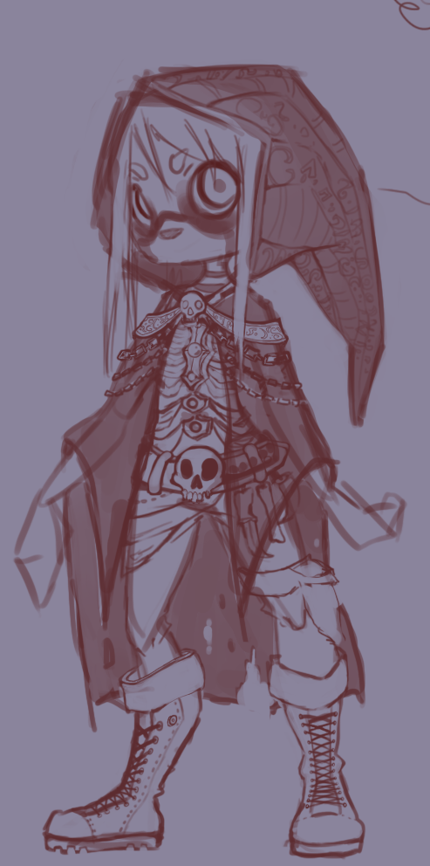
War: A medieval fantastic armor with bigger elements on the legs due to the camera's position.
Famine : An old peasant with a straw hat and bags on his hips. Very skinny, the player has to say :”How could he got so far ?!”
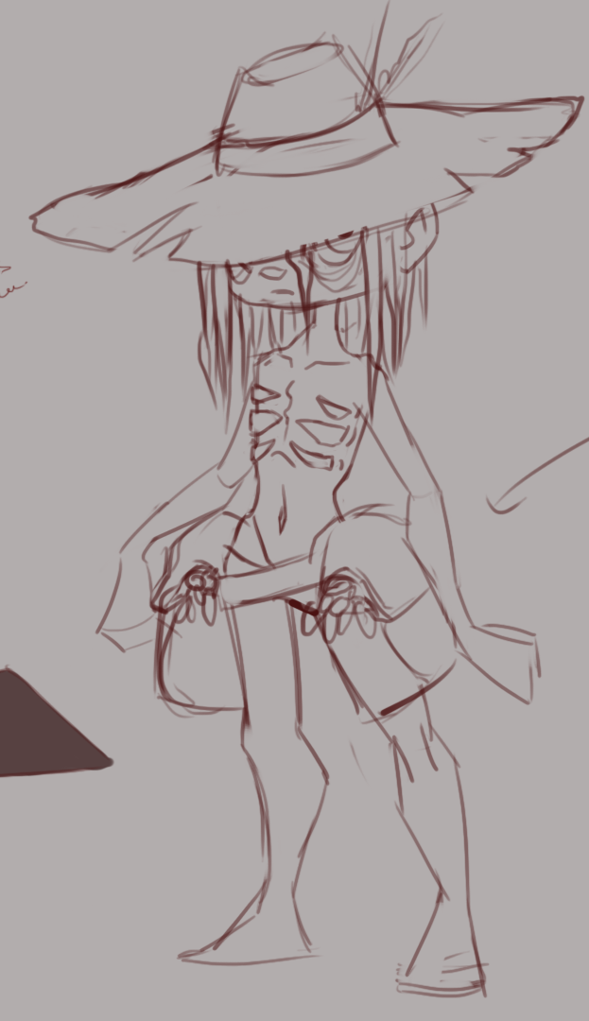
Pestilence : A count which ally dirt and nobles origins.
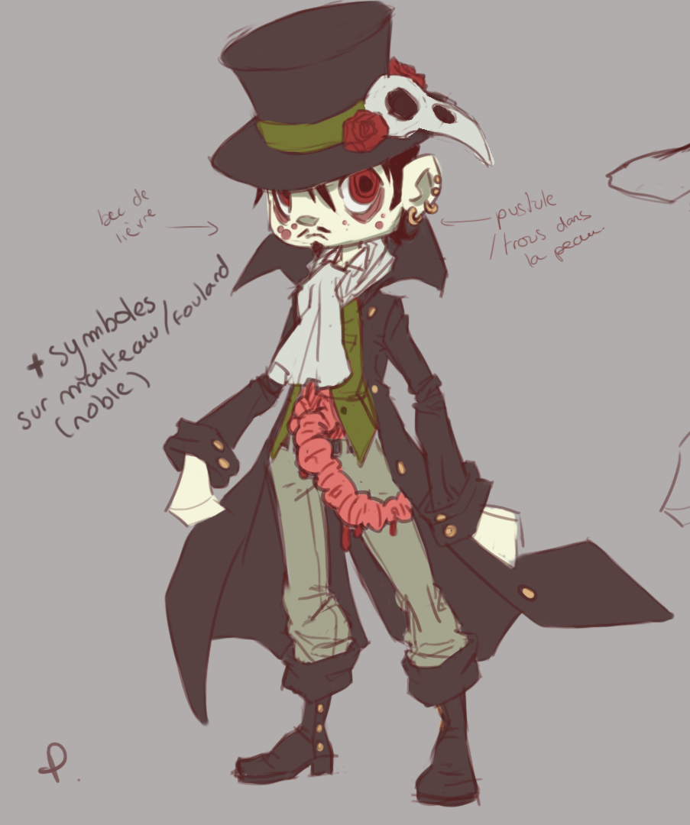

Environment design
Arena 1: A classical circle arena with no particular gameplay on it. Chosen to be the tutorial arena
Arena 2: Arena with 4 portals to its edges. These portals teleports to the portal in front of it.
Arena 3: 3 arenas in one disposed as a triangle with bridges connected to it. But doors stop the progression to each other part of the arena. The boss will destroy one arena for each third part life removed. The camera will focus on the door which will be unlocked. The player will have an amount of time to reach the other arena before fell with the destroyed arena.
Arena 4: A square arena with different labyrinthine patterns. Each minutes, all the walls will go underground and there will be any obstacles for the next 30 seconds. Then, another pattern will appear from the ground

Marketing & packaging

Cover (front & back)
TO DETERMINATE

Icon
TO DETERMINATE

3D Art and Animation
The team is in charge of all the conception and animation of all characters in this project

Sound and Music

Overall Goals
The music has to enhanced violence and to be violent with the boss. To incitate to fight. But it has also to remain Hell. The game is nervous but have DoDonpachis parts so it has to be fast.
Different music styles can be added for dialogs scene and cinematics to enhance the humoristic aspect.

SFX
The SFX are separated in two parts : Gameplay and UI. The UI has smooth click sound to navigate menus and a big bell sound when a battle is launched or New Game and Continue are selected.
During gameplay, there is a sound every bullet shots. The boss can talk and the player talk when a special attack is launch. Both have hurts and basic attacks voices sounds. There can be also sounds when the boss use a special attack.
The songs presents in the game :
- Menu music : To Determinate
- One music per arena
- One music per horsemen
- One music for credits : Hell's Bells AC/DC
The SFX presents in the game :
- Navigating sound : To Determinate
- Selection sounds : To Determinate
- Launch battle sound : Big Bell sound

Story

Global Story
Why they are here.

Horsemen
Make one story per horsmen ? (Inspired by Tekken stories)

Demons

Technical Specifications

Game Engine
Unity 3D 5.4.0 will be used for this project

Platform and OS
The game is developped for PC using Windows.

External Code
If we are using external plugins or scripts

Code Objects
Organisation of scripts
PLAYER :
CAMERA :
BOSS :
BULLETS :
GAME MANAGER :

Data Flow
What datas we will be in the save

Artificial Intelligence
A basic summary (Flowcharts) of how a boss will be acting recording to players movements and his health or boss's health

Production Schedule

Scope
Our project scope include the following :
- Designing and develop a game with Unity (no joking)
- Game has to be a bossfight with DoDonPachi experience
- Two Players handled
- Two characters playable
- One boss included
- One Arenas included
- Full Set of Menus

Info Creajeux
Groupe A
e-mails : Alex : alexandre.terrier@creajeux.fr

