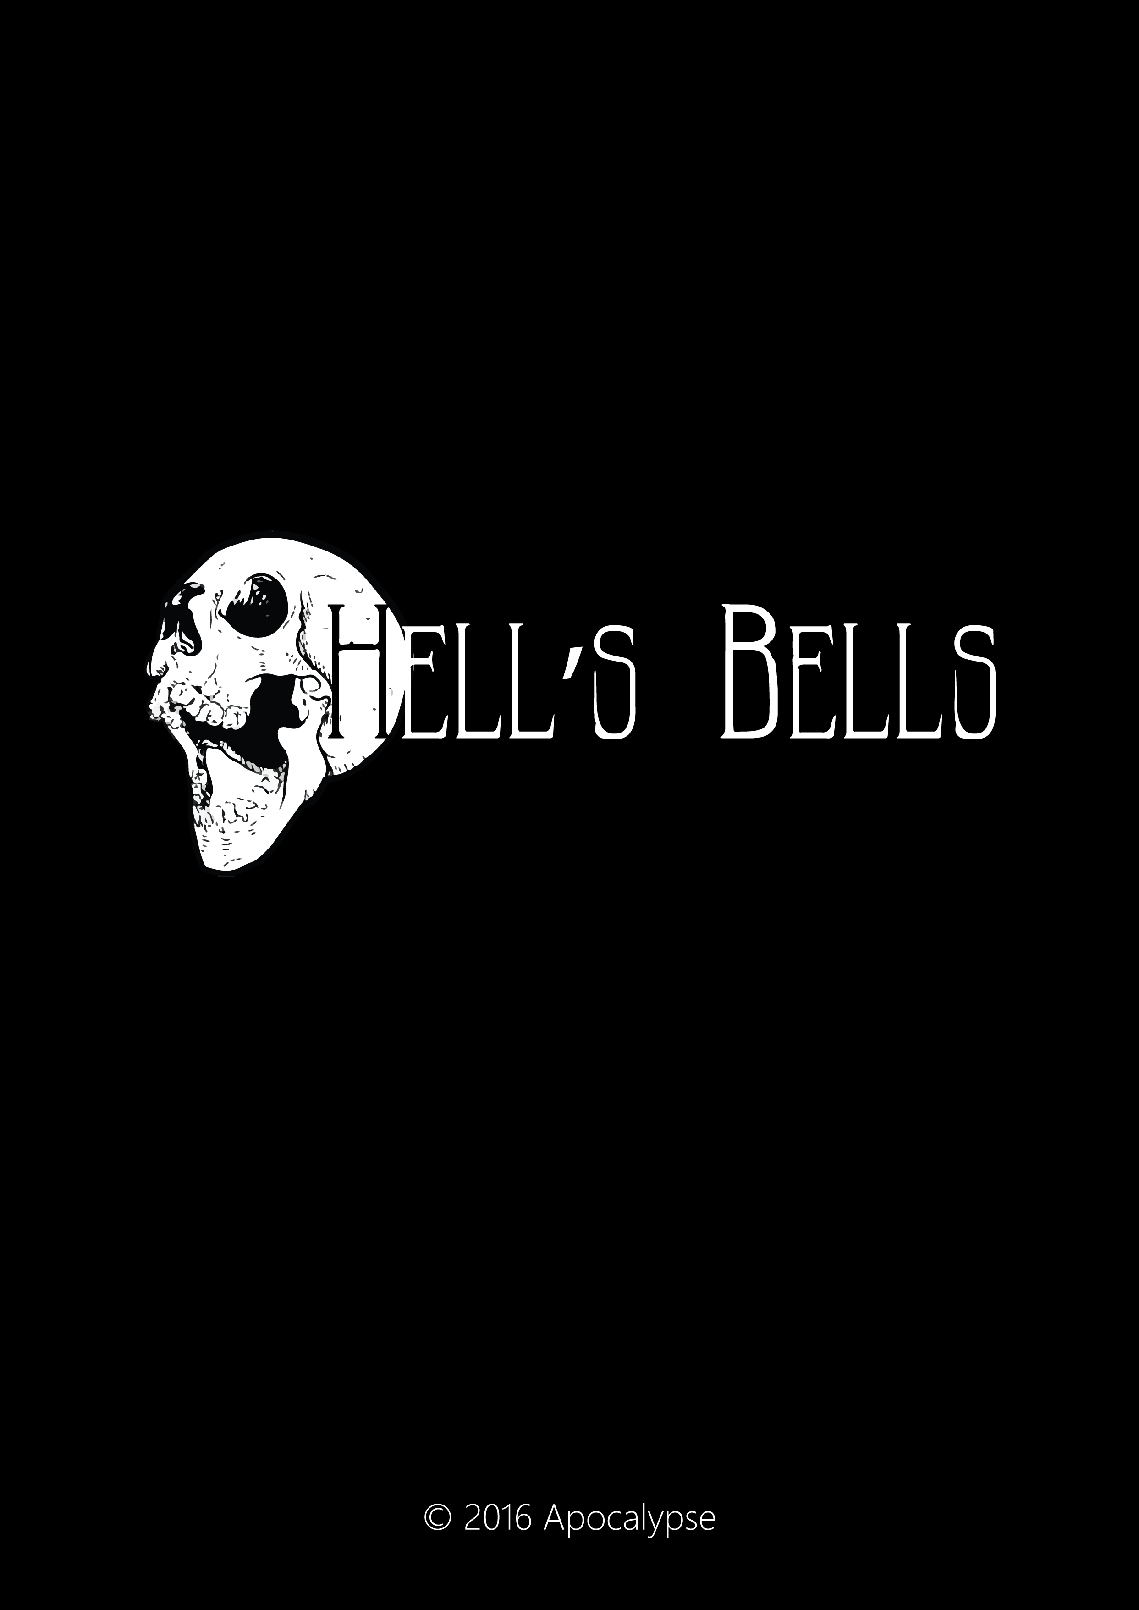
Version First Playable
March 27, 2017
Version Control
Version | Date | Author | Description
1.0 | Jan-12 | MARIE Alexandre | Document Created
1.1 | Jan-30 | MARIE Alexandre | Update MockUps + characters

Table des matieres
IDescriptive 1
I.1Support 1
I.2Rating 1
I.3The Team 1
I.3.IGraphic 1
I.3.IIProgrammers 1
I.4Environment & Gameplay 2
I.4.IVictory Defeat conditions. 2
I.4.IIGameplay 2
I.4.IIIControls 2
I.5Mood Board 3
I.5.IGeneral Ambiance 3
I.5.IICharacters Inpiration 4
I.5.IIIFinal Characters 5
I.6Scope 6

Descriptive

Hell’s Bells is a 3D cooperative shooter style game for PC. Up to 2 players control one of the four horsemen in different arenas and kill famous Hell demons extracted from the Holy Bible. It takes place in Hell.

Support
The game will be available on PC. We use Unity 5.4 for this project.

Rating

Our game is PEGI 12 rated.

The Team

Graphic
Ilona Bresson : Lead Artist, concept artist, character design & texturing
Raoul Desouhant : 3D Modeler, concept artist & animator
Océane Rosell : concept artist, environment design & texturing

Programmers
Alexandre Marie : Lead Programmer, UI & menu, SFX
Benjamin Bollet : IA & Enemy
Théo Cartégnie : Gameplay & controls
Remy Carivenc : Camera & sounds

Environment & Gameplay
You control one of the four Apocalypse horsemen, and you have to defeat a bunch of demons all extracted from the Oh My God Bible.
The Horsemen have to defeat several demons all chosen by Satan himself to prove there are still good enough in case of Apocalypse.

Victory Defeat conditions.
The game is a boss fight gameplay. The boss’s life fall under 0, you win. Otherwise, if its your life fall under 0, you loose and have to restart the fight.

Gameplay
The gameplay articulate around a 3D shoot’them up mix with a boss fight. You are in an arena (there will be four arena in total). You have one demon and one or two horsemen. A shared life options will be available.
The boss have several bullet’s patterns and 2 special attacks. Each quarter of life, the current pattern explode and update the next patterns.

Controls
The right trigger is for normal shooting.
The left bumper is for dashing.
A button special attack. (bullet storm)
Left stick to move
Right stick to aim

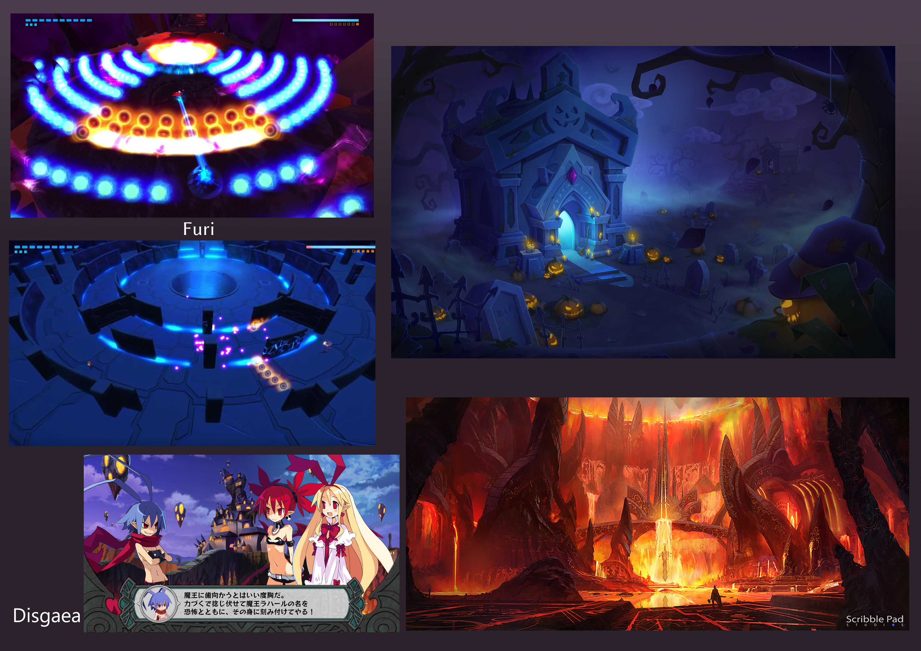
Mood Board

General Ambiance

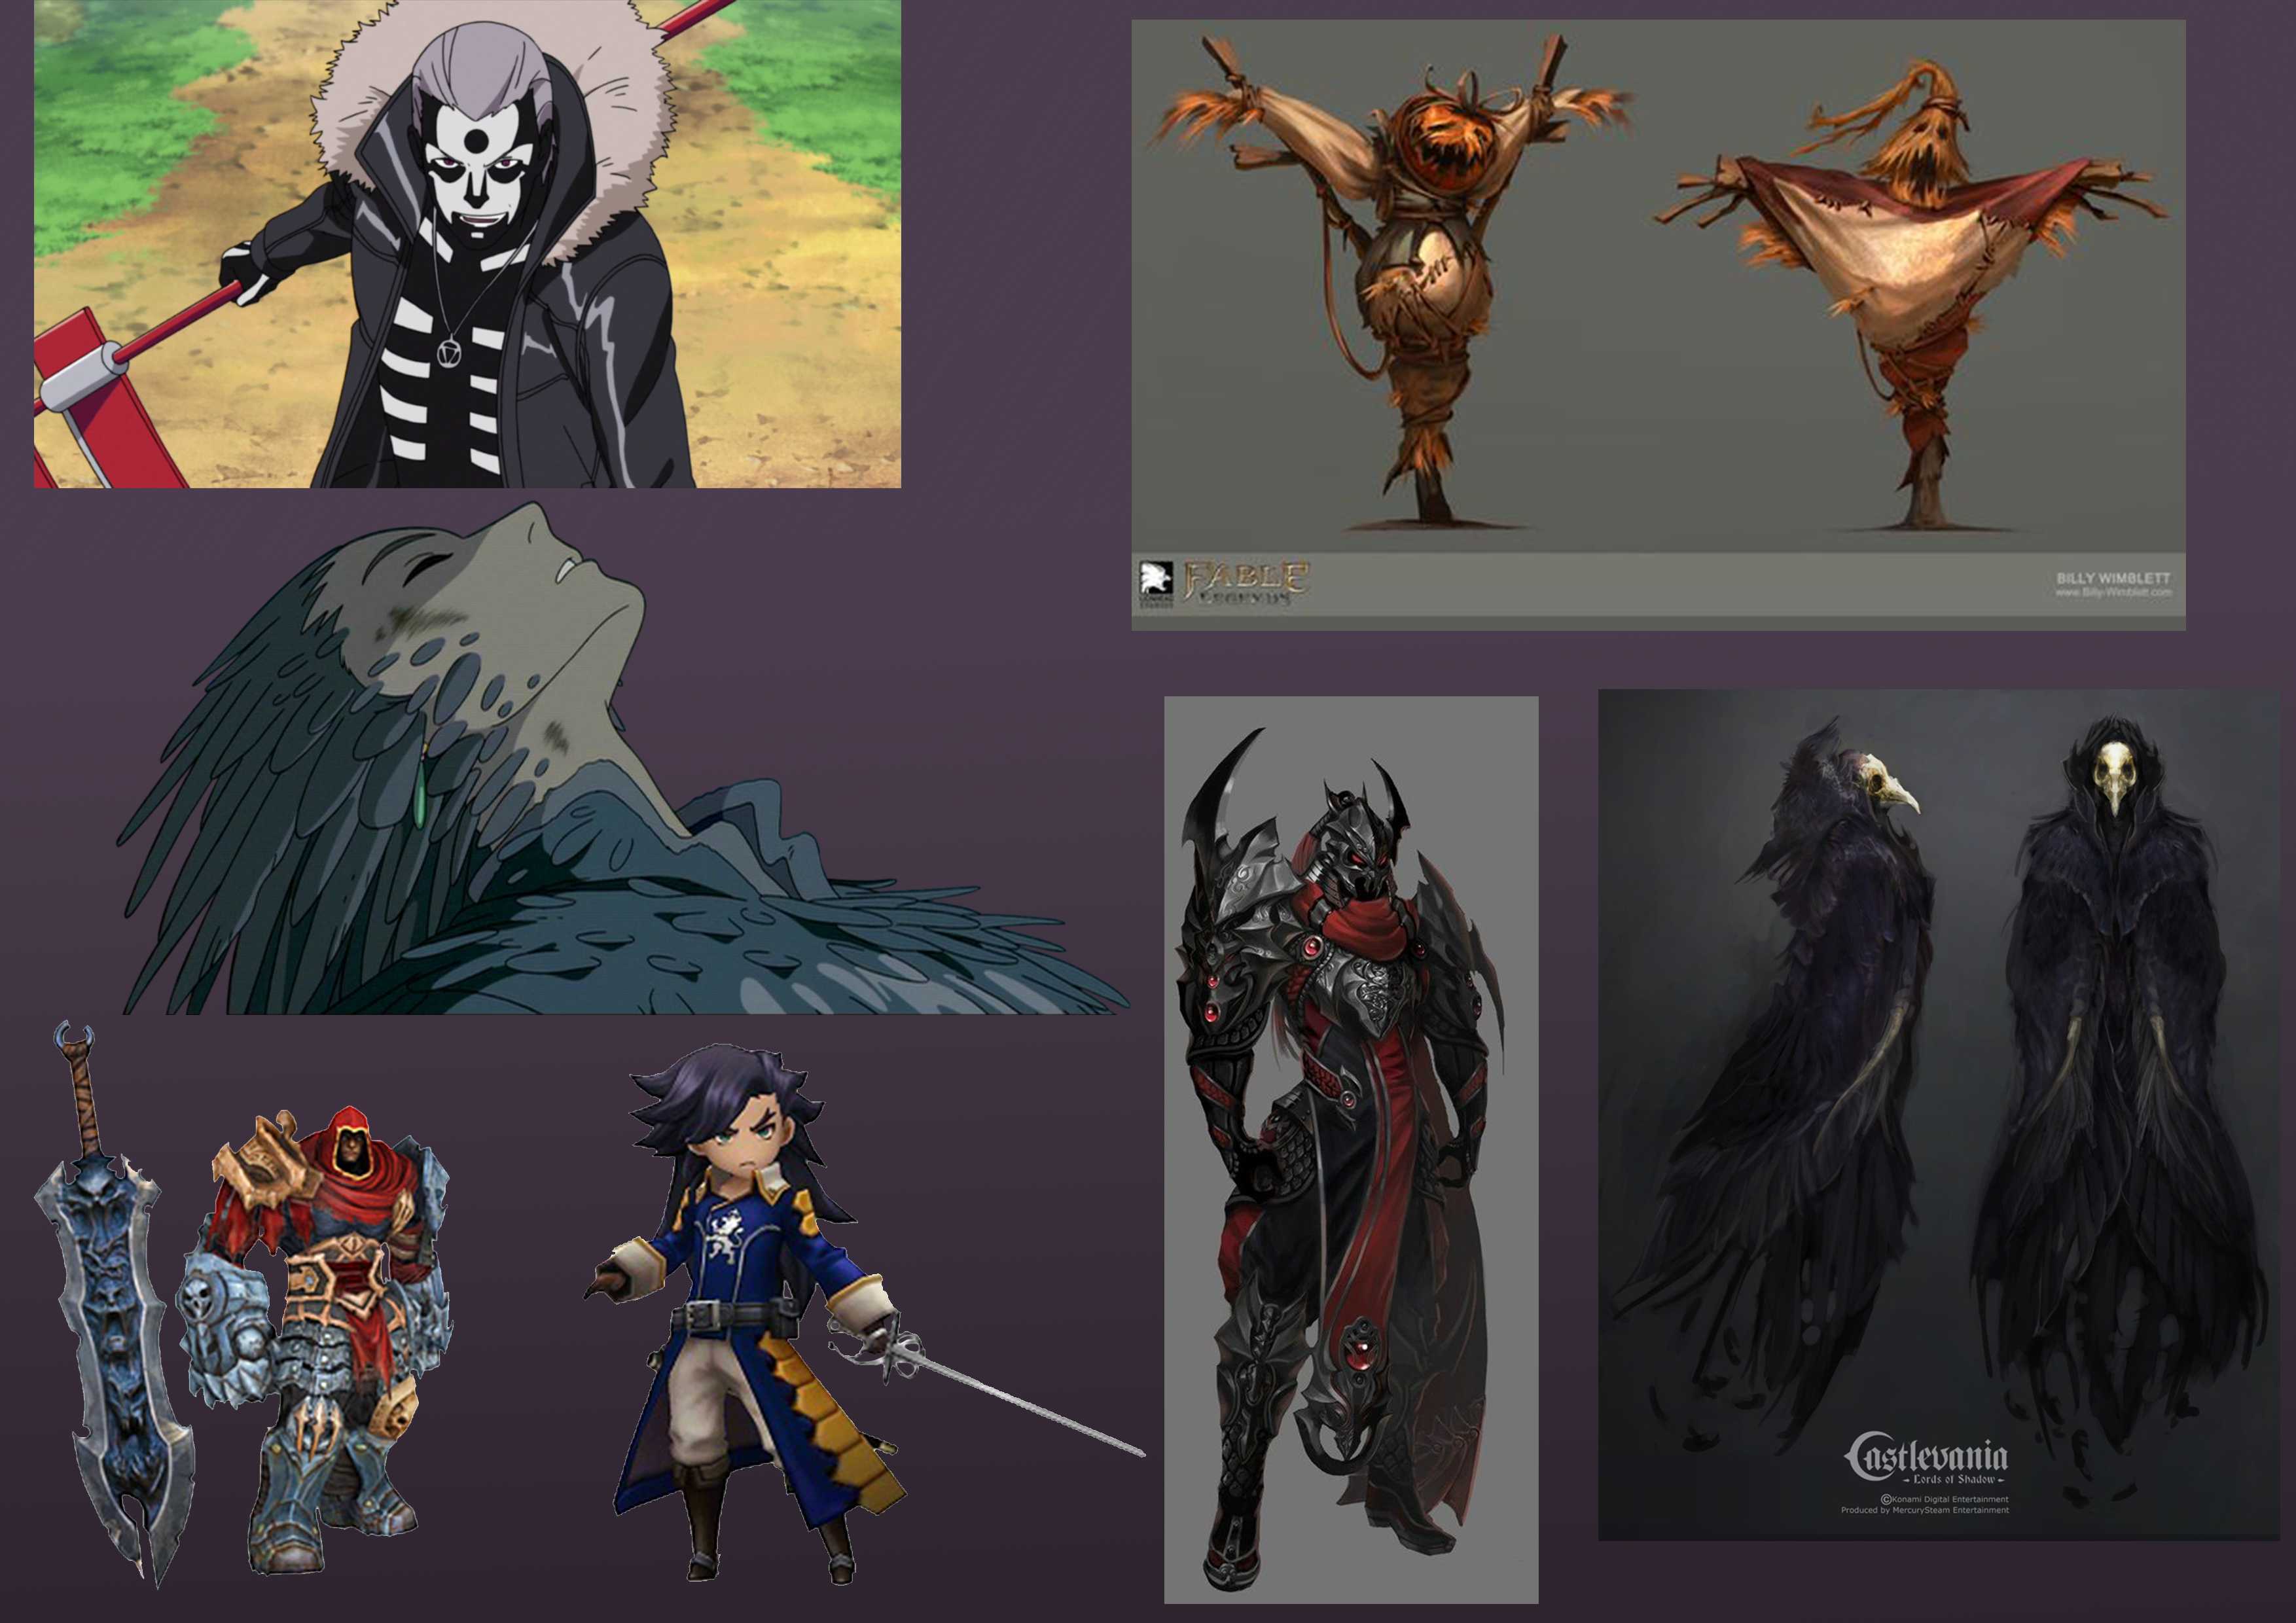
Characters Inpiration

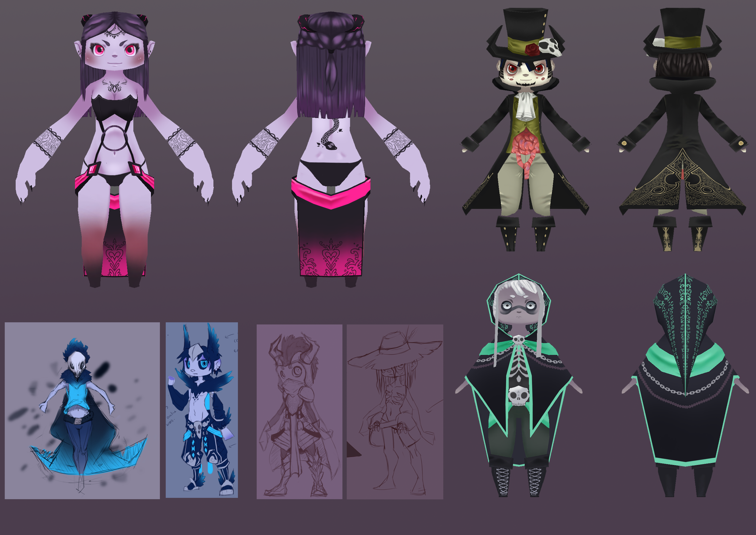
Final Characters

Scope
Our project scope include the following :
- Designing and develop a game with Unity (no joking)
- Game has to be a bossfight with DoDonPachi experience
- Two Players handled
- Two characters playable
- One boss included
- One Arenas included
- Full Set of Menus

