# README

Table des matières

README 1

1. Add librairies: 1

1.1-Remove missing librairies: 1

1.2-Add librairies: 3

2. Execute NetLink: 3

2.1-Run program: 3

3. For more explanations: 4

## 1. Add librairies:

### 1.1-Remove missing librairies:

To execute the program, you should first remove the two missing aima-core in Java Build Path.

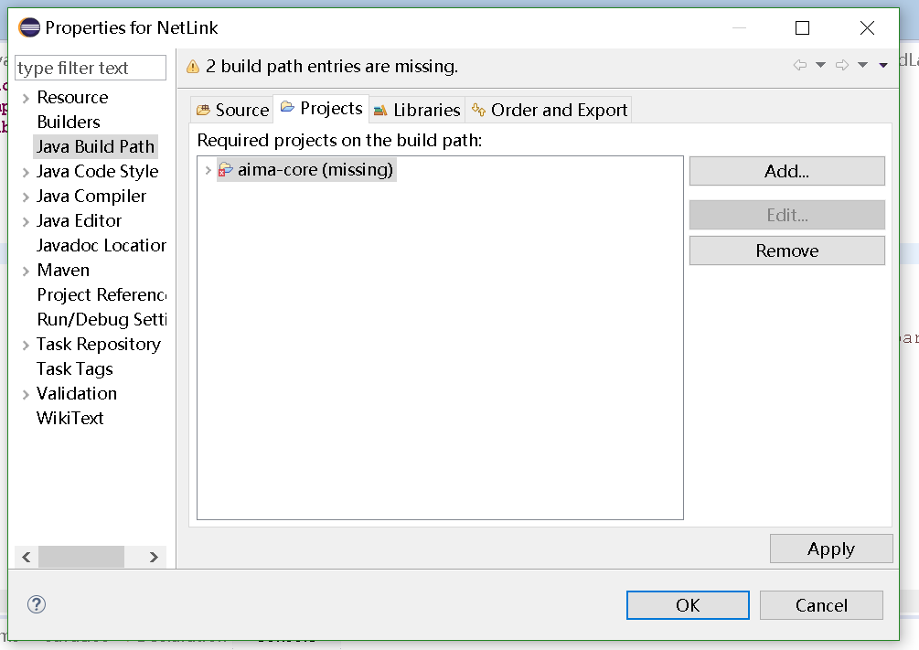

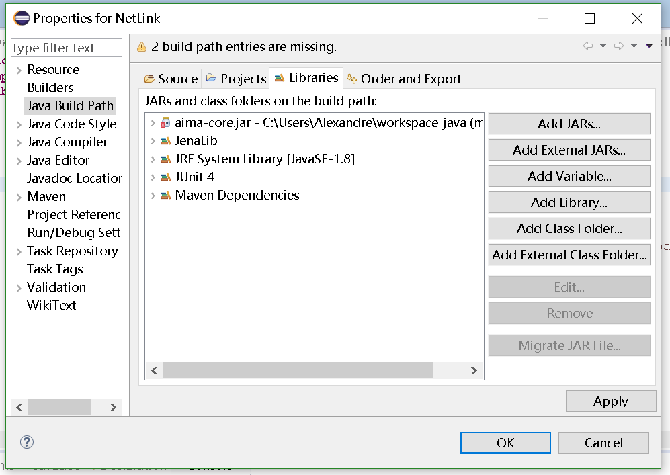

### 1.2-Add librairies:

2. Then add jena lib and aima lib to this project. (You can find the aima-core.jar in this file.)

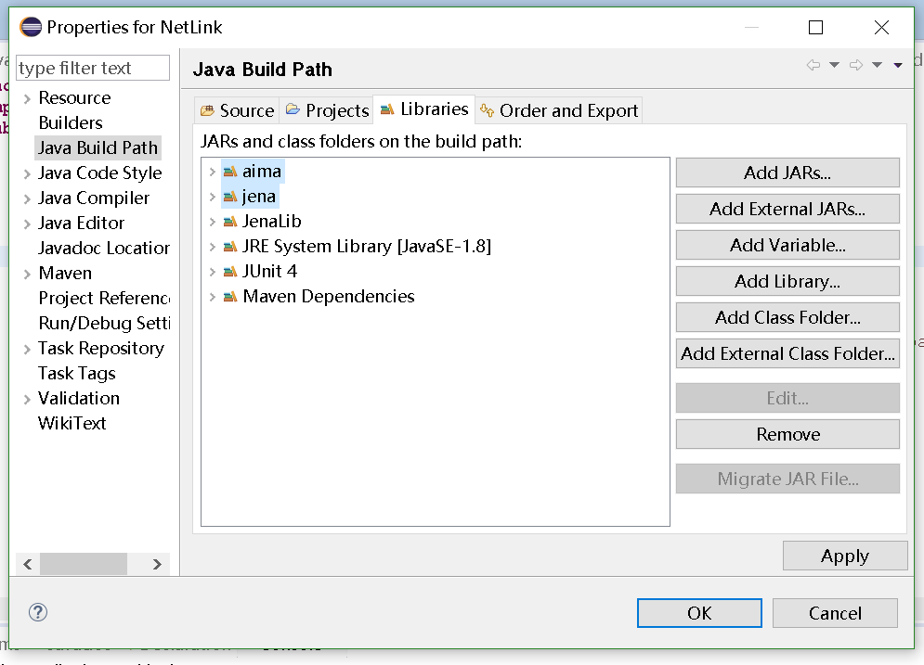

## 2. Execute NetLink:

### 2.1-Run program:

Then it can execute perfectly. The main function is in the Main.java

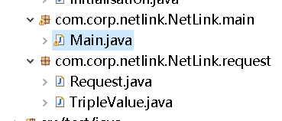

To test easily application, we define 10 local persons in owl file that you can use for some tests. Here are theirs names.

* **Cristophe**
* **Pierre**
* **Nicolas**
* **Hugo**
* **Julie**
* **Harry**
* **Batiste**
* **Sarah**
* **Jean**
* **Arthur**

To use application NetLink, we should add “h:” before the name. For example “h:Sarah” to “h:Jean”. And then it will show the answer.

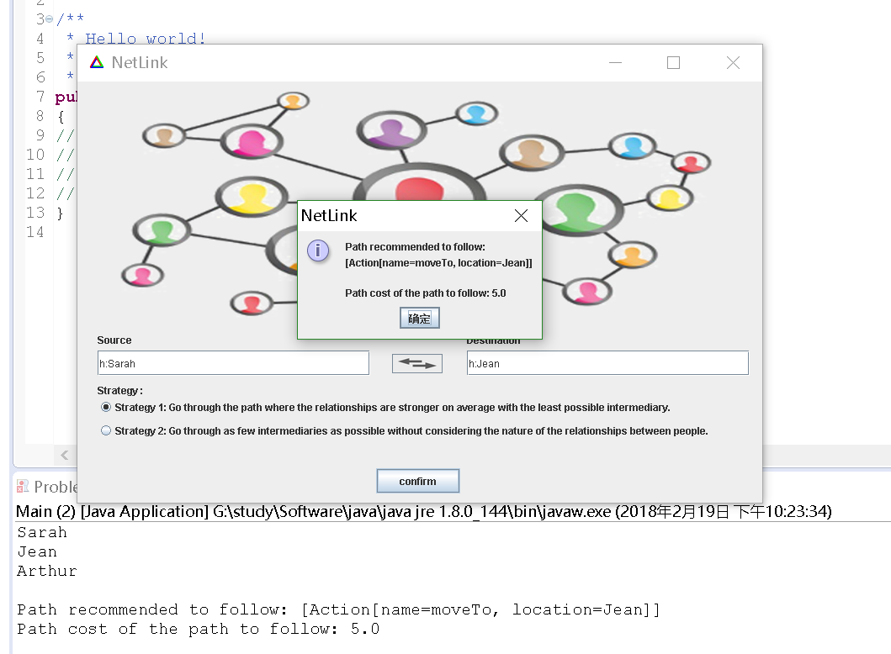

## 3. For more explanations:

For more explanations, please refer to file called « Rapport.pdf ».