Toptal ETL Project

Basic Usage Guide - FAQ

How can i access Airflow?

1. Go to <http://localhost:8080> on your browser
2. Login with username: airflow password: airflow

How can i access my DW?

1. Use the address localhost,1533 with username:sa/password:toptal
2. Put the credentials on any client of your choice
3. Access the DW database

How can i check the proposed reports?

1. Refer to the views on DW database: all_sales_by_month_2021, top_100_products_country_most_access, top_5_devices
2. Refer to the reports folder for the source code

How can i run DAGs?

1. On airflow dashboard, refer to the Actions column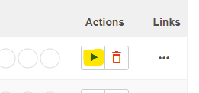
2. Click on it and then select “Trigger DAG”

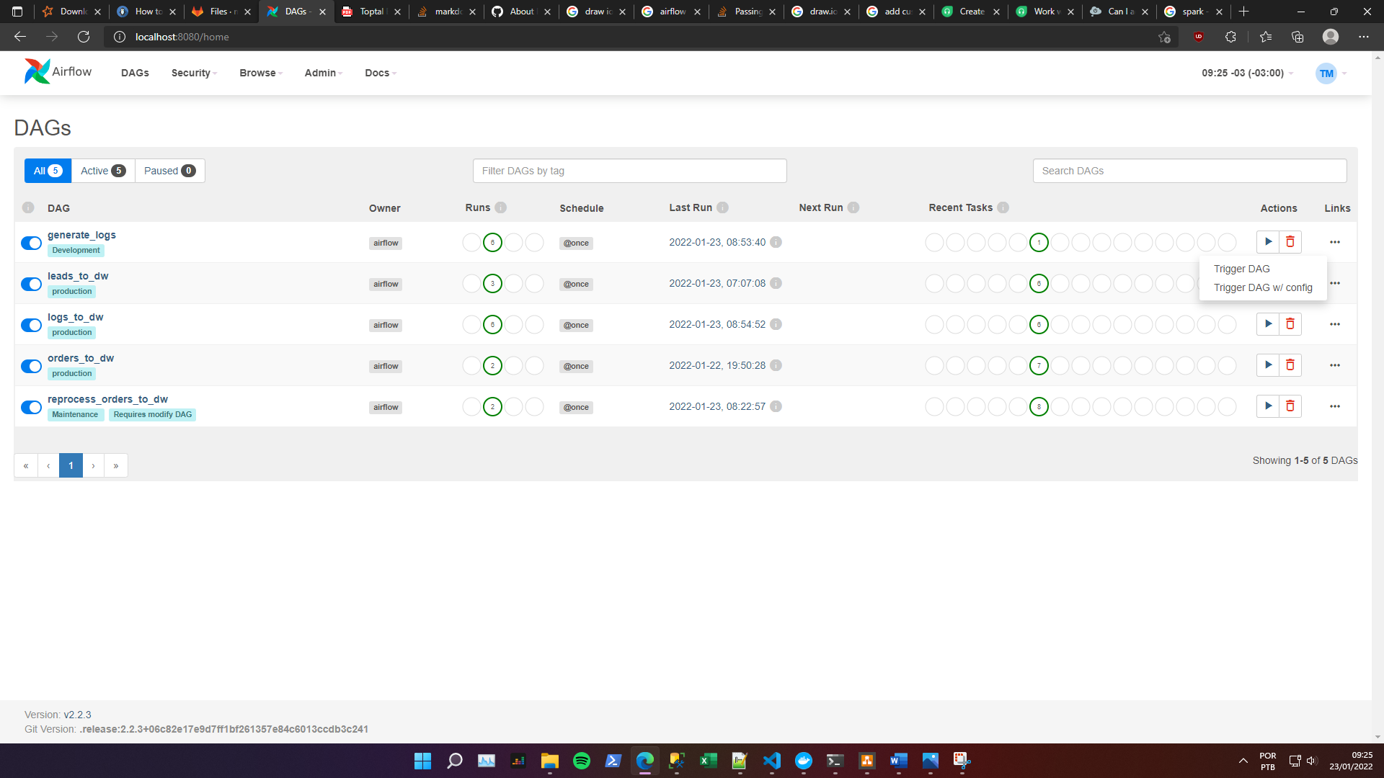

How can i check my DAG runs, status and history?

1. Refer to the dag that you want to analyze on the airflow dashboard. It will display macro information about the dag history such as how many runs sucedded or failed, schedule, last run, status for DAG tags etc.

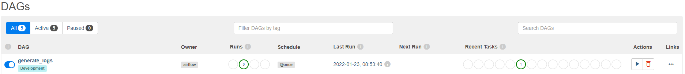

1. Clicking on DAG name displays a page with several views for the dag runs details.

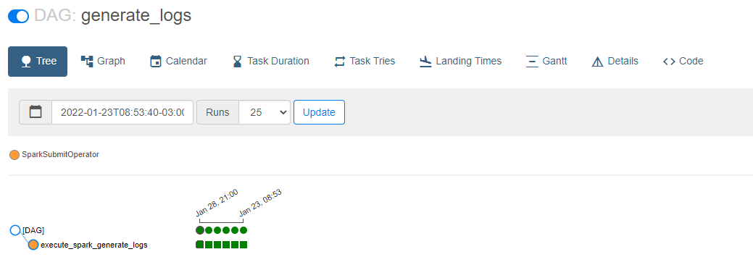

How can i test the system?

1. Run the DAGs on the following order:

orders_to_dw -> generate_logs -> logs_to_dw -> leads_to_dw

What is the reprocess_orders_to_dw?

1. It’s a DAG built for reprocess data from the B2BPlatform based on the order date. It requires editing on the dag source code to set the time range