R Notebook

This is an [R Markdown](http://rmarkdown.rstudio.com) Notebook. When you execute code within the notebook, the results appear beneath the code.

Try executing this chunk by clicking the *Run* button within the chunk or by placing your cursor inside it and pressing *Cmd+Shift+Enter*.

##   
## Attaching package: 'dplyr'

## The following objects are masked from 'package:stats':  
##   
## filter, lag

## The following objects are masked from 'package:base':  
##   
## intersect, setdiff, setequal, union

##   
## Attaching package: 'zoo'

## The following objects are masked from 'package:base':  
##   
## as.Date, as.Date.numeric

## [1] "Total Administered Connecticut 882777"  
## [1] "Total Delivered Connecticut 984275"  
## [1] "People with 1+ Doses Connecticut 595390"  
## [1] "People with 2+ Doses Connecticut 277009"  
## [1] "Total Administered per 100k Connecticut 24760"  
## [1] "Total Delivered per 100k Connecticut 27610"  
## [1] "People with 1+ Doses per 100k Connecticut 16700"  
## [1] "People with 2+ Doses per 100k Connecticut 7770"  
## [1] "Total Administered Maine 297116"  
## [1] "Total Delivered Maine 335375"  
## [1] "People with 1+ Doses Maine 204495"  
## [1] "People with 2+ Doses Maine 90423"  
## [1] "Total Administered per 100k Maine 22100"  
## [1] "Total Delivered per 100k Maine 24950"  
## [1] "People with 1+ Doses per 100k Maine 15210"  
## [1] "People with 2+ Doses per 100k Maine 6730"  
## [1] "Total Administered Massachusetts 1468992"  
## [1] "Total Delivered Massachusetts 1737170"  
## [1] "People with 1+ Doses Massachusetts 1080511"  
## [1] "People with 2+ Doses Massachusetts 384582"  
## [1] "Total Administered per 100k Massachusetts 21310"  
## [1] "Total Delivered per 100k Massachusetts 25200"  
## [1] "People with 1+ Doses per 100k Massachusetts 15680"  
## [1] "People with 2+ Doses per 100k Massachusetts 5580"  
## [1] "Total Administered New Hampshire 267893"  
## [1] "Total Delivered New Hampshire 328525"  
## [1] "People with 1+ Doses New Hampshire 184739"  
## [1] "People with 2+ Doses New Hampshire 82957"  
## [1] "Total Administered per 100k New Hampshire 19700"  
## [1] "Total Delivered per 100k New Hampshire 24160"  
## [1] "People with 1+ Doses per 100k New Hampshire 13590"  
## [1] "People with 2+ Doses per 100k New Hampshire 6100"  
## [1] "Total Administered Rhode Island 206034"  
## [1] "Total Delivered Rhode Island 246175"  
## [1] "People with 1+ Doses Rhode Island 142522"  
## [1] "People with 2+ Doses Rhode Island 63410"  
## [1] "Total Administered per 100k Rhode Island 19450"  
## [1] "Total Delivered per 100k Rhode Island 23240"  
## [1] "People with 1+ Doses per 100k Rhode Island 13450"  
## [1] "People with 2+ Doses per 100k Rhode Island 5990"  
## [1] "Total Administered Vermont 141436"  
## [1] "Total Delivered Vermont 163550"  
## [1] "People with 1+ Doses Vermont 94486"  
## [1] "People with 2+ Doses Vermont 46743"  
## [1] "Total Administered per 100k Vermont 22670"  
## [1] "Total Delivered per 100k Vermont 26210"  
## [1] "People with 1+ Doses per 100k Vermont 15140"  
## [1] "People with 2+ Doses per 100k Vermont 7490"

CDC population numbers

## # A tibble: 6 x 5  
## location m s1 m2 s2  
## <chr> <dbl> <dbl> <dbl> <dbl>  
## 1 Connecticut 3565603. 1063. 3565442. 719.  
## 2 Maine 1344006. 471. 1344189. 243.  
## 3 Massachusetts 6892267. 3374. 6892977. 1456.  
## 4 New Hampshire 1359682. 487. 1359719. 287.  
## 5 Rhode Island 1059260. 483. 1059295. 203.  
## 6 Vermont 624029. 193. 623997. 119.

Plot daily_vaccinations (it is already 7-day smoothed in the original data)

## Warning: Removed 1 row(s) containing missing values (geom_path).

Forecasting:

## [1] "Latest data from 2021-02-22"

Forecast Cumulative number of doses **distributed**

## [1] "Latest data from 2021-02-22"

## [1] "location Connecticut alpha 0.07 beta 0.248141485074873 level 1004295.71951859 trend 17739.5643177319"  
## [1] "location Maine alpha 0.07 beta 0.999933555372998 level 365651.262877354 trend 4486.41424117026"  
## [1] "location Massachusetts alpha 0.07 beta 0.865997215019203 level 1704220.4289539 trend 27452.5514440782"  
## [1] "location New Hampshire alpha 0.07 beta 0.964223300580648 level 361289.775177223 trend 4319.12829807246"  
## [1] "location Rhode Island alpha 0.07 beta 0.999933893038648 level 257660.332057628 trend 1997.50549315879"  
## [1] "location Vermont alpha 0.07 beta 0.667179775630575 level 166460.363865886 trend 3524.23063539745"

Forecast Cumulative number of doses **administered**

## [1] "Latest data from 2021-02-22"

## [1] "location Connecticut alpha 0.2 beta 0.999939092341694 level 894461.179625231 trend 29444.5539186828"  
## [1] "location Maine alpha 0.2 beta 0.816796699421531 level 293864.126486189 trend 13194.0541104458"  
## [1] "location Massachusetts alpha 0.2 beta 0.640053231731512 level 1460978.49026975 trend 57486.9829464387"  
## [1] "location New Hampshire alpha 0.2 beta 0.697651849562025 level 264382.03755997 trend 9530.09766026523"  
## [1] "location Rhode Island alpha 0.2 beta 0.999933893038648 level 205796.464649177 trend 14091.305199399"  
## [1] "location Vermont alpha 0.2 beta 0.999933893038648 level 140429.408398273 trend 5749.67736255111"

Forecast **Daily** number of doses **administered**

## [1] "Latest data from 2021-02-22"

## [1] "location Connecticut alpha 0.3 beta 0.999933893038648 level 28442.5259266706 trend 224.849855189333"  
## [1] "location Maine alpha 0.3 beta 0.508895688078132 level 12239.7848640534 trend 1263.96791746077"  
## [1] "location Massachusetts alpha 0.3 beta 0.300609732437315 level 51413.5754783539 trend 1093.74781554166"  
## [1] "location New Hampshire alpha 0.3 beta 0.116253217045365 level 7486.18869280409 trend 170.679466305619"  
## [1] "location Rhode Island alpha 0.3 beta 0.99995299976546 level 9575.69606371887 trend 1257.18587046026"  
## [1] "location Vermont alpha 0.3 beta 0.999926870187325 level 4611.96273933583 trend 328.829334576985"

Plot Forecasted Cumulative number of doses distributed & administered

## [1] "'Availability' = [Cumulative number of doses distributed] - [Cumulative number of doses administered] - [waste(0.13% of total)]"

## Warning: Removed 3 row(s) containing missing values (geom_path).

## MAXIMUM CAPACITY

## Warning: Unknown or uninitialised column: `cap`.

## calculate derivative of daily_vaccinations and totals per 100K people

## [1] "Latest data from 2021-02-22"

## SAVE data for Shiny App

## [1] "SAVING Latest data from 2021-02-22"

# WEEKLY REPORT STARTS HERE

# FEMA-R1 Vaccine Assessment

## [1] "Latest data from 2021-02-22"

## 7-day forecast of availability and administration of doses

The following figure shows a forecast of availability and administration of doses per state for the next 7 days. The blue bars show the estimated availability of doses, where the dark blue represents the current availability estimated as $D−V−W$, where $D$ is the cumulative number of doses distributed, $V$ is the cumulative number of vaccinations, and $W$ is waste (estimated as 0.13% of the total **MAUREEN, CAN YOU ADD THE SOURCE?**), as of February 21st. The light blue bar is the forecast of doses distributed to the state within the next 7 days. The orange bars represent the forecasted number of vaccinations (light orange is the number of people expected to get the first dose of Pfizer or Moderna while the dark orange is the number expected to get the second dose).  
Fig. 1 suggests that most New England states depend on receiving new shipments within the next 7 days (light blue) in order to be able to serve the expected number of vaccinations (orange). Rhode Island is at risk of running out of doses this week according to current trends. This is probably because of the disruptions caused by the winter storm that delayed shipments for all 50 states last week (<https://www.npr.org/sections/coronavirus-live-updates/2021/02/19/969519016/extreme-winter-weather-creates-backlog-of-6-million-vaccine-doses>). The only exception is New Hampshire, which will likely be able to serve this week’s vaccinations with the doses already shipped and currently not administered (dark blue).

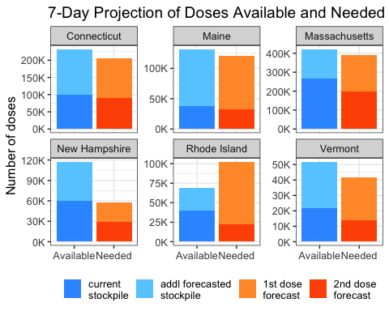

Figure 1. 7-day forecast of availability and administration of doses for the New England states. Source: CDC/Our World in data, Feb 21.

## 14-day forecast of availability and administration of doses

Figure 2 shows a forecast of availability and administration of doses per state for the next 14 days and suggests that CT, MA, RI, and VT are at risk of running out of doses within the next two weeks according to current trends. Again, this is probably because of the disruptions caused by the winter storm that delayed shipments last week. (New Hampshire and Maine will likely be able to serve the next two week’s vaccinations with the doses available and expected to be received.)

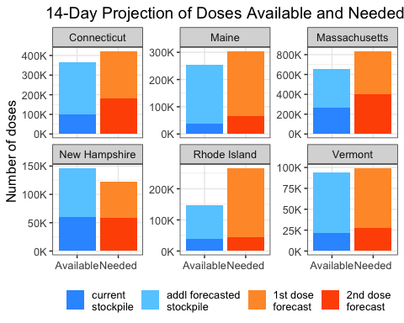

Figure 2. 14-day forecast of availability and administration of doses for the New England states. Source: CDC/Our World in data, Feb 21.

## Forecasting method

The projections above are based on the forecast of the cumulative number of doses distributed and the cumulative number of doses administered, shown in Fig. 3. Both forecasts are obtained as a linear projection of the recent trend in the cumulative totals. Note that the recent trends of CT, MA, RI and VT indicate that total vaccinations may reach the total number of doses shipped within the next week. This is because vaccinations have accelerated in the previous days in those states, while distribution has not been followed by a similar increase (possibly because of the impact of the recent snow storm). The risk of vaccine shortage may be higher for facilities which shipments may be lower and vaccinations higher than the state averages.

## Warning: Removed 3 row(s) containing missing values (geom_path).

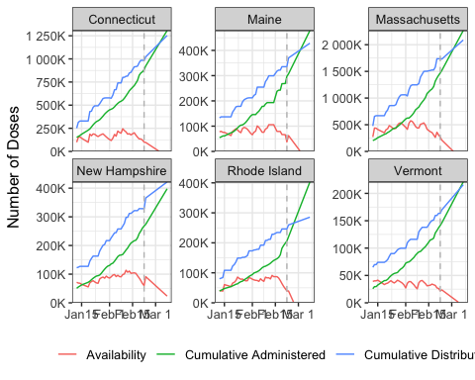 Figure 3. Forecast of cumulative number of distributed doses, cumulative number of doses administered, and availability of doses for the New England states. Source: CDC/Our World in data, Feb 21.