**Claw coloration in the fiddler crab *Leptuca uruguayensis* has no correlation with male quality**

Zackary A. Graham1,*, Jônatas de Jesus Florentino2,*, Samuel P. Smithers3, João C. T. Menezes2,4, José Eduardo de Carvalho5, Alexandre V. Palaoro2,5,6,7,†

**Protocol to measure lipid content**

We measured the body condition of each crab based on measurements of total amount of lipids stored within an individual (Koop et al. 2011). Across animals, lipid content is used as an index of body condition and individual quality due to its correlation to food quality (Cranford 1999; Blanckenhorn et al. 2003; Svensson et al. 2004; Mckinney et al. 2014; Aoki et al. 2021). Thus, by estimating the amount of lipid, we can infer if color is associated with male quality. Measuring lipid content consisted of two steps: (i) the extraction of the lipids from the tissue, and (ii) measurement of total lipids in the sample. For the extraction of lipids, we used the protocol from Folch et al. (1957) and Parrish (1998) and adjusted it for small tissue samples. To do this, we dissected the individuals and weighed the internal contents of the carapaces (e.g., stomach, gonads, gills, and hepatopancreas). Next, we immersed each entrail sample in a chloroform: methanol solution (i.e., homogenization solution) with a 2:1 volume ratio. The volume of homogenization solution added was equal to 50 times the mass of each sample (e.g., for a sample weighing 0.02 g, the volume of homogenization solution added was 1 mL). After immersion of the samples, they were homogenized at approximately 20 rpm with an Ultra Turrax homogenizer at room temperature until there were no visible tissue parts. We added distilled water to this mixture in a volume equal to 1/7 times the initial volume of the homogenization solution (e.g., for a 0.02 g sample to which 1 mL of homogenization solution was added, the volume of distilled water added was approximately 143 µL). Then, we centrifuged the samples at 1000 rpm for 3 minutes at room temperature.

After centrifugation, a two-phase system was formed in each sample. We collected the lower (organic) phase and transferred it to another capped flask. To the upper phase, we added a volume of homogenization solution equal to 1/3 times the volume of homogenization solution added at the beginning of the extraction (e.g., for a 0.02 g sample to which 1 mL of homogenization solution was added, the volume of homogenization solution added at this stage was approximately 333 µL). Then, we centrifuged the samples again to form the two-phase system. We performed the process of collecting the lower phase and adding homogenization solution to the upper phase at least three times for each sample. After collecting the lower phase from the resulting two-phase system of the third centrifugation, we discarded the remaining upper phase and worked only with the collected lower phase.

After centrifugation and discarding the upper phase, we added 0.73% NaCl to the lower phase samples in a volume equivalent to 1/5 times the volume of homogenization solution added at the beginning of the extraction (e.g., for a 0.02 g sample to which 1 mL of homogenization solution was initially added, the volume of 0.73% NaCl added at this stage was approximately 200 µL). Immediately afterwards, we added 400 µL more of homogenization solution to each sample and stirred to mix the solvents. Then, we left the samples at room temperature, covered, and capped, until a clear two-phase system was formed in them without particles in suspension. When the two-phase system was well defined, we collected and discarded the upper phase, and gently washed the surface of the lower phase with a solution of chloroform: methanol: magnesium chloride 0.034% in a volumetric ratio of 3:48:47, without allowing any mixing between the lower phase and the solution. The process of discarding the upper phase followed by washing the surface of the lower phase was repeated until there were no residues on the surface of the lower phase. Then, we added methanol to each sample in sufficient quantity so that, by shaking the sample, a single-phase system was formed. We then placed the samples in an oven for the solvents to evaporate. After the solvents had evaporated, we dissolved the samples in 250 µL of chloroform and stored them at -20°C until we determined the total lipids.

For the second step, measuring total lipids, we usedan adapted protocol from Frings & Dunn (1970), Frings et al. (1972), and Knight et al. (1972) (Frings and Dunn 1970; Frings et al. 1972; Knight et al. 1972). To do this, we collected 20 µL of each lipid sample suspended in chloroform and transferred it to new tubes, which were then placed in an oven until completely dried. Then, we added 200 µL of concentrated sulfuric acid to each tube and shook it. Next, we placed the samples in a boiling water bath for 10 minutes. After the samples cooled for 5 minutes, we added 5 mL of phosphovanillin reagent (0.6% vanillin: distilled water: concentrated phosphoric acid in a volumetric ratio of 7:1:12) to each tube and incubated the samples for 15 minutes at 37°C. After cooling, we measured the absorbance of each sample at 540 nm using a spectrophotometer calibrated with a solution prepared only with reagents (i.e., without a lipid sample).

To calculate the amount of lipids in each sample based on the absorbance values obtained, we established a standard curve using a standard solution of 1 µL of cod liver oil for every 99 µL of chloroform. The total lipid amount of the standard solution was calculated by placing 1 mL of the solution in two small tin foil bowls, drying the solvent in an oven, and weighing the dry material on a precision scale. We estimated the total lipid mass for each 1 mL of the standard solution from the average mass values of the two aluminum forms. Then, the standard curve was established using different volumes of the standard solution to obtain the absorbance values through the sulfo-phosphovanillin reaction described above, and then defining the equation of the line from the known values of lipid mass for each absorbance value obtained.

The absorbance values of the lipid samples obtained from the crabs were used in the linear equations calculated for the standard curve, and thus we estimated the expected amount of lipids for each absorbance value of the samples. Since the estimated lipid mass of the samples was calculated for each 20 µL of lipid extract sample, we calculated the mass of lipids for the total 250 µL of sample (which contained all the lipids extracted from the individuals). Knowing the total mass of the entrails of each collected individual, we obtained the amount of lipids (in mg) that each crab had per gram of entrails (mg/g), and this value was used to infer the quality of the collected individuals (i.e., the more stored lipids, the higher the quality of the individual).

**Table S1.** Results from the tests of a relationship between red, green, and blue reflectance and body/claw measurements. From each model, the estimate (β), standard error (SE), z-value, and *p-value* are reported. All models assumed a beta distribution. Results are reported from the analysis of 39 male *Leptuca uraguayensis* claws. Formulas presented in the table are in the following format: Dependent variable ~ independent variable, the tilde denotes that the dependent variable is in function of the independent variables. Significant effects are bolded.

|  |  |  |  |  |
| --- | --- | --- | --- | --- |
| **Model (formula: *y* ~ *x*)** | **Red** | | | |
|  | Estimate (β) | SE | z-value | *p-value* |
| (a) Percent red reflectance ~ carapace width | 0.543 | 0.505 | 1.076 | 0.282 |
| (b) Percent red reflectance ~ claw length | 0.098 | 0.194 | 0.507 | 0.612 |
| (c) Percent red reflectance ~ muscle weight | 6.177 | 21.524 | 0.287 | 0.774 |
| (d) Percent red reflectance ~ lipid content in body | -0.079 | 0.065 | -1.200 | 0.23 |
|  | **Blue** | | | |
| (e) Percent blue reflectance ~ carapace width | 0.161 | 0.435 | 0.369 | 0.712 |
| (f) Percent blue reflectance ~ claw length | -0.064 | 0.164 | -0.390 | 0.697 |
| (g) Percent blue reflectance ~ muscle weight | -9.324 | 18.44 | -0.506 | 0.613 |
| (h) **Percent blue reflectance ~ lipid content in body** | **-0.123** | **0.057** | **-2.153** | **0.031** |
|  | **Green** |  |  |  |
| (i) Percent green reflectance ~ carapace width | 0.262 | 0.484 | 0.584 | 0.559 |
| (j) Percent green reflectance ~ claw length | -0.009 | 0.171 | -0.058 | 0.954 |
| (k) Percent green reflectance ~ muscle weight | -3.893 | 19.038 | -0.205 | 0.838 |
| (l) Percent green reflectance ~ lipid content in body | -0.013 | 0.006 | -2.003 | 0.053 |

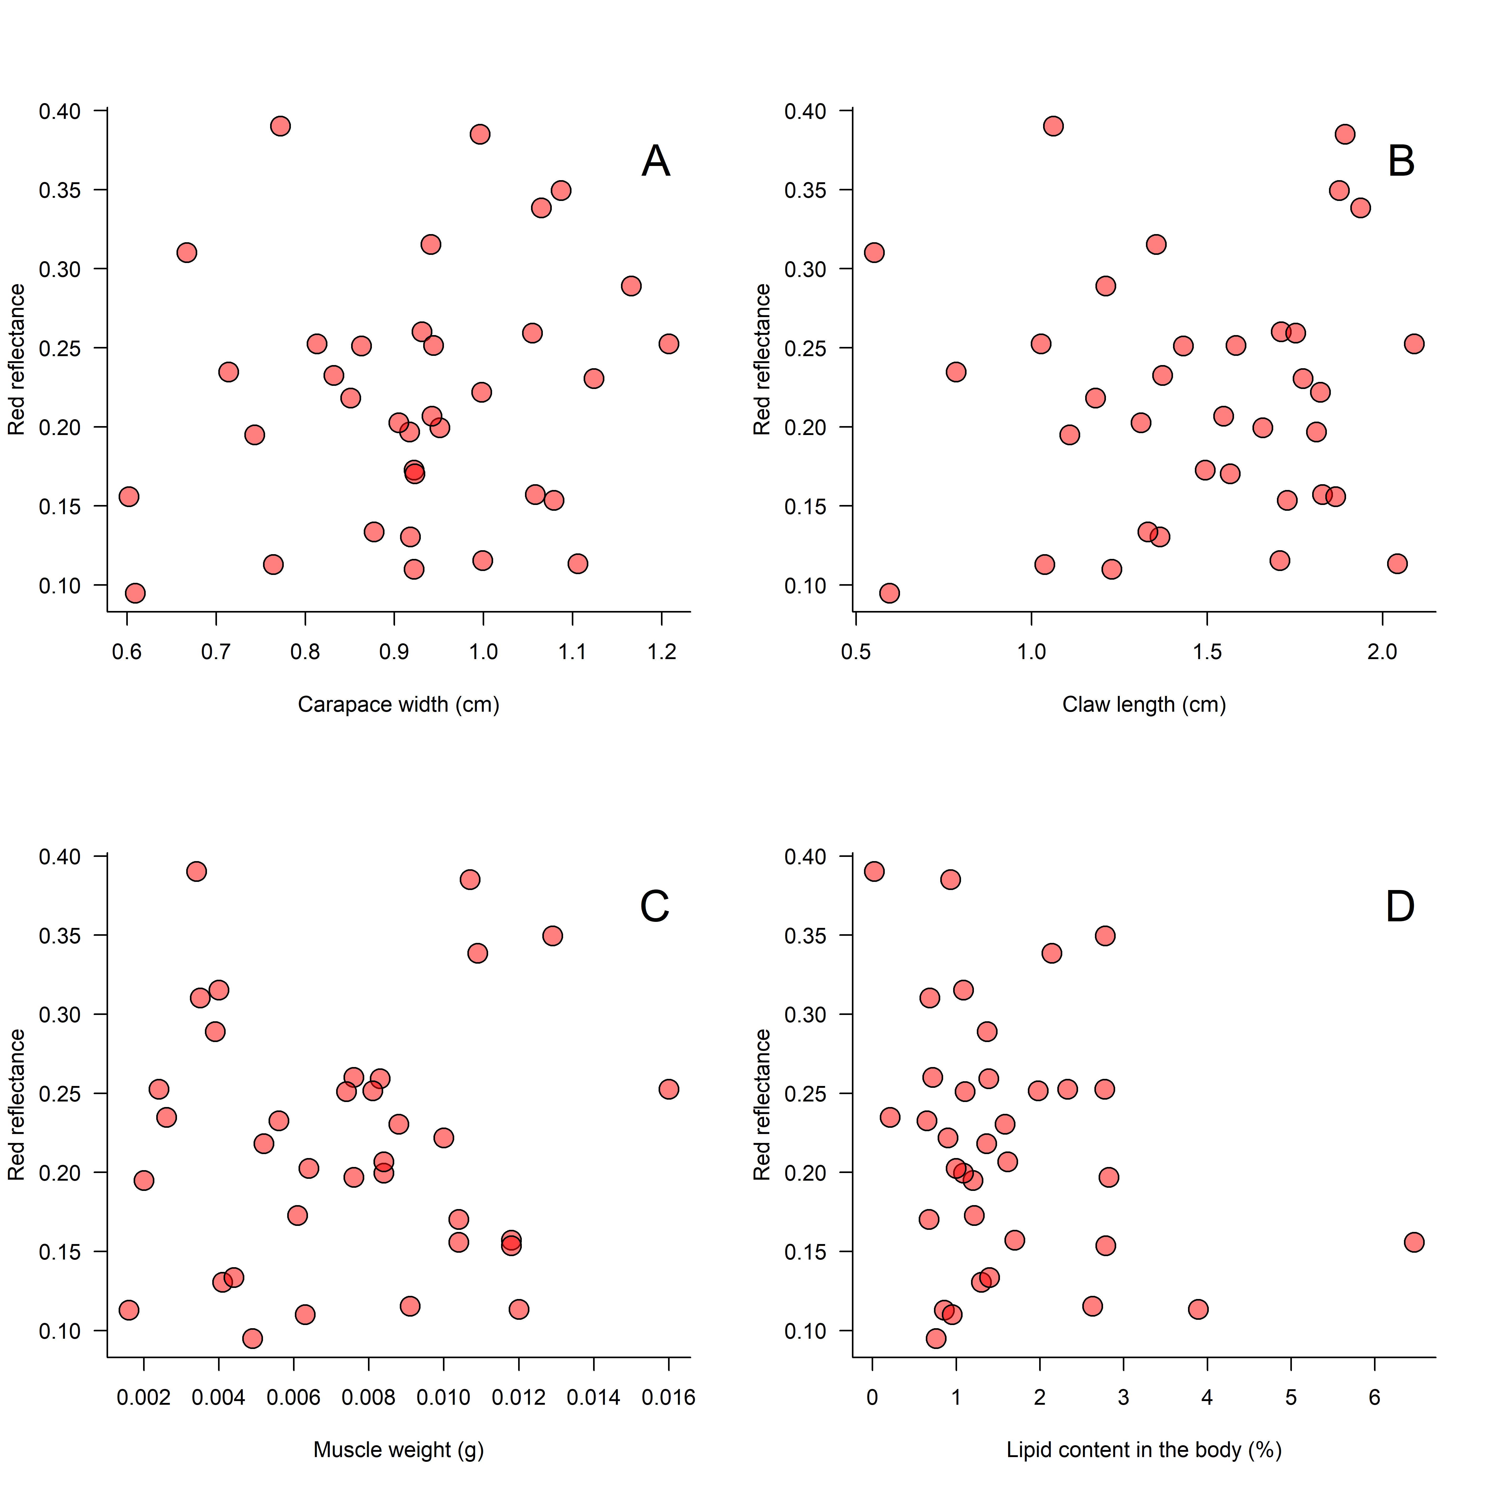

**Figure S1.** The relationship between reflectance within the red channel and A) carapace width, B) claw length, C) claw muscle weight, and D) lipid content in the body. There was no significant relationship between these variables. All figures represent data from 39 *Leptuca uruguayensis* males. Since none of the correlations were significant, we did not draw tendency lines.

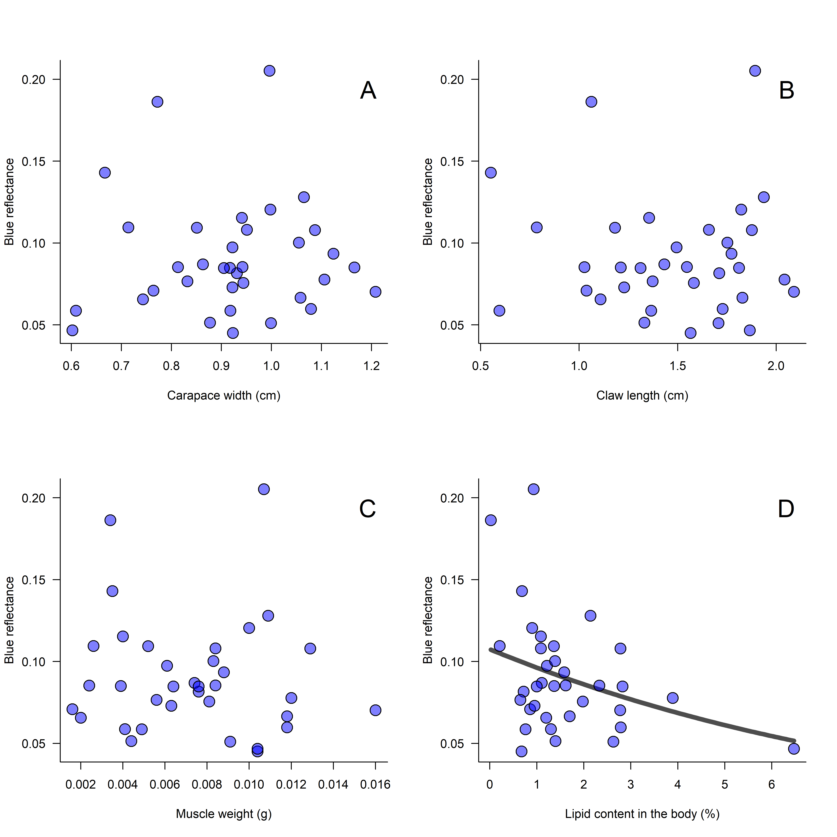

**Figure S2.** The relationship between reflectance within the blue channel and A) carapace width, B) claw length, C) claw muscle weight, and D) lipid content in the body. The solid line represents the significant correlation between lipid content and blue reflectance using a beta regression (hence the non-linearity of the curve). There was no significant relationship between these variables aside from a significant negative relationship in D). All figures represent data from 39 *Leptuca uruguayensis* males.

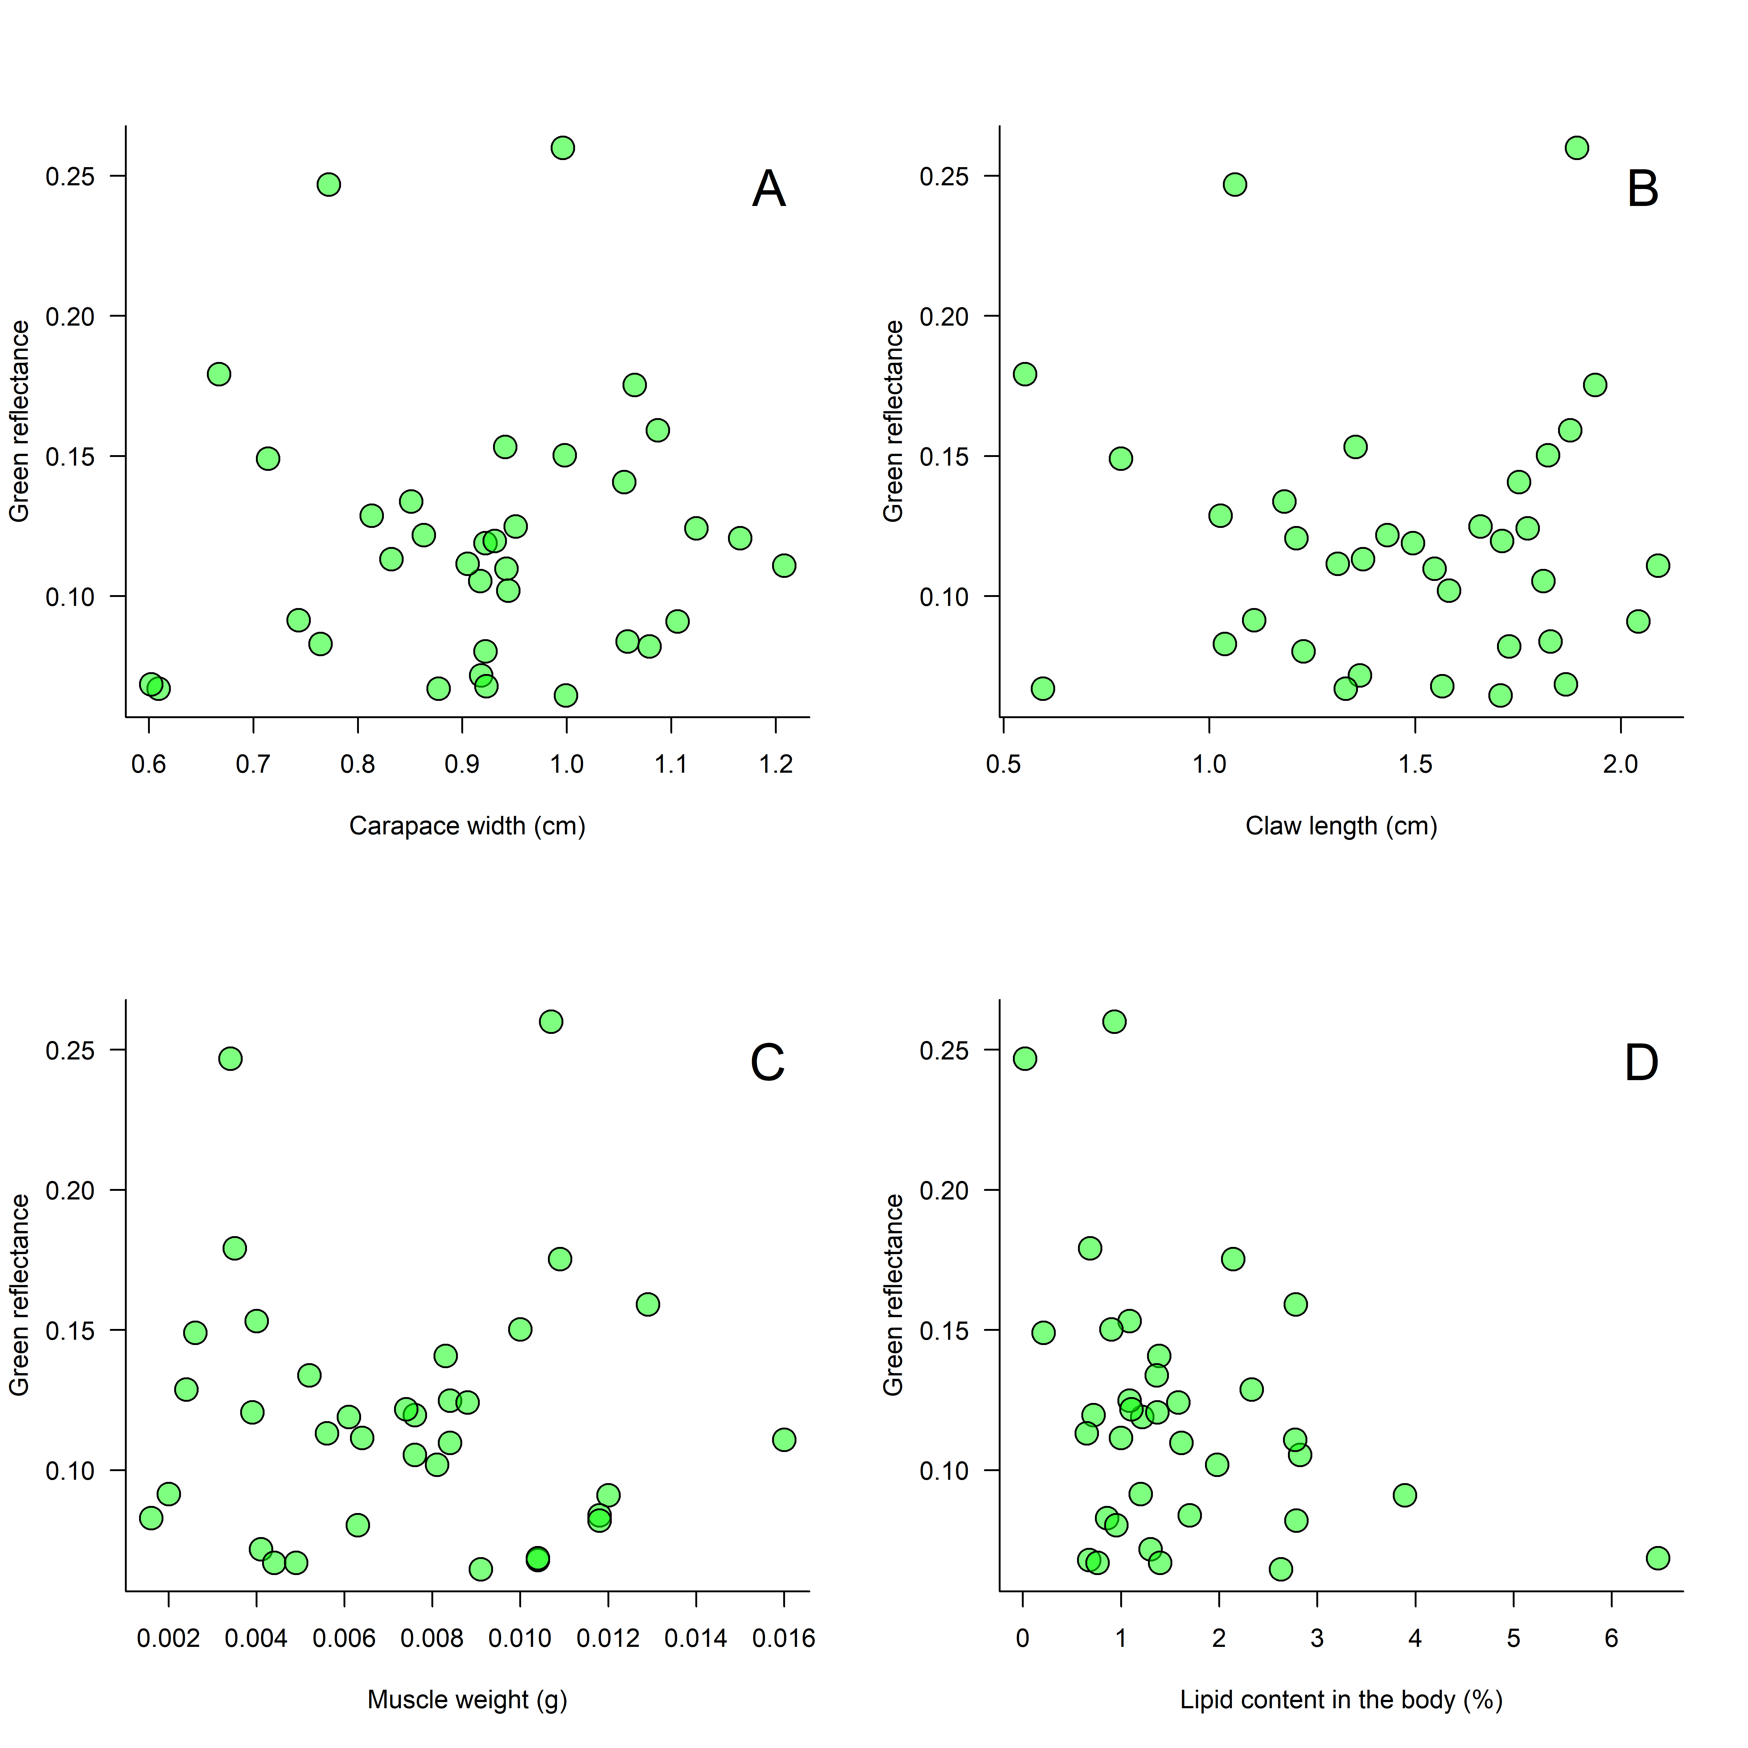

**Figure S3.** The relationship between reflectance within the green channel and A) carapace width, B) claw length, C) claw muscle weight, and D) lipid content in the body. There was no significant relationship between these variables. All figures represent data from 39 *Leptuca uruguayensis* males. Since none of the correlations were significant, we did not draw tendency lines.