**ECE 5332-011: Deep Learning for Medical Signal/Image data**

Algorithm for part 3:

The classification task in part 3 is a bit different from conventional machine learning based classification process. In conventional machine learning based approach we use some kind of iterative process to train a model and then test it on previously unseen data. Here the term ‘training’ and ‘testing’ are a bit different. In the training process we gather information; image features; from all training data and then use it to classify the test data.

For the dataset, we have 10 objects and 24 projection images for each object.

K = 10; total number of objects and N = 24; total number of projection images.

Moreover, the number of training images is given by Nt and the number of strongest features used per image is Ns.

Nt = {5,10,15,20} and Ns = {2,4,8,16}

The simplified algorithm can be summarized as below:

First, divide the dataset into training and test set based on Nt. You can either do this manually or automate the process using some random indexing.

Second, obtain the Training Feature Matrix for each object. The flowchart for that is shown in figure 1. We would call it the TRAINING BLOCK.

Third, for the testing phase, we compare features from each test image with all Training Feature Matrix and classify it to the object having the largest number of matched feature. The flowchart for that is shown in figure 2. We’ll call it TESTING BLOCK. After testing is done for all test images, compute accuracy by the formula given in equation 1.

Lastly, repeat the process for all possible combination of Nt and Ns and finally plot the accuracy curve. Figure 3 shows the overall algorithm and figure 4 shows a sample accuracy plot.

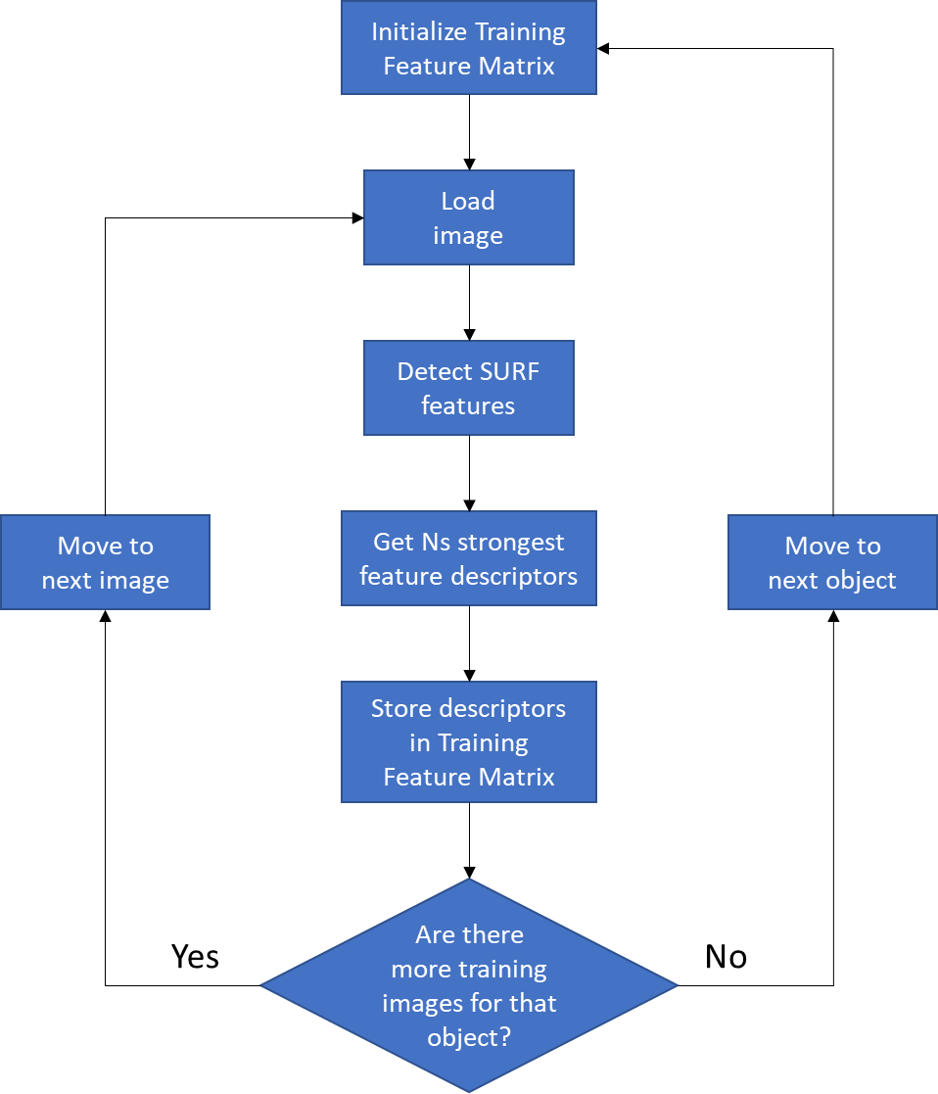

Figure 1: TRAINING BLOCK

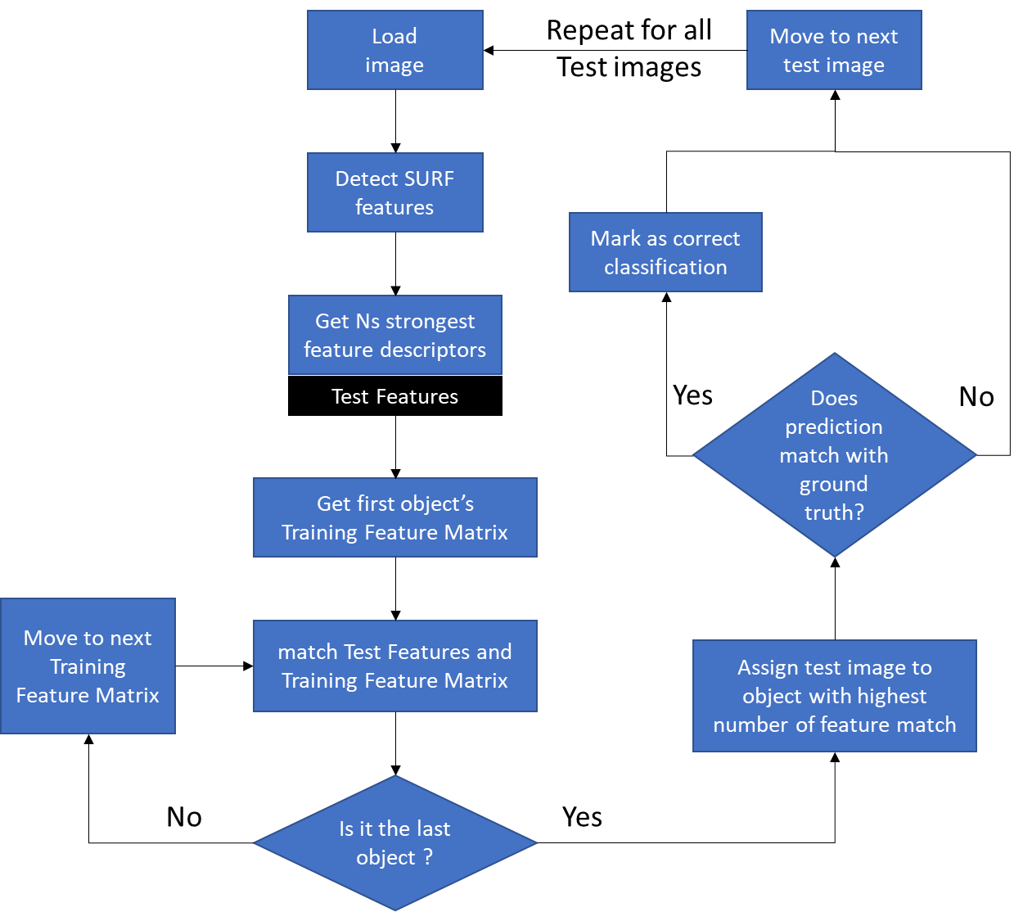

Figure 2: TESTING BLOCK

Accuracy (%) = $\frac{Number of correctly classified Test Images}{Total number of Test Images}$ x 100

…. Eq (1)

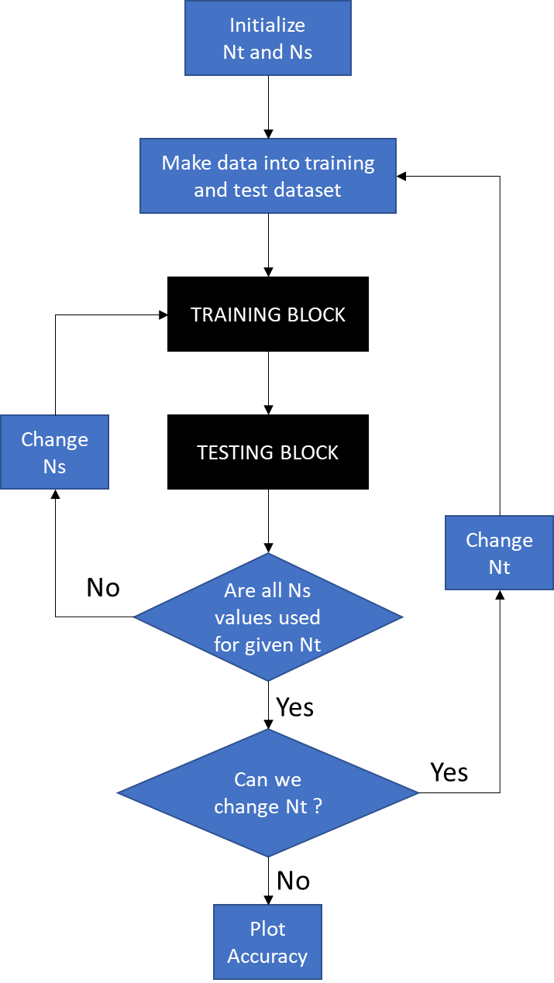

Figure 3: Full algorithm



Figure 4: Sample accuracy curve