ECE 5332-011: Deep Learning for Medical/Image data

1. Basic Image processing:
2. From the MATLAB image dataset, we were able to load the image onion.png to obtain RGB display.

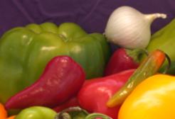

Figure 1: RGB Onion.png

This image in figure 1 was converted to gray scale using rgb2gray syntax

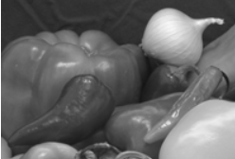

Figure 2: onion_gray.png

1. Introduction to the 2D Fourier space

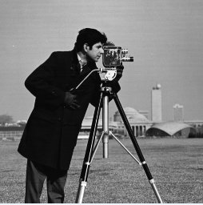We were able to load the image ‘cameraman.tif’ from the MATLAB image database and the image was transformed using Fourier transform to a 2D image.

Figure 3: 2D Fourier

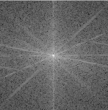With the aid of fftshift() function, the image can be positioned at the center. Also, with the aid of the logarithmic intensity transform, the image was made in a 2D Fourier space.

Figure 4: 2D Fourier Space

The cameraman image was reconstructed using the masked Fourier space images into two binary masks, low pass masks and high pass masks using fixed radius of 5, 10 and 25. It was observed that the more the radius for the high pass, the more blurred and darker the image and its environment appear unlike the low pass where the reverse was the case. When a high pass filter was applied, the image and its environment appear even darker and blurred. However, the low pass filter corrects the effect of the high pass filter and restore the image to its original form.

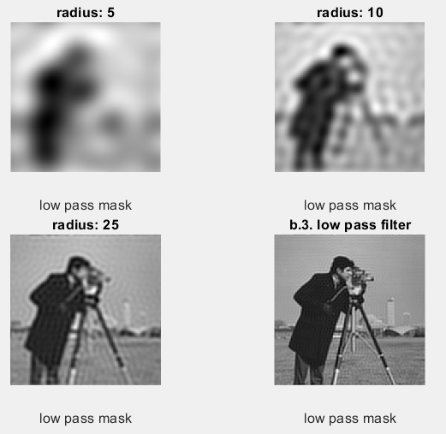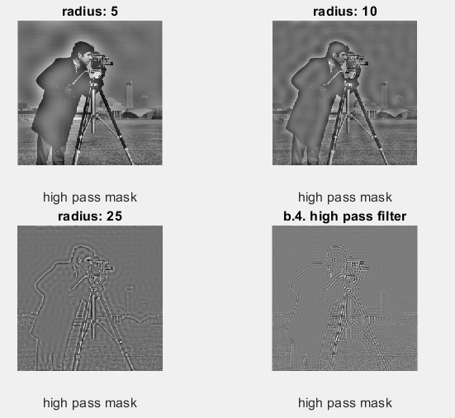

Figure 5: Display of the low and high pass masks with different radius.

1. We applied the 2D convolutions to obtain different transformations to the image. The testing was done on a coins.png image using 3x3 Sobel kernel to obtain the gradient it was observed that the image appears blurred ad darker.
2. and the outcome was passed through a spatial low pass kernel (integrator) and a high pass kernel.