**Texas Tech University**

**ECE 5342 - Deep Learning, Dr. Sunanda Mitra and Harshit Parmar**

Alexandre S. Silva, Rishi Das, Jud Wizee

**1. The Perceptron Algorithm**

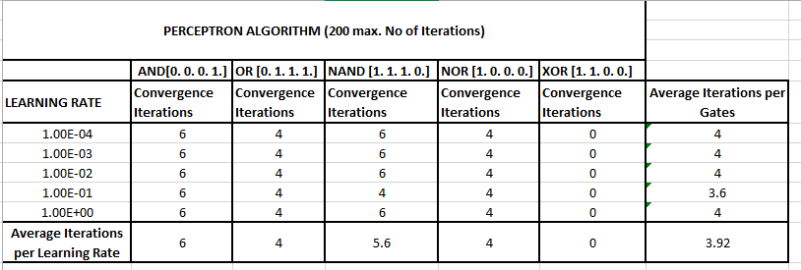

From the table above, it is obvious that the XOR gate do not converge. Therefore, XOR gate cannot be implemented using this approach.

**Reason:**

The output of a perceptron is a linear combination of its inputs. Hence, it can classify input-output space only if you can fit a line between the two or more classes. However, this is not true with the XOR problem, which is non-linearly separable.

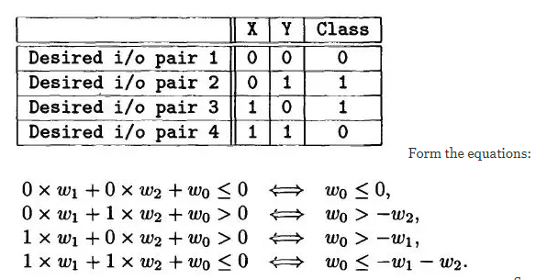

If Wo is greater than –W2 AND –W1 then the fourth equation is not realizable since it is self-contradictory. Therefore, XOR cannot be predicted using the linear learner perceptron.

**2.a. 2-bit logic gates**.

5 different neural networks (NN) were trained to predict the logic gate AND, OR, NAND, NOR, XOR. By using backpropagation and gradient descent to minimize cost of a mean square loss function and to update the NN’s weights, the NN.

The results can be seen below:

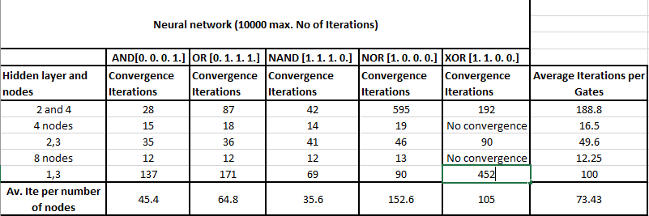

The neural network was tested with different number of hidden layers and different number of units within each layer. The results were validated by matching prediction and target, with prediction being rounded for the matching process. Printing the cost function during iterations, along with a measure of accuracy, was also used to verify that the NN was converging. With one layer of nodes, it was not possible to converge to a correct XOR prediction. However, with the addition of another hidden layer, within a few iterations the NN converges to the correct prediction.

**2.a. BONUS CREDIT**

The previous NN required a modification to predict this function. Instead of outputting at its last layer the two probabilities of 0 or 1 – which requires normalizing the sigmoid output to sum up to one – both of this NN’s outputs can have 0’s or 1’s. The network details can be seen on the next page:

**NN ============================**

no. inputs (layer 1): 2

layer 2: 32 units

layer 3: 64 units

layer 4: 32 units

output layer (5): 2

learnable weights: 4224

max epochs: 10,000,000

learning rate(rho): 0.3

And the convergence data:

converged: **True**

no. of iterations to converge: **17**

max iterations set: **10,000,000**

learning rate: **0.3**

matches with target: **True**

prediction:

[[0. 0.]

[1. 0.]

[1. 0.]

[0. 1.]]

**2. b and c. Classification of Iris dataset**

We were required to train a model to classify Fisher’s iris dataset, where the input data were 4 measurement and the output were classification of 3 categories of flowers. We used the same cost function and we defined our initial weight biases with number of features, hidden units and number of outputs. We used the same forward and back propagation functions (which were written for arbitrary numbers of layers/units) to train and predict functions. Selecting random train samples with parameters, the algorithm is trained based on a slice of data for train and the remaining data were used for testing purposes. The iris flower classifications were setosa, versicolor, and virginica. Finally, we trained the NN and fed train_package variable to a prediction function. A learning rate of 0.1 was used for the purpose with a maximum 5000 epochs.

In our observations, one additional small layer has not required more iterations to train than with one layer.

**2b data**

train/test samples: **50/100**

* NN ************************************

no. inputs (layer 1): **4**

layer 2: **2 units**

output layer (3): **3**

learnable weights: **14**

max epochs: **5,000**

learning rate(rho): **0.1**

Start/final Cost: **6.059387/0.723772**

Train start/final accuracy(50 train samples): **2.00/96.00**

Test accuracy(100 test samples): **85.00%**

Time Taken: **5.620442867279053 seconds**

train/test samples: **75/7**5

* NN ************************************

no. inputs (layer 1): **4**

layer 2: **2 units**

output layer (3): **3**

learnable weights: **14**

max epochs: **5,000**

learning rate(rho): **0.1**

Start/final Cost: **9.394372/1.823107**

Train start/final accuracy(75 train samples): **1.33/74.67**

Test accuracy(75 test samples): **57.33%**

Time Taken: **5.262930870056152 seconds**

train/test samples: **100/50**

* NN ************************************

no. inputs (layer 1): **4**

layer 2: **2 units**

output layer (3): **3**

learnable weights: **14**

max epochs: **5,000**

learning rate(rho): **0.1**

Start/final Cost: **12.217134/0.923285**

Train start/final accuracy(100 train samples): **0.00/96.00**

Test accuracy(50 test samples): **98.00%**

Time Taken:  **5.195034503936768 seconds**

train/test samples: **125/25**

* NN ************************************

no. inputs (layer 1): **4**

layer 2: **2 units**

output layer (3): **3**

learnable weights: **14**

max epochs: **5,000**

learning rate(rho): **0.1**

Start/final Cost: 15.304454/0.921326

Train start/final accuracy(125 train samples): 1.60/96.80

Test accuracy(25 test samples): **84.00%**

Time Taken:  **5.28982400894165 second**s

**2c data**

train/test samples: **50/100**

* NN ************************************

no. inputs (layer 1): **4**

layer 2: **2 units**

layer 3: **4 units**

output layer (4): **3**

learnable weights: **28**

max epochs: **5,000**

learning rate(rho): **0.1**

Start/final Cost: **5.789398/0.008458**

Train start/final accuracy(50 train samples): **32.00/100.00**

Test accuracy(100 test samples): **86.00%**

Time Taken: **5.363662958145142 seconds**

train/test samples: **75/75**

* NN ************************************

no. inputs (layer 1): **4**

layer 2: **2 units**

layer 3**: 4 units**

output layer (4): **3**

learnable weights: **28**

max epochs: **5,000**

learning rate(rho): **0.1**

Start/final Cost: **8.685021/0.322521**

Train start/final accuracy(75 train samples): **33.33/98.67**

Test accuracy(75 test samples): **94.67%**

Time Taken: **5.396573543548584 seconds**

train/test samples: **100/50**

* NN ************************************

no. inputs (layer 1): **4**

layer 2: **2 units**

layer 3: **4 units**

output layer (4): **3**

learnable weights: **28**

max epochs: **5,000**

learning rate(rho): **0.1**

Start/final Cost: **11.665744/0.308544**

Train start/final accuracy(100 train samples): **32.00/99.00**

Test accuracy(50 test samples): **94.00%**

Time Taken: **5.481348752975464 second**s

train/test samples: **125/25**

* NN ************************************

no. inputs (layer 1): **4**

layer 2: **2 units**

layer 3**: 4 unit**s

output layer (4): **3**

learnable weights: **28**

max epochs: **5,000**

learning rate(rho): **0.1**

Start/final Cost: **14.502462/0.348447**

Train start/final accuracy(125 train samples): **33.60/99.20**

Test accuracy(25 test samples): **84.00%**

Time Taken:  **5.712730646133423 seconds**