DevCamp
Coding Foundations course.
2024, December.

Content extracted and abstracted from:

Module 1.
HTML & CSS
foundations

Module 1. HTML/CSS foundations

Index

- Objectives
- Bottega Support Application Overview
- HTML CSS Course Introduction
- What are HTML and CSS?
- The Website We're Going to Build in the HTML/CSS Course
- Tools We'll Use in the Course and Basic HTML Structure Overview
- How to Install the devCamp VS Code Extension
- Introduction to Using CSS Styles
- How the CSS Cascading Process Works
- Guide to HTML Links
- Working with the div Tag in HTML
- Guide to HTML Classes and IDs
- Introduction to Flexbox
- Guide to Padding in CSS
- Guide to Margin in CSS
- Course Update: New Import for Font Awesome
- Integrating Icons with Font Awesome
- How to Select and Style Child Tag Elements
- Introduction to CSS Grid
- How to Import and Use Custom Fonts in HTML
- How to Import and Style Images in HTML
- Refactoring the CSS Code to Use More Specific Selectors
- Integrating Flexbox Inside of a CSS Grid Container to Align Items
- Introduction to CSS Animations
- Styling the Right Column of the Navigation Bar
- Finalizing the Navigation Bar and Organizing the Style Files to Conform with Development Best Practices
- How to Build a Parallax Scrolling Feature
- Adding Text Overlays On Top of the Parallax Image
- Adding the HTML Structure and Icons for the Feature Section of the Homepage
- How to Create Columns with Animated Hover Effects in CSS
- Working with nth Child Selectors in CSS
- How to Work with Box Shadows in CSS
- How to Embed a Google Map into a Website
- Building the Footer's HTML Structure
- Controlling the Flex Direction to Layout the Footer Styles
- How to Apply Filters and Control an Image's Opacity with CSS
- Finalizing the Footer Styles
- Building the HTML Structure for the About Page Header
- How to Skew Images in CSS
- Using the CSS Float Property to Have Text Flow Around an Image
- Building the Square Grid HTML Structure
- Creating a Two Column Layout with CSS Grid and Flexbox
- Finalizing the About Page Styles and Review of Code Organization Best Practices
- Populating the Menu Page with the Two Column Grid
- Guide to HTML Bullet Point and Numbered Lists
- How to Implement Anchor Tags in HTML
- Overview of the Before and After Pseudo Selectors in CSS
- Creating the Initial Structure for the Contact Page
- Building the Contact Page Layout with CSS Grid
- Introduction to HTML Form Elements
- How to Style Text Inputs with CSS
- Styling the Form Textarea and Button
- Building the Label and Form Element Drop Shadow Styles
- Integrating Custom Form Placeholder Text Styles
- How to Animate Form Labels
- Finalizing Contact Page Styles
- Introduction to CSS Media Queries
- Finalizing the Homepage Responsive Styles
- Implementing Responsive Styles to the Square Grid, Image Skew, and Form Elements
- HTML Concept Quiz
- CSS Concept Quiz

1.1 Objectives

During this section of the coursework, the following objectives will be met. You will learn to:

Take advantage of these other development skills resources:

● Identify tools used to program websites.

● Describe basic HTML Website Structure

● Use HTML tags such as head tag, div tag, span tag, etc.

● Utilize HTML IDs and Classes

● Integrate HTML tables, forms, text input, checkboxes, radio buttons, etc.

● Implement Inline and Embedded CSS styles

● Use CSS best practices with style sheets

● Utilize CSS selectors.

● Incorporate CSS animations, borders, and styling of tables.

Please make sure you are Coding Along with the videos. A few guides from now you will start building out a website in HTML. You need to be coding along with the Instructor, creating the website on your own computer as the instructor creates it on theirs. To do this, you will need a text editor. You can use any text editor that you like, but for beginners we recommend Visual Studio Code. Other text editors you might want to use are Atom and Sublime.
If you are having any trouble as you code along, please reach out on the Support App. We have a team of Mentors who will be able to answer any questions and help you debug your code.
When you are done with this section, you will need to reach out with a ticket and have the Devcamp Fries Website passed off.
Visual Studio https://code.visualstudio.com/
Sublime https://www.sublimetext.com/3
Atom https://atom.io/

3.2 Bottega Support Application Overview

Blank.

1.3 HTML CSS Course Introduction

Welcome to this HTML-CSS Bootcamp course, where you are going to learn how to build a real-world website, and along the way, you're going to be able to learn all about HTML and CSS.

My name is Jordan Hudgens, and I'll be your instructor throughout the course material. I'm currently the lead instructor and CTO of the Bottega Code School.

In addition to the work I do with Bottega, throughout the past 15 years, I've been building out web applications for companies like Eventbrite and Quip.
In this course, you're going to learn all of the key skills that you're going to need in order to start building out professional websites.
Some of the skills that you're going to learn are going to be HTML5, CSS3, Flexbox, CSS Grid, how to build animations, how to work with navigation, fonts, and also how to integrate images directly into your websites.
As we go through the course material, you'll notice that I'm going to teach you my own process that I use whenever I'm building out a website.
My goal for this entire course isn't just to teach you how to build a single website, but instead my goal is to be able to leverage this project build that we're going to put together, teach you the fundamentals as we implement every single feature, and then by the end of it, you're not just going to be able to build the single website and follow along with what I do, but you'll be able to build any type of website.
There are no technical prerequisites for going through this course. This is the perfect course to go through if you want to learn how to build websites completely from scratch.
The ideal student is someone who is dedicated, wants to learn, and also wants to learn how to build websites using the most modern and up to date technologies. So, thank you for spending the time and going through this material, and good luck with the coding.

1.4 What are HTML and CSS ?
This guide will discuss the concept of cramming vs consistent study. And don’t change the channel if you’re not in school, if you’re a developer or if you want to learn software development… the learning never ends.

What are HTML and CSS? Well, technically they're just tools that you can use, and they're syntaxes you can use that allow you to write code that can be interpreted by browsers. By default, a browser can only interpret and then render on the screen so many different types of code.
For example, if you were to take an Excel spreadsheet or a Word doc and you try to open it up in Google Chrome or in Firefox, it is not going to work. That's because the browser is not capable of taking a file like that and interpreting it into something that it can show on the screen.
HTML and CSS are capable of that. Their goal is to provide a syntax so that when the browser sees it, it can interpret it and then it can show exactly what you're wanting on the screen.
Literally, every web page in the entire world has HTML, and pretty much all of them also have CSS. We're going to talk about the different types of roles that each one of them supports.
HTML stands for hypertext markup language. Now, when you hear the word language, you may think programming language, but that's not quite accurate because it really is just providing you a syntax for writing code so that the browser's able to read it properly.
It's really more of just a markup language, whereas a programming language such as JavaScript or Java or Ruby allows you to have some extra behavior like conditionals and loops and those kinds of concepts.
With HTML, you're simply writing a static page, meaning there's not really a lot of behavior in it. You need to use other languages in order to make that happen.
HTML allows you to wrap a structure around content. If you imagine having some type of blog page, HTML allows for you to designate where the content is, where the title is, or where a video or an ad might be. Then you're able to then organize it and later on, style it.
That's where CSS comes in.
CSS stands for cascading style sheets. The style word in there may indicate it's main primary objective. CSS is in charge of giving style to websites. You're able to take all of that HTML code that you organize and you put on the page.
CSS then goes in, and it adds all of the style elements. This can be anything from colors, to fonts, to animations. Anything that you look at on the page that has a type of style associated with it most likely is coming from CSS.
Let's walk through a real-world analogy that will hopefully help you understand the differences and the specific roles that HTML has compared with CSS.
Imagine that you're building a house. If you're building a house, the HTML is kind of like the foundation and the wood framing and the roof and the sheetrock.
The CSS, on the other hand, is more like the paint and the carpet and any kind of design accent that isn't really associated with the structure, but it is what allows a house to look good.
Now let's take a look at a website and see what happens when you have a website that has HTML and CSS compared with a website that only has HTML.
Right here you can see a fully built out website.
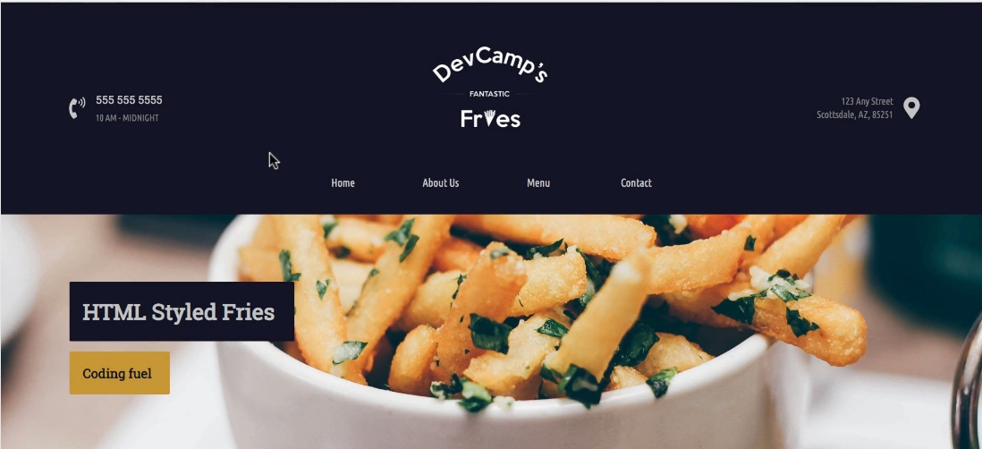
This has everything from a navigation bar, it has a parallax feature with background images, it has animations, it has a map and all of the different elements you'd expect in a website.
This website has HTML and CSS. Now, I duplicated this website, and if you want to take a look at it, what I did is I removed the CSS. I didn't make a single change to the HTML. All I did was I removed the calls that brought in the CSS styles, and this is what you would get.
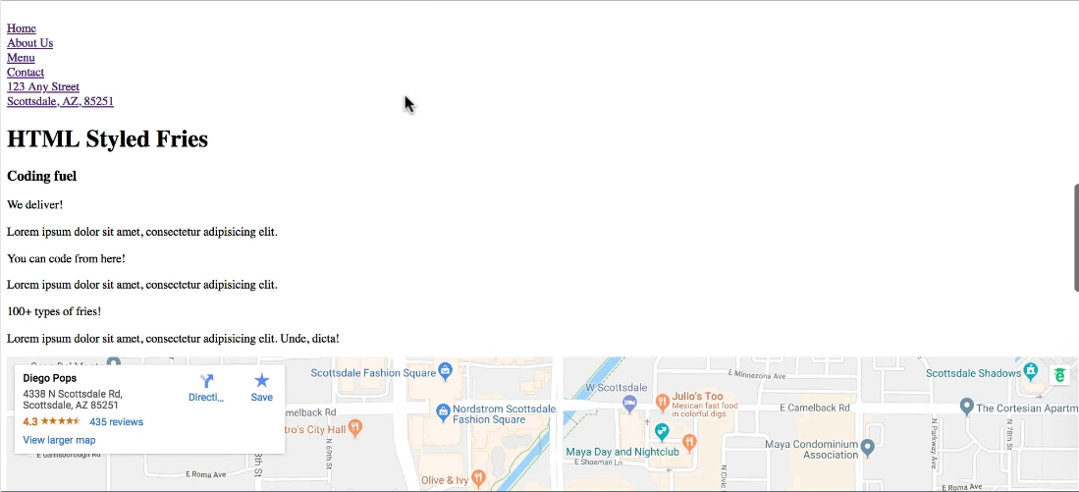
Now, if you scroll through it, it still has all the same content, and it even kept a few elements like the embedded map and some things like that, but because CSS is in charge of adding styles, what we're left with here is just plain HTML.
It has all of the same structure, but because it doesn't have the CSS, it doesn't have any kind of alignment. It doesn't have the colors. It doesn't bring in the background images, and it doesn't align the items in the proper way.
In review, that is a high-level overview of what HTML and CSS are. HTML is a markup language that web browsers are able to look at, and they're able to interpret. They're able to take in content and then show that on the screen.
It provides the structure; whereas, CSS is also a language that you're able to use, and you're able to write in the CSS syntax and then have that applied to the HTML code that you write.

1.5 The Website We're Going to Build in the HTML/CSS Course
As you can see here, we are going to build a restaurant website. By building out this project, you're going to learn all of the key fundamentals around HTML and CSS, and how you can build websites exactly like this using all of the modern tools that are available to you.
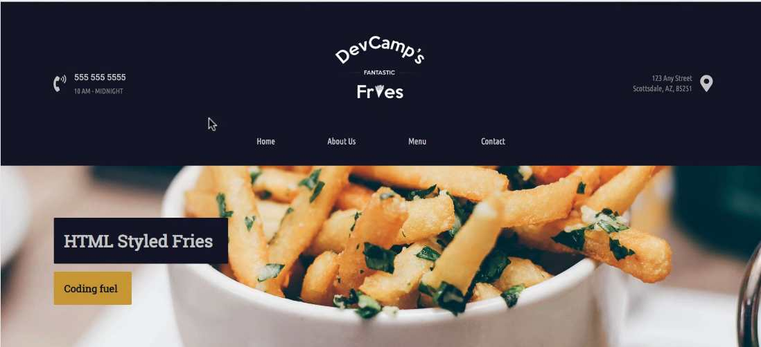
I'm going to take a very high-level approach in this video, and just show you some of the features that you're going to get to build. As you can see, you're going to get to work with images, such as logos and also background images.
You'll be able to work with custom fonts, and learn how you can align every piece of an element on the page using tools that you're going to learn about, like Flexbox and CSS Grid. You're also going to learn how to build a responsive navbar that has different animations.
As you can see right here, as I'm hovering over each one of these elements, we actually are able to change the look and feel, based on the user behavior.
Scrolling down, you'll see that not only are you going to get to learn about images, but you'll also get to learn how you can implement features such as parallax scrolling as you can see right here. Where the image stays in the background and the scrolling simply goes past that.
Moving down, you'll learn about grid layouts, and how you can set up different components on the page, like we have right here, along with how you can combine that with animations.

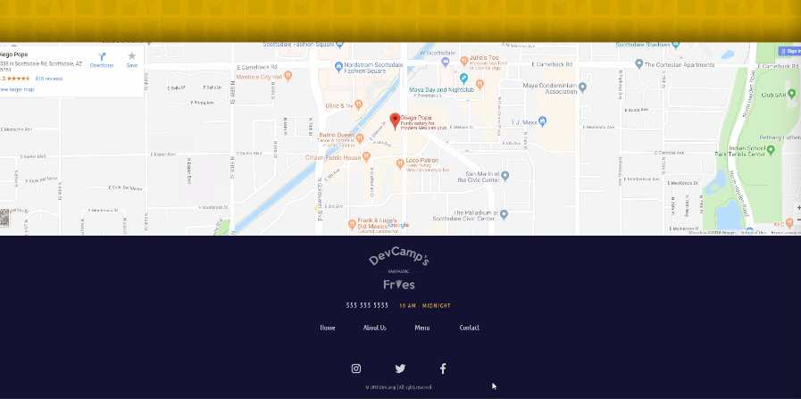
Moving down, you can see that you'll be able to embed and customize a Google Map. This is a map that is fully responsive right here. Where a user is able to click on it and use it, exactly the way that they would use inside of the Maps application.

Then we're going to build a footer on the bottom that can combine images, different styles, another nav bar, and then links to social media. Right here, you're going to be able to learn how to work with Font Awesome, which is a great way of integrating different icons directly into your application.
Now, you'll also learn how you're able to implement links for navigation. Right here, if I click on the About Us section, you can see I'm taken to the About Us page, and then the menu, and then the contact.
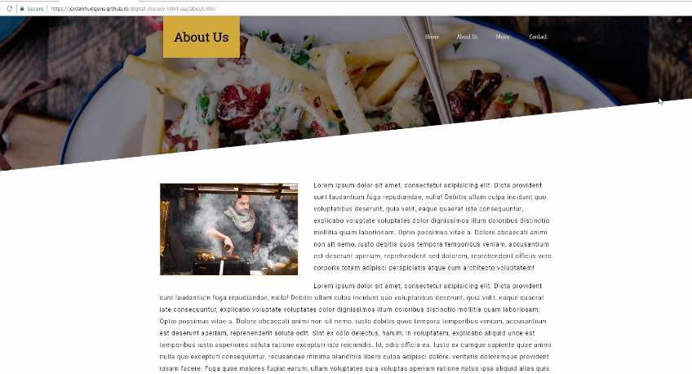
Now, if you come back to any of these pages, you'll see that you'll learn how to build a completely different layout than the homepage.
You're also going to learn some more advanced techniques, such as how to build these kinds of designs, how you're able to implement a tool called clip-path, where you're able to implement a look and feel that is much more modern. These designs are the exact same type of designs that a professional developer needs to learn how to implement.
Moving down, you'll see how you can integrate images directly into content. Then you can also see how you're able to set images right next to other styled content, such as headings and paragraphs.
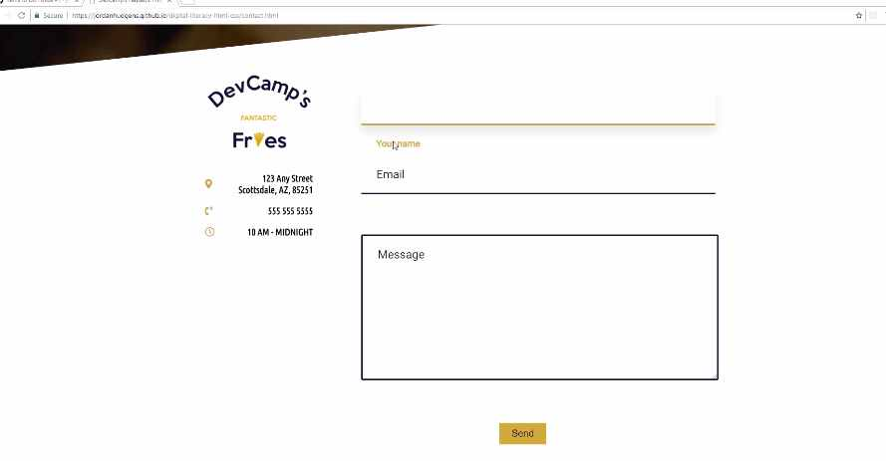
You can do that on multiple pages, and it's going to give you the ability to take any kind of program that you need to build out, any type of interface that you need to implement and be able to do that.
Moving to the last page we're going to build four pages throughout this application, you can see that we're also going to learn how to build a modern-looking form. Right here, you can see we have a contact form we're going to build.

If you click on that, you'll see that we even are going to be able to use animations like we're doing here, on each one of the elements, along with building out a custom button with custom actions, such as being able to add drop shadows and various animations like that.
All in all, this is going to be a very comprehensive course that is going to teach you HTML, CSS, and how you can use all of the modern tools associated with them. Right here, you can see that when I was putting this entire course together, I wanted to make sure that this covered all of the various techniques you need in order to build any type of website.
Each one of these features here is what we're going to cover as you go through the material. Now that you know what we're going to build, we're going to get into, in the next guide, some of the tools you're going to need in order to do that.

1.6 Tools We'll Use in the Course and Basic HTML Structure Overview

Now, there are two items that you're going to need no matter what kind of operating system that you're on. The first item is a browser, but since I'm assuming you're watching this video in a browser, I'm assuming you already have that.
Now, the type of browser is also important. I personally prefer and recommend using Google Chrome, and the main reason for that is because Google Chrome offers some great developer tools.
Now, if you've never seen them before, the way that you can test them out is, if you come and right-click on any element on the page, then click on Inspect.
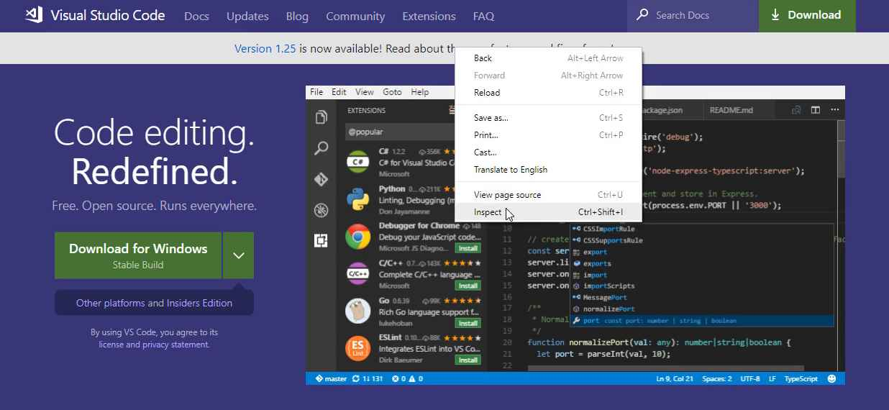
What this does is it brings up the actual HTML and CSS code right here, and you can play with it. You can see that on this Visual Studio code page, it selected this message element, and if I come here on Element Style, I can say, "Color," and then I can change it to red.
Then I could say font size and change it to 2em and you can see that I've actually altered the code right here and I'm able to see what this would look like in a different color and also a different font size.
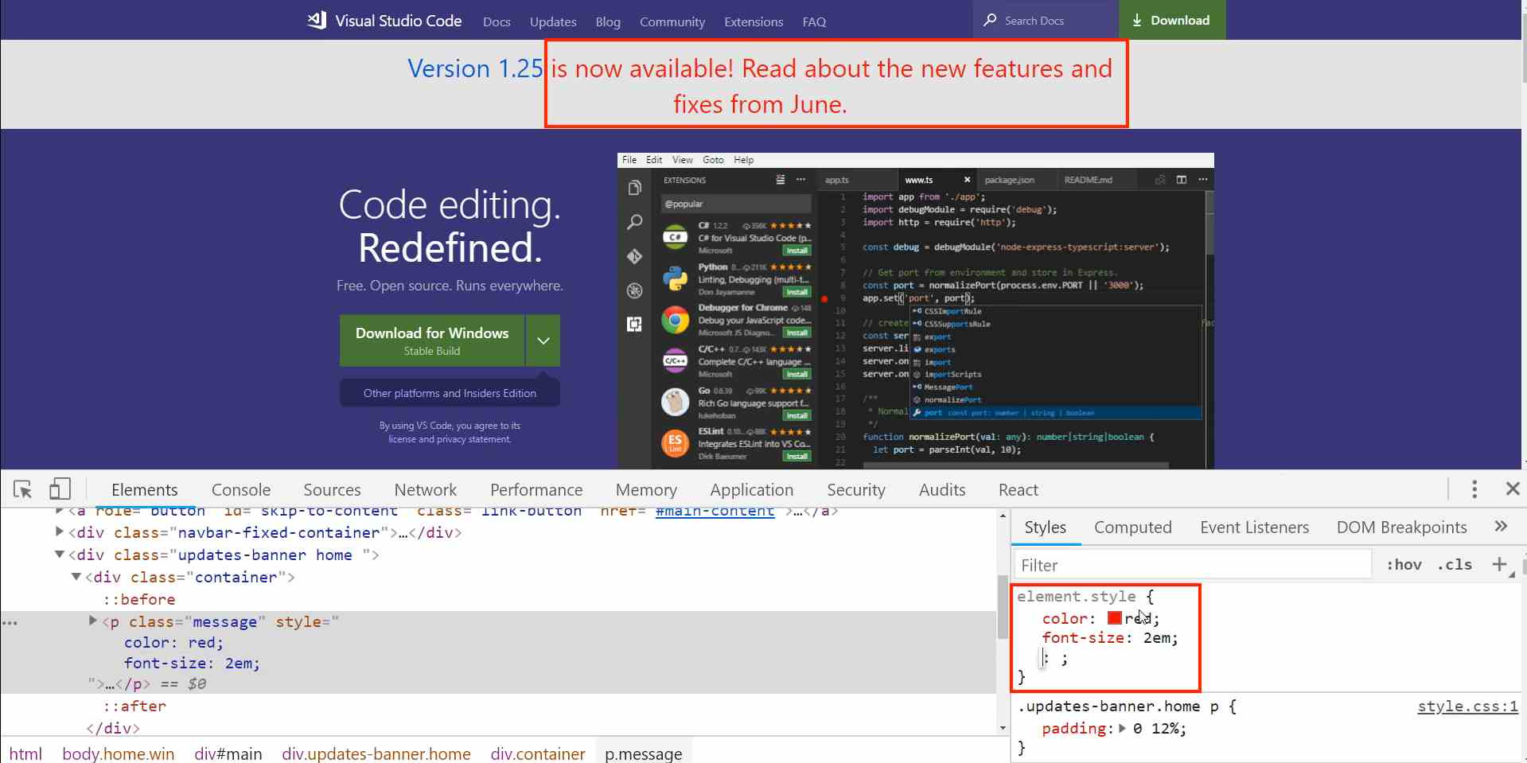
Now, this does not change it on the visual code servers. If I hit refresh, you'll see that it goes back to normal. So what I just did was temporary, but this is very helpful when you're building out websites because it gives you the ability to make small changes and see what happens on the page. So, that's the reason why the browser that you choose is important.
Now the next item that you need is a text editor. There are all kinds of editors on the market. Some are free, some are paid, some are what are called IDE's, which stands for a integrated development environment. What we are going to use is just a very basic one, but it has a lot of features, called Visual Studio Code. It's completely free and it also works great on all the platforms.
So if you're on Mac, Windows or Linux, you can use Visual Studio code. You can get it for free by going to code.visualstudio.com and then just click on the green download button.
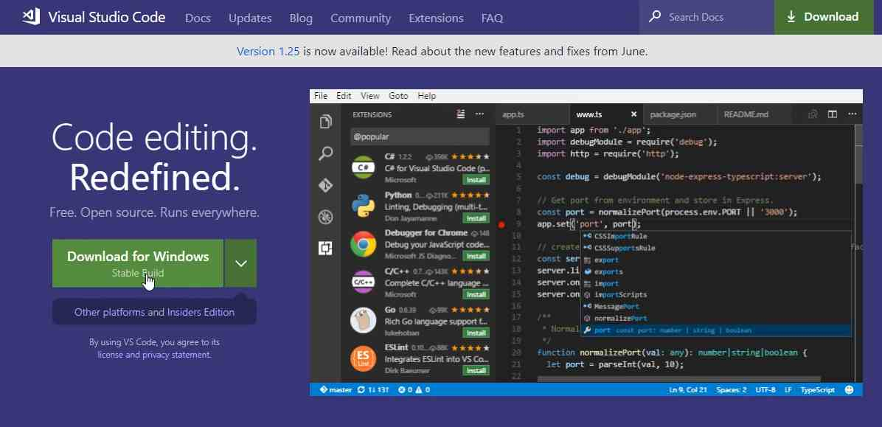
Now, I already have it installed, but all you need to do is click on download. It's going to download on your system and then you can double click that installer, run through and just add all of the defaults, there's nothing special that you need to add.
So just install it on your system and then when you open it up, you should have a program that looks like this.
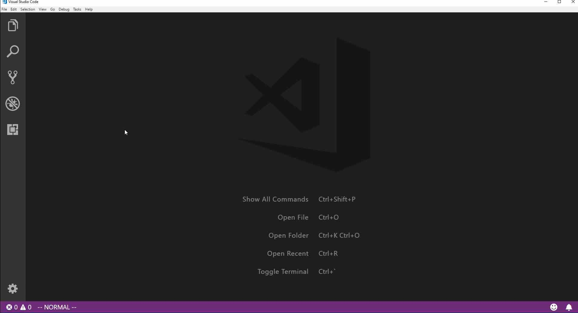
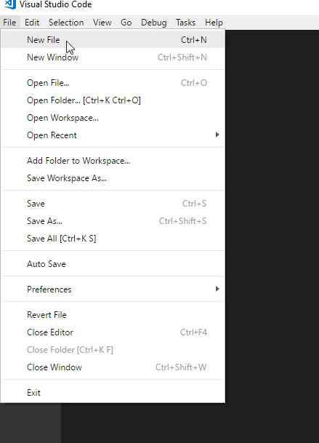
Now, if you're opening that up for the first time, you've never used it before, then there might be some other text and instructions, but you can just ignore those.
Right here, we're just going to create our very first ever HTML document and we're going to see how we're able to open it up in the browser. So the way you can do it is by going to file, new file.

You can also hit control + N, or if you're on Mac, you can hit command + N. Then this is going to bring up a new file. Now, I'm going to hit save, so control + S. You could also go to file and then just go down to save or save as. And I'm going to save this on the desktop, you want to change the entire file name, you don't want this .text.
So I'm going to say index.html. Hit enter and now you can see that Visual Studio Code has actually changed the little icon here so that it's telling you that it understands this is HTML code. If you come down to the bottom right hand side where it says HTML, what this means is that Visual Studio Code is going to give some very helpful syntax highlighting.
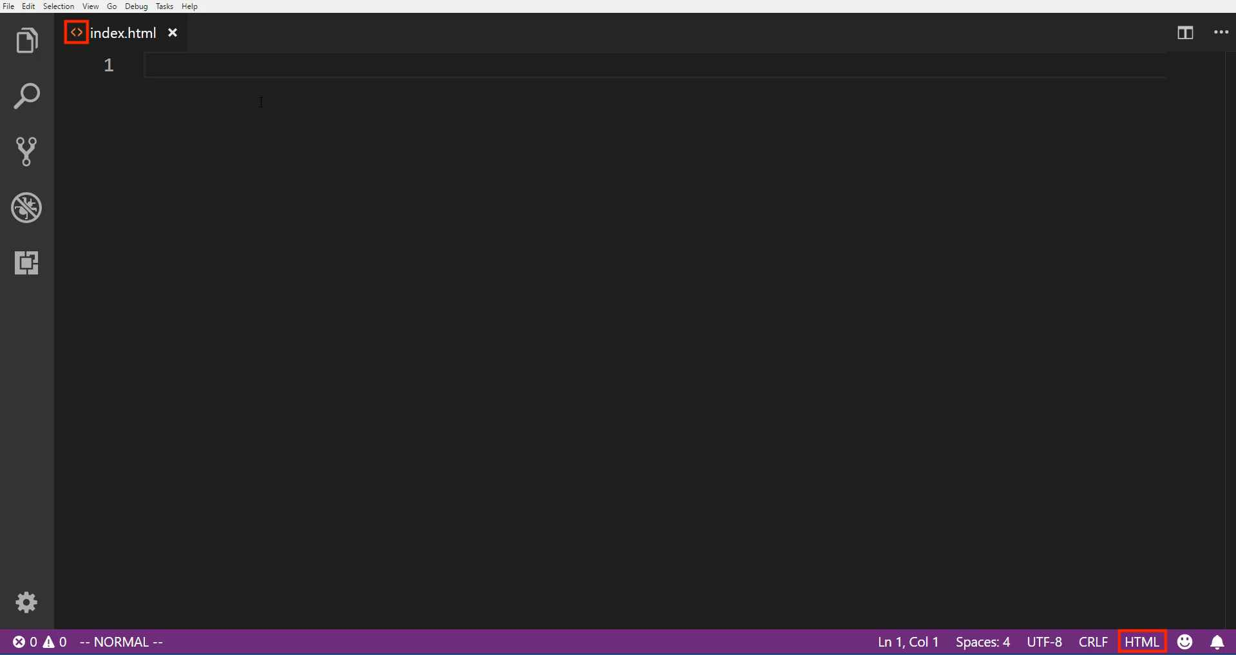
And all that means is that as we're typing, it's going to pick up and give us some ideas for the type of code we want to write and it's going to show some of the different elements with different colors. It's a very helpful thing, especially as you're building out websites.
So I am going to build our very first website here. So I'm going to just say hi there. Now notice I'm not wrapping this in any other code. I'm just typing hi there and I'm going to hit save. Now, if I come back to the browser, I can hit control + o and that is going to open this up. If you're on Mac, it's going to be command + O.
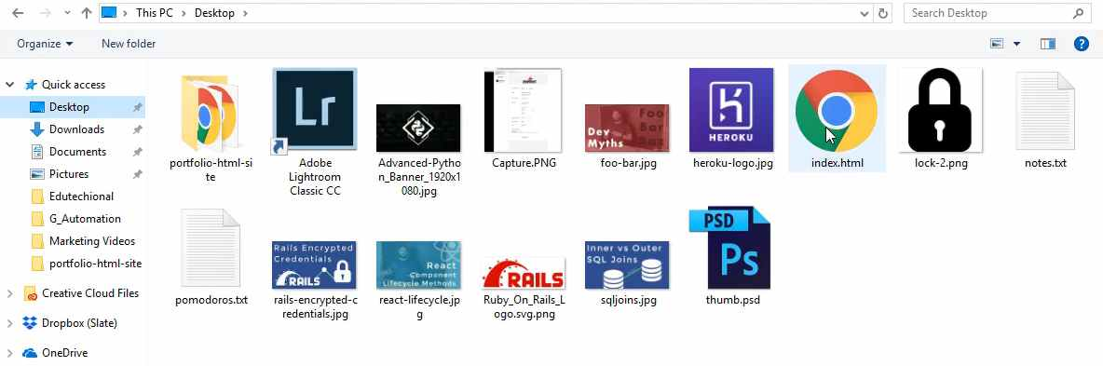
Then go and find that file that we created. So, you can see right here.
I have an index.html file and if I hit open, you can see it says hi there.

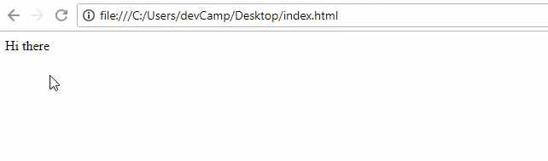

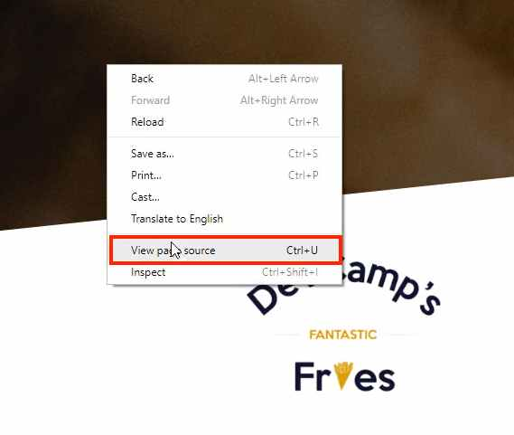
So, we have created our very first web page.

Now, it's not very exciting and there's a little issue with it.
If you come to, let's just go to a demo site right here and click on view page source, you'll see that we have all kinds of code here.
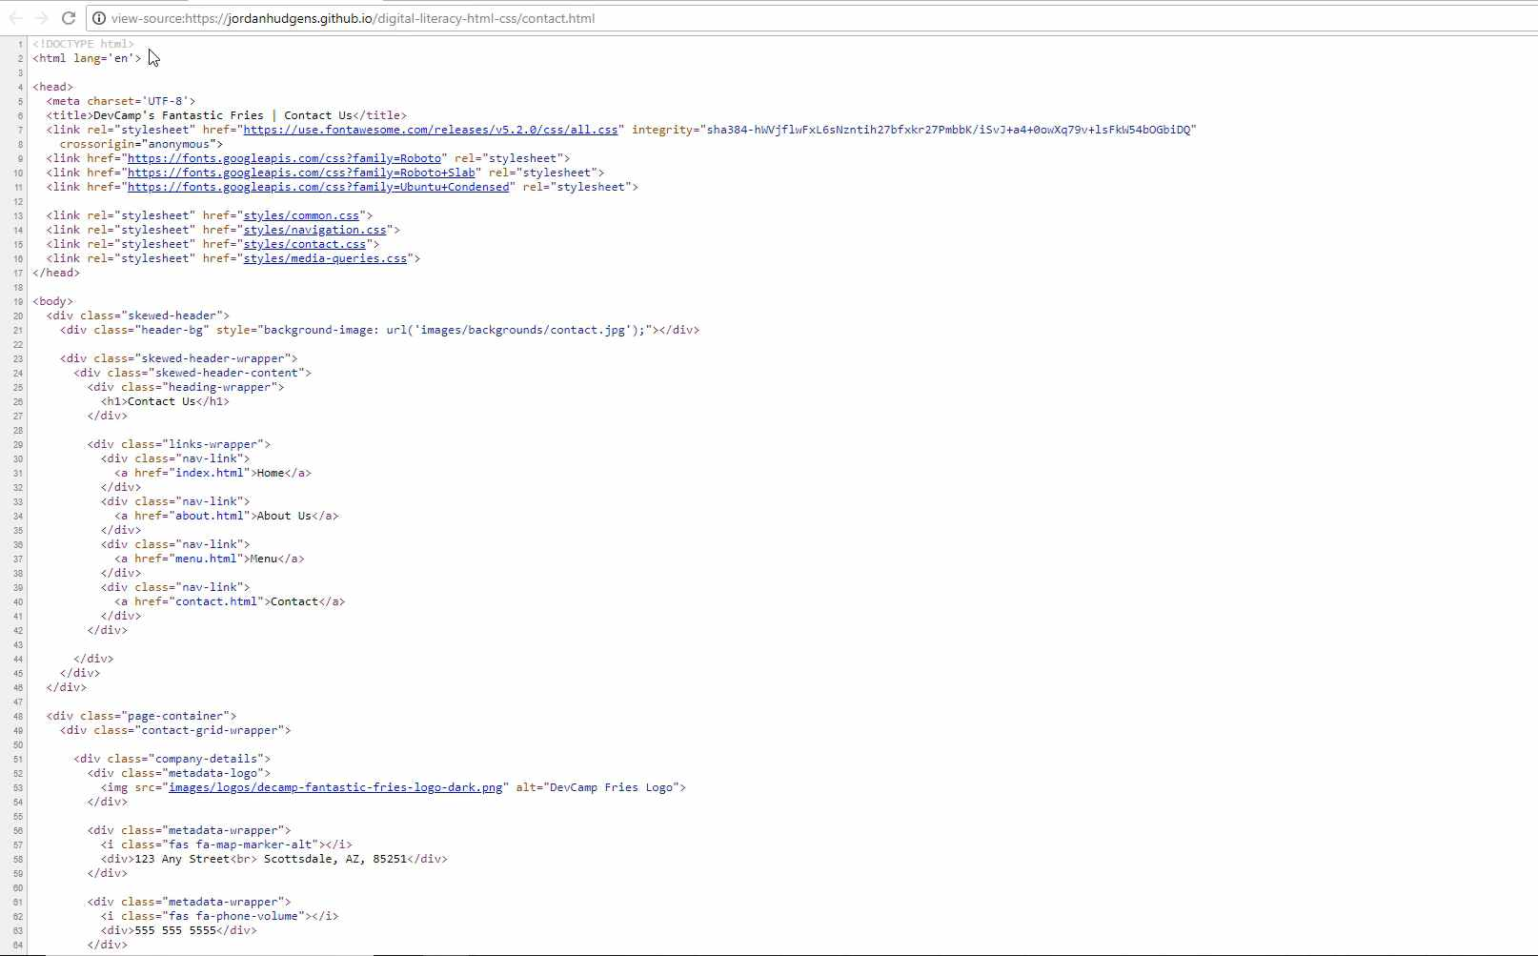
It has all of these different kinds of tags. It starts at the very top where it says DOCTYPE html, then it has all of the code underneath that. Now, that's what is required for this to be valid html, what we wrote is something you can see here, but it's technically not HTML. The browser is just taking a glob of text and it's opening it.
So let's fix this and let's build out our full, fully functional HTML page. So I'm going to get rid of this Hi there and if you're using VS code, it has a very helpful tool built into it called Emmet.
What that does is it gives you some auto complete features. So if you just start typing HTML five. Then what it's going to do is it's going to give us the ability to complete all of that base HTML code that you need. So right here you can see where it says HTML and so what you have here is it's called the simple HTML five starting point.
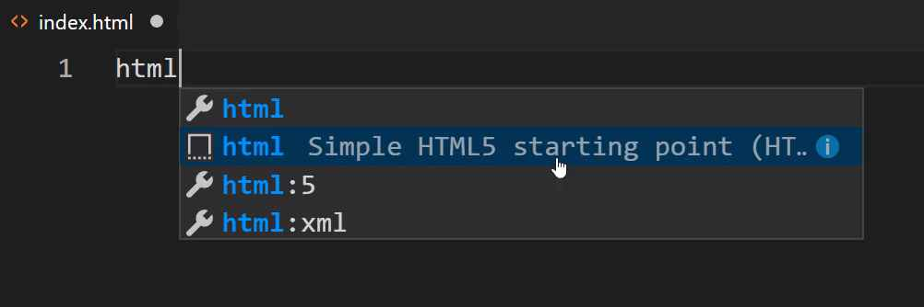
So you should just have to type that in and this little pop up should come up and say okay. Would you like to use the simple HTML starting point? You also have a few other options here. So if you click on HTML:5, it's going to be very similar.
Now, depending on the version of VS Code you have, these might look a little bit different and that really doesn't matter, what I'm doing is just a shortcut. After I click on that, you can see that it gives us all of this code automatically.
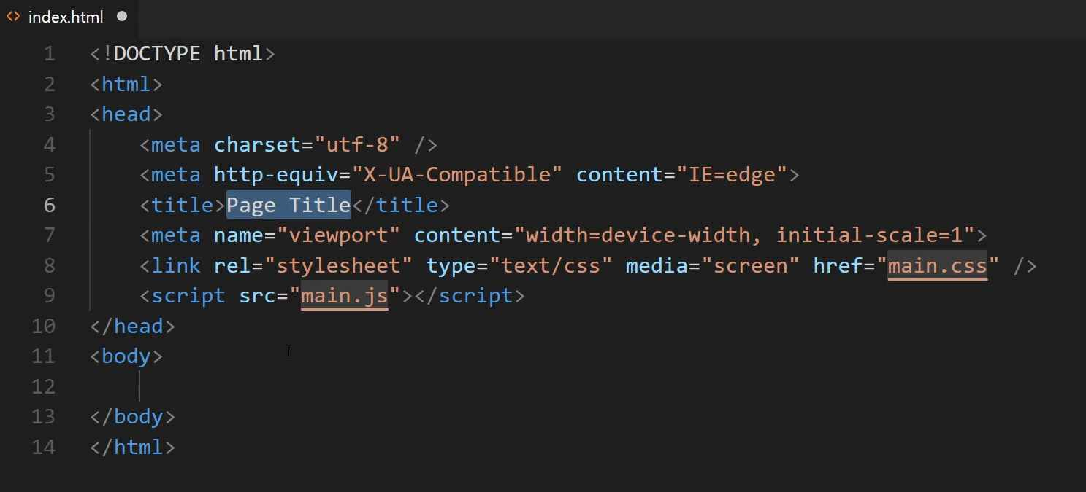
Now, some of this you're not going to need whatsoever, and I'm going to walk through line by line exactly what's needed and what's not. If for some reason you don't have that emmet auto complete, then you can just pause the video right now and then go and type out all of this code. Or you can get it from the show notes.
Now, let's walk through what is happening here because this is very important in understanding HTML and seeing exactly what's on the page. So, at the very top, what we're doing, this is called the declaration. This is a HTML document and we are saying that it is going to use HTML code inside of it. Obviously as you could see earlier, the browser doesn't need it to render the text, but if you are going to be building a web page, this has to be your very first line.
The next one is where we're going to be including all of our HTML code inside. Now, whenever you see these little greater than and less than symbols in HTML, what this means and what it's called is a tag. So you're going to be using tags throughout any type of HTML that you build out, any web pages are all going to use tags. So you have a beginning and then you have what is called a closing tag.
So at the very beginning tag, you can see it's just using the less than symbol then the HTML word and then it closes that off with the greater than symbol. Then everything inside of this, all the way down to the bottom is going to be inside of that tag.
So everything, this head, this body, all these elements, they are what are called nested inside of the HTML. Now whenever you use a closing tag, it's going to look almost identical except you're going to have this slash right in front of it and that's how you know that it's a closing tag.
Now moving down, you can see that inside of the HTML, we have what is called a head tag. And we have the beginning of the tag and then we have the closing tag. Then if you hover over your VS Code gives you a little bit of it's own tutorial.
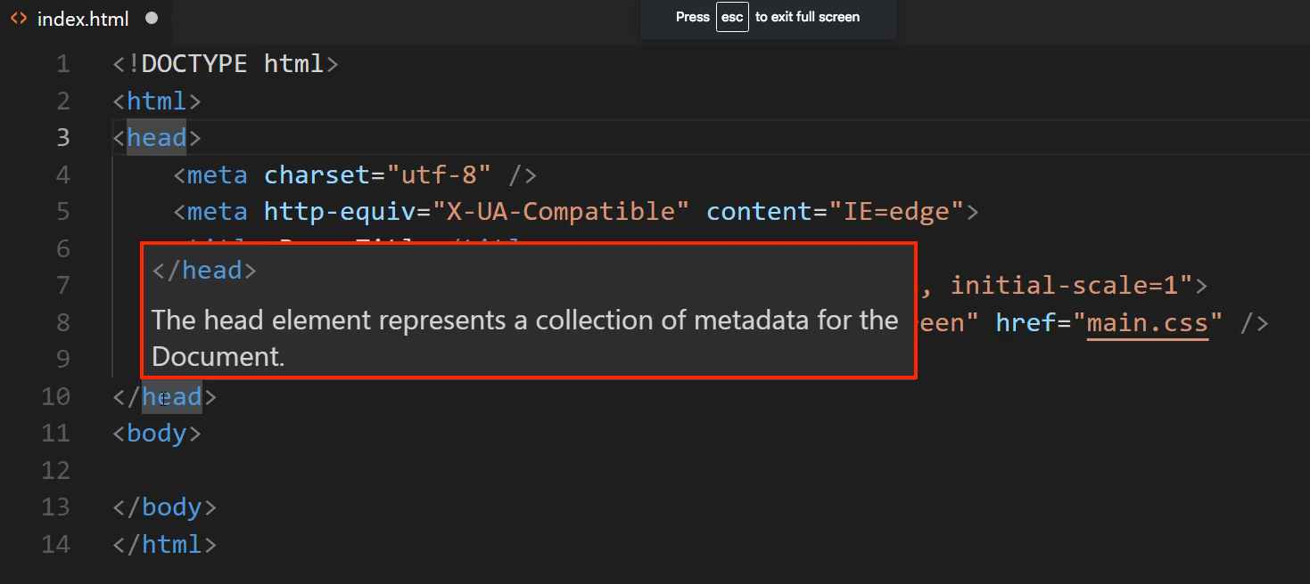
So it says the head element represents a collection of meta data for the document. Now if that sounds weird to you and you don't understand it, don't worry. What that means is that all of the code that is placed inside of your head tag is, it's kind of invisible. It's invisible to the user.
So if you go to a regular website like we have right here,
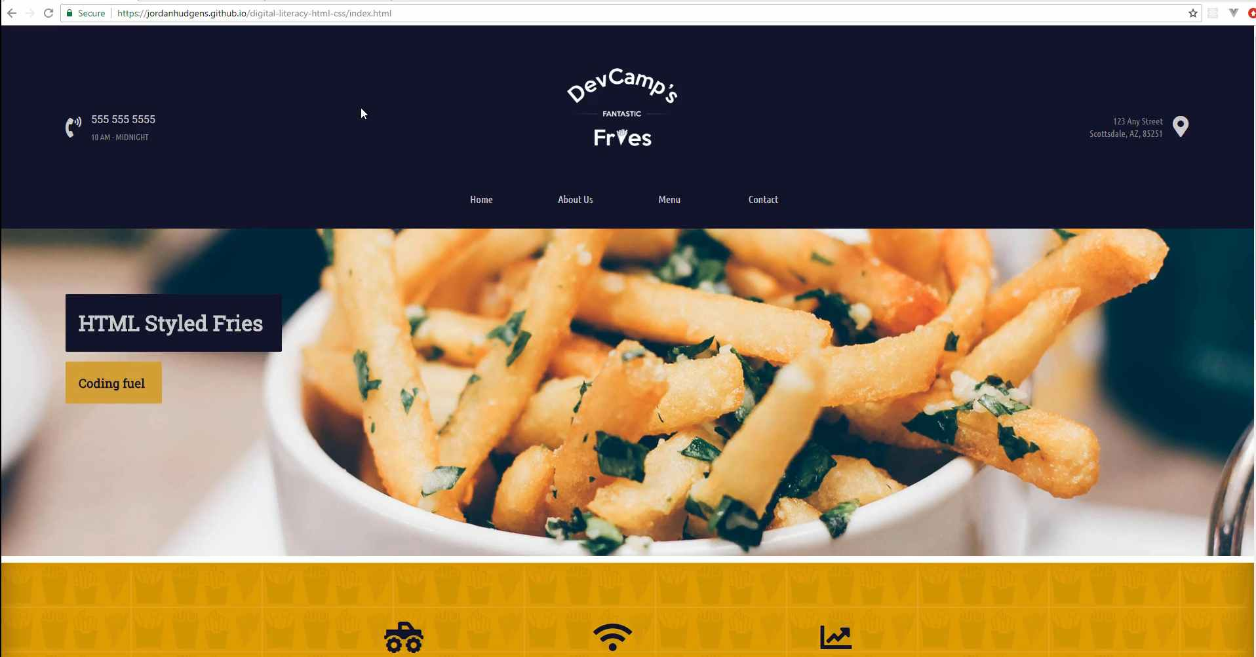
this has a head tag. However, you don't actually see it unless you go and you view the page source and you can see you have your head tag right here.
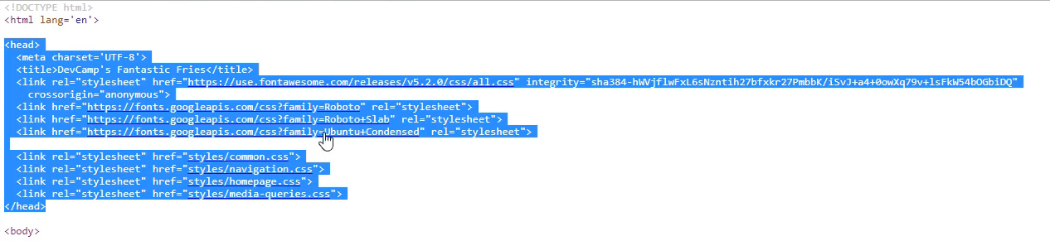

So this does things like gives you the ability to implement custom fonts and it calls your CSS files. So it's a way that you can set up the way the document is going to work, but the users don't actually see it. So that is what you use the head tag for.
Moving down to line four, you see where it says meta and then charset utf-8. What this is, is this is what's called a meta tag and this gives you the ability to define some more information and some rules that you want the document to follow.
So right here what we're saying is that the character set, meaning the content inside of this HTML document, is going to conform to this kind of encoding, utf-8 encoding. So what that means is that you have all kinds of different encoding out there. So if you want to use emojis or if you want to use foreign characters or anything like that, then this is where you're going to define the type of encoding that's used.
I would say that, assuming that you are building websites for a US based audience or a UK based audience, you're just using standard English, then utf-8 is perfectly fine. If you're having to use other encoding, then you're going to have to change it. But for everything that I use for the most part, this is the encoding that gets used.
Now, the next meta tag here is what is called a http equivalent tag. And what this is doing is, if you have ever seen a website that looks different in one browser than another, then that is what this meta tag is addressing, specifically internet explorer. So for years and years, when I've built out websites, starting a very long time ago, internet explorer kind of had their own rule set when it came to how it was going to interpret how a website looked.
Its gotten a lot better through the last few years, but about, I'd say, five, ten years ago or so, you'd have to almost build an entirely different website for Internet Explorer. You'd have to have all kinds of other tools that would be put in and other rule sets. So what this meta tag does here is, it just says that we want to use the compatible mode with Internet Explorer.
Now, I'm giving you that information just so your aware of it. For the purposes of what we're doing right now, I'm just going to get rid of it. It's not necessary for what we're doing and I don't use it on most of my applications. But, I will tell you whenever I see anything like that, I'm going to give you a heads up because I'm assuming you're going to be working on other websites and you may need that. Or you may see it and wonder what it's there for. So I'll still mention it.
Now, the next line here is our title tag. Now you will notice that it starts off just like the HTML and just like the head tag. So you can see it has a beginning tag and a closing tag. So, if you want to say that this is My Cool Website, that is going to be the title for the document.
And if you go to the actual browser page, so now let's some back to our index.html and let's hit refresh right here. Do you see here at the very top where it says My Cool Website? That is getting pulled in from the title tag.
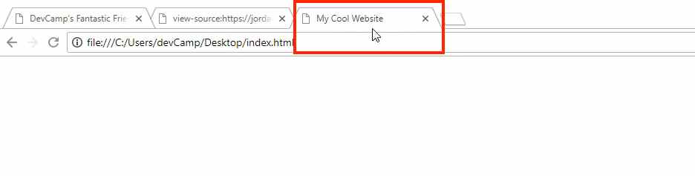
So if I want to say My Cool Website and then say again. And now come back, hit refresh, you can see it says My Cool Website Again. So whenever you want to change the title up here, this is what the user sees when they look up in their tabs, the title tag is where you are going to do it.
Now moving down to line six, this is the meta tag for the view port. Now what the view port is, is this gives us the ability to make our sites responsive. By responsive, what I mean is that it will look one way on a smartphone, but it will look completely different on a different device, such as being on the computer or a tablet. So if you want to see this application here, if I open this up in a new browser, you can see this is exactly how it looks when it's in desktop mode.
If I shrink it, this is the way it will look when it's on a tablet.
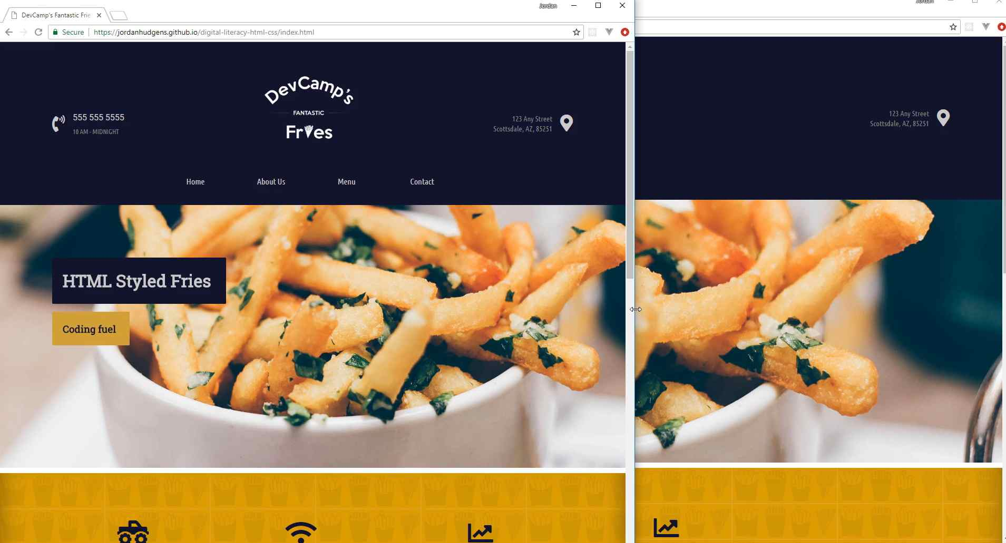
If I shrink it even more, you can see how the entire site adjusts and now the navigation bar is stacked on top of itself.
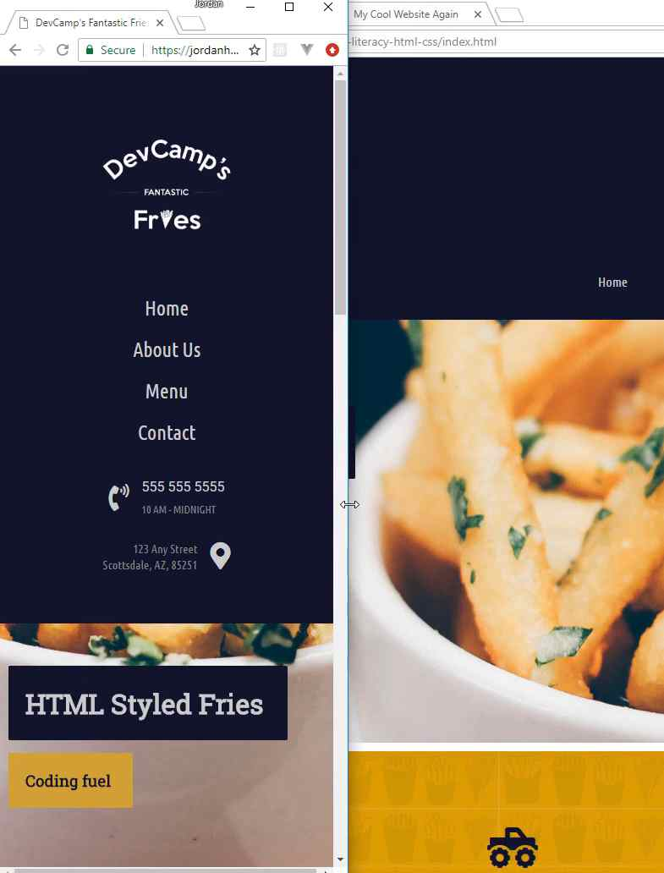

These items are stacked on top and now everything is sitting exactly like the way you'd want on a smart phone.
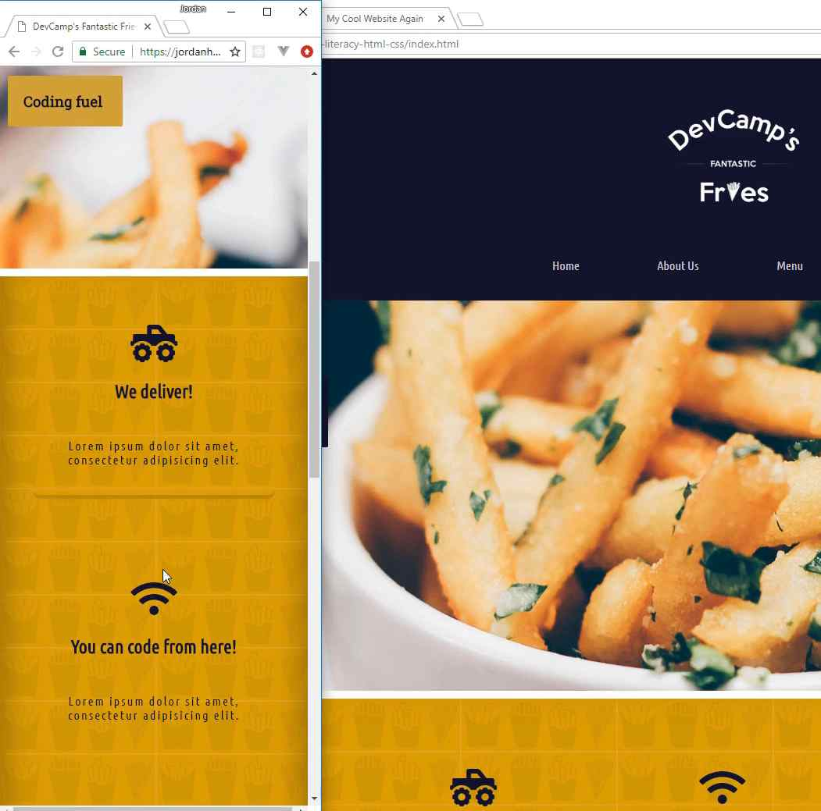
That is what the view port allows you to do, it's to implement the ability to know how wide and how tall the browser is so it can adjust if it's on a different device, so we're going to keep that one in there.
Now, the next two are ones that I'm going to remove because they're not needed, but we will later on get into what these represent. The very first one is a style sheet import link. So what this does, and you may notice this is whats called a self closing tag. So we have a link that starts out here, but instead of having something like we did with the title where we had a closing tag that was separate, the link tag actually is just one tag.
So it goes from all the way from the left all the way to the right. It doesn't have a closing one, it has a slash right before the greater than symbol. So this means, and it's what is called, a self closing tag. It's just using one.
And what this does, is it imports the style sheet. We're not going to worry about it now and we will get rid of that for the moment, but when you want to import a third party style sheet or you want to have a dedicated style sheet, this is the way that you can do it.
The same thing here, this is how you can import JavaScript code.
<script src="main.js"></script>

So now that we've done all this, we've cleaned up our head tag and nothing is on the page. So if I hit save and come back here, this is what we opened up. If I hit refresh, nothing's on the page and the reason for that is we have to add content.
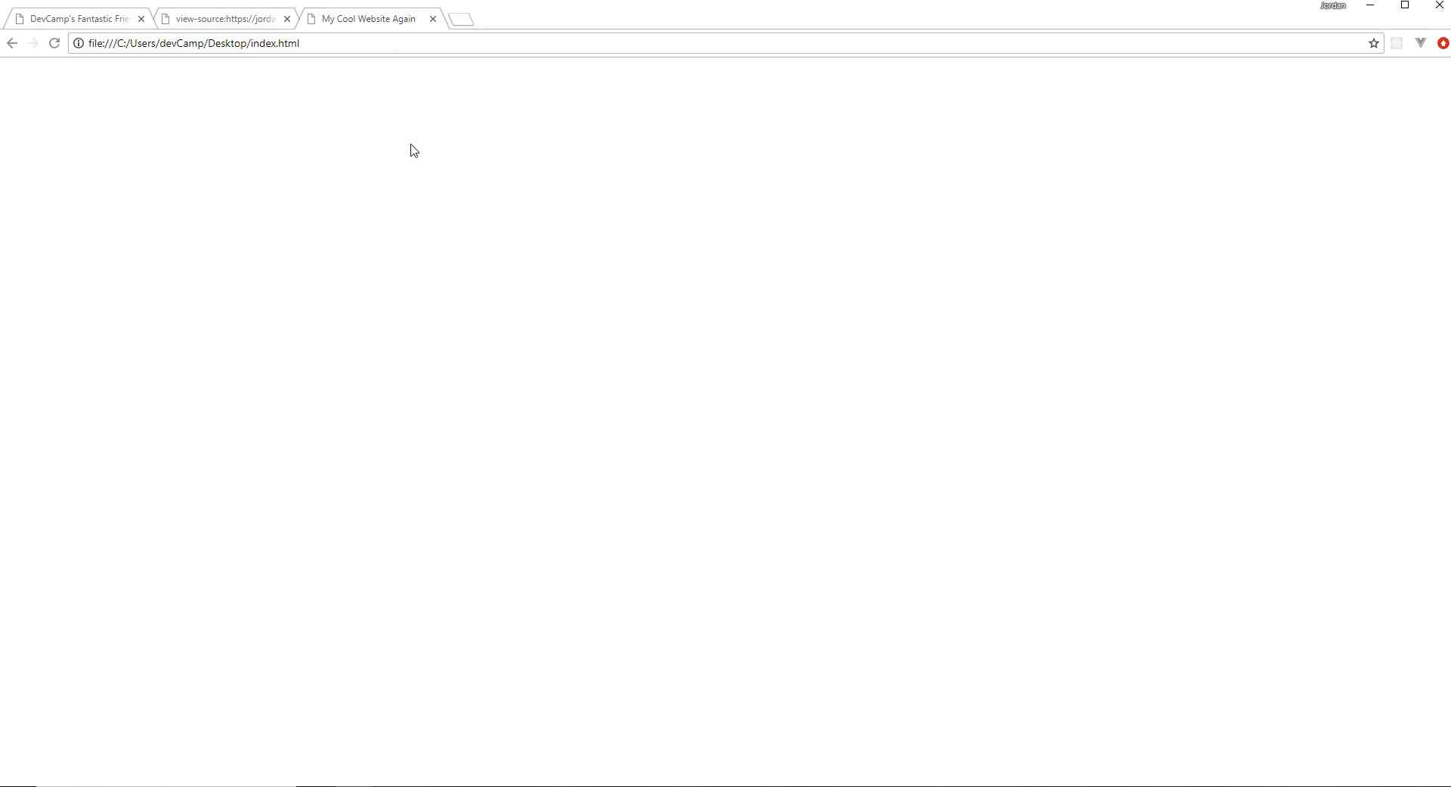
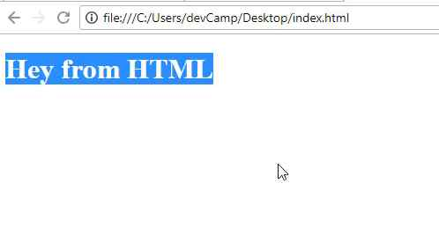
Now, content goes inside of the body tag. So, if I open this up and I'm going to use a heading. So this is going to be big, so I am going to have a heading tag that says Hey from HTML. You may notice here that this heading tag has a start and a close and then I'm putting the content inside of that. If I hit refresh, now you can see it says hey from HTML.

So you're still rendering something out into the browser, but now it's actually valid HTML code because you have this doc type, you're letting the browser know that we're going to be opening up an HTML file. And then you have your head tag and then your body tag where all of the content is going to go inside.
So in review, we walked through the different tools that you need in order to get started with HTML and CSS and building out websites. And then also, the structure and the basic structure for building out a website.
Coding Exercise
Make an "h1" tag that says "Hello World".

1.7 How to Install the devCamp VS Code Extension

Blank.

1.8 Introduction to
Using CSS Styles
Now that you know what an HTML document is, let's get into the role that CSS plays in building out websites. We're also going to build out our structure for the website that we're going to build throughout this course.

I'm going to open up the code file right here, and I still have it open. If you open it up in VS Code or whatever text editor you're using, we're going to talk about CSS and how you can implement it. CSS stands for Cascading Style Sheets and there are three main ways that you can use CSS code.
The first is going to be inline, the second is going to be what is called embedded, and then the third is imported. We're going to use all three just so you can become familiar with them, but then I'm going to show the best practice.
Inline means that we are going to add a style directly to the element. If you come and you have this H1 right here. If you type style, then inside of here you can type some type of style rule. So I'm going to go with the basic one and just say color:, and then we can give this any color that we want.
I'm going to say color: red;, end it with a semi-colon. Now if I hit save, what is going to happen here, if I come back, hit refresh, you can see that, that is red.
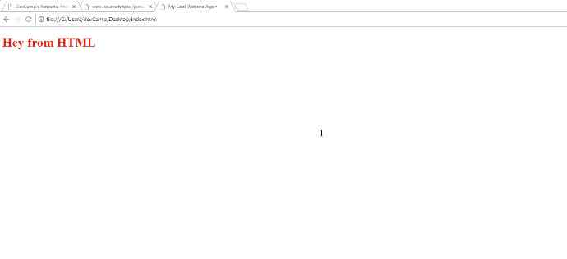
Now, we're going to be using the developer tools quite a bit so let's start getting used to that. If I right-click on that element, click inspect, you can see that it says the element style is red.
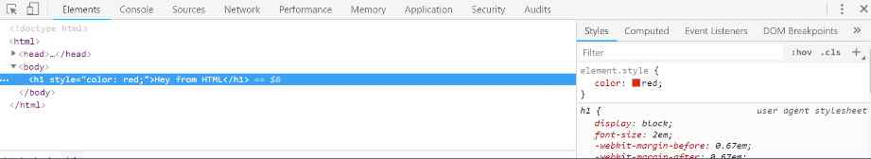
So if I wanna change this to blue, now you can see the color has been changed to blue and the element itself has the inline style of color: blue.
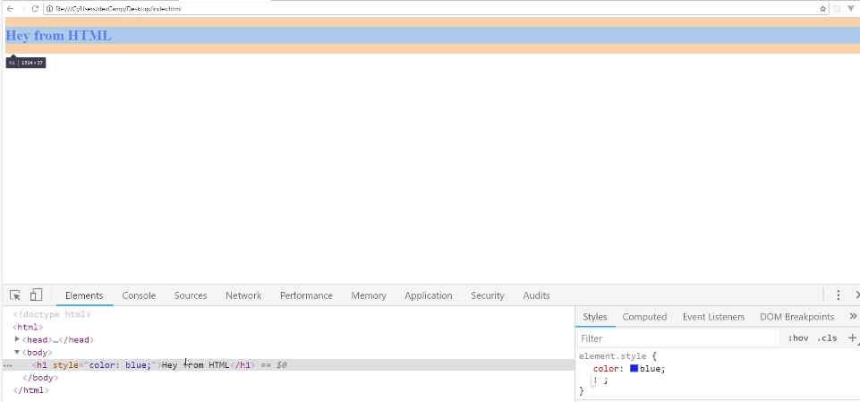
So that is how you can use an inline style. Now I'm going to comment this out. The way that you can comment in VS Code, is if you're on a line of code, you can type control and then the slash character. So it'll look like control + /. Type those key bindings in, on whatever line you're on, and this will add a comment.
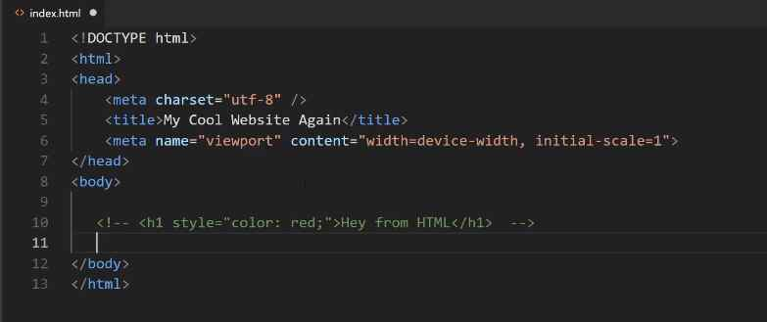
Now you also could just type this out manually, so you could just say <!--some content -->. What a comment is going to do is it's going to remove it from the page. So if you come back here, hit refresh, you can see that it's gone.
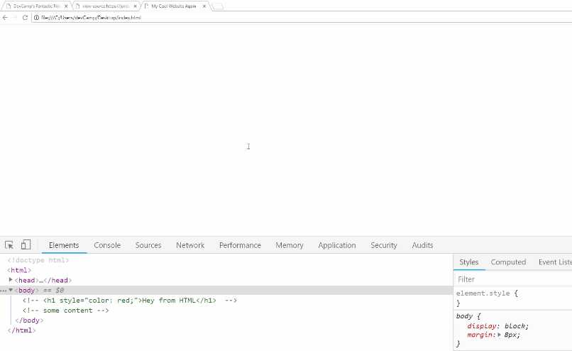
It's still in the code so you can see right, it's commented out. It is still in the code, but it's not going to be shown to the user. The reason why I'm doing that is because I want you to be able to see all three versions on how you can import and work with style sheets. I don't wanna delete them so you can kind of compare and contrast.
Now let's come down here, and I'm going to just copy that line of code. Uncomment this out. I'm going to remove this entire style rule. Now that is gone. We're back to just having an H1.
If I come up into the head tag here and now type <style>, what this is going to do is it's going to give me a beginning and an ending tag and we can embed style here. So any time that you want to select an item on the page, then you can just grab that element.
Right here, I want to grab the H1 tags, so I'm going to say
<style>
h1 {
color: red;
}
</style>
Then in curly braces, I'm going to add a style. Here we'll go with our same color red. Once again, hit save, and now if I come back, hit refresh, you can see we're back to it saying Hey from HTML.
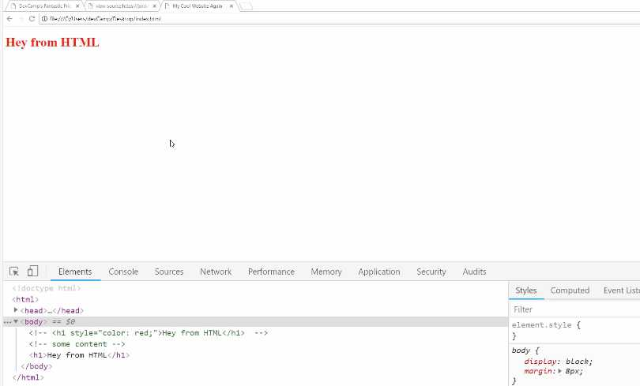
What we're doing here, and I'm walking through a few different concepts here all at the same time, so if this is confusing, I definitely recommend for you to go through it a couple of times just to familiarize yourself with it.
Because we are getting here, not only to embedded styles but the only way that an embedded style works is to work with CSS selectors. Now selectors are going to be something you're going to be doing throughout this entire course and for pretty much every website you ever build, you're going to have to use selectors.
We're going to walk through them quite a bit in the next set of videos, but what we have here is we're saying that we wanna have every H1 heading to have the color red. That's a reason why it was able to know that Hey from HTML should be red without us having to put inline.
The reason why this is really helpful is, imagine that you have some kind of scenario. Let's add another style here. You can add as many as you want, so if I want to say text-decoration, say underline. This is going to underline this text as you can see right here.
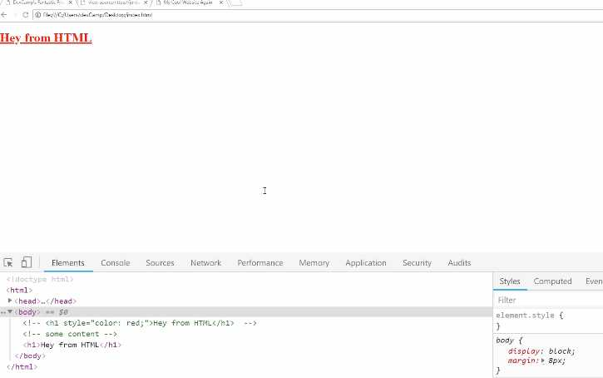
The reason why you want to go with this approach is, imagine a scenario where you have multiple headings on the page. You could have all kinds of different paragraphs, and you want your headings to all to be the same.
What you're able to do here is you're able to say, "Okay, I want to have every H1 to have these styles." If you use inline styles, you'd need to type this entire line of code every single time that you called the heading. That's not very scalable.
Imagine a scenario where you want to change the colors. So you wanna change it to blue or some other color, then what's going to happen is you're going to have to go and remember every spot that you typed that code and then change it.
As you can see here, if I just copy this and say Hey from HTML again, hit refresh, you can see that the same style is applied right here. This is a much more scalable way of doing it.
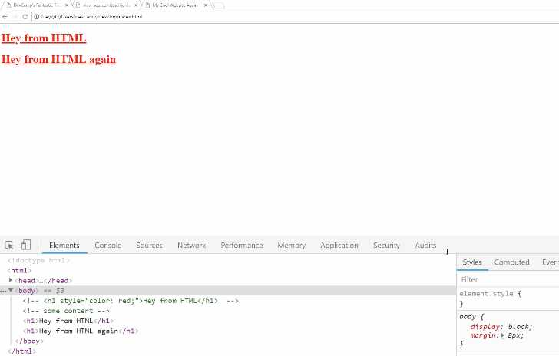
Now, so far we've gone through two ways, we've seen how we could use inline styles, that's where we add the tag directly to the element. Then we saw how we can use embedded styles, that's where we have more of this abstract concept of a style tag in the document.
Now it gets a little bit trickier when we go into the third option, which is to have external style sheets. The reason why you need external style sheets is, let's take a real-world example.
Say you're building out this website, which we're about to do. If you wanted to make some kind of style rule, such as the hover effect right here on the navigation items if you wanted to have that same effect and you wanted it to be on all of these other pages like we do right here.
If you use embedded styles then what that would mean is that you'd have to literally copy and paste all of the style information and all of that code into every single page of the entire site.
What this would mean is inside of this style tag, you would have literally thousands of lines of code all right here, and it would be on every single page.
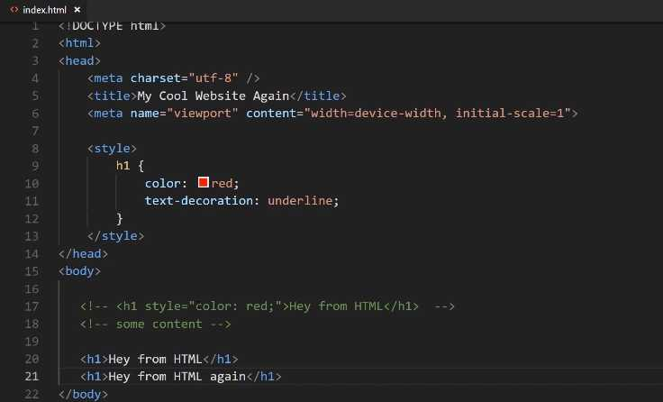
Then, kind of like the issue we had with the inline styles, what you'd have to do is if you had to make a change, so say that you wanted to change that kind of gold color to something else, you'd have to go and make the change in every spot in every file in your project.
Now, this is going to be a relatively small project, we're only going to have four pages. Imagine a scenario where you have hundreds of pages. That would start to get very unwieldy, very quickly. So instead, we have a third option, which is called external style sheets.
In this case, I'm going to be able to keep these here because the way that you select the items is going to be exactly the same and as we're doing with embedded. It's only how we're defining them that'll be different.
I'm going to comment all of this out. Once again, if you're new to VS Code, if you wanna comment out multiple lines of code, you can just select all of it and then hit the control + / again. That will comment all of that out.
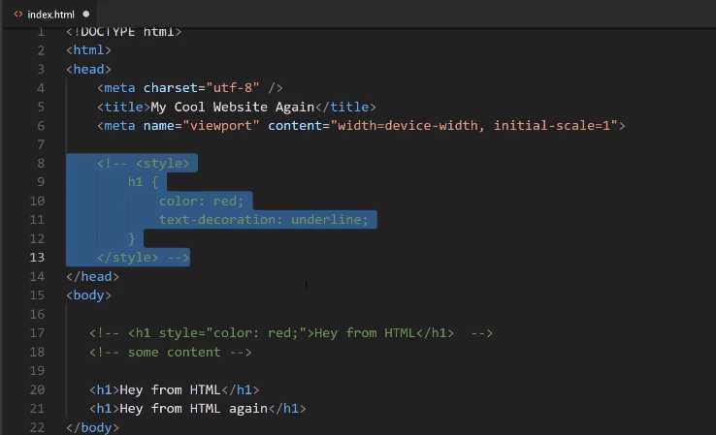
Now, our third option of having our external style sheets, you're going to use a link. This is going to be link, a self-closing tag. If you're using VS Code, it should do all this for you automatically. If you type in link and then tab, this is going to give you a stylesheet.
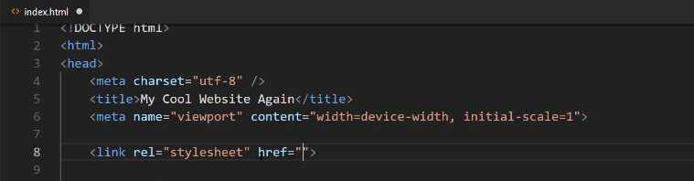
What our href stands for is it's asking for a reference. What it means is it is saying, "I need you to tell me where to go find this other file." For here, just for ease of use, I'm just going to say styles.css.
You give the full name to the file, hit save, and now we're not going to have any styles. If I come back here and hit refresh, you can see we don't have any styles. Technically there's going to be an error if you click on console.
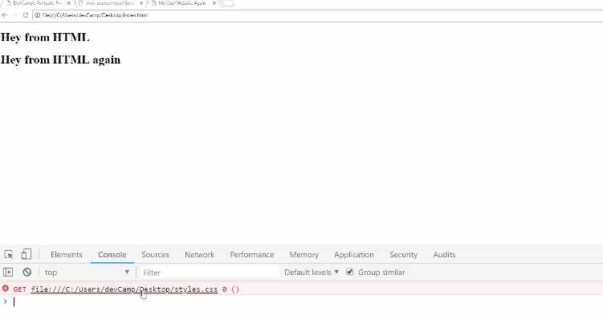
You can see right here where it gives you this error. What it's saying is that it tried to go find this styles file, and it couldn't do it. We're going to fix that now. If you click on this little explorer here, then you can see that in the open editor we have the index file and we also do not have a folder open.
Let's create a project folder. I'm going to click open folder. We're here on the desktop, and now let's just right-click, say new folder and we're just going to call this HTML-CSS. Let's open this up, click on select folder, and this is now going to open up a project.

Now we wanna put our index.HTML file in there, so if you go down into the explorer or if you're on Mac you can go into the finder and then go to your desktop. You can just click and drag the index file directly into our new project folder. You can see it's right there. Now click on new file and say styles.CSS.
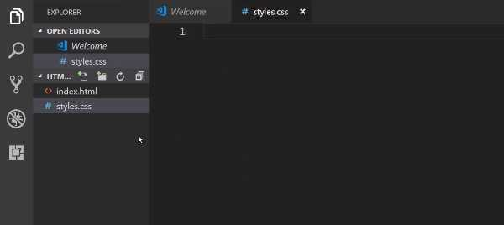

In here, let's use that same exact code. So h1 and then inside of it we'll say color: red;. Then let's go with that text-decoration of underline

h1 {
color: red;
text-decoration: underline;
}

Hit save, and now let's go back and see if that worked. If you come back, hit refresh. Oh and actually I made one mistake. Right here, you can see it's still looking for this file on the desktop. This is a good mistake to make because what it means is it'll just kind of reinforce understanding of how the path system works.

The way the browser is using this file and the way it's reading it is it's going into the hard drive, then it goes into the user's directory. Then into one I have called devCamp, then it goes to the Desktop then it tries to find this file. It can't do that anymore because we moved the file.
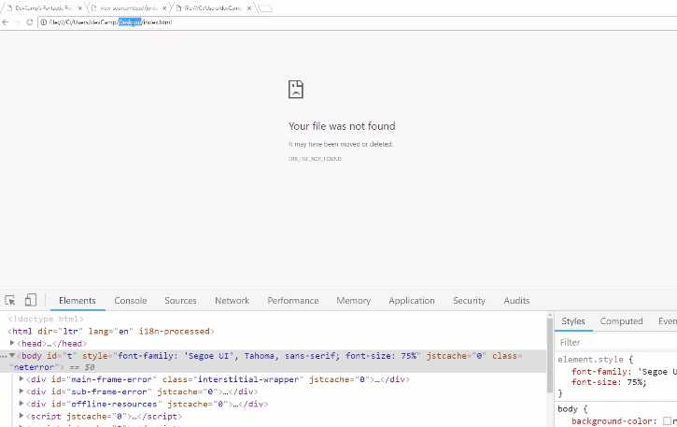
If you hit control + o and click on html-css, then click on index and open it up. Now you can see we have our file back again, and the styles are being applied.
In review, we now have our index file using an external style sheet. So instead of having to put this code in every single file of our entire project, what we can do is we can just call this one file, or you can even call other files, and then import those directly into any other page of your project.
Coding Exercise

Using what you just learned about CSS styling, write CSS code that would make the text of the provided h1 tag the color green. Don't use any HTML in your submission.

<h1>Make me green!</h1>

1.9 CSS Cascading process

If you're new to building websites, the name cascading style sheet may a little bit confusing, so in this guide, I want to go through that just to give you an idea of how important it is.
I think that it's worth it to go through an entire guide just to understand CSS because I've seen this particular feature of CSS get very confusing, especially as developers get into more advanced programs.
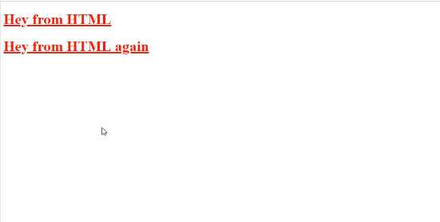
Now if you come back into the text editor, notice how the text was red.
If you want to override that, watch what happens here when I add different styles in below.

styles.css
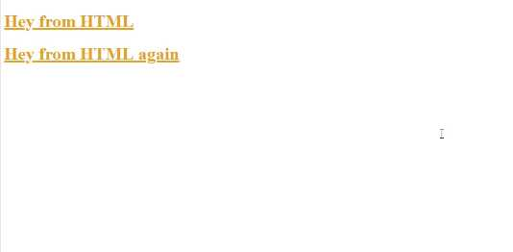
h1 {
color: red;
text-decoration: underline;
}

h1 {
color: goldenrod;
}
If you come back to the website and hit refresh, you can see that the color is now goldenrod.

What this means from a cascading perspective is it is perfectly fine, and it's also a very normal process to have styles overriding other ones. Now it doesn't make sense in this exact use case, 'cause if you wanted to change the style by overriding it, then you wouldn't usually put this directly in the same file.
Let's test out something a little bit more advanced. If I go into our file directory, and I create, say, styles2.css, let's go and grab this code from here, and just paste this in Styles2.
styles2.css
h1 {
color: goldenrod;
}
Next, inside of our index.html file, remember how I told you that you could import multiple files? Well, let's come and do that.
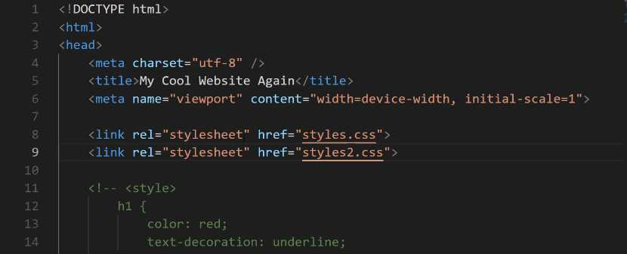
Hit save here and then come back in the browser.
You can see this works exactly the same way.
One way that you could imagine that the workflow for importing style sheets is, HTML loads the document, and when it gets to the <link> tags, it pulls in the styles.
It'll pull in the first styles.css and run everything in it, then right afterward it gets to this other <link> and it says, "Oh, okay. We need to pull in this other style sheet." And then it pulls that in and runs it.

styles.css
h1 {
color: red;
text-decoration: underline;
}

p {
background-color: red;
color: white
}
Now let's check out the browser.
You can see that it says "My Cool Content", and it has a background of red and the color of white, so even though the heading tag did get overridden, the paragraph tag styles still are working.
This means that if you import multiple files, just like we did here, only the overrides are going to take the place of the preexisting one, so, in other words, this Style 2 is only going to override the H1 tag. It's not like it wipes away all of the styles from those other files.
Now we can get even more specific here. I think this is going to help because this is where a lot of bugs come in later on if you're not used to it.
Let's go, and let's un-comment the styles in index.html, and we're going to change this color back to red and hit save.
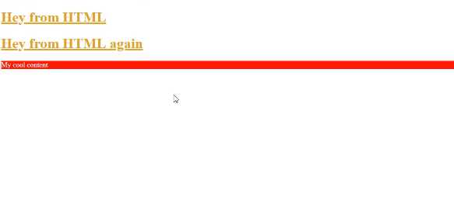
Now it's not overriding the file at all. It is simply overriding the selector, which is important to also keep in mind.
If we were to come down on the bottom of index.html, and we're going to use what's called a paragraph tag, or <p> </p>. We'll get into this later, but it's pretty self-explanatory. It just gives you the ability to have paragraph content.
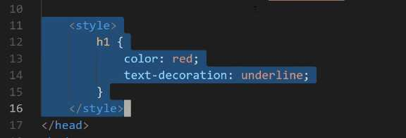
I'll say <p>My cool content</p> here, and hit save, and now I'll go into our main styles file and style this.
We have added our embedded styles back in and if I hit refresh, you can see that we are back to red again. This means, that our embedded styles are going to override the selectors in both the first call and the second one.
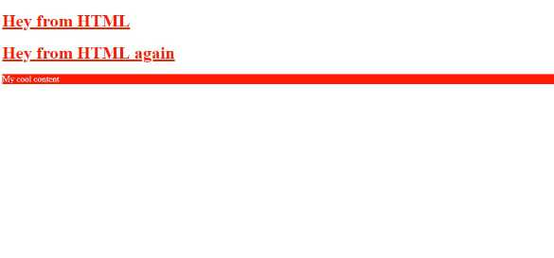
Now the order here is very important. If I cut the embedded styles out, and I go, and I put them above those imports and come back, you can see that we're back to that goldenrod color.
Now, this may seem a little confusing if you've never done it before, however, you can think of this as just being an order of operation. As soon as the index.html file calls this style tag, it is going to set this as a rule. Then, if it gets another rule, then it's going to override it. Then if it gets another one for the same element, it will override it. And it will do that for every element on the page.
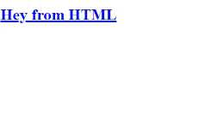
Now we can get even more specific. Let's comment out our tags and use our in-line styles instead. Let's change this one to blue. If I hit refresh, you can see that it's blue.

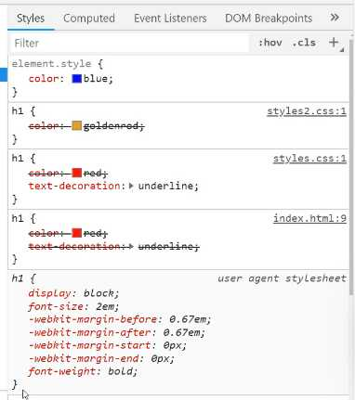
This is the way your style rules are going to work with cascading style sheets. That's the whole reason for the name. Now you also have the ability to see this process inside of the inspector.
Now I'm going to show you these rules. You notice how it actually has our full history of that cascade process.
So starting at the very bottom, this is the base HTML set of rules. So when you use an H1 tag in HTML, it is going to have these rules associated with it. It's going to have a default font size, it is going to have all of these other things.
You don't have to worry about them right now. You're going to learn how all of these work as you go through the material.
Then, you have an H1 rule, and you can see that this was declared inside of the index file. So if you click on that, it even shows you exactly where this was defined. This was our embedded style. Now going back to elements, you can see the next one was defined inside of our styles.css file.
This is the very first external style sheet that we created. And you can see when it shows that's marked out, that means that that rule has been overridden.
Then from there, moving up, we go to styles2.css, which you can see right here with a color of goldenrod. And that also has been overridden. And lastly, we have the element style. This is the in-line style that was added directly here of color blue. So, this is very helpful.
I can tell you, this may seem a little trivial or contrived right now, but I promise you, when you start building out big applications and big websites, you're going to run into a number of issues where you think that you have applied a certain style to an element, and it's not going to be applied.
It's going to be very frustrating if you don't know how this process works. So, one of the very first things I do when I apply a style, and it's not reflected on the page, I will open up the inspector. And then many times, what I see is that it has a little slash through it where it has this strikethrough effect.
What that tells me is that there is another style that is overriding the one that I was trying to do. And then I know what to do in order to go fix it, which is to go change up the order and to be able to have something that gives the style I was looking for.
In a final review, what we walked through in this guide is understanding the cascading nature of CSS and how the order in which you call the styles is very important, how it gives you the ability to override elements, and how you can see this entire process inside of the browser's development tools.

Coding Exercise
Make the text of the p tag pink and also give it an underline.
<p>Hey there! Make this text pink and add an underline!</p>

1.10 HTML links
Right here, you can see in the finished product, we have these navigation elements. If I click on them, they will take us to these other pages. Let's walk through exactly what needs to happen in order for that to work.
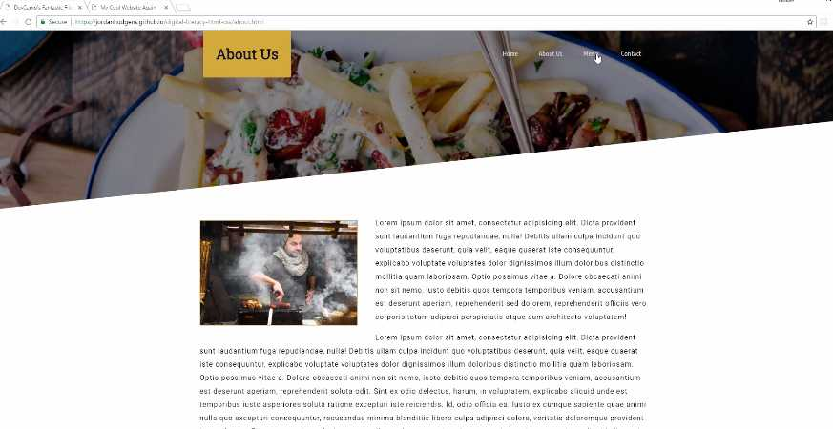
We're also going to add all of the pages that this entire project is going to use. We're going to start building this out. Now, I know that you may be getting a little bit frustrated because we've been doing quite a bit of work, and we still seem like we're a very far distance away from here.
If you're learning HTML and CSS for the first time, it is critical to have some of the fundamentals down. We are building out the project, but we're learning the fundamentals as we go. Let's get started on this. Let's create the other files that we need, and let's talk about links.
I'm going to switch back to the code editor here and I'm going to get rid of all of these sample code items. I'm going to get rid of styles too, and everything else here. I'm going to start by just saying homepage. I want to do another h1 and I'll say homepage.
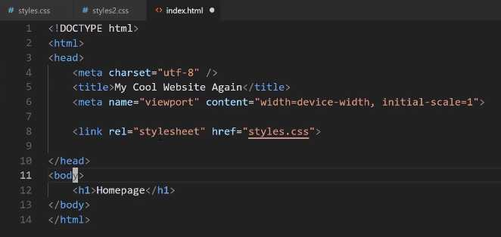
I'm also going to indent that. Just a little side note, the indentation that you use is very important. The browser doesn't care about indentation at all, so it's perfectly fine. You could technically have tabs all over the place and place this right here, and this is still going to work.

If you hit refresh, you can see it still says homepage, but from a best practice perspective, you really want to make sure that your code is aligned properly. As you go through the project, you'll see how it should be.
For right now, just know that if you have a nested item like this h1 tag is nested inside of this body tag, then it's probably a good idea to indent it. That way it's very clearly nested inside.
Now, with all that in place, let's also update the title. This is going to say Homepage. Later on, we're going to probably change it, but for right now, let's keep it at Homepage. Now, let's create those other files.
Let's copy everything that we have here, and now we're going to create an About page, a Contact page, and a Menu page. The way you can do that is by just coming over here in Visual Studio Code on the left-hand side, go to the menu bar, click on new document and say about.html.
Then you can paste that into the title. Let's say About, and then in the content itself, just so we can watch it all changing, we're going to say About. Now, let's copy this, and now go and create another document.
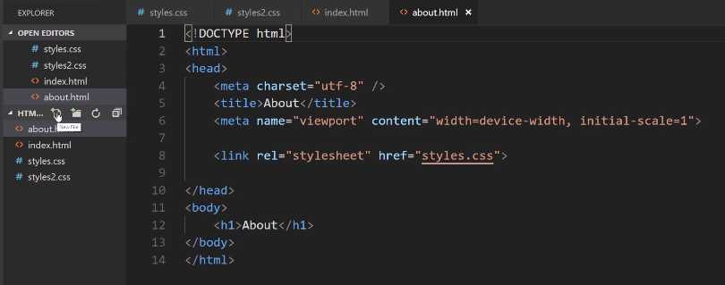
This one will say menu.html. Paste that in and as you may have guessed, change the title to say Menu, and then change that heading to say Menu. We just have one more left, so create one more document. We'll call it contact.html.
Now, you can call these files whatever you want, but I think it makes sense for them to have a very similar name just so you know exactly what is inside of each one of them. Say for example, and I have seen some students do this, where they'll create one file and call it index.html. That's a convention, your homepage should also be called index.html.
That's what browsers look for, but what the issue is I've seen before is something like having the index page there and then the other pages would be something like 2.html, 3, 4, 5, and 6.html.
That's not very clear. If you have, say a hundred pages, you want to very clearly and quickly be able to look on the left-hand side, know what is in that file, and then it will make it easier for you later on when you want to go and make updates. The last one is going to be Contact, and hit save.
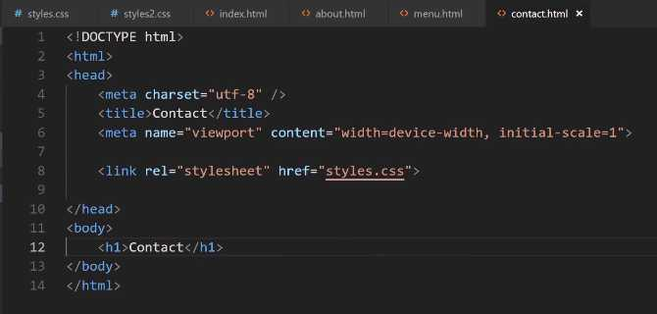
Now, if we come back here, right now we just have our Homepage, but if you come up here to the menu bar and you type say, menu, you can see it pulls up our menu document.
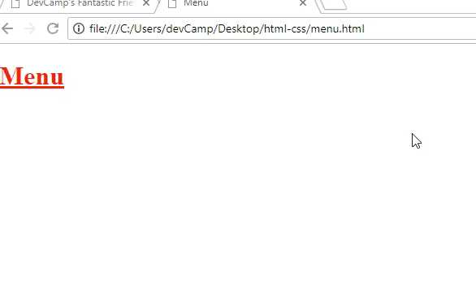
Then, here if I say contact, it's going to pull up the contact document. This is exactly the same process as if you hit control + o, and then you just went and you clicked on one of these. If I click on index once again, then we're back on the homepage.
All of our files that we want to use are all there. Now, how can we link to them? In the index, the way that you can do this, and this is going to be the start of our navbar, is we are going to use what is called an a-tag.
You can just start typing a, then hit tab complete, and it's going to look for an href. Now, this href, as you may have noticed, is also the same href we used up here for styles.
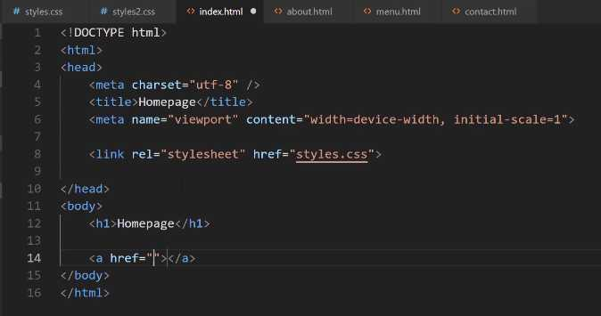
What the HTML document is saying is that we need to provide a path to the file that we're wanting to call. That's really all a link is. For a basic HTML site is a link to another document. Here, we can say about.html and inside of the tag itself we can say About.
**index.html
<a href="about.html">About</a>
Now, let's just copy this. Now, we're going to say menu and then menu. Then, we'll say contact and then contact. At the very top, let's also add one for our homepage. This is going to be index.html and this will just say Home.
<h1>Homepage</h1>

<a href="index.html">Home</a>
<a href="about.html">About</a>
<a href="menu.html">Menu</a>
<a href="contact.html">Contact</a>
Now, I do want to go back just very briefly and say I've kind of glossed over the reason why we use index.html and we use this naming convention. It's because many servers when they call for a file or they go into a directory, so kind of like, say that you have a server that goes and it hits this HTML CSS directory. The very first thing it's going to show is a file called index.html.
If you don't set up any rules on the server or anything like that, it is going to assume that there is an index file, and it's going to try to show that. Once you get into bigger frameworks, like using tools like React or Rails, a lot of that is done for you and you don't have to do this part yourself, but that is the standard convention.
You're going to see the name index.html quite a bit as you build out websites and that's the reason. It's because that's what the server looks for. Okay, so now that you have that piece of information, let's switch back to the browser on our homepage and hit refresh.
Now, you can see we have our menu here. If I click on about, then you can see it takes us to the about page. I'm going to go back and if I click on menu, it takes me to the menu page. Contact takes me to the contact page.
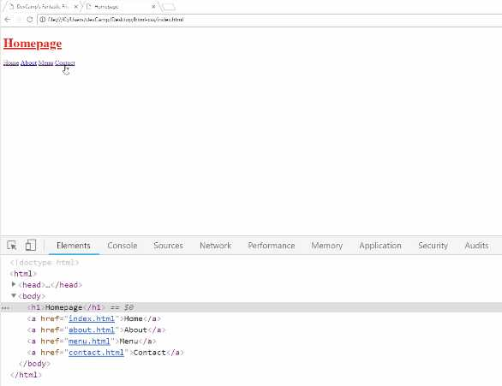

That's all that links are is we are just telling HTML where to go find another document. In this case, it's just the documents that we have here locally. Now if you want to add this navbar to all of the other pages, then you have to copy this code and put it on each one of those pages.
Let's do that now, just to make it a little bit easier to navigate. I'm going to add it to about.html, menu.html, make sure you're saving it after each time, and then contact.html.
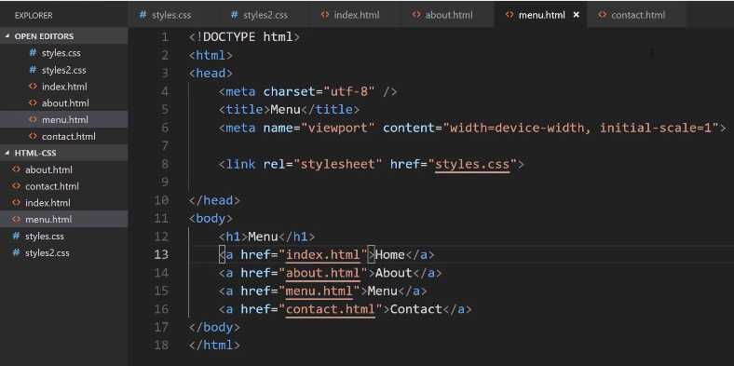

Hit save, and then come back and hit refresh. Now, if you click on any of these links, you'll see that our navigation menu's still there and it's because we copied all the links over. That gives us the ability to do that.
Now, I told you that this is a path to the document. It's important that it isn't just the document name. Let's add in a little demo here. If I click on new folder and say I have a folder here called pages. Inside of pages, I have another document and we'll just call this something like, let's say just demo.html, just like this.
In the index.html page, if I come down here and I create a new link and say <a href="demo.html">Demo</a>, hit save. Let's come and let's copy all of this content here just so we know once we've successfully reached the demo page. That's demo and then demo.
Okay, so I'm going to hit save. Notice I'm also keeping these nav elements here. It's for a reason I'm going to show you here in a second. Now, if we come back to the homepage, you can see we have this little demo link.
Now, if I click this, it's going to throw an error and the reason is because, and you can find this up in the URL bar, notice where it tried to find the document. It was still in the HTML-CSS directory, and then it just tried to find demo.html.
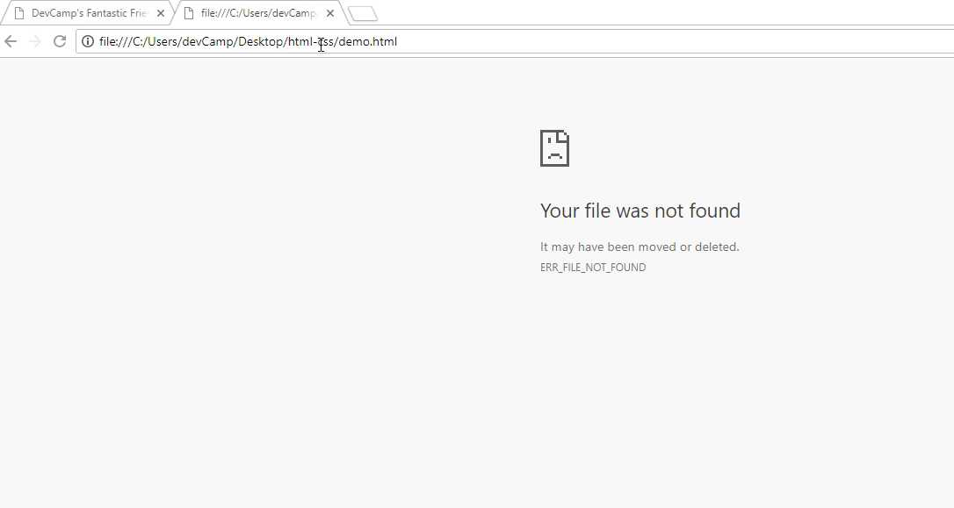
It's not just the file name. It's actually the full path that you have to provide. The way you could fix that is right here just say pages/demo.html. Now, if you hit refresh and go and click on this link, you can see that that works. That's part of it.

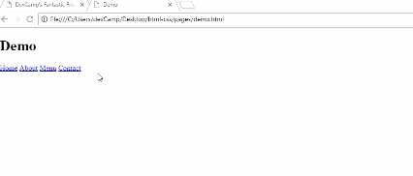

Now, there are a couple other things that it's important to understand when it comes to links. Do you notice how the styles are no longer being applied? The reason for that is because when we're importing the style sheet here in the demo, what is happening is it's all relative.
The demo.html file is looking for a styles.css file inside of the pages directory. That is very important to understand. If you don't understand that part, then you are going to run into a lot of bugs when it comes to understanding how the path works and how you can access and import files.
We saw how you can go and grab that demo link. Let me close off some of these other files and also, one very helpful little trick if you've never done this before. Let me close off everything.
I'm going to have demo open and then, let's also take a look at the index page right next to each other. You can right-click on a file and then, right here you can say open to the side.
Now, you can see both of these right next to each other. I'll close this. Now, the issue that we're having is that our styles is looking for it in the wrong place. What we can do here is go backwards. We're going to use a little bit different syntax.
Inside of our pages directory, when we want to move backwards we need to use two dots. In front of styles, put ../styles.css. That is going to traverse us back up one directory. Now, if I hit refresh, you can see the styles are now being pulled in properly. That's how you can traverse that.
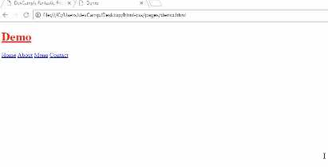

Now, we would also have to do the same thing right here. Let's just go and let's take this demo just so we have all the same exact links. Notice here, when you're in that demo directory, in the pages directory, you do not want to say pages again or else then it's going to try to jump up into another page's directory.
We want to delete that, but now, if you hit refresh, all of these are going to be broken. If you click home, that's broken, about is broken, and hopefully by now it's starting to make sense why those are broken. It's because we need to move one level up.
The way we can do that is just to add that .. in front of each one of these file calls. I'm going to say ../, hit save, and notice I did not do with the demo because that one is actually in the right directory.
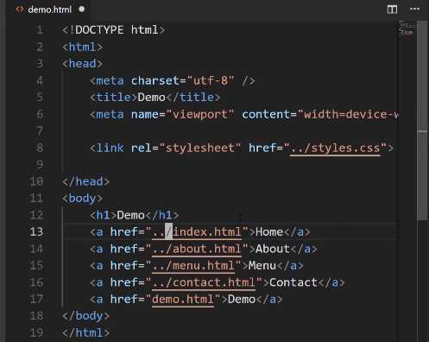
Now, if I hit refresh, click on about, that works. Click on menu, click on home, go back to demo, demo still works when you click it, and then you can navigate to all of the other pages. That is how you can work with the path whenever you're wanting to link to other pages in the program.
Now, the very last element that I'm going to talk about, let's close off demo, is when you want to link to an outside service. Say that you want to link to Instagram. You can say <a> and then here, if you want to link to a outside website, you need to provide the full path.
Here, I can say <a href="https://Instagram.com/JordanHudgens">Instagram Profile</a> and we'll just say this is the Instagram Profile. Hit save, now come hit refresh, and now you can see Instagram Profile is here.
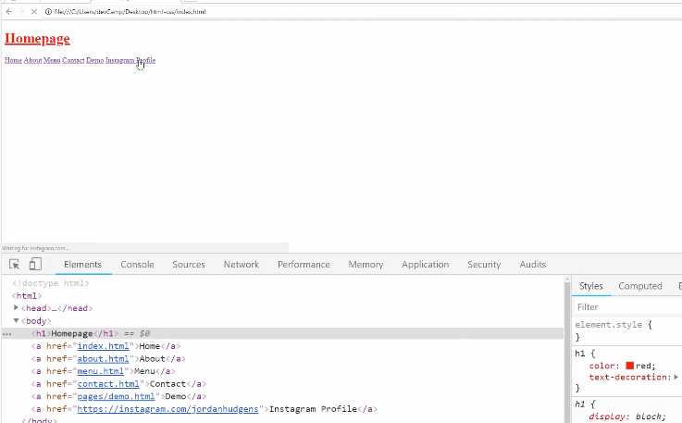
If I click on this, then it's actually going to open up Instagram just like that. You're able to not only link to your own internal documents, but you can also link to other websites or anyplace on the website that you want to navigate the user to.
Now, do you notice also how when I clicked on that, it actually took us away from the page? That may not always be what you want to do, so I think it's a good time to talk about some of the optional attributes that you have with links.
Right here, this is the most basic kind of link you're ever going to use. You have an <a> tag with an href, which is where you want the user to go if they click. Then, you have the content. Now, you also have the ability inside of that tag to say target="_blank".
The link is going to open up that target or it's going to open up that link in a new tab. Now, if you switch back, hit refresh, if you click on Instagram profile now, you'll see that it opens up in a new tab and it didn't get rid of the actual page that we were on.
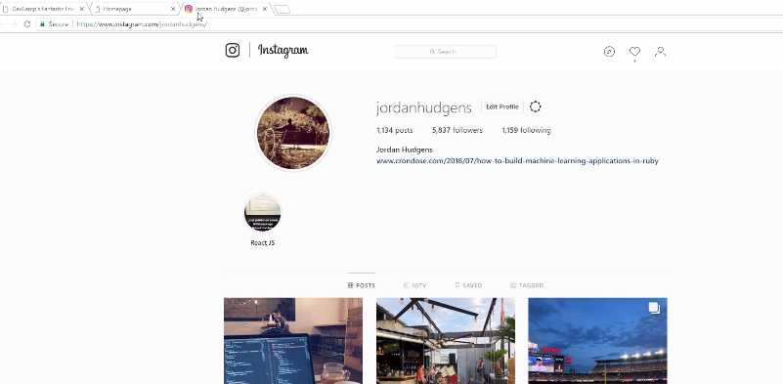
Depending on the type of user experience that you're wanting to give your site visitors, you have both options available to you.
In review, we starting building out our navigation bar, we saw how links work, we saw how we can work with different path values, and how we can traverse up and backward. We also were able to see how you can link out and have some optional behavior, like targets, when you're wanting to connect to third party websites.

Coding Exercise
Make a link with an href set to https://devcamp.com/ and also add the target so that it opens in new browser tab.

1.11 DIV tag
When it comes to organizing elements on the page, you are going to use a very important tag called the div tag. Now, we're going to be using div tags throughout this entire course. Pretty much every element that we're going to be putting on the page, is going to be wrapped inside of a div tag.
It gives us the ability to select the item and be very specific about it, and also to organize and align the content however we need to. With that, we're going to be building out this nav bar.
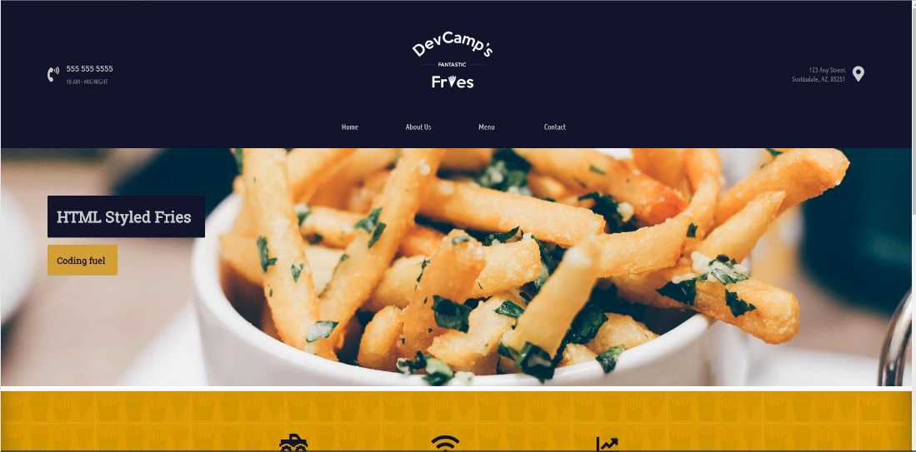
Now we're not going to be organizing it like this in this guide. We're not going to move it to the right and left, and center it, and add in the styles. We're going to save that for a later guide.
For right now, I just want to get all of this content on there. Let's start off with the phone number. We know we're going to need to have this phone number. We'll add the icon later, as well as the hours of operation.
We're going to need our links, which we already have, and then we're going to add the address. We're going to use div tags in order to accomplish all of that.
Open up your index.html and in between videos, I removed some of the demo content, like some of the things we were just using for an example. Your file structure on the left-hand side should look exactly like what I have here with the about, contact, index, menu, and style files.
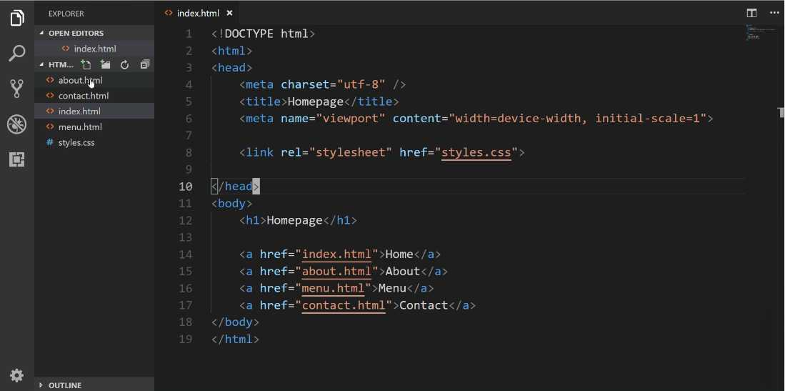

Now in this guide, we're not going to be actually changing a lot on the page besides just adding some content. That is going to be something we do in later guides where we're going to use CSS. For right now, this is all about structure.
Let's change some things in index.html
index.html
<!DOCTYPE html>
<html>
<head>
<meta charset="utf-8" />
<title>Homepage</title>
<meta name="viewport" content"width=device-width, initial-scale=1">

<link rel="stylesheet" href="styles.css">

</head>
<body>
<div>
<a href="index.html">Home</a>
<a href="about.html">About</a>
<a href="menu.html">Menu</a>
<a href="contact.html">Contact</a>
</div>
</body>
</html>
Now, let's come back and hit refresh on our page,
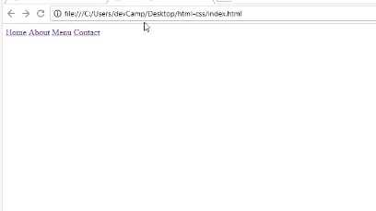
You'll notice nothing changes. Each one of these elements is working exactly the same way as before. Now, we have some other ways that we want to use divs.
Whenever it comes to nesting elements and organizing them in code, using a div is going to be the best way to do that. Now we have this entire nav component right here. What we want to do is we want to make that entire thing one big div.
We're going to create what I like to call a wrapper div.
index.html
</head>
<body>
<div>
<div>
<a href="index.html">Home</a>
<a href="about.html">About</a>
<a href="menu.html">Menu</a>
<a href="contact.html">Contact</a>
</div>
</div>
</body>
</html>
Now, this may seem really weird to you if you've never worked with div's before, this should seem like a little bit of weird syntax. The reason why I'm doing this is that the more divs that you have, the more control you're going to have when it comes to selecting elements on the page.
Hopefully, that's going to make a little more sense the further we go along. Especially when we dive into CSS, but for right now let's just add in some comments here.
index.html
</head>
<body>
<!-- Navigation wrapper -->
<div>

<!-- Link wrapper -->
<div>
<a href="index.html">Home</a>
<a href="about.html">About</a>
<a href="menu.html">Menu</a>
<a href="contact.html">Contact</a>
</div>
</div>
</body>
</html>
Now we have some spots where we can actually put the rest of our content. I know that we have that phone number and those hours, so let's add another div here.
index.html
</head>
<body>
<!-- Navigation wrapper -->
<div>
<!-- Hours + phone -->
<div>
555-555-5555
10 AM - MIDNIGHT
</div>

<!-- Link wrapper -->
<div>
<a href="index.html">Home</a>
<a href="about.html">About</a>
<a href="menu.html">Menu</a>
<a href="contact.html">Contact</a>
</div>
</div>
</body>
</html>
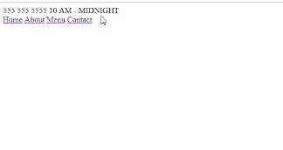
Let's come back to the home page.

The next item we want to add is the address. I'm going to copy it from the design and add it in.
index.html
</head>
<body>
<!-- Navigation wrapper -->
<div>
<!-- Hours + phone -->
<div>
555-555-5555
10 AM - MIDNIGHT
</div>

<!-- Link wrapper -->
<div>
<a href="index.html">Home</a>
<a href="about.html">About</a>
<a href="menu.html">Menu</a>
<a href="contact.html">Contact</a>
</div>

<!-- Address -->
<div>
123 Any Street
Scottsdale, AZ, 85251
</div>
</div>
</body>

</html>
Let's check the browser again.
As you can see, we have our content there, but we still seem like we're really far away from where we want to go, and that's fine. That is the natural progression, so don't let that discourage you whatsoever.
Just so you know, everything we implemented is actually almost all of the HTML code that is right here on the page believe it or not. CSS is what's going to give us the ability to structure the page, to place the elements and align them where we want, and add in those styles.

Now we're not quite done yet. I want to add a few other items. In addition to having things like these wrapper elements, the other thing that I like to do is, I like to have div's wrapping around the single elements themselves.
So take, for example, our nav links. I think that each one of these needs to have its own div.

index.html
</head>
<body>
<!-- Navigation wrapper -->
<div>
<!-- Hours + phone -->
<div>
555-555-5555
10 AM - MIDNIGHT
</div>

<!-- Link wrapper -->
<div>
<!-- nav Link -->
<div>
<a href="index.html">Home</a>
</div>

<!-- nav Link -->
<div>
<a href="about.html">About</a>
</div>

<!-- nav Link -->
<div>
<a href="menu.html">Menu</a>
</div>

<!-- nav Link -->
<div>
<a href="contact.html">Contact</a>
</div>
</div>

<!-- Address -->
<div>
123 Any Street
Scottsdale, AZ, 85251
</div>
</div>
</body>
</html>
So I'm going to get rid of that. And now right here, let's indent that. So this is going to be a wrapper div for the nav link. Let's just add a comment here. And we'll just say this is going to be the nav link. And then let's go and do it for each one of the other elements. So copy this, indent.
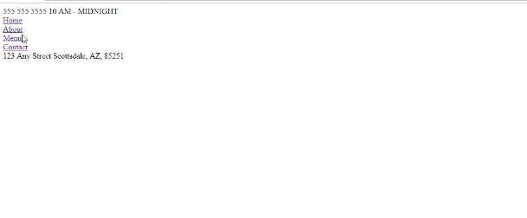
That's all we need. Each one of our links now has a div wrapper.
If you've been curious and you wonder what a div does besides just giving you some content, it also will place each item on its own line. So if I hit refresh, now you can see our nav links are all on their own line.
Now, this is not what we're going to have at our end result. But this is important because if you've never worked with div's before this might seem a little bit confusing on understanding exactly what a div does.
Now let's click on one of these div's, and it can be any of them, and if you come here on the right-hand side, do you see where it says, div { display: block; }?
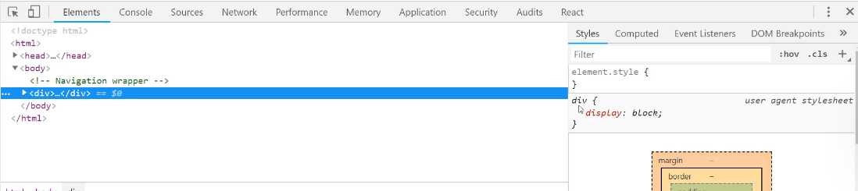
What this means is anytime you see that something inside of the inspector tools is in italics, that means it's a base HTML default style.
Display block means that this element is going to just take up its own block space here on the page. That's the reason why before, all of our links were sitting right next to each other. But when we wrap them in div's, it moved them all on to their own lines.
That is what display block does. And this is going to be a perfect lead into what we're going to do in the very next guide.
In the next guide, we're going to be introduced to one of the most powerful tools in CSS, called Flexbox. And Flexbox is going to be what we can use to start arranging and aligning each one of these elements on the page.

Coding Exercise
Place a div at the top that says "Welcome to my site!". Below that, make an a with the url set to about.html and have the link say "Get to know me".

1.12 HTML .class and #id

The reason for that is because we still have one piece of prerequisite knowledge that we need to walk through before we can get into Flexbox, and that is the process for working with IDs and classes in HTML and how to use those in CSS.
Let's review what we've done in regards to selectors up to this point. I'm going to open up the style.css file, and also I want to show you a cool little tool. Throughout this entire course, I want to give you some additional knowledge on how to work with tools like VS code.
If you type control + p, this is going to bring up the ability to search for any file name in your entire project. Now, when you only have five files, this may not seem like a big deal, but if you're working with hundreds or even thousands of files on a large project, I can promise you that you will be using this tool quite a bit.
I want to open up the styles.css file here, and in between videos, I cleared it out just so we had a clean slate. We're not going to use any of that demo content anyway. Up until this point, we would select items on the page doing something like this:
styles.css
div {
color: royalblue;
}
We'd give the tag name and then inside of that, we would provide whatever value we wanted to use. So let's use royalblue. Now if I hit save and then switch back to the homepage and hit refresh, you can see that our text, all of our div elements are now in royalblue. That's what you'd probably expect.
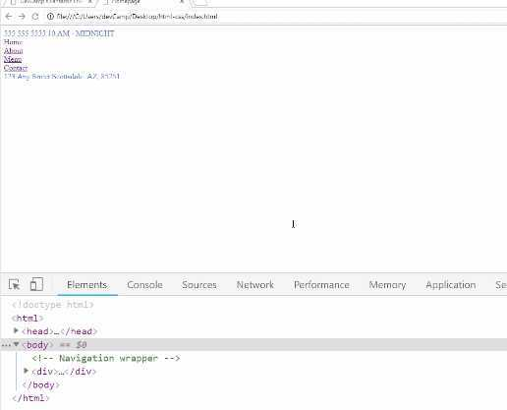

Now, what happens when you want to only apply one style to one of these elements, such as the hours and the phone number, but you don't want it to apply to the address? Well, what we can do is add a class that is going to allow us to do that.
Now let's look at this code at the same time. So I'm going to right-click on style here, and let's go down to split down. This is going to let us look at the files with HTML on the top, and the CSS on the bottom. I'm going to close out of the top one.
The way that you can implement a class in HTML is inside of the div tag, just say <div class="" > and then give a name that you want to use. Right here I want it to be nice and descriptive. So I'm going to say <div class="contact-hours-wrapper">, just like that.
Notice how in our comments, we had to put comments here so that we would know what the contact was about or what the div tag was about. If I have a very good descriptive name like I have right here, I can actually get rid of that content, because now the class itself is very nice and descriptive.
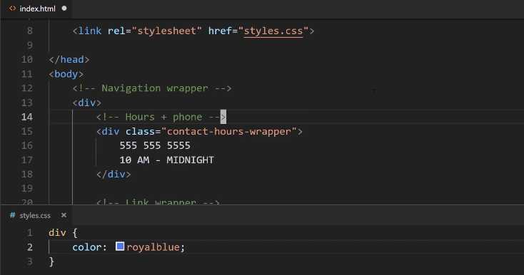
I don't usually like having a lot of comments throughout my code. Usually, when I see comments, it usually means I didn't pick out the right class names because they're not descriptive enough. With all that being said, let's come down here.
Now in the style.css file, you are going to grab this class different than you did with the tag. So remember with the div tag, we selected it just by saying div. Well if you say contact-hours-wrapper, this is not valid CSS code.
If I hit save here and come back and hit refresh, you can see that our royalblue has not been applied. We want it to be applied to that one element.
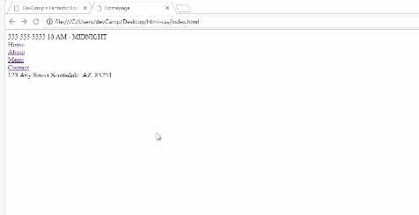

The way that you select a class in CSS is by saying ., So you're going to say .contact-hours-wrapper, hit save. Now if you come back and hit refresh, now you have selected the right element on the page. That is how you can create a class and then call it using CSS.
The other idea that we need to understand is how to work with IDs. So an ID is very similar to a class, except it has a few differences and we'll walk through those here in a little bit. Now the syntax for creating them is pretty much the same.
You're just going to say id="", and then inside of quotation marks, you're going to say what this value is. Here I'm just going to say, id="address-wrapper", hit save. Now down below, let's try to make this red.
The way that you are going to select an ID by using the # symbol and then the name of the ID. So address-wrapper and now let's just say color: red.
styles.css
.contact-hours-wrapper {
color: royalblue;
}

#address-wrapper {
color: red;
}
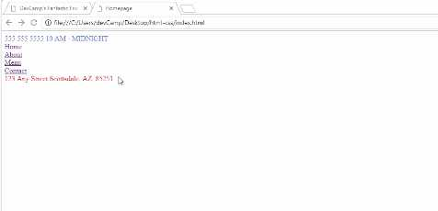
Now if I save and come back, hit refresh, you can see that we have selected the address. So this is all working very well. The very first question that you might have is what is the difference? Because they seem to act pretty much the same exact way, and for our very tiny use case, they do.

For a larger application, the rule of thumb is that if you are ever, ever going to have multiple items on the page, so say that you're going to have this contact-hours-wrapper multiple times on the same page, you want to use a class. If you are only going to be using an element one time, then you can use an ID.
Now throughout this course, I will most likely be using a class for almost every single element that we're going to build. The reason for that doesn't really have anything to do with a project this size. The issue that you could run into is some of the larger frameworks like React or Angular or some of those, they actually can create some conflicts here.
Some of the frameworks will override the ID value. Because of the way that their system works and the way those frameworks work, sometimes they will set the ID dynamically. You don't even have any control over that or you don't without creating a lot of work arounds.
You could create code exactly like how we have right here and then your selector doesn't work, because technically your address-wrapper no longer exists because the ID got overridden. For the sake of just being safe, I just pretty much use a class all the time, and that is the recommendation from a best practice perspective.
I'm going to get rid of this comment because we don't need it anymore, and then I'm going to change the ID to a class. Right here, you can see we have all these nav links right here. Well, what we can do is we can actually get rid of the comments and then here, let's just add classes.
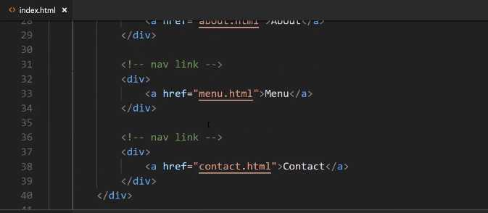
Now it's going to be class="nav-link". Let's go and do that for each one of them. I'm going to do it here for this one and the same thing for contact. Now, nothing's changed here. Now we just have some nav-links.
Once we get into the next guide, where we are going to get into Flexbox, you're going to see that we're going to add a few more classes so that we can select those items.
I wanted you to be able to see that when you use a class, it's very common to use it multiple times on the same page. Then you have the ability when you have that, to select specific elements instead of just being very generic with your selectors. Like where you just grab an entire div, because then you're going to affect every single div on the page.
If you try to apply one color for example, and then you just selected the div, then you'd be overriding every single div in the entire page, which is not probably what you want. That's where classes and IDs can be very helpful because they allow you to become much more granular, and you have more specific control on what you're selecting.

Coding Exercise
Write a div with an id of "header-wrapper" and another div with a class name of "content-wrapper".

1.13 Flexbox
In this lesson, we're going to start building out this navbar component.
This will be everything from the hours and phone number to these links, and then also the address. We're not going to have the logo here later. We're going to save that for a guide that talks specifically about how we can use images in HTML.
Whenever you have something like this that you want to build out, and you have a three column layout. Right here you can see. You can kind of visualize that each one of these elements is represented and contained inside of a column.
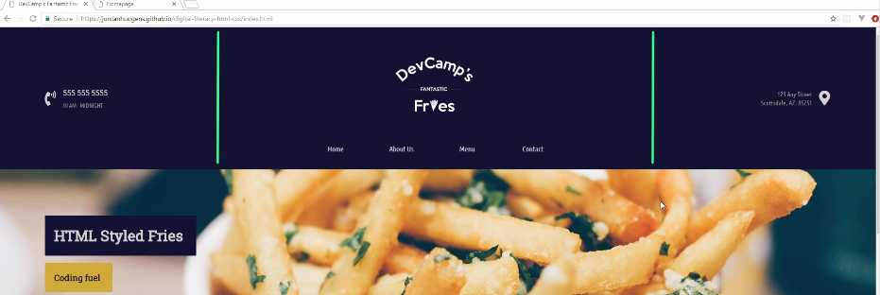
Years ago if you wanted to implement something like this, this took quite a bit of work. Thankfully because of the skill that we're going to learn in this guide with Flexbox, this is going to be a relatively straightforward system to build out.
Let's switch back to our code here and then open up the text editor. What we're going to do is we're going to start at the very top of the chain here. You can see that we have this div and then inside of it, that's where all of the navigation elements are.
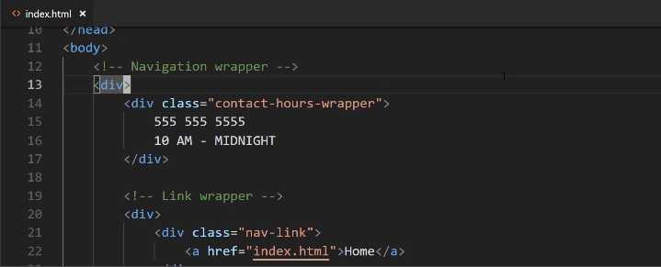

You can see we even put that comment there. Well, just like we did before, I'm going to get rid of the comment and instead, I'm going to give it a class. This is going to have class="navigation-wrapper".
Now let's come down into the styles.css, and at the very top here, I am going to add a comment. You can see the comments in CSS have a little bit different syntax where it's the /* */, then whatever you want to put inside of it.
Here, I'm just going to say, "Common nav styles", and the reason why I'm doing that, it doesn't have anything to do with code. It's just so that later on when we want to reference this, we'll know exactly where the nav styles are.
Right here, I'm going to start by adding styles to the navigation wrapper. Inside of here, I first want to establish a height. Right now, the height is going to be determined by the content and I don't really want that.
If you look at the end goal, you can see that this has a predetermined height right here. Let's come over and let's add that height. We're going to use a height attribute, and the value's going to be 190px.
styles.css
.navigation-wrapper {
height: 190px;
}
If you're not familiar with what a pixel is, it's pretty much what every kind of screen out there, every image, anything digital is made up of pixels. If you're looking at an image, is a great example, and you want to zoom in. If you can zoom in all the way to the pixel level, you'll see that that image is made up of squares.
What a pixel does is it is a unit of measure. Right here you'll see what we're going to do, is we're saying that we want 190 of those little squares, and that is what the height's value is going to be.
If you're coming from a non-coding background and you're just used to working with inches or millimeters or anything like that, a pixel is essentially the digital version of that unit of measure.
Now that we have a height, let's also add a background-color. So I'm going to say, background-color. Up until now, we've used these nice little names, and these are some built-in colors provided by CSS. We also have a few other options and we're going to talk about those throughout the rest of the course.
If you start off your color with a #, what this means is that you can give a hexadecimal value. I'm going to say #11122B. What this is going to give us is a nice dark blue color. That's going to be the background color.
Now, we also want to have a color for the text and so whenever you want to have a background color, the attribute name is going to be background-color.
Whenever you just say color, that is referring to the text. Here I'm going to give another # value and it's going to be #CBCBCB, just like that, and that will give us a light gray color.
styles.css
.navigation-wrapper {
height: 190px;
background-color: #11122b;
color: #cbcbcb;
}
Let's hit save, and just see what that's given us so far. There you go. You can see that we now have that dark blue color, and you may also notice that we have some white around the edges. I'll show you how to fix that because we want our background just like this to be able to be nice and flush.
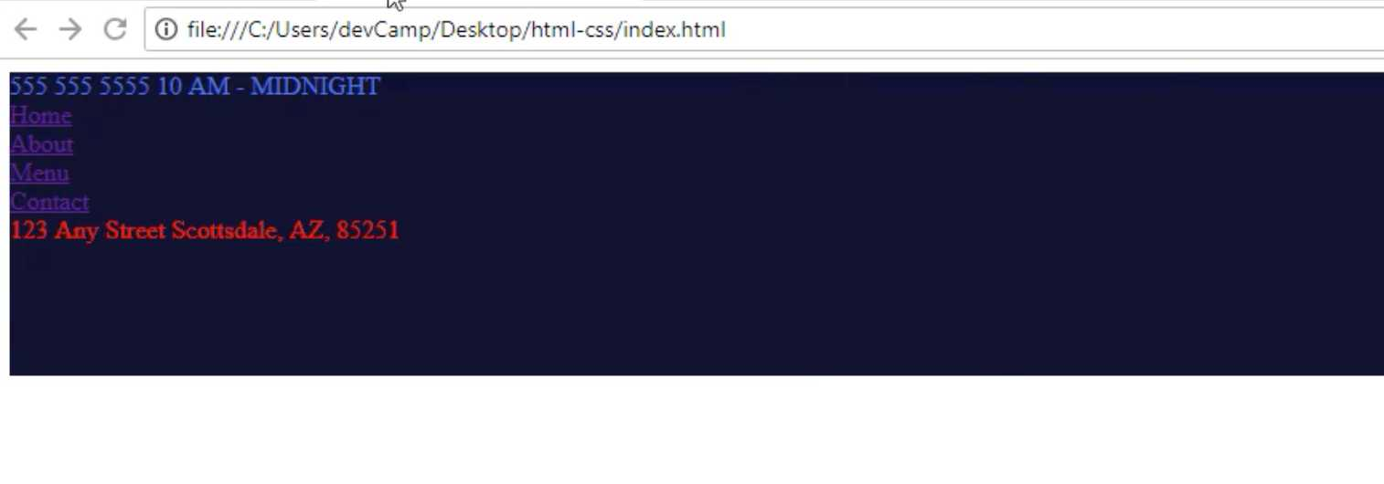
We're not going to worry about that right now. We'll do that later on. Now that we have that, we're going to get into using Flexbox. What Flexbox is, is it's built directly into CSS. You don't have to install anything or import any libraries or anything like that.
You can just use it if you're building CSS code. What it allows you to do is to align items on the page in a much easier fashion than before. If you were to see the way that we had to align items back 10, 15 years ago, it was really not fun.
You had to get a little bit tricky with how you arranged everything on the page, but with tools like Flexbox and CSS grid, it gives you a really nice way of organizing and aligning items.
Now, anytime that you want to have Flexbox used, the first thing that you need to do is type display, and then just say display: flex. That means that this navigation wrapper is now going to be what is called a Flexbox container.
I'm going to add a comment just right above here and say this is now making this a "Flexbox container". Don't worry about what this word means. We're going to talk about it, but it's a very important piece of terminology.
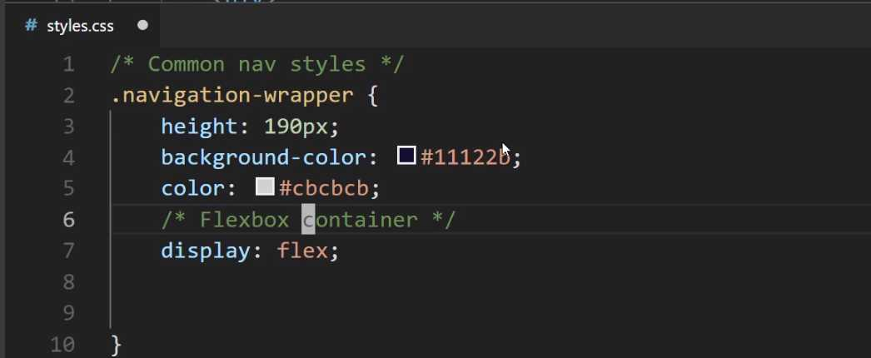

We have Flexbox containers and we have Flexbox items. As soon as you understand the difference between the two and how they work together, everything in Flexbox and how you can arrange items on the page is going to make a lot more sense.
Right here, we have now, because we've said display: flex, we've made the navigation-wrapper a Flexbox container. Let's also add a few Flexbox rules, so I'm going to say justify-content:. Let's make this one space-between and I'll talk about what that represents here in a second, and then align-items: center.
styles.css
.navigation-wrapper {
height: 190px;
background-color: #11122b;
color: #cbcbcb;
/* Flexbox container */
display: flex;
justify-content: space-between;
align-items: center;
}
For right now, let's keep it just with that. We'll add a few more things here shortly. If you hit refresh, you can see that that has now got us a little bit closer to our goal. Now obviously, we still have long ways to go before it looks like this.
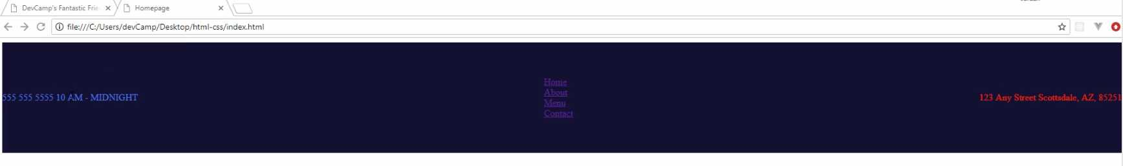
However, by using Flexbox you see how we were able to arrange the items on the page exactly where we wanted them. This is critical for understanding the way that the process works. What Flexbox does is we have made this entire unit here, so this entire nav bar is now a Flexbox container.
All of the items inside of it. So each div becomes a Flexbox item. The way that it works is we have now one container, and then we have three items inside of it. Let's look at the HTML code, and I'll close styles off here.
What this did is navigation-wrapper, when it became a Flexbox container, automatically with the way Flexbox works, is it took each element inside. It took this div of contact-hours-wrapper, then it took the link-wrapper, and then it took the address-wrapper and it made those all Flexbox items automatically.
Now, the way that Flexbox works is this is not a deep nested relationship. What I mean by that is that it only looks one level deep. So the nav-links, so each one of these links, are not Flexbox items.
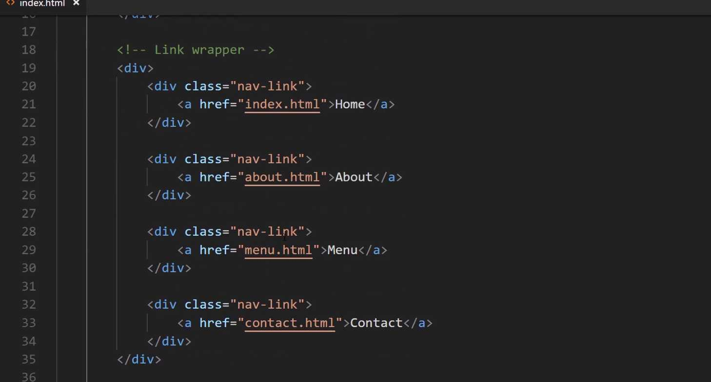
We're actually going to use another tool for that later on. All that Flexbox does is it looks at the very next level. If you think I'm going and I'm kind of repeating myself here a little bit, I am because this part is so important.
When I was learning how Flexbox works, it didn't really click for me until I understood this one process: that there is a parent-child relationship where you have this container element and then, however many items are inside, those are the elements. Those are the Flexbox items.
I just want to show you this one more time. If I add another address here, the way it works is if you come back here and hit refresh, you see how it got added automatically here to the right-hand side.
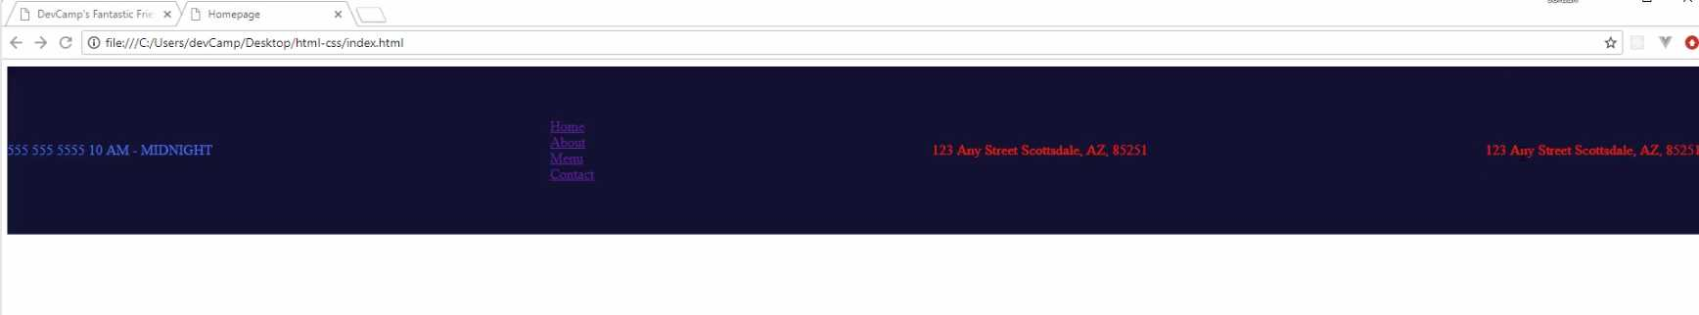

The way it works is you have the first element, the second element, the third, and then the fourth. Then to go kind of line by line, we'll open up styles.css. We gave our height, we gave our background-color and our color.
Then inside our Flexbox rules, we displayed flex, which made this a Flexbox container. Then from there, what we did is we said, justify-content. Let's talk about this. What justify-content does is it tells the elements inside how to behave.
It says if you want to do space-between, which is what we did, that means that the way they're going to be separated is by the space. All of the potential space between them. In this case, it is going to go all the way from side to side, and then they're going to be separated by whatever available space that they have in between each one of those items.
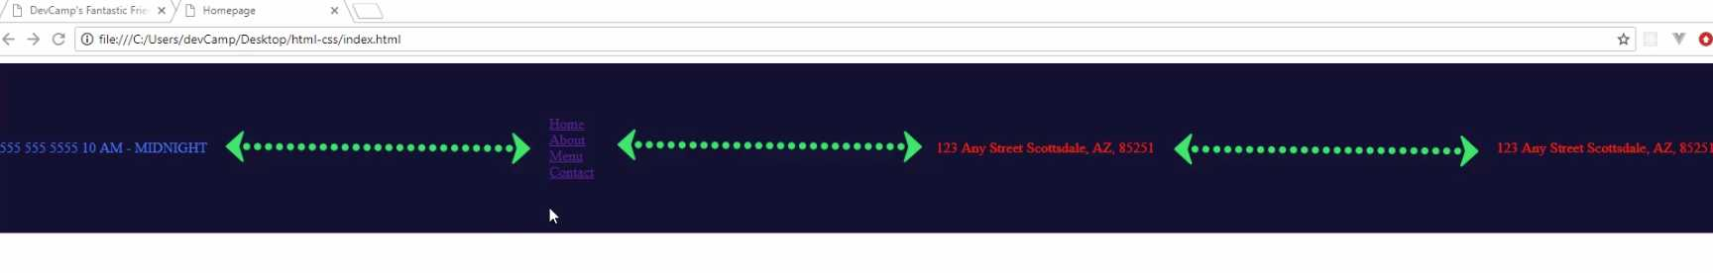
That space is flexible. If you were to come back here to index.html and let's add a few more of these, hit save, come hit refresh. Now, do you see how the space in between has shrunk?
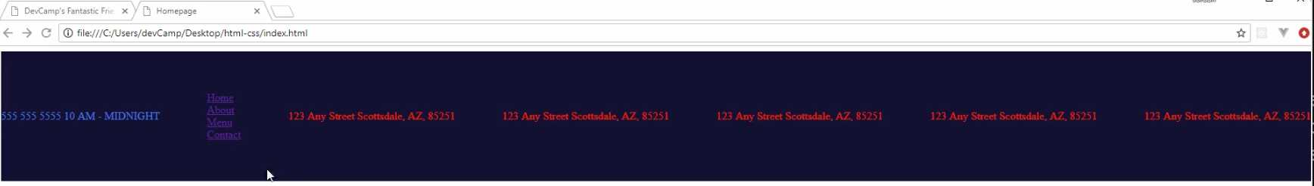
What that means is with space-between, it just is going to allow for any of the available open space to be used. You can see here in the final version, this is exactly what we have going on. Where we have the space-between has all of this open area.
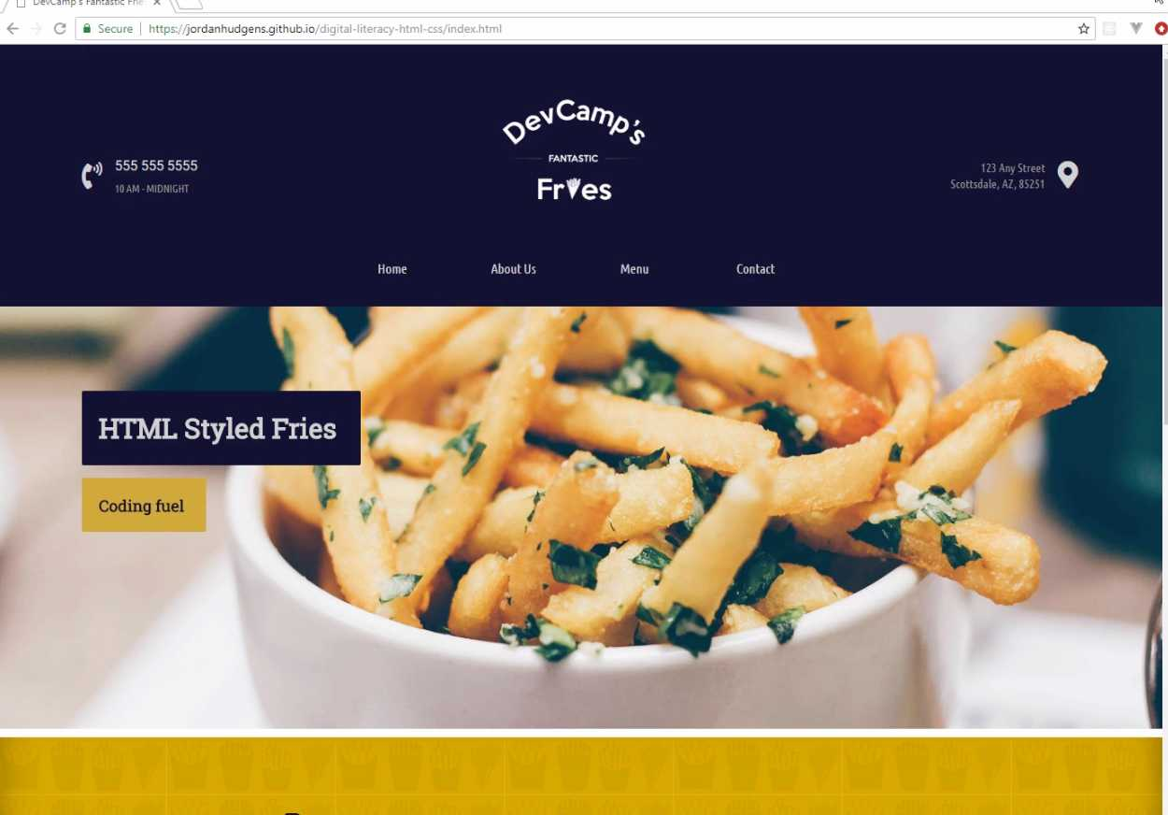
If we were to pop this open in a new browser window and shrink it, watch what happens. Do you see how the space shrinks depending on the size of the window? That's the way it works. It is not a hard-coded value.

There are ways of doing hardcoded ones. If you do need the space to remain there, but in our case, I want this to be flexible. That's giving us exactly what we're looking for right there. Let's come and let's get rid of the addresses that we don't need. Hit save, hit refresh, and we're back to where we wanna be. That is how justify-content works.
Now if you come down here, you can see that we also have align-items. The way align-items works, if justify content provides us the ability to tell Flexbox how we want these items to be aligned, what align-items does is it says how they should be aligned vertically.
When we said align-items: center, what we're saying is I want these items to be arranged at the very centermost part of that div element. That is going to be the way that they work. That's the way we want them to be because we want these to be centered.
If you wanted them to be at the top, then we would change this rule and we would say align-items: flex-start. Now, if you hit refresh, you can see that is at the top and let's also use these tools right here.
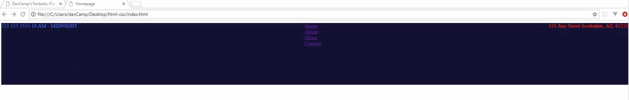
Let's use the browser tools. You can see we have align-items here. If we wanted to say flex end, you can see they go down to the bottom.
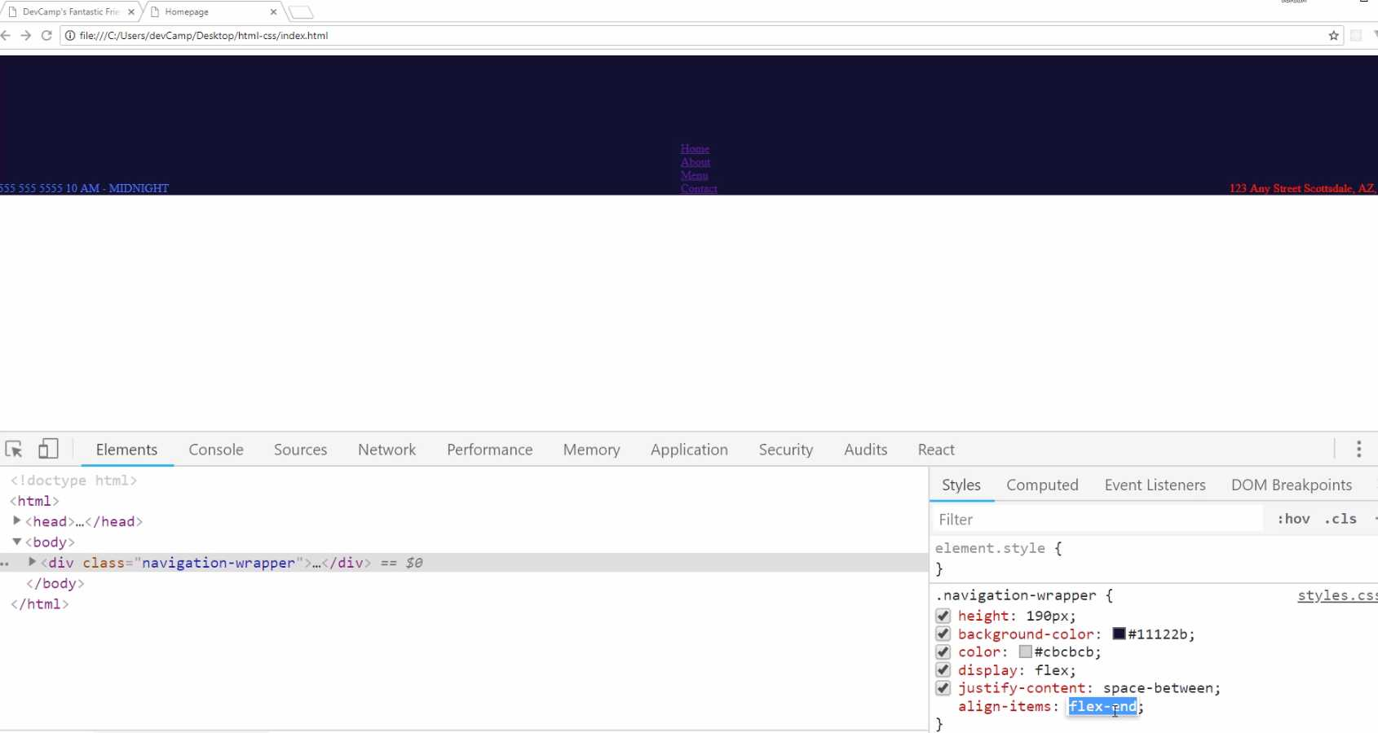
I'm going to go back to center. This is where we want them to be. Now, we also could play with justify-content. If you want to see some of the other options here, you have space-between. you also have center. If you wanted all of the items aligned perfectly in the center, then you could use the center rule.
Now, you could use flex-end and they would all be at the right-hand side, flex-start and they'd all be on the left-hand side. You can also do space-around. You can see our space-around places all of the items here. It takes open space on the left-hand side, open space between the elements, and then open space on the right-hand side.
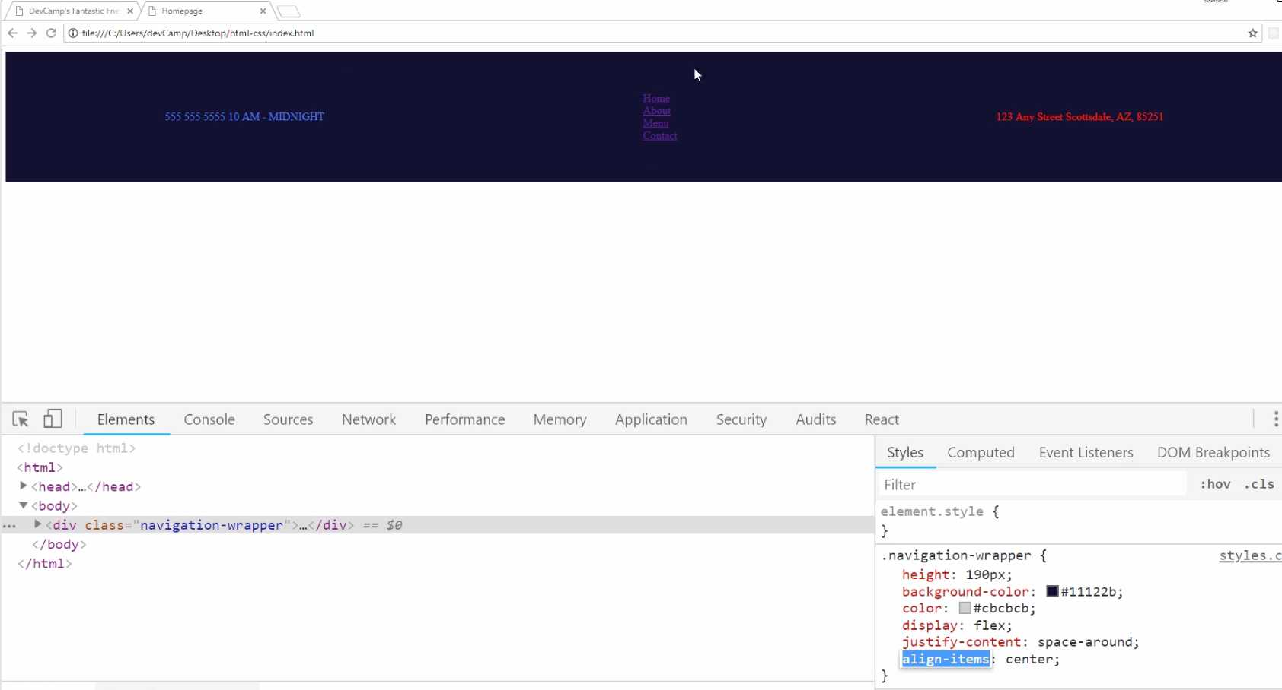
Now, I did contemplate using this. This would work for a number of situations, but later on, I'm going to show you, actually in the next guide, how we can hardcode some values. Because I would like to have some open values here.
I don't wanna use space-around on that side. I'd rather the middle be flexible, and then us to have enough open area here on the right and left-hand side, just to make sure that we always have kind of that symmetrical look.
I don't care about this space, but I do care about the space on the right and left-hand side. So with all of that being said, great job. If you went through that, you now know how to implement a Flexbox container and how to align the items inside of it.

Coding Exercise
Utilize flexbox with space-between and align the divs in the center, the same as you did in the video.
<div class="parent">
<div class="child">Spread</div>
<div class="child">These</div>
<div class="child">Out</div>
<div class="child">With</div>
<div class="child">FlexBox!</div>
- </div>

1.14 CSS Padding
This is going to be a relatively short guide, but we're going to discuss a very important topic in CSS. That topic is padding.
Let's switch back to the code, and let's also revert this back so align-items is back to center. I'm going to say align-items: center. Then as we've already discussed, we want to have some value, we want to have some empty white space here on the right and left-hand side as you can see this value that we have here.
Now, I did not want to use the space-around. It's mainly because I want to have exactly the type of look and feel what we have right here. If we had space-around, and we can actually change this just using the devtools. With navigation-wrapper, if I remove the padding, as you can see, that's going to change a lot of things.
Let's ignore that for right now. If I did space-around instead of space-between, you could see it kind of gets us where we want, but it's not perfect. It's not exactly what the designer originally intended.
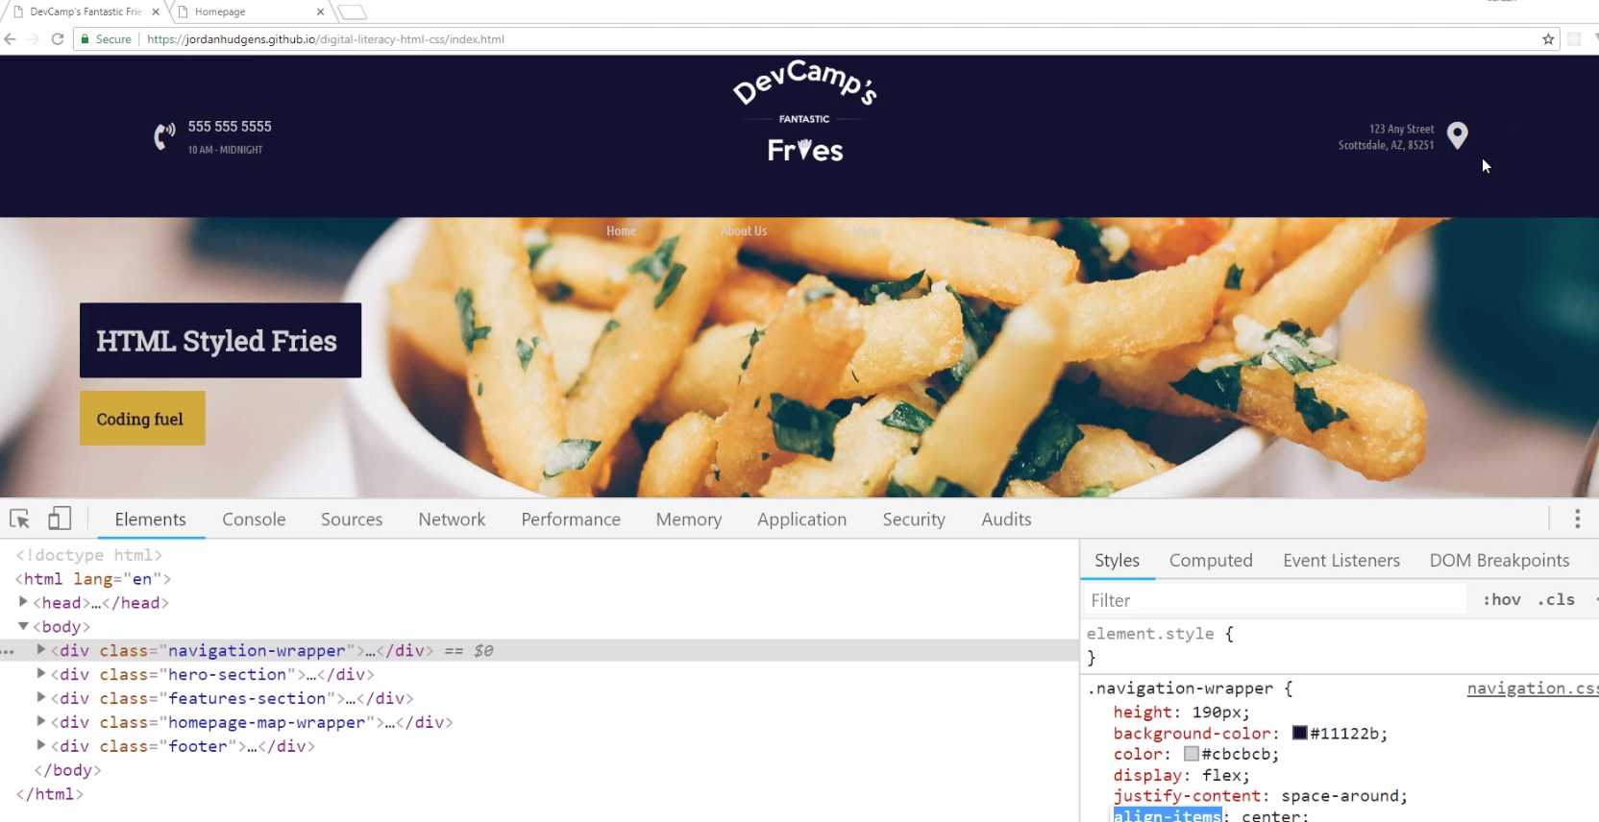
Instead, what I would like to do is I'd like to have some hard-coded values for the left and right here, and then also on the top and bottom. That's what padding is going to allow us to do.
I'm going to get us back to where we want here, and now let's come back into the code, and let's see exactly what we need to do. I'm going to, at the very bottom here, I'm still in the navigation-wrapper style definition, and I'm going to say: padding.

styles.css
.navigation-wrapper {
height: 190px;
background-color: #11122b;
color: #cbcbcb;
/* Flexbox container */
display: flex;
justify-content: space-between;
align-items: center;
padding:
}
Now, there are a couple ways that you can declare padding. I'm going to show you a few different options, and then I'm going to explain which one that I personally like going with.
We could say something like padding: 100px. This is going to be kind of the sledgehammer. This is going to change the padding for the top, the bottom, the left, and the right. If I hit refresh now, you can see that this is way too much space.
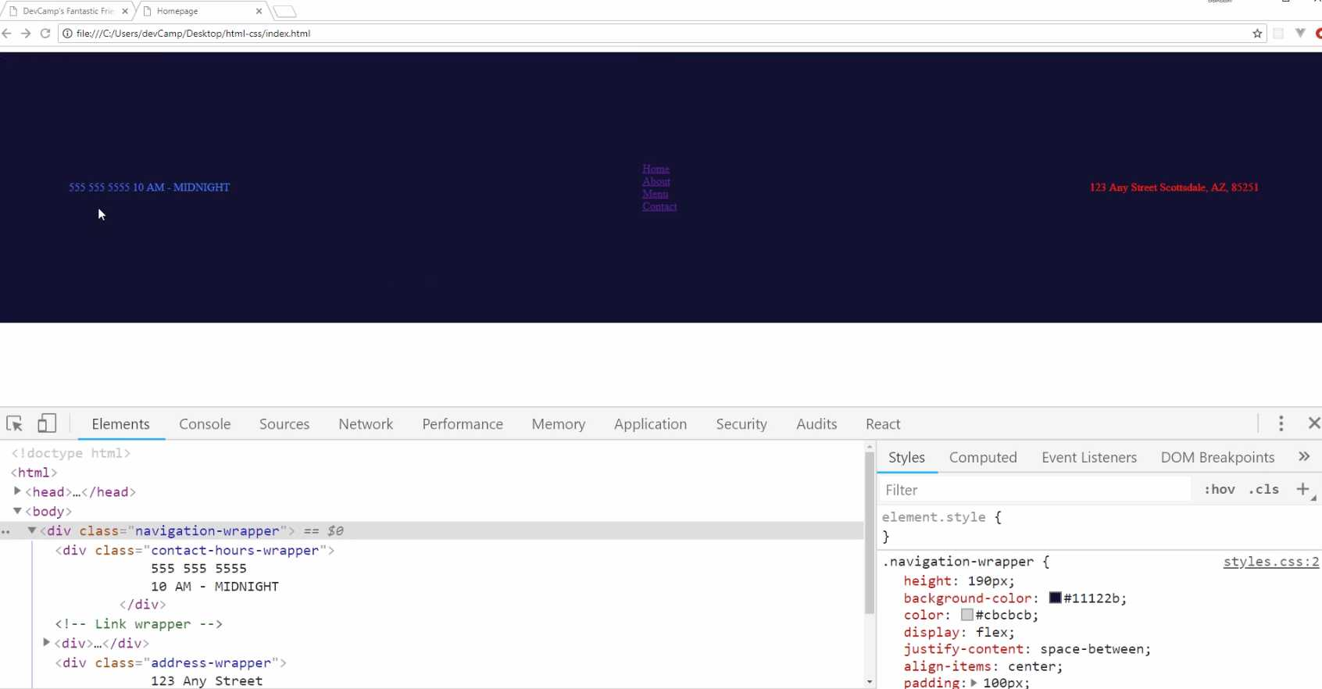
This is giving us padding all over the place. What I'd like to do is become a little bit more granular with it. Another option is I could go, and let me comment this out, I could create a rule for each side. I could say:
styles.css
.navigation-wrapper {
height: 190px;
background-color: #11122b;
color: #cbcbcb;
/* Flexbox container */
display: flex;
justify-content: space-between;
align-items: center;
/* padding: 100px; */
padding-top: 60px;
padding-bottom: 60px;
padding-right: 100px;
padding-left: 100px;
}
This is an approach that I will use from time to time, so if you hit refresh, you can see that that's giving us more the size that we're looking for.
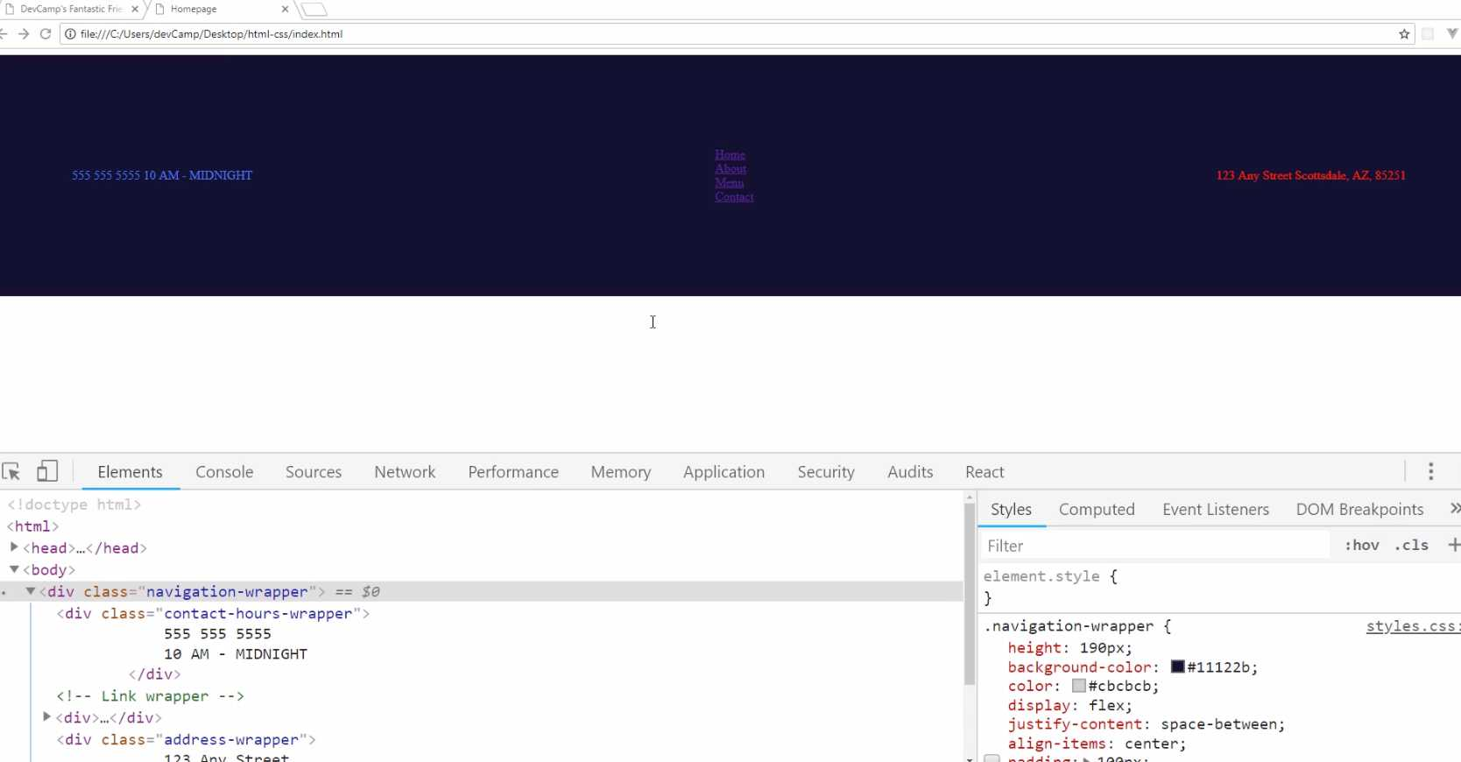
We still have a few other options, so that gives us the ability to do everything all on one separate line, but you can also do it all together. I could say padding here, and then you could pass in either two or four arguments. I'm going to do four arguments at first.
It goes clockwise, so the way it works is I could say: the top is going to be 60px. Then the next one is going to be to the right, so that's going to be 100px. Next one's going to be on the bottom. That's 60. Then left.
styles.css
.navigation-wrapper {
height: 190px;
background-color: #11122b;
color: #cbcbcb;
/* Flexbox container */
display: flex;
justify-content: space-between;
align-items: center;
padding: 60px 100px 60px 100px;
/* padding-top: 60px;
padding-bottom: 60px;
padding-right: 100px;
padding-left: 100px; */
}
If you think of the way a clock looks, the way that you give these style values here work exactly the same way. You just start at the very top of the clock, then you go to the right where the three would be, then you go down to the bottom where the six would be, and then all the way around to the left where the nine would be, and that gives you all of those values.
If you hit Refresh, you can see nothing changes. This is giving us the exact same control as when we did it all on their own dedicated lines.
Now, if you ever run into a situation where you see this, where you want to have identical values for the top and bottom, and then identical values for the left and the right, there's even another short-hand syntax.
You can come here, and you can just use two values. What this will do is you'll say, the first one is going to work for the top and bottom, and the second one's going to be for left and right.
styles.css
.navigation-wrapper {
height: 190px;
background-color: #11122b;
color: #cbcbcb;
/* Flexbox container */
display: flex;
justify-content: space-between;
align-items: center;
padding: 60px 100px;
/* padding-top: 60px;
padding-bottom: 60px;
padding-right: 100px;
padding-left: 100px; */
}
If I hit save, hit refresh, you can see we have the exact same values. Now, this is going to be the best solution for this particular use case. Just because we are in a situation where we want to have top and bottom the same and then left and right the same.
That is what I'm going to go with, but I did want to show you all three options just so you're always familiar with that. Hit Refresh. Make sure everything is working.
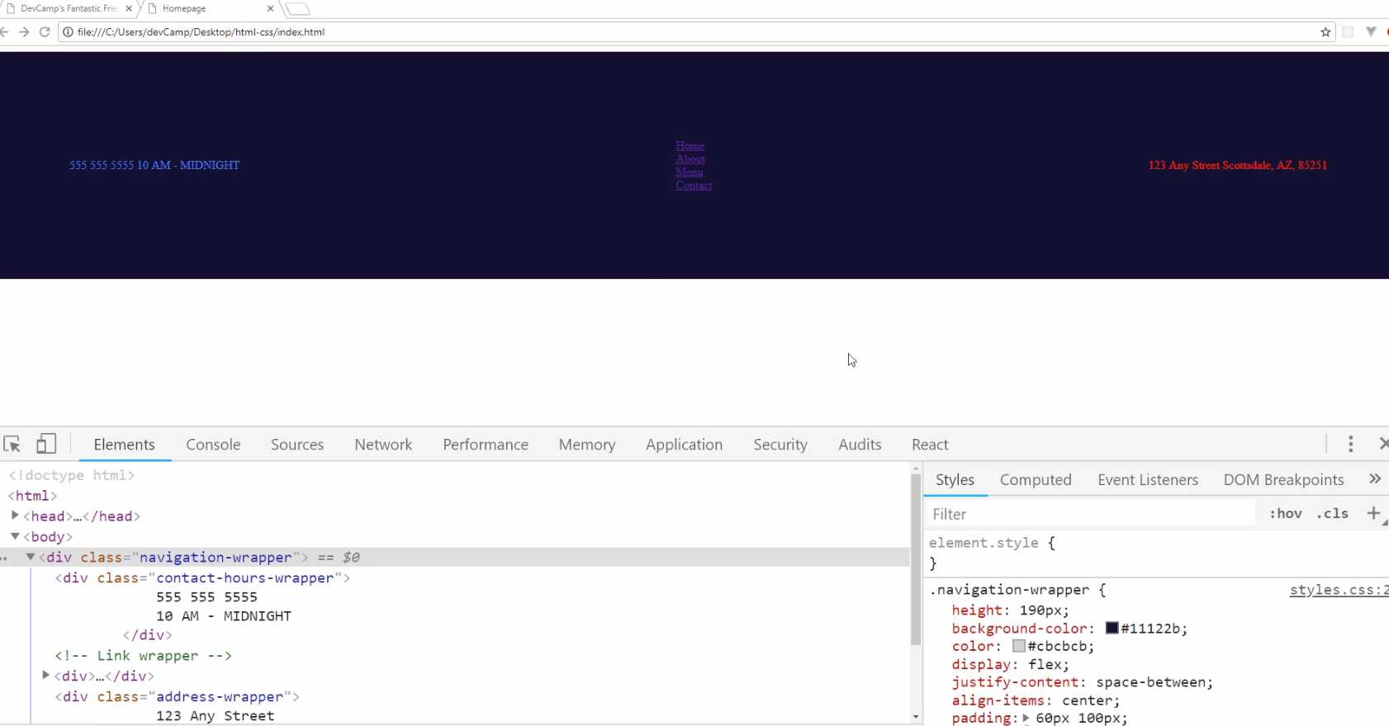

Now, before we take a break and go on to the next video, I want to show you what padding represents. Thankfully, there is this very helpful little diagram here that's provided with the Google developer tools that shows what padding is.
Right here, you can see that if you hover over padding on the top there, it actually shows in that green box what the padding values are. It even says that right there we have 60 on the top and bottom and then 100 on the left and right.
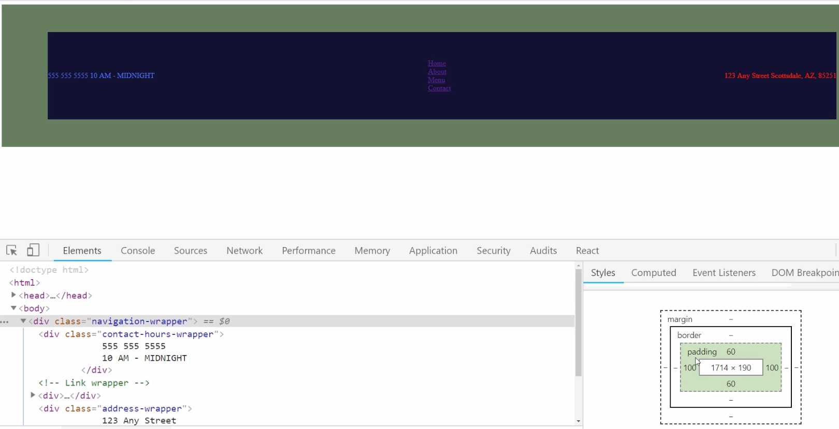
Now, make sure, if you're not seeing this exact value, make sure that you either go in here in the elements and click on navigation-wrapper or just go and select the navigation-wrapper using the inspect tool.
What this does is this gives you what's called the box model in CSS. We haven't talked about all of these yet, so I'm not going to get into them yet, but I wanted to show you padding because this is very helpful.
Whenever you're building out some kind of interface and maybe the items are too far to the right or to the left, or they're just not lining up the way that you want, one of the best ways to debug that is to come down here to this box diagram and see what the values are.
There are plenty of times where I've done that, and then I've seen that "Oh, there's some padding value that needs to be set," or, "The border's throwing it off, or maybe the margin," which we'll talk about these later on.
That gives you the full box model. You have the core content, which, if you hover over it, this shows you all of the flex items, and then outside of that is where the padding lives. Then the border, which right now, there is no border, and then the margin. We haven't provided a margin or border, so that's why they don't have any values.
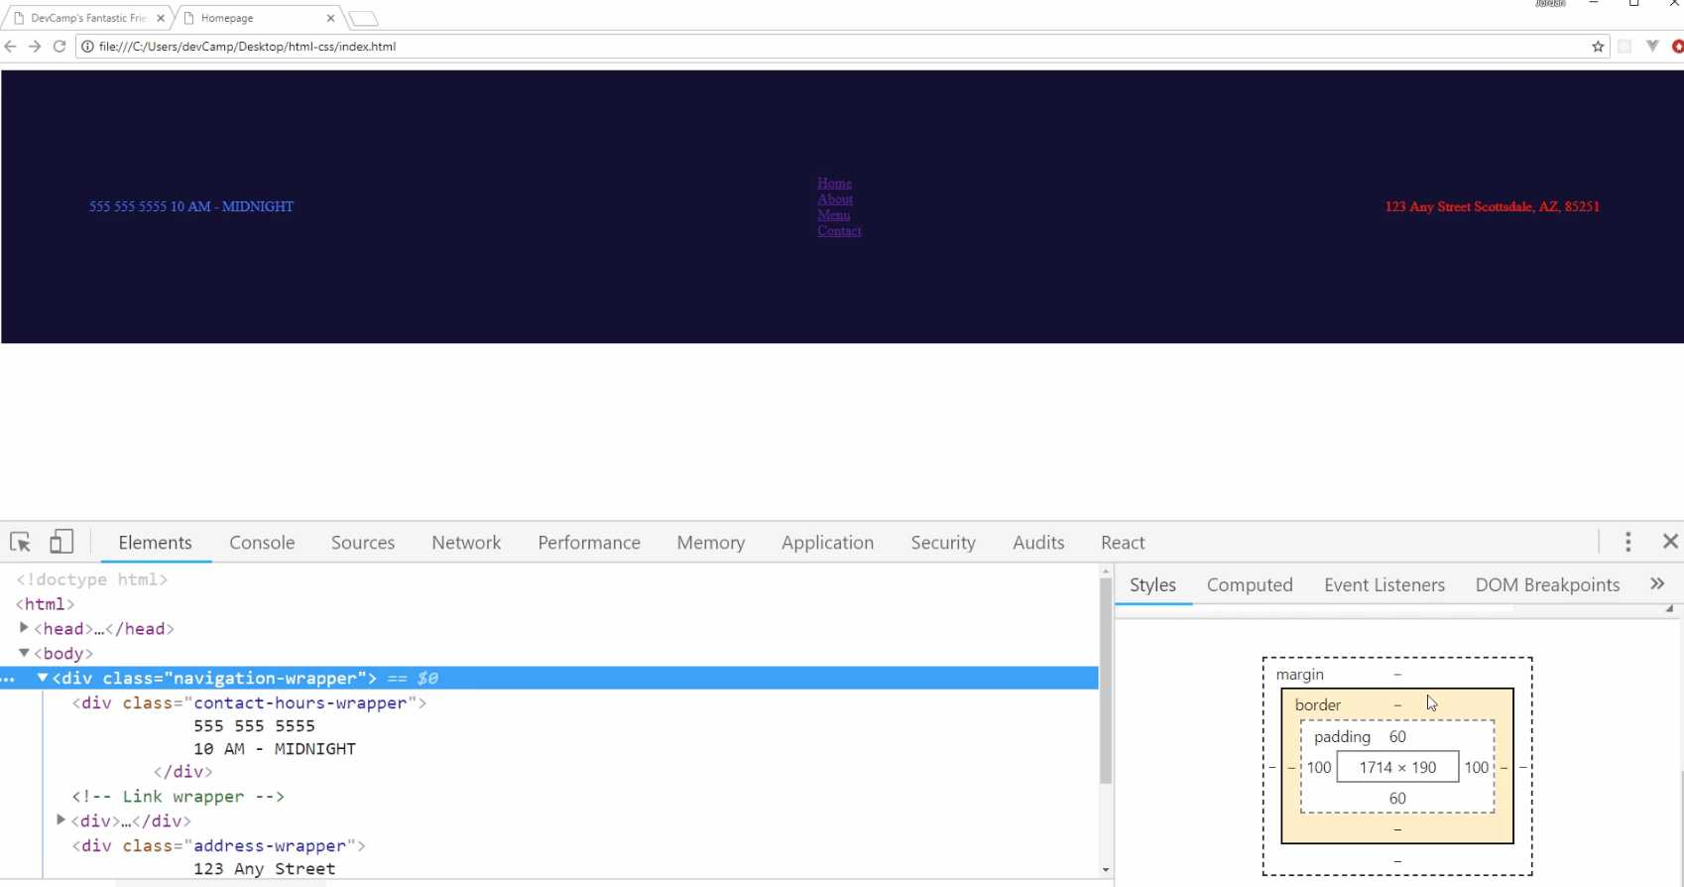
For right now, I think it really helps to visualize exactly what the padding represents and what it represents for every stage and around each side of the div. If you went through that, great job. You now know how to work with padding in CSS.

Coding Exercise
On the div tag below, add padding of 20px to the top, 43px to the right, and 50px to the left.
<div class="style-this-div">
<div>Item 1</div>
<div>Item 2</div>
</div>

1.15 CSS Margin

In the last guide, we talked about padding. I think it is a natural progression to now talk about margin.
We also have a little bug here that I want to fix, and it's a perfect case study for how we can use margin. Now, do you see right here? Might be a little bit hard to see on your screen, but you see how there is a white border going around the entire div that we have here?
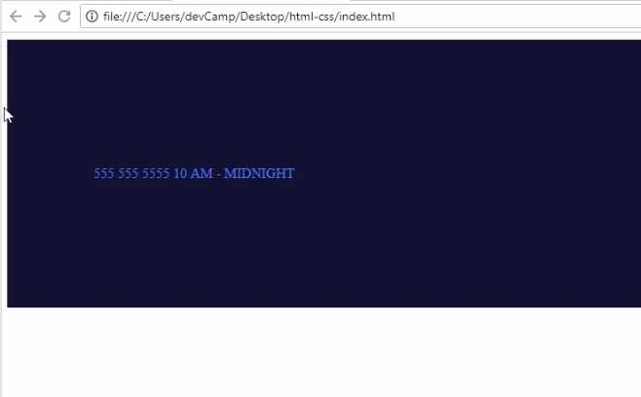
That's not what we want. We want our entire website to be flush. The reason for that border is because, by default, HTML wraps a margin around the body tag.
You can see this for yourself if you click on body here, and then you come down to where you see our little box model diagram. Do you notice how it has a margin of 8 on the top, right, bottom and left parts of the body?
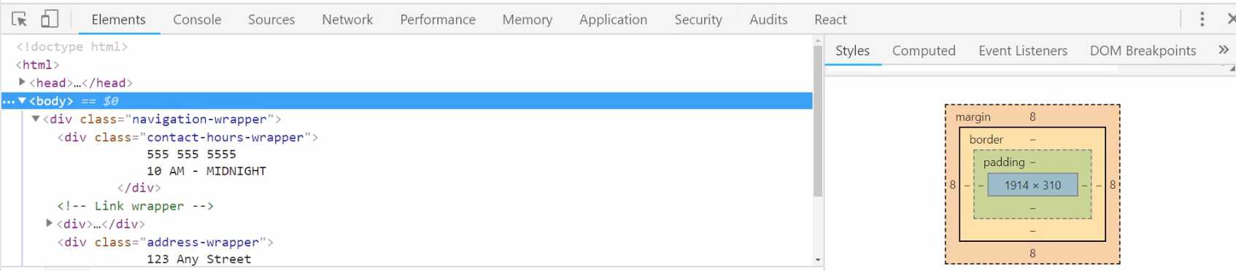
That means that if you put all over kinds of elements here, you had all kinds of images and text and everything, you'd always have these 8px of margin right here. Well, we can get rid of that by overriding the value.
Let's switch back to the code here, and I'm going to come up to the very top. I'm just going to add a comment, and we'll call these "Common Styles" because these are styles that are going to be used for every page of the application.
The way that you can select the body because it's a tag, you can just say body, you don't have to have a class or anything like that for it. You can say:
styles.css
/* Common Styles */
body {
margin: 0px;
}

/* Common nav Styles */
.navigation-wrapper: {
height: 190px;
background-color: #11122b;
color: #cbcbcb;
/* Flexbox container */
display: flex;
justify-content: space-between;
align-items: center;
padding: 60px 100px;
}
Now if you hit save and come back, you can see that that has now overridden the value and now we don't have any margin here. That is the way it works.
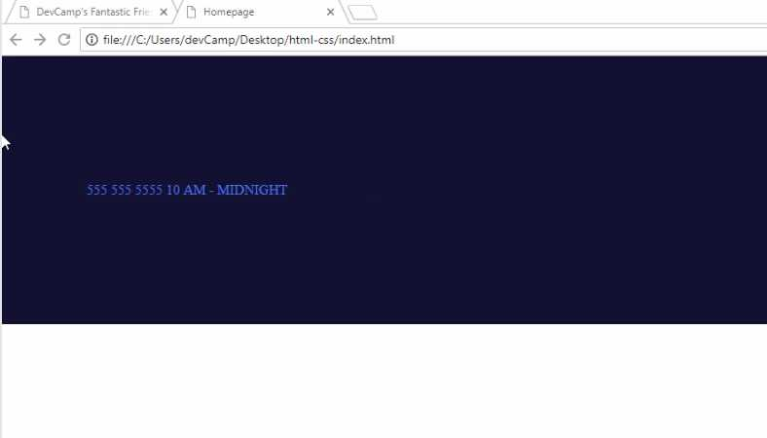
Now, if part of that is still a little confusing or fuzzy, what I recommend is playing around with both values and seeing how they change. After this video's done, just don't go on to the next one.
If it's not clear, update the padding values, and watch how everything changes right here in the diagram. You can look at the body and see that now we have no margin. There's no margin going around it, but if you click on navigation wrapper, you can see how we have padding and no margin.
You can also even edit that, so you can click on navigation-wrapper. See what happens if you come down here and say, "okay, what happens if I have a margin of 30px". You can see how it is now wrapping 30px around every edge of that div.
Now that's not what we want, but the whole goal of this project and this course is for you to understand the way that HTML and CSS work. So, I definitely recommend for you to explore those.
This diagram right here is incredibly helpful. It gives you a really nice visual for being about to tell the difference between margin and padding.
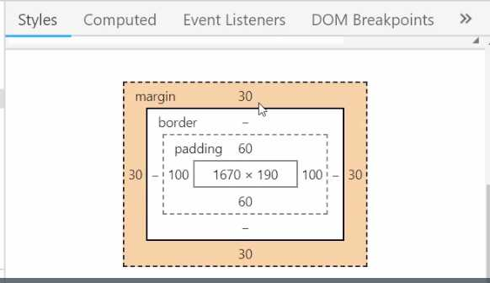
The key one, being I think pretty clear right here, and that is, the margin is the space. It's the white space that goes around the outside of whatever element that you're working with. The padding is the white space inside of it. That is the main key difference.
Later on, we're going to talk about the border. The border is the little component that separates the margin and the padding, but we're not going to use a border on this element, so it's not needed.
After you're done, you can always either just hit refresh or click this little checkbox and it'll go away, and you'll be back to where we need to be.

Coding Exercise
Apply a margin of 15px to all sides of the below div.
<div class="card">
Some content
</div>

1.16 Custom Icons, logos, ...

In this lesson, we're going to walk through how we can import Font Awesome to start integrating icons into our website.
As you can see here from the finished version, you can see that we have this little phone icon here and we have a map icon. Those are, even though they look like images, they're actually just fonts. They're just characters that we can use.
That makes them very helpful because you're able to treat them like fonts, which means they scale up as big as you want, they don't get pixelated or distorted and they worked quite nicely for that. Now to bring Font Awesome in, just start typing in font awesome into Google, and then it'll take you right to FontAwesome.com.
Depending on the version that you are using, then you may have some slight differences, some slight variations, but for the most part, you should be able to use exactly the same workflow that I'm showing right now.
If you click on start using here, this is going to give you whatever you need in order to import font awesome into the website. What we're going to be doing is we're actually going to be pulling in a CSS file provided by Font Awesome.
When we do that, we'll have access to their full free library. They also have a paid version, but we're just going to use the free one, so you can click on the little copy code icon here.
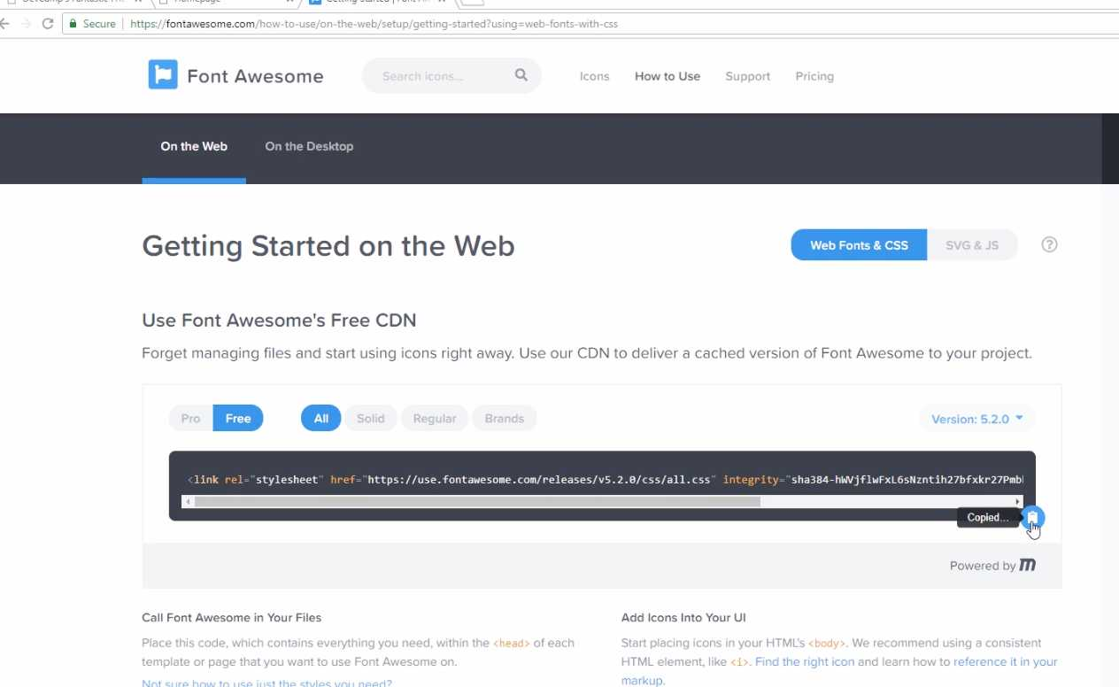
Then if you switch back, and go to the index.html. Now, this is very important. You need to make sure that you are putting this above the styles. I'm going to paste that in and hit save.
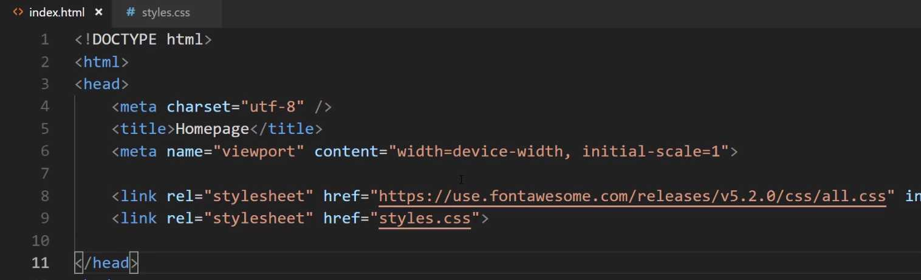
The reason for that is because we're not going to do it in this course but I don't want you to be confused in a different project. If you ever call any of the icons from the CSS file, because of the cascading nature of CSS, you need to make sure that you're importing at above whatever file you're going to use.
We're going to be calling it directly in the HTML though, so you could technically put it anywhere. Just as a best practice, you always want to make sure your fonts are above your style sheet calls. Now that we have that, let's see if we can actually get this working.
Now I'm going to go to Font Awesome and you can go search for icons. I'm just going to type in phone and you can see that we have all kinds of different icons. If they are darkened, that means that they're in the free version. If they're lightened and they're kind of grayed out, that means they are in the paid pro version.
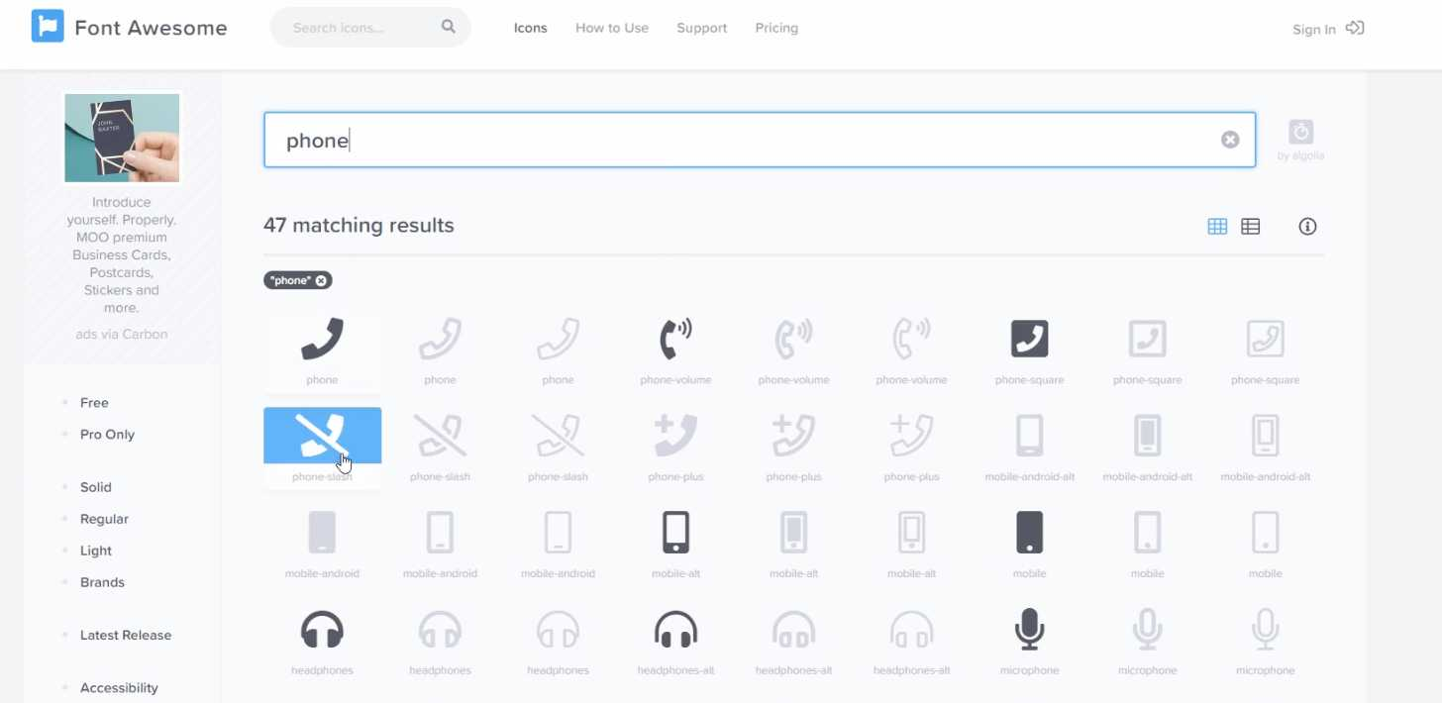

Just click on this phone volume icon. This is going to show you all kinds of different variations and different things like that, which is helpful. The way that we're going to import it is it actually gives us the HTML code right here.
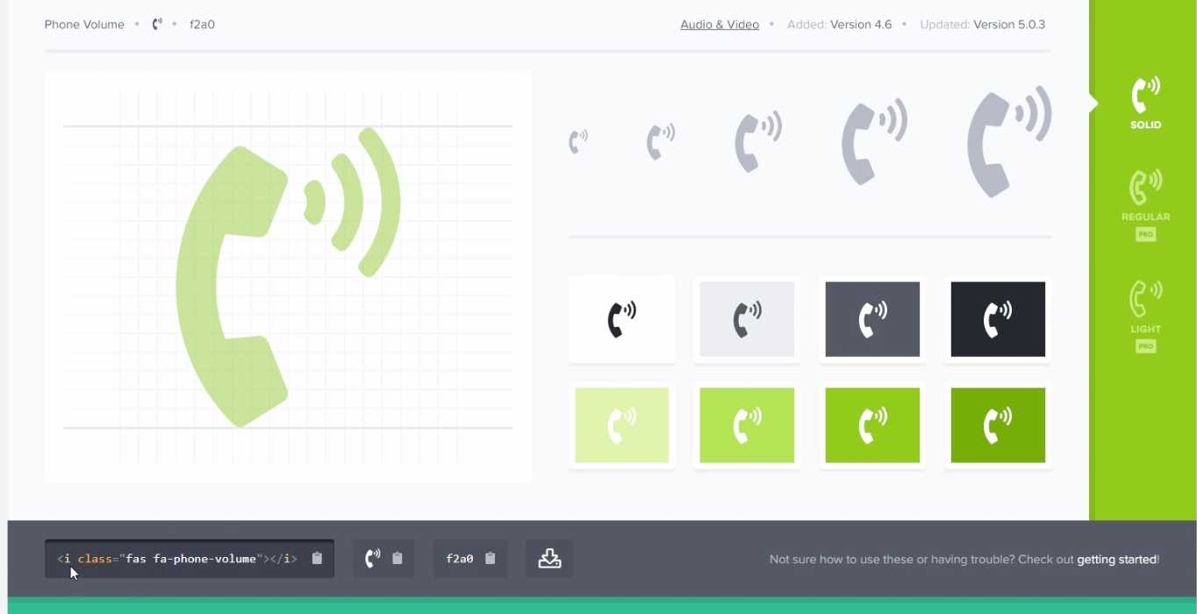
It gives us an icon tag which is represented with the i and then it has a specific class. The way that this works is pretty cool. It is connected directly into that CSS file that we imported.
That CSS file from font awesome that we just put in the index.html file, what this is going to do is when the webpage finds this icon with the class of fas fa-phone-volume, it's going to look to see if there is any spot where these classes are defined and it's going to find them.
Then it's going to render this icon on the page. To get this working, just click on copy code.
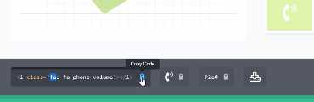

Then go back to the homepage and open up the text editor. Now inside of contact-hours-wrapper here, let's go and let's place in that code. We're still going to do some work and we're going to add some more divs to organize this properly, but for right now, let's just put it right next to each other.

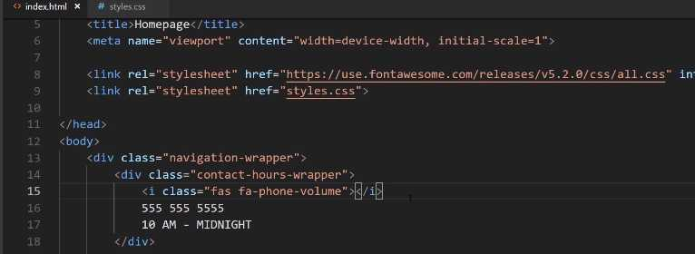
Hit save and hit refresh over here. You can see we have our little icon there. Now we'll style it and we'll make it look good, but that gives us exactly what we want.
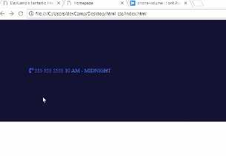

That means that we have one, we've imported Font Awesome properly and two, we have called it correctly. Now that we have that, there's one other icon, this little map icon, so let's come back over here and search for a map.
There you go, you can see it right here. It's called map marker alt or short for alternative. Let's copy this.
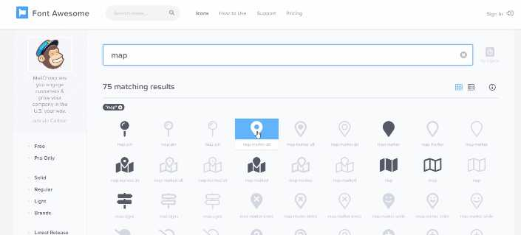
We're going to do the exact same thing down here just to make sure that we can call it inside of our address-wrapper.
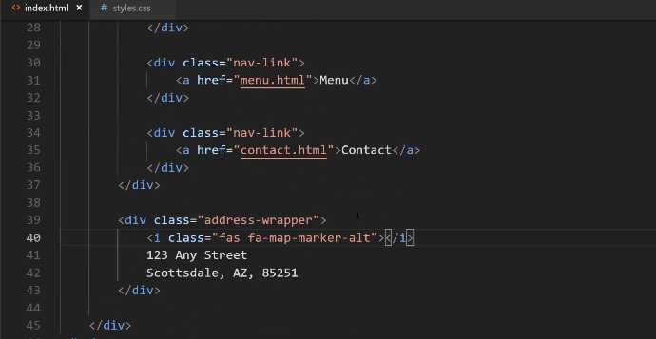
Hit save and hit refresh and there you go. We have our little font awesome icon for the map.
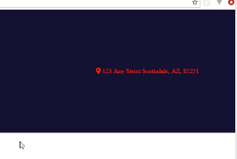

Now we're going to learn how we can move it and arrange it properly. We're going to use some other divs and CSS classes to do that, but for right now, we have now successfully brought in Font Awesome and now we can use their full library of icons.

Course Update: New Import for Font Awesome

Note

You will need to use the FontAwesome CDN for the latest version of icons. Place this script tag in your project instead of the link tag used in the ###video

<script src="https://kit.fontawesome.com/0f3793b933.js" crossorigin="anonymous"></script>

Also note you may need to apply styles for FA icons to show up in your project, an FA sometimes removes or changes icons so check their free icon ###names.

Alternatively, if you continue to have issues with using FA, it is recommended you create a free account with an individual provider link:

https://docs.fontawesome.com/web/setup/get-started
Whenever I hear that students are running into a potential issue, then I wanna push up and update just so that you're not spending a lot of time confused or having to go through a complex debugging type session. So in the very next episode, I'm gonna show you how to integrate Font Awesome into the application. But Font Awesome has changed slightly since I originally recorded this, and so there's a slightly different process that you need to implement in order to get it working, and so I'm gonna show that to you right now, and then you'll be able to implement it in the next video.
So right here, I'm not working on the project itself. I have just a dedicated html file, and this is gonna give you a little preview of how to import Font Awesome. So right here, this is what we're gonna do. We're gonna make a link call, and we're going to import the style sheet for Font Awesome, and that's gonna give us the ability to have all the icons, and this url right here had a few issues for certain students on certain systems,
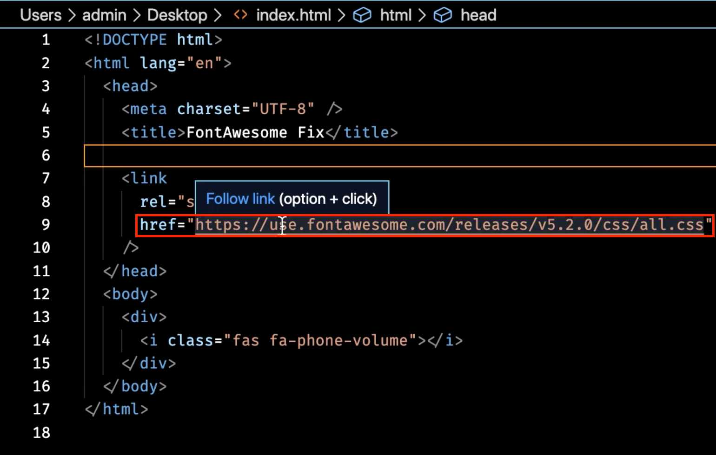

and this is what I, this is the exact url that I show in the next video, so I don't want you to use that one, or if you do use it and your icons don't show up, then you can implement this fix.
So if I switch to the browser here, you'll see that this is working for me, and it might still work on your machine. It's only on machines that have certain firewall settings and certain browser rules that this breaks for. And so this, the fix I'm gonna show you, is something that may not even be necessary, but I wanted to include it just in case. So in order to get this working, we simply need to change this url here.
So I'm gonna get rid of the entire link here, and in another window, I brought over the link that you need to use, so I'm just gonna paste this in. And this is a pretty long link, so do not worry about actually having to type all of these characters in, because that would not be fun.
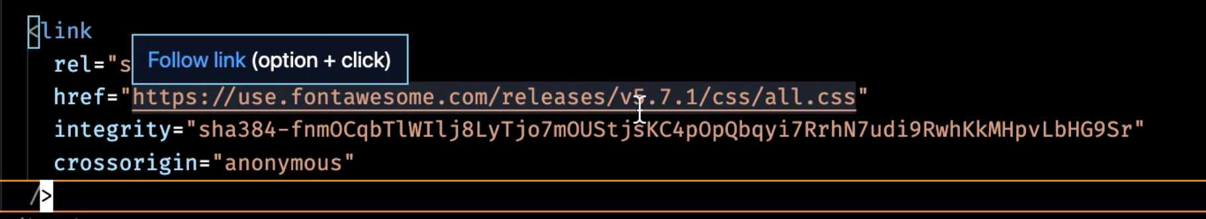
In the show notes, at the bottom of this guide, you can go and just copy this link and that's what you can use in the next video. You can see, I'm using a slightly different version of Font Awesome, but it's gonna be exactly the same in terms of how you make the calls and how the icons show up, and then it has a few flags here, and this is the reason why it's going to work, it has a cross origin flag, and then it has an integrity flag, and so certain browsers that have settings where the security's pretty high, the old url call was not working for those.
So this is one that will work, and so if you run into any issues, you can just use this code, and if you switch right back to the browser, you'll see that still working. So good luck in the next lesson.

New Import Code
<script src="https://kit.fontawesome.com/0f3793b933.js" crossorigin="anonymous"></script>

Updates
<i class="fa-solid fa-phone-volume"></i>
<i class="fa-solid fa-location-dot"></i>

Coding Exercise
Go to FontAwesome.com and search for "Instagram". Then place the i tag with the Font Awesome class name for Instagram, below.

1.17 Child tag elements
In this guide, we're going to work more on our icon and hours of operation. The way that we'll do this is utilizing something called "Parent-Child relationships", which will give us greater control in our styles.
We're making great progress as we're building out this project. Now, if you are curious, and you're wondering if it takes this long to build out every single website, the answer is no.
Part of the reason why this is taking us awhile is that we're not just building out the website, we're also learning all of the key HTML and CSS fundamentals as we go. So, listening and going through those explanations definitely takes longer.
The more times you do this you're going to be able to eventually simply run through and build these types of projects very quickly, especially when you get a lot of practice with using tools like Flexbox.
Those are gonna be some of the bread and butter items that are gonna help you understand exactly how to place items on the page, how to align them, and how to style them however you need. So, with all that being said let's keep on building this out.
As you can see here on the left-hand side we have a little bit different set up than we're working with right now.


Right now we have all of our items right next to each other.

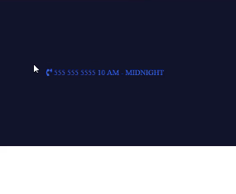

That is the default HTML behavior, but what I'd like to do now is I'd like to start customizing this.
The very first thing we're gonna do is we're going to create a wrapper div for all of this content. So, just like we have a wrapper Flexbox container for the entire nav bar, we're now going to create a component that is going to wrap up our little phone icon, the phone number, and then the hours.
So, let's get started with that. Open up index.html and in this contact hours wrapper, let's create a wrapper for that, and I'm going to call it the left column because that's what it is. It's gonna be that left column.
index.html
<div class="navigation-wrapper">

<div class="left-column">
<i class="fas fa-phone-volume"></i>

<div class="contact-hours-wrapper">
555 555 5555
10 AM - MIDNIGHT
</div>

</div>
let's just see what this looks like now.

Now you can see that it's changed the color because this is no longer highlighted and it's no longer in that contact hours wrappers, so it's not blue anymore. This is a little bit better except right now it's using the default HTML behavior, and instead, I'd like to use Flexbox.
This gets to a very important topic, which is that you can have flex items that also are flex containers because remember, this whole nav bar is a flex container.
This contact element here is a flex item, but we can make it a flex container, and then all of the elements inside can be aligned however we need to. Let's go and let's do that. I'm also gonna add another wrapper class for this icon.
index.html
<div class="navigation-wrapper">

<div class="left-column">
<div class="icon">
<i class="fas fa-phone-volume"></i>
</div>

<div class="contact-hours-wrapper">
555 555 5555
10 AM - MIDNIGHT
</div>
</div>
I had one of my early mentors who helped me understand some best practices with HTML and CSS. What he told me was that he has never had a situation where he had too many divs, but he had plenty of situations where he didn't have enough.
Remember that when you add divs you're giving yourself the ability to have more granular control over the items. You can align them better. You can style them with more specificity. That's gonna give you just a lot more control as you build out your interfaces.
So, now that we have this left column let's actually turn this into a flex container. Let's go into styles.css. This is still under common nav styles, and also just to make sure that we are not confusing ourselves I'm gonna get rid of these placeholder color items.
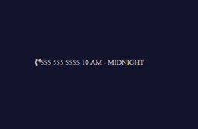
styles.css
/* Common nav styles */
.left-column {
display: flex;
align-items: center;
}
Now if we hit save and hit refresh that is getting us a little bit closer.

That looks really good. The next step is going to be to give some styles to this icon.
styles.css
/* Common nav styles */
.icon {
margin-right: 15px;
}
Now, this is going to take us into a very important topic which is Parent-Child Relationship Selectors. Now if that sounds very foreign and confusing do not worry. We're gonna go over a lot throughout this course.
We want to apply styles not only to the icon, we also want to apply styles to that little 'i' tag inside of it. What we can do with CSS is grab specific tags, Like so.
styles.css
/* Common nav styles */
.icon {
margin-right: 15px;
}

.icon i {
font-size: 2em;
}
Now, do not worry. We have not talked about this yet, so that's what we're gonna discuss this little EM. So far everything we have talked about has been in pixels. Pixels are what you use when you want to have a hard coded unit of measure.
We talked about this before, and we said pixels are kind of like inches or centimeters. They are a hard coded, definite type unit of measure. A EM and its sibling REM, what these are is they are more like percentages. So, if I said, 1em nothing would change here.
That 1em is going to give you just essentially 100%. What 2em is gonna do is it's gonna give you whatever double the normal size is there. So, we're gonna be able to control this font size, and this is gonna increase the size of the icon.
Now that we have that, our phone number and the hours are sitting right on top of each other, and that's not what we really want.
In the next guide what we're gonna do is we are going to learn how to use a very powerful tool called CSS Grid to be able to build a little grid here that is gonna help us align these items.
Coding Exercise
Using CSS Parent-Child Relationship Selectors, make the nested p tag's text red.
<div class="elephant">
<p>Make this text red!</p>
</div>

1.18 CSS grid
Right now, we have our nav bar that's using Flexbox, and we have a little component for a font awesome icon, a phone number, and then our hours, and this is another Flex container.
Now, CSS Grid is a tool that has some similarities to Flexbox, but it gives us some different utility, and that's what we are going to utilize here. Specifically, we're going to use it so that we can have the phone number on one line, and then our different hours right below that.
Let's go and let's see what that syntax looks like. In our styles.css you can see we have our icon, we have this left column, and we're going to use the left column, and we're going to learn, also, about how we can give some more specific styles.
You can see our contact hours wrapper is a child of the left column div. Here's what we can do
styles.css
.left-column > .contact-hours-wrapper {

}
What this is telling CSS is "I want you to find the left-column, and then from here, I want you to find the child class of contact-hours-wrapper. We're going to refactor and dive a little bit more into this in one of the next guides.
You're going to see how we can do this for all of our classes. We'll also talk about the importance of it. But for right now, just know that this is very similar to what we did on line 27, where we used the icon class and then we grabbed all of the I-tags inside of it.
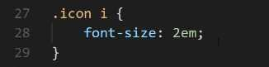

Let's add some styles.
styles.css
.left-column > .contact-hours-wrapper {
display: grid;
grid-template-columns: 1fr;
}
Now, this might be a little mind-blowing if you've never seen it before, so we'll walk through it. What we're saying here is, Grid, as you may have guessed, it works on a grid-type system.
If you were to look at the website, what that means is you have the ability to set up a grid, however you want, here on the page. You could have 12 columns, you could have one column, and you could have it separated and organized however you want.
Now, I'm using Flexbox for these other elements, and so we're going to simply be using Grid right now for this element, but what I'd like to do is I would like to stack the phone number on top of the hours.
Now we're just going to have two rows, and it's only going to have one column.
Right now, we're saying we want to have 1fr grid-template-columns. What does fr mean? We haven't seen that before. What fr means is it stands for one fractional unit. This is pretty much the same as saying, "I want you to take up all of the space available, and I want you to just go with the default."
Now, we're going to talk about a few options later on how you could change that, and we'll also have some other examples.
But for right now, know that if you use grid-template-columns, and you just say, "1fr," this means that the first child element is going to take up all of the first row, and then any elements underneath that are going to take up all of their rows.

Let's save this and see what this does.
If we hit refresh nothing is changing, so let's debug this. Let's go to our left column here, and then we have our icon. We have our contact hours wrapper, and we have grid-template-columns. Oh, and I know what our issue is.
Earlier, I said how you can never have too many divs? Well, I was right, and you could see what the bug is here.
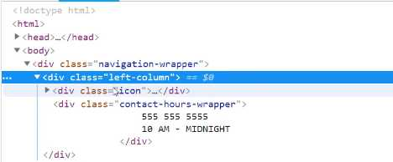

This works the same way the Flexbox works. Remember how Flexbox works where it does not have deep nesting. It simply looks at all of the elements inside. So, in the case of our contact hours wrapper, even though we have two lines, it still only sees one element.

What we need to do is to create some wrapper divs here.
index.html
<div class="contact-hours-wrapper">
<div class="phone">
555 555 5555
</div>

<div class="hours">
10 AM - MIDNIGHT
</div>
</div>

Now, I did not do that on purpose, but I am kind of glad that it happened, because you're able to see the issue on why it's so important to have these wrapper divs and to wrap your elements up, because it gives you the ability to treat them as separate components on the page.

Now if we hit Refresh, there we go.

Now this is doing exactly what we're wanting.
Now, I promised that we were going to have a visual, so let's take a look at this. If you are using Chrome or Firefox and you click the Inspect tool, and then come over here and click on contact hours wrapper, do you see how those little-dotted lines there that are separating our two rows?

That is a very helpful little tool that the browsers give us. This is invisible to regular users unless they open up the dev tools, but what this does is it is only shown whenever you're using CSS Grid, and it also gives you the ability to visualize where those columns are.
Let's play around with this a little bit.

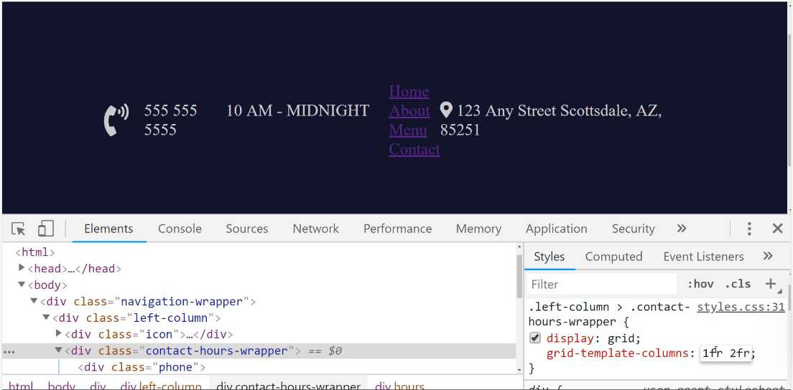
When you say 2fr then that tells the grid that we don't want one column, we want two columns.
The first column we want to take up just the normal amount of space. The second column we want to take up double whatever this one is, which is the reason why the hours here are much wider than the phone number.
Now, if you reverse this, you can see how this is now taking up double the amount of space.
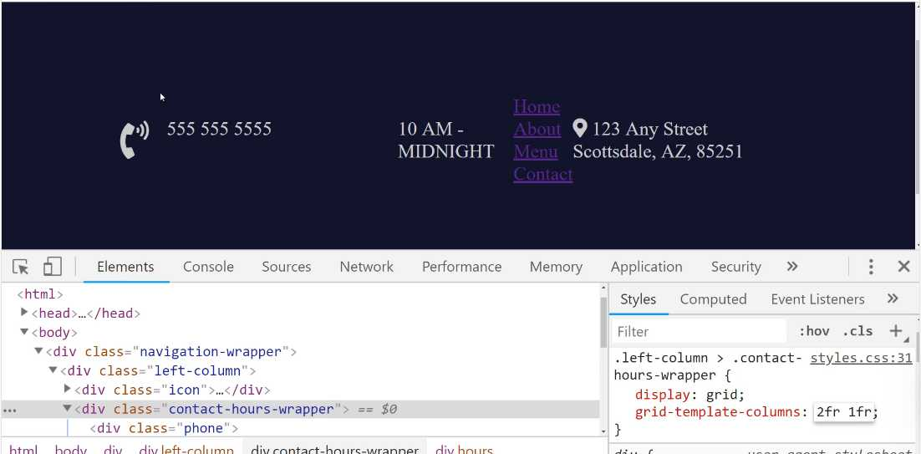
This is something that's really helpful. We're going to be talking quite a bit more about Grid as we go throughout the course. This is just the introduction.
But you can see how powerful this is. This gives you the ability to create these kinds of grids anywhere in the application that you want.
It's technically possible, to lay out your entire application on a grid, so everything from the nav bar down to all the elements underneath it, all of that would be one master grid. Then you could integrate Flexbox and Grid inside of it. That's definitely a possibility.
Let's go back to where we were before, and there's one more element I want to show you because it's quite helpful, and that is called Grid Gap.
We've implemented Flexbox, and now we've implemented Grid. They're very similar, your first question may be, "Why would I want to use Flexbox versus Grid?"
My answer to that is usually if you know how many elements that you are going to have for just a guaranteed number, then I like to use Grid, where there is a little bit more hard coding into it. So, if you know exactly how many columns you're going to have and that kind of thing, then Grid works really well.
If you want to have more of a variable number of items, kind of like you saw how we were able, earlier on, how we were able to add as many addresses here as we want, and we were able to make the navigation bar very flexible simply by using Flexbox, then that's what I like to use.
But what my top advice really is to work with both of them a lot, and then use them when you feel like it's the most appropriate. There's not really a right or wrong answer, so don't feel afraid thinking that you need to know when it's right to use one versus the other.
I have seen some fantastic applications where the developer might have done the exact opposite. They would have used Flex when I used Grid, and vice versa, and it still works. So, I'd say, use whatever gives you the best results, and whatever you understand the best.
As we go through the rest of this application, we're going to be using both quite a bit. That is what we have there.
Now, the other thing I really like about Grid that isn't really available in Flexbox is, do you notice how these two items are kind of close together? If you look the end goal, they have some space between them.


Well, Grid has this really cool little tool here, and it is called grid-gap. I can say, "grid-gap," right here, and then I can pass it a value, like 10 pixels.
Now do you see how we have this space here?


We didn't have to mess with padding, we didn't have to mess with margin, anything like that because those can throw your items out of alignment. You notice how we had to do that for this icon, and that was perfectly fine because we were just moving this and giving a little space in between.
But here, whenever I'm working with vertical alignment, grid-gap works very nicely, because it just does all that for you. It manages the margin, the padding, and it looks really nice.
Now, if you click on here, now you can see that our columns actually have some space in between them.


They're both exactly the same height and width as they were before, but now what it does is it just automatically puts some space between those, and it's still aligned perfectly.
If you were to try to say, "Add some margin-top here," or "some margin-bottom here," you might run into a situation where they get out of alignment, but grid-gap allows you to have that space automatically.
I'm just going to copy this, and this is a pattern I follow quite a bit, is whenever I don't know the exact styles I want to implement, I will use the developer tools here in Chrome, and build those styles, get them perfect to exactly where I want them.
Then from there, I can just go and I can add them directly into the code. So, I can just paste that in,
styles.css
.left-column > .contact-hours-wrapper {
display: grid;
grid-template-columns: 1fr;
grid-gap: 10px;
}
This is starting to look a lot more like what we have in our design. In the next guide, we'll go and we'll style this up, and we'll also start importing our custom fonts.

Coding Exercise
Apply grid to the parent container. Then apply 3 template columns of the same size, each being 1fr, and a grid gap of 23px.
<div class="grid-container">
<div>Use</div>
<div>Some</div>
<div>Grid</div>
</div>

1.19 Importing Custom Fonts
Our navbar is coming along nicely. Along the way, you are learning a lot about HTML and CSS. The next thing that we're going to learn is how to integrate custom fonts.
Fonts are absolutely critical to giving a really nice look and feel to your application. You can even see the difference, look at right here. We have pretty much all of the same components here, from a content perspective.
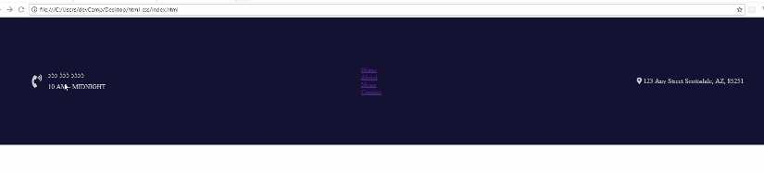
Look at the difference between this application, and what we have right here just on the navbar. The fonts make a huge difference, and so now we're going to learn how we can install custom fonts.

The first thing you're going to do is go to fonts.google.com. This is a great source for free custom fonts that'll look really good. They also have some really nice ways of showing how you can integrate it directly into your project.
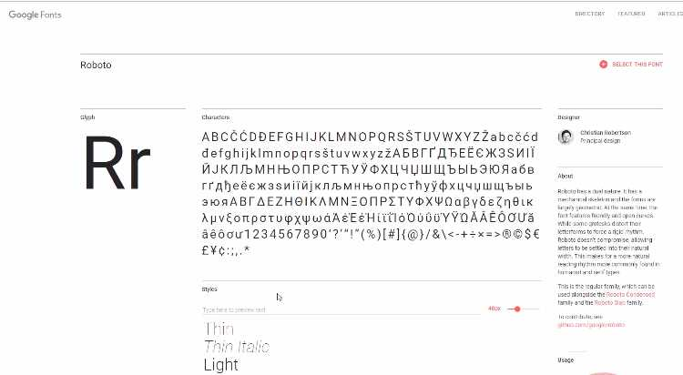
There are going to be two fonts that we're going to pull in right now. The first is called Roboto, and you can either search for it right here, in the top right-hand side. You also have access to see it right here.
I'm going to search for it, just because I'm assuming that most of the time it's not going to be something that's readily available. You can see it is right here, and there's a couple things you can do.
When you're researching fonts, you can click on the name, and then it has all kinds of helpful details. It shows all the different versions, it shows usage, it shows some nice combinations, different things like that.
Now, you can also click on select this font, and it says you have one family selected. It gives you instructions on how to integrate it into your application. I'm just going to grab this standard link here.
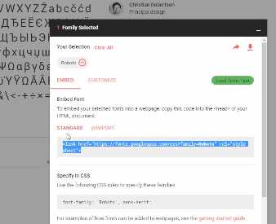

Let's switch back to the code, and let's put this at the very top. You can just put it right above where it says font awesome. That's going to be the first one. Now, we also want to install a second font.
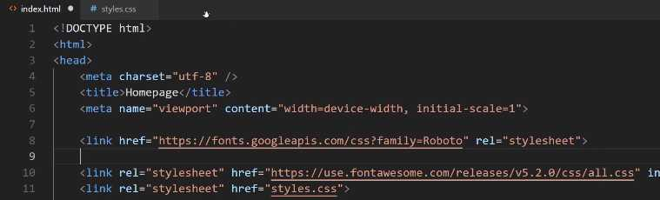
Oh, one other quick note, we need to bring in this font-family for the entire project. This is going to be the master font-family.
If you want to use something else, that's perfectly fine. Have fun, and search through the Google Font library and use whatever you want, because the process is going to be identical with what we're doing right here.
In addition to importing it, we also have to use it. So, I'm going to switch back, hit save, and come to styles.css. Right in the body, because this is going to be the master font for the entire application. Hit save, and this is going to be imported.

styles.css
body {
margin: 0px;
font-family: 'Roboto', sans-serif;
}
Now, the way that this works is we have a normal style declaration here, where it says font-family, and then we give the name that we want to use. The other items and you can have more than one extra one, but what this does is like you can see, if you hover over it. It says it specifies a prioritized list.
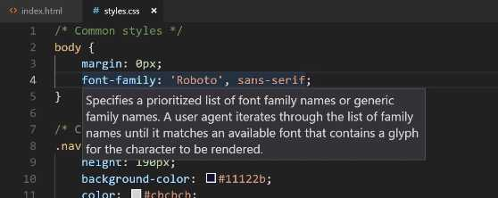
That means that the project is going to try to load Roboto, and this is the imported version. Imagine that you are, say, in an airplane and you're working on this site, and you do not have access to pull this down. Because in order to import this, this has to call a website and ask to bring it down.
This is not going to be an issue doing that for regular users, because the only way they can access your site is if they're on the Internet. That's not going to be an issue, assuming Google doesn't go down, which it is pretty reliable.
What this does, though, is it gives you the ability to have backups. Every system in the world has these fonts that are built directly into the system.
What we're saying here is if for some reason Roboto is not available, such as you working on the site when you're on the airplane, and you don't have Roboto on your system, then just use the default sans-serif font.
What sans-serif means is there are a couple different kinds of fonts out there. You're going to, as far as generic fonts, you're either going to have sans-serif fonts, or you're going to have serif fonts.
The difference is something I can show you. Let's see. I'll actually just Google it because it'll be a little bit easier for you to see. I'll say serif font. You can see right here, just by clicking on some of these images, what the key differences are.
If it's a serif font, it means it has these little edges on the end. This is just kind of a generic serif font, here.

Whereas a sans-serif font, if you click right here, doesn't. This is helpful, you can see them right next to each other. Serif has all these little curves and edges and it's a little bit more kind of old-school. Old-school meaning like a couple hundred years ago in regards to how the original typewriters used to be.
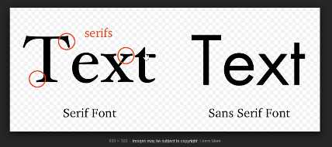

Right here, this is just more of a machine-based kind of font. This doesn't have any kind of curves or edges around the beginning or end. This is a sans-serif font. This is what we're going to use for the majority of the application.
That is all that that means. Let's put it back, so we're using sans-serif, hit save, and now we can actually go and look at the website, even before we go and import the other one. If I hit refresh now, you can see we have a different font. This is now using Roboto.
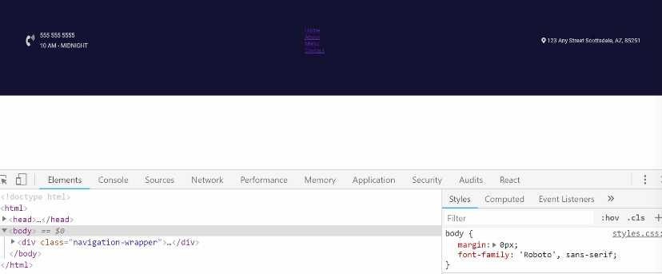

You can see right there in the body we now have font-family: Roboto, and this is looking better. It's not perfect yet, but it is looking better, so let's bring in the second font here. I am going to say clear all, and then let's search for it.
I'm going to use one called Ubuntu. I'm going to use Ubuntu Condensed. Right from here, you can either click on it, or you can just click the plus sign right from here, and it's going to have the exact same instructions.
I'm going to import this into the HTML page, so let's do it right here.
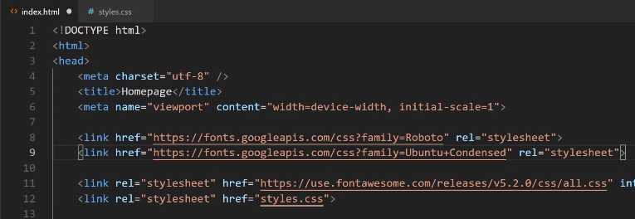
Then we want to call it, but we only want to use it on a few elements. Roboto's going to be the main font we use throughout the entire project, but we want to use this on a few custom elements.
If you come back and look at the final version, a few spots that you can have right in the nav that are going to use it are going to be the hours, the little nav links, and then the address right here. Let's go and apply those right now.
For our phone, let's come down and see where we put the phone number. It looks like we haven't added a custom one yet, so let's do that now. I'm going to say, inside of the contact-hours-wrapper, we are going to have a phone class. There we want the font-family to be the Ubuntu Condensed.
styles.css
.contact-hours-wrapper > .phone {
font-family: 'Ubuntu Condensed', sans-serif;
}

Let's just make sure that our selector is working. If I come back here, hit refresh, you can see that that phone number's working. Except, it looks like I actually reversed it. We want the phone number to be the Roboto, I want the hours to be different.

Let's see what that hours selector is, I'm pretty sure I just used hours, and yes, that's correct. Instead of phone, just change this right here to say hours.
styles.css
.contact-hours-wrapper > .hours {
font-family: 'Ubuntu Condensed', sans-serif;
}
Hit save, hit refresh, and there you go. Later on, we'll add some polishing touches so that we can have some of that different coloring and also the smaller font size, but we're not going to worry about it now.
Now, let's go and let's apply this to each one of these links. We're going to have a whole section dedicated just to styling these links, but for right now, let's just apply the font to them.
We know what we want to apply if you just click on inspect. We have this nav-link, so let's go and let's go and style the nav-link. We can say nav-link a tag because we want the a tag inside of that nav-link, and there we want to use that font-family.
styles.css
.nav-link a {
font-family: 'Ubuntu Condensed', sans-serif;
}
Now, if we come and hit refresh, it's a little bit hard to see, so let's add a different color here, as well. Just because I know, especially if you're watching on video, it's going to be hard to see.
styles.css
.nav-link a {
font-family: 'Ubuntu Condensed', sans-serif;
color: white;
}
We'll change it temporarily right now, and we'll most likely update it so we're not using a pure white for the links. Let's just do it so we can see it, and there you go. You can see that it is using that different font.

Lastly, let's go and do the same thing for that address. We have that address-wrapper, and let's come down here. We have the address-wrapper, we're going to have to apply CSS grid just like we did before.
For right now we'll just have the address-wrapper use this font. So here, we can just copy this whole line and paste that in.
styles.css
.address-wrapper {
font-family: 'Ubuntu Condensed', sans-serif;
}
Hit refresh, and there you go. We now have all of our custom fonts that we're going to want to use in the navbar, and we're going to be using that throughout the rest of the project, as well.
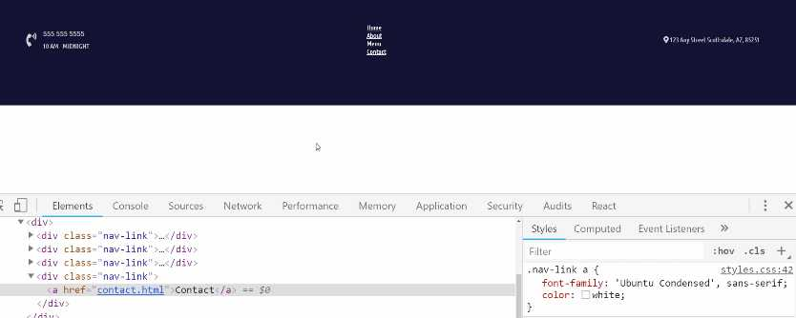
Great job if you went through that. You now know how to import and then use custom fonts in a website.
GoogleFonts: https://fonts.google.com

Coding Exercise
Go to GoogleFonts go to the categories dropdown selector and select monospace. Apply the CSS font family to the below span tag.
<span class="greeting">Hello World!</span>

1.20 HTML images: Importing, Styling, ...
We're going to see how we can import the image, how we can select it using CSS, and then how we can style it and customize its size. If you want to, you can use your own logo or you can use one of the demo ones that I have here. I'll include a link in the show notes for you.
The very first thing you can do is open this up and you can see we have a dark version and then a white version. For this specific background, we really need to use the white version. So, right-click on this and then click Save Image As.
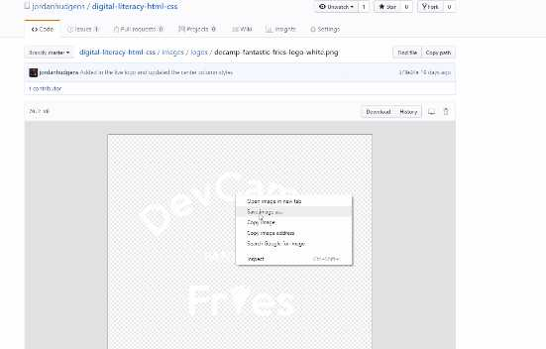
You can keep the name exactly the same and then place it inside of your project. Now, you can just hit Save right now, but we'll customize exactly where it's at so that we can see the path and so we can organize it properly.
If we switch back here and then go to the code, I'm going to place this above all the other nav-links here and let's just call it .banner-image. This is going to be a wrapper div. Then I want to use an image tag.
If you're using Visual Studio Code, you can type img, hit tab, and this is going to give you the values that you want. Now because we place this at the root of our project, you can see that we have this decamp-fantastic-fries-logo-white right here.
We could just grab this value. Let me actually copy that name, so that I'm not typing it out verbatim. Then you can place that inside of this src tag.
Now this src tag. It stands for Source, which means that we're telling the image tag that the source of this image is this path. Then we'll play around with how we can place this image inside a different part of the project.
index.html
<div class="banner-image">
<img src="decamp-fantastic-fries-logo-white" alt="">
</div>
Now we also have this alt tag. Here I'm going to say the Logo. Now technically. you could say anything that you wanted right here.
index.html
<div class="banner-image">
<img src="decamp-fantastic-fries-logo-white" alt="Logo">
</div>
The rationale for the alt tag is, there are a couple of reasons. One is if someone has disabled images in their browser, then the alt tag will show up instead of the image. The most common reason for using the alt tag is for accessibility reasons.
So if someone, say, someone who's blind, is going through your site, the way it works is there are systems out there that will read things like the alt tags in your content. If you leave the alt tag blank, then they're not going to know that a logo was there. That's part of the reason.
Google also reads through this for search engine optimization reasons. It's always good to put some kind of value here that describes what the logo is or that a logo is there. That is going to give us our basic import.
Let's go back and hit refresh, and wow, you can see, that it is imported, but that's definitely not what we're looking for. That's fine, that's what we expected.

By default, the way that HTML works is it brings in the image and it does not do anything to it. It doesn't try to make it fit or anything like that. That is our job. Now let's see how we can select this image.
We know that we have a class here called banner-image, and there are a couple of different ways that we could customize it. I could come in the tag itself and just say that I want to provide a hard-coded width inline.
Here I could say width, and for this kind of size, the value that I saw that looked the best was something like 216px. Then let's give it a height, and the height here, you can combine pixels and percentages. So, for the height here I could say just 100%.
index.html
<div class="banner-image">
<img src="decamp-fantastic-fries-logo-white" alt="Logo" width="216px" height="100%">
</div>
What this means is that we are controlling the width, we're saying how wide it should be. Then we're telling the height to just be automatic. I'll hit save, and now if I hit refresh, you can see that works. That looks really good.


That's perfectly fine. I usually don't do it this exact way. The approach I usually take is to apply an actual CSS class to it. So, if I have my banner-image here, what I can do is come down to the bottom of the styles.css file, and say .banner-image.
Then I want to select the image tag inside of that. Now I can apply the exact same rules. So here, I can say:
styles.css
.banner-image img {
width: 216px;
height: 100%;
}
Hit save, go back, and hit refresh. You can see that is working properly. That's just my own personal preference. Part of the reason is because I don't really like my images to get really messy.
The more code that you put inside of this tag, the longer it's going to be for you to find it when you need to fix it, and it just starts to look a little bit cluttered. I'd much rather put it inside of a style tag. That is how you can import and then customize an image using HTML.
There's only one more thing that I want to do before we end this guide and that is I want to place this inside of a little bit more logical place. Right now, you can see that I have the image at the root of the project, but this doesn't make a lot of sense because.
If I start bringing in dozens or hundreds of images, this is going to start to get really messy. Instead, what I'm going to do is I'm going to create a new tag or a new folder here. I'm just going to call it images, and then inside of images, I want to pass in another folder.
I can right-click on it and click new folder. Here I'm going to say logos, and then what I can do is I can just click and then drag this in, and it says, "are you sure you want to move this?" Yes, I say I want to move it.
Now this will break the site. If I hit refresh here you can see ... oh, one thing that is cool. You see that little alt tag is showing up. If the image is not available, it will show the alt tag.


Now we have a broken image and it's because we need to update the path. So here, I will say that I want it to find it in the images directory, in logos, and then it will go and find the image file.
index.html
<div class="banner-image">
<img src="images/logos/decamp-fantastic-fries-logo-white" alt="Logo">
</div>
Switching back to the browser, hitting refresh. You can see that the image is back and it is working properly.

Coding Exercise
Create a image tag with the src path set to my-great-logo.jpg and the alt set as My Logo.

1.21 Refactoring CSS Code … to use more specific selectors.

In this lesson, we're going to perform some refactoring. If you've never heard of what refactoring is, what it essentially means is when you have code that can be improved.
Many times it revolves around making sure that you conform to best practices, and so that's what we're going to do here. We, for the most part, have been following along with all the best practices that you'd usually want to use, but there are a few little items that I purposefully left off.
The main reason for that is because it's really important in understanding how CSS works. I wanted to start off with more of a simple implementation, and then show you why you will want to become a little bit more specific.
Let's switch back to the code, and I'm going to close this off to the side. Now, do you see right here how we have some generic styles here? So, navigation-wrapper, that's pretty specific but left-column.
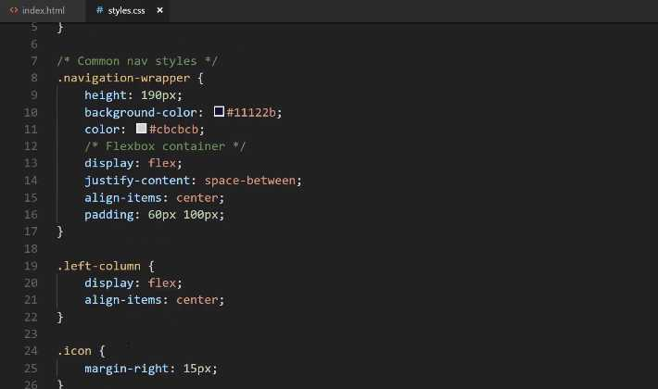
Let's imagine that you have a scenario where you want to use the name left-column later on, but you may want it on a different page. You may want to use it on the About page and you want to use this left-column and you may not want to use Flexbox. You may want to use CSS grid for it.
Well, with what we have right here, that would be a problem. We would have left-column and then either this set of styles would be applied for that other page or we would implement some other styles later on that would override these. Then that would cause an issue with the navbar.
What we're going to do is we're going to make our system a little bit more specific. We know that our left-column needs to have these styles when it's inside of the navigation-wrapper, so what we're going to do is we're going to use inheritance. We've shown how to do this right here on line 32.
We're essentially going to be doing the same thing. So here, I can say .navigation-wrapper and then we want to say .navigation-wrapper > .left-column. So inside of here, whenever you find a left-column we want you to apply these styles.
What this means is that if we ever want to use a left-column in some other part of the project, it's perfectly fine because it's not going to be nested inside of the navigation-wrapper. That's what we're doing there.
Same thing for this icon. We don't want to use a margin-right: 15px for every icon on the entire site. We simultaneously don't want to use a font-size, a 2em, across the board either.
We can look at the HTML here and so we can see that that icon here specifically is the icon that is inside of the left-column. That's where we want to apply those styles. We also have our little navigation-wrapper here.
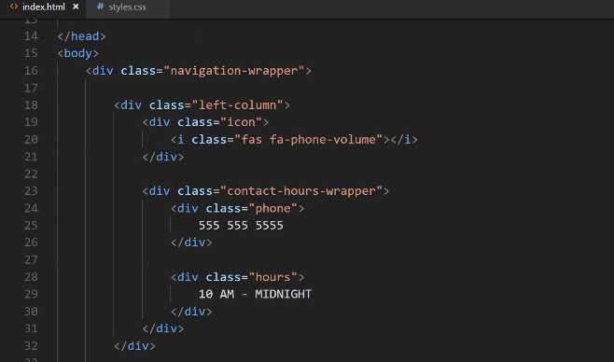
Let's play around with this and see exactly how the inheritance works. If I say .navigation-wrapper > .icon, let's see if these same styles get applied, and we'll do the same thing here. So, say: navigation-wrapper, hit save, and let's see if that works.
styles.css
.navigation-wrapper > .icon {
margin-right: 15px;
}

.navigation-wrapper > .icon i {
font-size: 2em;
}
If I come here and hit refresh, you can see that those styles disappear.

So, why is that exactly? Well, it's because of how this little > symbol works. This does not work on a deeply nested level. Instead, what it says is you first need to become more specific. For the navigation-wrapper, if you want to grab this icon, it needs to know that chain of events.
It needs to know for the navigation-wrapper what other classes connect to icon. In this specific case, if you look at HTML, we have the navigation-wrapper, then we have the left-column, then we have the icon.
We have a couple different options. We could just do this. We could say .navigation-wrapper > .left-column > .icon, and then do the same thing here.
styles.css
.navigation-wrapper > .left-column > .icon {
margin-right: 15px;
}

.navigation-wrapper > .left-column > .icon i {
font-size: 2em;
}
Hit save, hit refresh, and now you can see that that is back to working.

In this specific scenario, it's up to you. If you're making a very large application, you do want to be specific like this. Imagine a scenario where you leave off the navigation-wrapper, so you just do it like this .left-column > .icon. This will still technically work for this one-use-case.
You can see nothing changes here, but the one issue is if you create a new left-column class and it has an icon class inside of it, then you might be overriding those values or these values might be overridden.
All of this goes back to the nature of CSS and its cascading kind of behavior. When in doubt, the best option is to be as specific as possible. Now when you start to get into more advanced techniques, so there is a skill set out there, it's a very cool tool called SCSS and it's usually, even though it sounds like SASS, it actually is usually spelled out like SCSS.
When you get into that you'll see that this process becomes much more intuitive, but we can't do it in this introductory course just because you need to learn the fundamentals before you start getting into the more advanced techniques.
It's very important to understand that CSS operates like this. This is an important thing to understand, especially if you're just learning how to build websites for the first time. So I'm happy with these. Let's keep on moving down.
Now this left-column right here, we could really apply the same exact technique here. I don't see any reason why not to. I could say .navigation-wrapper, .left-column, and then that's all going to work.
styles.css
.navigation-wrapper > .left-column > .contact-hours-wrapper {
display: grid;
grid-template-columns: 1fr;
grid-gap: 10px;
}
.contact-hours-wrapper is going to be the same thing, except here, what I'm thinking, let's say that if I want to do navigation-wrapper and left-column just like that.
styles.css
.navigation-wrapper > .left-column > .contact-hours-wrapper {
display: grid;
grid-template-columns: 1fr;
grid-gap: 10px;
}

.navigation-wrapper > .left-column > .contact-hours-wrapper > .hours {
font-family: 'Ubuntu Condensed', sans-serif;
}
Let's just verify that that is correct. Okay, yes, so contact-hours-wrapper. All that should be working fine. So nav-link, this is one that we're going to have to fix. If we had the nav-link anywhere else then this might start to get a little bit messy.
Now I'm not going to use the navigation-wrapper here. Instead, what I'm going to do is we're going to create a link class, another link class. The reason for this is because I want to show you how later on you can reuse some of this functionality.
That way you can use these links and have a lot of these styles built-in in the footer or in some other spot that doesn't have a navigation-wrapper. In this case, I'm going to create, just like I have that comment up there, I'm going to create a class called links-wrapper.
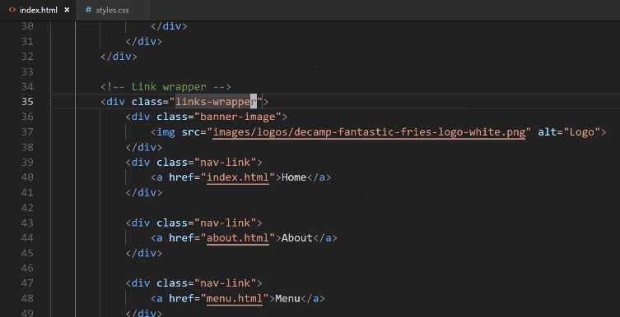
Now what I can do, because I'm pretty confident that links-wrapper is not going to be placed anywhere that I don't want these navigation links placed. What I can do is, for this nav-link, I can say:
styles.css
.links-wrapper > .nav-link a {
font-family: 'Ubuntu Condensed', sans-serif;
color: white;
}
Then we want to say everything inside of that is going to take in those same styles. For the address-wrapper, if we come here you can see that right now we have this entire thing as its own div, I think it would make sense to actually update that.

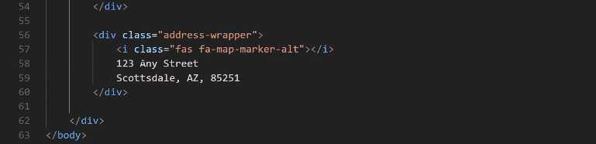
I think we should have some wrapper divs. This links-wrapper div should also be the center-column, and then we should have a right-column here. I think that way is best because, if you remember, we have a left-column on this side so let's perform the same task.
Let's say that we want this to be the center-column.
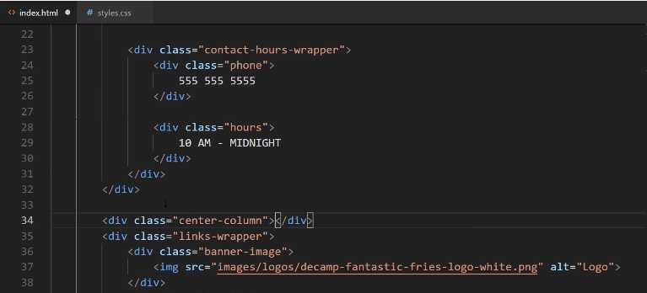
Then if we move down here to the closing div, and we want to close that off. Now let's also make sure we keep our indention just so it's nice and readable.
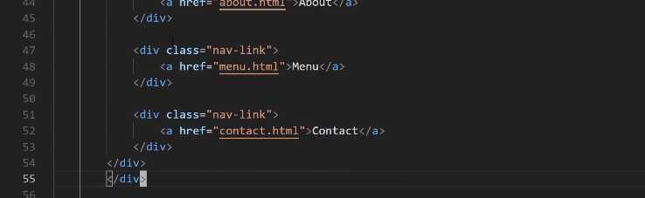
Now our center-column has our links-wrapper inside of it. Now, for the address-wrapper we're going to do the same thing. So here, we'll say this is going to be the right-column, let's indent this, and then close off that div.
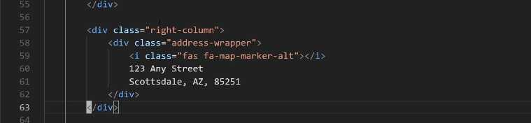
Now if you hit save and go back. Now you can see that everything is still working. We have our right-column here, our center-column, and then our left-column. Now we can get a little bit more specific.
Right here we have our navigation-wrapper which has the font, then we have our links-wrapper here. For this one, I am going to just keep that the same because, like I said, I may want to use that in the footer or something when it's not in the center column.
For address-wrapper we definitely want this to become a little bit more specific. For this one we could say something like:
styles.css
.navigation-wrapper > .right-column > .address-wrapper {
font-family: 'Ubuntu Condensed', sans-serif;
}
Hit save, come back, hit refresh, everything there's looking good. Lastly, here, we have our banner-image. Now the banner-image is going to be inside of the navigation-wrapper because I want these styles really only when I'm on the home page on that navbar.
So it's going to be .navigation-wrapper > .links-wrapper > .banner-image img. As I'm saying this, I think there's a better way of doing this. I think this should be the center-column, I'll explain why here in a second, so I'm going to say:
styles.css
.navigation-wrapper > .center-column > .banner-image img {
font-family: 'Ubuntu Condensed', sans-serif;
}
If I come over here, you see how I have links-wrapper and I have that banner-image inside of it? I think that's actually a mistake because I like my code to be very descriptive. You should as well.
If I come to a class called links-wrapper my expectation is that it's only going to have links inside of it. So instead, let's take this banner-image and place it outside of that wrapper. Now we have a center-column that contains a logo and then all of the links just like that.
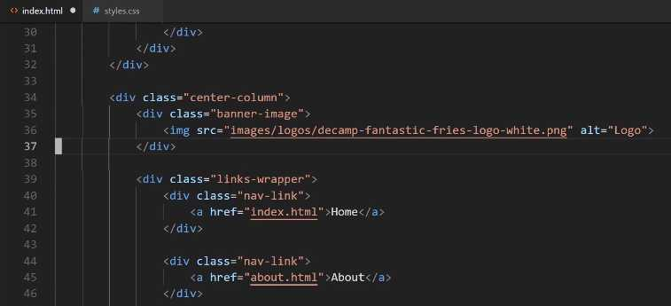
Let's hit save, and let's see if we broke anything. Nope, everything is still looking good.
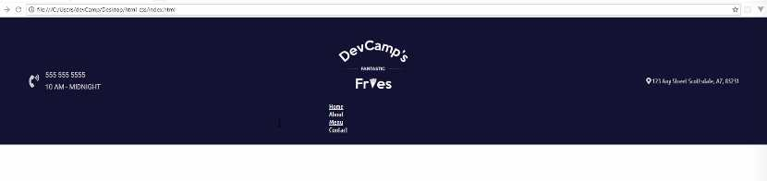
What we've done here is, and sorry if this is a little tedious, but it is important to understand how CSS works. I am assuming that's the whole reason why you're taking the course and spending all the time going through here is being able to understand the exact process.
You're not always going to have a tutorial to follow. You're going to get to the point where you're going to have to build this kind of project out by yourself, and understanding the fundamentals behind it is absolutely critical.
What we've done here is we have refactored all of our styles so that we're very specific. If you're ever curious on a style not being applied. Say you think that you have built out your style, so they should be working, and then you see that it's not working. Well, that is where the devtools are really helpful and that's where they come into play.
Here you can see we have our div, our navigation-wrapper, and look how much easier this is to read. It's very clear that everything here is in the left-column, everything here's in the center, and everything here's on the right.
If I click on the center column and then click on one of these links. If I scroll down here, you can see that you can actually trace the entire lineage. All the way from the body to the navigation-wrapper to that div. Just like we're doing right here.
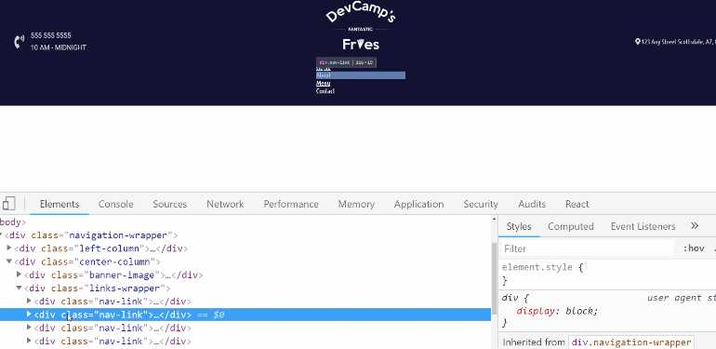
You can become even more specific. If you say that you apply a style or you add in a style and it's not working, well, the browser thankfully does not lie. You can see right here that you have a links-wrapper and it is grabbing using the > symbol.
It's grabbing the next item, which is the nav-link. Then it's grabbing the actual a tag inside of there. That's where we're getting the color and the font-family. You can also trace which values have been overridden through that.
That is the way that, whenever I have a style that isn't working right, I always go straight here to the browser tools to see exactly what is happening and what values are being set. Now we have code that's been refactored, it's now conforming to best practices, and hopefully, you have an even better understanding of how CSS works.

Coding Exercise
Using CSS inheritance selectors, make the below paragraph tag's font size 30px
<div class="item-wrapper">
<span class="item-description">
<p>Make this font size 30px!</p>
</span>
</div>

1.22 Align Items with Flexbox inside of a CSS grid container
In this guide, we're going to work on centering the column element on the page here and we're going to see how we can use CSS grid combined with Flexbox in order to get the type of behavior that we're looking for.
Remember this is what we're actually looking for.
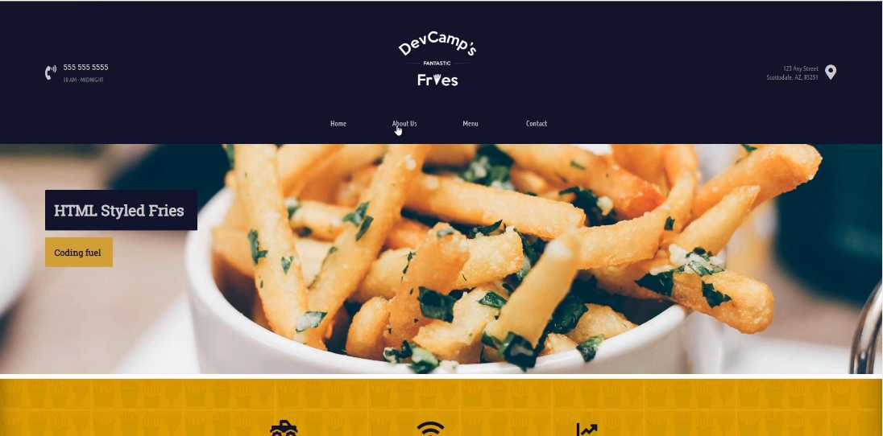
We want to have some nice space and styles here for this nav bar and then the logo right on top of it. So let's start building that out. We already have all of the structure that we're going to need from an HTML perspective.
We're not going to do any work here but we do need to start adding some custom styles, and as you know we have our navigation wrapper and then we have all of our left columns styles and now what we're going to do is we're going start working on the center column.
So far we've only used the center column banner image selector but right above here I'm going to create some styles just for the center column.
styles.css
.navigation-wrapper > .center-column {
display: grid;
grid-template-columns: 1fr;
grid-gap: 42px;
width: 500px;
}
Hit save, now come back and hit refresh and you can see that that's working.

Now it's not centered but that's perfectly fine. We're not done yet. Let's right click and hit inspect and let's see exactly what this is looking like if we inspect the element.
You can see we have the image, if we click on center-column you may notice that what it's doing, it may look like it's off centered but the element itself is actually perfectly centered.
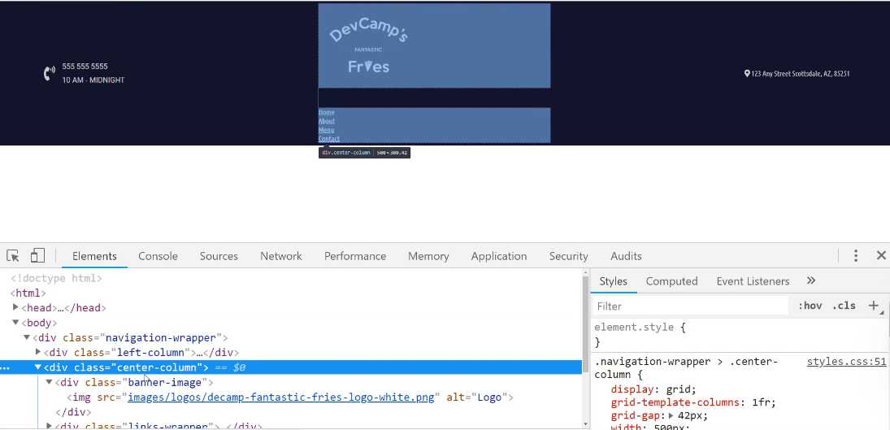
It just goes from left to right, so in order to center the items, we'll see what we need to do in order to do that. But as far as the column itself, it is taking up the exact amount of space that we're wanting.
Now what I want to do and this is part of the reason why I added a banner-image-wrapper instead of just having the image, I want to take just the banner-image-wrapper, so I'm going to remove the image selector here at the very end.
styles.css
.navigation-wrapper > .center-column > .banner-image {
display: flex;
justify-content: center;
}
Let's hit save. Notice how we have a grid container that has two grid elements, the banner-image itself and the nav-links, and inside of that banner-image, we are turning that into a flex container so we can manage the image positioning.
So now if I hit refresh you can see that our image is now centered perfectly.

So that is looking good.
Now what we have to do is grab those links and do the same thing with them.
styles.css
.links-wrapper {
display: flex;
justify-content: space-between;
align-items: center;
}
I'm just going to call the links-wrapper by itself so that we can use it in other parts of the application. I think this is going to be a better use of that links-wrapper class so that it's a little bit more scalable and reusable.
let's come and hit refresh and look at that.

We actually have something that is getting much closer to the final version. This is coming along quite nicely. And notice how we have been able to use two Flexbox containers and we have those nested inside of a CSS grid container.
One of the common questions that I get, especially from new students who have just been introduced to tools like CSS grid and Flexbox, is which one I prefer.
In my personal opinion, it's been my experience in the projects I've built out that it's not a choice between the two but the two actually complement each other perfectly.
I know I've said that before but I do want to just reiterate it because this is a question that I've been asked multiple times so I want to make my own feelings on it clear.
I think that Flexbox and the CSS grid tools should be used in conjunction with each other because like you've seen right here we were able to take both of those and we're able to create a really nice looking interface by combining them and utilizing their strengths.
We're going to take a break right now. That is a great job, you have learned how to combine CSS grid and Flexbox and how you can switch between them in order to align items perfectly on the page.

Coding Exercise
Utilize flexbox on the below links to align them vertically and horizontally in the same way as demonstrated in the lesson video.
<div class="link-box">
<span class="link">
<a href="home.html">HOME</a>
</span>
<span class="link">
<a href="contact.html">CONTACT</a>
</span>
<span class="link">
<a href="portfolio.html">PORTFOLIO</a>
</span>
</div>

1.23 CSS animations
Pending

