Project Plan

Document Number: 001

Date: 9/20/2023

*Spectrum Analyzer Tool*

Seema Kumaran  
Alexandor Pinion  
George Vendeta  
Jeffrey Amakihe  
Chris Williams

Client: Robins AFB

Table of Contents

1. Introduction 3

2. Project Overview 3

2.1 Scope 3

2.1.1 Identification 3

2.1.2 System Overview 3

2.1.3 Document Overview 3

2.2 Background 4

2.3 Objective 4

2.4 Scope 4

2.5 Operational Policies and Constraints 4

2.6 Users or Involved Personnel 4

3. Development Background/Approach 5

3.1 High Level Estimates 5

3.1.1 Initiation Phase 5

3.1.2 Planning Phase 6

3.1.3 Execution Phase 6

3.1.4 Monitoring and Controlling Phase 7

3.1.5 Closure Phase 7

3.2 Key Contacts and Stakeholders 7

4. Features, Primary Deliverables, and External Commitments 8

4.1 Feature List 8

4.1.1 Milestone 1 8

4.1.2 Milestone 2 8

4.1.3 Final Delivery 8

5. Project Schedule 10

6. Project Resource Requirements 10

6.1 Staffing/ Skill Requirements 10

6.2 Plan to Fill Skill Gaps 11

7. Dependencies and Constraints 11

7.1 Constraints 11

7.2 Dependencies 11

8. Project Configuration and Data Management 12

8.1 Configuration Management 12

9. Project Process 12

9.1 Software Life Cycle Model 12

10. Glossary 13

11. Change Record 14

12. References 15

# Introduction

Engineers and analysts at the 402 SWEG Robbins AFB are responsible for verifying frequency and amplitude data from a video of a Spectrum Analyzer representing an Aircraft Electronic Warfare (EW) System Under Test (SUT). The test could be a calibration or a test of the EW response to threat systems. The goal of the project is to reduce the manual toil involved in the review process and allow the transcribed data to be manipulated and further analyzed for anomalies. The current software project plan will provide a path for completing and managing the development and delivery of the provided software solution. This plan functions as a software development road map. It outlines all the procedures and information required to develop the program, including what it should do, who will work on it, when it will be completed, and how much it will cost. It keeps things organized and aids with everyone's understanding of what must be done, ensuring that the program is finished effectively and on schedule.

# Project Overview

## Scope

The scope of this project is to design, develop, test, and deploy a user-friendly application for the Robins AFB to use for solving spectrum analyzer video analysis problems. Key features include image signal processing of video, formatted csv data representing spectrum analyzer signals, and a standalone deployment environment for the client’s platform. The project aims to deliver a stable and scalable that solves the customers problem while adhering to a defined budget and timeline.

### Identification

Below are the full identification of the system and software that this project plan pertains to:

* + Title: Spectrum Analyzer Tool (SAT):
    - Release: 0.0.1
    - Abv: SAT

### System Overview

Robins Air Force Base (AFB) stands as a vital hub for aviation operations, relying on legacy Spectrum Analyzers to gauge the quality of communication signals within their ground stations. These Analyzers collect data during flight operations, yielding hours of valuable information essential for maintaining the integrity of communications systems. However, the current manual process of inspecting video recordings of these datasets for signal quality anomalies presents operational inefficiencies and demands significant human resources. To address this challenge, Robins AFB has sponsored KSU’s Master of Software Engineering Capstone Students to devise an automated solution for the analysis of flight data, ensuring timely identification of signal quality issues while streamlining operations and resource utilization. This paper elucidates the development and implementation of this innovative solution, shedding light on its impact in enhancing efficiency and precision within the aviation ecosystem at Robins AFB. The group of students supporting this project plan will develop an open-source standalone application that will run on Robins AFB personnels intended machines and will provide a guided process for loading data of interest, processing, and providing output resources most useful for the Robins AFB stakeholders.

### Document Overview

The purpose of this document is to provide a main function that offers a thorough road map for the effective execution of a project by detailing its goals, objectives, tasks, timetables, resources, and milestones. Throughout the course of the project's lifespan, it acts as a crucial reference tool for stakeholders, assisting them in understanding their roles and duties and facilitating efficient coordination and decision-making. High-level privacy concerns for the project plan document include protecting confidential project information, sensitive client data, and individual user information, making sure that only authorized personnel have access, and putting secure storage measures in place to prevent unauthorized disclosure that might jeopardize the project's integrity and the project teams' interests.

## Background

“*Military Flight Test Ranges have a variety of Radio Frequency (RF) threats used for testing Aircraft Electronic Warfare (EW) Systems during flight. Flight Test Ranges have a tracking station that is used to record RF transmissions of the threats for testing and calibration purposes. The transmissions are recorded via video from a Spectrum Analyzer and are provided to the system engineers for the System Under Test (SUT) on video. Currently, analysis of the data requires engineers to actively watch a selection of video data to verify frequency and amplitude of a specific Threat System.*” [1].   
  
Below are a list of related material links pertaining to the project’s background:

* [SpectrumAnalyzerExplained.docx](https://kennesawedu.sharepoint.com/:w:/r/sites/Team-RobinsAFBFall2023capstone-SpectrumAnalyzerAnalysisTool/Shared%20Documents/General/SpectrumAnalyzerExplained.docx?d=w77c4b13aac0b41b7834d5dd3b1c89ca5&csf=1&web=1&e=qSTOl9)
* [Video: What is a Spectrum Analyzer?](https://www.youtube.com/watch?v=8Zhufd64rGg)
* [Website: Image and Video Processing in Python](https://new.pythonforengineers.com/blog/image-and-video-processing-in-python/)
* [Video: Video Data Processing with Python and OpenCV](https://youtu.be/AxIc-vGaHQ0?si=T0cBgYCksE0p7Azn)
* [Video: Object Tracking with Opencv and Python](https://youtu.be/O3b8lVF93jU?si=_z5ifxg5trO-b4gc)

## Objective

Reduce the manual time and toil needed from an analyst or engineer to review spectrum analyzer videos containing RF signal frequency and amplitude data for electronic warfare threats. The intent of the automated analysis is to identify out of spec frequency and amplitude data as well as timeframe of the identified signal intercept.

## Scope

At present day, an analyst or engineer reviews the recording of a spectrum analyzer, recorded during a test of the Aircraft Electronic Warfare (EW) systems. The analyst receives a video on CD/DVD and reviews the video, recording the information for all signal intercepts that exceed the established threshold in the test. These videos can be of varying lengths up to 8 hours in duration. This manually intensive effort slows the process of determining the success of the EW and any further investigation into root causes.

## Operational Policies and Constraints

Completed system must be installable from CD/DVD and runnable on a Windows 10 computer.

## Users or Involved Personnel

Analysts or engineers will load the program onto a designated Windows 10 physical computer. They will then load the video to be processed and provide the program with at least minimal input for the input video location and the location/destination for the output csv file to be used for additional analysis.

# Development Background/Approach

In the current development activities involve the structure of the application being designed, the code being written, tested, and debugged to verify that each of the system requirements are met functionally. Python is an accessible choice for creating a variety of applications, from simple scripts to intricate software systems, and is the preferred language from the client, Robins AFB. All of the development being done currently for the application is performed in a development environment such as PyCharm on a Windows 10-based machine. PyCharm is an Integrated Development Environment (IDE) software application that provides a comprehensive environment for programmers to write, edit, debug, and manage their Python code efficiently in a single integrated platform. Once released of the application are generated, all software build artifacts will be generated through means of a standalone executable created from the Python module, PyInstaller. The target platform for the standalone executable will be the Windows 10-based machines used by the customer. This allows the clients’ team members to run the application on any of their personnel machines, allowing them leverage and ease for utilizing the software application under development. The development efforts will allow for the following use-case scenario to occur with the application:

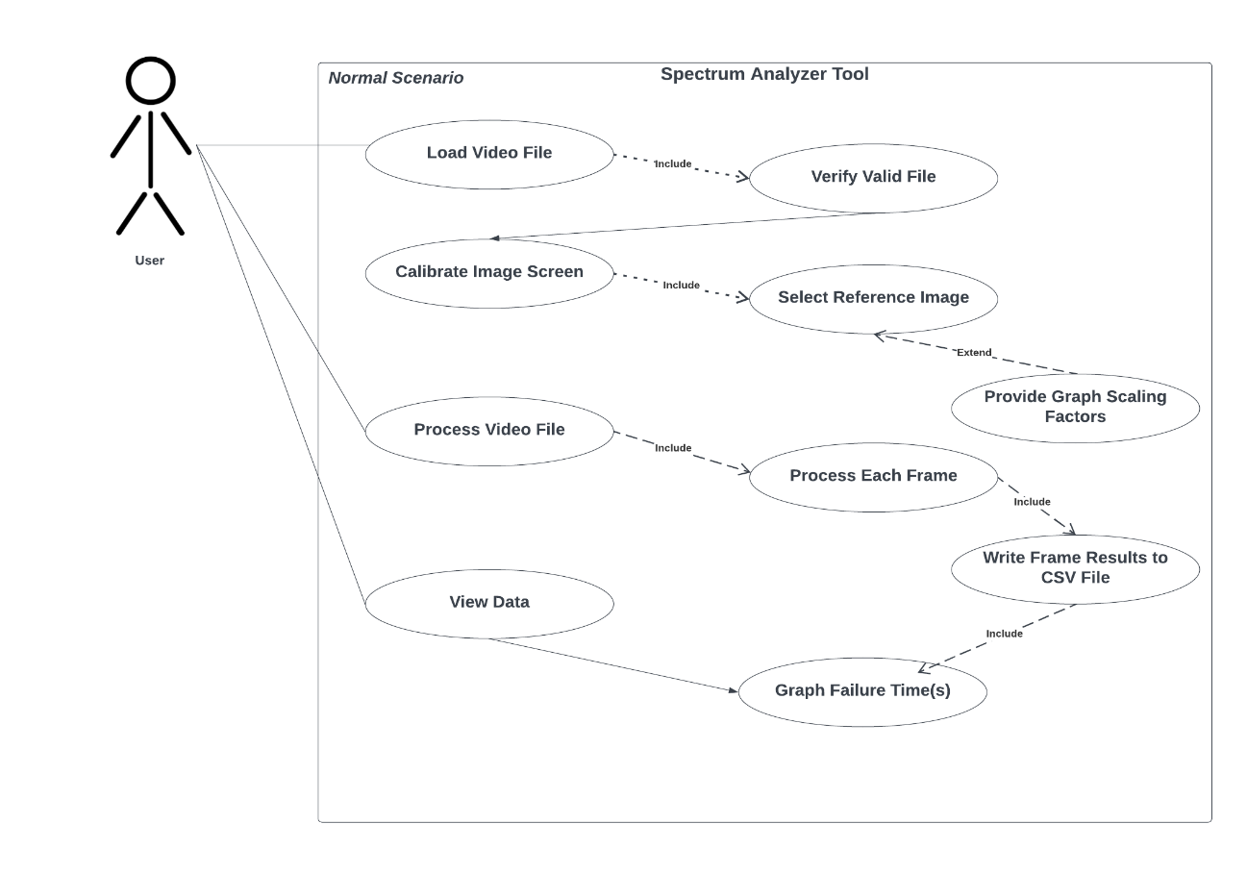

Figure 1 - Use-case Normal Scenario for User

## High Level Estimates

Below are estimates of each phase of the project, along with related metrics and context for the phase of development:

### Initiation Phase

In this phase the project development team and stakeholders will discuss the purpose and feasibilities of the project. The stakeholders will define the needs and goals of the project, and the development team will be gathered. Estimates for this phase include the following:

* Total effort:
  + Kickoff Meeting:
    - 2-4 labor hours
  + Initial Plan:
    - 1-2 labor hours
  + Requirements:
    - 0 labor hours
  + Documentation:
    - Presentation Material:
      * 1-2 labor hours
* Lines of Code:
  + 0 lines

### Planning Phase

A thorough project plan is created, outlining the tasks, deadlines, budgets, and resource distribution. To direct the project's execution, it contains risk analyses, quality assurance plans, and communication strategies. Requirements, solicitation and interviews exist between stakeholders during this phase. Estimates for this phase include the following:

* Total effort:
  + Requirements Solicitation:
    - 5 labor hours
  + Team Planning
    - 4-8 labor hours
  + Prototype Planning:
    - 5-10 labor hours
  + Documentation:
    - Project Plan:
      * 5-10 labor hours
    - Requirements Document:
      * 4-8 labor hours
* Lines of Code:
  + 100-200 lines

### Execution Phase

The project plan must be implemented at this phase. Tasks are carried out, and project advancement is carefully watched. The creation of project deliverables and the integration of multiple project components may also be included. Estimates for this phase include the following:

* Total effort:
  + Prototype Development:
    - 20-40 labor hours
  + Team Planning
    - 4-8 labor hours
  + Documentation:
    - Project Plan:
      * 5-10 labor hours
    - Requirements Document:
      * 4-8 labor hours
    - Design Document:
      * 5-10 labor hours
* Lines of Code:
  + 500 to 1000 lines

### Monitoring and Controlling Phase

Progress on the project is continuously monitored and measured against the project plan. To keep the project on schedule, any issues or deviations are noted, and appropriate remedial action is then implemented. Estimates for this phase include the following:

* Total effort:
  + Design Development:
    - 40-80 labor hours
  + Team Planning
    - 4-8 labor hours
  + Documentation:
    - Requirements Document:
      * 2-4 labor hours
    - Design Document:
      * 10-15 labor hours
    - Test document:
      * 5-10 labor hours
* Lines of Code:
  + 500 to 1000 lines

### Closure Phase

The project is formally closed in the last stage. This includes releasing project resources, performing a project review, distributing deliverables to stakeholders, and recording lessons learned. It signals the project's formal completion. Estimates for this phase include the following:

* Total effort:
  + Deployment Development:
    - 20-40 labor hours
  + Testing
    - 10-20 labor hours
  + Documentation:
    - Design Document:
      * 2-5 labor hours
    - Test Document:
      * 5-10 labor hours
    - Deployment/Release Document
      * 5-10 labor hours
  + Final Package Deliverable
    - 10-15 labor hours
* Lines of Code:
  + 100 to 500 lines

## Key Contacts and Stakeholders

|  |  |  |  |
| --- | --- | --- | --- |
| *Name* | *Role* | *Email* | *Phone* |
| *Elizabeth Dayton* | *PoC and Product Owner from 402 SWEG Robins AFB* | [*elizabeth.dayton@us.af.mil*](mailto:elizabeth.dayton@us.af.mil) | *478-926-2638* |
| *Nasiya Sharif* | *Capstone Coordinator* | [*nrahman1@kennesaw.edu*](mailto:nrahman1@kennesaw.edu) |  |
| *Jeffrey Amakihe* | *KSU Project Development Team PoC* | *jamakihe@students.kennesaw.edu* |  |

# Features, Primary Deliverables, and External Commitments

## Feature List

The below sections consist of features, primary deliverables and commitments prescribed for the project life cycle.

### Milestone 1

|  |  |  |
| --- | --- | --- |
| Feature | Requirements Document Trace | Description |
| Analyze Video of Spectrum Analyzer | 4.2.2 Scenario 2 | Analyze graph data to determine required data points to capture |
| CSV File Output | 4.3 | Basic output collected data into a csv |
| CSV File Processor |  | Process output data from csv to determine suspicious failure points/signal drops across a given threshold. |

### Milestone 2

|  |  |  |
| --- | --- | --- |
| Feature | Requirements Document Trace | Description |
| User Input | 4.1 |  |
| Analyze Video of Spectrum Analyzer | 4.2.2 Scenario 1 | Analyze graph data to determine threshold and signal intercept, rough PoC for multiple signals |
| CSV File Output | 4.3 | Output collected data into signal specific csv files |
| UI | 4.4 | Rough PoC – Summary data and graph of collected data |

### Final Delivery

|  |  |  |
| --- | --- | --- |
| Feature | Requirements Document Trace | Description |
| Analyze Video of Spectrum Analyzer | 4.2.2 Scenario 1 | Analyze graph data to determine threshold and signal intercept, multiple signals fully supported |
| CSV File Output | 4.3 | Output collected data into signal specific csv files |
| UI | 4.4 | Summary data, graph of collected data, and scrolling ability to intercepts |
| Standalone Executable |  | Self-contained computer program that can run independently on a computer without the need for additional software or dependencies. |
| Final Package/Presentation Demo |  | Entire package of all necessary software artifacts released to the customer. |

# Project Schedule

| **Date (**YYYY-MM-DD) | **Milestone/ task** | **Deliverable** | **Remarks** |
| --- | --- | --- | --- |
| 2023-08-28 | Team Formation and Project Familiarization | Build team and understand the project needs |  |
| 2023-09-04 | Team Project Setup | Determine roles and responsibilities, set up GIT repo, Jira, initial PoC exercise, SDLC |  |
| 2023-09-12 | Requirements Draft | Initial requirements document |  |
| 2023-09-20 | Milestone 1 | Tool selection and rough product, final requirements document, draft project plan |  |
| 2023-09-24 | Project Plan | Final document detailing the project |  |
| 2023-10-04 | Milestone 2 | Semi-functional/Imperfect version of product  May have processing of single RF signal working with multiple RF signal processing in progress |  |
| 2023-10-25 | Finalized Design | Design document detailing specifics on system architecture and application design |  |
| 2023-11-27 | Testing | Test documentation, plan, execution, and outcomes |  |
| 2023-12-03 | Preliminary Code | Code version that may be incomplete yet functional for review |  |
| 2023-12-05 | Final Presentation and Demo | Video of process and code working along with appropriate background, processes, and outcomes |  |

# Project Resource Requirements

## Staffing/ Skill Requirements

**Alexandro Pinion**

**Role: Team Leader**

**Critical Skills: Python, Rudimentary NodeJS/React, OpenCV, Project Management, Spectrum Analyzer, Test Instrumentation Knowledge**

**Skill Gaps: Rudimentary NodeJS/React**

**George Vendetta**

**Role: Analyst/Backend Engineer**

**Critical Skills: Python, Rudimentary NodeJS/React, OpenCV, Test Instrumentation Knowledge**

**Skill Gaps: Rudimentary NodeJS/React**

**Chris Williams**

**Role: Analyst/Front/Backend Engineer**

**Critical Skills: System Analysis, Python, Rudimentary NodeJS/React, OpenCV, Test Instrumentation Knowledge**

**Skill Gaps: Video processing, OpenCV, Test Instrumentation Knowledge**

**Seema Kumaran**

**Role: Analyst/Frontend Engineer**

**Critical Skills: Python, NodeJS/React, Front end development, python, OpenCV**

**Skill Gaps: Video Processing, OpenCV**

**Jeffrey Amakihe**

**Role: Analyst/Backend Engineer**

**Critical Skills: Python, Full Stack development, Test Instrumentation Knowledge**

**Skill Gaps: Image Processing**

## Plan to Fill Skill Gaps

Identifying areas where team members lack knowledge or competency and strategically assigning tasks or responsibilities to capitalize on their strengths will be the fundamental approach for filling skill gaps. Additionally, cross-training sessions may be performed between team members to help each member pick up any skills that are lacking. The team leader may promote a cooperative atmosphere where team members can openly exchange knowledge and best practices and learn from one another, ultimately ensuring that the project team has the necessary knowledge, skills, and abilities to successfully complete the project. More experienced members will create the framework for the given piece and the team member with the missing skill will study independently and take guidance from an experienced member with that skill.

# Dependencies and Constraints

## Constraints

Below is a list of constraints for the software application:

* Target Operating System:
  + Windows 10
* Runtime Installation:
  + From CD/DVD, excluding BlueRay
* Processing time:
  + Process an 8 hour video in 5 minutes
* Standalone Executable

## Dependencies

Below is a list of constraints for the software application:

* Development Language:
  + Python
  + Libraries:
    - opencv-python~=4.8.0.76
    - numpy~=1.25.2
    - Kivy~=2.2.1
    - plotly~=5.17.0
* Deployment Environment:
  + OS:
    - Windows 10/11
  + Interpreter:
    - Python 3.11 (64bit)
  + Libraries:
    - Pyinstaller~=5.13

# Project Configuration and Data Management

## Configuration Management

Over the course of the project, systematic processes of tracking and controlling changes to software, revision control of documentation, and intended design and requirement artifacts will be managed through the technologies prescribed below:

* Git - One of the most popular distributed version control systems, it enables project members and developers to coordinate project development and keep track of source code modifications. Git is renowned for its quickness, adaptability, and powerful merging and branching skills. Specifically, GitHub is used to store and manage the project’s Git workflow. The repository is located here: <https://github.com/alexandropinion/spectrum-analyzer-tool-group4/tree/development>
* Jira: A well-liked project management and issue tracking program, Jira allows for the software development team to use it to successfully plan, track, and organize their work as well as collaborate. Jira is a flexible application for varied project management requirements because it includes tools for task creation and administration, project progress tracking, and aiding Agile approaches like Scrum and Kanban. The Jira space is located at the following location (access required): <https://chwill.atlassian.net/jira/software/projects/SWE7/boards/2>
* SharePoint: The adaptable collaboration tool SharePoint, which acts as an organizational hub for document sharing, content management, and cooperation, is used as the project’s documentation CM tool for the software project’s life cycle. For the creation, storage, and access of a variety of project content, including documents, spreadsheets, presentations, and more, this tool is used to provide security and individualized environment for the project. Document libraries, lists, and editable web pages are some of SharePoint's key features, which let users effectively organize and share information across the project team members.

# Project Process

## Software Life Cycle Model

The Agile life cycle model is used as the primary project methodology. It is is an incremental, iterative method to software development that emphasizes adaptability, teamwork, and client pleasure. It is intended to deliver functional software in smaller, incremental chunks, often in two to four-week cycles termed iterations or sprints, and to respond to changing requirements. The agile methodology affords the project life cycle requirements gathering, planning, iterative development, continuous integration and customer feedback. The development tool used to help aid in the Agile process is Group 4’s Jira space. Jira allows the Agile method to live throughout the life cycle through issue tracking, workflows, integration, reporting and dashboards, and ultimately scalability for project development.

# Glossary

|  |  |
| --- | --- |
| Abbreviation | Definition |
| AFB | Air Force Base |
| CM | Configuration Management |
| EW | Electronic Warfare |

# Change Record

|  |  |  |  |  |  |
| --- | --- | --- | --- | --- | --- |
| Date | Change Request # | New Issue # | Description | Reason for change | Personnel |
| 9/16/2023 | - | 1 | Initial Draft |  | Chris Williams |
| 9/20/2023 | 001 | 2 | Initial Release | Add context to fulfill Project Plan documentation requirements | Chris Williams, Alex Pinion |

# References

[1] E. Dayton, “Request for College of Computing and Software Engineering Capstone Project Proposal Section I -Company and Mentor Information Section II -Project for Which Students Will Participate.”

[2] E. Dayton, “Spectrum Analyzer Expected Output,” Sep. 2023.

[3] C. Williams, “Spectrum Analyzer Software Requirements Document (Draft -SWE 7903 Spectrum Analyzer Capstone -Team 4),” Sep. 2023.

‌

