Appendix

# Appendix A: 1st Interview with the Client

Date of Interview: 25th June 2023

**Me:** As we have already established what I will be developing a solution for (i.e., the “Valuator” program, solution to problems that face investment bankers such as my father), how would you like the program to ‘be’? What would you like to see?

**Client:** I would like the program to fully digitalize my workflow, I do not want to have to pull out a pen and paper while using this program. Mostly, I want to just input some values from a physical document. I also want the interface to be clean and easy to use, the reason I am asking you to develop this program is to save time—efficiency is key. I also want the program to keep logs of what happens, I want to be able to see changes made in files which are saved daily, so that I can go back to them. To conclude on my needs, I want this program to digitalize the entirety of my workflow surrounding valuating companies.

**Me:** How would you like data to be stored? Would you prefer a database using technology such as SQL or other methods such as flat file storage (e.g. .csv)?

**Client:** Most of the data for companies I use is stored on .csv files, or I must perform the task of transcribing data from a physical file to a .csv file. Therefore, I would prefer for the program to run on flat file spreadsheet files to store company data. When it comes to user data, I do not have a preference.

**Me:** When it comes to making the program easy-to-use, something which you brought up after my first question, what kind of features would you like to see implemented to address this need?

**Client:** First, I want the program to have plenty of documentation for features embedded into the windows. What I envision is something like a hidden textbox or popup note of some kind appearing by the click of a button in areas which need documentation. I do not really want to have to open an external PDF file which documents the program every time I want to learn something about it, I want it to all be there. A FAQ section would also be useful.

**Me:** Since this program will be handling a lot of data and information about the companies, what would you like to be done with this data. What formulas would you like to be used to calculate values and what statistics would you like to be shown graphically?

**Client:** I would like to be able to provide the program with data about a specific company’s sources of revenue and expenditure, and how much revenue they pull in and how much cash is spent—to put it simply. Using the sources of revenue and expenditure, I want the program to be able to calculate the cash flow of the company and use this to estimate the company’s value. I want you to use the discounted cash flow method, since I know this is not your field of expertise. If you have any questions about it—what the formula is—you can just come to me and ask me. One thing you do need to keep in mind is that you will not have to calculate the discounted rate for the company, an integral part of the formula, as that is evaluated by risk management at the company with other calculations. I want the focus of the program to be to take all this data into account and produce a predicted report for the value of the company now, and what the predicted value will be in a few years. Another thing we [investment bankers] try to help companies with is suggesting where they can cut costs to up their positive cash flow, using my help I can show you how based on pure data you are able to draw ideas about where costs can be cut. I would like the program to be able to do this as well. I know I am rambling on about the specifics now, but I want every feasible quantifiable statistic to be able to be graphically represented (if data exists for it in comparison to something, or if there is continuous data for it).

**Me:** One thing I know about investment banking is that you often deal with mergers, is this something you would like the program to handle?

**Client:** Yes. Although I know this program has a more statistical focus so I’m not asking for it to review legal processions, however, I would like for the program to be able to simulate the effects of a merger on market share (according to data provided in each company file) and produce a report for the combined valuations of the companies.

**Me:** We have outlined some basic features that the program will have. Apart from these features, is there anything else you would like to be specifically designed?

**Client:** I would like there, as I stated in response to the previous question, a logging system to keep track of every change made and every piece of data inputted. I want to keep records. I also want these records to be easy to parse through and read, whether it be in text file form or on a screen. So that is something I would like you to add.

**Me:** Can you specify if you would like just one user to be able to use the system, or would it benefit you to be able to have multiple users or multiple profiles?

**Client:** I would like there to be multiple user profiles. I would not only like this for my own personal use but also when training a new employee, we could use alternative profile and imaginary values and imaginary companies to train them on, not on the real data. For that reason, the program would benefit from having the ability to have multiple users.

# Appendix B: 2nd Interview with the Client

Date of Interview: 29th July 2023

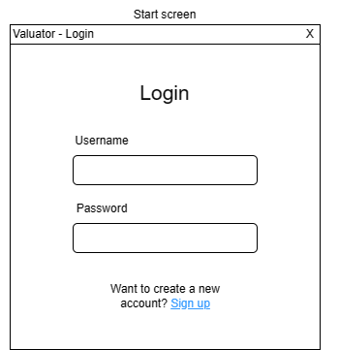

Figure Login interface.

**Me:** What you can see in Figure 1 is the start screen, or the initial interface that the user will see when opening the program: the login interface. This should present an overview of the design features used throughout, so please let me know your honest feedback about this interface. Do you like it?

**Client:** It seems to be completely fine; I like that it is not cluttered. The position of the buttons seems intuitive and easy to use. My main feedback is that this seems to be devoid of life, this could be the login interface for any company.

**Me:** How do you propose we fix that? Is there a specific color you would like me to add?

**Client:** I think some shade of blue. I’d like to implement it as a banner at the top of the interface. This would work.

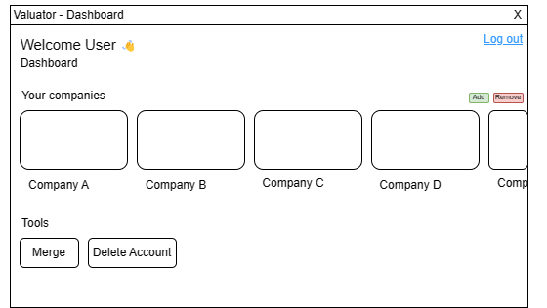

Figure Dashboard interface.

**Me:** Moving on, in Figure 2 you can see the primary dashboard used for handling everything in the program.

**Client:** Hmm… I’m not particularly fond of it. I think that it has a lot of clutter and unnecessary information, and that tools like merging could probably be handled within the company files. Also, the addition and removal of company buttons are too small on the screen. Please simplify this window.

**Me:** I understand, and what about user deletion? Do you like the flow of user deletion?

**Client:** I would need to see the interface. What I can see here is a logging out button, which I’d just like to replace with the action of simply closing the window, and not saving people as logged in. Also, I’d like the inclusion of the blue banner at the top of the screen here, maybe we are maybe it something consistent among the windows of the program.

**Me:** Yes, I see. All of these are possible. I will now show you the user deletion process.

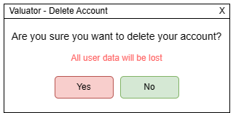

Figure Account deletion interface.

**Client:** I’m not a fan of this. Also, the only data that would be lost is login, as we stated the companies will be handled universally. I think that user deletion should just be done by deleting the file of the user. I do not think we need to create a sort of ‘self-destruct’ for the user, it does not provide a real value to the program.

**Me:** Understood, it is generally good practice but in the case of our program the only issue would be the storing of the user as an existing user in perpetuity—unless the main data file with the userbase were to be deleted. Speaking about that, where do you want files to be stored?

**Client:** This program will be running primarily on Windows machines, so Mac support is not important. The most logical place would be documents.

**Me:** Perhaps so, however due to the nature of the data being program data I feel a better location would be in the user’s “appdata”.

**Client:** Okay, if you say so. I do not mind where exactly the files are if they are accessible in the same way across all windows devices—at the same relative path.

Figure Company dashboard interface.

**Me:** What are your thoughts about Figure 4, the company dashboard interface?

**Client:** I’m once again not a fan, I want it to be simpler. I do not think I need to represent statistics the way you are showing them. I also do not like the additional fields, the description, and the image, as they would simply add to my workload when creating or loading company data.

**Me:** Those can easily be removed! How about the company removal and deletion? How do you feel about that?

**Client:** This is confusing, as we are not sure where we are removing the company from. The removal should be handled within the main dashboard, as we had said earlier. Remove the remove button! Also, deletion I think will be better handled by deleting the CSV for the company, so you can handle that likewise and remove the button.

**Me:** Okay, I see. Generally, do you want the interface to be simpler and have a more colorful pop to it?

**Client:** Exactly, I need it to be functional and not too aesthetic to the point where it interferes with my workflow while using it.

Figure Company merging interface.

**Client:** I do not think this must be so complex, I do not think we need a separate interface for the company merging.

**Me:** You are referring to Figure 5, the company merging interface, right?

**Client:** Yes, I think that company selection should also happen from the individual files. I do not mind this, but it is an overcomplication of the issue. Ah! I forgot earlier, I would also like the inclusion of more documentation.

**Me:** I can make those changes to this interface, I may even choose to may it a popup and see how those fares, it may be simpler. Also, how would you like this information/documentation to be embedded?

**Client:** You know those little “i” buttons? The ones they have in interfaces representing information. Maybe something like that in the corner of each window.

**Me:** I’ll see what I can do.