Regular expression

1. Using any regular expression tester(online or build-in any programing language) create next patterns:
   1. Your name and surname

Expression: Alexandr Pershin

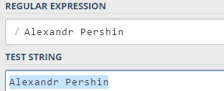

* 1. Phone number. Try to make it as for any phone number as for numbers of certain country or phone operator.

I have created pattern for telephone numbers of Moldova, (Moldcell,Orange,Unite).

Expression: [+] 373 [6-7] [0|2|7|8|9] [0-9] {6}

Test number: + 373 6 8 392700

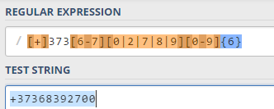

* 1. E-mail address

Expression: ^[_A-Za-z0-9-]+(\.[_A-Za-z0-9-]+)[*@[A-Za-z0-9]+(\.[A-Za-z09]+)*(\.[A-Za-z]{2,})$](mailto:*@[A-Za-z0-9]+(\.%5bA-Za-z09%5d+)*(\.%5bA-Za-z%5d%7b2,%7d)$)

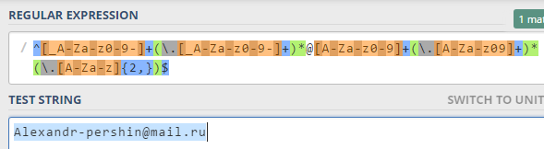

* 1. IP address

Expression: ^([01]?\d\d?|2[0-4]\d|25[0-5])\.([01]?\d\d?|2[0-4]\d|25[05])\.([01]?\d\d?|2[0-4]\d|25[0-5])\.([01]?\d\d?|2[0-4]\d|25[0-5])$

Test : 192.168.1.1

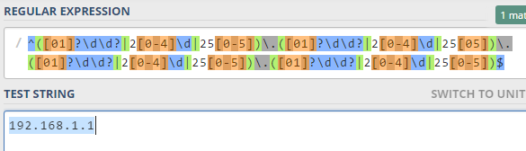

* 1. MAC address

Expression : ^([0-9A-Fa-f]{2}[:-]){5}([0-9A-Fa-f]{2})$

Test : 3D:F2:C9:A6:B3:4F

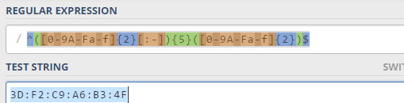

1. Simplify your patterns with groups and quantifiers.
   1. (Alexandr Pershin)
   2. ([+]) (373) ([6-7]) ([0|2|7|8|9]) ([0-9] {6})
   3. ^([_A-Za-z0-9-]+(\.[_A-Za-z0-9-]+)*)@([A-Za-z0-9]+(\.[A-Za-z09]+)*)(\.[A-Za-z]{2,})$
   4. ^([01]?\d\d?|2[0-4]\d|25[0-5])\.([01]?\d\d?|2[0-4]\d|25[05])\.([01]?\d\d?|2[0-4]\d|25[0-5])\.([01]?\d\d?|2[0-4]\d|25[0-5])$
   5. ^([0-9A-Fa-f]{2}[:-]){5}([0-9A-Fa-f]{2})$
2. To understand how to work lookahead, lookbehind and conditions create next regular expressions:
3. regex that checks for opening and closing brakes;

lookahead positive (?=[()])

lookahead negative (?![()])

lookbehind positive (?<=[()])

lookbehind negative (?<![()])

1. regex that extracts and checks names from email that appears in field “Name” and in email body;
2. public static void main(String[] args) {  
     
    String email="Name: Alexandr Pershin" +  
    " body:" +  
    " Hello Roman, " +  
    "I would like to discuss details related with new project..." +  
    "Kind regards," +  
    " Alexandr. ";  
     
    Pattern pattern=Pattern.*compile*(".*Name:(.+).body:(.+)$");  
    Matcher matcher=pattern.matcher(email);  
    String name="";  
    String body="";  
    while (matcher.find()) {  
    name = matcher.group(1);  
    body = matcher.group(2);  
    }  
    System.*out*.println(name);  
    System.*out*.println(body);  
   }

output:



3) regex that checks double words in text like “ blablabla the the blabla”.

\b(\w+)\b\s+\b\1\b

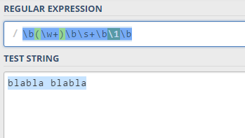

1. Try same regular expressions on different regular engines to understand difference between them and their syntax. To make this exercise you can use http://regex101.com/#pcre