Controlled Failure of
Router-Based ROS 2 Middleware under Degraded Wireless Links
Alexandru GHEORGHITA
Institute of Solid Mechanics of the Romanian Academy (IMSAR)
Bucharest, Romania alexandru.gheorghita@imsar.ro

Abstract
Middleware benchmarks for ROS 2 report performance almost exclusively under nominal network conditions, and recent studies recommend the router-based rmw_zenoh for wireless deployments. We present a controlled-degradation benchmark (tc netem) that compares rmw_zenoh and rmw_cyclonedds in two environments with identical degradation parameters and an identical measurement protocol: software-in-the-loop (SIL, loopback, N=10) and hardware-in-the-loop (HIL, real Wi-Fi between two machines, N=5). The two environments disagree sharply. On loopback, Zenoh handles degradation comparably to CycloneDDS (1.3% vs. 1.8% sample loss under 200 ms latency with 50 ms jitter). On real Wi-Fi under the same emulated condition, Zenoh loses 96% of samples with a mean RTT of 6.2 s -- more than 13x the RTT of CycloneDDS in the same representative run (469 ms, 2.7% loss; 14.7% aggregated) -- although no packet loss is injected at all. The RTT structure indicates TCP retransmission and router-hop buffering triggered by the physical medium, a failure mode invisible on loopback. Our results (i) characterize regime-dependent failure modes of the two middlewares, and (ii) carry a methodological warning: SIL-only validation would have certified the fragile middleware as safe. We release the benchmark, configurations, and data.
[TODO ALEXANDRU: rescrie abstractul cu vocea ta dupa ce sectiunile 3-5 sunt finale.]
Index Terms: ROS 2, middleware, Zenoh, DDS, network degradation, hardware-in-the-loop, benchmark.

1. Introduction
Communication is a weak link of field robotics: disaster environments combine long relays, interference, and non-line-of-sight propagation into links with high latency and double-digit packet loss. ROS 2 delegates transport to interchangeable middleware implementations through the RMW abstraction layer [2], [19], and the recent rmw_zenoh [3] offers an alternative to the DDS family designed for constrained and wide-area networks. Existing comparisons, however, measure throughput and latency on healthy networks [5], leaving open the question that matters operationally: what does middleware choice cost when the network degrades?
A second, less visible question concerns how such an evaluation should be run. Simulation-based (SIL) benchmarks are cheap and reproducible; hardware-in-the-loop (HIL) benchmarks are costly. If the two agree, SIL suffices. We show that for this question they do not agree.
Contributions.
- A reproducible SIL + HIL testbed for controlled network degradation (tc netem) applied to ROS 2 middleware, with identical degradation parameters and measurement protocol in both environments.
- A comparative characterization of rmw_zenoh and rmw_cyclonedds failure modes under packet loss and latency on real Wi-Fi.
- The SIL-HIL divergence result: under latency-plus-jitter, Zenoh's collapse is induced by the physical medium, not by the protocol logic -- simulation alone misses the dominant failure mode entirely.
- An architecture decision guide for middleware selection in wireless teleoperation, with a methodological caveat on SIL-only validation.

2. Background and Related Work

2.1 The RMW layer and the two middlewares
ROS 2 nodes talk to an abstract middleware interface (RMW); the concrete implementation is selected at runtime via RMW_IMPLEMENTATION [2]. rmw_cyclonedds implements the DDS/RTPS model: fully peer-to-peer, UDP-based, with decentralized discovery (SPDP/SEDP) that relies on periodic multicast announcements [4]. rmw_zenoh replaces DDS with the Zenoh protocol [12]: nodes hold TCP sessions to a local zenohd router, routers gossip discovery information among themselves, and multicast scouting is disabled by default [3]. The architectural contrast -- brokered TCP versus peer-to-peer UDP -- is the axis of this study.
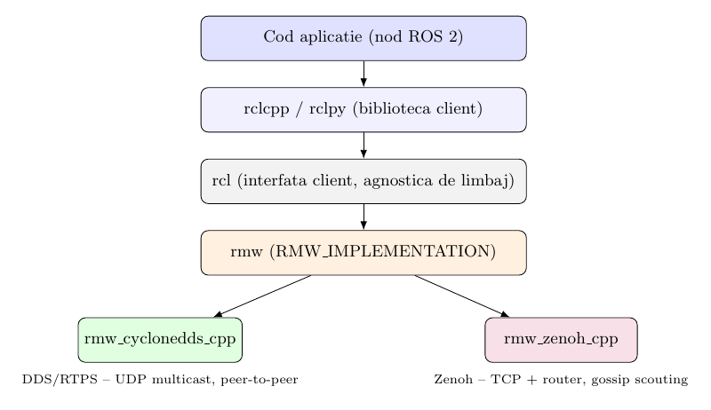
Fig. 1. The RMW abstraction: identical application code runs over either middleware; only the transport stack changes.

2.2 Prior benchmarks
Early ROS 2 evaluations characterized DDS performance and executor overheads on healthy networks [8], [11]. Liang et al. [6] compared Zenoh, MQTT, Kafka, and DDS on throughput and latency, finding Zenoh competitive -- but exclusively on healthy links. An edge-to-edge study [5] reports CycloneDDS strongest on Ethernet and Zenoh strongest on nominal Wi-Fi and 4G, attributing the latter to DDS multicast discovery struggling on wireless. Recent work documents DDS fragility under wireless packet loss [7], and loss-injection studies model DDS latency analytically [16]. Controlled netem injection on ROS 2 dates back to a 2016 evaluation of Connext and Fast RTPS [17], and a field study compares the middlewares on a physical mesh under real -- but uncontrolled -- degradation [18]; none of these includes rmw_zenoh under parameterized impairment. To our knowledge, no prior work compares the two middlewares under controlled, parameterized degradation, nor contrasts SIL and HIL results for the same degradation matrix; this gap is the target of the present study.
[TODO ALEXANDRU: verifica FIECARE citare in text complet inainte de submisie; populeaza [1]-[10] din Zotero.]

2.3 Positioning
Our results do not contradict the nominal-Wi-Fi literature: they extend it into the degraded regime. The recommendation "Zenoh for wireless" holds for healthy links; we show it inverts once the physical link degrades.

3. Methodology

3.1 Testbed
SIL. Both endpoints and, for Zenoh, the router run on a single Linux machine over the loopback interface; degradation is applied to lo. This isolates protocol logic from all physical effects.
HIL. A laptop (client + Zenoh router) and a Raspberry Pi 4 (echo server + Zenoh router) communicate over a real consumer Wi-Fi network; degradation is applied symmetrically with netem on the wireless interface of both machines, so both middlewares experience identical network physics on top of the real medium. Both environments run ROS 2 Jazzy with unmodified application code; the middleware is switched only via RMW_IMPLEMENTATION. The laptop runs rmw_zenoh 0.2.9 and rmw_cyclonedds 2.2.3 (Eclipse Cyclone DDS 0.10.5) on Linux kernel 6.17. The Zenoh mesh uses one router per machine (listening on all interfaces, with an explicit unicast connect between the two), since multicast scouting is disabled by default [3].
[TODO ALEXANDRU: confirma via apt history (zgrep -i -E 'zenoh|cyclonedds|linux-image' /var/log/apt/history.log*) ca versiunile de mai sus, inclusiv kernelul, sunt cele din campanie; adauga versiunile Pi cu snippetul SSH din VERSIUNI_3.1.md.]
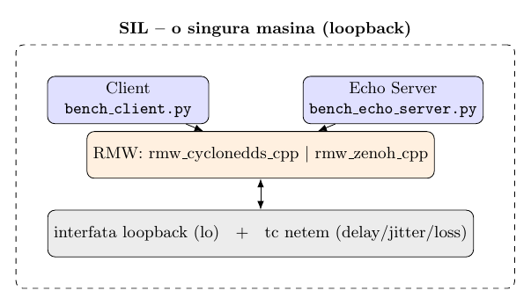
Fig. 2. SIL architecture: single host, loopback, netem on lo.
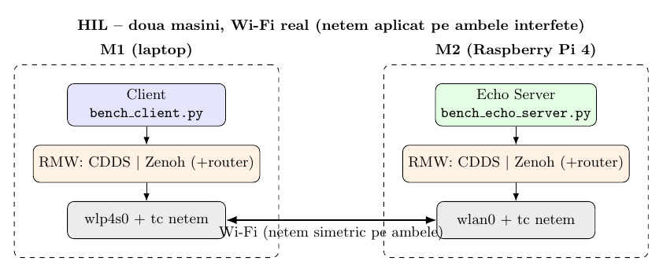
Fig. 3. HIL architecture: two hosts over real Wi-Fi, symmetric netem, one Zenoh router per host with explicit unicast connect.

3.2 Degradation model
Degradation is injected with tc netem [9], [10]. Table I lists the eight conditions. The netem qdisc is attached in every condition, including ideal (delay 0 ms, jitter 0 ms, loss 0%), so all conditions run under the same queueing discipline and differ only in the emulation parameters. Loss uses netem's Bernoulli i.i.d. model (each packet dropped independently with probability p). Jitter is applied without a distribution table; in this configuration the netem kernel implementation draws the per-packet delay uniformly,
d_i = DELAY + x_i * JITTER, x_i ~ U(-1, 1), (1)
bounding the delay to [DELAY - JITTER, DELAY + JITTER]. We note a documented discrepancy: the tc-netem manual page states that the default distribution is normal [9], while the kernel source (tabledist() in sch_netem.c) applies a uniform fallback when no distribution table is loaded; we report the distribution the kernel actually applied. We deliberately use the memoryless loss model for comparability with prior work; bursty models (Gilbert-Elliott) are future work (Sec. 7).
Condition | Delay (ms) | Jitter (ms) | Loss (%)
ideal | 0 | 0 | 0
loss_5 | 0 | 0 | 5
loss_15 | 0 | 0 | 15
loss_20 | 0 | 0 | 20
loss_25 | 0 | 0 | 25
loss_30 | 0 | 0 | 30
lat200_jit50 | 200 | 50 | 0
lat200_l15 | 200 | 50 | 15
Table I. netem conditions (identical in SIL and HIL; source: bench_core.py).

3.3 Metrics and protocol
A client publishes timestamped payloads echoed by a server; RTT uses a single clock. Per run we record RTT percentiles (p50/p95/p99), mean, min, max, and sample loss = 1 - received/sent, where a sample counts as lost if not returned within a per-sample deadline. Each run sends 989 samples at 50 Hz for 20 s per payload class (64 B command, 4 KB telemetry, 64 KB map/image). Conditions are repeated N=10 times (SIL) and N=5 times (HIL); condition-level figures aggregate per-repetition summaries.

3.4 Reproducibility
Benchmark code, router configurations (JSON5), netem manifests, and all raw data are public.
[TODO ALEXANDRU: link repo GitHub + DOI/Zenodo daca faci arhivare.]

4. Results
Unless stated otherwise, figures refer to the 4 KB payload class.

4.1 Baseline (ideal)
On loopback both middlewares are equivalent: mean RTT of 1.1-1.4 ms, 0% loss. On real Wi-Fi both remain clean at 64 B and 4 KB (0% loss), with a mean RTT of 11-13 ms at 4 KB. At 64 KB on Wi-Fi, however, Zenoh loses 58% of samples with no degradation injected, while CycloneDDS loses none (Fig. 4): with large payloads on a bandwidth-limited link, CycloneDDS throttles the publisher whereas Zenoh keeps sending without back-pressure. The effect reproduced identically across three separate campaign runs, so we report it as an architectural property, not an artifact.
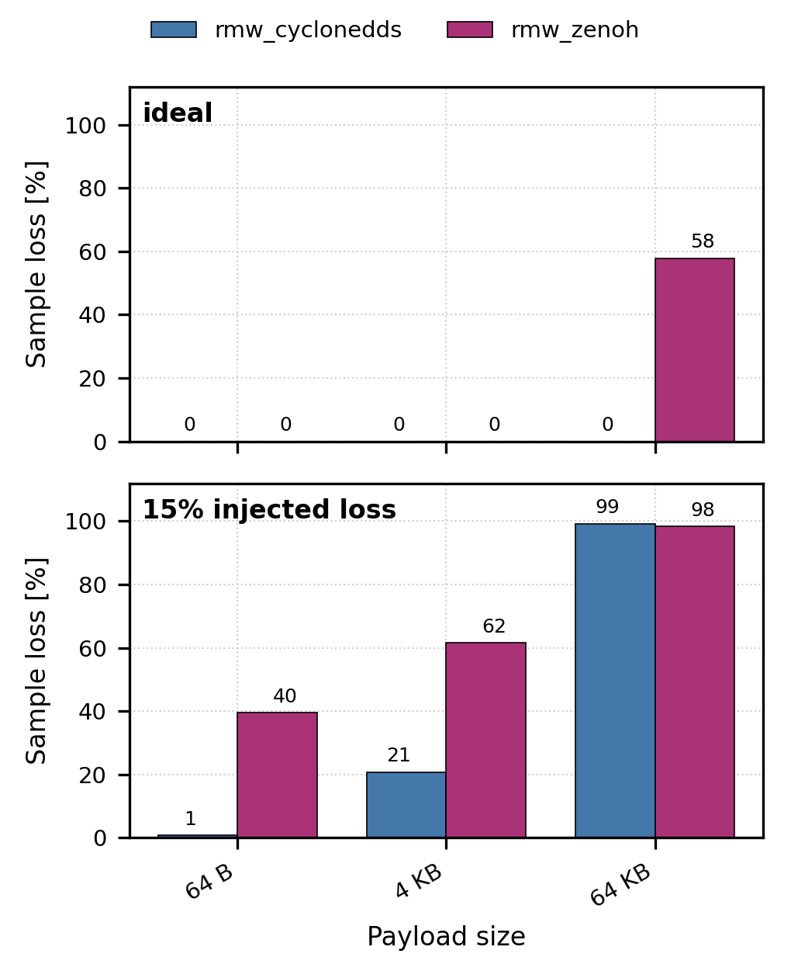
Fig. 4. Effect of payload size on sample loss (HIL Wi-Fi, N=5): ideal condition (top) and 15% injected loss (bottom).

4.2 SIL: the protocol in isolation
Table II (SIL columns) shows the loopback picture (Fig. 5, top). Under pure loss Zenoh degrades earlier than CycloneDDS (8.5% vs. 1.4% sample loss at 15% injected loss) but both remain functional, and under pure latency-plus-jitter the two are practically indistinguishable (1.3% vs. 1.8%). Judged on SIL alone, Zenoh appears a reasonable choice for degraded links.

4.3 HIL Wi-Fi: the real medium
The HIL columns of Table II tell a different story (Fig. 5, bottom). Under injected loss Zenoh collapses roughly 3x harder than CycloneDDS at every level (61.6% vs. 20.8% at loss_15) and saturates near-total loss from loss_20 onward. Most strikingly, under lat200_jit50 -- 200 ms delay, 50 ms jitter, zero injected loss -- Zenoh loses 96.3% of samples while CycloneDDS loses 14.7%.
Condition | SIL CDDS | SIL Zenoh | HIL CDDS | HIL Zenoh
ideal | 0.0 | 0.0 | 0.0 | 0.0
loss_5 | 0.0 | 0.0 | 0.0 | 0.0
loss_15 | 1.4 | 8.5 | 20.8 | 61.6
loss_20 | 7.7 | 16.9 | 53.5 | 93.7
loss_25 | 26.5 | 34.1 | 70.4 | 98.8
loss_30 | 41.0 | 57.8 | 80.5 | 99.2
lat200_jit50 | 1.8 | 1.3 | 14.7 | 96.3
lat200_l15 | 36.0 | 20.8 | 72.4 | 100.0
Table II. Transport sample loss (%), 4 KB payload. SIL: N=10; HIL Wi-Fi: N=5. Source: campaign summaries, 2026-07-01.
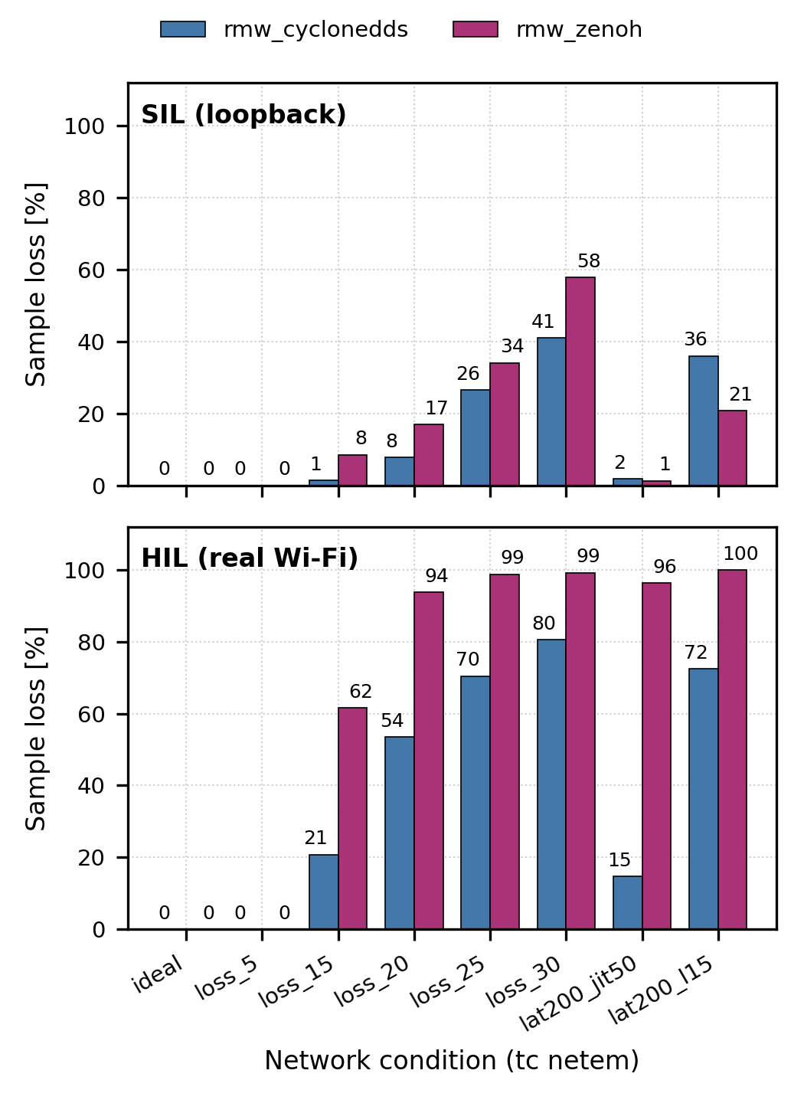
Fig. 5. Transport sample loss per netem condition and middleware (4 KB payload): SIL loopback, N=10 (top) vs. HIL real Wi-Fi, N=5 (bottom). Identical injected parameters in both environments; data as in Table II.

4.4 The SIL-HIL divergence
The same middleware, under the same netem parameters and the same measurement protocol, behaves radically differently depending only on the physical medium: at lat200_jit50, Zenoh goes from 1.3% loss (SIL) to 96.3% (HIL). CycloneDDS shifts too (1.8% to 14.7%) but remains functional. The divergence, not either environment alone, is the central result.
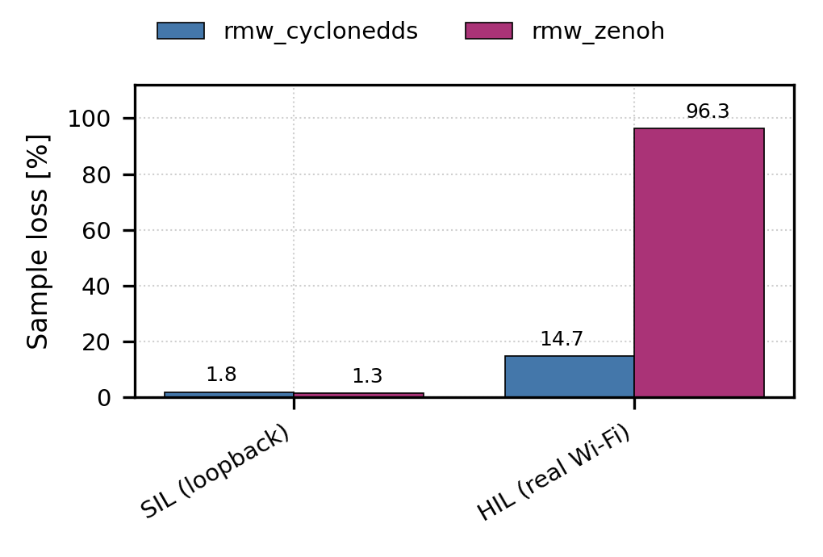
Fig. 6. The SIL-HIL divergence at lat200_jit50 (200 ms delay, 50 ms jitter, no injected loss): identical code and netem parameters, different physical medium. Data: Table II.

4.5 Failure mechanism: what the RTT structure shows
Table III gives the aggregated p95 RTT at lat200_jit50 (per-condition p95: Fig. 7); the per-run detail is sharper. In a representative HIL run, CycloneDDS returns 962/989 samples with mean RTT 469 ms and a tight distribution (min 402, max 543 ms) -- exactly the injected 200 ms each way plus Wi-Fi overhead. Zenoh returns 184/989 samples with mean RTT 6,185 ms (min 1,591, max 7,872 ms). The excess of ~5.7 s over the injected latency cannot originate in the channel; its structure is consistent with TCP retransmission timeouts compounding across the two router hops (node-router-router-node) and with router-side buffering. Because the injected jitter is uniformly bounded (Sec. 3.2), the emulated channel adds at most 250 ms per direction; CycloneDDS's maximum RTT of 543 ms in the same run bounds the medium's typical contribution. The multi-second Zenoh RTTs therefore cannot be explained by the emulated channel and must originate in the transport stack. On loopback the same condition yields a clean Zenoh RTT (mean 427 ms, max 636 ms, 977/989 received): without the physical medium's contention and radio jitter, the cascade is never triggered. We state this as an inference from the RTT structure; direct protocol-level instrumentation is future work (Sec. 7).
Env. | RMW | RTT p95 (ms) | Loss (%)
SIL | CycloneDDS | 484 | 1.8
SIL | Zenoh | 476 | 1.3
HIL | CycloneDDS | 635 | 14.7
HIL | Zenoh | 7,697 | 96.3
Table III. RTT p95 (ms) and loss at lat200_jit50, 4 KB payload, aggregated over repetitions.
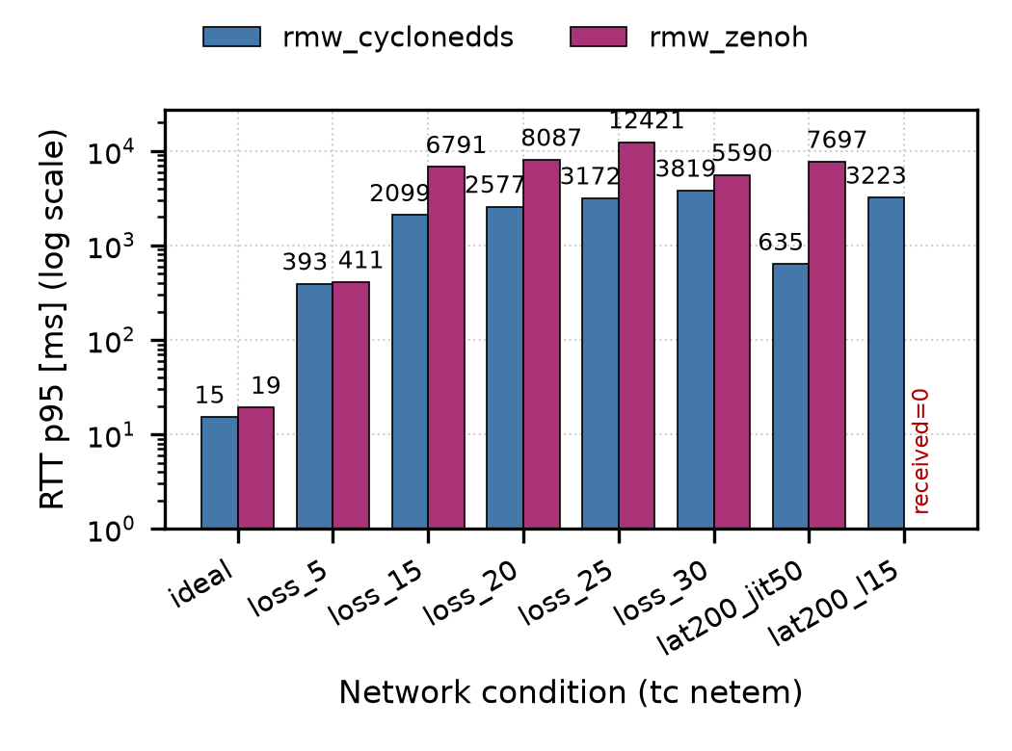
Fig. 7. Per-condition p95 RTT on HIL Wi-Fi (log scale, 4 KB payload, N=5); received=0 marked where no samples returned. p95 is computed over delivered samples only; under near-total loss it reflects a shrinking, survivorship-biased subset (hence loss_30 < loss_25 for Zenoh).
Under high injected loss on HIL, the middleware logs additionally showed bidirectional routing-protocol errors (unknown routing context / undeclared subscriber), indicating that Zenoh's control plane itself degrades once loss is severe.
[TODO ALEXANDRU: fraza de mai sus se refera la erorile observate LIVE in timpul campaniei sub loss; pastreaz-o doar daca esti confortabil ca observatie de rulare (logurile nu s-au salvat).]

5. Discussion

5.1 Why the environments disagree
SIL isolates protocol logic: netem's delay is "clean" -- added in the kernel, with no contention, collisions, or radio-level jitter. On that substrate Zenoh's TCP sessions never enter sustained retransmission. The real Wi-Fi medium adds 802.11 contention, retries, and rate adaptation on top of the injected impairment; combined latency and jitter push TCP round-trip-time estimators and retransmission timers into a regime where windows collapse and retransmissions compound at each router hop -- the classic failure mode of TCP over lossy wireless links [13], amplified by queue buildup along the path [14]. CycloneDDS over UDP has no such machinery: samples are late or lost, but never amplified into multi-second queues.

5.2 Methodological implication
Had we run only the (cheaper, more convenient) SIL campaign, Zenoh would have appeared safe for degraded links. The HIL campaign inverts the conclusion. For middleware selection on wireless robots, SIL-only validation can produce false confidence; the physical medium is not a nuisance parameter but the trigger of the dominant failure mode.

5.3 Architecture decision guide
On healthy Wi-Fi with small-to-moderate payloads, the literature's recommendation of Zenoh stands [5]. On degraded wireless links -- the SAR regime -- our data favor CycloneDDS: graceful, roughly proportional degradation instead of cliff-edge collapse. Where large payloads must cross a bandwidth-limited link, CycloneDDS additionally avoided the ideal-condition losses observed for Zenoh (Sec. 4.1).

6. Limitations
(1) A single hardware testbed (one laptop, one Raspberry Pi 4, one consumer access point); claims are scoped to this setup. (2) Memoryless Bernoulli loss and uniformly distributed, bounded jitter (Sec. 3.2); bursty loss (Gilbert-Elliott) is not modeled. (3) Stock middleware configurations; tuned Zenoh (TCP buffers, QoS, batching) might shift the boundary. (4) N=10 (SIL) vs. N=5 (HIL) repetitions. (5) The failure mechanism is inferred from RTT structure, not from protocol-level instrumentation. (6) netem's realized jitter has been reported to undershoot its nominal value [15]; we did not verify the realized jitter distribution on our kernels, so the effective jitter at lat200_jit50 may be below the nominal 50 ms.

7. Future Work
Bursty-loss models (Gilbert-Elliott) to test whether correlated loss deepens the router-based failure; protocol-level instrumentation (packet capture, router logs) at lat200_jit50 to confirm the retransmission cascade directly; Zenoh tuning as a mitigation study; and dynamic RMW selection driven by measured link state, feeding the SAR swarm demonstrator of the broader thesis.

8. Conclusion
Under controlled degradation with identical parameters, ROS 2's two transport philosophies diverge only when the physical medium is real: on loopback Zenoh matches CycloneDDS, on real Wi-Fi it collapses -- most dramatically under latency and jitter with no injected loss at all (96% vs. 15% sample loss; 12x p95 RTT). Middleware choice for wireless robots is regime-dependent, and the regime cannot be probed in simulation alone: the medium is the mechanism.

References
Intrari populate cu identificatori verificati (DOI/arXiv, research 2026-07). Regula anti-fabricare ramane activa: verifica FIECARE sursa in text complet inainte de submisie; completeaza URL-ul exact si data accesarii la [2]-[4], [9], [17]; confirma DOI-ul [1] pe IEEE Xplore; renumeroteaza referintele in ordinea primei aparitii la camera-ready.
[1] J. Casper and R. R. Murphy, "Human-robot interactions during the robot-assisted urban search and rescue response at the World Trade Center," IEEE Trans. Syst., Man, Cybern. B, vol. 33, no. 3, pp. 367-385, 2003. doi:10.1109/TSMCB.2003.811794.
[2] Open Robotics, "ROS 2 documentation: About different ROS 2 middleware vendors," docs.ros.org. [Online]. [TODO: URL exact + data accesarii].
[3] ros2/rmw_zenoh, "rmw_zenoh design document," github.com/ros2/rmw_zenoh. [Online]. [TODO: commit + data accesarii].
[4] Eclipse Foundation, "Eclipse Cyclone DDS documentation," cyclonedds.io. [Online]. [TODO: sectiunea + data accesarii].
[5] J. Zhang, X. Yu, S. Ha, J. P. Queralta, and T. Westerlund, "Comparison of middlewares in edge-to-edge and edge-to-cloud communication for distributed ROS 2 systems," J. Intell. Robot. Syst., vol. 110, no. 4, art. 162, 2024. doi:10.1007/s10846-024-02187-z (arXiv:2309.07496).
[6] W.-Y. Liang, Y. Yuan, and H.-J. Lin, "A performance study on the throughput and latency of Zenoh, MQTT, Kafka, and DDS," arXiv:2303.09419, 2023.
[7] S. Lee, T. Kim, J. Chae, and K.-J. Park, "Optimizing ROS 2 communication for wireless robotic systems," arXiv:2508.11366, 2025. [TODO: verifica daca a aparut versiune peer-reviewed].
[8] Y. Maruyama, S. Kato, and T. Azumi, "Exploring the performance of ROS2," in Proc. 13th Int. Conf. Embedded Software (EMSOFT), 2016, art. 5. doi:10.1145/2968478.2968502.
[9] tc-netem(8), Linux manual page, man7.org. [Online]. [TODO: data accesarii].
[10] S. Hemminger, "Network emulation with NetEm," in Proc. Linux Conf. Au (LCA), 2005, pp. 18-23.
[11] T. Kronauer, J. Pohlmann, M. Matthe, T. Smejkal, and G. Fettweis, "Latency analysis of ROS2 multi-node systems," in Proc. IEEE MFI, 2021. doi:10.1109/MFI52462.2021.9591166 (arXiv:2101.02074).
[12] A. Corsaro et al., "Zenoh: Unifying communication, storage and computation from the cloud to the microcontroller," in Proc. 26th Euromicro Conf. Digital System Design (DSD), 2023, pp. 422-428. doi:10.1109/DSD60849.2023.00065.
[13] H. Balakrishnan, V. N. Padmanabhan, S. Seshan, and R. H. Katz, "A comparison of mechanisms for improving TCP performance over wireless links," IEEE/ACM Trans. Netw., vol. 5, no. 6, pp. 756-769, 1997. doi:10.1109/90.650137.
[14] J. Gettys and K. Nichols, "Bufferbloat: Dark buffers in the internet," ACM Queue, vol. 9, no. 11, pp. 40-54, 2011. doi:10.1145/2063166.2071893.
[15] A. Jurgelionis, J.-P. Laulajainen, M. Hirvonen, and A. I. Wang, "An empirical study of NetEm network emulation functionalities," in Proc. 20th ICCCN, 2011. doi:10.1109/ICCCN.2011.6005933.
[16] S. Lee, H.-S. Park, J. Chae, and K.-J. Park, "Probabilistic latency analysis of the Data Distribution Service in ROS 2," arXiv:2508.10413, 2025.
[17] R. Kozik and M. Choras, "Evaluation of the ROS2 communication layer," ROSCon 2016 presentation. [Online]. Available: roscon.ros.org/2016/presentations/rafal.kozik-ros2evaluation.pdf [TODO: data accesarii].
[18] L. P. Chovet, G. M. Garcia, A. Bera, A. Richard, K. Yoshida, and M. A. Olivares-Mendez, "Performance comparison of ROS2 middlewares for multi-robot mesh networks in planetary exploration," J. Intell. Robot. Syst., 2024. doi:10.1007/s10846-024-02211-2 (arXiv:2407.03091).
[19] S. Macenski, T. Foote, B. Gerkey, C. Lalancette, and W. Woodall, "Robot Operating System 2: Design, architecture, and uses in the wild," Sci. Robot., vol. 7, no. 66, eabm6074, 2022. doi:10.1126/scirobotics.abm6074.

