**Testing**

The software testing practice was completed by following the principles of the agile manifesto, emphasizing testing from the perspective of customers who will utilize the system

The system was tested by testing all the Use cases.The testing was divided into the test cases below:

**Test case #1**

Test Case Login

**Test case #2**

Test Case Search/View

**Test case #3**

Test Case Add

**Test case #4**

Test Case Remove

**Test case #5**

Test Case Update

**Test case #1**

Test Case Login

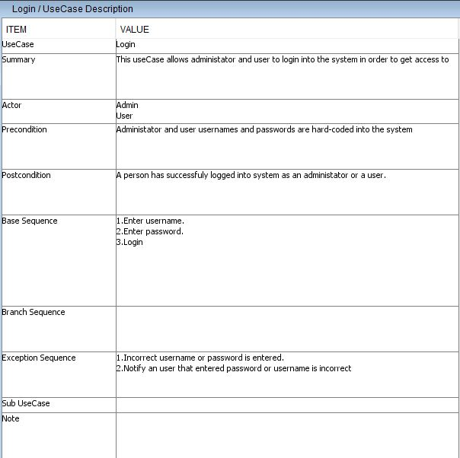

Subcase #1 -testing legal values eg User/Admin

Expected result-login successful

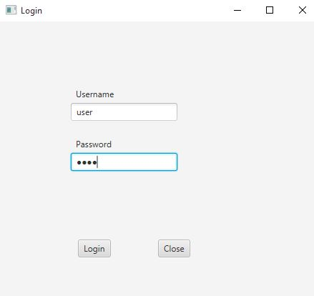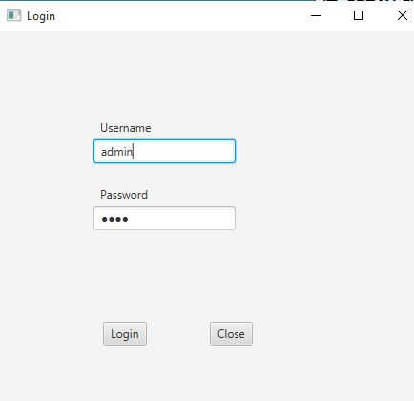

Result: using the correct credential allows the user to login successfully.

Subcase #2 -testing illegal values eg Incorrect username/password/empty fields.

Expected result-login failed, does not show an error message.

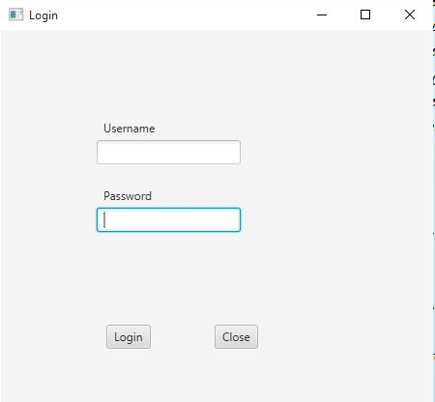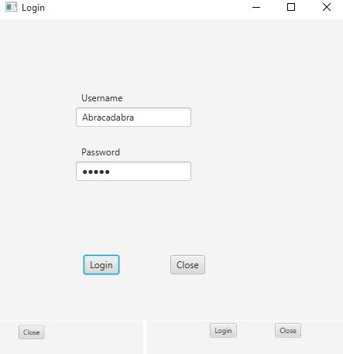

Result: using wrong username or password or just trying to login with blank fields does not allow the user to login and nothing happens.

Improvement : System to show error message.

**Test case #2**

Test Case Search/View

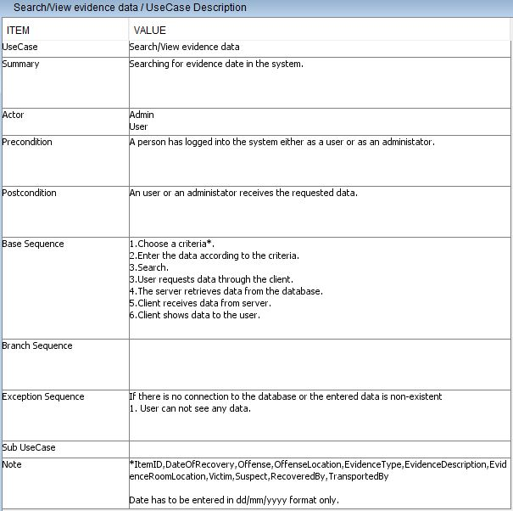

Subcase #1 -testing legal values eg items existing in the list

Expected result-item/list of items found.

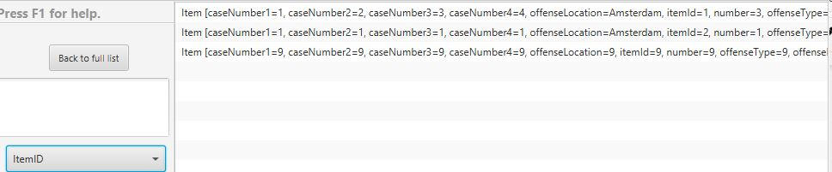

Full list of items

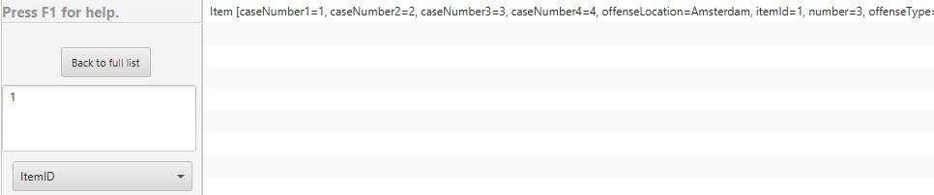

Test with ID=1

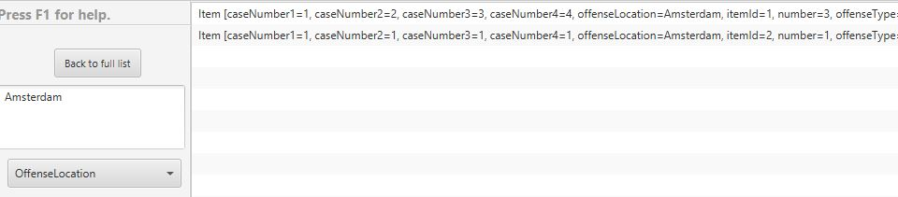

Test with Offense Location=Amsterdam

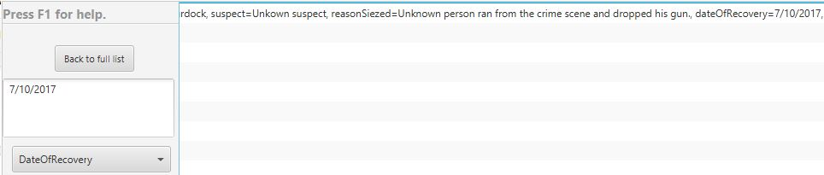

Test with a valid Date Of recovery

Subcase #2 -testing legal values eg non-existent parameters

Expected result-item/list of items not found.

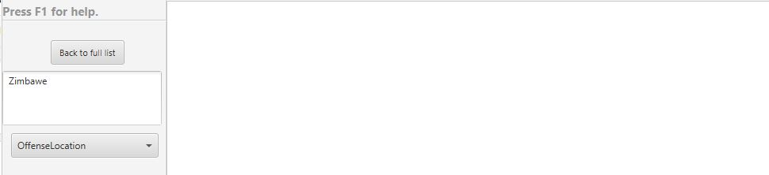

Test with Invalid location

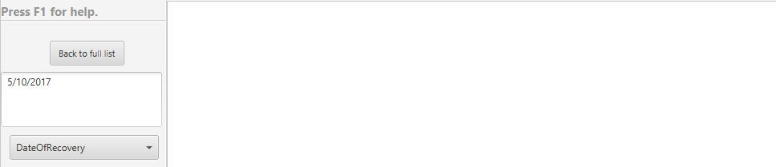

Test with an invalid Date Of recovery

Result : As seen from the tests the search works and the expected result coincides with the result.

Improvement:Adding more search criteria.

**Test case #3**

Test Case Add

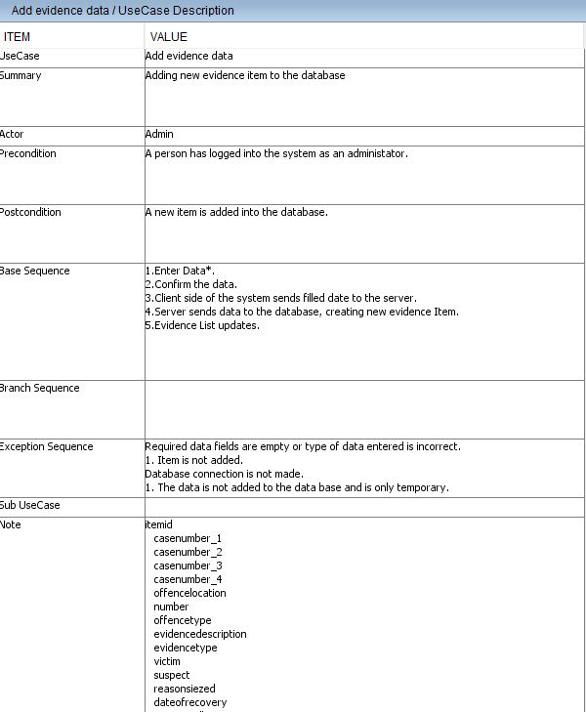

Delimitation:The system does not check for data validity/format.

Expected result:A new item is created and added to the list of evidence items.

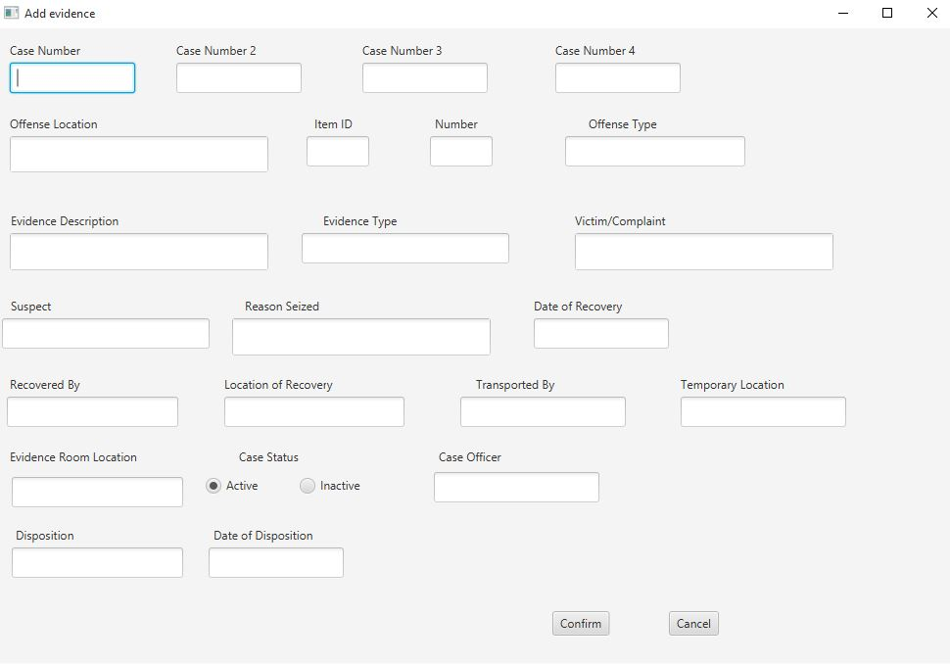

Add window

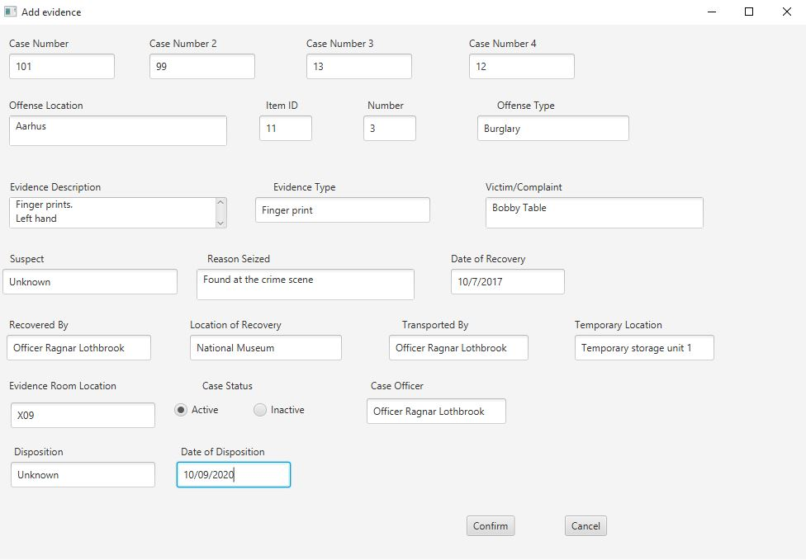

Filing information

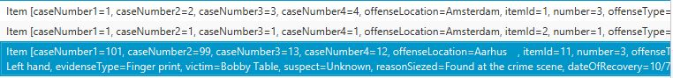

List of items updated with the new item

As the system does not check for validity any kind of data format can be entered and added as data for that particular Item.The only exception are the Date fields DateOfRecovery and DateOfDisposition,the date format has to be followed as “DD/MM/YEAR”

If a different format is detected it will throw an error when writing into the database and not insert the new item in the list.

Result :A new item is created and added to the list of evidence items.

Improvement:Invalid format to throw errors.

**Test case #4**

Test Case Remove

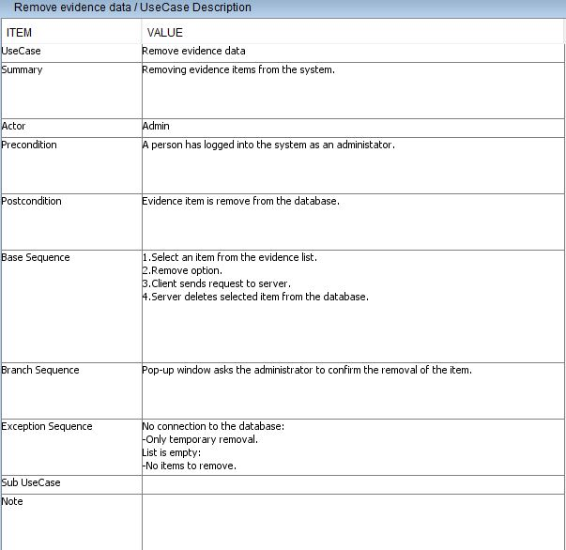

Subcase#1 removing an item/several items

Expected result: The selected item is removed.

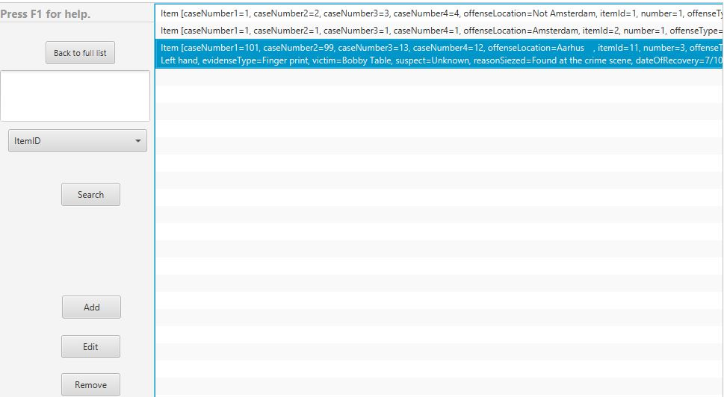

Item to be removed is selected.

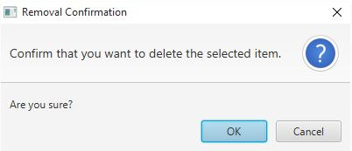

Confirmation window.

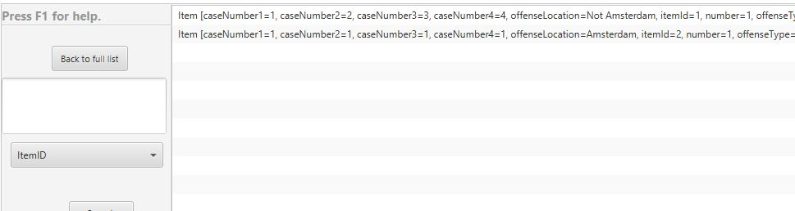

Item removed.

Subcase #2 removing an item when the list is empty.

Expected result: Nothing happens.

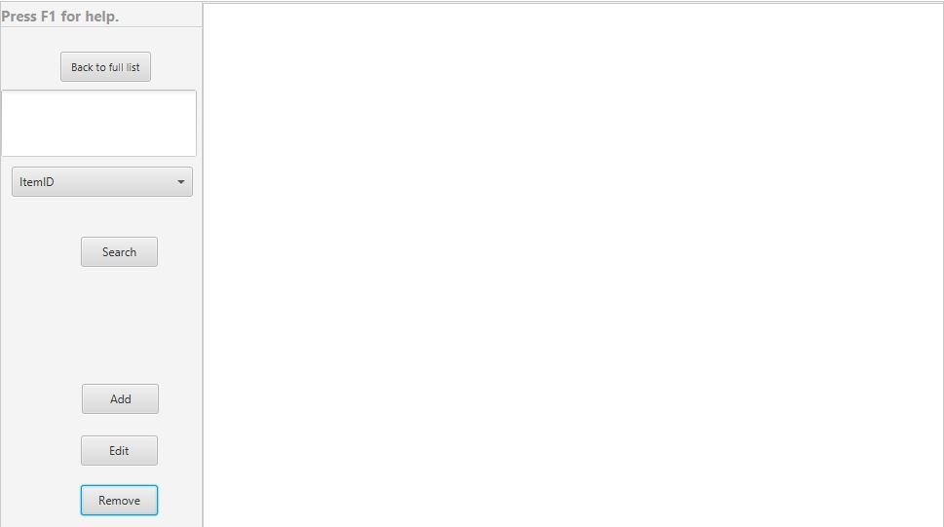

Removing from an empty list.

Result:Item removed when selected.

Improvement:Throw error message when no item is selected and Remove button is pressed.

**Test case #5**

Test Case Update

Expected result: the selected item is updated.

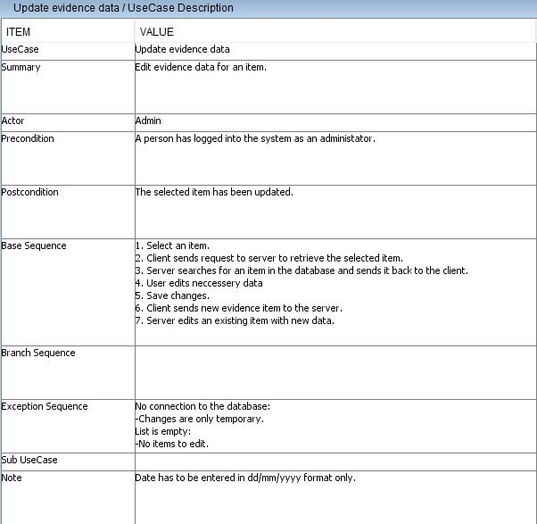

Delimitation:The system does not check for data validity/format.Date has to follow format “DD/MM/YEAR”

Expected result:A new item is created and added to the list of evidence items.

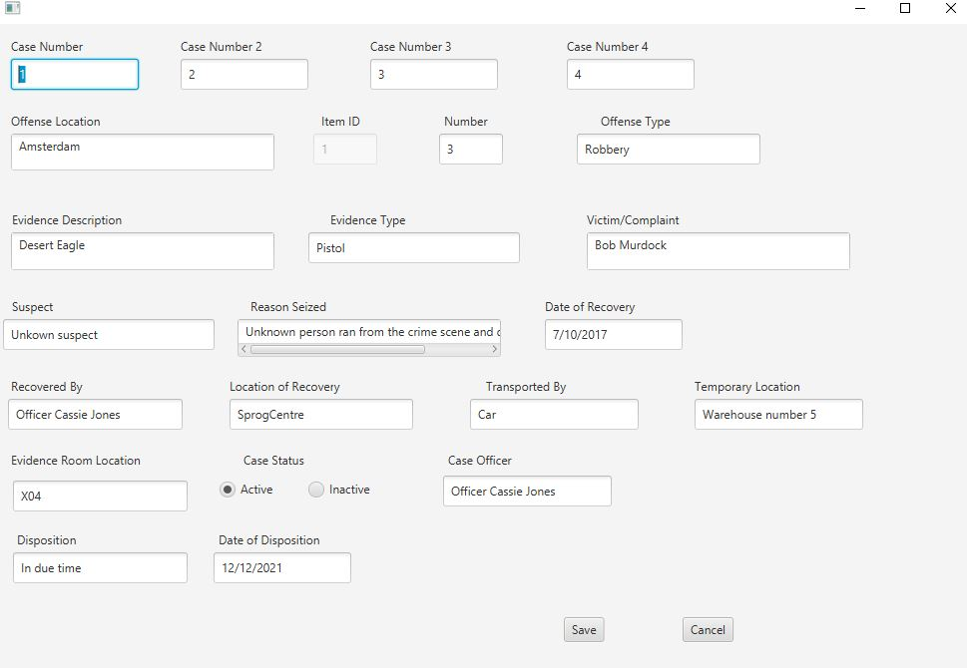

Old evidence item

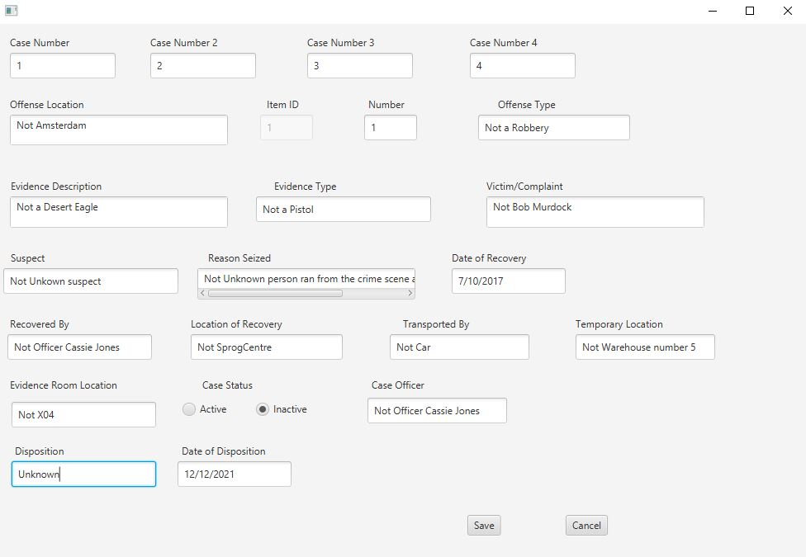

Updating the item data

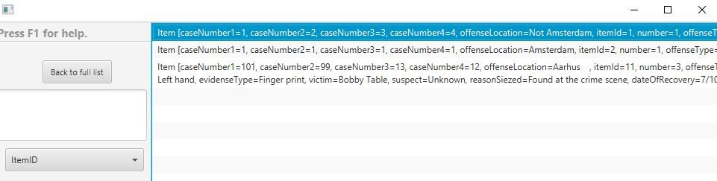

Item updated and shown in the list.

Result :The item is updated and shown in the list of evidence items.

Incorrect format not allowed.

Improvement:Invalid format to throw errors.