Orar: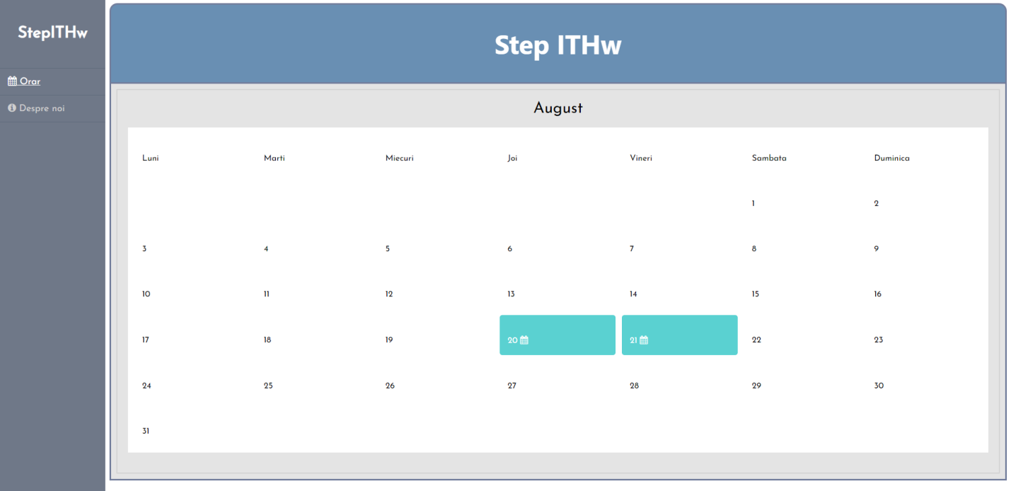

Sidebar tranzitie (hover):

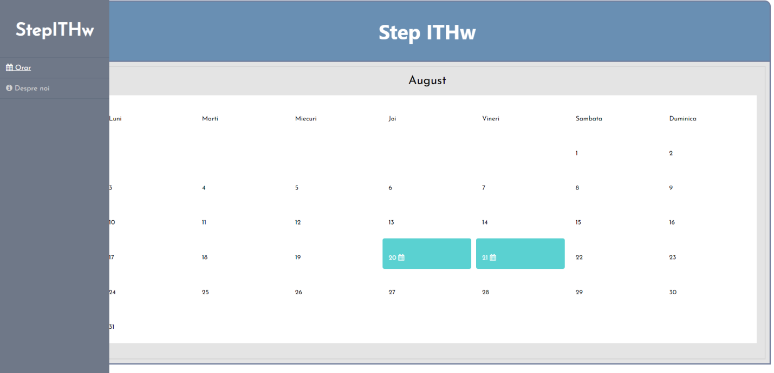

Despre noi (elemente grafice):

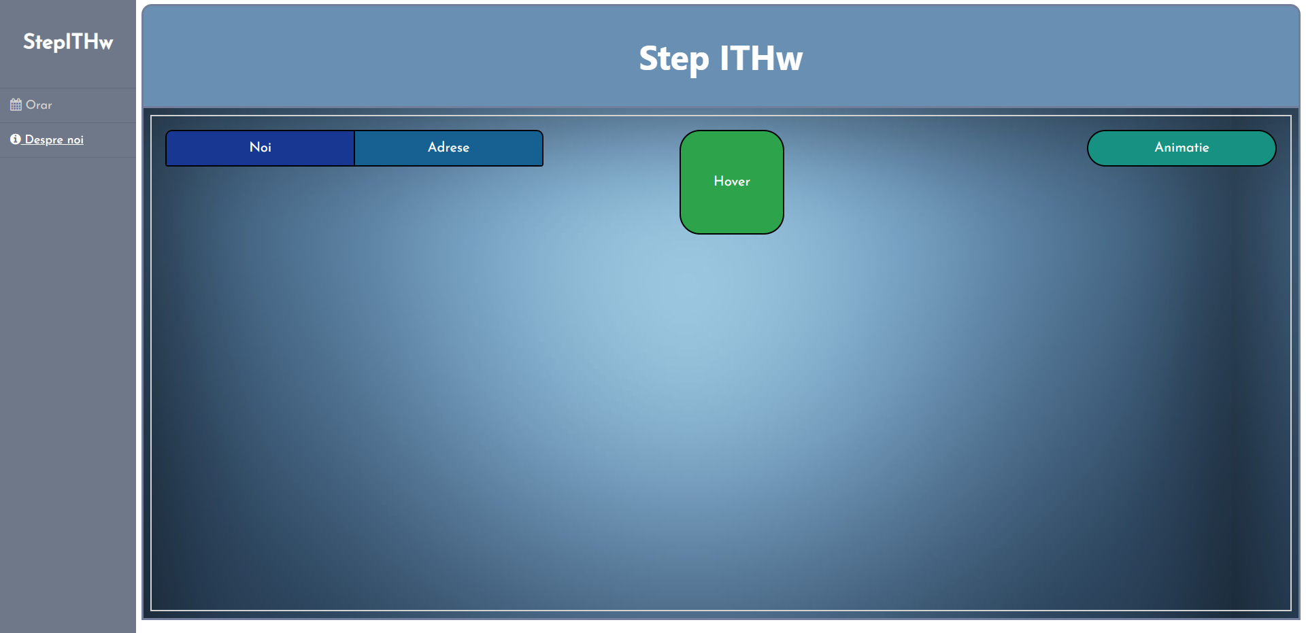

Noi hover, Adrese hover:

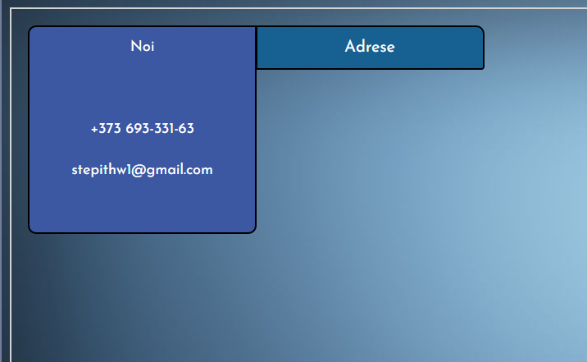 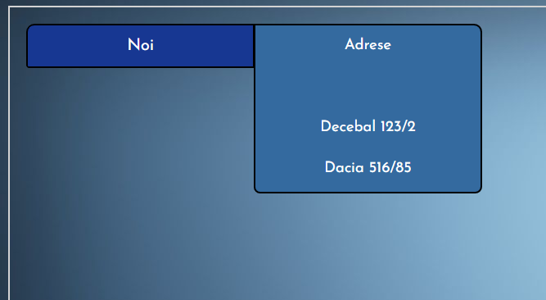

Hover hover (apare imagine):

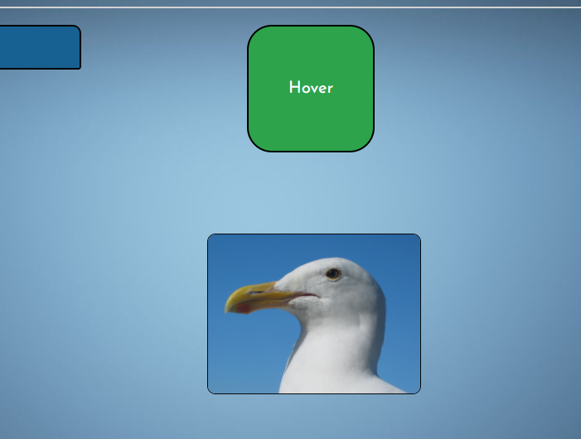

Animatie hover:

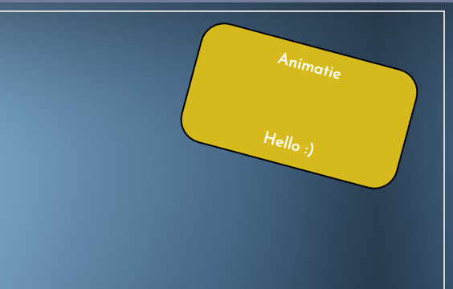

Cod:

Index.html (Orar)

<!DOCTYPE html>

<html>

    <head>

        <meta charset='utf-8'>

        <title>Step IThw</title>

        <meta name='viewport' content='width=device-width, initial-scale=1'>

        <link rel="stylesheet" type="text/css" href="css/style.css">

        <link rel="stylesheet" href="https://cdnjs.cloudflare.com/ajax/libs/font-awesome/4.7.0/css/font-awesome.min.css">

    </head>

    <body>

        <div id="sidebar">

            <h2>StepITHw</h2>

            <ul>

                <li><a href="Index.html"><span id="active"><i class="fa fa-calendar"></i><span class="sbtext"> Orar</span></a></span></li>

                <li id="sblast"><a href="About.html"><span><i class="fa fa-info-circle"></i><span class="sbtext"> Despre noi</span></a></span></li>

            </ul>

        </div>

        <header>

            <h1>Step ITHw</h1>

        </header>

        <div id="main">

            <div id="content">

                <center style="font-size: 30px;"> August </center>

                <table border="0" width="100%" height="90%" bgcolor="white">

                    <tr>

                        <td>Luni</td>

                        <td>Marti</td>

                        <td>Miecuri</td>

                        <td>Joi</td>

                        <td>Vineri</td>

                        <td>Sambata</td>

                        <td>Duminica</td>

                    </tr>

                    <tr>

                        <td> </td>

                        <td> </td>

                        <td> </td>

                        <td> </td>

                        <td> </td>

                        <td>1</td>

                        <td>2</td>

                    </tr>

                    <tr>

                        <td>3</td>

                        <td>4</td>

                        <td>5</td>

                        <td>6</td>

                        <td>7</td>

                        <td>8</td>

                        <td>9</td>

                    </tr>

                    <tr>

                        <td>10</td>

                        <td>11</td>

                        <td>12</td>

                        <td>13</td>

                        <td>14</td>

                        <td>15</td>

                        <td>16</td>

                    </tr>

                    <tr>

                        <td>17</td>

                        <td>18</td>

                        <td>19</td>

                        <td class="dlectie">20 <i class="fa fa-calendar"></i></td>

                        <td class="dlectie">21 <i class="fa fa-calendar"></i></td>

                        <td>22</td>

                        <td>23</td>

                    </tr>

                    <tr>

                        <td>24</td>

                        <td>25</td>

                        <td>26</td>

                        <td>27</td>

                        <td>28</td>

                        <td>29</td>

                        <td>30</td>

                    </tr>

                    <tr>

                        <td>31</td>

                        <td> </td>

                        <td> </td>

                        <td> </td>

                        <td> </td>

                        <td> </td>

                        <td> </td>

                    </tr>

                </table>

            </div>

        </div>

    </body>

    <script> </script>

</html>

About.html (Despre noi)

<!DOCTYPE html>

<html>

    <head>

        <meta charset='utf-8'>

        <title>Step IThw</title>

        <meta name='viewport' content='width=device-width, initial-scale=1'>

        <link rel="stylesheet" type="text/css" href="css/style.css">

        <link rel="stylesheet" href="https://cdnjs.cloudflare.com/ajax/libs/font-awesome/4.7.0/css/font-awesome.min.css">

    </head>

    <body>

        <div id="sidebar">

            <h2>StepITHw</h2>

            <ul>

                <li><a href="Index.html"><span><i class="fa fa-calendar"></i> Orar</a></span></li>

                <li id="sblast"><a href="About.html"><span id="active"><i class="fa fa-info-circle"></i> Despre noi</a></span></li>

            </ul>

        </div>

        <header>

            <h1>Step ITHw</h1>

        </header>

        <div id="mainab">

            <div id="content">

                <div id="noi">

                    Noi<br><br>

                    +373 693-331-63<br>

                    stepithw1@gmail.com

                </div>

                <div id="adrese">

                    Adrese<br><br>

                    Decebal 123/2<br>

                    Dacia 516/85<br>

                    Moscova 43/8

                </div>

                <div id="animatie">

                    Animatie<br><br>

                    Hello :)

                </div>

                <div id="animatiehover">

                    Hover

                    <img id="imagine1" src="https://upload.wikimedia.org/wikipedia/commons/9/9a/Gull_portrait_ca_usa.jpg">

                </div>

            </div>

        </div>

    </body>

    <script> </script>

</html>

style.css

@import url("https://fonts.googleapis.com/css2?family=Josefin+Sans&display=swap");

*

{

    padding: 0;

    text-decoration: none;

    table-layout: fixed;

    border-spacing: 12px;

}

body

{

    font-family: 'Josefin Sans', sans-serif;

}

header

{

    margin-left: 200px;

    background-color: rgb(105, 143, 179);

    color: white;

    width: auto;

    min-height: 116px;

    text-align: center;

    line-height: 80px;

    border-radius: 15px 15px 0px 0px;

    border: 3px solid rgb(115, 126, 156);

}

header h1

{

    font-size: 50px;

    font-weight: bold;

    font-family: 'Segoe UI', Tahoma, Geneva, Verdana, sans-serif

}

#main

{

    margin-left: 200px;

    min-height: 750px;

    /* height: auto; */

    width: auto;

    background-color: rgb(228, 228, 228);

    display: flex;

    border-bottom: 3px solid rgb(115, 126, 156);

    border-left: 3px solid rgb(115, 126, 156);

    border-right: 3px solid rgb(115, 126, 156);

}

#mainab

{

    margin-left: 200px;

    min-height: 750px;

    /* height: auto; */

    width: auto;

    background-image: url("https://i.pinimg.com/originals/d7/59/b5/d759b559ad669f9e199f1aaaa381a8ab.jpg"

);

    display: flex;

    border-bottom: 3px solid rgb(115, 126, 156);

    border-left: 3px solid rgb(115, 126, 156);

    border-right: 3px solid rgb(115, 126, 156);

}

#sidebar

{

    box-sizing: border-box;

    top: 0;

    left: 0;

    position: fixed;

    float: left;

    width: 200px;

    height: 100%;

    background-color: rgb(111, 120, 136);

    padding: 25px 0;

    transition-duration: 0.4s;

}

#sidebar h2

{

    text-align: center;

    font-size: 30px;

    color: white;

    font-weight: bold;

    padding-bottom: 25px;

    transition-duration: 0.4s;

}

#content

{

    float: left;

    margin: 10px;

    width: 100%;

    height: auto;

    background-color: inherit;

    border: 2px solid rgb(211, 211, 211);

    padding: 20px;

}

#sidebar ul li

{

    list-style: none;

    padding: 15px;

    border-top: 1px solid rgba(87, 98, 116, 0.6);

}

#sidebar ul li a

{

    font-size: 18px;

    color: rgb(207, 207, 207);

    display: block;

}

#sblast { border-bottom: 1px solid rgba(87, 98, 116, 0.6);}

#sidebar ul li:hover

{

    background-color: rgb(101, 112, 128);;

}

#content table

{

    margin-top: 20px;

    margin-bottom: 20px;

}

#content table tr td

{

    padding-left: 15px;

    padding-top: 20px;

    overflow: hidden;

}

.dlectie

{

    background-color: rgb(90, 209, 209);

    color: white;

    border-radius: 5px;

}

#active

{

    color: white;

    text-decoration: underline;

}

#sidebar:hover

{

    width: 280px;

}

#sidebar:hover h2

{

    font-size: 46px;

    padding-bottom: 5px;

}

#noi

{

    float: left;

    line-height: 50px;

    height: 50px;

    width: 275px;

    background-color: rgb(23, 55, 146);

    text-align: center;

    color: white;

    border: 2px solid black;

    border-right: 1px solid black;

    border-radius: 10px 0px 0px 3px;

    font-size: 20px;

    transition-duration: 0.5s;

    overflow: hidden;

}

#noi:hover

{

    background-color: rgb(61, 88, 163);

    border-radius: 10px 0px 10px 10px;

    border-right: 2px solid black;

    font-size: 18px;

    height: 250px;

}

#adrese

{

    float: left;

    line-height: 50px;

    height: 50px;

    width: 275px;

    background-color: rgb(23, 97, 146);

    text-align: center;

    color: white;

    border: 2px solid black;

    border-left: 1px solid black;

    border-radius: 0px 10px 3px 0px;

    font-size: 20px;

    transition-duration: 0.5s;

    overflow: hidden;

}

#adrese:hover

{

    background-color: rgb(61, 109, 163);

    border-radius: 0px 10px 10px 10px;

    border-left: 2px solid black;

    font-size: 18px;

    height: 250px;

}

#animatie

{

    margin: 0px;

    float: right;

    line-height: 50px;

    height: 50px;

    width: 275px;

    background-color: rgb(23, 146, 130);

    text-align: center;

    color: white;

    border: 2px solid black;

    border-radius: 30px;

    font-size: 20px;

    transition-duration: 1s;

    overflow:hidden;

}

#animatie:hover

{

    margin: 20px;

    background-color: rgb(214, 186, 29);

    transform: rotate(15deg);

    height: 150px;

}

#animatiehover

{

    margin-left: 200px;

    float: left;

    line-height: 150px;

    height: 150px;

    width: 150px;

    background-color: rgb(45, 163, 75);

    text-align: center;

    color: white;

    border: 2px solid black;

    border-radius: 30px;

    font-size: 20px;

    transition-duration: 1s;

    overflow: visible;

}

#imagine1

{

    position: relative;

    top: 100px;

    right: 50px;

    height: 192px;

    border-radius: 10px;

    border: 1px solid black;

    opacity: 0;

    transition-duration: 1s;

}

#animatiehover:hover #imagine1

{

    opacity: 100;

}