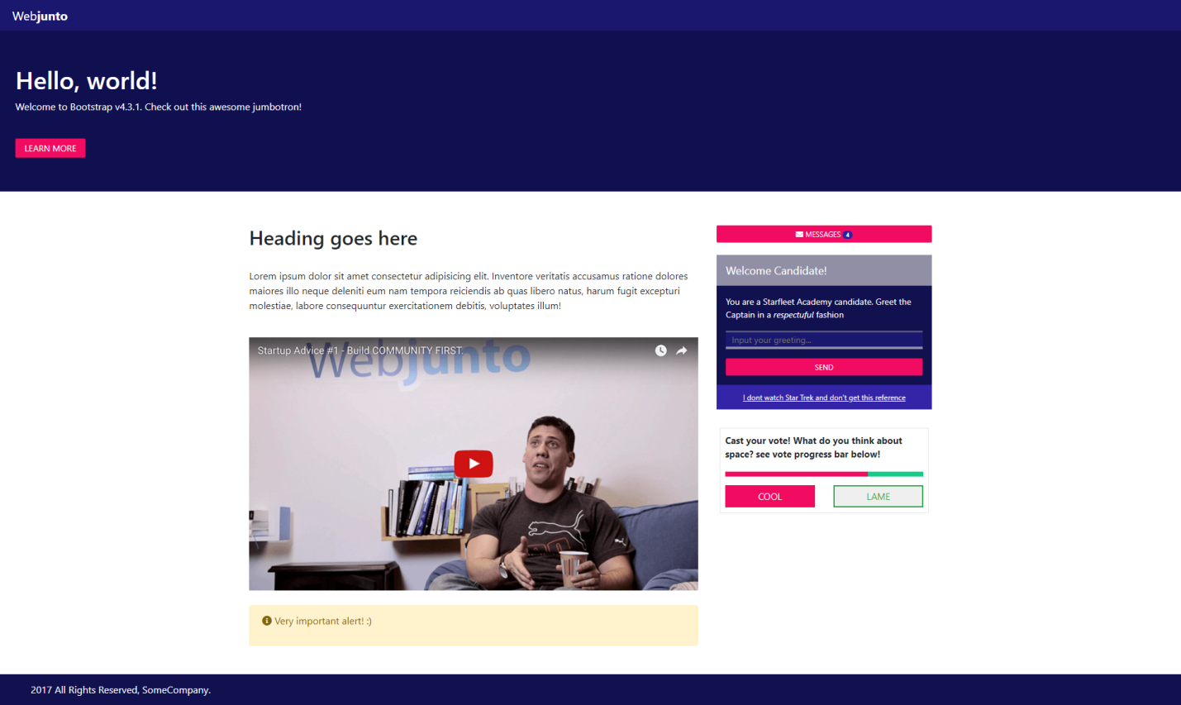

HTML:

<!DOCTYPE html>

<html>

    <head>

        <script src="https://code.jquery.com/jquery-3.5.1.min.js"

        integrity="sha256-9/aliU8dGd2tb6OSsuzixeV4y/faTqgFtohetphbbj0="

        crossorigin="anonymous"></script>

        <meta charset="UTF-8">

        <link rel="stylesheet" type="text/css" href="bootstrap/css/bootstrap.min.css">

        <script type="text/javascript" src="bootstrap/js/bootstrap.min.js"></script>

        <link rel="stylesheet" type="text/css" href="css/style.css">

        <link href="https://pro.fontawesome.com/releases/v5.13.0/css/all.css" rel="stylesheet">

        <title> HW</title>

    </head>

    <body>

        <div id="topdiv">Web<b>junto</b></div>

        <header id="helloworldheader">

            <h1>Hello, world!</h1>

            <p>Welcome to Bootstrap v4.3.1. Check out this awesome jumbotron!</p> <br>

            <button type="button" class="buttonroz" id="learnmorebuttonh">LEARN MORE</button>

        </header>

        <div id="main" class="container">

            <div class="row">

                <div class="col-8" id="content">

                    <h2>Heading goes here</h2> <br>

                    <p>Lorem ipsum dolor sit amet consectetur adipisicing elit. Inventore veritatis accusamus ratione dolores maiores illo neque deleniti eum nam tempora reiciendis ab quas libero natus, harum fugit excepturi molestiae, labore consequuntur exercitationem debitis, voluptates illum!</p> <br>

                    <img src="images/video.png" style="width: 100%;"> <br> <br>

                    <div class="alert alert-warning fade show">

                        <!-- <button type="button" class="close" data-dismiss="alert">x</button> -->

                        <p><i class="fas fa-info-circle"></i> Very important alert! :)</p>

                    </div>

                </div>

                <div class="col-4" id="rightside">

                    <button type="button" class="buttonroz fullwidthbutton">

                        <i class="fas fa-envelope"></i> MESSAGES <span class="badge badge-pill" id="badgemsg">4</span>

                    </button>

                    <div id="greeting">

                        <div id="wlcandidate">Welcome Candidate!</div>

                        <div id="sendgr">

                            <p>You are a Starfleet Academy candidate. Greet the Captain in a <i>respectuful</i> fashion</p>

                            <form action="sendgreeting.js">

                                <input type="text" id="edit1" placeholder="  Input your greeting... ">

                                <input type="submit" class="buttonroz fullwidthbutton" value="SEND"></button>

                            </form>

                        </div>

                        <center id="idontst">I dont watch Star Trek and don't get this reference</center>

                    </div>

                    <div id="voting">

                        <b>Cast your vote! What do you think about space? see vote progress bar below!</b>

                        <div class="progress" id="pbvote">

                            <div class="progress-bar" id="pbpink"></div>

                            <div class="progress-bar bg-success" id="pbgreen"></div>

                        </div>

                            <div class="row">

                                <div class="col-6">

                                    <button type="button" class="btnvote" id="btncool">COOL</button>

                                </div>

                                <div class="col-6">

                                    <button type="button" class="btnvote btn-outline-success" id="btnlame">LAME</button>

                                </div>

                            </div>

                    </div>

                </div>

            </div>

        </div>

        <footer id="footer">

            2017 All Rights Reserved, SomeCompany.

        </footer>

    </body>

</html>

CSS:

#topdiv

{

    background-color: #19176e;

    line-height: 50px;

    color: white;

    padding-left: 20px;

    font-size: 20px;

}

#helloworldheader

{

    background-color: #101050;

    color: white;

    padding: 55px 25px;

}

.buttonroz

{

    background-color: #f20c61;

    color: white;

    font-size: 14px;

    border: 0px;

    border-radius: 2px;

}

.buttonroz:hover

{background-color: #a70043;}

#learnmorebuttonh

{padding: 5px 15px;}

#main

{

    margin-top: 55px;

}

.fullwidthbutton

{

    padding: 5px;

    width: 100%;

    font-size: 12px;

}

#badgemsg

{

    background-color: #2e1fa6;

}

#greeting

{

    margin-top: 20px;

    color: white;

}

#wlcandidate

{

    background-color: #908fa6;

    line-height: 50px;

    padding-left: 15px;

    font-size: 18px;

}

#sendgr

{

    background-color: #12114f;

    padding: 15px;

    font-size: 14px;

}

#edit1

{

    border: 0px;

    width: 100%;

    background-color: #1a176e;

    border-top: 3px #54537e solid;

    border-bottom: 4px #9090a8 solid;

    margin-bottom: 15px;

    color: white;

}

#idontst

{

    cursor: pointer;

    display: block;

    background-color: #3424a8;

    font-size: 12px;

    line-height: 40px;

    text-decoration: underline;

}

#voting

{

    margin: 5px;

    margin-top: 30px;

    border: 1px rgb(230, 230, 230) solid;

    padding: 8px;

    font-size: 15px;

}

#pbpink

{

    background-color: #f20c61!important;

    width: 72%;

}

#pbgreen

{

    background-color: #15cb89!important;

    width: 28%;

}

#pbvote

{

    margin-top: 18px;

    margin-bottom: 14px;

    height:8px;

    border-radius: 0px;

}

.btnvote

{

    width: 100%;

    border: 0px;

    border-radius: 0px;

    line-height: 30px;

}

#btncool

{

    color: white;

    background-color: #f20c61;

    border: 2px #f20c61 solid;

}

#btncool:hover

{

    background-color: #a70043;

    border: 2px #a70043 solid;

}

#btnlame

{

     border: 2px solid;

}

#footer

{

    margin-top: 30px;

    background-color: #12114f;

    line-height: 50px;

    color: white;

    padding-left: 50px;

    padding-right: 50px;

}