Código

Página web

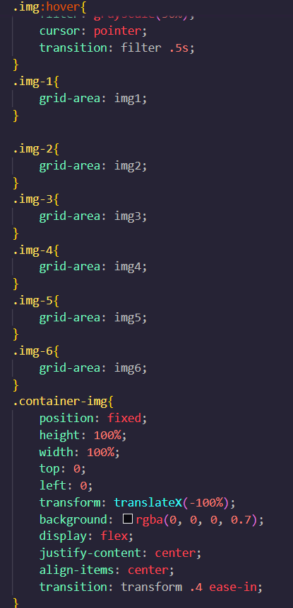Estilo css

\*{

    margin: 0;

    padding: 0;

    box-sizing: border-box;

}

body{

    font-family: 'Arial';

}

.container-grid{

    display: grid;

    height: 100vh;

    grid-template-columns: repeat(5,1fr);

    grid-template-rows: repeat(6,1fr);

    grid-template-areas:

    "img1 img2 img3 img3 img3"

    "img1 img2 img3 img3 img3"

    "img4 img4 img3 img3 img3"

    "img4 img4 img3 img3 img3"

    "img6 img6 img5 img5 img5"

    "img6 img6 img5 img5 img5";

    gap: 5px ;

}

.img{

width: 100%;

height: 100%;

object-fit: cover;

}

.img:hover{

    filter: grayscale(50%);

    cursor: pointer;

    transition: filter .5s;

}

.img-1{

    grid-area: img1;

}

.img-2{

    grid-area: img2;

}

.img-3{

    grid-area: img3;

}

.img-4{

    grid-area: img4;

}

.img-5{

    grid-area: img5;

}

.img-6{

    grid-area: img6;

}

.container-img{

    position: fixed;

    height: 100%;

    width: 100%;

    top: 0;

    left: 0;

    transform: translateX(-100%);

    background: rgba(0, 0, 0, 0.7);

    display: flex;

    justify-content: center;

    align-items: center;

    transition: transform .4 ease-in;

}

.move{

transform: translateX(0);

}

.img-show{

    height: 80%;

    transform: scale(0);

    display: block;

    object-fit: cover;

    transition: trasform .2 .4;

}

.show{

    transform: scale(1);

}

.copy{

    position: fixed;

    color: #fff;

    bottom: 40px;

}

.bx.bx-x{

    position: absolute;

    color: #fff;

    top: 20px;

    right: 10px;

    font-size: 40px;

    cursor: pointer;

}

@media screen and (max-width:700px){

    .img-show{

        width: 90%;

    }

    .copy{

        bottom: 20px;

    }

    .bx.bx-x{

        top: 10px;

        font-size: 20px;

    }

}

Java

const images = document.querySelectorAll('.img');

const containerImage = document.querySelector('.container-img');

const imageContainer = document.querySelector('.img-show');

const copy = document.querySelector('.copy')

const closeModal = document.querySelector('.bx.bx-x')

images.forEach(*image* =>{

*image*.addEventListener('click', ()=>{

        addImage(*image*.getAttribute('src'),*image*.getAttribute('alt'))

    })

})

const addImage =(*srcImage*, *altImage*)=>{

    containerImage.classList.toggle('move');

    imageContainer.classList.toggle('show');

    imageContainer.src = *srcImage*;

    copy.innerHTML=*altImage*;

}

closeModal.addEventListener('click', ()=>{

    containerImage.classList.toggle('move');

    imageContainer.classList.toggle('show');

})

