Game Design Document

Fill up the Following document

1. Write the title of your project.

Flappy bird

1. What is the goal of the game?

Get as many points as possible

1. Write a brief story of your game?

The bird got lost in the city, guide it to reach it’s home, which is the forest.

1. Which are the playing characters of this game?

* Playing characters are the ones which respond to the user based on the input from the user
* Cars, monkeys, dinos, wizards etc, are the playing characters in the game.

|  |  |  |
| --- | --- | --- |
| Number | Character Name | What can this character do? |
| 1 | bird | fly |
| 2 |  |  |
| 3 |  |  |
| 4 |  |  |
| 5 |  |  |
| 6 |  |  |
| 7 |  |  |
| 8 |  |  |

1. Which are the Non Playing Characters of this game?

* Non Playing characters are the ones which don't have an action or a behaviour when the user interacts with the game.
* Hurdles, stones, bananas, coins, etc are non playing characters in the game.

|  |  |  |
| --- | --- | --- |
| Number | Character Name | What can this character do? |
| 1 | pipes | Be an obstacle along the path of the bird |
| 2 |  |  |
| 3 |  |  |
| 4 |  |  |
| 5 |  |  |
| 6 |  |  |
| 7 |  |  |
| 8 |  |  |

Draw your imagination of this game. What does this game look like?

* Draw the game either on your computer or on paper,
* Add images of scenes of the game to show each of the playing and non-playing characters at least once.

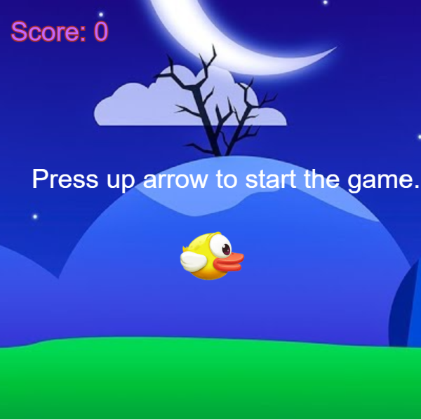

How do you plan to make your game engaging?

After some time, the speed of the background and the pipes is increasing. The score and highest score are displayed on the screen, different sounds play when the bird starts flying, when it hits a pipe, and when the highest score value changes.