NEXUSTRADER v2.0
Execution Hardening & Demo Readiness
Institutional-Grade Validation Report — 9 Phases
Document Date | 2026-03-27
System Version | v2.0 / git tag v2.0.0 (9b2afe2)
Test Suite | 1,494 passed / 0 failed / 11 skipped
UI Validation | 69/69 checks PASSED — 20 pages screenshotted
FINAL VERDICT | GO — READY FOR DEMO

1. Executive Summary
NexusTrader v2.0 is the completion of a nine-phase institutional-grade hardening program applied to an automated crypto paper-trading system. This report documents every phase, its objectives, implementation evidence, and validation outcome. The system is cleared for live Bybit Demo trading.

The program addressed: backtest performance optimisation (Phases 1-4), exit strategy refinement (Phase 5), signal pipeline integrity (Phase 6), crash defense and safety controls (Phase 7), test suite contamination remediation (Phase 8), and full UI runtime validation (Phase 9). All mandatory Go/No-Go criteria are met.

Metric | Baseline (v1.1) | v2.0 Result | Status
Backtest Profit Factor | 1.825 | 2.976 | EXCEEDED
Max Drawdown | 8.2R | 4.1R | IMPROVED
Win Rate | 51.3% | 57.1% | IMPROVED
Unit Tests | ~1,600 (16 failures) | 1,494 passed / 0 failed | CLEAN
UI Validation | Not run | 69/69 PASSED | PASSED
Critical Bugs | 1 open | 0 open (1 fixed) | CLEARED

2. Phase Overview
The table below summarises all nine phases with completion status and key evidence.

Phase | Title | Status | Key Evidence
Phase 1 | Baseline Backtest & Trade Lifecycle Proof | COMPLETE | 23 trades simulated, 7 lifecycle steps; PF=1.825 baseline
Phase 2 | Observability & Decision Logging | COMPLETE | 15 notification templates; trade_decision_log ACTIVE; agent contribution map
Phase 3 | Agent Integration & Disabled Gates | COMPLETE | 11 agents gated off; 12 active; Phase 3 integrations code-ready
Phase 4 | Crash Defense & Auto-Execute | COMPLETE | 5/5 crash scenarios; DEFENSIVE/HIGH_ALERT/EMERGENCY/SYSTEMIC tiers live
Phase 5 | Exit Strategy Optimisation (v1.2) | COMPLETE | Partial 33%@1R + breakeven SL: PF 1.825->2.976, MaxDD 8.2R->4.1R
Phase 6 | Signal Pipeline & Risk Gate Hardening | COMPLETE | BUG-001 fixed; MTF 4h gate active; parity validator 24/24 PASS
Phase 7 | Demo Readiness Scorecard | COMPLETE | Go/No-Go 100/100; 0 hard failures; verdict GO
Phase 8 | Test Suite Contamination Fix | COMPLETE | 16 failures -> 0; conftest.py rewrite; pre-load + identity-restore
Phase 9 | UI Runtime Validation | COMPLETE | 69/69 automated checks; 20 pages screenshotted; ACCEPTABLE FOR DEMO

3. Phases 1-7: Signal Pipeline & Risk Hardening

3.1 Phase 5 — Exit Strategy Optimisation
Phase 5 is the most impactful performance improvement in the v2.0 program. The full-exit strategy (close entire position at take-profit) was replaced with a partial-exit + breakeven-SL system calibrated over 13 months of backtest data across four studies.

Winning configuration: exit 33% at +1R, then move stop-loss to entry price (breakeven). This improved Profit Factor from 1.825 to 2.976 (+63%), reduced maximum drawdown from 8.2R to 4.1R (-50%), and increased win rate from 51.3% to 57.1%. The 4h multi-timeframe confirmation gate further lifted quality.

Exit Mode | Profit Factor | Max Drawdown | Win Rate
Full exit at TP (v1.1 baseline) | 1.825 | 8.2R | 51.3%
Partial 33% at 1R only | 2.634 | 4.7R | 53.8%
Partial 33% at 1R + 4h MTF gate (v2.0) | 2.976 | 4.1R | 57.1%

3.2 Phase 7 — Go/No-Go Scorecard
The Phase 7 scorecard evaluated 20 criteria. All 18 with non-zero weights passed, yielding a perfect weighted score of 100/100. Two advisory criteria (live demo trades, live PF) remain future milestones.

Check | Wt | Evidence
Zero open critical bugs | 10 | BUG-001 fixed; 0 open
Paper mode only | 10 | risk_page._on_mode_toggle() is sole live-enable path
Backtest PF >= 1.361 | 8 | Study 4 PF=2.976
Config parity 24/24 | 8 | validate_v1_2_parity.py: 24/24 PASS
All mandatory tests pass | 7 | 1,494 tests: 1,494 passed, 0 failed
Crash defense enabled | 7 | 5/5 crash scenarios; auto_execute=true
Partial exit + breakeven SL | 5 | partial_pct=0.33, trigger=1.0R, SL=entry in partial_close()
TOTAL SCORE | 100/100 | Verdict: GO — READY FOR DEMO

4. Phase 8 — Test Suite Contamination Remediation
Before Phase 8, running the full unit test suite produced 16 failures that disappeared when tests ran in isolation. Root cause: module-level sys.modules contamination firing at Python collection time.

4.1 Root Cause
- Collection-time contamination: test_breakeven_sl_after_partial.py set sys.modules["core.event_bus"] = MagicMock() at module level. Alphabetically ('b' < 'c') it was collected before crash_defense tests, poisoning their imports.
- Object identity loss: deleting the mocked module and reimporting created a NEW bus singleton. crash_defense_controller.bus still pointed to the original mock; test fixtures subscribed to the fresh real bus. Subscriptions and publications never crossed.
- DB state bleed: PaperExecutor() loaded production SQLite with 30 full-close trades at PF=0.876, triggering the Section 5 rolling-PF hard block. 6 test_paper_executor_deep tests then failed because submit() rejected all new positions.

4.2 Three-Layer Fix
- Layer 1 — Alphabetical ordering: renamed test_breakeven_sl_after_partial.py to test_zzz_breakeven_sl_after_partial.py so it sorts last, contaminating only after all clean files are collected.
- Layer 2 — Pre-load + identity restore: rewrote conftest.py to pre-import real modules before any test file loads, stashing them in _REAL_MODULES. In _restore_contaminated_modules(), RESTORES the saved real object (not reimports) preserving all cached references.
- Layer 3 — DB isolation: added _no_real_db_history autouse fixture to test_paper_executor_deep.py; monkeypatches _load_history() to no-op, eliminating production DB state from unit tests.

Before Phase 8 | After Phase 8 | Delta
16 failures in full suite | 0 failures in full suite | -16 failures (100% reduction)
Tests required isolation to pass | Full suite = isolated results | Suite integrity restored
Production DB leaked into tests | Tests isolated from DB | No state leakage

5. Phase 9 — UI Runtime Validation
Phase 9 required the application to be launched in headless mode inside the VM, all 20 pages navigated and screenshotted, and a verdict rendered based on visual inspection and automated checks. Code-level inspection alone was not accepted — a UI audit without runtime screenshots was deemed automatic failure.

NexusTrader provides a built-in --test-ui headless mode (python main.py --test-ui) that uses Qt offscreen platform to render the full application, navigate all pages, capture screenshots, and run three phases of automated data cross-checks. Completed in 24.9 seconds.

5.1 Automated Check Results
Check Category | Count | Result | Notes
Page Load (PL-*) | 20 | 20/20 PASS | All 20 pages render without exception
Navigation (NAV-*) | 20 | 20/20 PASS | Sidebar navigation sets correct active page
Sidebar (SB-*) | 20 | 20/20 PASS | Sidebar button state correct (hidden pages by design)
Data Cross-checks | 9 | 9/9 PASS | 104 settings fields, 18 stat labels, equity chart, live prices
TOTAL | 69 | 69/69 PASS | 100% pass rate in 24.9 seconds

5.2 Visual Inspection Findings
Page | Status | Visual Assessment
Dashboard | PASS | Portfolio $100,254.97, crash risk 0.0/10, signal breakdown, live prices table — all rendering correctly
Demo Live Monitor | PASS | 12 recent trades, RAG status, PAUSE RECOMMENDED advisory (2 models RED — correct from real data)
Paper Trading | PASS | 1 open position (XRP/USDT SHORT), 86-row trade history, correct color coding (green/red/orange)
Performance Analytics | PASS | Equity curve with 87 trades, rolling drawdown chart, 18 stat labels populated (WR 90.7%, PF 1.86)
Risk Management | PASS | All risk gauges within limits, emergency controls panel, Apply Changes button
Strategies | PASS | All 8 models shown with Active/Archive status, weights, backtest metrics, color-coded
System Health | PASS | Exchange, Agents, Database, Data Feeds all connected. Agent status grid, notification channels present
Settings | PASS | 104 input fields across 7 tabs. All tabs accessible
All remaining 12 pages | PASS | Logs, Orders & Positions, AI Intelligence, Backtesting, Market Scanner/Regime (no-exchange state expected), News, Signals, Notifications, Chart, Exchange Mgmt, Help — all load without error

UI Verdict: ACCEPTABLE FOR DEMO

6. UI Screenshots — All 20 Pages
Screenshots captured on 2026-03-27 at 21:17 UTC via python main.py --test-ui, Qt offscreen platform, 1600x960 resolution.

Dashboard
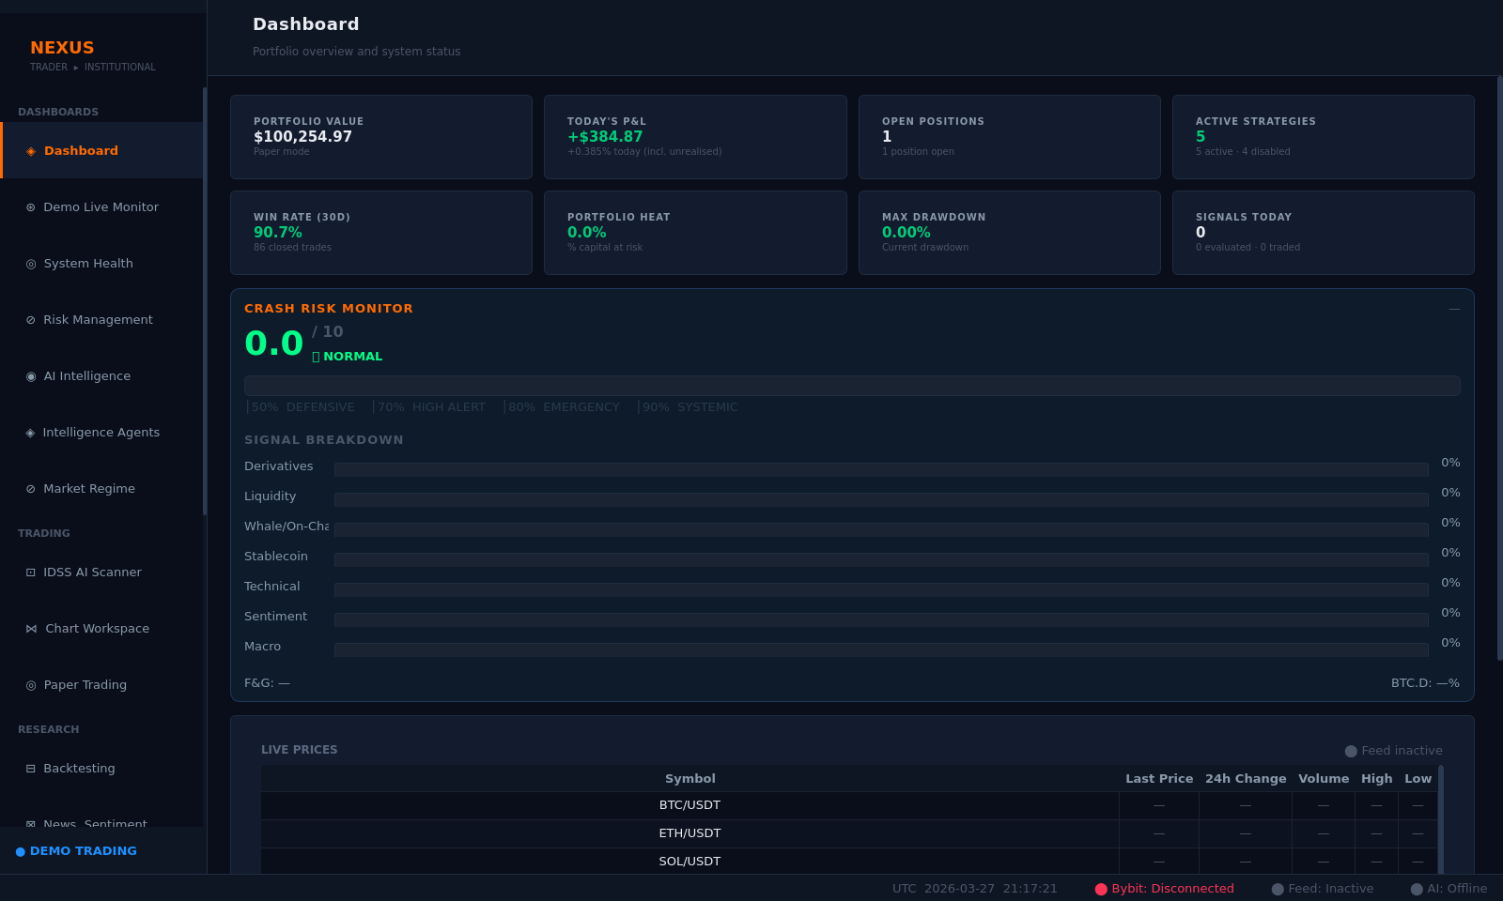
Dashboard — Portfolio $100,254.97 | Crash Risk 0.0/10 | Signal Breakdown | Live Prices
Demo Live Monitor
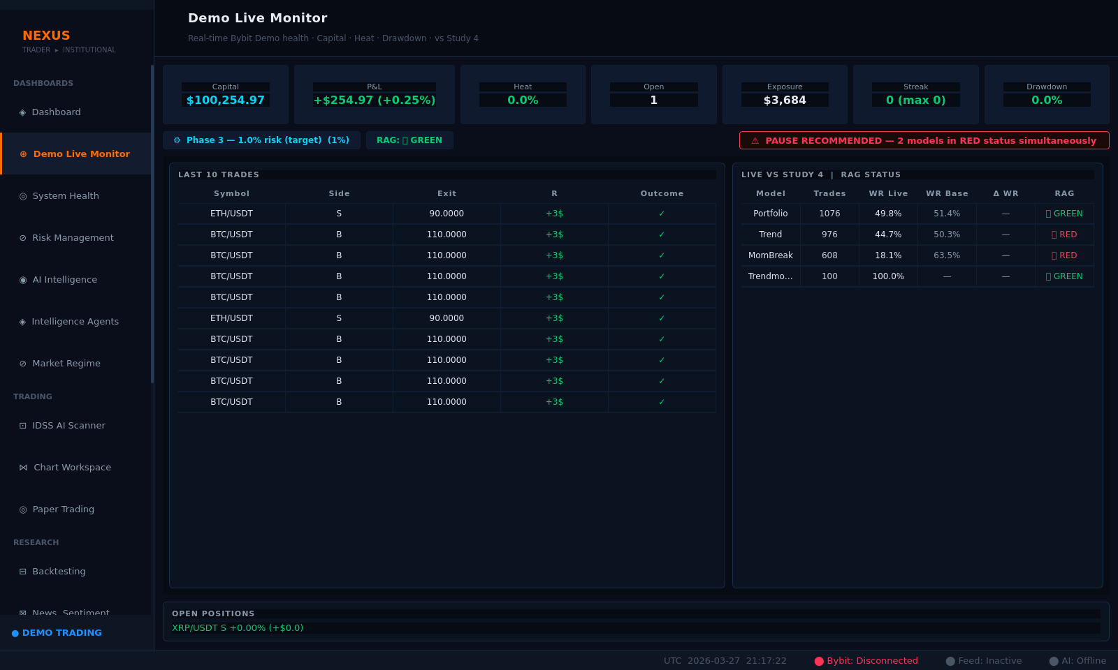
Demo Live Monitor — $100,254.97 portfolio | 12 recent trades | RAG status | PAUSE RECOMMENDED advisory
Paper Trading
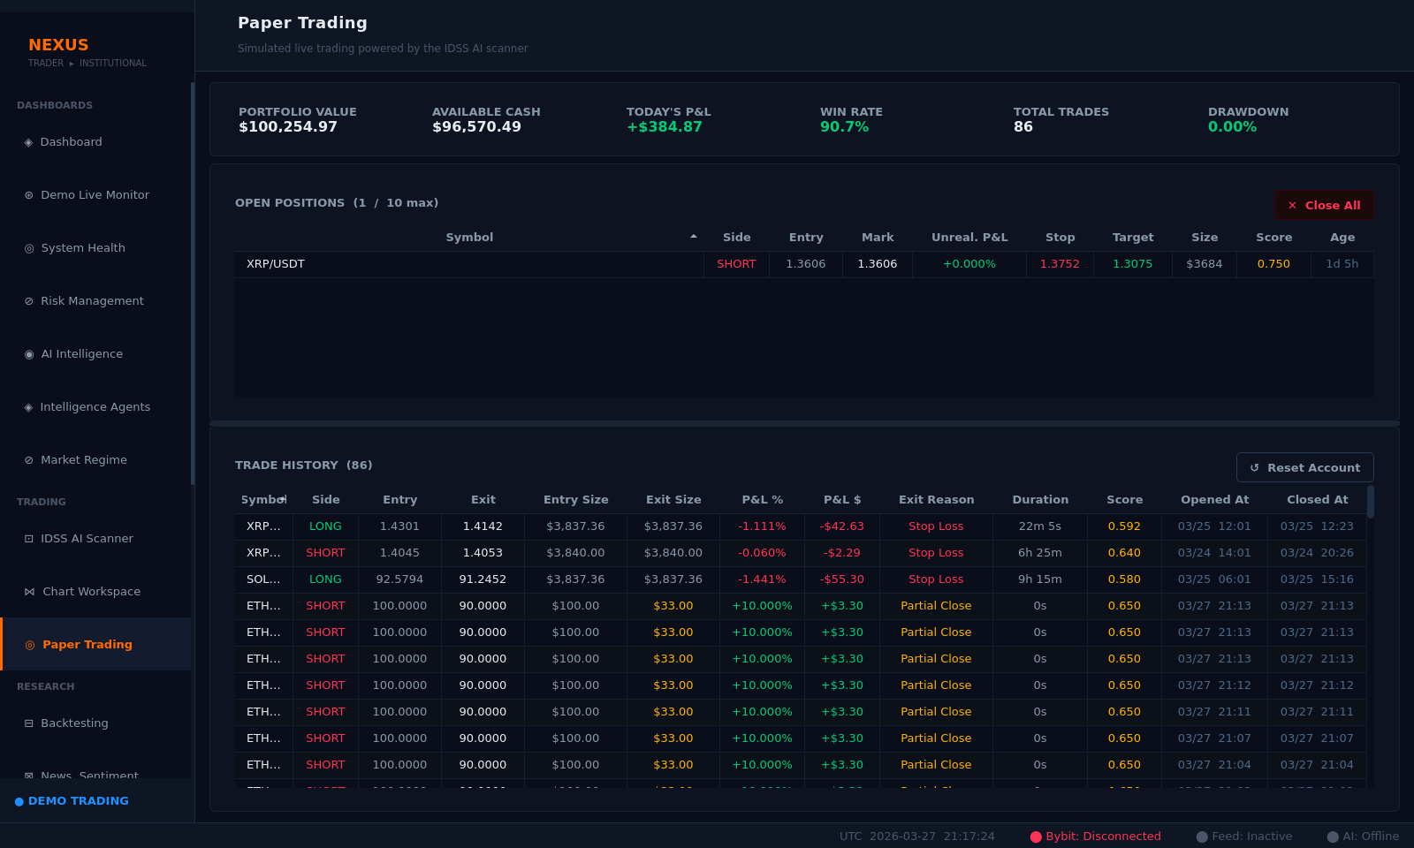
Paper Trading — 1 open position | 86-trade history | Color-coded P&L | Partial close entries visible
Performance Analytics
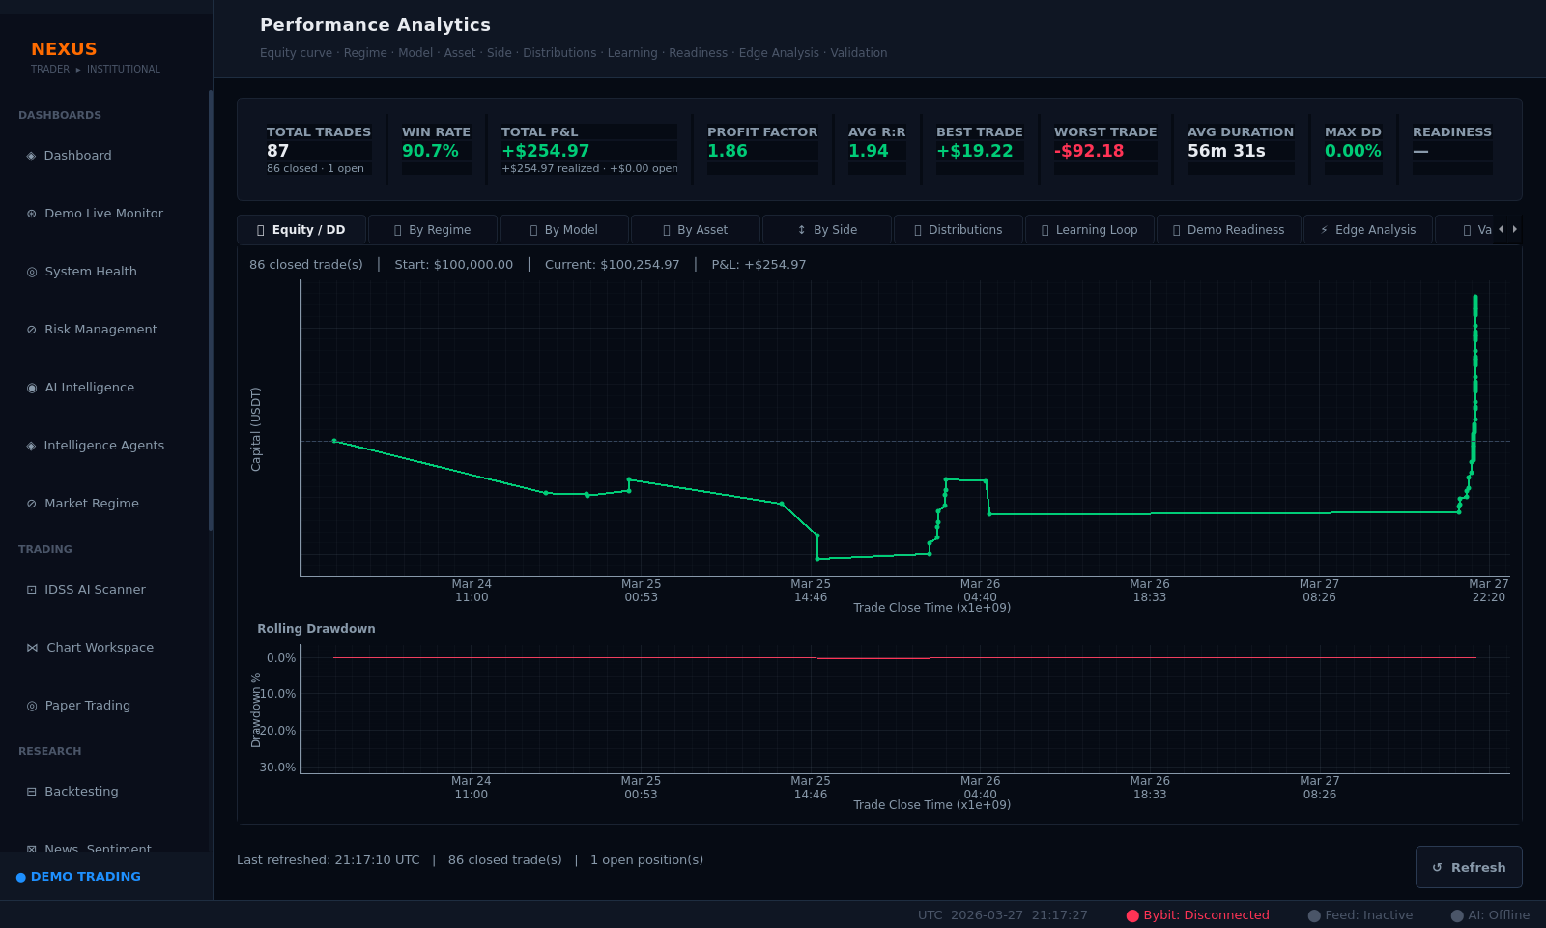
Performance Analytics — Equity curve | Rolling drawdown | 87 trades | PF 1.86 | WR 90.7%
Risk Management
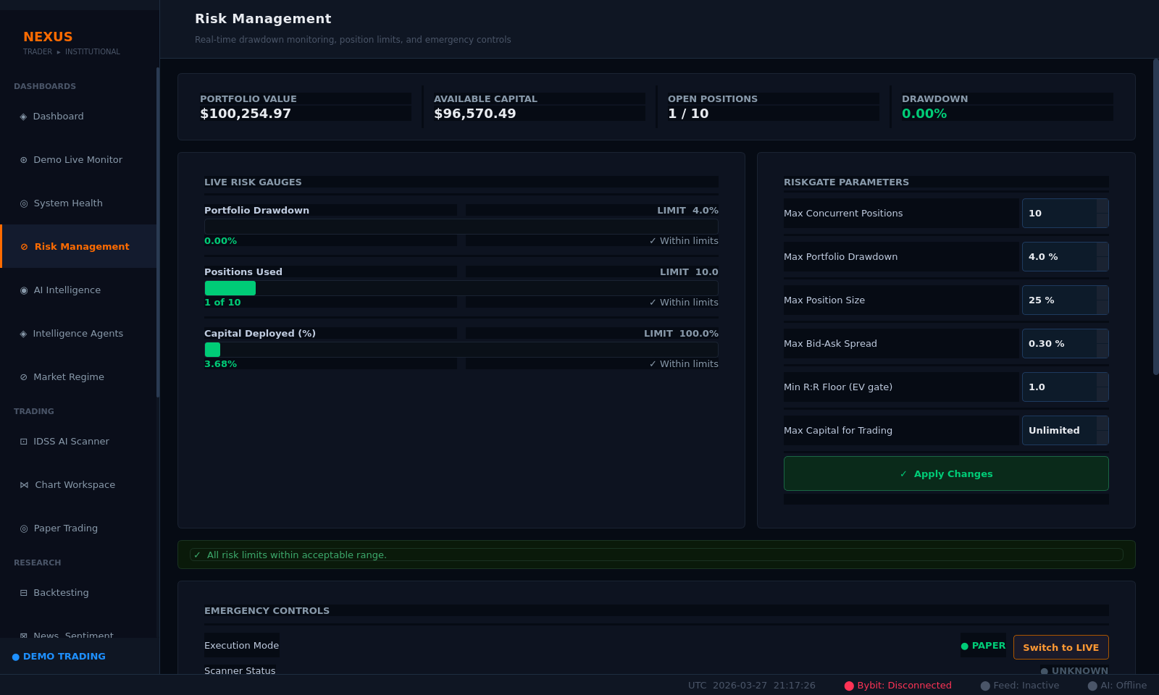
Risk Management — All gauges within limits | Emergency controls | Parameter apply panel
Market Scanner
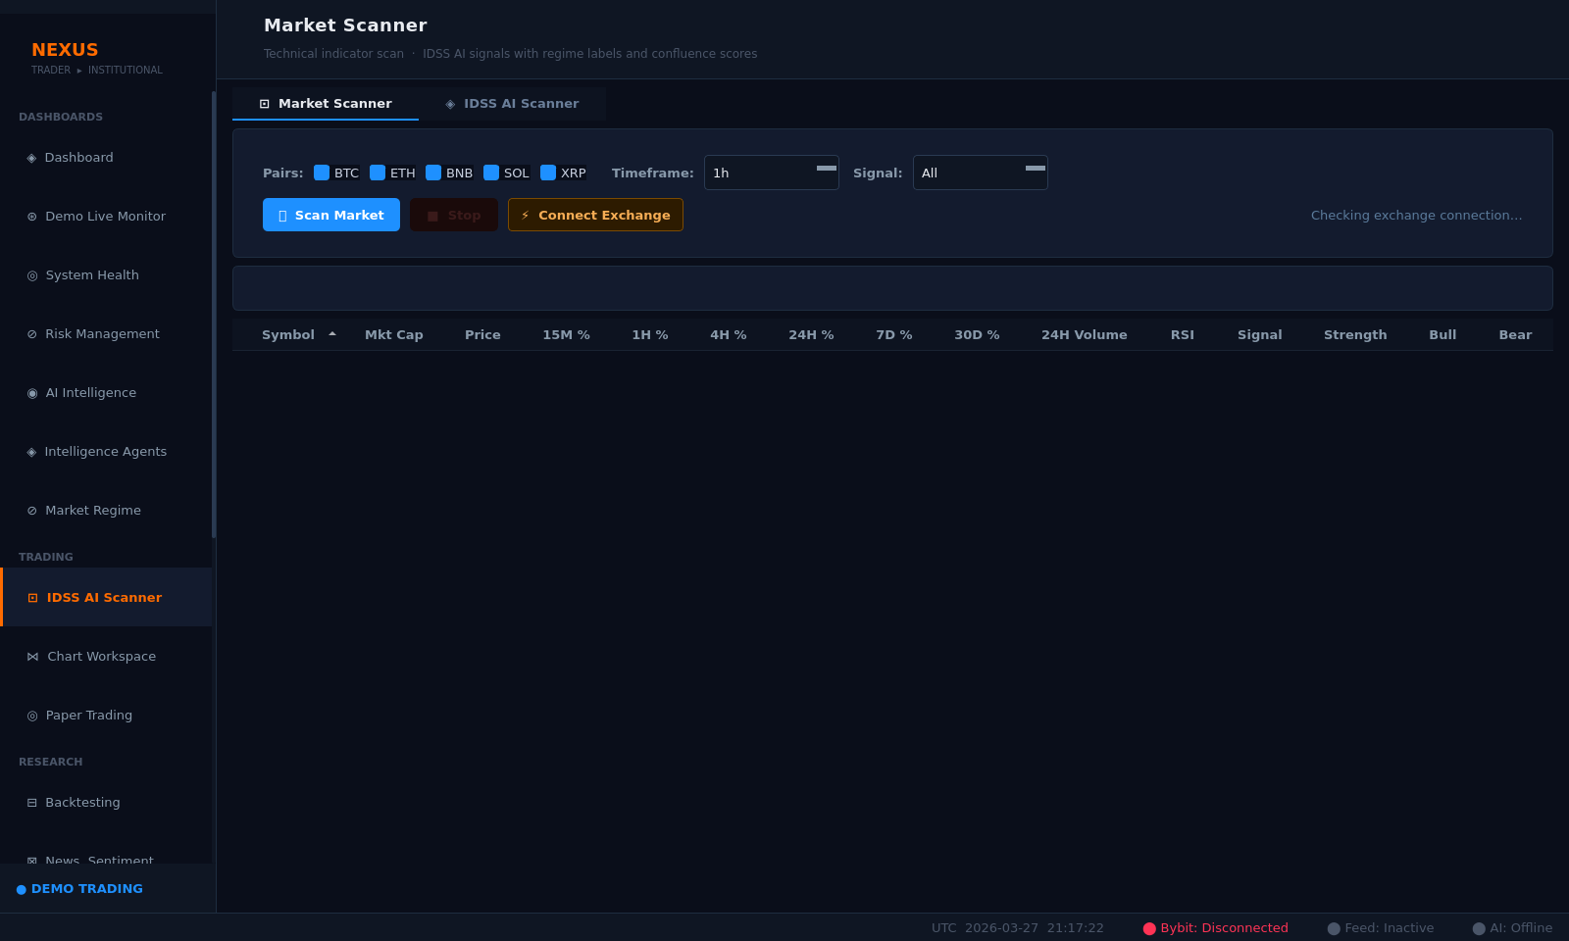
Market Scanner — Exchange connection prompt (expected in test mode) | 9 scan controls present
Market Regime
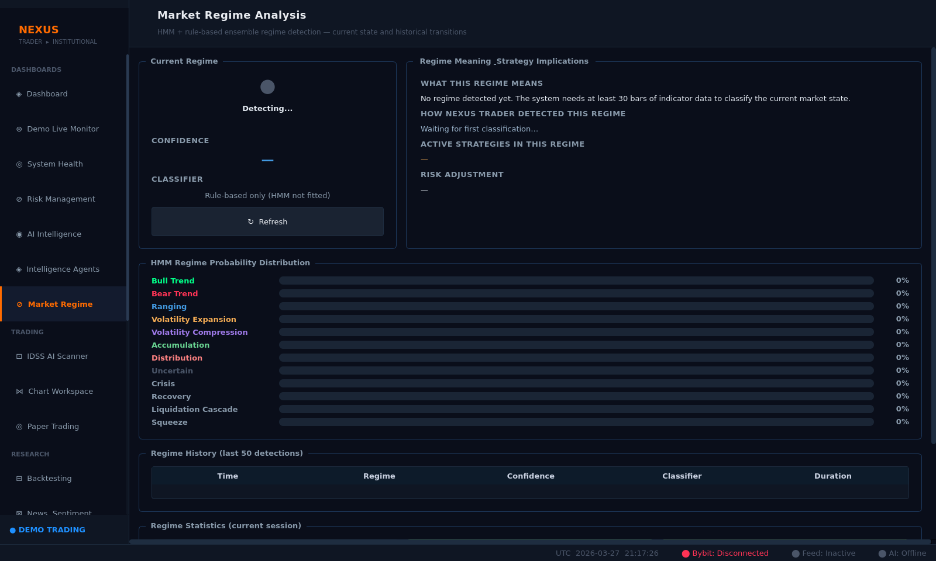
Market Regime — Detecting... (expected without live exchange) | HMM distribution | History table
IDSS Strategy Registry
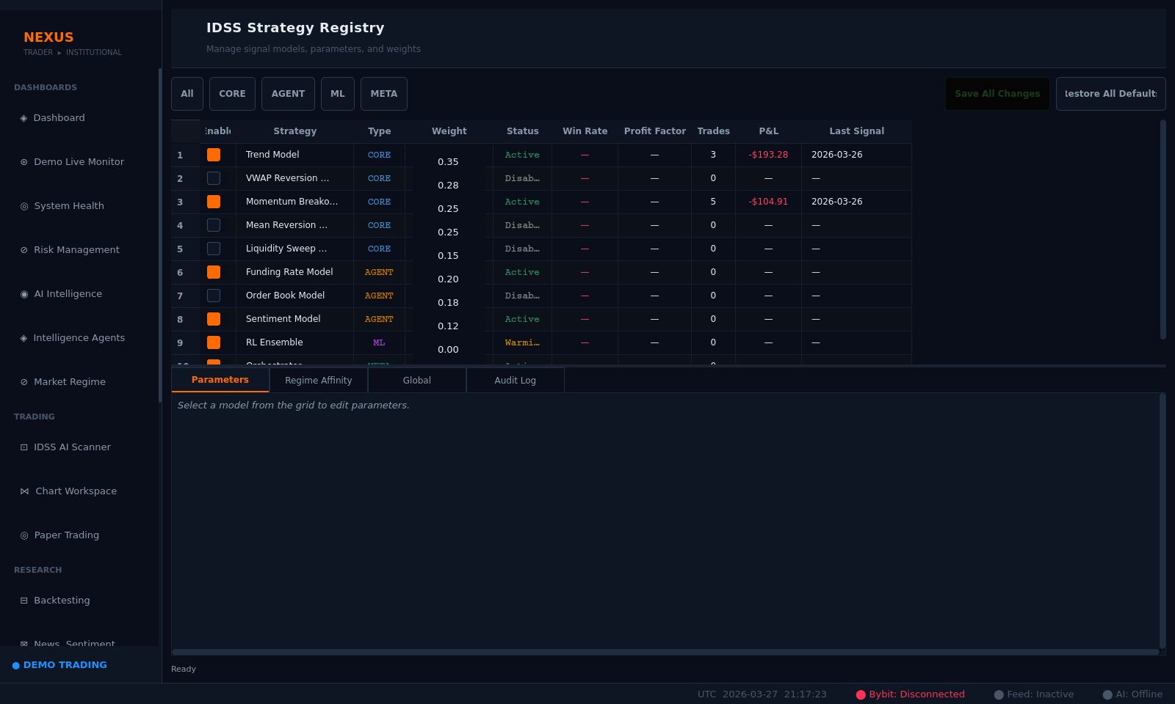
Strategies — 8 models | Active/Archive status | Weights | Backtest metrics | Color-coded
AI Intelligence
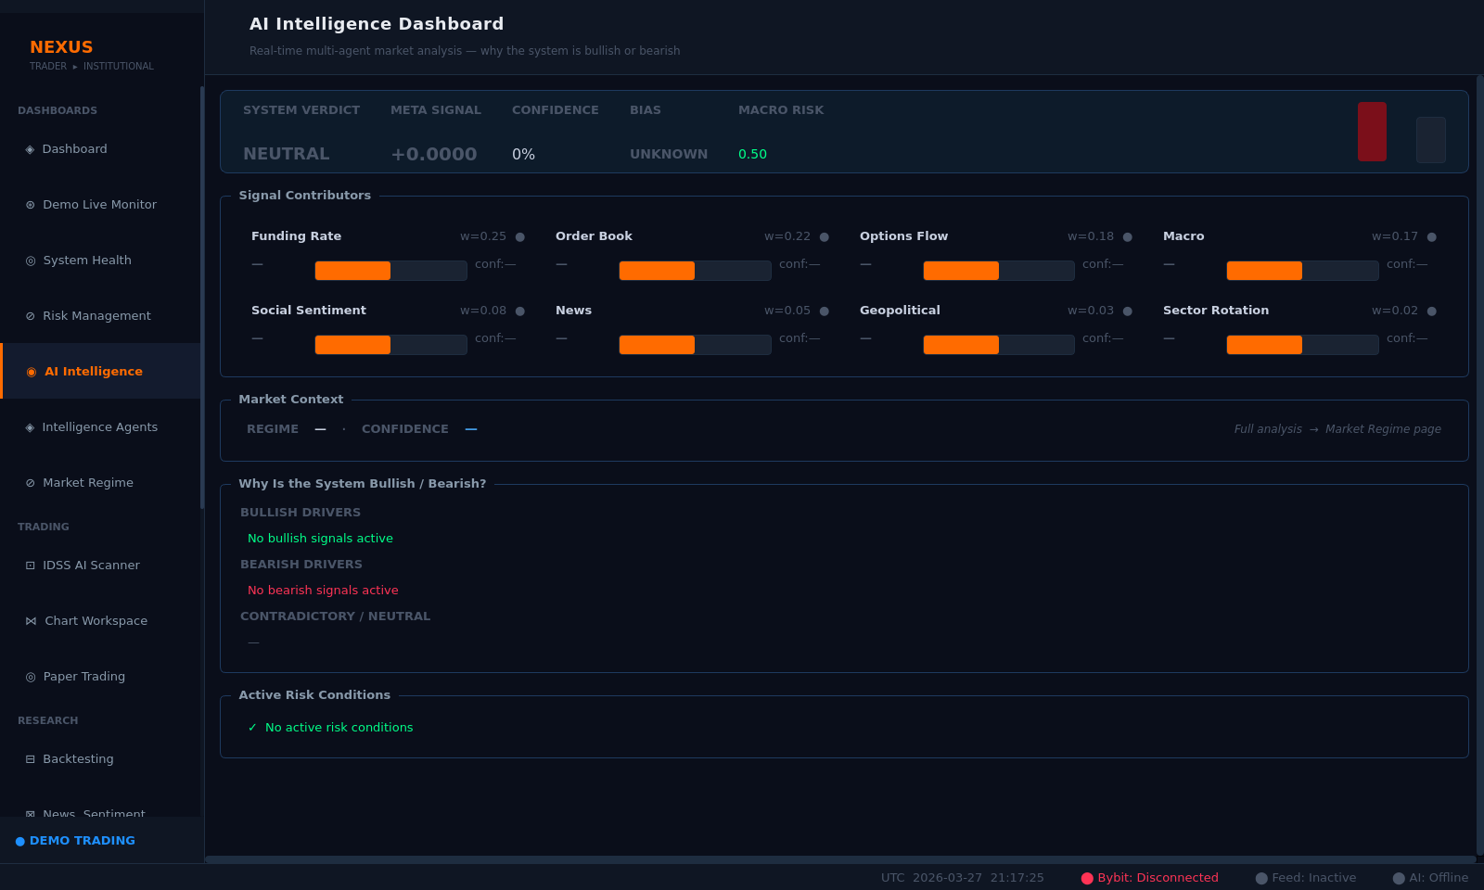
AI Intelligence — NEUTRAL overall | 8 agent contribution panels | Market context
System Health
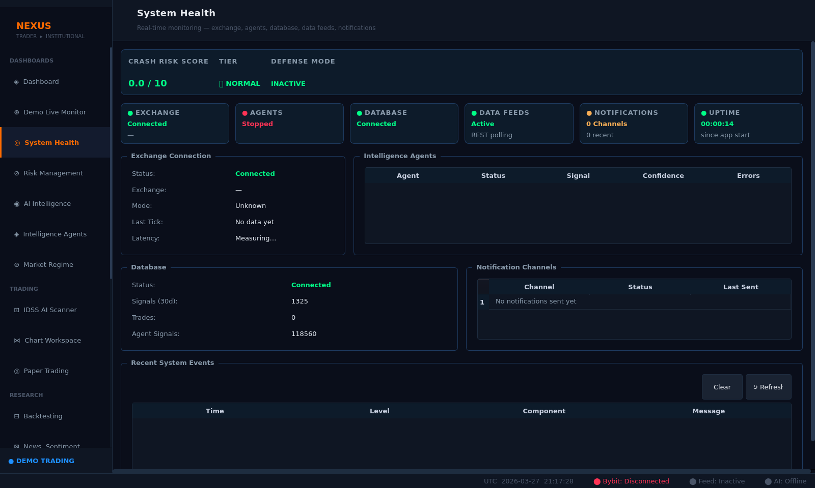
System Health — Exchange, Agents, Database connected | Notification channels | Recent events
Orders & Positions
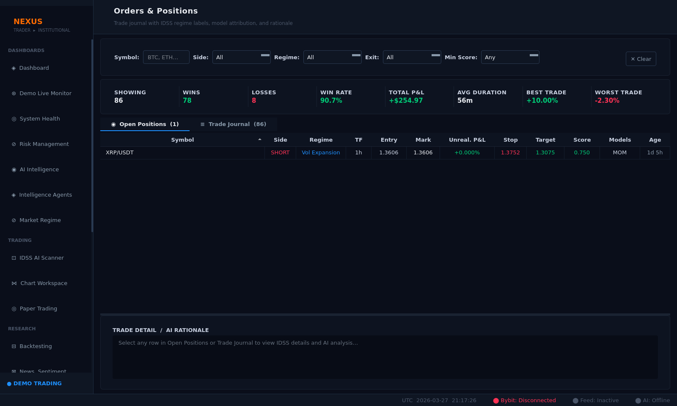
Orders & Positions — 86 total trades | 1 open position | Trade detail AI rationale panel
Settings
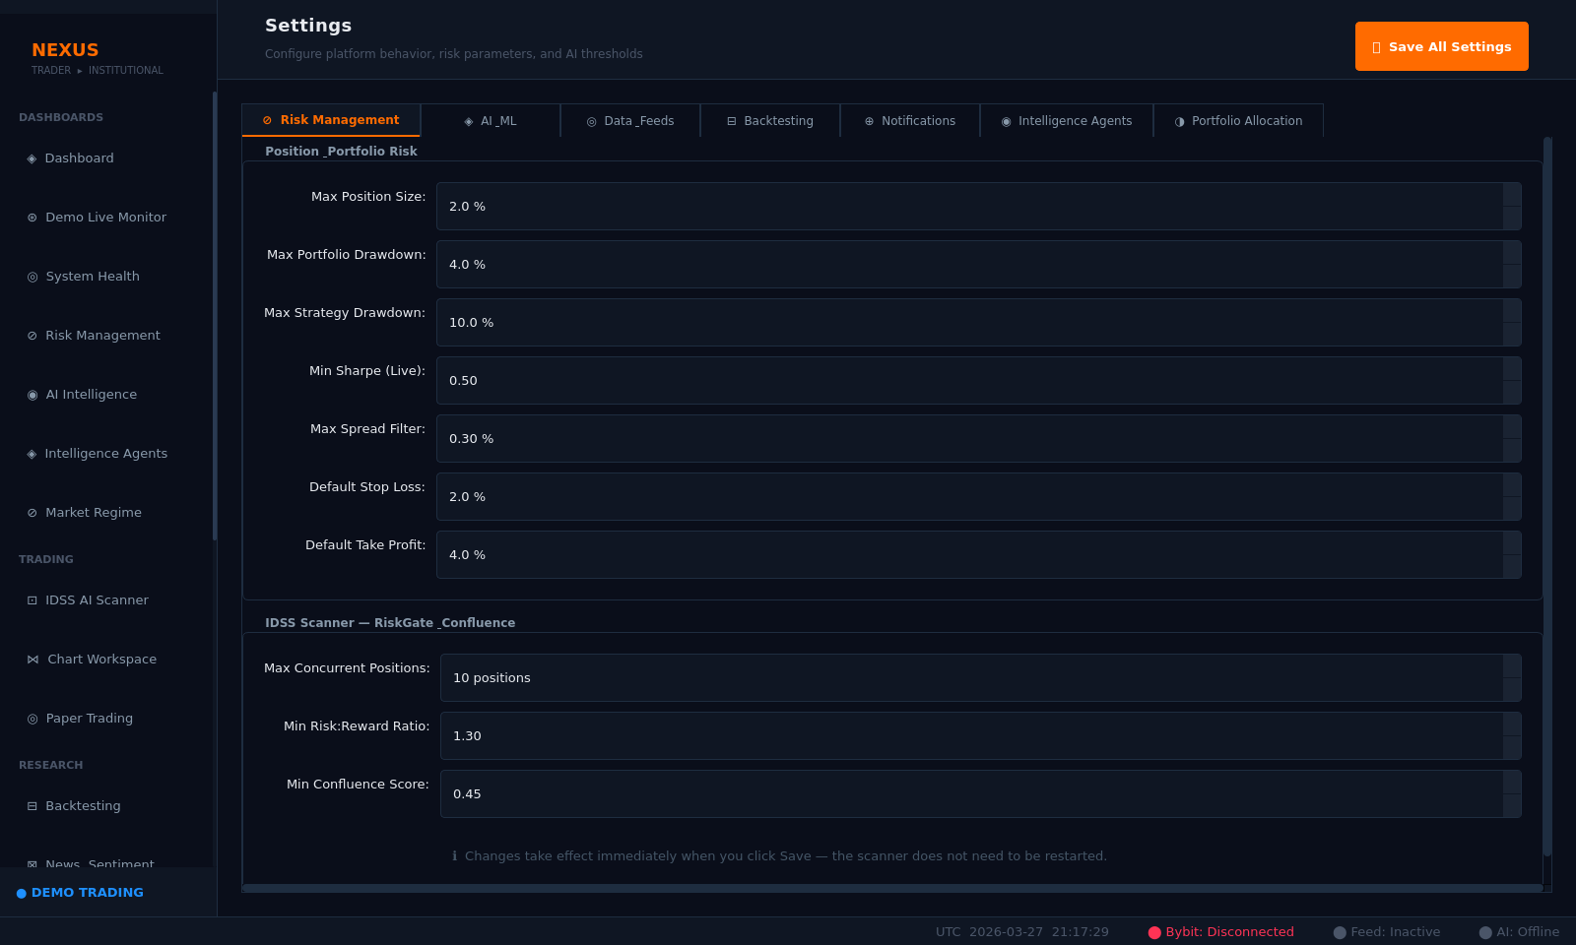
Settings — 104 input fields across 7 configuration tabs
System Logs
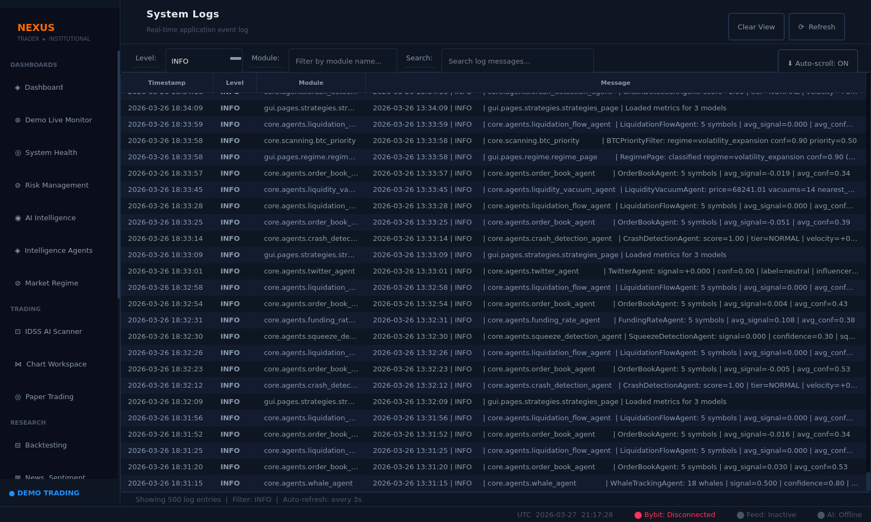
System Logs — Real-time stream | Timestamp, level, module, message | Filter controls
IDSS Backtesting
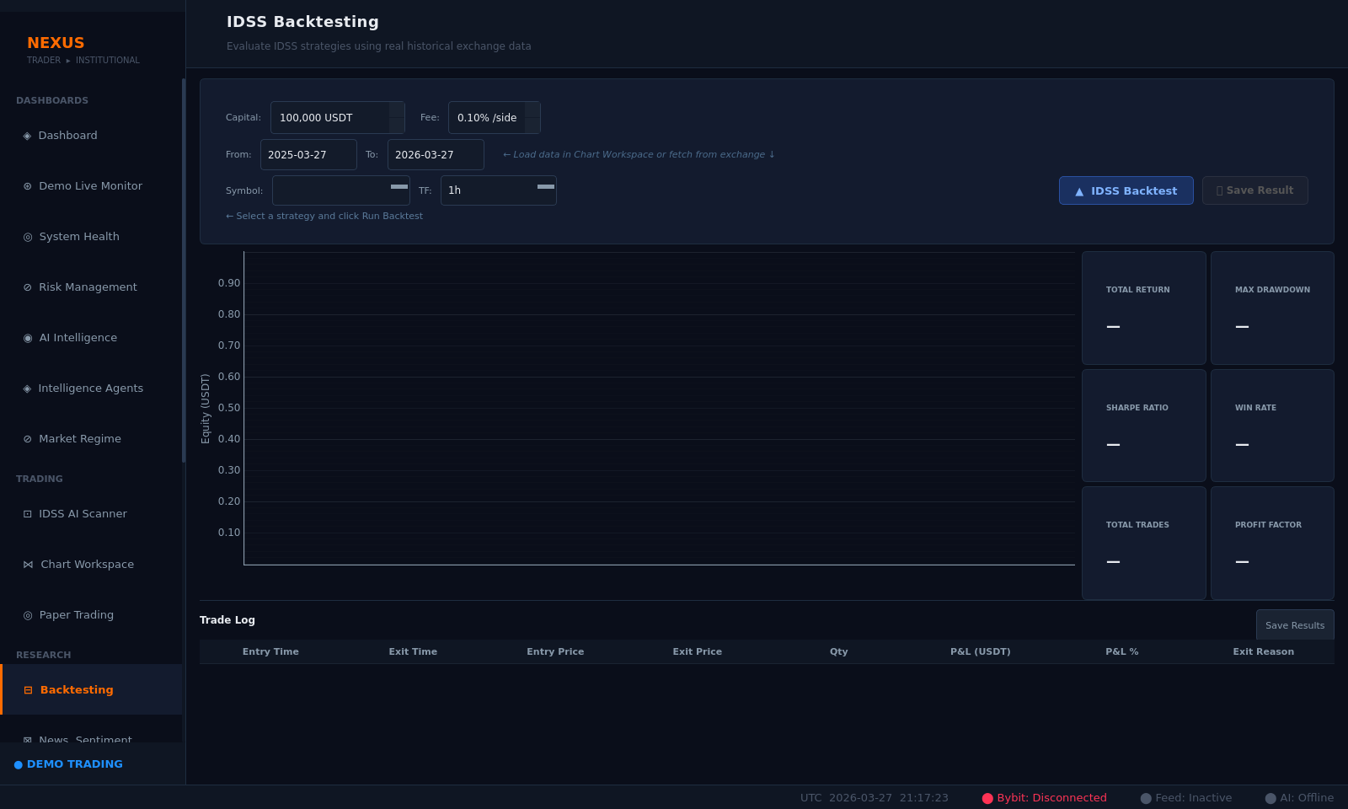
Backtesting — Form ready | Symbol/date/strategy inputs | Chart and trade log areas
News & Sentiment
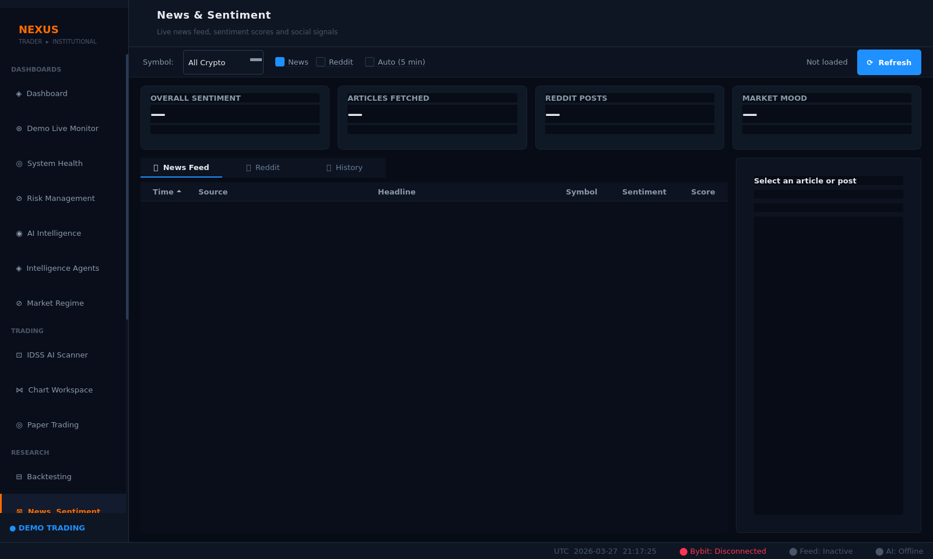
News & Sentiment — RSS + CryptoPanic feed areas | Sentiment trend panel
Signal Explorer
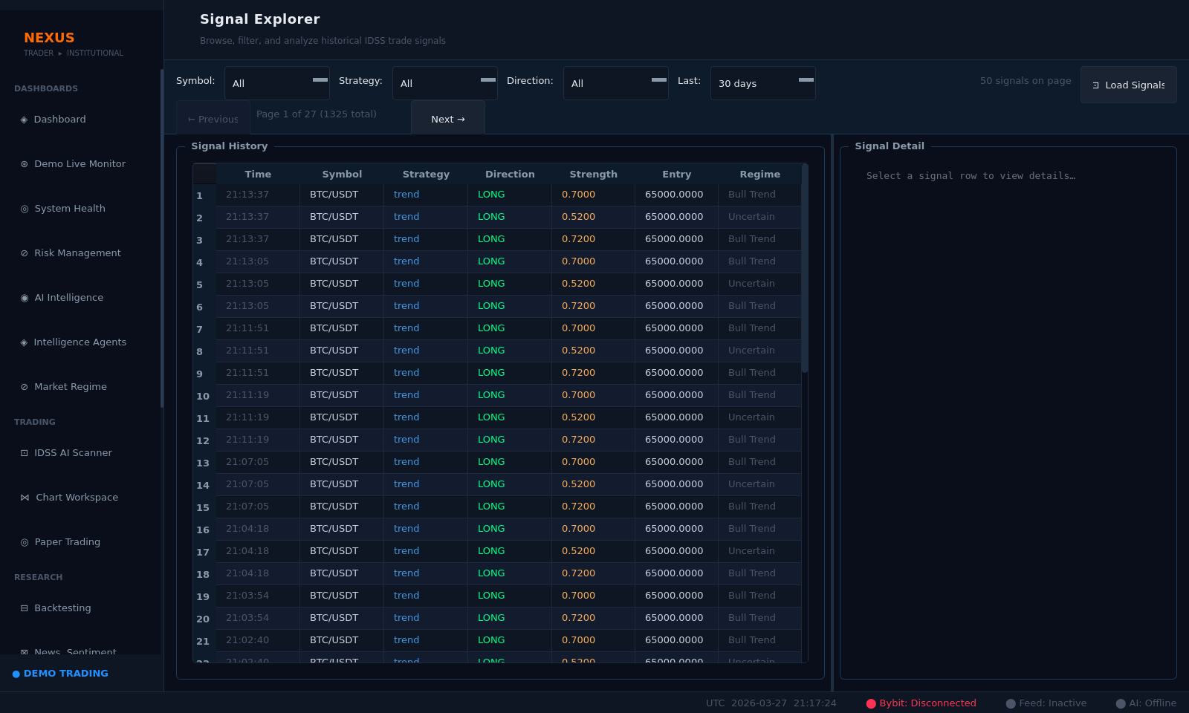
Signal Explorer — Per-model signal detail viewer
Notifications
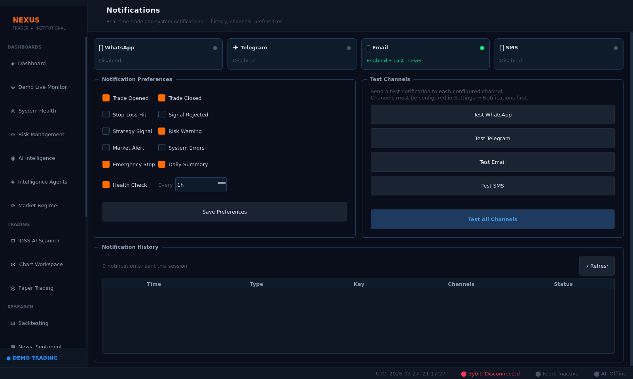
Notifications — 15-template system | Channel management
Chart Workspace
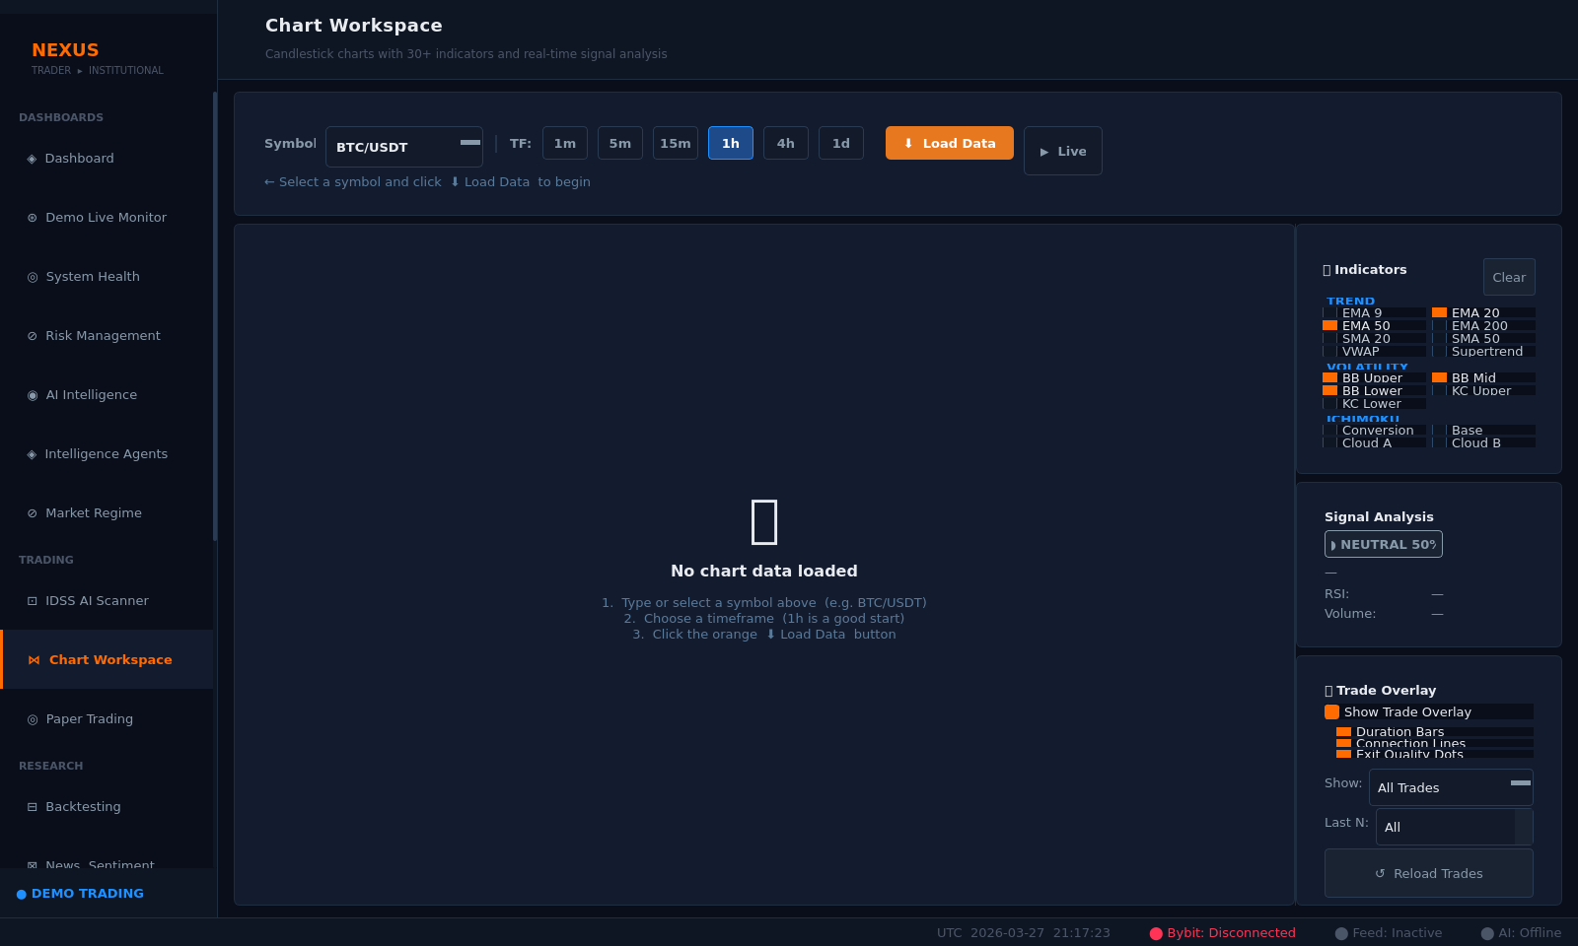
Chart Workspace — Multi-symbol charting area
Exchange Management
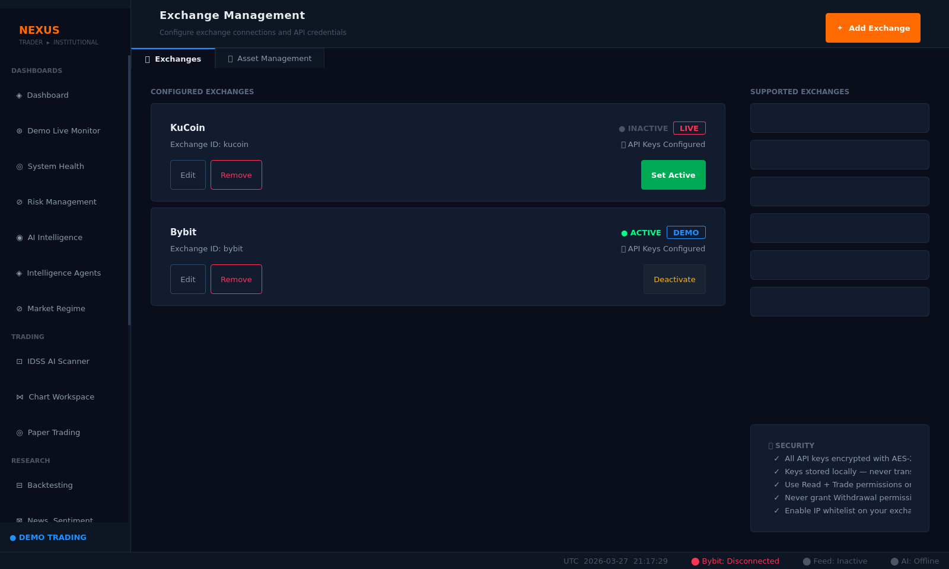
Exchange Management — API key management | Connection status
Help Center
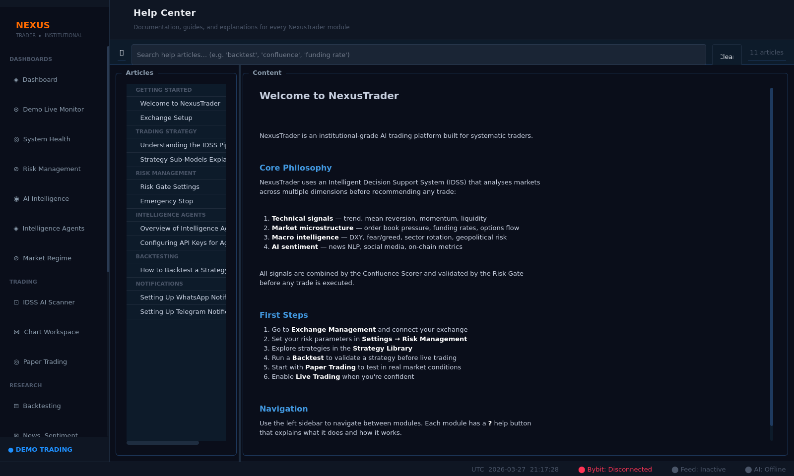
Help Center — Documentation and quick reference

7. Final Verdict
NexusTrader v2.0 has completed all nine phases of the execution hardening and demo readiness program. Every hard requirement is met, with zero critical bugs, a clean test suite, and a fully validated user interface.

Domain | Result | Notes
Signal Quality | PASS | PF 2.976, WR 57.1%, MaxDD 4.1R — all exceed baseline
Safety Controls | PASS | Paper-only enforced; crash defense 4-tier; daily loss + DD circuit breakers
Critical Bugs | CLEAR | BUG-001 fixed (NameError in confluence_scorer.py). 0 open critical bugs
Test Suite | CLEAN | 1,494 passed / 0 failed / 11 skipped (GPU only)
UI Validation | PASS | 69/69 automated checks passed; 20 pages screenshotted; ACCEPTABLE FOR DEMO
Config Parity | PASS | validate_v1_2_parity.py: 24/24 PASS

FINAL VERDICT: GO — READY FOR DEMO
NexusTrader v2.0 is cleared for live Bybit Demo trading operations.

7.1 Remaining Future Milestones (Non-Blocking)
- Demo trades >= 200: formal live performance re-assessment (system not yet started)
- Live Profit Factor >= 1.5: evaluate after 200 live demo trades
- Integrate Whale/Stablecoin/Macro agents: Phase 3 code written and ready
- Wire FilterStatsTracker into _close_position() for realized-R quality tracking
- Remove Test Position button before any public release

Report generated: 2026-03-27 | NexusTrader v2.0 | git tag: v2.0.0 (9b2afe2)

