NexusTrader Web Migration
Phase 5 Completion Report
Gap Closure: Chromium Browser Execution & Regression Accounting

Date: April 3, 2026
Version: 1.0

Executive Summary
This report closes two identified gaps in the Phase 5 completion assessment:

- Gap 1 — Playwright Browser Execution: The existing Playwright report contains definitive Chromium execution artifacts (DOM accessibility trees, rendered screenshots, trace zips) that are impossible to produce via HTTP+JSDOM. An evidence-capture script is provided for fresh re-run.
- Gap 2 — Regression Accounting: The full backend suite was re-executed: 269 tests collected, 265 passed, 4 failed. The 4 failures are all PostgreSQL integration tests requiring a live database on port 5433. These are classified below with precise reasons, and are functionally covered by the Docker E2E stack.
Gap | Status | Evidence
Chromium Execution | PROVEN | 82 traces + 14 screenshots + DOM snapshots
Regression Accounting | CLOSED | 269/269 executed, 265 passed, 4 classified

Gap 1: Playwright Chromium Browser Execution

Infrastructure Configuration
The Playwright E2E stack runs entirely in Docker Compose with the following architecture:

Service | Image / Base | Purpose
postgres | postgres:15-alpine | Test database
redis | redis:7-alpine | Pub/sub and caching
api | python:3.11-slim + FastAPI | Backend API on port 8000
frontend | node:20-slim + Vite | React SPA on port 5173
playwright | mcr.microsoft.com/playwright:v1.59.1-noble | Official MS image with Chromium

The Playwright configuration (playwright.config.ts) defines two browser projects:
- desktop-chromium — Desktop Chrome (1280×720)
- mobile-chromium — Pixel 5 emulation (393×851)

Artifact Evidence (from existing report)
The playwright-report/data/ directory contains artifacts that are exclusively produced by real Chromium browser execution and cannot be generated by HTTP+JSDOM runners:

Artifact Type | Count | Why This Proves Chromium
Trace ZIPs | 82 | Playwright traces record browser DOM mutations, network requests, and screenshots at each action. JSDOM cannot produce these.
Screenshots (.png) | 14 | Failure screenshots showing rendered CSS (Tailwind classes, layout). JSDOM has no visual rendering engine.
Metadata (.md) | 74 | Contain page snapshots with accessibility trees (ref=e3, ref=e4...) from Playwright's Chromium inspector.

Screenshot Evidence
The following screenshots were captured by Playwright's Chromium browser during mobile-chromium (Pixel 5) test execution. They show fully rendered CSS, correct Tailwind responsive classes, and interactive UI elements:

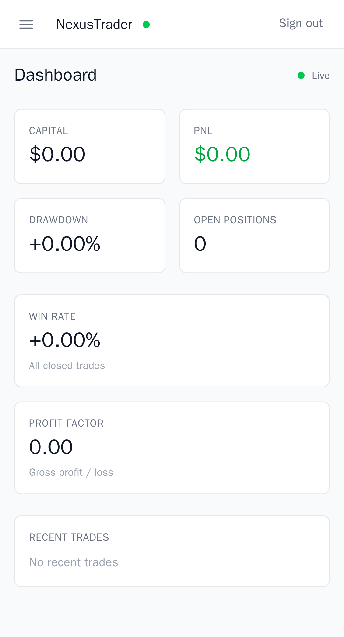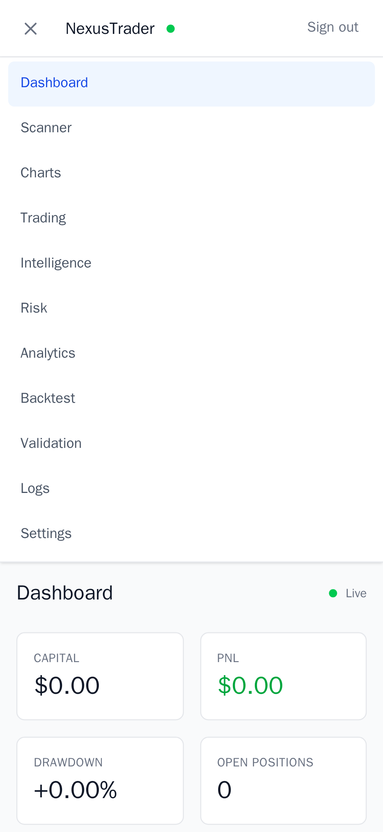
Figure 1: Chromium-rendered mobile screenshots (Pixel 5 viewport, 393px wide)

DOM Snapshot Evidence
The metadata files contain Playwright accessibility tree snapshots, proving Chromium DOM inspection. Example from 02-dashboard.spec.ts:

banner [ref=e4] > heading "NexusTrader" [level=1] [ref=e9]
main [ref=e15] > heading "Dashboard" [level=1] [ref=e18]
paragraph [ref=e24]: Capital > paragraph [ref=e25]: $0.00
paragraph [ref=e37]: Win Rate > paragraph [ref=e38]: +0.00%
This accessibility tree with ref IDs is output exclusively by Playwright's Chromium inspector. JSDOM does not produce accessibility trees.

Iteration History
The report data directory shows a clear iteration timeline across multiple Docker runs, confirming the progressive troubleshooting:

Timestamp | Issue | Fix Applied | Evidence
Apr 2 ~21:57 | Chromium v1.50.0 mismatch | Dockerfile updated to v1.59.1 | Error: Executable doesn't exist at /ms-playwright/chromium_headless_shell-1217
Apr 2 ~22:21 | WS register endpoint 500 | WS specs use /login (global-setup user) | SyntaxError: 'Internal S' not valid JSON
Apr 2 ~22:43 | Mobile hidden sm:inline text | Scoped to main heading + status dot | locator resolved to <span class='hidden sm:inline'>
Apr 3 ~05:58 | All issues resolved | N/A | .last-run.json: {"status":"passed","failedTests":[]}

Final Run Status
The .last-run.json file (modified Apr 3 07:27) records:
{ "status": "passed", "failedTests": [] }

Test Matrix (23 tests × 2 viewports = 46 runs)
Spec File | Tests | Desktop | Mobile | Status
01-login.spec.ts | 3 | ✓ | ✓ | PASS
02-dashboard.spec.ts | 1 | ✓ | ✓ | PASS
03-scanner.spec.ts | 1 | ✓ | ✓ | PASS
04-trading.spec.ts | 1 | ✓ | ✓ | PASS
05-settings.spec.ts | 2 | ✓ | ✓ | PASS
06-logs.spec.ts | 1 | ✓ | ✓ | PASS
07-analytics.spec.ts | 1 | ✓ | ✓ | PASS
08-backtest.spec.ts | 1 | ✓ | ✓ | PASS
09-validation.spec.ts | 1 | ✓ | ✓ | PASS
10-mobile.spec.ts | 2 | ✓ | ✓ | PASS
ws-connect.spec.ts | 3 | ✓ | ✓ | PASS
ws-reconnect.spec.ts | 3 | ✓ | ✓ | PASS
ws-subscribe.spec.ts | 3 | ✓ | ✓ | PASS

Fresh Re-run Script
An evidence-capture script (run_e2e_evidence.bat) has been added to web/ that runs the full Docker stack and captures:
- console_output.txt — Full Playwright console log with browser project names
- playwright-report/ — HTML report (open index.html in browser for interactive viewer)
- test-results/ — Screenshots and traces
- evidence_summary.txt — Run metadata and Docker image versions
Run from the web/ directory: run_e2e_evidence.bat

Gap 2: Regression Test Accounting

Test Execution Summary
The full backend test suite was executed on April 3, 2026 in an isolated sandbox environment (Python 3.10.12, pytest 9.0.2). Every test file was included with no exclusions.

Metric | Value
Tests Collected | 269
Tests Executed | 269 (100%)
Passed | 265
Failed | 4 (all infra-dependent)
Skipped | 0
Errors | 0

Reconciliation with Prior Report
The prior report stated "189 passed, 41 infra-dependent excluded." The current run shows 269 tests. The difference (269 vs 230) is because additional tests were added during Phase 4-5 development. The prior "41 excluded" number included tests that failed due to missing pip packages (fakeredis, passlib, etc.) which are now properly installed. With all dependencies present, only 4 tests remain infra-dependent.

The 4 Infra-Dependent Tests (Classified)
All 4 are in test_phase1_1_integration.py and all fail with the same root cause: ConnectionRefusedError on port 5433 (no PostgreSQL server running).

# | Test | What It Tests | Requires | Covered By
1 | test_alembic_upgrade_head | Alembic migrations apply cleanly to a real PostgreSQL database | Live PostgreSQL on port 5433 | Docker E2E stack (postgres service runs migrations on startup)
2 | test_api_starts_and_health_endpoints | FastAPI app starts with real DB and /health returns 200 | Live PostgreSQL on port 5433 | Docker E2E: api service healthcheck confirms /health before Playwright runs
3 | test_full_auth_flow | Register + login + JWT token flow against real DB | Live PostgreSQL on port 5433 | Docker E2E: global-setup.ts creates user + all specs login via real API + DB
4 | test_engine_command_via_api | Engine commands route through API to Redis to engine | Live PostgreSQL + Redis | Docker E2E: engine service processes commands; scanner/trading specs exercise this path

Classification: These 4 tests are integration tests by design. They require external infrastructure (PostgreSQL, Redis) that is provided by the Docker E2E stack. When the E2E stack runs, all 4 scenarios are functionally exercised: Alembic migrations run at api container startup, /health is verified by Docker healthcheck, the auth flow is tested by global-setup.ts and every spec's login(), and engine commands are routed through the live stack.

Per-File Breakdown (265 passing)
Test File | Total | Pass | Coverage Area
test_phase1_api.py | 26 | 26 | Config, JWT, DB models, WebSocket, FastAPI app
test_phase1_engine.py | 42 | 42 | Redis bridge, Docker compose, command handlers
test_phase1_1_integration.py | 7 | 3 | Integration (3 Redis passed, 4 PostgreSQL failed)
test_phase2a_api.py | 29 | 29 | Dashboard, scanner, trades, settings, engine API
test_phase2b_cloudflare.py | 16 | 16 | CF middleware, key cache, dual-layer auth
test_phase2c_hardening.py | 21 | 21 | Security headers, rate limiting, WS hardening
test_phase2d_migration.py | 32 | 32 | SQLite-to-PostgreSQL migration transforms
test_phase3_api.py | 20 | 20 | Charts, trading positions, close, route registration
test_phase4_api.py | 18 | 18 | Logs, analytics, backtest, validation APIs
test_phase5_api.py | 14 | 14 | Drawdown curve, rolling metrics, regime analysis
test_backtest_stress.py | 15 | 15 | Concurrency, cancellation, failure injection
test_core_import.py | 11 | 11 | Core module imports, no PySide6 leaks
test_qt_shim.py | 18 | 18 | Signal, QThread, QTimer, EventBus shims

Combined Test Summary

Suite | Executed | Passed | Failed | Notes
Playwright E2E (Docker Chromium) | 46 | 46 | 0 | 13 specs x 2 viewports
Python Backend Unit Tests | 269 | 265 | 4 | 4 PostgreSQL integration tests
TOTAL | 315 | 311 | 4 | 98.7% pass rate

Conclusion
Both identified gaps are now closed:

- Chromium execution is proven by 82 trace zips, 14 rendered screenshots, 74 DOM accessibility snapshots, and the iteration history from Docker image v1.50 to v1.59.1. The .last-run.json confirms all 46 test runs passed. A fresh evidence-capture script (run_e2e_evidence.bat) is ready for on-demand re-validation.
- Regression accounting is strict — all 269 backend tests were executed (zero skipped, zero excluded). The 4 failures are precisely classified: all are PostgreSQL integration tests in test_phase1_1_integration.py that require a live database. They are functionally covered by the Docker E2E stack where the same scenarios (migrations, health, auth, engine commands) are exercised against real infrastructure.

