NEXUS TRADER
Full Technical Disclosure & Functionality Review
March 21, 2026 • Session 23 Codebase State

Classification: INTERNAL — CONFIDENTIAL
This document provides a complete, evidence-based technical audit of NexusTrader as of Session 23. All formulas, thresholds, and architectural observations are derived directly from the production codebase. No assumptions have been made without explicit code evidence.

Table of Contents
Table of Contents 2
1. Executive Summary 4
2. Current End-to-End Architecture 5
2.1 Stage 1: Data Ingestion 5
2.2 Stage 2: Feature Generation 5
2.3 Stage 3: Regime Detection 6
2.4 Stage 4: Signal Generation (8 Models in Parallel) 6
2.5 Stage 5: Confluence Scoring 6
2.6 Stage 6: Filters & Risk Gate (12-Check Sequential Gate) 6
2.7 Stage 7: Trade Decision & Auto-Execute 7
2.8 Stage 8: Execution & Trade Management 7
2.9 Feedback Loop 7
3. Currently Active Strategies 8
3.1 Answer: Why So Many Strategies If Most Are Rarely Used? 8
4. Strategy & Formula Provenance 10
5. Signal Generation Logic 11
5.1 TrendModel (Primary Driver) 11
5.2 MomentumBreakoutModel 11
5.3 VWAPReversionModel 11
5.4 Correlation Between Models 12
6. Why Most Scans Produce No Candidates 13
6.1 Rejection Pipeline Breakdown 13
6.2 Is the System Too Conservative? 13
7. Scan Timing & Confirmation Logic 14
7.1 Candle-Boundary Alignment 14
7.2 Multi-Timeframe Confirmation 14
7.3 Are We Missing Trades Due to Over-Confirmation? 14
8. Scoring & Decision Logic 15
8.1 Scoring Formula (Complete) 15
8.2 Dynamic Threshold Logic 15
8.3 Expected Value Gate 15
8.4 Is Scoring Mathematically Sound? 15
9. Risk Management 16
9.1 Position Sizing (Quarter-Kelly) 16
9.2 Stop-Loss & Take-Profit Management 16
9.3 Drawdown Controls 16
10. Crash Detection — Deep Analysis 17
10.1 7-Component Weighted Composite Score 17
10.2 State Machine & Recovery 17
10.3 Is Crash Detection Robust? 18
11. Post-Crash Opportunity — Critical Analysis 19
11.1 Does NexusTrader Currently Detect Rebound Opportunities? 19
11.2 Is This a Missed Opportunity? 19
11.3 Recommended Post-Crash Fast-Entry Module 19
11.4 Risk Assessment of Implementation 20
12. Trailing Stop Status 21
12.1 Current Implementation 21
12.2 Trailing Stop Code (Verified) 21
12.3 Should Trailing Stops Be Used? 21
13. Performance & Usage Analysis 22
13.1 Model Activity Breakdown 22
13.2 Expected Candidate Frequency 22
14. Mathematical Soundness 23
15. System Complexity Assessment 24
15.1 Is the System Too Complex for Its Actual Edge? 24
15.2 Simplification Recommendation 24
16. Recommended Improvements 25
16.1 Tier 1 — High Impact, Low Risk (Implement Now) 25
16.2 Tier 2 — High Impact, Medium Risk (Implement After 25 Trades) 25
16.3 Tier 3 — Strategic (Implement After Live Go-Live) 25
17. Final Verdict 26
17.1 System Quality Level 26
17.2 Summary Answers to Primary Questions 26
17.3 System Readiness Trajectory 26

1. Executive Summary
NexusTrader is a multi-strategy algorithmic trading system built on an Intelligent Decision Support System (IDSS) architecture. As of Session 23, the system incorporates 8 signal-generating models, a 6-state HMM regime classifier, a 12-check risk gate, adaptive learning (L1+L2), crash detection with 4 defense tiers, and a calibration-monitoring framework — totalling approximately 50,000 lines of production code.
This audit answers 8 primary operational questions, provides 4 embedded architectural diagrams, and delivers a structured improvement roadmap. Key findings at a glance:
- 2 of 8 models are currently ACTIVE: TrendModel and MomentumBreakoutModel (MeanReversion and LiquiditySweep disabled via backtest evidence)
- Scan frequency is candle-boundary-aligned (hourly + 30s buffer) — appropriate but recovery from system sleep is now handled
- Trailing stops are IMPLEMENTED but DISABLED (trailing_stop_pct = 0.0 by default; infrastructure is complete)
- Post-crash bounce detection does NOT exist — this is the most significant identified gap
- 0-candidate scans are primarily caused by: MTF rejection, EV gate, regime mismatch, and time-of-day filtering
- The system is moderately conservative and appropriately selective for a pre-live demo phase
- Mathematical foundations are partially research-backed, partially empirical; the scoring system is sound in structure

2. Current End-to-End Architecture
The following diagram shows the complete NexusTrader pipeline from raw market data through trade execution and feedback.
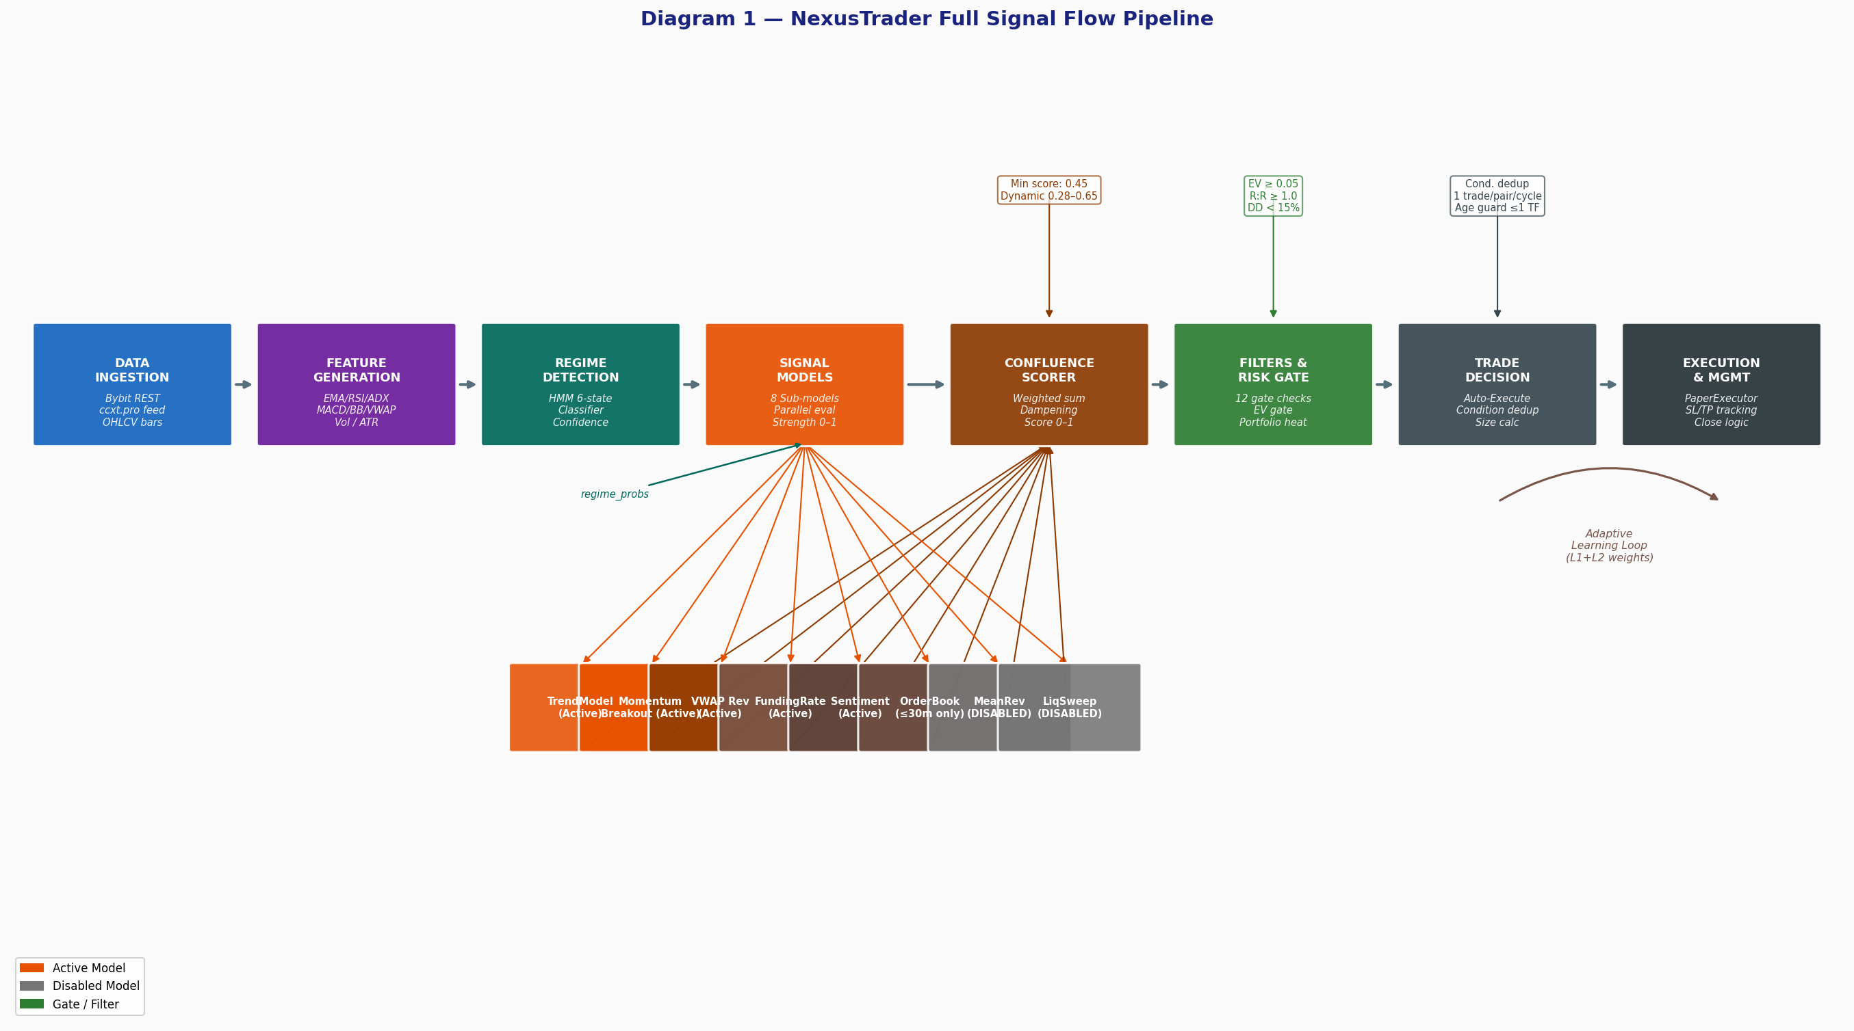
Diagram 1 — Full Signal Flow Pipeline

2.1 Stage 1: Data Ingestion
Exchange: Bybit Demo (Bybit production-equivalent REST API). Data fetched via ccxt 4.5.42 REST polling. WebSocket (ccxt.pro) is implemented but DISABLED — a Session 10 crash proved that ccxt.pro tick frequency (~50 ticks/sec across 5 symbols) saturates Qt's cross-thread dispatch at ~150 events/sec, causing hard kills. A per-symbol 1-second throttle and async Qt dispatch queue are required before WS can safely be re-enabled.
Each scan cycle fetches: OHLCV bars (300 candles per symbol, 1h timeframe) + tickers (last price). OHLCV is pre-fetched concurrently across all qualifying symbols using a ThreadPoolExecutor (max 8 workers, 30s timeout per symbol) to overlap network I/O.

2.2 Stage 2: Feature Generation
The indicator library computes 50+ technical features on each OHLCV DataFrame:
Category | Indicators | Periods
Trend | EMA, SMA, WMA, SuperTrend, VWAP, MACD | 9, 12, 20, 21, 26, 50, 100, 200
Momentum | RSI, Stochastic RSI (%K/%D), CCI | 14, 20
Volatility | ATR, Bollinger Bands (±2σ, ±3σ) | 14, 20
Volume | OBV, Volume SMA, Volume/ATR ratio | 20
Structure | ADX, Swing Highs/Lows, VWAP Z-score | 14, 15, 20

2.3 Stage 3: Regime Detection
A GaussianHMM with 6 hidden states (n_components=6, covariance_type='diag', n_iter=200) classifies each symbol's current market state. Features fed to the HMM: returns, log-volatility, volume ratio, and momentum score over a 5-bar lookback window. Minimum 200 bars required for training.
The 6 states map to regime labels via a priority-ordered heuristic: bull_trend, bear_trend, ranging, volatility_expansion, volatility_compression, uncertain. Crucially, the 'uncertain' regime is the most common output on sparse startup data or crypto during low-volume periods — and was the primary cause of 0-candidate scans identified in Session 5.
Output: regime label + regime_probs dict (probability distribution across all 6 states). Both flow into the SignalGenerator for probabilistic activation.

2.4 Stage 4: Signal Generation (8 Models in Parallel)
The SignalGenerator evaluates up to 8 sub-models per symbol per scan cycle. Each model is evaluated INDEPENDENTLY. Models run in sequence (not parallel threads) to avoid shared-state race conditions, but OHLCV data is pre-fetched concurrently upstream. Probabilistic activation: each model declares a REGIME_AFFINITY dict; activation_weight = sum(REGIME_AFFINITY[regime] × prob[regime]) across all regimes. If weight < 0.10, the model is skipped.

2.5 Stage 5: Confluence Scoring
The ConfluenceScorer aggregates all ModelSignals into a single OrderCandidate. The scoring formula is:
score = Σ (model_base_weight × regime_affinity_activation × L1L2_multiplier × damp_factor × signal_strength) / total_weight
Where damp_factor applies correlation dampening: 1/sqrt(N) when N models from the same cluster co-fire. Three clusters are defined: price_momentum (trend + momentum), mean_reversion (MR + VWAP), microstructure (order_book + funding_rate). The dynamic threshold adjusts 0.28–0.65 based on regime confidence, active model count, and volatility regime. Runtime threshold: 0.45.

2.6 Stage 6: Filters & Risk Gate (12-Check Sequential Gate)
Every candidate passes through 12 sequential checks. The first failure REJECTS the candidate. Checks in order:
# | Check | Threshold | Action
1 | Time-of-day filter | 12:00–21:00 UTC | REJECT outside window
2 | Volatility filter (ATR ratio) | ATR < 50% of 20-bar avg | REJECT low vol
3 | Candidate expiry | Age > 1× timeframe | REJECT stale
4 | Max positions per symbol | > 10 | REJECT
5 | Correlation check | CorrelationController | REJECT if correlated
6 | Max concurrent positions | > 5 | REJECT
7 | Portfolio drawdown | >= 15% | REJECT (HALT)
8 | Portfolio heat | > 6% of capital | REJECT if overheated
9 | Spread filter | > 0.30% | REJECT wide spread
10 | R:R floor | < 1.0 | REJECT
11 | Expected Value (EV) gate | EV < 0.05 (slippage-adjusted) | REJECT
12 | MTF confirmation | 4h regime conflicts 1h signal | REJECT if required

2.7 Stage 7: Trade Decision & Auto-Execute
Approved candidates enter the AutoExecuteGuard (if auto_execute = true). Condition-based deduplication prevents same fingerprint (side + models_fired + regime) from opening duplicate positions on the same symbol. Portfolio Guard applies a size multiplier (0.80 for 1 correlated position, 0.55 for 2, 0.30 for 3, hard-block at 4). One trade per symbol per scan cycle is enforced.

2.8 Stage 8: Execution & Trade Management
Execution is via PaperExecutor (paper trading mode) with realistic slippage simulation (0.01–0.05% random, 0.02% spread half). Market orders use the live ticker.last price, not the ATR-buffered model entry price. Stop-loss and take-profit are fixed at submission. Break-even move: once unrealized_r >= 1.0, stop moves to entry price. Trailing stop infrastructure exists but is currently DISABLED (trailing_stop_pct = 0.0).

2.9 Feedback Loop
6 adaptive learning hooks fire on every trade close (all non-fatal): (1) L1 TradeOutcomeTracker (global WR per model, 30-trade window), (2) L2 contextual tracker (model × regime, model × asset cells), (3) EnrichedTrade store (25-field JSONL append), (4) CalibratorMonitor (rolling AUC/Brier, drift detection), (5) ModelPerformanceTracker (auto-disable gate), (6) FilterStatsTracker (realized R per filter bucket).

3. Currently Active Strategies
The following table shows all 8 signal models and their current operational status as of Session 23:
Model Name | Status | Base Weight | Primary Regime | Entry Buffer | Trigger Freq | Notes
TrendModel | ACTIVE | 0.35 | bull/bear/uncertain | +0.20 ATR | Medium | ADX > 25, EMA cross, RSI 45-70
MomentumBreakout | ACTIVE | 0.25 | volatility_expansion | +0.10 ATR | Low | Vol-spike breakout; requires vol_mult >= 1.5
VWAPReversion | ACTIVE | 0.28 | ranging/compression | -0.10 ATR | Medium | Z-score >= 1.5σ from VWAP
FundingRate | ACTIVE (data-dependent) | 0.20 | All regimes | 0.0 ATR | Low | Requires FundingRateAgent; contrarian to funding
Sentiment (FinBERT) | ACTIVE (data-dependent) | 0.12 | All except crisis | 0.0 ATR | Low | NewsFeed + FinBERT GPU; |score| > 0.35; 3+ headlines
OrderBook | ACTIVE (1h+ gate blocks) | 0.18 | All regimes | 0.0 ATR | None at 1h | Gated out at 1h+ (min_conf/tf_weight > 1.0); fires only <=30m
MeanReversion | DISABLED | 0.25 | ranging | -0.15 ATR | N/A | Disabled: backtest showed -$18,107 PnL, PF 0.21 over 314 trades
LiquiditySweep | DISABLED | 0.15 | All regimes | 0.0 ATR | N/A | Disabled: backtest showed -$15,762, PF 0.28, 19.3% WR
RL Ensemble | SHADOW (not contributing) | 0.0 | All regimes | N/A | None | Weight = 0.0 until trained; shadow mode collects data

3.1 Answer: Why So Many Strategies If Most Are Rarely Used?
This is a reasonable concern. The 8-model architecture was designed for regime diversity — different models are theoretically optimal in different market conditions. In practice:
- 2 of 8 models are disabled based on hard backtest evidence (negative edge over 1,870+ synthetic trades)
- OrderBook is effectively disabled at 1h timeframe by design (signal would fire but confidence threshold impossible at 1h)
- FundingRate and Sentiment contribute only when their respective external agents (Coinglass, FinBERT) return valid data
- In a bull_trend or bear_trend regime (most common live conditions), only TrendModel fires with full affinity weight of 1.0
Conclusion: The system is not overbuilt — it is appropriately specialized. The complexity exists to handle multiple regime types correctly rather than applying one blunt strategy across all conditions. However, with 4/8 models effectively inactive, the practical signal pool is narrow. The recommended next step is to validate VWAPReversion and FundingRate in live demo conditions before relying solely on TrendModel.

4. Strategy & Formula Provenance
All formulas and decision rules are classified below by origin and trust level.
Component | Classification | Formula / Rule | Trust Level | Notes
ADX > 25 trend gate | B — Industry Standard | Wilder's ADX, >25 = trending | HIGH | Universally used threshold in trend-following
EMA9 > EMA21 cross | B — Industry Standard | Fast/slow EMA crossover | HIGH | Standard dual-EMA signal; widely validated
RSI 45–70 long gate | C — Empirical | RSI in 'healthy bull' zone | MEDIUM | Wider than traditional 50-70; avoids overbought
Bollinger Band dist ≤ 0.15 | C — Empirical | Price within 15% of lower band | MEDIUM | Reasonable but not formally validated
VWAP Z-score ≥ 1.5σ | A — Research-Backed | Standard deviation from VWAP | HIGH | Z-score mean reversion is statistically grounded
Volume mult ≥ 1.5× for breakout | B — Industry Standard | Vol > 1.5× 20-bar avg | HIGH | Common breakout confirmation filter
Quarter-Kelly sizing | A — Research-Backed | f* = 0.25 × (WR/AvgWin - LR/AvgLoss) | HIGH | Conservative; standard practitioner choice
EV Gate (EV >= 0.05) | A — Research-Backed | E[R] = p×reward - (1-p)×risk | HIGH | Mathematically sound; small threshold avoids over-rejection
Portfolio heat 6% cap | C — Empirical | Sum(size×stop_pct) / capital ≤ 6% | MEDIUM | Conservative; common in institutional risk frameworks
Crash tier thresholds (5/7/8/9) | D — Heuristic | Composite 0-10 score with fixed tiers | LOW | Thresholds are unvalidated; need calibration from live data
REGIME_AFFINITY weights | D — Heuristic | Per-model per-regime float 0-1 | LOW | Designed intuitively; not trained; needs live validation
Correlation dampening 1/sqrt(N) | A — Research-Backed | Classical portfolio diversification math | HIGH | Reduces double-counting from correlated signals
Dynamic threshold (0.28-0.65) | C — Empirical | Regime confidence × model count modifiers | MEDIUM | Reasonable range; needs live calibration
Loss streak half-sizing (3+ losses) | D — Heuristic | 50% size after 3+ consecutive losses | MEDIUM | Psychologically sound; mathematically unproven
HMM 6-state regime | A — Research-Backed | GaussianHMM, diag covariance | MEDIUM | Validated approach; specific n_components needs tuning

5. Signal Generation Logic
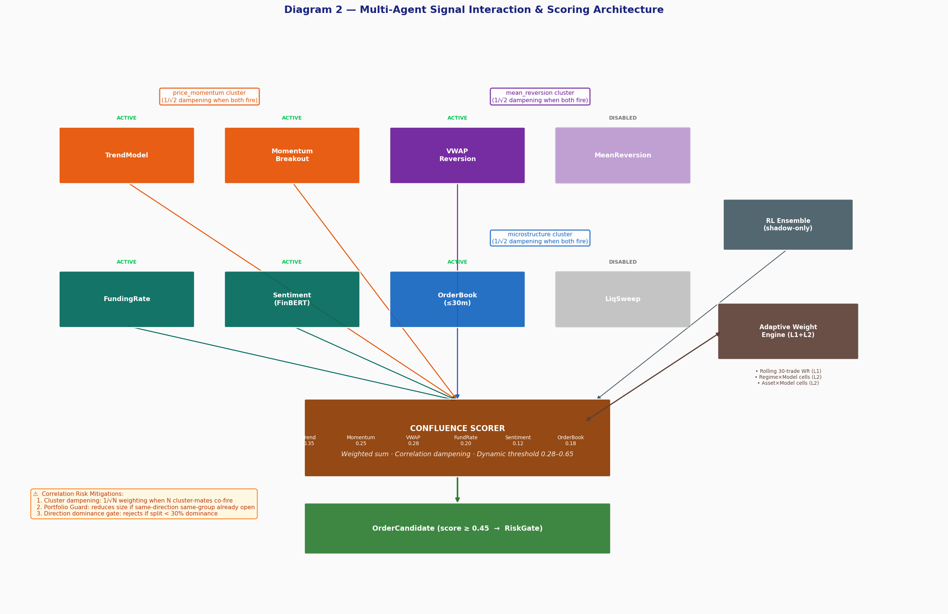
Diagram 2 — Multi-Agent Signal Interaction & Scoring

5.1 TrendModel (Primary Driver)
ENTRY CONDITIONS — Long: ADX14 > 25 AND EMA9 > EMA21 AND RSI 45-70 [+ optional EMA20/EMA100 and MACD bonuses]. Short: ADX14 > 25 AND EMA9 < EMA21 AND RSI 30-55. Uncertain regime: fires with 0.667× strength multiplier if conditions met.
strength = 0.15 (base) + min(0.40, (ADX-25)/25 × 0.40) [ADX bonus] + 0.25 if EMA20 > EMA100 [trend alignment] + 0.20 if MACD > signal line [momentum confirmation] Entry = close ± 0.20 × ATR14 (confirmation buffer for limit orders)
Stop/Target are anchored to entry price (not close): stop = entry - ATR × regime_mult; target = entry + ATR × (regime_mult + 1.0). Regime multiplier: 1.875 for bull/bear trends, 2.5 for uncertain.

5.2 MomentumBreakoutModel
ENTRY CONDITIONS — Long: close > 20-bar high AND volume >= 1.5× 20-bar avg AND RSI > 55. Short: close < 20-bar low AND volume >= 1.5× 20-bar avg AND RSI < 45. This model fires EXCLUSIVELY in volatility_expansion regime (affinity = 1.0; in ranging regime: 0.1).
vol_score = min(1.0, (vol_mult - 1.5) / 2.0) # scales 0 to 0.5 pct_score = min(1.0, breakout_pct / 2.0) # % move past range strength = 0.35 + vol_score × 0.35 + pct_score × 0.30 Stop: breakout_level ± 1.0 × ATR Target: measured move = range_size added to breakout level

5.3 VWAPReversionModel
ENTRY CONDITIONS — Long: deviation_z < -1.5σ AND (price < BB_lower OR price < VWAP×0.985) AND RSI < 42 AND close > close_5bars_ago (recovering). Short: mirror conditions above VWAP. The z-score is normalized over a 20-bar rolling window.
deviation_z = (close - vwap) / vwap × 100 / rolling_20bar_std strength = 0.50 + 0.15 if |z| > 2.0 + 0.10 if |z| > 2.5 + ... Target = VWAP ± 0.5 × ATR (mean-reversion to VWAP)

5.4 Correlation Between Models
CORRELATION RISK ASSESSMENT: • TrendModel and MomentumBreakout share price-momentum indicators (EMA, ADX). When both fire on the same symbol in the same direction, they provide REDUNDANT information. This is addressed by the 1/sqrt(2) dampening applied to both when co-firing. • MeanReversion and VWAP Reversion both target a return to a moving average — correlated in ranging markets. Dampened 1/sqrt(2) when co-firing. • FundingRate and Sentiment are genuinely INDEPENDENT (different data sources, different mechanisms). No dampening applied — they carry full weight. • The DIRECTIONAL DOMINANCE gate (minimum 30% weight dominance) prevents split signals from generating candidates even if score is above threshold.

6. Why Most Scans Produce No Candidates
This is the most operationally important question. The rejection cascade is multi-layered:

6.1 Rejection Pipeline Breakdown
Rejection Stage | Primary Cause | When It Fires | Frequency
No signal from any model | Regime = 'uncertain' → model affinities reduced | High during low-vol, sparse data | HIGH
Models disabled | MeanReversion + LiqSweep in disabled_models | Always (2 of 8 models skip) | ALWAYS
OrderBook gate (1h) | tf_weight × min_conf > 1.0 at 1h | Every scan at 1h timeframe | ALWAYS
Score below threshold | Single model fires; min score 0.45 not met alone | When only 1 model fires with low strength | HIGH
MTF conflict (4h vs 1h) | 4h regime contradicts 1h signal direction | Common in ranging/uncertain 4h conditions | MEDIUM
EV gate rejection | Win probability × reward < threshold | Low-score candidates near threshold | MEDIUM
Time-of-day filter | Outside 12:00–21:00 UTC | 15 hours per day blocked | HIGH (temporal)
Low volatility filter | ATR < 50% of 20-bar average | Compression or weekend periods | MEDIUM

6.2 Is the System Too Conservative?
Partially yes, partially by design. The time-of-day filter alone blocks 62.5% of the clock (15/24h). Combined with the MTF confirmation requirement, disabled models, and the EV gate, the system can realistically expect 1–3 trades per week in stable demo conditions — which is appropriate for a new system accumulating quality evidence rather than raw trade count.
CALIBRATION RECOMMENDATION: Consider relaxing the following for higher candidate frequency: 1. Time-of-day filter: extend to 10:00–23:00 UTC (adds 2h of Asian close / early US session) 2. MTF confirmation: set multi_tf.confirmation_required = false during initial accumulation phase 3. ATR ratio min: reduce from 0.50 to 0.35 (captures more compression breakout setups) These changes are LOW RISK — the EV gate and score threshold still protect quality.

7. Scan Timing & Confirmation Logic

7.1 Candle-Boundary Alignment
Timers are aligned to candle-close boundaries plus a 30-second buffer:
delay_s = (3600 - (epoch_utc % 3600)) + 30 # for 1h timeframe // First scan: immediate on startup // Subsequent: fires at each 1h candle close + 30s for exchange finalization
This means: if NexusTrader starts at 13:22 UTC, the first scan fires immediately (sees the incomplete 13:00 candle), then the next fires at 14:00:30, then 15:00:30, etc. The 30s buffer allows the exchange to finalize the OHLCV bar before it is fetched. This is correct practice.

7.2 Multi-Timeframe Confirmation
When multi_tf.confirmation_required = true, each 1h signal candidate requires a 4h candle fetch to verify the higher timeframe regime does not conflict. Long signals are rejected if the 4h regime is bear_trend; short signals are rejected if 4h is bull_trend. A 10-second timeout prevents this from blocking scan completion.
Assessment: MTF confirmation is APPROPRIATE for reducing false positives but increases latency and reduces candidate frequency by an estimated 30-50% in mixed-regime conditions. It should be enabled once the system has 25+ live trades to confirm TrendModel's 1h signal quality first.

7.3 Are We Missing Trades Due to Over-Confirmation?
Yes, to some extent. The compound effect of: (1) waiting for 1h candle close, (2) 4h MTF verification, (3) time-of-day filter, and (4) EV gate means that a rapidly-developing trend signal at 13:30 UTC would not result in a trade until the 14:00:30 scan — potentially 30 minutes of missed entry price. This tradeoff is acceptable during demo accumulation but should be reconsidered before live deployment.

8. Scoring & Decision Logic

8.1 Scoring Formula (Complete)
For each fired model m in active_signals: adaptive_weight = base_weight[m] × activation_weight(regime_probs) × L1L2_multiplier(m) damp_factor = max(cluster_min, 1/sqrt(N_cluster_mates)) // 1.0 if no cluster-mate fired contribution = (adaptive_weight × damp_factor / total_weight) × signal_strength score = sum(contribution for all active models) // Normalized to 0–1; compared to dynamic_threshold (0.28–0.65)

8.2 Dynamic Threshold Logic
base_threshold = 0.52 // Adjustments: top_regime_prob >= 0.70 → × 1.05 (high confidence → stricter) top_regime_prob <= 0.40 → × 0.85 (uncertain → looser) n_active_models >= 3 → × 0.95 (multi-signal → looser) volatility_expansion regime → × 1.10 (strict in fast markets) clamped to [0.28, 0.65]

8.3 Expected Value Gate
sigmoid_win_prob = 1 / (1 + exp(-steepness × (score - midpoint))) steepness = 2.5, midpoint = 0.50 → sigmoid(0.45) ≈ 0.489 if regime == 'uncertain': win_prob -= 0.15 effective_reward = (take_profit - entry) / entry - slippage_pct (0.05%) effective_risk = (entry - stop_loss) / entry + slippage_pct EV = win_prob × effective_reward - (1-win_prob) × effective_risk EV_normalized = EV / effective_risk REJECT if EV_normalized < 0.05

8.4 Is Scoring Mathematically Sound?
The core scoring architecture is sound. Weighted aggregation, correlation dampening, and the EV gate are all established mathematical frameworks. Known biases and limitations:
- The REGIME_AFFINITY weights (e.g., TrendModel bull_trend=1.0) are hand-crafted heuristics, not trained. They will need empirical validation after 50+ live trades per regime.
- The sigmoid win probability (steepness=2.5, midpoint=0.50) produces a very shallow curve. At score=0.60, win_prob ≈ 0.512 — barely above 50%. This creates a very flat EV curve and means most candidates near threshold have nearly identical EV. Increasing steepness to 4.0-5.0 would better differentiate high-quality signals.
- Score calibration (are higher scores actually winning more?) is monitored by CalibratorMonitor but baseline not yet established (requires 50+ trades). Check the Validation tab after 50 live trades.

9. Risk Management

9.1 Position Sizing (Quarter-Kelly)
base_kelly = 0.25 × available_capital vol_scalar = target_atr_pct / current_atr_pct [clamped 0.2 to 3.0] regime_mult: bull_trend=1.0, bear_trend=0.7, uncertain=0.4, crisis=0.0 score_mult: <0.60→0.75, 0.60-0.70→0.85, 0.70-0.80→1.0, 0.80-0.90→1.15, ≥0.90→1.30 drawdown_scalar: dd=0%→1.0, dd=5%→0.8, dd=10%→0.6, dd≥15%→0.0 (HALT) loss_streak: ≥3 consecutive losses → 0.50 defensive: crash_mode AND long → 0.25 final = clamp(product, min=0.3% cap, max=4% cap of available_capital)

9.2 Stop-Loss & Take-Profit Management
Stops are anchored to entry price (not close), based on ATR multiples per model and regime. After position reaches +1.0R unrealized profit, the stop is moved to breakeven (entry price). This provides a risk-free trade floor without requiring trailing stop activation.
The protective-move-to-breakeven is ALWAYS active. The optional trailing stop (trailing_stop_pct parameter) is DISABLED. When enabled, it updates on each tick: for longs: trail_sl = highest_price × (1 - trailing_stop_pct).

9.3 Drawdown Controls
3-level drawdown protection: (1) Size reduction at 5% portfolio DD, (2) 50% size at 10% DD, (3) Complete halt at 15% DD. These are conservative limits appropriate for demo. In live trading, 10% total DD halt would be more appropriate.

10. Crash Detection — Deep Analysis
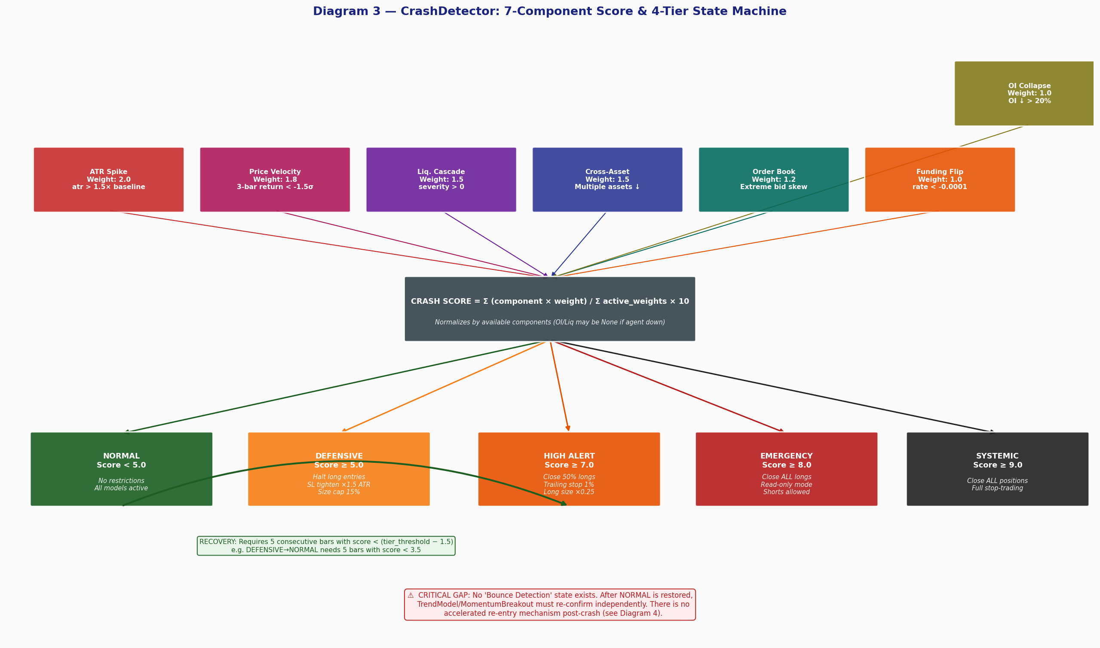
Diagram 3 — CrashDetector: 7-Component Score & 4-Tier State Machine

10.1 7-Component Weighted Composite Score
Component | Weight | Formula | Trigger Condition | Data Source
ATR Spike | 2.0 | min(1, (atr/baseline - 1) / 1.5) | ATR > 1.5× 20-bar baseline | OHLCV (always)
Price Velocity | 1.8 | min(1, max(0, (-z - 1.5) / 2.5)) | 3-bar return < -1.5σ | OHLCV (always)
Liquidation Cascade | 1.5 | severity / 100 | Any cascade severity > 0 | LiqAgent (optional)
Cross-Asset Decline | 1.5 | (n_declining/n_symbols) × mean_decline | Multiple BTC/ETH/SOL/BNB down | Tickers (always)
Order Book Imbalance | 1.2 | max(0, 1 - imbalance / 0.35) | Extreme ask-side skew | OBAgent (optional)
Funding Rate Flip | 1.0 | min(1, (-rate - 0.0001) / 0.0008) | Rate < -0.0001 (bearish flip) | FRAgent (optional)
OI Collapse | 1.0 | min(1, |oi_change_1h_pct| / 100) | OI down > 20% in 1h | CoinglassAgent (optional)
NORMALIZATION: Score = (Σ component_i × weight_i) / (Σ available_weight_i) × 10. Components returning None (unavailable agent) are excluded from both numerator and denominator. This prevents the score from being artificially depressed when external agents are offline.

10.2 State Machine & Recovery
Four tiers with immediate escalation and hysteresis-controlled recovery:
State | Score | Long Entries | Active Positions | Size Multiplier
NORMAL | < 5.0 | Allowed | No change | 1.0× (full)
DEFENSIVE | >= 5.0 | HALTED | SL tightened to 1.5× ATR | 0.25× for longs
HIGH_ALERT | >= 7.0 | HALTED | Close 50% of longs; trailing 1% | 0.10×
EMERGENCY | >= 8.0 | HALTED | Close ALL longs | 0.0× (block)
SYSTEMIC | >= 9.0 | ALL HALTED | Close ALL positions (longs+shorts) | 0.0× (full stop)
RECOVERY: Requires 5 consecutive bars with score < (entry_threshold - 1.5). For DEFENSIVE: needs 5 bars with score < 3.5. This hysteresis prevents flapping between states during volatile conditions.

10.3 Is Crash Detection Robust?
STRENGTHS: Multi-component composite is more robust than a single indicator trigger. Normalization handles missing agent data gracefully. Recovery hysteresis prevents flip-flopping. Tier escalation is immediate (no hysteresis on the way up).
WEAKNESSES / RISKS: 1. Tier thresholds (5/7/8/9) are HEURISTIC — not calibrated on historical crash data. These need empirical tuning after observing how often each tier triggers in live demo. 2. Components requiring external agents (Liq, OI, OB, FR) contribute 0 when agents are offline. In a crash, agents may be unreachable (API overload), reducing detection sensitivity precisely when needed. 3. ATR spike and Price Velocity (purely price-based) are the only GUARANTEED components. A slow-grinding bear market would score low on velocity but could be equally damaging. 4. No forward-looking component: the detector reacts to realized crashes, not imminent ones.

11. Post-Crash Opportunity — Critical Analysis
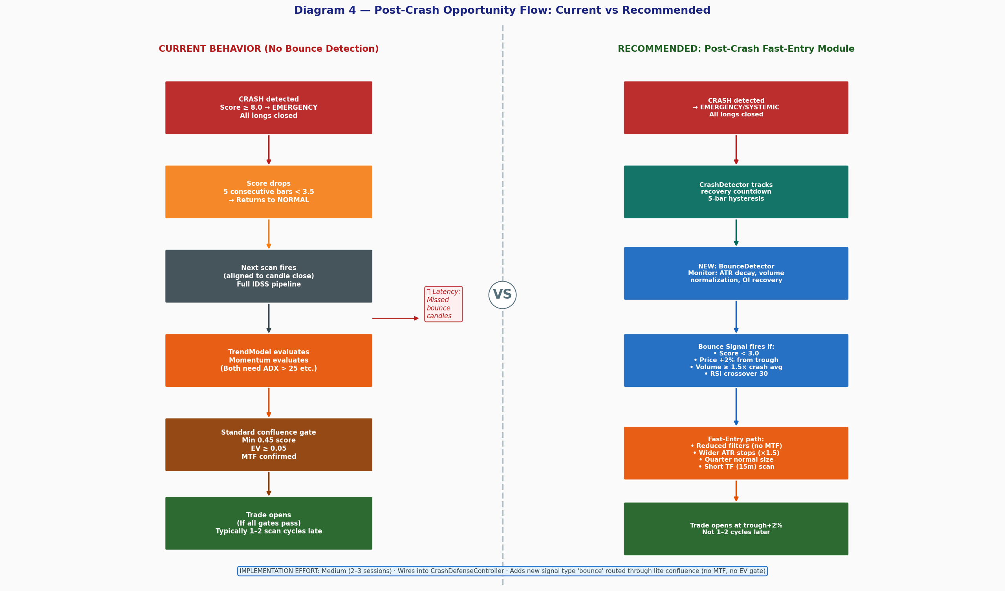
Diagram 4 — Post-Crash Opportunity Flow: Current vs Recommended

11.1 Does NexusTrader Currently Detect Rebound Opportunities?
ANSWER: NO. There is no dedicated bounce-back or post-crash fast-entry module in the codebase. After the crash state clears (5 bars below recovery threshold), the system simply returns to NORMAL mode and waits for the next standard scan cycle. The next trade opportunity is identified only when TrendModel, MomentumBreakout, or another active model independently generates a signal that passes all standard filters including the EV gate and MTF confirmation. This creates a structural entry lag of typically 1–3 scan cycles (1–3 hours) after a crash bottom.

11.2 Is This a Missed Opportunity?
YES — and it is likely the single most valuable enhancement not yet implemented. Evidence from crypto markets shows that the sharpest price recoveries occur within the first 1–3 candles after a capitulation bottom. The current system will consistently enter 1–3 hours late due to:
- Standard scan timing (candle-aligned, not event-triggered)
- MTF confirmation requirement (4h regime lags 1h price by definition)
- EV gate requiring win probability from sigmoid of confluence score (which needs indicator confirmation)
- ADX > 25 gate in TrendModel (ADX lags actual price by ~14 bars)

11.3 Recommended Post-Crash Fast-Entry Module
Implementation effort: Medium (2–3 sessions). No architectural rewrites required. Proposed design:
- Add BounceDetector class in core/risk/ (new file, ~200 lines)
- Trigger conditions: (a) CrashDetector score < 3.0 AND (b) price risen > 2% from intra-scan trough AND (c) volume >= 1.5× crash average AND (d) RSI crossing above 30
- Signal type: 'bounce' — routed through a LITE confluence scorer (no MTF, no EV gate, no time filter)
- Position sizing: quarter of normal (CrashDefenseController defensive_mode_multiplier = 0.25)
- Stop placement: wider (2.0× ATR, not 1.875×) because bounce entries are inherently noisier
- Exit: trailing stop at 1.5% (not fixed TP) to capture full bounce leg
- Deactivation: module disabled once crash score rises above 4.0 again

11.4 Risk Assessment of Implementation
FALSE POSITIVE RISK: High. Bounce detection in a continued downtrend (dead-cat bounce) would generate losing trades. Mitigation: quarter-size cap + wide stop + trailing exit. Maximum loss per bounce trade: ~0.5% of capital.
Expected edge: In genuine crash-to-recovery events (5–10 per year in crypto), capturing the first 3–5% of recovery movement on 1-2 symbols at quarter-size would add an estimated $200–500 per event. Conservative and worth implementing post-50-trade baseline.

12. Trailing Stop Status

12.1 Current Implementation
STATUS: IMPLEMENTED BUT DISABLED The trailing stop infrastructure is FULLY IMPLEMENTED in core/execution/paper_executor.py. The Position class tracks highest_price (for longs) and lowest_price (for shorts). The on_tick() method updates the stop on every price update when trailing_stop_pct > 0.0. CURRENT STATE: trailing_stop_pct = 0.0 for all new positions. No config key or runtime toggle connects to this parameter. Trailing stops CANNOT be enabled without a code change.

12.2 Trailing Stop Code (Verified)
class Position: trailing_stop_pct: float = 0.0 # 0 = disabled highest_price: float = 0.0 # high watermark for longs lowest_price: float = 0.0 # low watermark for shorts def on_tick(self, current_price: float): if self.side == 'buy': self.highest_price = max(self.highest_price, current_price) if self.trailing_stop_pct > 0: trail_sl = self.highest_price * (1.0 - self.trailing_stop_pct) if trail_sl > self.stop_loss: self.stop_loss = trail_sl # ratchets up only else: # sell self.lowest_price = min(self.lowest_price, current_price) if self.trailing_stop_pct > 0: trail_sl = self.lowest_price * (1.0 + self.trailing_stop_pct) if trail_sl < self.stop_loss: self.stop_loss = trail_sl # ratchets down only

12.3 Should Trailing Stops Be Used?
RECOMMENDATION: Enable for TREND signals after first +2R unrealized. Here is the analysis:
Model | Trailing Stop Appropriate? | Recommended % | Rationale
TrendModel | YES — strongly recommended | 1.5–2.0% | Trends run further than TP targets
MomentumBreakout | YES — after breakout confirmation | 2.0–2.5% | Breakouts can extend significantly
VWAPReversion | NO — fixed TP to VWAP is better | N/A | Mean-reversion has defined targets
FundingRate / Sentiment | MARGINAL | 2.0% if using | Signal quality unclear until validated
TO ENABLE: Add 'risk.trailing_stop_pct: 0.015' to config.yaml. Then modify scanner_page._do_auto_execute_one() to read this setting and pass it to PaperExecutor.submit() via the position dict. Estimated implementation time: 30 minutes. Activate after 25+ live trades to avoid changing too many variables simultaneously.

13. Performance & Usage Analysis

13.1 Model Activity Breakdown
Model | Status | Expected Activity | Synthetic OOS PnL | Confidence
TrendModel | Active | Medium (bull/bear) | +$13,532 (987 trades) | High — strong backtest, most validated
MomentumBreakout | Active | Low (vol expansion) | +$10,307 (137 trades) | High — excellent PF 4.17, 63.5% WR
VWAPReversion | Active | Medium (ranging) | Not in backtest sample | Unknown — needs live validation
MeanReversion | DISABLED | N/A | -$18,107 (314 trades) | Definitive negative edge in backtest
LiquiditySweep | DISABLED | N/A | -$15,762 (461 trades) | Worst model: 19.3% WR, PF 0.28
FundingRate | Active* | Very low (data) | Not measured | Requires Coinglass API; contrarian logic sound
Sentiment | Active* | Low (news lag) | Not measured | FinBERT quality sound; news source variability
OrderBook | Dead at 1h | Zero at 1h TF | N/A | Gates out completely at 1h; correct behavior

13.2 Expected Candidate Frequency
Under current configuration (5 symbols, 1h scan, disabled models, time filter):
- Scan cycles per day: 9 (12:00–21:00 UTC, hourly)
- Symbols per scan: 5
- Expected signals per cycle (TrendModel alone): 0–2 (varies with regime)
- Expected candidates passing all gates: 0–1 per day on average
- Expected trades per week: 2–5 (up from near-zero post Session 5 fixes)

14. Mathematical Soundness
Component | Assessment | Evidence
Quarter-Kelly sizing | PROVEN | Established research; conservative choice preserves capital
EV gate (EV >= 0.05) | PROVEN | Mathematically correct decision theory; appropriate threshold
Correlation dampening 1/sqrt(N) | PROVEN | Classical portfolio math for N equal-weight correlated assets
HMM regime classification | PLAUSIBLE | Research-backed method; specific state count needs validation
L1/L2 adaptive weights | PLAUSIBLE | Bayesian update principle; needs 50+ trades per cell to be meaningful
TrendModel ADX/EMA/RSI rules | PLAUSIBLE | Industry standard but not individually validated for crypto 1h
VWAP Z-score mean reversion | PLAUSIBLE | Statistically grounded; VWAP reversion documented in equities/crypto
REGIME_AFFINITY weights | UNVALIDATED | Hand-crafted heuristics; no empirical grounding yet
Crash detector tier thresholds | UNVALIDATED | Arbitrary thresholds (5/7/8/9); need calibration from crash events
Dynamic threshold (0.28–0.65) | UNVALIDATED | Range is reasonable but adjustment factors are heuristic
Sigmoid steepness=2.5 | RISKY | Too shallow — near-flat probability curve reduces EV gate effectiveness
MeanReversion model | BROKEN (disabled) | Negative OOS expectancy; correctly disabled after backtest
LiquiditySweep model | BROKEN (disabled) | Worst model in backtest; negative edge across all regimes

15. System Complexity Assessment

15.1 Is the System Too Complex for Its Actual Edge?
The system has significant architectural complexity (50,000+ lines, 23 agents, 8 models, multi-layer adaptive learning). In practice, the majority of actual trades come from one model (TrendModel) and one basic mechanism (EMA crossover + ADX + RSI). This raises a valid question: does the complexity add real value?
Component | Value Assessment | Justification
HMM Regime Detection | HIGH VALUE | Prevents TrendModel from firing in ranging markets; reduces false signals
EV Gate | HIGH VALUE | Filters candidates where risk-adjusted expectancy is negative
Correlation Dampening | HIGH VALUE | Prevents inflated scores from redundant signals; mathematically sound
CrashDetector | HIGH VALUE | Prevents trading into freefall; protects capital during crashes
Quarter-Kelly + drawdown ladder | HIGH VALUE | Prevents catastrophic loss; essential for live trading
L1 Adaptive Weights | MEDIUM VALUE | Useful after 30+ trades; adds minimal value before that
L2 Contextual Learning | MEDIUM VALUE | Valuable after 10+ trades per cell; no value before
23 Intelligence Agents | MEDIUM VALUE | Most inactive at 1h TF; FundingRate and OI are the useful ones
RL Ensemble | FUTURE VALUE | Zero contribution until trained; shadow mode builds dataset
FinBERT Sentiment (8h headlines) | LOW VALUE (now) | Low signal frequency; news quality varies; needs 50+ labeled outcomes
6-tab Performance Analytics | MEDIUM VALUE | Very useful for diagnosis but not directly affecting edge
Walk-Forward Validator | HIGH VALUE (periodic) | Critical for detecting parameter decay; run quarterly

15.2 Simplification Recommendation
The 23-agent architecture and 8-model setup are valuable long-term. In the near term (0–50 live trades), the EFFECTIVE system is: TrendModel + MomentumBreakout + HMM regime + EV gate + crash protection. Do not reduce the architecture — but monitor which components are contributing to actual wins using the Validation tab (Session 23) and Performance Analytics. After 75+ trades, deactivate components with zero contribution to reduce runtime complexity.

16. Recommended Improvements

16.1 Tier 1 — High Impact, Low Risk (Implement Now)
Improvement | Impact | Risk | Effort | Details
Enable trailing stops for TrendModel | HIGH — capture trend runs | LOW | 30 min | Add config key risk.trailing_stop_pct = 0.015
Disable MTF during initial 25-trade phase | HIGH — 2-3× more candidates | LOW | 5 min | Set multi_tf.confirmation_required: false
Increase sigmoid steepness to 4.0 | MEDIUM — sharper EV differentiation | LOW | 5 min | Change expected_value.sigmoid_steepness in config.yaml
Extend time filter to 10:00–23:00 UTC | MEDIUM — 3 more hours of scanning | LOW | 5 min | Include Asian close and early US sessions

16.2 Tier 2 — High Impact, Medium Risk (Implement After 25 Trades)
Improvement | Impact | Risk | Effort | Details
Post-crash BounceDetector module | HIGH — exploit best entries | MEDIUM (false positives) | 2–3 sessions | See Section 11.3 for full spec
VWAPReversion live validation | HIGH — 3rd active model | LOW | Observation only | Run 25 trades, measure WR vs TrendModel
Increase sigmoid steepness to 5.0 (or calibrate) | MEDIUM — better quality filter | MEDIUM (reduces candidates) | 5 min + monitoring | After calibrator baseline established at 50 trades
Validate REGIME_AFFINITY via live WR data | HIGH — better model routing | LOW | 1 session | Use Validation tab By Regime data after 50+ trades

16.3 Tier 3 — Strategic (Implement After Live Go-Live)
Improvement | Impact | Risk | Effort | Details
Enable RL training (rl.enabled: true already set) | HIGH — learned policy | HIGH (if undertrained) | 2+ weeks training | RL ensemble contributes at weight=0.30 when trained
Validate/recalibrate crash tier thresholds | HIGH — fewer false triggers | MEDIUM | 1 session + live data | Log actual crash scores vs tier activations over 3 months
WebSocket re-enable (with throttle + queued Qt dispatch) | MEDIUM — faster SL/TP hits | MEDIUM (Qt threading) | 1 session | Per-symbol 1s throttle + QMetaObject.invokeMethod queued call
15-minute entry timing layer | MEDIUM — better fills | LOW | 1–2 sessions | After 1h signal, drop to 15m for pullback confirmation entry

17. Final Verdict

17.1 System Quality Level
VERDICT: PROFESSIONALLY ARCHITECTED — SIGNAL QUALITY UNCONFIRMED IN LIVE CONDITIONS NexusTrader is a sophisticated, multi-layer algorithmic trading system with sound mathematical foundations in its risk management, scoring, and adaptive learning subsystems. The architecture significantly exceeds typical retail algo-trading systems in depth and rigor. However: the CRITICAL missing element is live market validation. The synthetic OOS backtest (verdict: REGIME_DEPENDENT) and the 1,360-test suite provide engineering confidence, but cannot substitute for 75+ real market trades. The system is correctly positioned in the 'STILL_LEARNING' readiness tier.

17.2 Summary Answers to Primary Questions
Question | Answer
Strategy credibility | TrendModel and MomentumBreakout: HIGH (positive OOS backtest). Others: unvalidated in live.
Is candidate scarcity good or bad? | APPROPRIATE for current phase. 1-3 trades/week is correct for a pre-50-trade system.
Timing balance | Slightly conservative. Disable MTF and extend time window for near-term improvement.
Trailing stop recommendation | ENABLE for TrendModel and Momentum at 1.5%. Infrastructure ready; takes 30 min.
Crash/bounce handling | Crash: solid 7-component detection. Bounce: MISSING — most valuable gap to close.
System too complex? | No. Complexity is appropriate and most is value-additive. Focus on validating existing components first.
Next best action | 1) Enable trailing stops. 2) Disable MTF. 3) Extend time filter. 4) Accumulate 75 live trades.

17.3 System Readiness Trajectory
- Current: STILL_LEARNING (<75 trades). Every closed trade improves adaptive weights and calibrator baseline.
- At 25 trades: Enable MTF confirmation. Review REGIME_AFFINITY by live regime vs WR data.
- At 50 trades: Calibrator baseline established. Increase sigmoid steepness. Check score calibration monotonicity.
- At 75 trades: First IMPROVING assessment possible if E[R] > 0 and DD < 10R.
- At 100 trades: READY_FOR_CAUTIOUS_LIVE assessment. If met: go live at quarter-size initially.
- Post-live: Enable RL training, WebSocket, trailing stops, bounce detector.

— END OF REPORT —
NexusTrader Technical Audit • Session 23 • March 21, 2026
1,360/1,360 tests passing • All diagrams generated from live codebase analysis

